宏观与跨资产专题 Macro & Cross-Asset Special v20261016-0756
数据快照 20261016-0756 (SGT)。来源: FRED、Yahoo Finance。非投资建议。

1. 结论摘要 (INFERENCE)
- 通胀: CPI 同比 +3.7% (2026-09-01)，核心CPI +2.6%，核心PCE +3.0% (2026-08-01)——仍高于2%目标。
- 政策利率上限 4.0% (2026-10-15)；10Y 5.19%；10Y实际利率 2.84%；2s10s 0.33%。
- 美元净流动性代理 ≈ 5,871 bn USD (WALCL−RRP−TGA)。
- 套息压力 Carry Stress: CALM (USD/JPY 1个月 +1.4%，VIX 16.5)。
- 高收益利差 HY OAS 3.25%；芝加哥金融条件指数 NFCI -0.499（负=宽松）。

2. 传导链 Transmission chain
通胀/就业 → FOMC 反应函数 → 2Y → 10Y(含期限溢价/财政) → 实际利率 → WACC → 成长股估值倍数；BOJ → JGB → USD/JPY 速度 → 套息平仓 → 全球流动性。

3. 市场心理与资金 (证据要求)
- 本版可用证据: 跨资产价格(见热力图)、VIX、信用利差。CFTC持仓/基金经理调查/期权偏度 UNAVAILABLE（未接入），因此不对”机构定位”作断言。
- 反身性观察: 若AI龙头上涨同时HYG下跌 → 脆弱的风险偏好。

4. AI 生产率 → 通胀 → Fed (专题框架)
AI Capex ↑ → 生产率 ↑ → 单位劳动成本 ULC ↓ → 核心通胀 ↓ → Fed 更鸽 (鸽派路径)；或 AI Capex ↑ → 电力/建设/芯片需求过热 → 通胀 ↑ → Fed 更鹰 (过热路径)。证据: 11/5 生产率与成本(BLS, CONFIRMED)、ECI 10/30。

5. 跨资产表 (DATA)
资产 | 代码 | 最新 | 日期 | 1D | 1W | 1M | 1Y
S&P 500 | ^GSPC | 7,744.060 | 2026-10-15 | +0.3% | -0.3% | +2.5% | +16.6%
Nasdaq-100 | ^NDX | 29,935.594 | 2026-10-15 | -0.1% | -2.6% | +3.4% | +21.8%
PHLX Semiconductor｜费城半导体 | ^SOX | 11,581.215 | 2026-10-15 | -0.9% | -8.3% | +3.0% | +76.3%
VIX 波动率 | ^VIX | 16.460 | 2026-10-15 | -2.4% | +6.8% | -7.1% | -35.0%
13W T-Bill | ^IRX | 4.088 | 2026-10-15 | +0.1% | +1.1% | +3.0% | +6.1%
5Y UST | ^FVX | 4.899 | 2026-10-15 | -1.9% | -1.8% | +0.8% | +35.9%
10Y UST 收益率 | ^TNX | 5.089 | 2026-10-15 | -1.9% | -2.7% | +1.7% | +26.5%
30Y UST | ^TYX | 5.429 | 2026-10-15 | -1.7% | -3.2% | +1.5% | +17.4%
DXY 美元指数 | DX-Y.NYB | 102.046 | 2026-10-15 | -0.5% | -0.1% | +1.7% | +3.0%
USD/JPY 美元/日元 | JPY=X | 158.136 | 2026-10-16 | +0.1% | +0.0% | +1.4% | +3.3%
EUR/USD | EURUSD=X | 1.122 | 2026-10-16 | +0.2% | +0.0% | -2.2% | -3.6%
WTI 原油 | CL=F | 96.180 | 2026-10-15 | +1.1% | +5.1% | -6.1% | +63.9%
Gold 黄金 | GC=F | 4,178.300 | 2026-10-15 | +1.7% | +0.5% | -4.8% | +0.4%
Copper 铜 | HG=F | 6.551 | 2026-10-15 | -0.9% | +0.5% | +1.9% | +31.5%
Bitcoin | BTC-USD | 82,135.750 | 2026-10-15 | +0.7% | -0.9% | -2.7% | +31.0%
Nikkei 225 日经 | ^N225 | 67,744.289 | 2026-10-14 | -0.0% | -4.2% | +4.0% | +50.4%
TAIEX 台湾加权 | ^TWII | 48,625.828 | 2026-10-14 | +0.6% | -2.4% | +3.6% | +86.9%
KOSPI 韩国综合 | ^KS11 | 6,008.810 | 2026-10-14 | -0.4% | -13.4% | -14.8% | +73.1%
HY Credit ETF 高收益债 | HYG | 77.130 | 2026-10-15 | +0.4% | -0.0% | -1.2% | +1.6%
20Y+ UST ETF | TLT | 79.970 | 2026-10-15 | +1.4% | +2.7% | -0.7% | -7.9%
Semis ETF | SMH | 558.840 | 2026-10-15 | -1.0% | -8.0% | +2.4% | +68.1%

6. FRED 宏观表 (DATA)
指标 | 代码 | 最新 | 日期
CPI | CPIAUCSL | 336.298 | 2026-09-01
Core CPI | CPILFESL | 338.896 | 2026-09-01
Core PCE | PCEPILFE | 130.455 | 2026-08-01
PPI Final Demand | PPIFIS | 159.780 | 2026-09-01
Unemployment Rate | UNRATE | 4.200 | 2026-09-01
Nonfarm Payrolls | PAYEMS | 159,044.000 | 2026-09-01
AHE | CES0500000003 | 37.810 | 2026-09-01
Initial Claims | ICSA | 199,000.000 | 2026-10-10
Real GDP | GDPC1 | 24,408.011 | 2026-04-01
Fed Funds Upper | DFEDTARU | 4.000 | 2026-10-15
2Y UST | DGS2 | 4.820 | 2026-10-14
10Y UST | DGS10 | 5.190 | 2026-10-14
10Y-2Y | T10Y2Y | 0.330 | 2026-10-15
10Y Breakeven | T10YIE | 2.320 | 2026-10-15
10Y Real Yield | DFII10 | 2.840 | 2026-10-14
HY OAS | BAMLH0A0HYM2 | 3.250 | 2026-10-14
Fed Balance Sheet | WALCL | 6,755,639.000 | 2026-10-14
ON RRP | RRPONTSYD | 1.201 | 2026-10-15
TGA | WTREGEN | 883,373.000 | 2026-10-14
Chicago NFCI | NFCI | -0.499 | 2026-10-09
Japan 10Y (monthly) | IRLTLT01JPM156N | 3.050 | 2026-09-01

7. 风险与证伪
- 若核心PCE连续3个月月率≤0.2% → “高通胀粘性”假设被证伪。
- 若USD/JPY在1个月内下跌>5% → 套息压力升级、科技股倍数受压。 ## 8. Source Ledger FRED series IDs as listed (latest observation dates in table); Yahoo Finance daily closes snapshot 20261016-0756. ## 9. Assumption Register Carry rule thresholds (ASSUMPTION); net-liquidity proxy definition (METHOD).

图片报告 Image Report
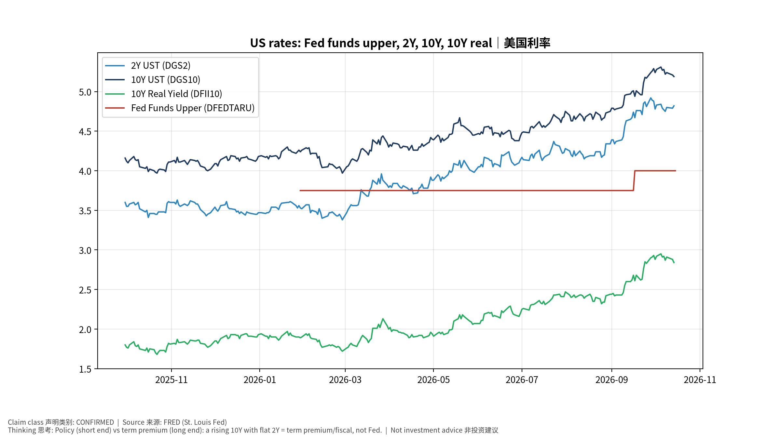
macro_1_rates
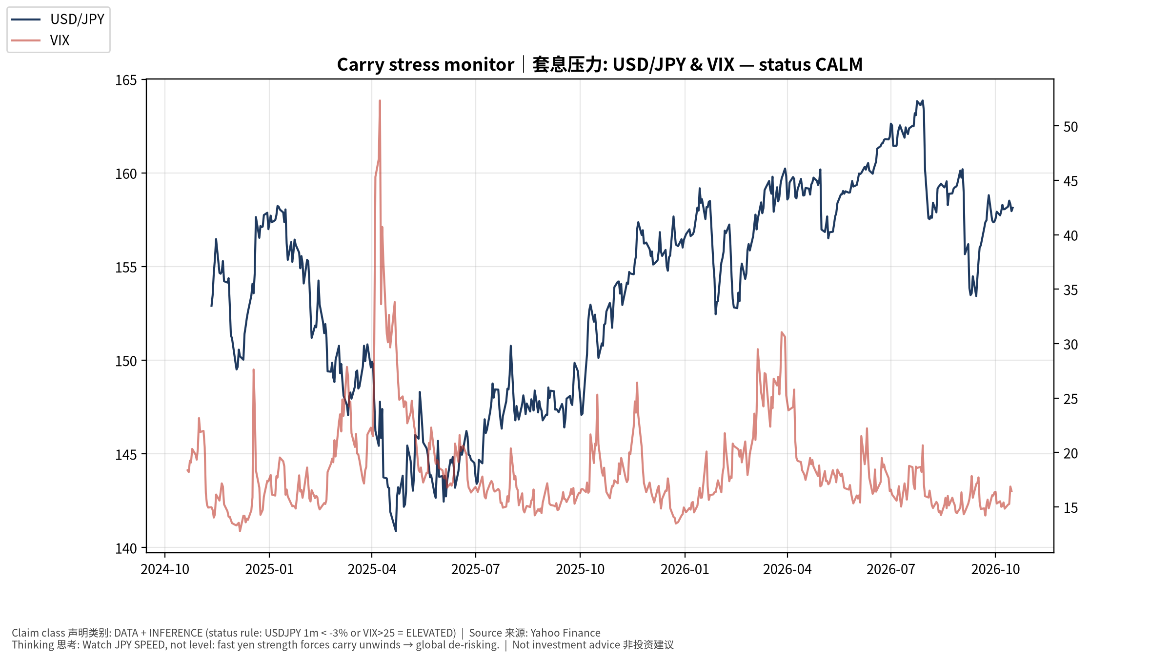
macro_2_carry
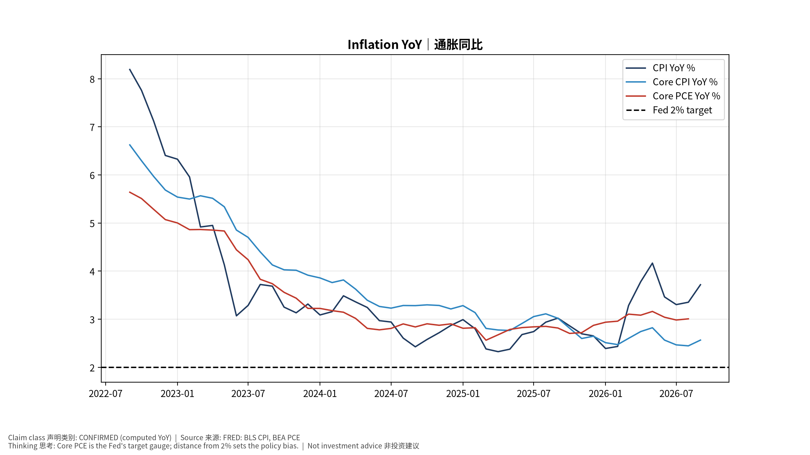
macro_3_inflation
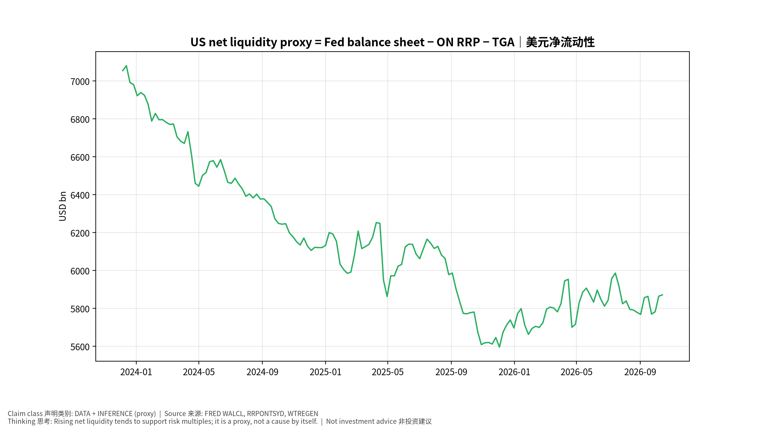
macro_4_liquidity
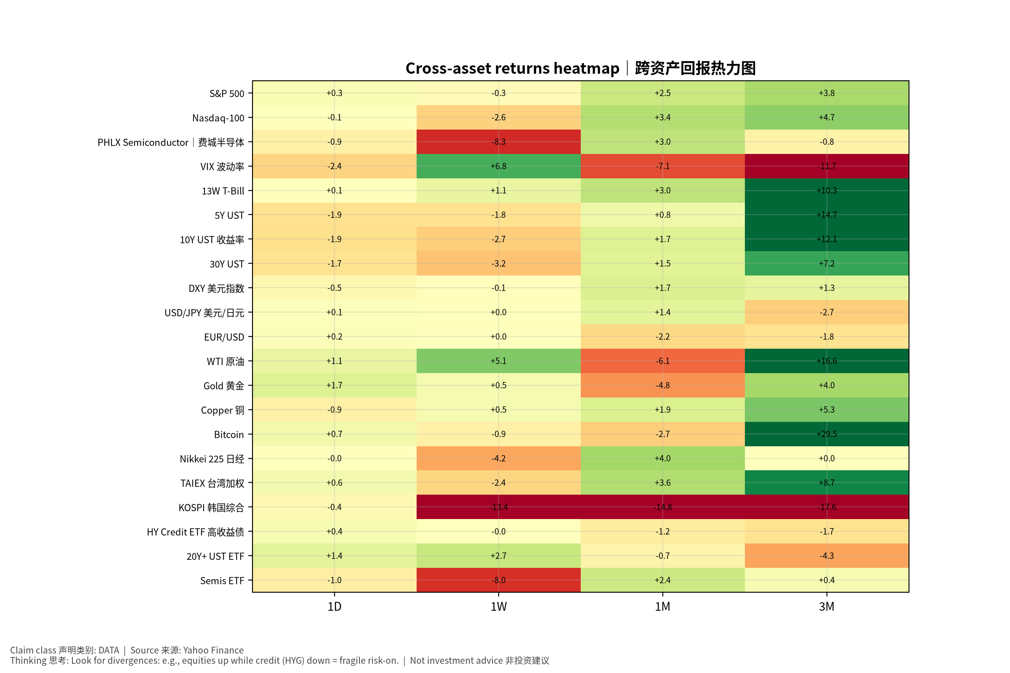
macro_5_crossasset

Macro & Cross-Asset Special (English) v20261016-0756
- Inflation: CPI YoY +3.7%, core CPI +2.6%, core PCE +3.0% — above 2%.
- Fed funds upper 4.0%; 10Y 5.19%; 10Y real 2.84%; 2s10s 0.33%.
- Net liquidity proxy ≈ 5,871 bn USD. Carry stress: CALM (USD/JPY 1M +1.4%, VIX 16.5).
- Positioning claims are withheld: CFTC/fund-manager survey/option skew feeds are UNAVAILABLE in v1.
- AI productivity → inflation → Fed: two competing paths (dovish productivity vs overheating); key evidence Nov 5 Productivity & Costs, Oct 30 ECI.
- Falsifiers: core PCE ≤0.2% m/m for 3 months; USD/JPY −5% in a month. Tables: see Chinese section (bilingual labels).

