台日韩题材雷达 TW/JP/KR Theme Radar v20261016-0756
快照 20261016-0756；等权篮子；评分 = 0.5×1W + 0.3×1M + 0.2×3M (ASSUMPTION)。分类到技术/制程/产品层级(L2)。非投资建议。

1. 题材排名 Theme ranking
市场 | 题材L1 | 成分数 | 1W | 1M | 3M | 评分 | 状态
KR | Battery 电池 | 1 | +2.9% | +10.3% | +23.5% | +9.2 | STRONG 强
JP | Power Grid 电网 | 1 | -1.0% | +8.5% | +19.6% | +6.0 | STRONG 强
TW | PCB 印刷电路板 | 1 | -4.4% | +15.5% | +16.1% | +5.7 | STRONG 强
TW | Thermal 散热 | 2 | -10.3% | -2.4% | +50.4% | +4.2 | NEUTRAL 中性
TW | ASIC/SoC 芯片设计 | 3 | -11.6% | +5.9% | +32.5% | +2.5 | NEUTRAL 中性
TW | Optical 光通信 | 2 | -11.2% | -2.0% | +41.3% | +2.1 | NEUTRAL 中性
TW | PCB/ABF Substrate 载板 | 2 | -13.4% | +17.3% | +5.0% | -0.5 | NEUTRAL 中性
TW | CCL 覆铜板 | 2 | -9.7% | +7.2% | +7.2% | -1.2 | NEUTRAL 中性
TW | Advanced Packaging 先进封测 | 1 | -8.1% | +8.9% | -1.5% | -1.7 | NEUTRAL 中性
TW | Foundry 晶圆代工 | 1 | -5.6% | +1.5% | +0.3% | -2.3 | WEAK 弱
TW | Networking 网通 | 1 | -3.2% | +3.4% | -16.0% | -3.8 | WEAK 弱
JP | Materials 材料 | 1 | -4.3% | +3.8% | -18.3% | -4.7 | WEAK 弱
JP | Test 测试 | 1 | -16.8% | +1.2% | +15.1% | -5.0 | WEAK 弱
TW | AI Server ODM 服务器代工 | 4 | -7.6% | -8.0% | +4.8% | -5.2 | WEAK 弱
JP | Robotics 机器人 | 2 | -8.9% | -0.8% | -27.8% | -10.3 | WEAK 弱
JP | SPE 半导体设备 | 4 | -15.3% | +3.4% | -22.4% | -11.1 | WEAK 弱
TW | Power 电源 | 1 | -18.1% | +0.6% | -13.8% | -11.6 | WEAK 弱
TW | Memory 存储 | 2 | -14.1% | -10.2% | -11.4% | -12.4 | WEAK 弱
JP | Optical 光通信 | 2 | -17.7% | -5.9% | -14.6% | -13.6 | WEAK 弱
KR | PCB 印刷电路板 | 1 | -21.1% | -14.8% | -7.2% | -16.4 | WEAK 弱
JP | ASIC/SoC 芯片设计 | 1 | -18.5% | -1.6% | -35.2% | -16.8 | WEAK 弱
KR | Defense/Space 国防航天 | 1 | -15.2% | -22.8% | -14.8% | -17.4 | WEAK 弱
JP | PCB/ABF Substrate 载板 | 1 | -24.9% | -10.8% | -9.1% | -17.5 | WEAK 弱
KR | Autos/Robotics 汽车/机器人 | 1 | -12.1% | -24.0% | -35.0% | -20.2 | WEAK 弱
JP | Components 被动元件 | 1 | -22.3% | -9.9% | -31.3% | -20.4 | WEAK 弱
KR | Power Gen 发电 | 1 | -21.4% | -29.6% | -19.0% | -23.3 | WEAK 弱
KR | Advanced Packaging 先进封测 | 1 | -27.3% | -24.0% | -13.4% | -23.6 | WEAK 弱
KR | Components 被动元件 | 1 | -27.5% | -16.9% | -26.6% | -24.1 | WEAK 弱
JP | AI Platform/Capital AI 资本 | 1 | -23.1% | -28.7% | -23.8% | -24.9 | WEAK 弱
KR | Memory 存储 | 2 | -24.3% | -26.9% | -34.2% | -27.1 | WEAK 弱
KR | Power Grid 电网 | 3 | -25.4% | -32.0% | -34.5% | -29.2 | WEAK 弱
JP | Memory 存储 | 1 | -28.0% | -33.5% | -49.8% | -34.0 | WEAK 弱

2. 个股明细 (技术/制程/产品 L2)
市场 | 题材L1 | 细分L2 | 代码 | 1D | 1W | 1M | 3M
TW | Foundry 晶圆代工 | N3/N2 先进制程 + CoWoS | 2330.TW | -2.0% | -5.6% | +1.5% | +0.3%
TW | ASIC/SoC 芯片设计 | Custom ASIC / 手机SoC | 2454.TW | -6.9% | -13.9% | -9.2% | +11.4%
TW | ASIC/SoC 芯片设计 | Custom ASIC 设计服务 | 3661.TW | -6.0% | -11.6% | +1.5% | -0.0%
TW | ASIC/SoC 芯片设计 | ASIC 设计服务 | 3443.TW | -7.0% | -9.3% | +25.3% | +86.2%
TW | AI Server ODM 服务器代工 | GB/VR rack 整机 | 2317.TW | -1.4% | -5.0% | -3.4% | +0.2%
TW | AI Server ODM 服务器代工 | L10-L11 rack | 2382.TW | -2.0% | -5.5% | -5.9% | -13.4%
TW | AI Server ODM 服务器代工 | Hyperscaler 白牌 | 6669.TW | -9.9% | -15.0% | -17.5% | +11.5%
TW | AI Server ODM 服务器代工 | L6-L10 | 3231.TW | -5.9% | -4.9% | -5.1% | +21.0%
TW | Advanced Packaging 先进封测 | OSAT / CoWoS-like | 3711.TW | -9.9% | -8.1% | +8.9% | -1.5%
TW | PCB/ABF Substrate 载板 | ABF 载板 | 3037.TW | -9.3% | -17.6% | +10.0% | +14.9%
TW | PCB/ABF Substrate 载板 | ABF 载板 | 8046.TW | -5.9% | -9.1% | +24.5% | -4.9%
TW | CCL 覆铜板 | 高速 CCL (M8/M9) | 2383.TW | -7.2% | -13.9% | -4.6% | +1.2%
TW | CCL 覆铜板 | 高速 CCL | 6274.TWO | -6.3% | -5.5% | +19.0% | +13.2%
TW | PCB 印刷电路板 | AI server PCB/HDI | 2368.TW | -5.6% | -4.4% | +15.5% | +16.1%
TW | Thermal 散热 | 液冷 cold plate / 3D VC | 3017.TW | -6.9% | -13.0% | -8.5% | +43.3%
TW | Thermal 散热 | 液冷 CDU/manifold | 3324.TWO | -5.4% | -7.5% | +3.7% | +57.4%
TW | Power 电源 | AI rack PSU / HVDC | 2308.TW | -8.7% | -18.1% | +0.6% | -13.8%
TW | Optical 光通信 | InP 磊晶 epi wafer | 3081.TWO | -8.3% | -15.9% | -6.0% | +50.4%
TW | Optical 光通信 | 光收发模块/CPO | 4979.TWO | -7.8% | -6.4% | +2.1% | +32.2%
TW | Networking 网通 | 800G/1.6T 交换机 | 2345.TW | -4.9% | -3.2% | +3.4% | -16.0%
TW | Memory 存储 | DRAM 利基 | 2408.TW | -8.5% | -14.5% | -10.9% | -8.6%
TW | Memory 存储 | DRAM/NOR 利基 | 2344.TW | -6.1% | -13.6% | -9.6% | -14.1%
JP | SPE 半导体设备 | 刻蚀/涂布显影 | 8035.T | -7.8% | -17.1% | +1.6% | -26.4%
JP | Test 测试 | SoC/HBM ATE | 6857.T | -15.0% | -16.8% | +1.2% | +15.1%
JP | SPE 半导体设备 | Dicing/Grinding (HBM) | 6146.T | -8.5% | -13.4% | -0.4% | -26.5%
JP | SPE 半导体设备 | EUV mask inspection | 6920.T | -13.6% | -16.0% | +8.0% | -11.6%
JP | SPE 半导体设备 | 清洗设备 | 7735.T | -10.6% | -14.8% | +4.5% | -24.9%
JP | ASIC/SoC 芯片设计 | Socionext ASIC | 6526.T | -7.8% | -18.5% | -1.6% | -35.2%
JP | PCB/ABF Substrate 载板 | ABF 载板 (Ibiden) | 4062.T | -12.2% | -24.9% | -10.8% | -9.1%
JP | Materials 材料 | 硅晶圆/光刻胶 | 4063.T | -3.4% | -4.3% | +3.8% | -18.3%
JP | Optical 光通信 | 光纤/光缆 (Fujikura) | 5803.T | -12.7% | -20.4% | -12.5% | -11.5%
JP | Optical 光通信 | 光纤+电线 (Sumitomo Elec) | 5802.T | -9.1% | -15.1% | +0.7% | -17.7%
JP | Memory 存储 | NAND (Kioxia) | 285A.T | -12.3% | -28.0% | -33.5% | -49.8%
JP | Power Grid 电网 | 变压器/电网 (Hitachi) | 6501.T | -3.7% | -1.0% | +8.5% | +19.6%
JP | AI Platform/Capital AI 资本 | SoftBank/ARM/Stargate | 9984.T | -9.3% | -23.1% | -28.7% | -23.8%
JP | Components 被动元件 | MLCC | 6981.T | -10.0% | -22.3% | -9.9% | -31.3%
JP | Robotics 机器人 | Fanuc 工业机器人 | 6954.T | -5.5% | -4.2% | +2.0% | -17.5%
JP | Robotics 机器人 | Yaskawa 伺服/机器人 | 6506.T | -9.3% | -13.6% | -3.6% | -38.2%
KR | Memory 存储 | DRAM/HBM/Foundry (Samsung) | 005930.KS | -9.5% | -21.8% | -21.9% | -26.3%
KR | Memory 存储 | HBM 领先 (SK hynix) | 000660.KS | -11.1% | -26.8% | -31.9% | -42.1%
KR | Advanced Packaging 先进封测 | TC Bonder (Hanmi) | 042700.KS | -11.6% | -27.3% | -24.0% | -13.4%
KR | Components 被动元件 | MLCC/FC-BGA (SEMCO) | 009150.KS | -15.4% | -27.5% | -16.9% | -26.6%
KR | PCB 印刷电路板 | 高多层 PCB (Isu Petasys) | 007660.KS | -13.4% | -21.1% | -14.8% | -7.2%
KR | Power Grid 电网 | 变压器 (HD Hyundai Electric) | 267260.KS | -10.3% | -22.5% | -34.7% | -42.7%
KR | Power Grid 电网 | 配电 (LS Electric) | 010120.KS | -12.1% | -24.2% | -24.4% | -23.1%
KR | Power Grid 电网 | 变压器 (Hyosung Heavy) | 298040.KS | -14.7% | -29.6% | -37.0% | -37.7%
KR | Power Gen 发电 | 燃机/核电 (Doosan Enerbility) | 034020.KS | -8.8% | -21.4% | -29.6% | -19.0%
KR | Defense/Space 国防航天 | Hanwha Aerospace | 012450.KS | -2.1% | -15.2% | -22.8% | -14.8%
KR | Autos/Robotics 汽车/机器人 | Hyundai Motor/Boston Dynamics | 005380.KS | -5.7% | -12.1% | -24.0% | -35.0%
KR | Battery 电池 | LGES ESS | 373220.KS | -4.6% | +2.9% | +10.3% | +23.5%

3. 美股联动 US read-across
- Memory: MU ↔ 000660.KS/005930.KS/285A.T；Foundry: TSM ↔ 2330.TW；Optical: LITE/COHR/GLW ↔ 5803.T/3081.TWO/4979.TWO；Power grid: PWR/EME ↔ 267260.KS/6501.T；ASIC: AVGO/MRVL ↔ 3661.TW/2454.TW；SPE: AMAT/KLAC ↔ 8035.T/6857.T/6146.T。 ## 4. 教学 Teaching 题材轮动 (rotation｜轮动) = 资金从一个篮子转向另一个。看”1W强但3M弱”=新启动；“3M强但1W弱”=可能拥挤后降温。证伪: 美股对应龙头财报不及预期而亚洲篮子仍上涨 → 题材脱离基本面。 English: rotation = money moving between baskets; strong 1W/weak 3M = new leadership; strong 3M/weak 1W = possible crowding unwind. ## Source Ledger Yahoo Finance local-exchange daily closes, snapshot 20261016-0756. Theme mapping = analyst classification (pipeline/universe.py).
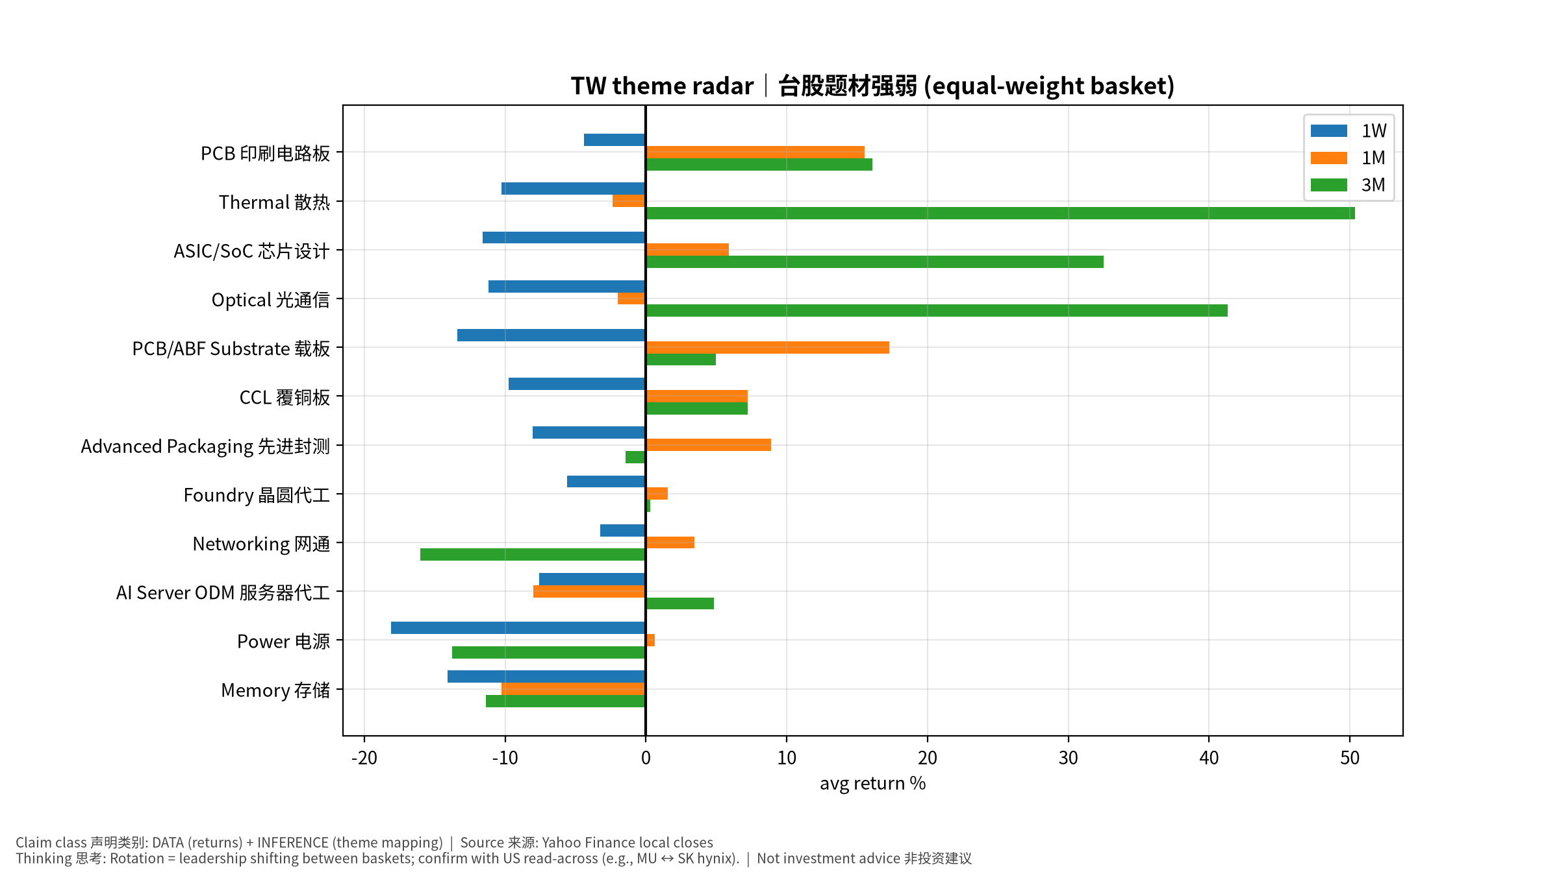
TW
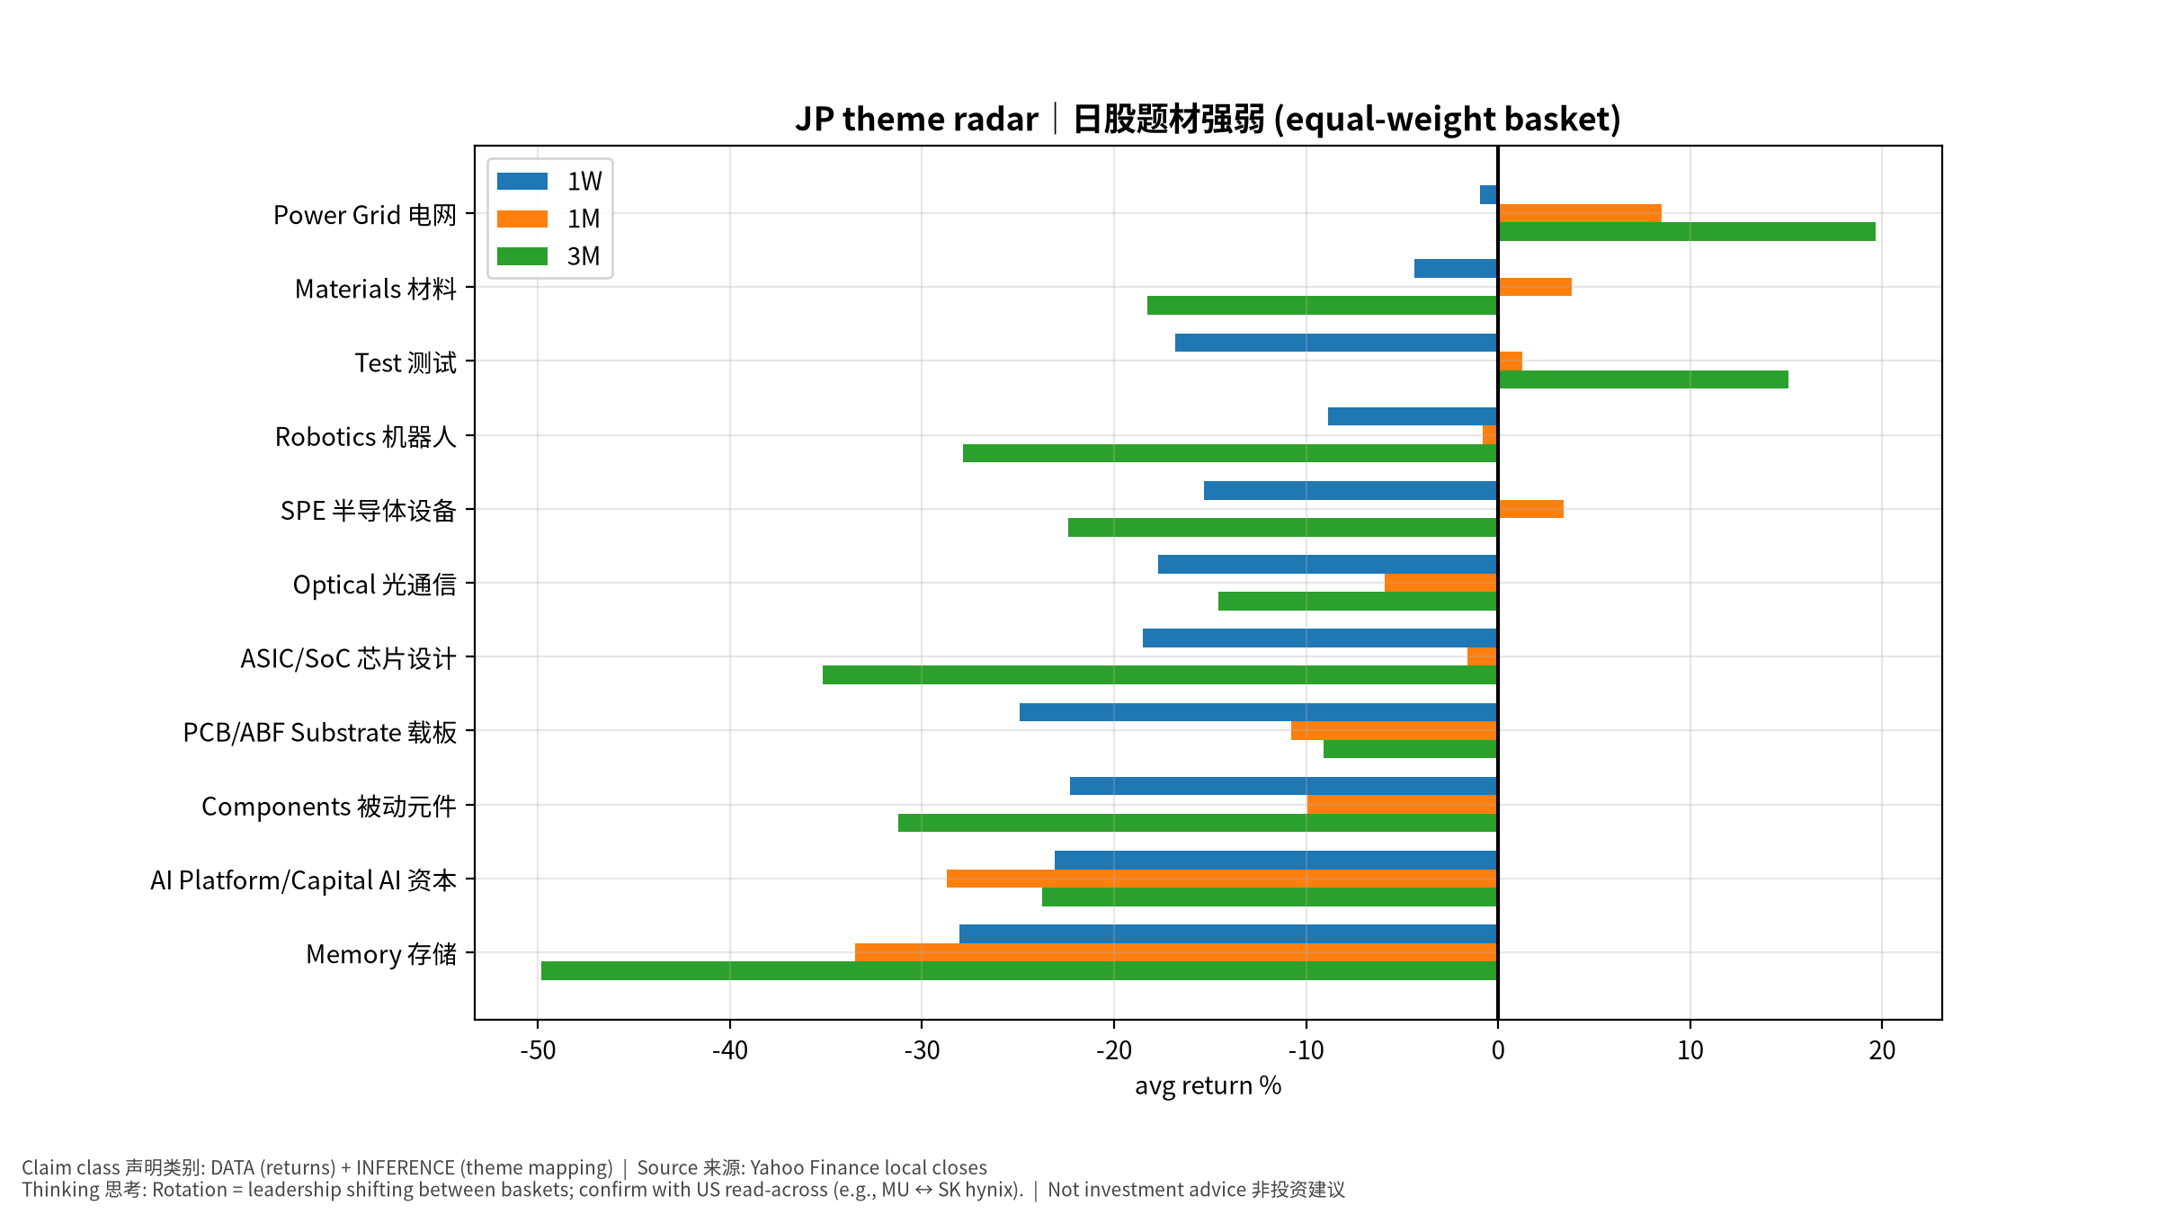
JP
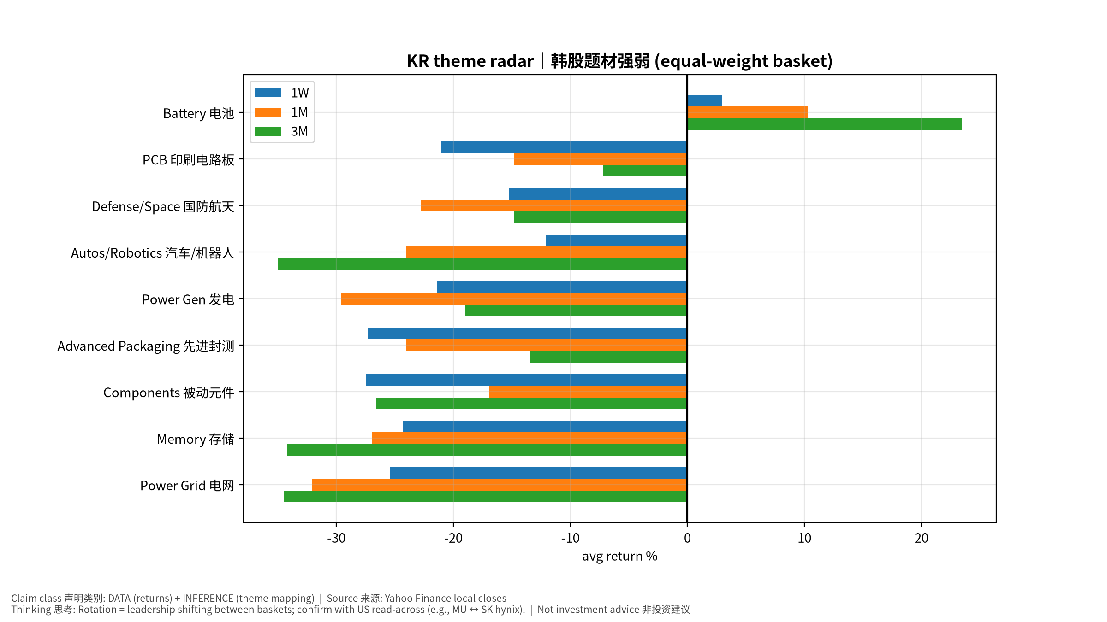
KR

