1. Download the tool AADConnectorPreview.zip file that I attached in this case note and unzip it to a location on the computer (see step 3 for example).
2. [**IMPORTANT**] Open a PowerShell window with "***Run As Administrator***"
3. [**IMPORTANT**] Move to the current folder where the AADConnectorPreview tool is located, e.g.:

cd \Temp\AADConnectorPreview

1. Import AADConnector module (a warning message will appear saying that not all AAD Connect functionalities will be available, that's fine, please ignore the message):

Import-Module .\AADConnector.psm1

1. Set a PSCredential for Global Admin authentication, aka. Company Administrator:

$creds = Get-Credential

1. Read all Public Folder objects from Azure AD:

Get-ADSyncAADObject -Creds <PSCredential> -SyncObjectType <ObjectType>

Example:

Get-ADSyncAADObject -Creds $creds -SyncObjectType PublicFolder

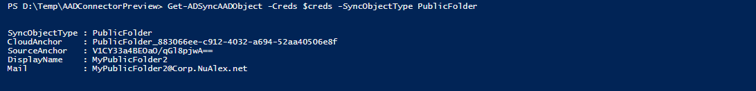

[**IMPORTANT**] Please confirm that returned results only contain PublicFolder objects.

1. [OPTIONAL] You can export the results for a CSV file for detailed reviewing. If there are any objects that **should not be deleted**, just remove that row from the list and save the new file.

Get-ADSyncAADObject -Creds <PSCredential> -SyncObjectType <ObjectType> | Export-Csv <filename.csv> [-NoTypeInformation]

Example:

Get-ADSyncAADObject -Creds $creds -SyncObjectType PublicFolder | Export-Csv .\allPublicFolders.csv

1. Delete one PublicFolder object from Azure AD:

Remove-ADSyncAADObject -Creds <PSCredential> -SyncObjectType <ObjectType> -SourceAnchor <SourceAnchor>

Example:

Remove-ADSyncAADObject -Creds $creds -SyncObjectType PublicFolder -SourceAnchor V1CY33a4BEOaO/qGl8pjwA==

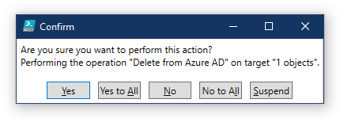

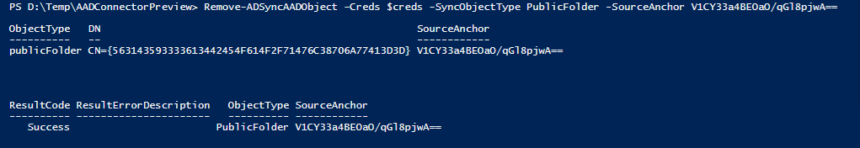

1. [OPTIONAL] To delete many PublicFolder objects at once, use the reviewed CSV filename as the *InputCsvFilename* parameter:

Remove-ADSyncAADObject -Creds <PSCredential> -InputCsvFilename <filename.csv>

Example:

Remove-ADSyncAADObject -Creds $creds -InputCsvFilename .\allObjsToDelete.csv

**[DISCLAIMER] This step will permanently delete all the PublicFolder objects contained in the input CSV file and cannot be restored.**

[NOTE] In case you find any issues running this tool use the **Verbose** parameter for a detailed output before raising an IcM escalation:

Remove-ADSyncAADObject -Creds $creds -InputCsvFilename .\allObjsToDelete.csv -Verbose