302-lab1-website-project-rod-gaitan
Screenshot of work completed for Lab 1 - • ALAB 302.1 - Branching, Merging, and Handling Conflicts
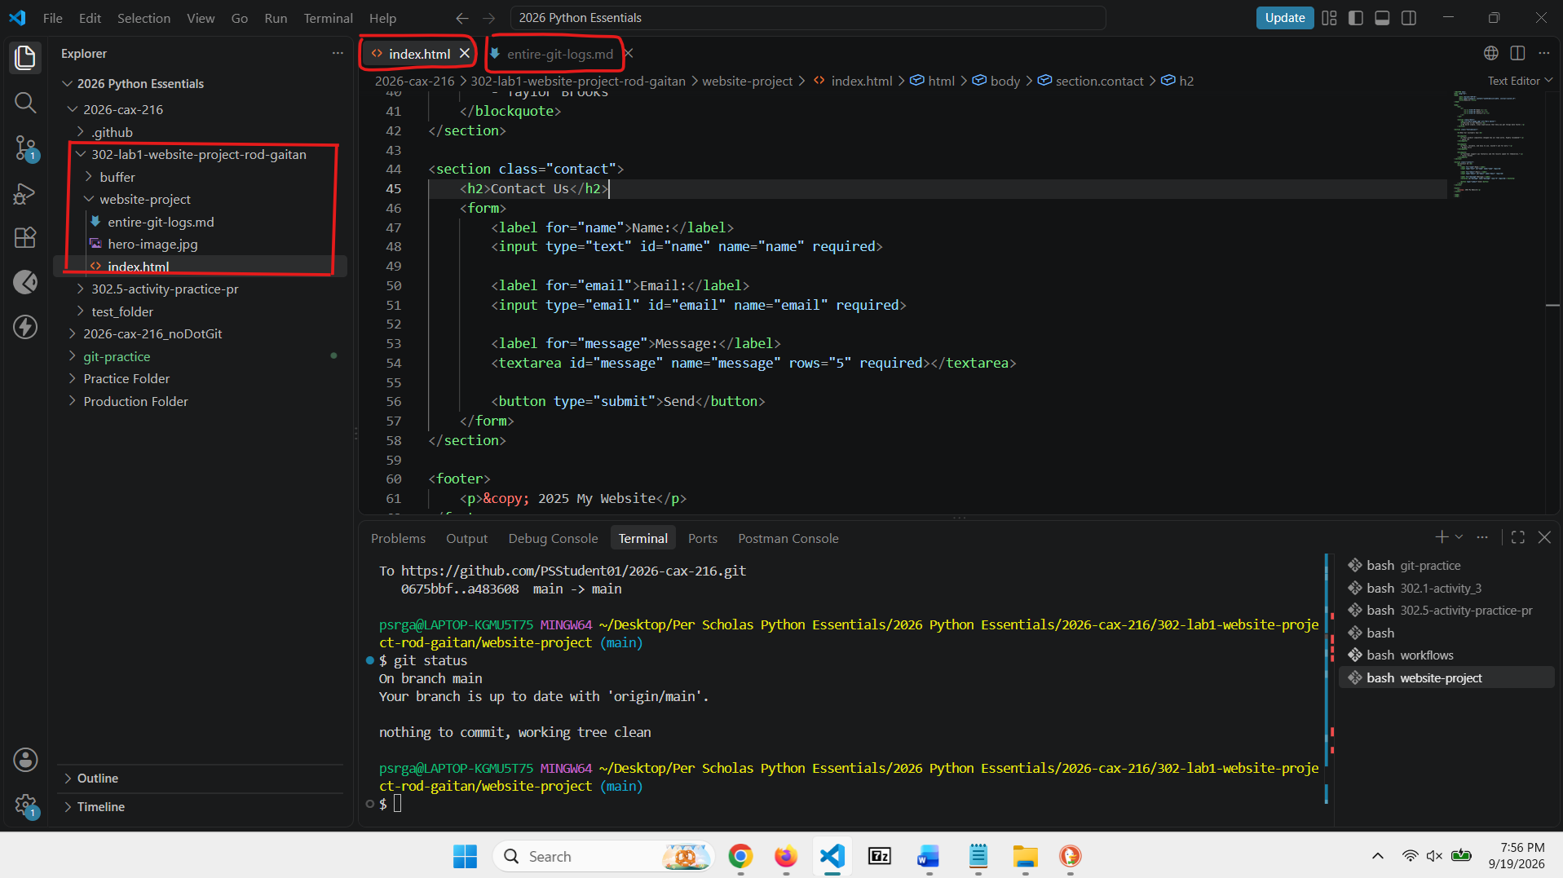

https://github.com/PSStudent01/2026-cax-216/tree/main/302-lab1-website-project-rod-gaitan/website-project
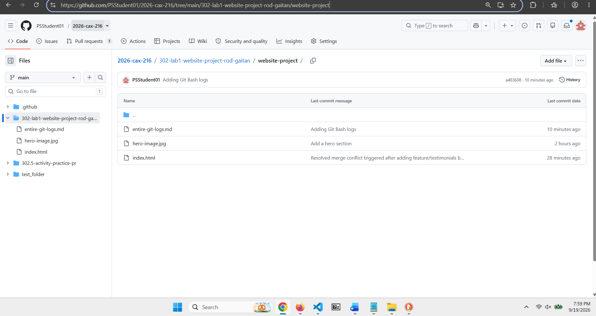

Please note: a complete set of Git Bash logs were pushed to this GitHub repo. Please see ‘entire-git-logs.md’ file

