Frontend Mentor - Bento grid solution

Please see Project Related Files ONLY:
README-template.md.docx
index.html
styles.css
tw-version (folder)
Reflection.docx

#Table of contents
## Overview
### The challenge
### Screenshot
### Links

## My process
### Steps taken
### Built with
## Author

## Overview
- This is a solution to the [Bento grid challenge on FrontendMentor](https://www.frontendmentor.io/challenges/bento-grid-RMydElrlOj).
- I chose the Bento project because it’s not only free but also it resembled very much to the previous exercises and labs that we learned during class.
- I felt this would be a good opportunity to re-enforced what we’ve learned so far.
- From what I understand, this project illustrates how crucial a grid layout is to the development of a web project. These grid layouts allow for a more efficient implementation of a project after handoff from the designer team.
- this particular project groups different cards into an attractive grid format that resembles a typical dashboard providing and instant summary view of a company’s many aspects related to the potential customer.

### The challenge
- The challenge is to replicate the bento grid provided and make it looks as close to the design as possible.
- Ultimately, users should be able to:
-- View the design on any device form a 1440px screen size to a mobile screen size.

### Screenshot
HTML / CSS:
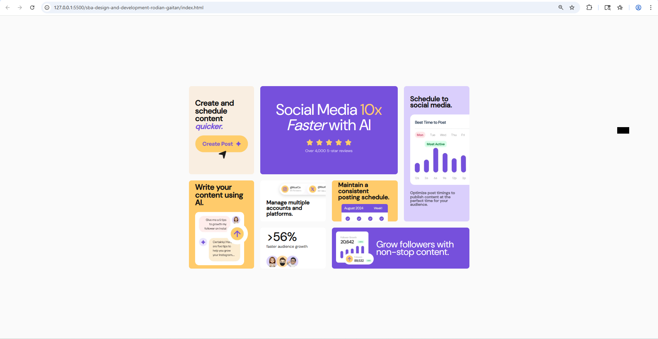

Tailwind:
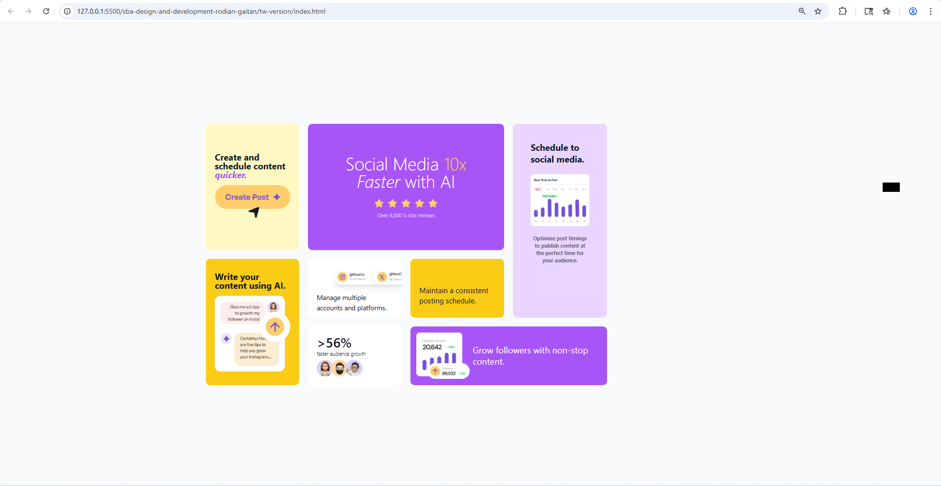

### Links
*
Figma layout URL: [https://www.figma.com/design/YcdiFfCL61b6K8HWE5fZ2I/desktop-design?node-id=0-1&t=vtmrqhV8GPjqGBc1-1]
*
Solution URL - GitHub Repository for SBA:
[https://github.com/PSStudent01/sba-design-and-development-rodian-gaitan]
*
Live Site URL - Netlify URL: [ https://ornate-marigold-b0d7e4.netlify.app/ ]

## My process
### Steps taken
I started by reading the challenge in detail and realized that the Figma file was not provided with this challenge. As a result, I had to import the Ms paint file into Figma and drew rectangular shapes around each layer( div container) that make up the design layout. Once I created the boxes I could better determine the dimensions of each card element including that of the main container.
Then I proceeded to do as follows:
- after converting the Ms paint file into a Figma layout I was able to sketch out a more helpful wireframe with specific dimensions.
- following the wireframe, I was able to code a semantic layout on html.
-- mapping the wireframe’s layers to div containers in my html.
-- and giving sensible names to the classes/ids for each of those containers.
-- at times I has to create containers within containers in order to best manipulate the content of each child div container
- with a now completed html files along with the information from the wireframe, I was then able to plan out the Grid layout by marking the grids across the wireframe to assist me with the css code.
- during the composition of my css code I was able to SPECIFICALLY target div containers in most cases, while having a difficult time in others.
- and once I was done with the css file, I then tried to convert my css into a Tailwind format, but I soon learned it was not as easy as I thought, mainly because of the complexity added by the particular grid layout; the particular details of some of the cards.

### Built with
- Figma
- VS Code
- Semantic HTML5 markup
- CSS custom properties
- Flexbox
- CSS Grid
- Tailwind CSS

## Author
- Website - [Rodian Gaitan ]
- Frontend Mentor - [@yourusername](https://www.frontendmentor.io/profile/yourusername)
- Twitter - [@yourusername](https://www.twitter.com/yourusername)

