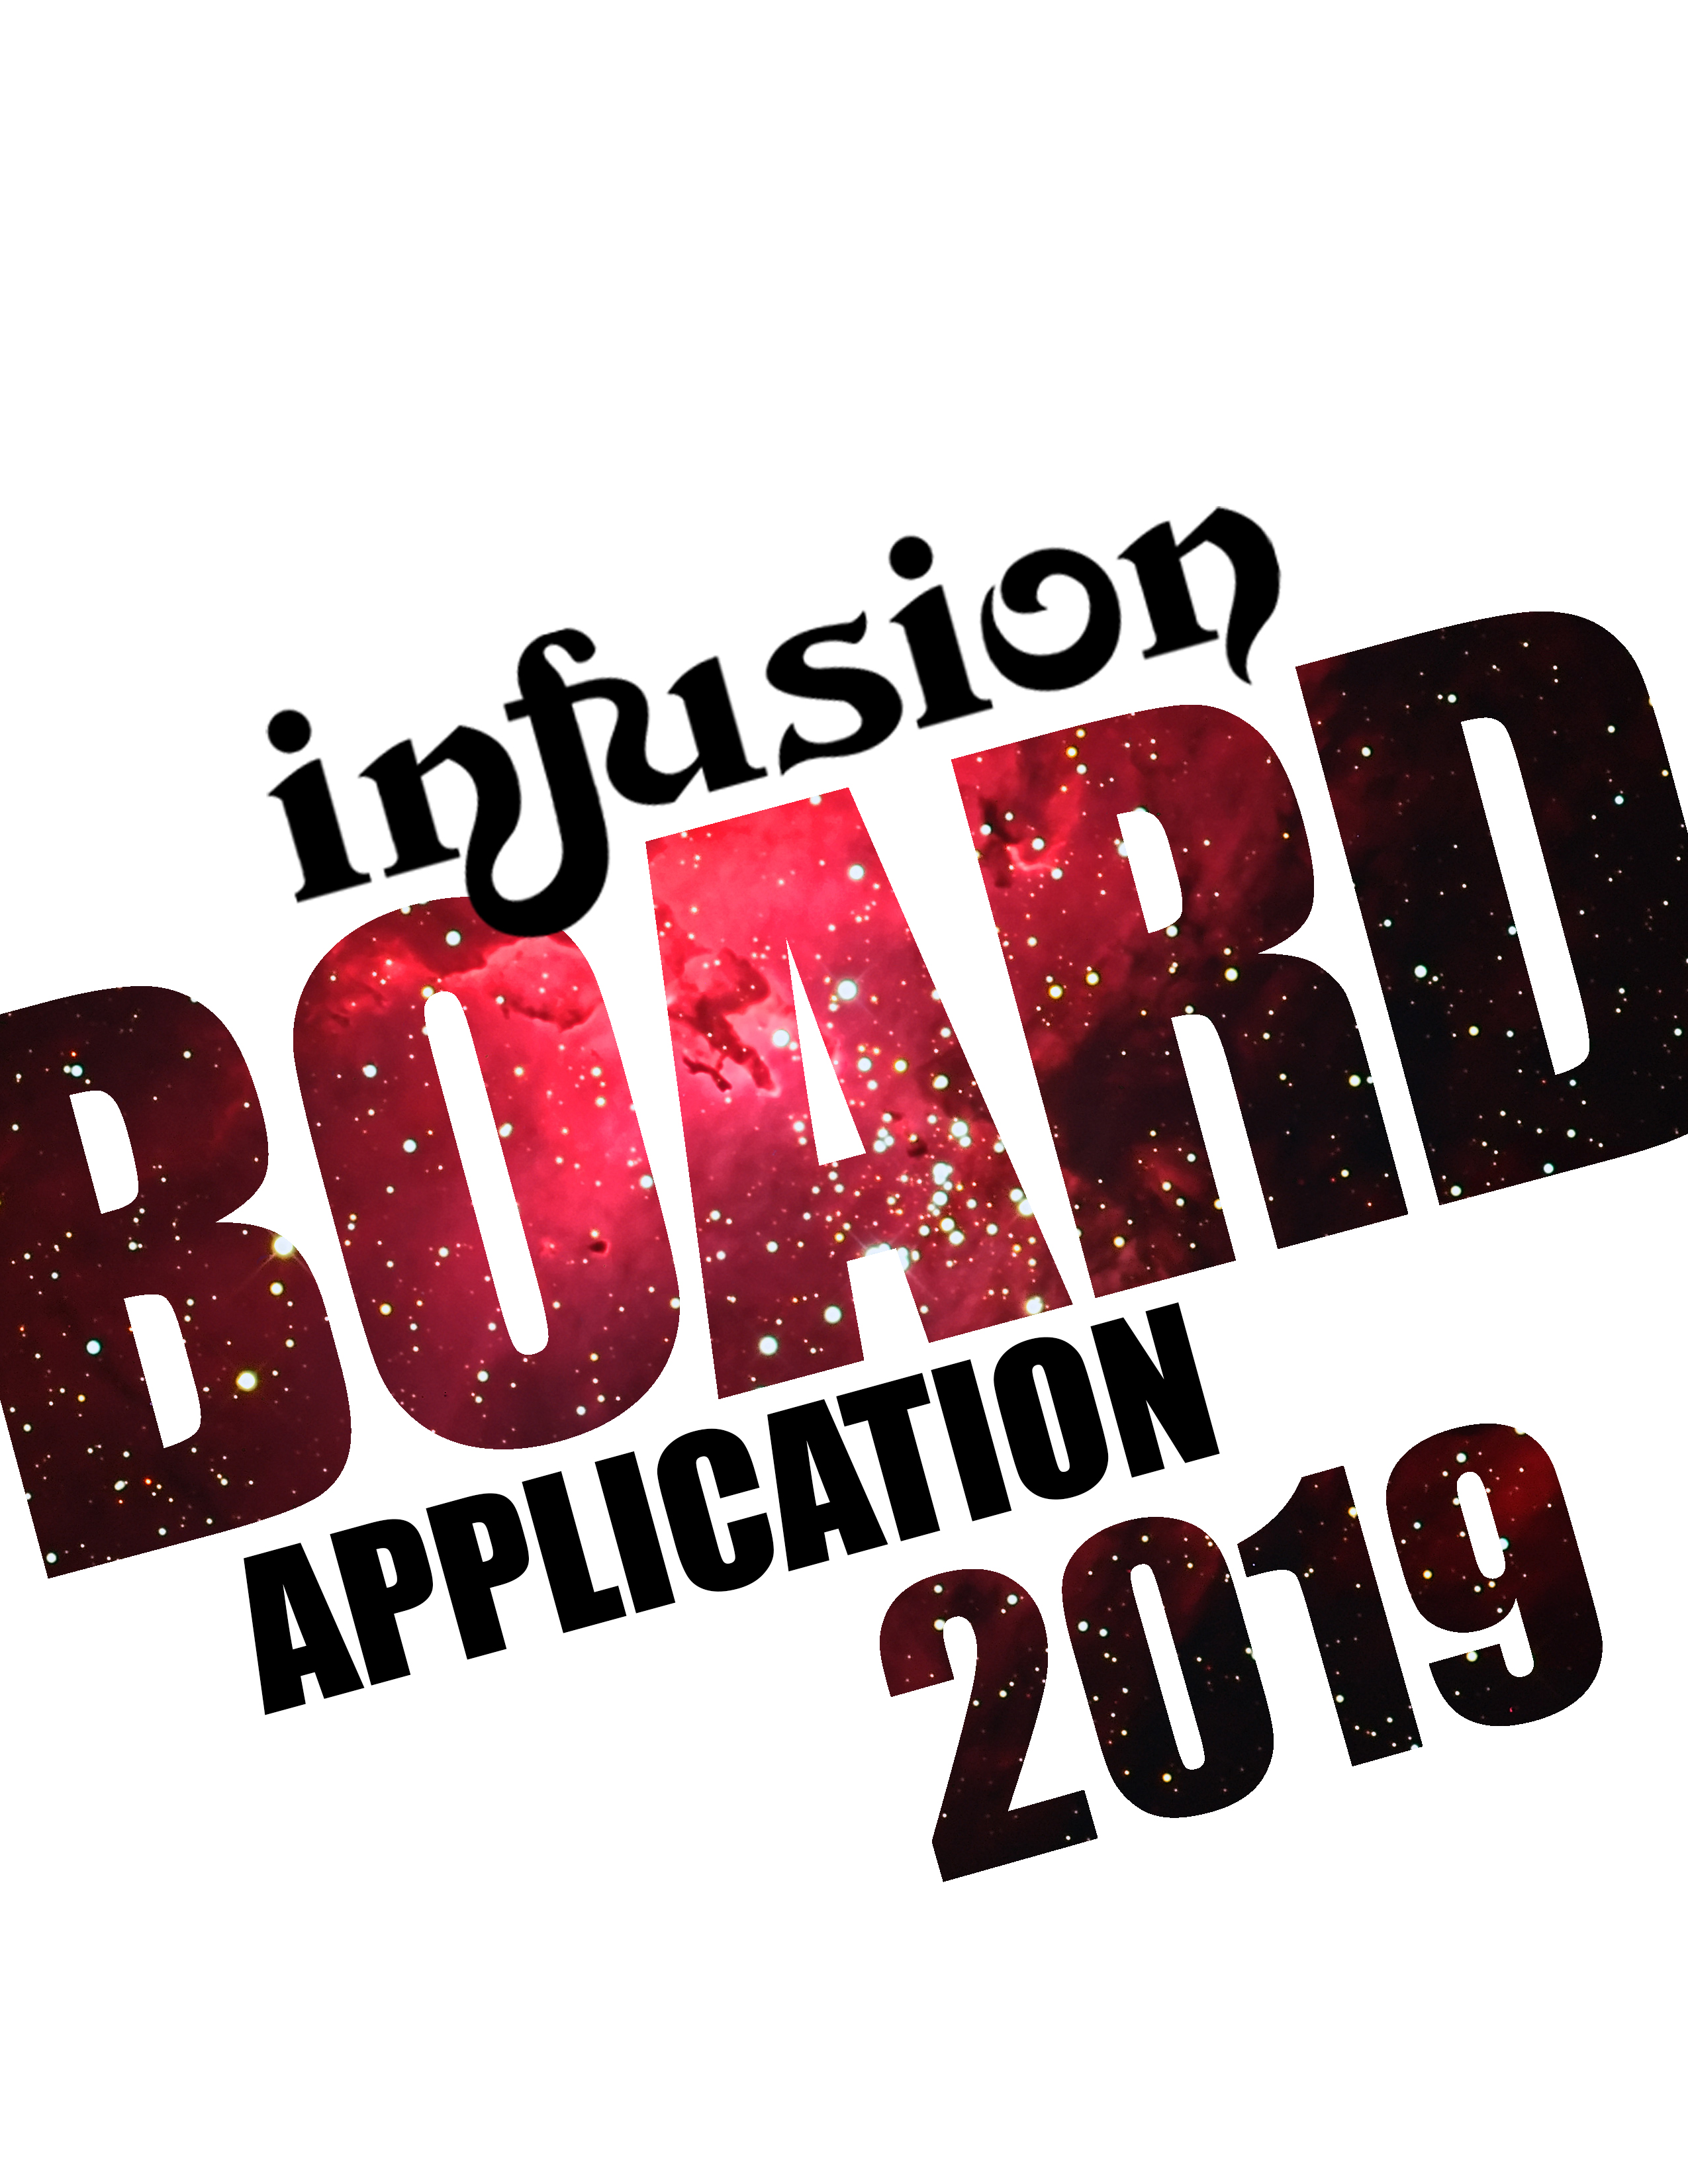

Dear Applicant,

Planning for ***Infusion*** 2019 has begun! After hosting a successful competition at Penn State for the past six years, we are so excited to begin preparations for next year! We are currently looking for qualified, enthusiastic individuals to carry on the legacy. Details about each executive board position are included below.

Before you complete this application, we hope that you will do all that you can to find out more about ***Infusion*** and about the commitment involved. Even though each board member has an assigned position, the difference between ***Infusion*** and other student organizations is that each board member is considered a vital part of the entire executive board. Board members are expected to take an active role in ALL parts of the competition. This means that, in addition to attending weekly meetings and fulfilling the roles of their own position, ***Infusion*** board members are often required to go above and beyond the responsibilities assigned to their respective positions. Any ***Infusion*** board member will tell you that being on the board is one of the most exciting and rewarding experiences they have had. However, they will also tell you that it is an extracurricular that will have significantly heavy time requirements.

With that being said, we hope that you will decide that you would like to be part of ***Infusion*** 2019 and help us continue to make our competition bigger and better with each passing year.

Sincerely,

***Infusion*** 2018 Executive Board

We are accepting applications for all the positions described below.

**Registration Director**

The Registration Team is the main contact point between the ***Infusion*** Executive board and all potential and participating fusion teams throughout the year. Registration Directors are responsible for selecting and inviting potential teams to ***Infusion*** as well as preparing relevant registration and marketing collateral. Additionally, they are responsible for collecting all registration and production materials from participating teams as well as maintaining constant communication throughout the year. Registration Directors are also responsible for directing all aspects of the judging process. This includes searching for and inviting qualified judges, facilitating the judging system and coordinating judges’ arrival and transportation. Lastly, Registration Directors work with the official hotel for all bookings including team rooms and the registration room. Registration Directors are required to be extremely organized and detail-oriented in addition to having strong interpersonal skills. The Registration Team works closely with all other directors at various points throughout the year and benefits from having a good understanding of the Filmi-Fusion/HFD circuit.

**Hospitality Director**

The Hospitality Team’s major responsibility is the mixer. Every aspect of the mixer – logistics, games, food, decorations, etc. – is the obligation of the Hospitality Directors. In addition, they are responsible for aiding Sponsorship and ensuring that the food for all participants throughout the course of the weekend is ready for distribution. Hospitality Directors also serve as head liaison; it is their duty to plan committee meetings and coordinate with committee members. They serve as the main bridge between the executive board and the committee as they orchestrate and oversee committee hours and other committee member responsibilities. Enthusiasm, creativity and quick thinking are key attributes of the Hospitality Director position as well as the ability to work well with others and plan efficiently.

**Finance Director**

The Finance Director is in charge of the budget for the entirety of ***Infusion***. This chairperson is expected to keep an up-to-date tally of all the money spent or donated as well as incoming money from any sponsors, profits from events and registration money. The Finance Director poses as the primary link of communication between the executive board and the various student organization offices (ASA, UPAC, etc.). The Finance Director is responsible for coordinating after-party logistics and serving as a primary contact with the venue. To be successful in this role, all deadlines must be met with the appropriate paperwork when working with the university. Most importantly, this individual serves as the primary contact with many faculty members of the university; therefore, maintaining relations are especially critical. The Finance Director is expected to work with all positions of the board.

**Sponsorship Director**

The Sponsorship Team is responsible for securing all donations and sponsorship affiliations, with both corporate organizations and local businesses. Directors are responsible for acquiring and organizing all meals for ***Infusion*** participants through monetary support and in-kind food donations, as well as reaching out to local networks for promotional opportunities. Primary duties include updating the sponsorship packets, deciding which local and corporate organizations to contact, and finalizing all deals as the competition nears. The weekend of ***Infusion***, Sponsorship Directors are expected to pick up all food donations and ensure that all promotional commitments are fulfilled. This position requires both strong organizational and communication skills, as well as the ability to effectively maintain business relationships.

**Technology and Production Director**

The Technology and Production Team serves as the main contact point between the teams and the Eisenhower and Livestream Staff. This includes a pre-production meeting a few months before the competition, a production meeting several weeks before the competition, and other meetings as necessary. The Technology and Production Director works with the Registration Directors to obtain all videos, music and prop lists submitted by the teams and to relay that information to the Eisenhower staff. In addition, they will work with the Public Relations Team to create filler videos, fliers, and any promotional materials required. During the competition weekend, the Production Team coordinates the dress rehearsals and ensures that production will meet and exceed team expectations. Technology and Production serves as the backbone of the competition and works with all other board positions. Some experience in design and multimedia production is highly preferred but not required.

**Public Relations Director**

The Public Relations Team is responsible for planning and coordinating all the pre-***Infusion*** events throughout the year that will be used to publicize or raise money for ***Infusion*** and the charities it supports. This includes, but is not limited to, making reservations at venues or the HUB, creating Facebook groups and events, and more. Public Relations is also responsible for keeping all social media accounts updated, including Instagram, Facebook, and Snapchat. In addition, he/she is responsible for encouraging students and community members to attend any ***Infusion*** events hosted throughout the year, as well as the competition itself. Overall, the Public Relations Director is responsible for educating and publicizing ***Infusion*** to all peoples: students, businesses, and communities in and out of State College.

Please fill out this form and submit it to [pennstateinfusion@gmail.com](mailto:pennstateinfusion@gmail.com). All completed forms are due by **11:59pm, on Monday, April 9th.** If you are selected to interview, we will contact you with further information.

**Name:**

**Year:**

**Major:**

**Email Address:**

**Phone Number:**

**Please list your times of availability for Wednesday, April 11th and Thursday, April 12th from 8pm-11pm.**

**Please list all other activities you plan to be involved with next school year and the estimated time per week you plan to dedicate to them.**

**What influenced you to apply for the *Infusion* 2019 Executive Board?**

**Where do you see yourself in the next 5 years? What skills are you interested in learning to help achieve your goals? How do you think *Infusion*** **will help you attain these skills?**

**Please describe your past involvement with *Infusion***.

**What position(s) are you applying for and why? Please indicate all positions that you are applying for and your order of preference. Please explain why you are applying for each position.**