

**The Pennsylvania State University Presents…**

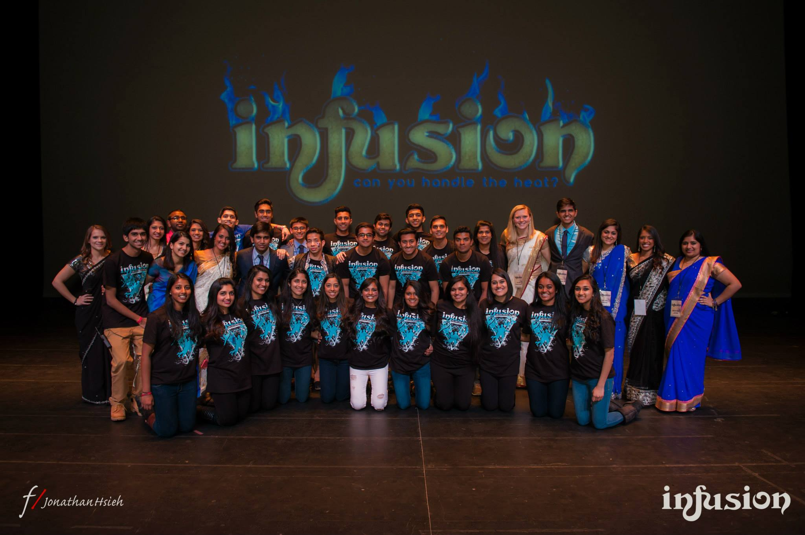

**COMMITTEE**

**APPLICATION**

**March 19, 2016**

**The Eisenhower Auditorium**

**State College, PA**

[**www.pennstateinfusion.org**](http://www.pennstateinfusion.com/)

**Due: Sunday, October 25th at 11:59pm**

Submit to: pennstateinfusion@gmail.com

Dear Applicant,

        Thank you for your interest in becoming a Penn State ***Infusion*** Committee Member! The ***Infusion*** Executive Board works hard to create a memorable weekend for 9 collegiate teams that come to Eisenhower Auditorium to compete for $3000 in cash prizes; however, we cannot fulfill our goal of being one of the most hospitable and entertaining competitions in North America without your help! If you are interested in helping in ways other than being a committee member, please contact us at [pennstateinfusion@gmail.com](mailto:pennstateinfusion@gmail.com).

**How can you become an *Infusion* Committee Member?**

Below you will find a list of the positions we are accepting applications for at this time. Please e-mail your completed application to pennstateinfusion@gmail.com by Sunday, October 25th at 11:59pm. Keep in mind that at this time you may not know all of the answers, but we simply want to see how you would react to different situations. Please answer all questions honestly and without consulting any outside sources. After completing the application, please make sure to save the application with your full name (InfusionCommitteeApplication_Firstname_Lastname.doc). Do not feel limited in your responses, as the field size will adjust automatically to fit your answer. If, after the interview process, you are chosen as an ***Infusion*** committee member, you will sign a commitment contract that will ensure that you agree to fulfill all of your duties in a timely manner. Breach of this contract will result in consequences, and if necessary, the position will be given to another applicant. For any applications with duplicate responses, neither application will be considered for an ***Infusion*** Committee position. If you have any questions, please feel free to email us at the email address listed below.

Thank you,

***Infusion*** Executive Board

pennstateinfusion@gmail.com

**Liaison:**

Each of the 9 competing teams receives two personal team liaisons. As a liaison, you will be the team’s direct contact at Penn State. You will be responsible for making sure the team has minimal difficulties at the competition. Tasks may include (but are not limited to) helping the team deliver their props to Eisenhower Auditorium, delivering meals (provided by ***Infusion*** Executive Board) to the team throughout the weekend, guiding the team around campus, and essentially aiding the team in making their weekend at ***Infusion*** the most comfortable it can be! It is truly a great way to meet new people and create long-lasting friendships with teams from all over the country. In addition to helping during the weekend of March 19th, 2016, liaisons also help design decorations for the team mixer before the show, partake in various marketing efforts around campus, and decorate a box for their assigned team. The team box is a welcoming gift used to add favors provided by ***Infusion****,* and other items you and your partner deem necessary. This is an additional financial obligation dependent upon how much you and your partner are willing to spend.

**Community Liaison:**

The Community Liaisons are responsible for choreographing and teaching the State College children a Filmi-Fusion dance that will be performed at ***Infusion***. They are also in charge of keeping in contact with the children’s parents and scheduling practice times. They act as the branch between the State College community and ***Infusion***. Also, they are required help design decorations for the team mixer before the show and partake in various marketing efforts around campus.

**Hospitality Manager:**

The Hospitality Team is essentially the main creative outlet behind ***Infusion*** weekend and helps plan an exceptional welcoming and hospitable experience for the teams throughout the weekend.

During ***Infusion*** weekend, one of the main tasks assigned to the Hospitality Team will be to set up and run the mixer on Friday, March 18th. The mixer is an extravagant welcome for the teams to the ***Infusion*** competition weekend and consists of games, ice-breakers, and creative decorations.

**Hospitality isn’t all about glitter and hot glue. Creativity and quick-thinking are a great plus!**

Hospitality Managers will be responsible for, but will not be limited to, the following:

1.     Aiding in the creative planning aspects of the mixer and competition

2.     Leading mixer decoration times at least 4 hours/week

3.     Distributing all meals during the competition weekend

**Production Manager:**

The Production Team serves as the main contact point ***between the*** ***teams and the Eisenhower staff***. This generally includes a pre-production meeting a few months before the competition, a production meeting several weeks before the competition, and other meetings as necessary. The team works with the Registration Directors to obtain all videos, music, and prop lists submitted by the teams and to relay that information to the Eisenhower staff. In addition, the team will work with the Public Relations Director to create filler videos, flyers, and any other promotional materials that need to be designed. During the ***Infusion*** weekend, the Production Team coordinates dress rehearsals and ensures that production will meet and exceed team expectations. Also, they are required help design decorations for the team mixer before the show and partake in various marketing efforts around campus.

**No design or technical experience is necessary. We will teach you the skills that it takes to run one of the best Filmi-Fusion competitions in North America!**

Production Managers will be responsible for:

1.     Aiding in the design of flyers, videos and other promotional materials.

2.     Communicating with teams for lighting cues, music, videos and props.

3.     Serving as a liaison between the teams and the Eisenhower staff.

4.     Executing all stage-related production aspects of the show.

During the weekend of the show, their primary responsibilities will include:

1.     Working with teams to ensure that all lighting, music, backdrops, etc. meet and exceed the teams’ expectations.

2.     Organizing team videos and music to create a seamless show line-up.

3.     Cuing three teams to their respective stage positions: on stage, on deck (in the loading dock), and in the

hole (in the stairway).

4. Communicating with the rest of the production team to ensure that the show runs in a fluid and efficient

manner.

**Please indicate what you are applying for (you may apply for more than one position):**

______ Liaison

______ Community Liaison

______ Hospitality Manager

______ Production Manager

**GENERAL INFORMATION**

Name:

Academic Year:  Freshman   Sophomore   Junior   Senior    Other

Major:

Gender:  Male Female

Email:

Phone:

Regardless of your position, we will be asking you to commit your time from Friday, March 18th at 2pm until Sunday, March 20th. Are you willing to commit to these time requirements of the competition weekend?

             Yes                                  No

**COMPETITION KNOWLEDGE**

How many Fusion, Raas/Garba or Bhangra competitions have you attended **as a spectator**?

             More than 10              5-9                        1-4                        0

How many Fusion, Raas/Garba, or Bhangra competitions have you attended **as a competing team member**?

             More than 10              5-9                        1-4                        0

Do you feel you have enough knowledge **at this time** of Fusion dance to help teams feel more comfortable?

             Yes                                  No

**GENERAL QUESTIONS**

What qualities do you feel ***Infusion*** committee members need to exhibit? Explain how you possess those qualities.

What do you hope to gain from being an ***Infusion*** committee member? Please explain.

**THINK OUTSIDE THE BOX**

If you could trade places with any other person for a day, famous or not, living or dead, real or fictional, with whom would it be and why?

If you were given a free full-page ad in the newspaper and had to sell yourself in six words or less, how would the ad read?

What route would you take to get from Eisenhower Auditorium to the Lion Shrine? Describe using recognizable landmarks.

**INTERVIEW AVAILABILITY**

If selected, **interviews for liaisons will be conducted on the dates listed below.** Please list all the times that you are available.

October 26th (7:00pm-11pm):

October 27th (7:00pm-11pm):

October 28th (7:00pm-11pm):

October 29th (7:00pm-11pm):

**PERSONAL AND PARTNER REVIEW**

**\*Only complete if you were a liaison for Infusion 2015. All answers will remain confidential.\***

**Personal Review:**

On a scale of 1-10 (1 being lowest, 10 being highest), rate your performance as a committee member for ***Infusion*** 2015 and explain: ______

What do you think you did well?

What could you have done better?

How would you improve ***Infusion 2016*** from what you experienced last year?

**Peer Review:** (only complete if partner still attends Penn State)

**Partner’s Name:**

How reliable was your partner during the weekend of ***Infusion***? (delivering team props, meals; decorating mixer; transporting team to venue, etc.)

What tasks did your partner do well?

What tasks could your partner improve upon?

Would you recommend your partner being a liaison again this year? (If no, please explain)