Portland, Oregon
NOISE-CON 2011
2011 July 25-27

Automatic wireless sound monitoring system and its application at Caldecott Tunnel

Mei Wua)
Mei Wu Acoustics
3 Twin Dolphin Drive, Suite 190
Redwood City, CA 94065

Stewart Heb)
PSW Technology
2063 Seabrook Court
Redwood City, CA 94065

This article presents an automatic wireless sound monitoring system. The system posts sound levels on a website at a pre-set time interval and therefore eliminates the need for regular site visits to confirm the operating status of the monitors and to download data. In addition to regular data posting, the system sends out instant text messages to computers and cell phones when the pre-set sound criteria are exceeded. This allows the system to be used for construction noise monitoring. To help the construction team to identify the noise sources of an exceedance event, it also posts the audio recording of the events. The system has been monitoring construction noise at Caldecott Tunnel Fourth Bore in California since May 2010.

1 INTRODUCTION

A fourth bore is being added to Caldecott Tunnel on Highway 24 in California to provide two additional lanes to relieve the daily traffic bottleneck. When completed in 2013, the new 3,389-foot-long tunnel will have two 12-foot lanes, shoulders and emergency walkways. In response to the noise concerns of the residents around the construction site, Caltrans (California Department of Transportation) has agreed to monitor evening and nighttime noise in residential neighborhoods near the tunnel’s west portal. Figure 1 shows the six community sound monitoring stations and the vicinity map of the construction site.
The project has distinctive requirements for sound monitoring such as continuous sound monitoring, instant alarm of any exceedance, and audio recording of all exceedance events. The construction team is required to stop construction within 20 minutes of any noise exceedance unless it is verified that the exceedance is not caused by construction activities. To fulfill these distinctive requirements, we developed a new wireless sound monitoring system with Scantek. Figure 2 shows photos of two monitoring stations.

2 PERFORMANCE REQUIREMENTS

The following are some of the performance requirements for the wireless sound monitoring system.
Sound Level Meter – The project specifies Type II sound level meters that meet ANSI S1.4:83 (A1:85) and ANSI S1.43:97 standards.
Sound Monitoring – The project requires continuous sound monitoring at 6 community stations plus 4 construction stations. It requires public posting of hourly L_{eq} and L_{max}, in dBA from 7 pm to 7 am for the community monitoring stations.
Noise Criteria – The project requires a two-week continuous noise monitoring at each community monitoring station before the start of any construction work. Based on the monitoring results, the L_{eq} and L_{max} criteria are established for each station at each hour between 7 pm and 7 am for weekdays and weekend days.
Instant Alarm – The project requires the construction team to stop working and apply noise control measures within 20 minutes when the sound levels exceed the criteria at any monitoring station. To meet this requirement, the construction team needs to be notified as soon as an exceedance event occurs.
Noise Source Identification – Since the community monitoring stations are located in populated areas, the exceedance events can be caused by community activities such as dogs barking or cars driving next to the monitoring station. The construction team needs the ability to identify the noise source within 20 minutes of an exceedance event.
Internet Connection – Some monitoring stations are located in areas where cell phone signal is so weak that we had trouble making cell phone calls. The wireless monitoring system has to function in these areas.
Weather Factor – The system has to withstand California’s strong summer sun, frequent winter rains, and high wind at the hilltop stations.
Public Website – A public website is required to serve daily data for public viewing.
Engineering Website – The construction team should have a password-protected private website with engineering details.
Record Keeping – All records are to be archived for future examinations.

3 SYSTEM DESIGN CONSIDERATIONS AND BASIC COMPONENET PERFORMANCE

The basic components of the system include a sound level meter at each monitoring station and a PSW wireless package. The sound level meter measures sound levels. The PSW wireless package compares the levels with the criteria and posts them on the websites. When an exceedance event happens, the wireless package sends out alarms and posts the event audio recoding. The system operates automatically.
Sound Level Meter – the system is designed to work with CESVA SC-160, a Type II sound level meter meeting the ANSI standards. For projects that accept IEC standards, the system can work with Rion NL-21. Rion NL-21 is a Class 2 sound level meter meeting IEC 61672-1: 2002 Class 2 and JIS C 1509-1 Class 2. Information on CESVA 160 and Rion NL-21 can be found on Scantek’s websiteˡ.
Weather Enclosure and Microphone Windscreen – Each station is equipped with a weather enclosure and an all-weather WS-03 windscreen for the microphone. The WS-03 windscreen provides a 28 dBA or 19 dBC wind noise reduction. At the time of the writing, the weather enclosure and microphone windscreen has protected the system through the summer, when temperatures reached a few degrees above 100˚F, and through a stormy winter.
Public Websites – Two websites, a public site and an engineering site, are established. The public website is displayed on the Caldecott Project². Figure 3 shows a page of the site. It serves the information required by the project specification, including a project vicinity map, daily nighttime L_{eq} and L_{max} at each station, and archived sound levels and exceedance events with identified noise sources. The system posts the data automatically as they come in.
Engineering Website – The engineering website is password protected. It serves more detailed information for the project team. It includes a project site map, hourly L_{eq} and L_{max} at each station through out the day, exceedance events along with its audio recording and sound source identification, an archive of data and audio recordings, and a log sheet revealing the operation condition of each station. In case of any station failure, the log sheet gives diagnostic information.
Hourly Data Posting – On the engineering website, at the end of each hour, hourly L_{eq} and L_{max} at each station are posted. Figure 4 shows the hourly sound levels of a demonstration system³ that posts L_{eq}, L_{max}, L₁₀, and L₉₀. Any missing data at a station, if not recovered on its own, may indicate a problem at the station. Before implementing self-recovery logic (explained below), we experienced numerous internet connection interruptions. With the self-recovery program, the most common failures we have encountered are power outages that last longer than a few hours.
Instant Alarm – When the noise exceeds the L_{eq} and L_{max} criteria, the wireless system sends out a text message and/or email alarm within 4 seconds to the pre-assigned cell phone numbers and email addresses. The message includes the station number and alarm date and time. At the same time, the wireless system posts station number and starting date and time of the event on the engineering website. At the end of the exceedance event, it posts the stopping time and the maximum sound levels of the event.
Audio Recording – Each station has continuous audio recording through the sound level meter microphone. When the noise exceeds a criterion, the audio recording from one minute before the exceedance to one minute after the exceedance, up to five minutes, is posted on the website. The construction team listens to the recording on the website at a computer or using a smart phone to identify the noise source and fill in a form with the noise sources. Figure 5 shows a noise source entry form. The non-exceedance, continuous audio recording is kept for 48 hours then erased automatically.
Archived Data – The hourly sound levels and exceedance list, including sound source and audio recording are archived on the engineering website. Archived data is searchable by station and time.
Wireless Data Transmission – The wireless system uses Verizon Wireless (although it can also work with WiFi or other cellular providers). It is equipped with an antenna at each station to increase signal strength. It is also equipped with a self-recovery program. When the Verizon signal is too weak or interrupted for any reason, the sound level meter continues to collect data and store the data. When the signal is strong enough, the system recovers itself and sends out the stored data. Without the self-recovery package, the system would stop once in a while. With the self-recovery program, the system runs for months without missing any data.
Power Supply – The system can be powered by grid power, battery, solar panel or a combination of the three. Due to the nature of the project, all monitoring stations are either in residential areas or on the construction site. The system at the Caldecott project uses grid power. Each station also has backup power that lasts a few hours.

4 SYSTEM SUMMARY

The PSW wireless sound monitoring system provides a cost effective way for large scale environmental sound monitoring. Since its operation at Caldecott Tunnel Fourth Bore in May 2010, Caltrans, the construction team, and the nearby residents are all happy with its performance. The wireless and automatic operation saves labor costs for the construction team. The archived sound levels and event audio recordings allow future examination to resolve disputes. The public website allows the residents to review noise data and exceedance events along with its noise sources. The system provides a new tool for noise compliant management.
The PSW wireless sound monitoring system⁴ equipped with instant alarm and event audio recording is ideal for construction noise monitoring and recreational activity noise monitoring, such as concerts and motor sport races. It is also good for traffic noise monitoring at highways, airports, or ports, and industrial noise monitoring, such as mines, quarries, chemical plants, power stations, and wind farms.

5 REFERENCES

1. http://www.scantekinc.com/soundmeters/soundmeters.htm
2. http://www.caldecott-tunnel.org/index.php?option=com_content&view=article&id=56&Itemid=73
3. http://www.mei-wu.com/pswdemo/
4. http://psw-tech.com/product.htm

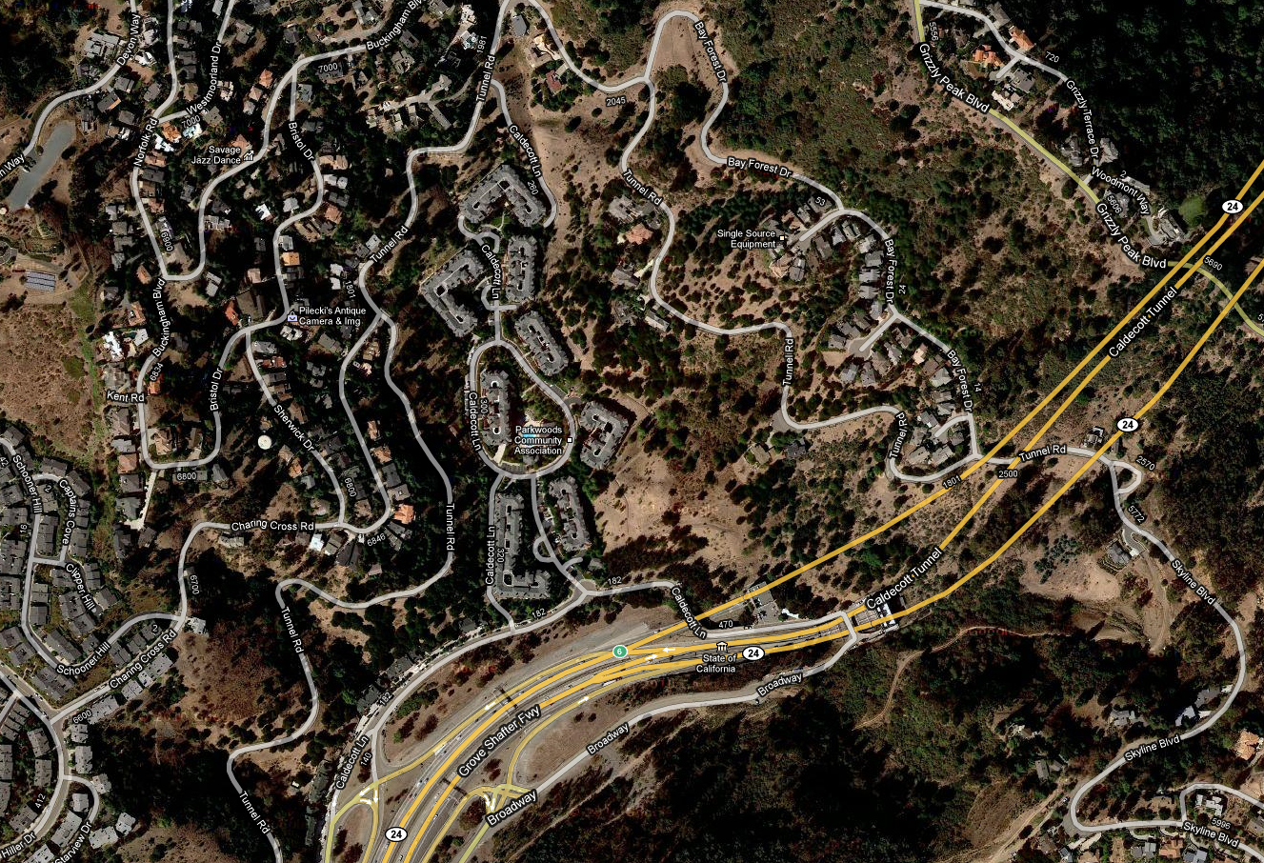
PS1
PS2
PS3
PS4
PS5
PS6

©2010 Google - Imagery ©2010 DigitalGlobe, USDA Farm Service Agency, GeoEye, U.S. Geological Survey, Map data ©2010 Google

Figure 1. Sound Monitoring Stations and Vicinity Map of Caldecott Tunnel, California. Sound monitoring stations are marked as PS1 through PS6.

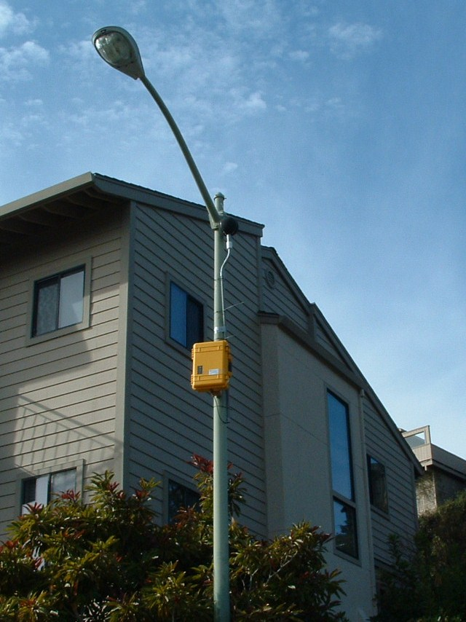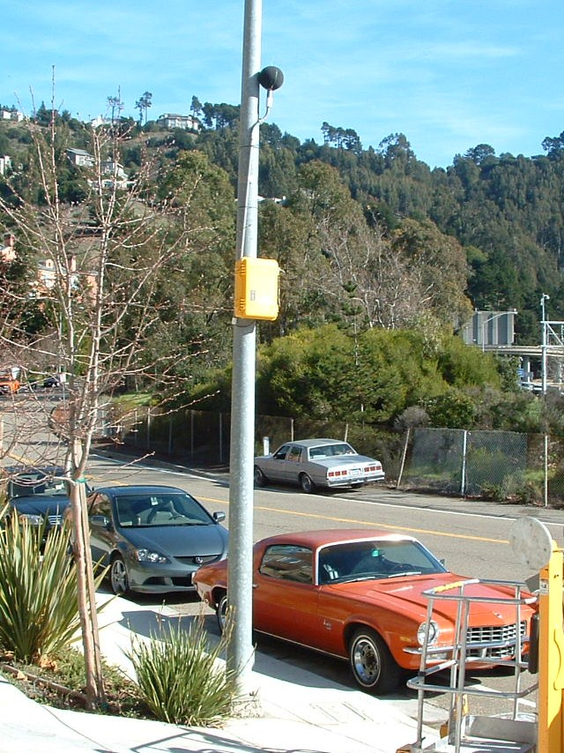

Figure 2. PSW Wireless Sound Monitoring Stations.


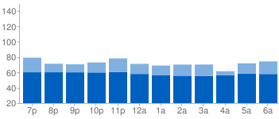

 | 7 PM | 8 PM | 9 PM | 10 PM | 11 PM | 12 AM | 1 AM | 2 AM | 3 AM | 4 AM | 5 AM | 6 AM
Leq | 60.2 | 60.2 | 60.1 | 59.9 | 60.4 | 58.0 | 56.6 | 55.7 | 55.5 | 56.3 | 58.5 | 57.9
Lmax | 79.2 | 71.3 | 70.5 | 72.9 | 78.2 | 71.1 | 68.9 | 70.2 | 70.2 | 61.5 | 71.8 | 74.3

Figure 3. Hourly Nighttime Noise Data as Shown on the Caldecott Tunnel Project Website. These are sound levels at Station 1. Station 1 is close to the west end of the existing Caldecott Tunnel on Highway 24. It is attached to a light pole at the entrance of a gated community. The equivalent sound levels are dominated by freeway traffic noise. The maximum sound levels are dominated by vehicles through the gate and sometimes people and dogs.
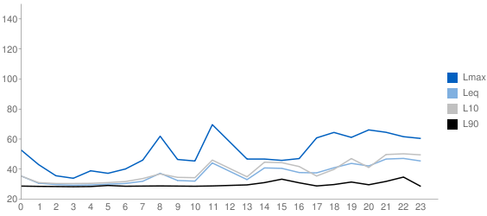

Figure 4. Hourly Sound Levels of a Demonstration System. This monitoring station is located inside a quiet residential house. Once in a while, people talk near the monitoring station.

Location | Date | Start Time | End Time | Exceedance | Description of Event
 |  |  |  | dBA
9 | 2010/11/0x | 19:32:41 | 19:32:42 | 71.00 | airplane
9 | 2010/11/0x | 19:32:43 | 19:32:51 | 72.70 | airplane
6 | 2010/11/0x | 19:54:34 | 19:54:36 | 80.40 | horn
6 | 2010/11/0x | 22:44:58 | 22:45:00 | 82.00 | car
1 | 2010/11/0x | 23:07:38 | 23:07:44 | 83.80 | people and dog
1 | 2010/11/0x | 23:08:35 | 23:08:41 | 80.50 | people and dog
2 | 2010/11/0x | 01:05:50 | 01:05:52 | 76.20 | motorcycle
3 | 2010/11/0x | 03:22:36 | 03:22:38 | 76.00 | truck
9 | 2010/11/0x | 04:10:31 | 04:10:32 | 69.50 | car
2 | 2010/11/0x | 04:26:27 | 04:26:30 | 79.90 | truck
8 | 2010/11/0x | 04:37:21 | 04:37:32 | 72.30 | car
3 | 2010/11/0x | 06:06:44 | 06:06:45 | 83.40 | truck
8 | 2010/11/0x | 06:13:15 | 06:13:16 | 79.00 | truck
8 | 2010/11/0x | 06:13:21 | 06:13:22 | 81.00 | truck
8 | 2010/11/0x | 06:13:24 | 06:13:25 | 78.80 | truck
8 | 2010/11/0x | 06:13:26 | 06:13:39 | 88.10 | truck
8 | 2010/11/0x | 06:13:42 | 06:13:49 | 89.70 | truck
6 | 2010/11/0x | 06:15:49 | 06:16:00 | 82.20 | car
1 | 2010/11/0x | 06:17:42 | 06:17:43 | 81.60 | air brakes

Figure 5. A Nighttime Noise Source Identification Form. This is the form for the night of Nov. x to Nov. x, 2010. All events are L_{max} exceedance events. Since the L_{max} criteria are specified as the average of ambient L_{max} levels before the construction work, false alarms caused by local cars, trucks, dogs and people are quite common at the community monitoring stations. It is also common to have an alarm caused by a 0.1 dB exceedance for 1 second. In November 2010, most alarms at west portal community stations were false alarms, because the main construction work was at the east portal of the tunnel.

a) Email: meiwu@mei-wu.com
b) Email: stewart.he@psw-tech.com

