R Markdown testbed

PSY 525

Rick Gilmore

2020-02-04 12:21:52

# This is a Heading 1

## This is a Heading 2

### This is a Heading 3

# Lists

## Not enumerated

* An item
  + A nested item with **boldface**
    - A doubly-nested item with *italics*
* Another item with some ~~text stricken out~~
* URL: [Penn State Home](https://www.psu.edu)

## Enumerated

1. An enumerated item
   * A nested item
2. A second enumerated item
   1. A nested item with a footnote [1] marker. Look for the text at the end of the document.
   2. A second nested item. See how alphabetical enumerated lists work like you’d expect.

## Block quotation

Four score and seven years ago, some famous President spoke infamous words that would live on throughout history. These words are famous enough that I want to highlight them with a block quote.

# Make some data

x = rnorm(n = 100, mean = 0, sd = 1) # N(0,1)  
y = rnorm(n = 100, mean = 2, sd = 0.5) # N(2, 0.5)

## Summarize

summary(x)

## Min. 1st Qu. Median Mean 3rd Qu.   
## -2.19582 -0.64419 0.09247 -0.02018 0.65263   
## Max.   
## 1.69605

summary(y)

## Min. 1st Qu. Median Mean 3rd Qu. Max.   
## 1.152 1.773 2.185 2.116 2.378 3.558

## Histogram

hist(x)

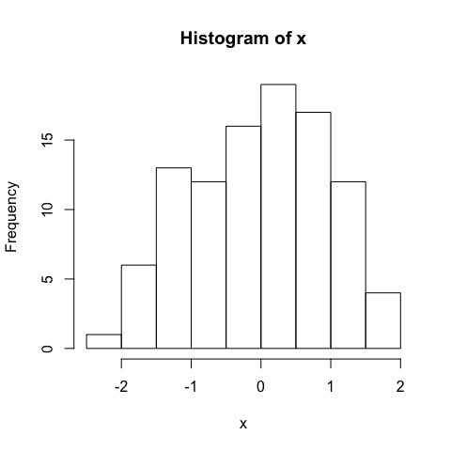

## Plot

plot(x,y)

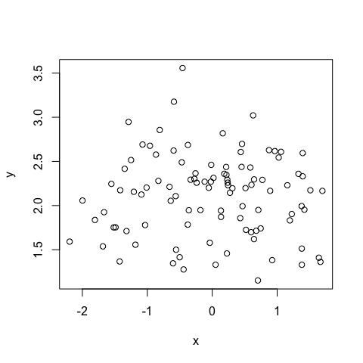

# Embed figures or videos

Some of these methods work better than others with a particular output format.

## From the web using knitr::include_graphics().

The html_document format is fine with using the URL as the input to knitr::include_graphics(), but the pdf_document format seems to want a local file path, hence the use of download.file().

download.file("https://nyu.databrary.org/party/6/avatar",'img/rog.png', mode = 'wb')  
knitr::include_graphics("img/rog.png")



## From a local file using HTML

## From a local file using knitr::include_graphics()

knitr::include_graphics("img/sleic.jpg")



## From a local file using Markdown syntax



## From YouTube

# Printing values from R

summ.x = summary(x)  
summ.y = summary(y)  
names(summ.x) # Figure out variable names for indexing

## [1] "Min." "1st Qu." "Median" "Mean"   
## [5] "3rd Qu." "Max."

*Index by variable name:* X lies within the range of [-2.1958216, 1.696045].

*Index by numeric index:* The (y-x) difference in means is 2.1363804.

*Calculate and report:* The correlation between x and y is -0.0284822.

# Math equations

$$e=mc^{2}$$

# Parameterized reports

## My name is Steve

## My quest is to find the grail

## My favorite color is blue

# Footnotes

1. Here is the footnote text. Note that it ends up at the end of the document.