

A Project

Report On

**PLACEMENT MANAGEMENT SYSTEM**

By

**P.Sangeethapriya**

Batch : 2021-6258

Center:Bangalore-S Prayas

**Under The Guidance Of**

**Anjana Sarode**

Technical Trainer

**Edubridge**

**(School of coding)**

**Introduction :**

placement management web sites, provides information on placement providers and the placements and also keeps up to date information of all students. It is a platform where students can view and assess their opportunities.This project includes following modules

* **Admin login**
* **Admin index**
* **Placement details**
* **College details**
* **Student details**

I have developed this Application in Java, Spring Boot, Spring MVC and MySQL. It’s a web-based projects so I have used HTML, CSS, JavaScript and Bootstrap also.

The main scope of the project is a total management and informative system, which provides the up- to-date information of all the students in the college.

The placement officer itself can carry out operations in a smooth and effective manner. They need not concentrate on record keeping. The college can maintain computerized records thus reducing paper work, time and money.

**Software Requirements:**

**Front end:** Java/J2EE technologies), HTML, CSS, JavaScript, Bootstrap, Spring Boot, Spring MVC.

**Back end:** MySQL workbench 8.0.23CE.

**Middleware/Server:** Apache Tomcat v8.5, Spring Tools Suite4 for Java EE Developers

**Browser:** Best result on Google Chrome.

**Operating System:** Window 10.

**Data Dictionary :**

* create database placement;
* use placement;
* create table Admin(id int primary key auto_increment,username varchar(255),password varchar(255));
* select * from Admin;
* create table College(id int primary key auto_increment,collegename varchar(255),collegelocation varchar(255),collegeadmin varchar(255),collegeemail varchar(255));
* insert into College(id,collegename,collegelocation,collegeadmin,collegeemail)values (1,"GCEB","sam","gceb@gmail.com");
* select * from College;
* create table Placement(id bigint primary key auto_increment,name varchar(255),college varchar(255),date varchar(255),qualification varchar(255),year varchar(255));
* select * from Placement;
* create table Student(id bigint primary key auto_increment,studentname varchar(255),course varchar(255),percentage int,mailid varchar(255),college varchar(255),roll long,qualification varchar(255),hallticketno int);
* select * from Student;

**Screenshots :**

***Admin login page***

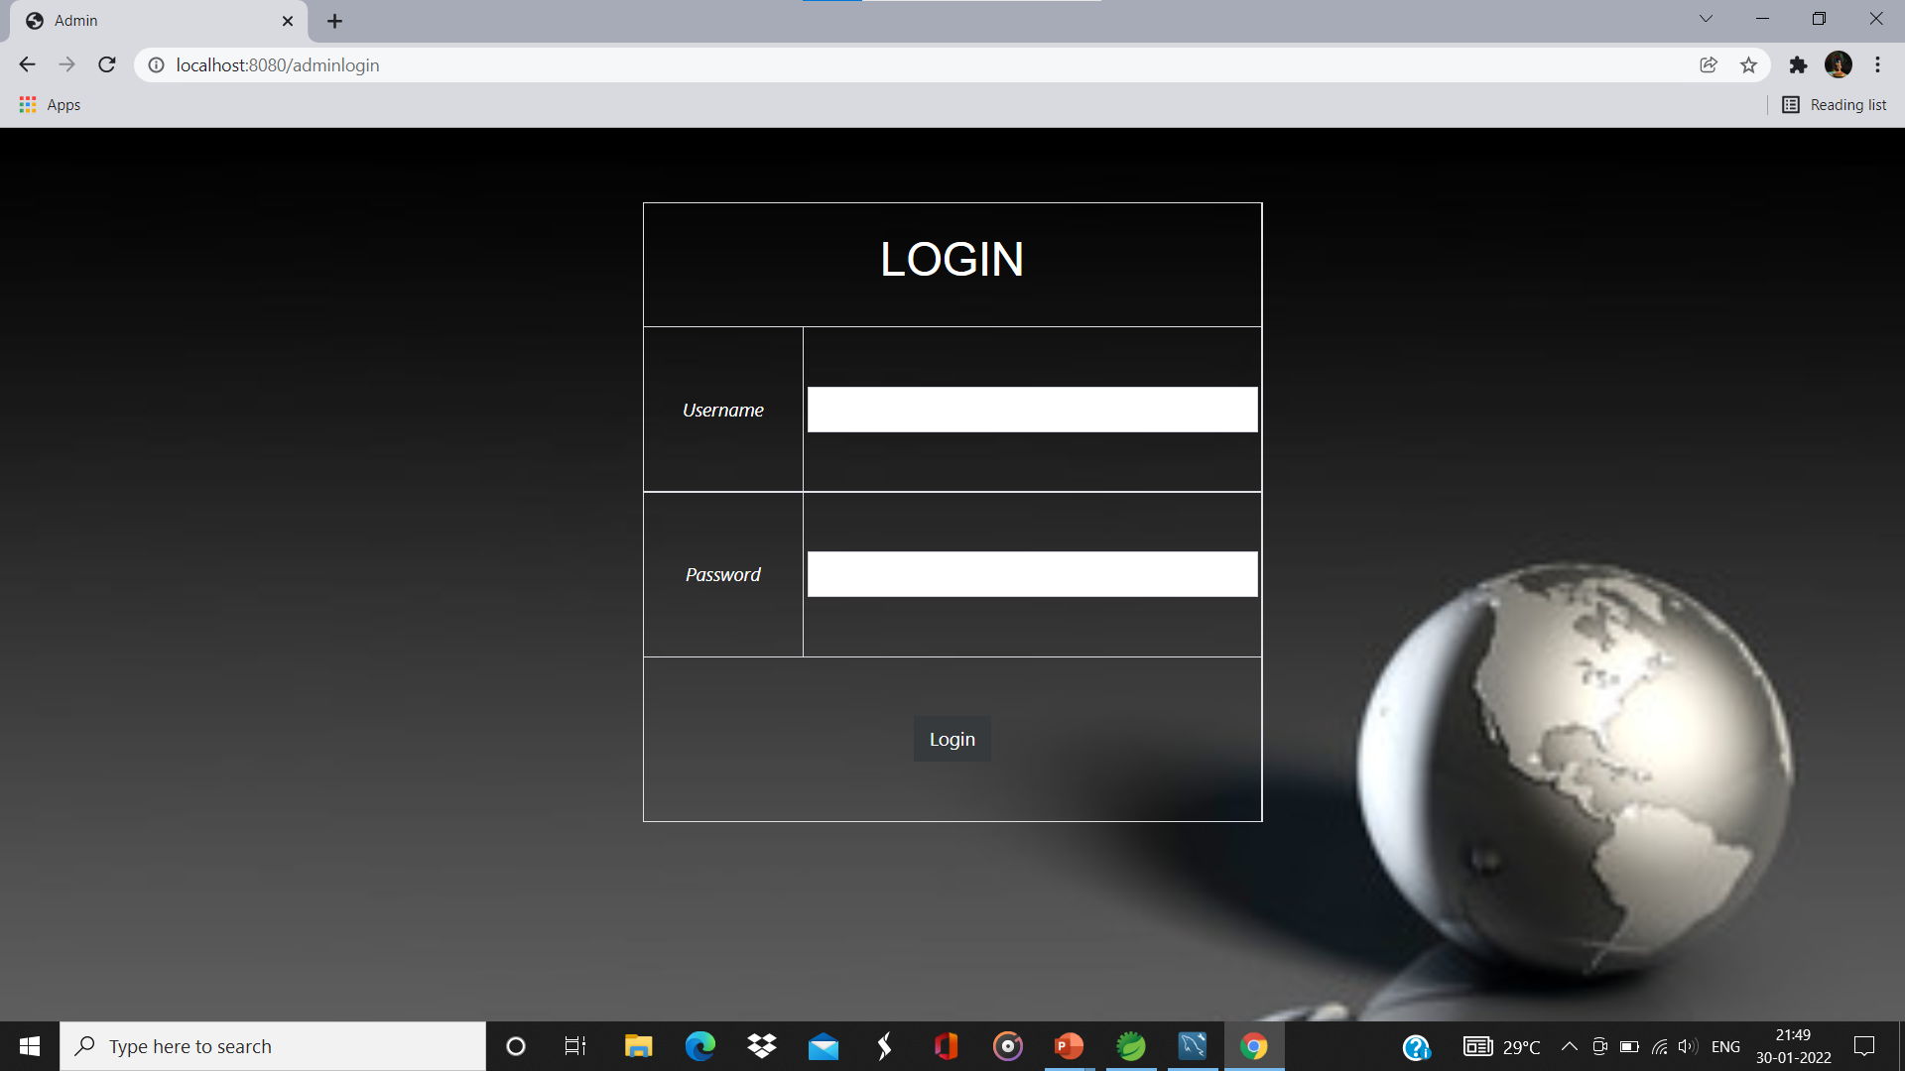

***Home Page***



***Placement Registration Page***

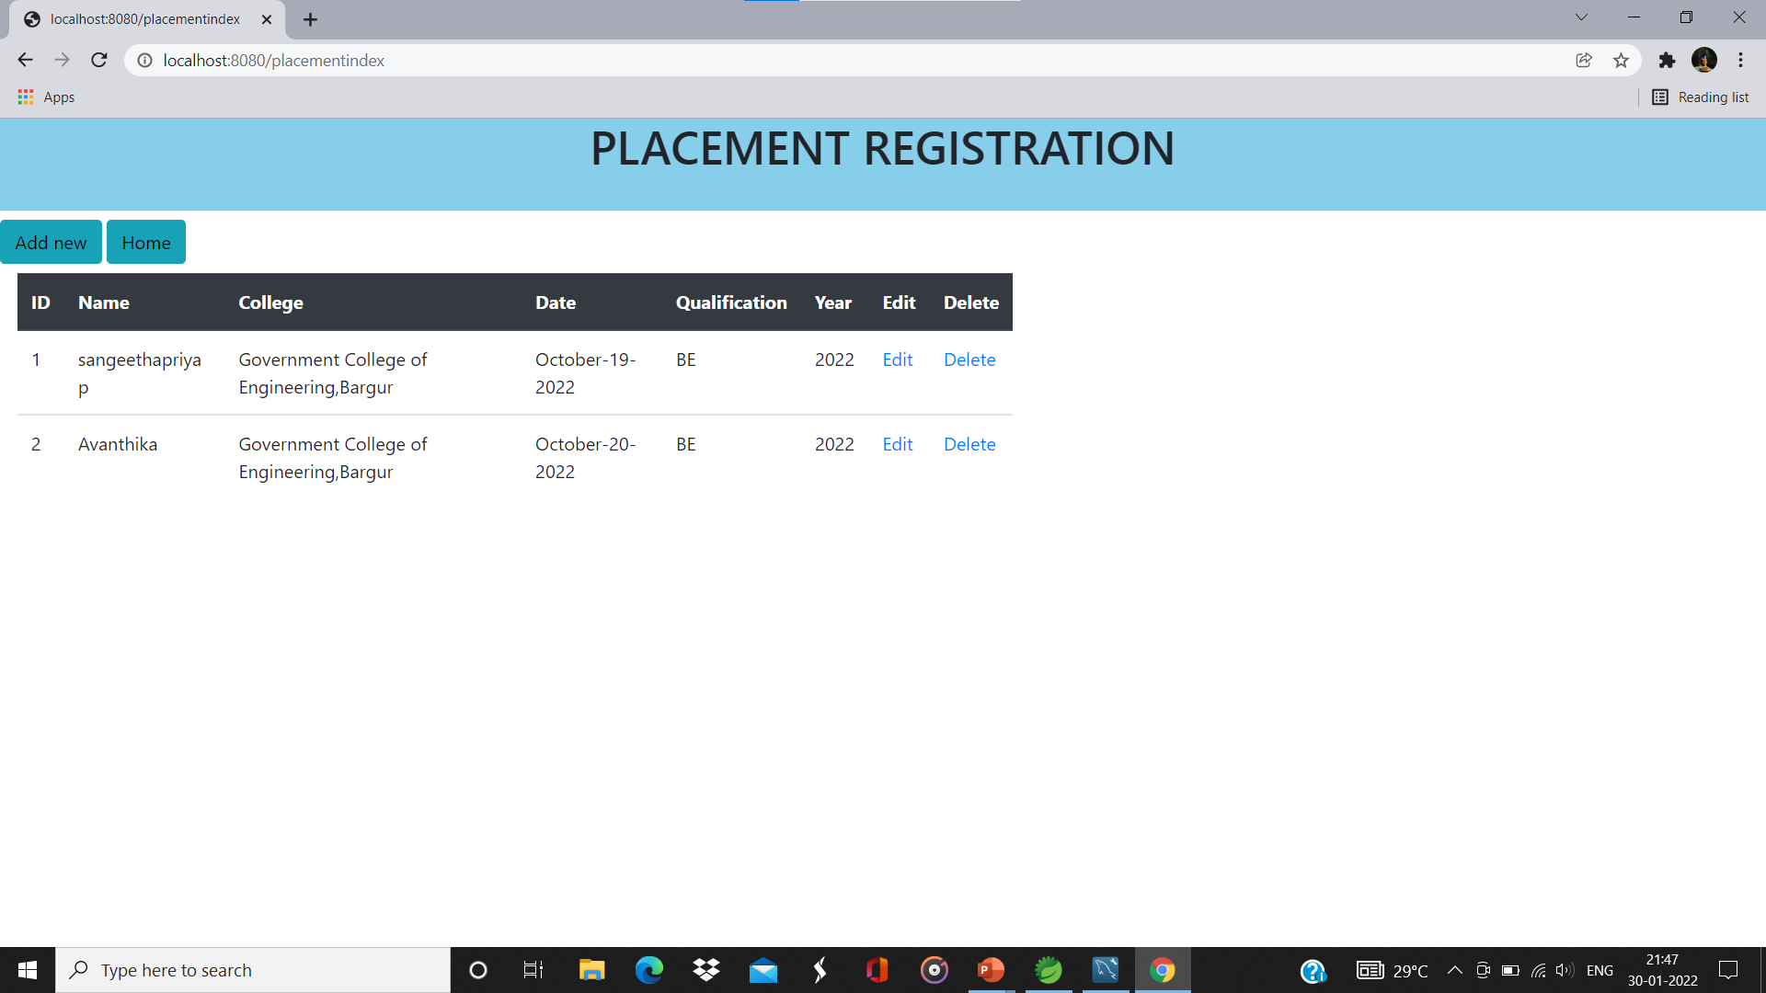

***Add Placement Data Page***

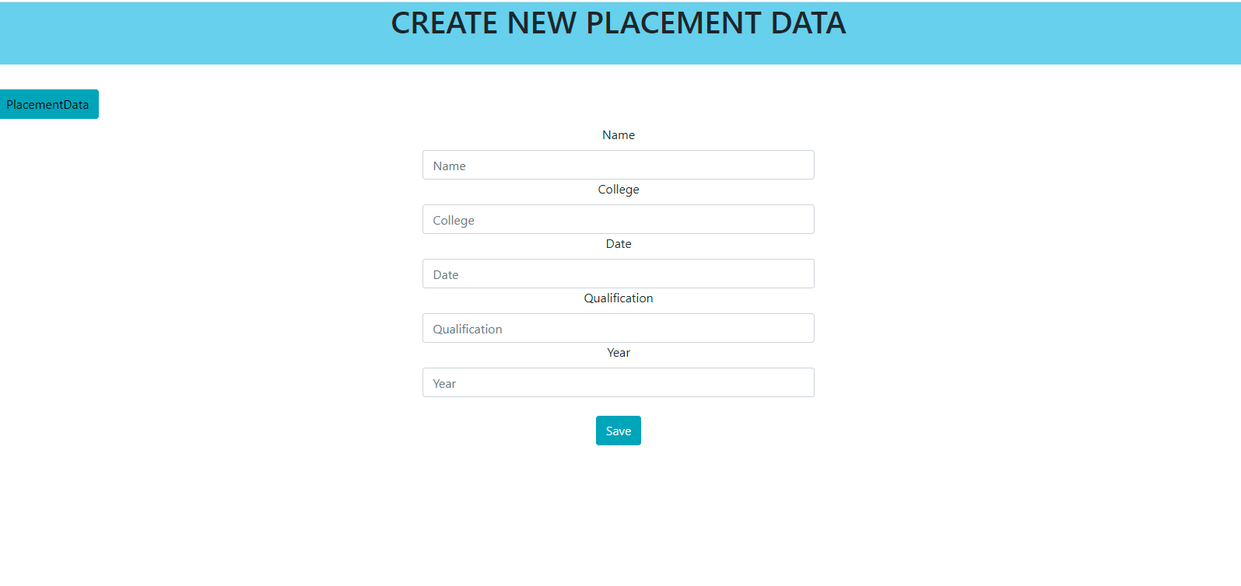

***College Registration Page***

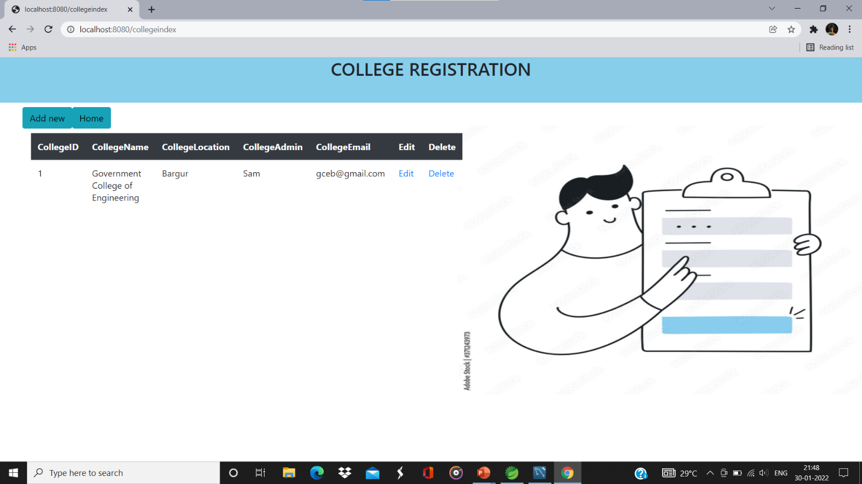

***Add College Data Page***

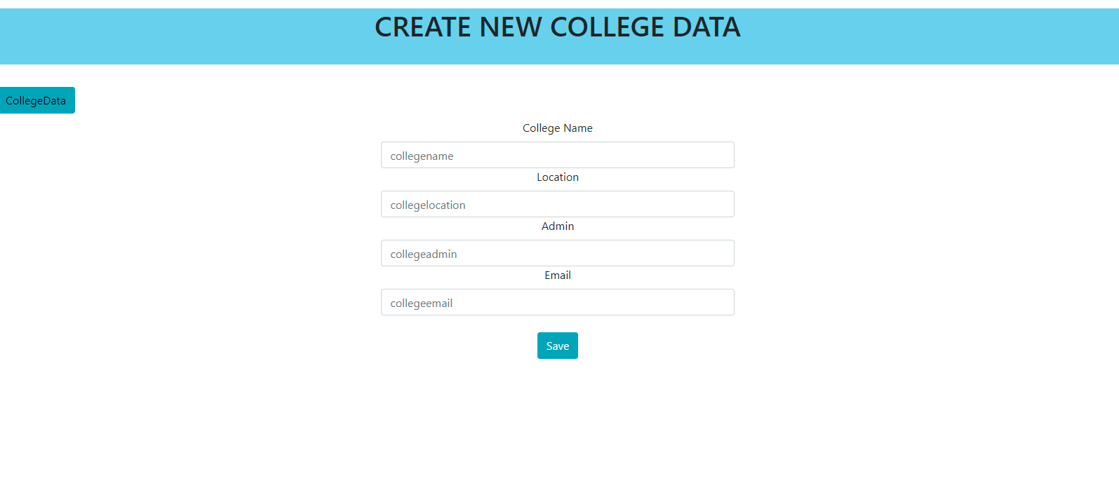

***Student Registration Page***

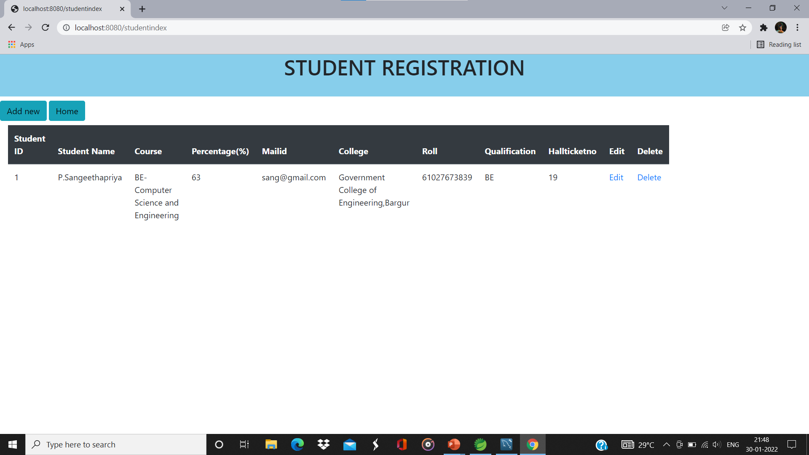

***Add New Student Data***

