# ngClass

If we want to apply mutiple classes conditionally , Angular provides us with the **ngClass** directive.

A directive is nothing but a custom HTML attribute that angular provides.

# Two way binding

When you work with the form inputs , it is essential that your model/class and the view/template are in sync.

i.e both the data binding and event binding are in sync.

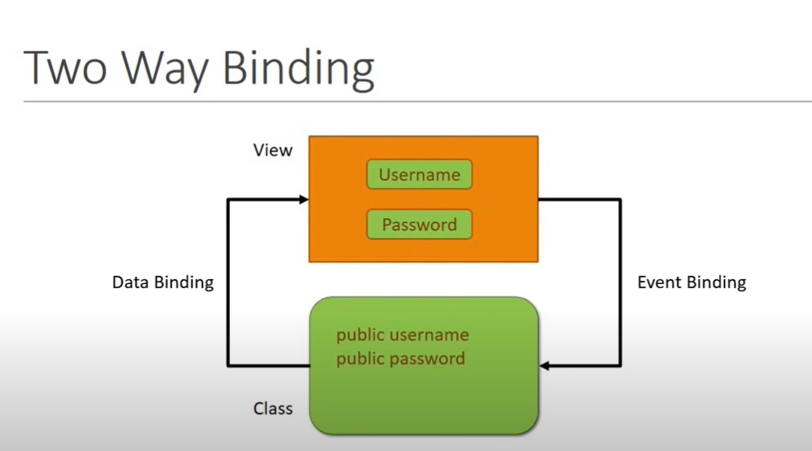

## ngModel

This directive is provided from the Forms Module of Angular , for two way binding.

Syntax is [(ngModel)] , think of banana inside a box.

We have **[]** for data binding , and **()** for event binding.

# Structural Directives

These directives let you add / remove elements from the DOM.

ngIf , ngSwitch are used to conditionally render HTML elements.

ngFor is used to reneder list for HTML elements.

## ngIf

If the HTML element has ngIf value , then it will render on the view , if it is false , it will not , one thing to note is that , when it is false , you can not find that element in the DOM source it self which is different from the setting css style **dsplay:none** in which case it is still exists in the DOM source.

## ng-template

It is basically like a container for other HTML elements , this is used by ngIf , to conditinally add / remove HTML from the DOM.

## ngSwitch

This is used when you want to handle mutiple conditional cases to render the HTML DOM elements.

## ngFor

It allows you to iterate over a collection, such as an array or a list, and generate HTML elements for each item in the collection.