Striver SDE Sheet
1 Linked List 2
1.1 Reverse a Linked List 2
1.2 Middle of the Linked List 4
1.3 Merge Two Sorted Lists 5
1.4 Remove Nth Node From End of List 6
1.5 Add two numbers represented as Linked Lists 7
1.6 Delete given node in a Linked List: O (1) approach 8
2 Linked List Part-II 9
2.1 Find intersection of Two Linked Lists 9
2.2 Detect a Cycle in a Linked List 11
2.3 Starting point of loop in a Linked List 13
2.4 Check if the given Linked List is Palindrome 14
2.5 Reverse Linked List in groups of Size K 15
2.6 Flattening a Linked List 15

Linked List

Reverse a Linked List
Problem Statement: Given the head of a singly linked list, write a program to reverse the linked list, and return the head pointer to the reversed list.
Input Format:
head = [3,6,8,10]
This means the given linked list is 3->6->8->10 with head pointer at node 3.
Result:
Output = [10,8,6,3]
This means, after reversal, the list should be 10->8->6->3 with the head pointer at node 10.
Brute Force :
A straightforward approach to reversing a singly linked list is to use an additional data structure such as a stack. As we traverse the list, we push each node’s value onto the stack. Since stacks follow Last-In-First-Out (LIFO) order, popping elements from the stack gives us the values in reverse order. After the stack is filled, we reassign the values to the nodes while traversing the original list again. This effectively reverses the list in terms of values without modifying node links.
Time Complexity: O(2xN) ,We traverse the linked list twice once to push all node values into the stack, and once to reassign values.
Space Complexity : O(N) , We use an extra stack to store all the node values, which requires O(N) additional space.
Best Approach1 : Iterative
The core idea is to change the next pointers of the nodes one by one so that they point backward instead of forward. By maintaining references to the current node, its previous node, and the next node, we can safely rewire the links without losing track of the list. Once all links are reversed, the last node of the original list becomes the new head.

Time Complexity : The time complexity is O(N) where N represents the number of nodes.
Space Complexity: O(1) We are not using any additional data structure or recursion. All modifications are done in-place using pointers.
Best Approach2 : Recursive
In the case of reversing a singly linked list: We're reducing the problem from reversing N nodes to reversing N - 1, N - 2, and so on. When we hit the base case (1 node), we start wiring the reversed nodes back together.
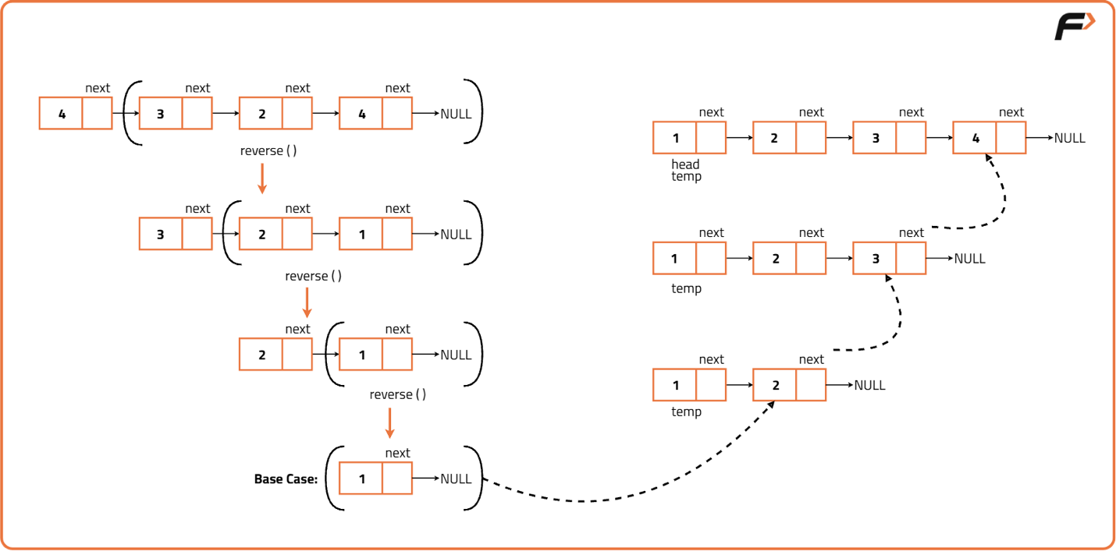
Time Complexity : The time complexity is O(N) where N represents the number of nodes.
Space Complexity : Apart from recursion using stack space, no external storage is used. Thus, space complexity is O(1).

Middle of the Linked List
Problem Statement: Given the head of a singly linked list, return the middle node of the linked list. If there are two middle nodes, return the second middle node.
Input: head = [1,2,3,4,5]
Output: [3,4,5]
Explanation: The middle node of the list is node 3.

Input: head = [1,2,3,4,5,6]
Output: [4,5,6]
Explanation: Since the list has two middle nodes with values 3 and 4, we return the second one.
Naive Approach : We can traverse through the Linked List while maintaining a count of nodes let’s say in variable n, and then traversing for 2nd time for n/2 nodes to get to the middle of the list.
Time Complexity : The time complexity is O(2 x N) where N represents the number of nodes, as we are traversing the list twice.
Space Complexity: We are not using any extra space, so it will be O(1).
Tortoise-Hare-Approach : we increment slow ptr by 1 and fast ptr by 2, so if take a close look fast ptr will travel double than that of the slow pointer. So when the fast ptr will be at the end of Linked List, slow ptr would have covered half of Linked List till then. So slow ptr will be pointing towards the middle of Linked List.
If there are two middle nodes, to return the first middle node.
initialize
fast_ptr = head ->next ;
Time Complexity: O(N)
Space Complexity: O(1)

Merge Two Sorted Lists
Problem Statement: Given two singly linked lists that are sorted in increasing order of node values, merge two sorted linked lists and return them as a sorted list. The list should be made by splicing together the nodes of the first two lists.
Input Format :
l1 = {3,7,10}, l2 = {1,2,5,8,10}
Output :
{1,2,3,5,7,8,10,10}
Iterative : Similar to Merge sort

- Create a new empty list, which will be the merged list
- Create two pointers, one for each input list.
- Compare the values of the current nodes of the two pointers.
- Add the node with the smaller value to the merged list, and move the pointer to the next node in that list
- Repeat step 3-4 until one of the input lists is exhausted
- Add the remaining nodes of the non-empty list to the merged list.
- Return the merged list
Time Complexity: O(M + N)
Space Complexity: O(1)
Recursive :
- If one of the input lists is empty, return the other list.
- Compare the values of the current nodes of the two input lists
- Add the node with the smaller value to the merged list
- Repeat steps 1-3 recursively for the next nodes of the chosen list and the remaining list.
- Return the merged list
Time Complexity: O(M + N)
Space Complexity: O(1)

Remove Nth Node From End of List
Problem Statement: Given a linked list, and a number N. Find the Nth node from the end of this linked list and delete it. Return the head of the new modified linked list.
Input: head = [1,2,3,4,5], n = 2
Output: [1,2,3,5]
Naive Approach: Traverse 2 times
The simplest way to delete the Nth node from the end is to delete the (L-N+1) th node from the start of the linked list, where L is the total length of the linked list. Therefore, this problem can be broken down into two sub-problems:
The first part involves the calculation of the length of the linked list.
The second part involves the deletion of the (L-N+1) th node from the start of the linked list.
Time Complexity: O( N + N )
Space Complexity: O(1)
Best Approach:
- Create two pointers, one called "first" and another called "second".
- Initialize the "first" pointer to the head of the list, and the "second" pointer to be n nodes ahead of the "first" pointer.
- Move the "first" and "second" pointers together until the "second" pointer reaches the end of the list.
- Remove the node that the "first" pointer is pointing to.
- Return the modified list
This algorithm uses two pointers to find the nth node from the end of the list. The first pointer is moved n steps ahead of the second pointer, then both pointers are moved together until the second pointer reaches the end of the list. At this point, the first pointer will be pointing to the nth node from the end ( since it second ptr has to cover remaining L-n nodes , first would have to cover the same distance to reach L-n node) , which can be removed. Finally, the modified list is returned.
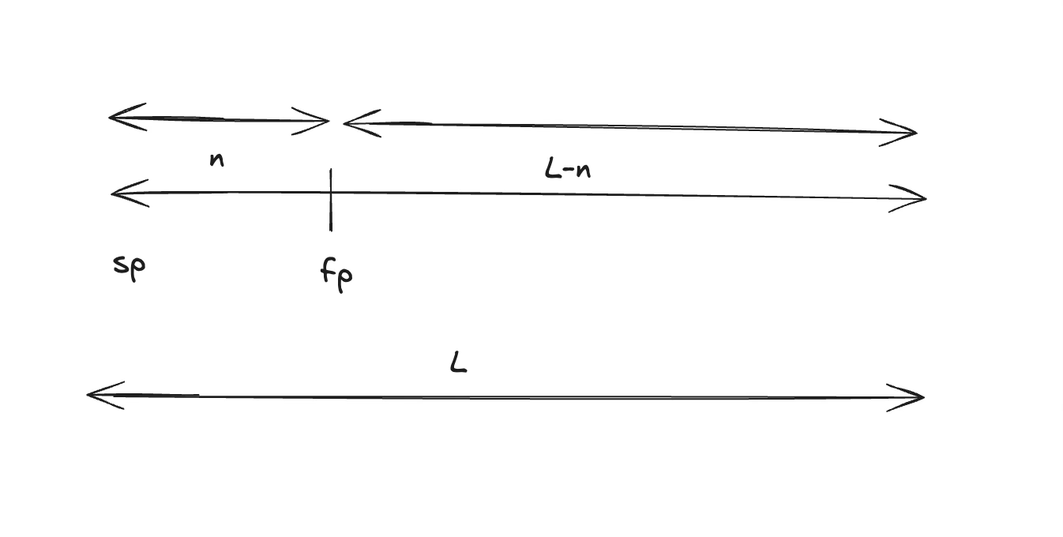
Time Complexity: O (N)
Space Complexity: O(1)

Add two numbers represented as Linked Lists
Problem Statement: Given the heads of two non-empty linked lists representing two non-negative integers. The digits are stored in reverse order, and each of their nodes contains a single digit. Add the two numbers and return the sum as a linked list.
Input: l1 = [2,4,3], l2 = [5,6,4]
Output: [7,0,8] (since input is given in the reverse order)
Explanation: 342 + 465 = 807.
Solution :
If lists are given straightly , we need to perform reverse operation first , then the addition and finally consider reversing the result.
- Create a dummy node to represent the head of the new linked list that will hold the sum of the two input linked lists.
- Initialize a variable called "carry" to 0, which will be used to keep track of any "carry over" from adding digits.
- Create a while loop that will continue until both input linked lists are empty.
- Within the while loop, add the values of the current nodes of the two input linked lists (if they exist) and the current value of the "carry" variable.
- Take the remainder of the sum divided by 10 and set it as the value of the current node of the new linked list.
- Update the "carry" variable to be the quotient of the sum divided by 10.
- Move on to the next node of both inputs linked lists.
- Once the while loop is finished, check if there is any remaining "carry" value. If so, create a new node with the value of the carry and add it to the new linked list.
- Return the new linked list.
- Done.

Time Complexity: O(max(m,n)). Assume that m and n represent the length of l1 and l2 respectively, the algorithm above iterates at most max(m,n) times.
Space Complexity: O(max(m,n)). The length of the new list is at most max(m,n)+1 , but this need not to be considered as it is required to store the answer.

Delete given node in a Linked List: O (1) approach
Problem Statement: Write a function to delete a node in a singly-linked list. You will not be given access to the head of the list instead; you will be given access to the node to be deleted directly. It is guaranteed that the node to be deleted is not a tail node in the list.
Input:
Linked list: [1,4,2,3]
Node = 2
Output:
Linked list: [1,4,3]
Explanation: Access is given to node 2. After deleting nodes, the linked list will be modified to [1,4,3].
Approach:
We are given access to nodes that we have to delete from the linked list. So, whatever operation we want to do in the linked list, we can operate in the right part of the linked list from the node to be deleted.
The approach is to copy the next node’s value in the deleted node. Then, link node to next of next node. This does not delete that node but indirectly it removes that node from the linked list.
Time Complexity: O(1)
Reason: It is a two-step process that can be obtained in constant time.
Space Complexity: O(1)
Reason: No extra data structure is used.

Linked List Part-II

Find intersection of Two Linked Lists
Problem Statement: Given the heads of two singly linked-lists headA and headB, return the node at which the two lists intersect. If the two linked lists have no intersection at all, return null.
Example 1:
Input:
List 1 = [1,3,1,2,4], List 2 = [3,2,4]
Output:
2
Explanation: Here, both lists intersecting nodes start from node 2.
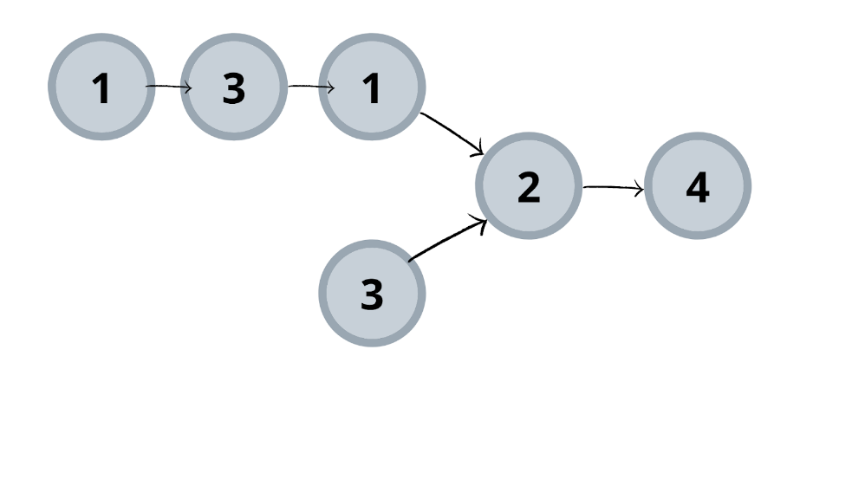

Brute Force: Run a nested loop to check if any node in list1 appears in the list2 also ( we are comparing the address of node as a whole not the value it self )
Time Complexity: O(m*n)
Reason: For each node in list 1 entire list 2 is iterated.
Space Complexity: O (1)
Reason: No extra space is used.
Better Approach : Hashing
- Iterate through list 1 and hash its node address. Why? (Hint: depends on common attribute we are searching)
- Iterate through list 2 and search the hashed value in the hash table. If found, return node.

Time Complexity: O(n+m)
Reason: Iterating through list 1 first takes O(n), then iterating through list 2 takes O(m).
Space Complexity: O(n)
Reason: Storing list 1 node addresses in unordered_set.
Best Approach: Difference of length
We will reduce the search length. This can be done by searching the length of the shorter linked list. How? Let’s see the process.
- Find length of both the lists.
- Find the positive difference of these lengths.
- Move the dummy pointer of the larger list by difference achieved. This makes our search length reduced to the smaller list length. ( because after the intersection point the length is common for the both of the lists , so the difference is before the intersection itself )
- Move both pointers, each pointing two lists, ahead simultaneously if both do not collide.

Time Complexity: O(l1) + O(l2) + O(l2-l1)
Space Complexity: O (1)

Detect a Cycle in a Linked List
Problem Statement: Given head, the head of a linked list, determine if the linked list has a cycle in it. There is a cycle in a linked list if there is some node in the list that can be reached again by continuously following the next pointer.
Brute Force : Hashing
We need to keep track of all the nodes we have visited till now so that once we visit the same node again we can say that a cycle is detected. The process is as follows:
- Use a hash table for storing nodes.
- Start iterating through the lists.
- If the current node is present in the hash table already, this indicates the cycle is present in the linked list and returns true.
- Else move insert the node in the hash table and move ahead.
- If we reach the end of the list, which is NULL, then we can say that the given list does not have a cycle in it and hence we return false.

Time Complexity: O(N)
Reason: Entire list is iterated once.
Space Complexity: O(N)
Reason: All nodes present in the list are stored in a hash table.
Best Approach : Slow and Faster Pointer (Floyd’s Cycle-Finding Algorithm)
Same approach followed for the finding of duplicate number in the array of size N+1.
For Floyd’s Cycle-Finding Algorithm (also known as the "Tortoise and the Hare"). Using slow and fast pointers , It may feels like they might just jump over each other forever, but the math guarantees they won't.
Once both the slow pointer (S) and the fast pointer (F) are inside the loop, let's look at the "gap" between them.
- In every step, S moves 1 node.
- In every step, F moves 2 nodes.
- Therefore, in every step, the distance between them decreases by exactly 1 node.
If the loop has a length L, and the initial distance between F and S is d (where F is trailing S), the distance d will sequence as:

d, d-1, d-2, …. , 2, 1, 0

Since the gap decreases by exactly 1 each time, it is impossible for the fast pointer to "jump over" the slow pointer. They must hit a distance of 0, which is the meeting point.
This guarantee is applied only when we have
S : speed 1
F : speed 2
On the other hand, if the list has no loop, the fast ptr will simply reach the end, and the algorithm terminates without any meeting.

Time Complexity: O(N)
Reason: In the worst case, all the nodes of the list are visited.
Space Complexity: O(1)
Reason: No extra data structure is used.

Starting point of loop in a Linked List
Brute Force Approach :
- Traverse through the linked list by assigning a temporary node to the head and moving to the next node repeatedly until reaching null.
- While traversing, keep a record of visited nodes using a map data structure.
- If a node already exists in the map, this confirms a loop, and we return that node as the starting point of the loop.
Time Complexity: O(N) where N is the number of nodes in the linked list. Each node is visited only once during traversal. Hashing allows O(1) lookup to check for previously visited nodes.
Space Complexity: O(N) due to the additional hash set used to store visited nodes. In the worst case (no cycle), all N nodes will be stored in the hash set.

Best Approach :
First find if a loop exists using the above problem solution , then if it exists, then use the fast pointer and slow pointer approach for finding duplicate element in array.
The key insight is that when the slow and fast pointers meet inside the loop, the distance travelled by each pointer can be used to calculate the starting point of the loop.

Time Complexity: O(N) where N is the number of nodes in the linked list. In the worst case, we traverse the entire list once with the slow and fast pointers, and then again to find the entry point of the loop.
Space Complexity: O(1) constant extra space. No additional data structures are used, only two pointers.

Check if the given Linked List is Palindrome
Given the head of a singly linked list representing a positive integer number. Each node of the linked list represents a digit of the number, with the 1st node containing the leftmost digit of the number and so on. Check whether the linked list values form a palindrome or not. Return true if it forms a palindrome, otherwise, return false.
Brute Force :
- Traverse the linked list from start to end, and push each node's value into a stack.
- Once done, start again from the head of the linked list.
- For each node, pop an element from the stack and compare it with the current node’s value.

Time Complexity: O(2 x N) , we traverse the entire linked list twice, once to push all elements into the stack, and once to compare them with the original list.
Space Complexity: O(N), we use a stack that stores all the elements of the linked list, which takes linear space in the worst case.
Best Approach :
Find the middle of the linked list , break the link and reverse second part , then compare the 2 linked lists.

Time Complexity: O(N), We traverse the list twice, once to reverse half of it and once to compare, each taking O(N/2), which simplifies to O(N).
Space Complexity: O(1), No extra space is used apart from a few pointers; operations are done in-place.

Reverse Linked List in groups of Size K
Given the head of a singly linked list containing integers, reverse the nodes of the list in groups of k and return the head of the modified list. If the number of nodes is not a multiple of k, then the remaining nodes at the end should be kept as is and not reversed. Do not change the values of the nodes, only change the links between nodes.

Flattening a Linked List
Given a linked list containing n head nodes where every node in the linked list contains two pointers:
(i) next points to the next node in the list.
(ii) bottom points to a sub-linked list where the current node is the head.
Each of the sub-linked lists nodes and the head nodes are sorted in ascending order based on their data. Flatten the linked list such that all the nodes appear in a single level while maintaining the sorted order.
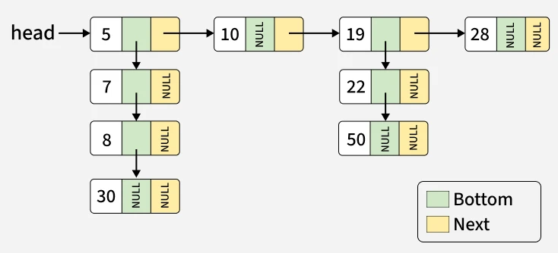

Output: 5 -> 7 -> 8 -> 10 -> 19 -> 22 -> 28 -> 30 -> 50

BruteForce : By using Array
- Initialize an array to store node values and traverse the list, collecting values from both top-level and child nodes.
- Sort the array to arrange the values in ascending order.
- Create and return a new linked list from the sorted array.

Best Approach : By using Recursion
We can solve this using recursion approach.
For each of the node first break it’s next link after storing in a temp variable.
As each of the node bottom elements are sorted already , we can use this to recursively merge all other nodes into a single node in bottom fashion.(The same approach which can be used in merge sort process.)

Rotate a Linked List
Given the head of a singly linked list containing integers, shift the elements of the linked list to the right by k places and return the head of the modified list. Do not change the values of the nodes, only change the links between nodes.

BruteForce Approach :
We are essentially moving the last node to the front of the list, k times. Each rotation means: take the last node, disconnect it from the list, insert it at the front (head) of the list. We repeat this process k times.
Time Complexity : k * len(LL)
Space Complexity : O(1), We do not use any additional data structures.
Optimal Approach :
Let’s take this example below :
head = [1,2,3,4,5], k = 2
Output: [4,5,1,2,3]

If we see here , we can easily achieve this rotation if we break the LL into 2 parts : first part of length L – k (or) L – (k%L). and rest will be 2nd part.
So , after that we need to attach the last the last node of the 2nd part to the first part.
OR
Simply , at first we can form a circular LL by linkinn last node of LL to the head node and traverse L – (k%L) , break the LL and make this starting point as the new head.
Time Complexity: O(N), We perform a single traversal to calculate the length, another to find the new tail, and one for final breaking all linear operations.
Space Complexity: O(1),No extra space is used; we just adjust pointers in place.

