🧱 Monolithic Architecture

A single, large application where all features (UI, business logic, database access) are built and deployed together.

Single codebase, single deployment (one JAR)

Pros
- Simple to develop initially
- Easy debugging (everything in one place)
Cons
- Hard to scale ( you scale entire app )
- Small change → redeploy whole app
- Tight coupling

🔗 Microservices Architecture
Application is split into small, independent services, each handling a specific business capability.

Each is:
- Independently deployable
- Has its own database (ideally)

Pros
- Independent deployment
- Better scalability (scale only required service)
- Loose coupling
Cons
- More complex ( network calls, failures )
- Requires service coordination

Service Registry (What & Why)

A Service Registry is a central server that keeps track of all available microservices and their locations (IP/port).

Using Eureka Server in spring boot

What it does

- Stores:
  - Service name
  - Instance details (host, port)
- Keeps services updated (heartbeat mechanism)

Service Discovery (How services find each other)

Service Discovery is the process where one microservice finds another using the registry.

Instead of calling: http://localhost:8081/orders
You call: http://ORDER-SERVICE/orders

The actual location is resolved dynamically.

By using Eureka Client in spring boot

When Service A needs to call Service B, it doesn't use a fixed URL like http://localhost:8081.

Instead, it uses a logical service name like http://SERVICE-B/

Client-Side Lookup: The calling service (client) queries the Eureka Server to get a list of all available instances for "SERVICE-B".

Load Balancing: If multiple instances of Service B exist, the client uses a load balancer (like Spring Cloud LoadBalancer) to pick one instance based on algorithms like Round Robin.

Spring Cloud Config Server

Spring Cloud Config Server is a centralized service used to manage external configuration (properties/yaml files) for multiple microservices in one place.

👉 Instead of each service having its own config, all configs are stored centrally and fetched at runtime.

Key Features

- Centralized configuration
- Environment-based configs (dev, qa, prod)
- Dynamic updates (with refresh)
- Version control (Git-backed)

Versioning

Versioning means maintaining multiple versions of an API or service so that changes don’t break existing clients.

👉 Example:
v1 → /api/v1/orders
v2 → /api/v2/orders

So you support old + new versions together

Backward Compatibility

Backward compatibility means that new changes should not break existing clients using older versions.

✅ Safe Changes
- Add new fields
- Make fields optional
- Add new endpoints

❌ Breaking Changes
- Remove fields
- Rename fields
- Change data types

API Gateway

An API Gateway is a single entry point for all client requests in a microservices architecture.

It uses reverse proxy design pattern.

Instead of clients calling multiple services directly, they call one gateway, which routes the request to the appropriate microservice.

Problems:
- Client must know all service URLs
- Duplicate logic (auth, logging)
- Tight coupling

Responsibilities of API Gateway

Typical responsibilities:
- 🔀 Routing → Forward request to correct service
- 🔐 Authentication & Authorization → Validate JWT
- ⚖️ Load Balancing → Distribute requests
- 🚫 Rate Limiting

In Spring ecosystem, we use: Spring Cloud Gateway

End-to-End Flow with Gateway + Eureka

1. Services register with Eureka
(USER-SERVICE, ORDER-SERVICE)

2. API Gateway also connects to Eureka

3. Client calls:
http://gateway/orders/1

4. Gateway:
- Finds ORDER-SERVICE via Eureka
- Routes request

5. Response returned to client

Load Balancer

A Load Balancer distributes incoming requests across multiple instances of the same service to ensure:
- High availability
- Scalability
- Fault tolerance

Client-side vs Server-side load balancing

- Client-side LB → Client decides which service instance to call (Eureka LB)
- Server-side LB → A separate load balancer decides and forwards the request (Nginx / AWS ALB)

API Gateway vs Load Balancer

Feature | API Gateway | Load Balancer
Purpose | Route + process requests | Distribute traffic
Level | Application-level | Infrastructure-level
Routing | Based on path (/users, /orders) | Same service instances
Authentication | ✅ Yes | ❌ No
Rate limiting | ✅ Yes | ❌ No
Transformation | ✅ Yes | ❌ No
Awareness of services | Multiple services | One service (multiple instances)

Circuit Breaker

A Circuit Breaker is a pattern that prevents a service from repeatedly calling another service that is failing, to avoid cascading failures.

Instead of “keep trying and failing,” it fails fast and optionally returns a fallback response.

States of a Circuit Breaker

- Closed (Normal Operation): Requests pass through. The system functions normally, but the breaker counts failures.
- Open (Blocking State): When failures exceed a defined threshold (e.g., 50% failures in 10s), the breaker trips, opening the circuit. Requests fail fast and never reach the downstream service.
- Half-Open (Testing State): After a waiting period ( waitDurationInOpenState ) , the breaker allows a limited number of test requests. If they fail, it re-opens; if they succeed, it returns to the Closed state.

🔄State Transition Flow
- CLOSED → (failures ↑) → OPEN
- OPEN → (wait time) → HALF-OPEN
- HALF-OPEN → (success) → CLOSED
- HALF-OPEN → (failure) → OPEN

Implementation in Spring Boot
We'd use Resilience4j (modern replacement for Hystrix)

⏱️ Timeout Pattern
A Timeout limits how long a service will wait for another service to respond.
👉 If the response doesn’t come within the time → request is aborted

🧠 Why needed?
Without timeout:
- Threads keep waiting indefinitely 😵
- Thread pool exhaustion
- Entire system slows down

🔁 Retry Pattern
Retry automatically retries a failed request a few times before giving up.
🧠 When useful?
- Temporary failures
- Network glitches
- Service warming up

Combined Flow of Timeout vs Retry vs Circuit Breaker

1st call → timeout
Retry → timeout
Retry → timeout
→ Circuit opens
→ Future calls skipped

Feature | Timeout | Retry | Circuit Breaker
Purpose | Limit wait time | Retry failures | Stop repeated failures
When triggered | Slow response | Failure/exception | Failure threshold reached
Behavior | Abort request | Retry request | Block requests
Goal | Avoid blocking | Recover transient issues | Protect system
Risk | Too short → false failures | Too many retries → overload | Misconfig → block too early

Bulkhead Pattern
The Bulkhead pattern isolates different parts of a system so that a failure in one part does not bring down the entire system.

👉 It’s about resource isolation (threads, connections, pools).

🧠 Why do we need it?
Without bulkhead: All incoming traffic shares a single thread pool.

Order Service → Payment Service (slow)
→ all threads blocked
→ entire Order Service stuck 😵

👉 One slow dependency → system-wide failure

With bulkhead:

Order Service
├── Thread Pool A → Payment Service
└── Thread Pool B → User Service

👉 Payment failure does NOT affect User calls

🔄 Concept
- Assign separate resources (thread pools) per dependency
- Limit how many concurrent calls can go to a service

Rate Limiting pattern

Rate Limiting pattern is about protecting your system from being overwhelmed (like DoS)—either by too many users, abusive clients, or sudden traffic spikes.

Rate Limiting restricts the number of requests a client can make to a service within a specific time window.

👉 Example:
“Max 100 requests per minute per user”
Common Algorithms
- Token Bucket: Tokens are added to a bucket at a fixed rate; each request consumes one token. It allows for short "bursts" of traffic.
- Leaky Bucket: Requests enter a queue and are processed at a constant, steady rate, smoothing out spikes.
- Fixed/Sliding Window: Tracks the number of requests in a specific time window (e.g., 100 requests per minute).

🔄 Basic Flow

1. Request comes in
2. Check request count for client
3. If within limit → allow ✅
4. If exceeded → reject ❌ (429 Too Many Requests)

Where is Rate Limiting Applied?
- API Gateway (most common)
- Service level
- Edge (CDN, Load Balancer)

Two-Phase Commit (2PC) protocol

Two-Phase Commit (2PC) is a distributed transaction protocol that ensures all participating services either commit or roll back together.
👉 Goal: Strong consistency across services

classic way to achieve a single “all-or-nothing” transaction across multiple systems

How 2PC Works (Two Phases)

There is a Coordinator and multiple Participants (services/DBs)

Each service ( participant ) :
- Executes transaction
- Does NOT commit yet
- Locks resources
- Responds to Coordinator YES/NO

Phase 1: Prepare Phase (Voting)

Coordinator → "Can you commit?"

Order Service → YES
Payment Service → YES

Phase 2: Commit Phase

Case 1: All YES

Coordinator → COMMIT

Order Service → commits
Payment Service → commits

Case 2: Any NO

Coordinator → ROLLBACK

Order Service → rollback
Payment Service → rollback

Problems with 2PC in Microservices

Single Point of Failure (Coordinator failure )
Tight coupling between services
Synchronous waiting / Blocking

Saga Pattern

The Saga pattern is a way to manage transactions across multiple microservices by breaking them into a sequence of local transactions, each with a compensating action (rollback).

👉 Instead of one big DB transaction, we use:
- Multiple small transactions
- With undo steps if something fails

A local transaction is a transaction that happens within a single microservice and its own database.

A compensating action is a reverse operation that undoes a previously completed local transaction if a later step fails.

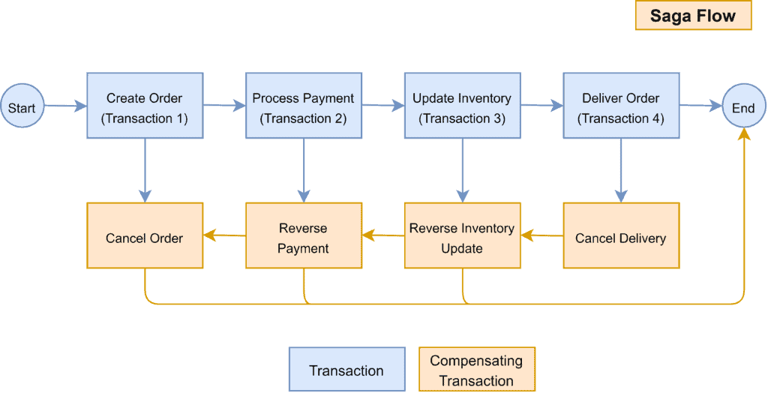

Key Characteristics
- Eventual consistency
- No global transaction
- Compensating transactions
- Asynchronous communication

Two Types of Saga

1️⃣ Choreography (Event-driven)

👉 No central controller
👉 Services communicate via events
Kafka / RabbitMQ

2️⃣ Orchestration (Central Coordinator)
👉 One service controls the flow (Orchestrator)

Database per Service

Database per service is a microservices design principle where each microservice owns and manages its own database, instead of sharing a single database across services.

👉 Each service:
- Has its own schema/database
- Is the only one allowed to access it directly

🧠 Why do we need it?
In microservices, we want:
- Loose coupling
- Independent deployment
- Independent scaling

👉 Sharing a DB breaks all of these.
👉 “You cannot directly access another service’s database”
Instead:
- Use API calls or events

CQRS
CQRS (Command Query Responsibility Segregation) is a pattern where you separate read operations and write operations into different models.

👉 Instead of one model doing both:
- Command side → handles writes (create/update/delete)
- Query side → handles reads

Why do we need CQRS?
In real systems:
- Writes are complex (validations, transactions)
- Reads are frequent and need to be fast
👉 One model struggles to optimize both

Use different classes/representations for writes and reads, ( even if data is stored in the same DB ).

It’s about separating responsibility in code, not necessarily the database.

Two Levels of CQRS

Level 1: Simple CQRS (Same DB, No Events)

Write → DB
Read → same DB (different query model)

Level 2: Advanced CQRS (Separate Read DB + Events)

Write → Write DB
→ Publish Event
→ Update Read DB
Read → Read DB

Example (Order System)

🟢 Database Tables

orders
order_items
users

🔴 Write Model (Command Model)
Designed for business logic and persistence

@Entity
public class Order {
@Id
private Long id;
private String status;
@OneToMany
private List<OrderItem> items;
private Long userId;
}

Used for: orderRepository.save(order);

🔵 Read Model (Query Model)
👉 Designed for fast and simple data retrieval

public class OrderSummary {
private Long orderId;
private String userName;
private int totalItems;
private double totalAmount;
}

Custom Query

@Query( // Join query )
List<OrderSummary> findOrderSummaries();

Notice:
- This is NOT an entity
- It’s a projection/DTO

Distributed Tracing
Distributed tracing helps track a single request as it travels across multiple microservices.
In microservices architecture:
- one user request usually touches many services
- each service may call other services
- debugging becomes difficult
Zipkin
- uses Trace ID for a request across services.
- request flows through multiple services.
- entire journey of request becomes visible.

Cloud-Native
Cloud native is the software approach of building, deploying, and managing modern applications in cloud computing environments.
Why is it called "Cloud-Native" ?
Unlike older software that was built to run on physical office servers (on-premises) and later just "lifted and shifted" to the cloud, cloud-native apps are designed from day one to exploit the elasticity, scalability, and resilience of the cloud.

Kubernetes
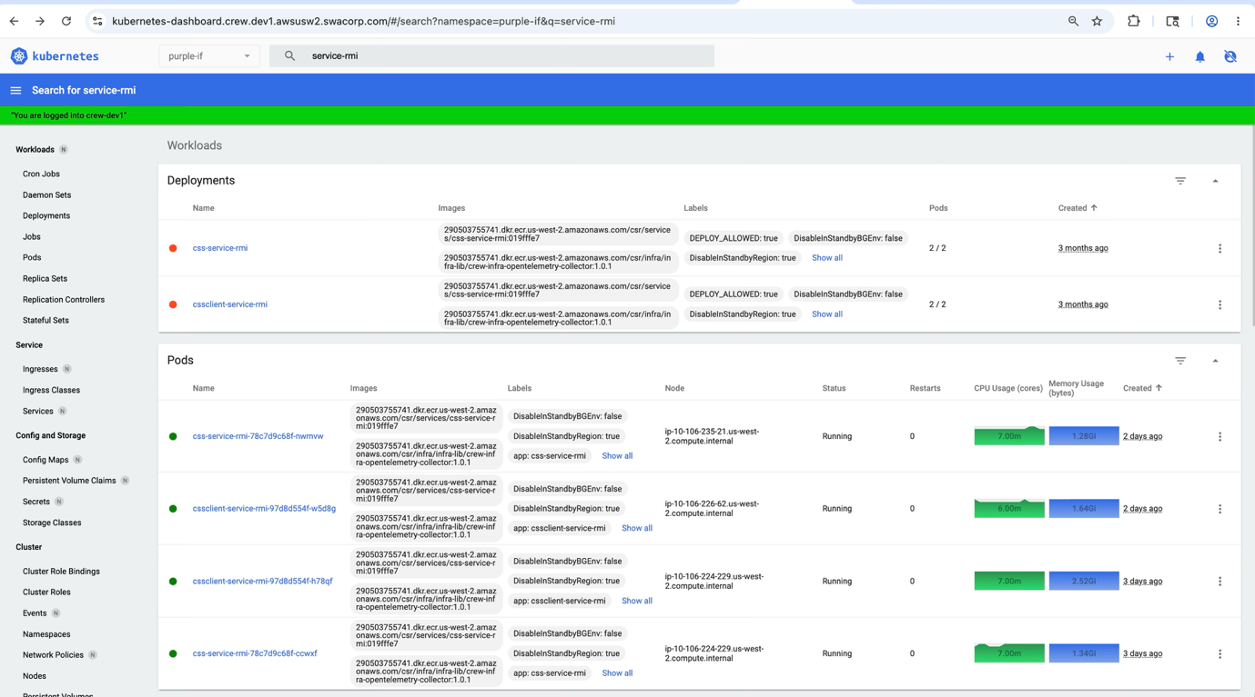

Kubernetes is an open-source platform used to deploy, manage, scale, and monitor containerized applications automatically.

If Docker helps you run one container, Kubernetes helps you manage thousands of containers reliably.

Cluster

A Kubernetes system is called a Cluster.
A cluster contains:
- Master Node ( Control Plane )
→ Brain of Kubernetes
- Worker Nodes
→ Machines where applications run

Node

A Node is a machine (VM or physical server) inside the cluster.
It runs your applications.

Types:
- Master Node / Control Plane Node
- Worker Node
Example:
- EC2 instance
- Azure VM
- GCP VM

Container

A Container packages:
- Application code
- Runtime
- Libraries
- Dependencies

Pod

A Pod is the smallest deployable unit in Kubernetes.
A Pod usually contains:
- One container
- Shared network
- Shared storage

Why not directly run containers?
Kubernetes manages Pods instead of containers because Pods provide:
- Networking identity
- Storage sharing
- Lifecycle management

Pod Sizing
You do not directly configure a fixed size for a Pod. Instead, you configure the size (CPU and memory) of the individual containers inside that Pod.

Kubernetes then adds these container sizes together to determine the total size of the Pod.

Requests: The minimum amount of resources the container guaranteed needs to start running.
Limits: The maximum amount of resources the container is allowed to consume.

Example :

apiVersion: v1
kind: Pod
metadata:
name: web-app-pod
spec:
containers:
- name: web-container
image: nginx
resources:
requests:
memory: "64Mi" # Minimum memory required
cpu: "250m" # Minimum CPU required (0.25 of a core)
limits:
memory: "128Mi" # Maximum memory allowed
cpu: "500m" # Maximum CPU allowed (0.5 of a core)

Deployment

Definition
A Deployment manages Pods automatically.
It ensures:
- Desired number of Pods run
- Failed Pods restart
- Updates happen safely

ReplicaSet

A ReplicaSet ensures a fixed number of Pods exist.
Deployment internally manages ReplicaSets.

Service

Pods are temporary.
Their IP changes frequently.
So how will other services communicate?

Solution → Service
A Service gives a stable network endpoint and DNS name to Pods.

Instead of : Call Pod IP directly
Use : payment-service

Kubernetes routes traffic automatically to Pods.

Namespace
A Namespace logically separates resources inside a cluster.

Useful for:
- Teams
- Environments ( dev , qa , prod )

Autoscaling
Kubernetes can scale automatically using Horizontal Pod Autoscaler (HPA).

Example:

CPU > 80%
Increase Pods from 3 → 10

ECS tasks and EKS pods
ECS tasks
✅ Simpler setup
✅ Less operational overhead
✅ AWS manages orchestration
✅ Good for small to medium microservice landscapes
Best Use Case:
Teams that want container orchestration without managing Kubernetes.

EKS Pods
✅ Kubernetes standard
✅ Advanced deployment strategies
✅ Service mesh support ( need to check this )
✅ Multi-cloud portability
✅ Large-scale microservice ecosystems
Best Use Case:
Organizations already using Kubernetes or requiring advanced workload orchestration.

Scenario based questions

Handling concurrent updates in inventory stock
Let's say there are two concurrent requests ( updates ) to a database going to different instances of the service , how would we handle such a scenario ?
To add more context , let's say there are two requests which are trying to update a stock inventory , how can you make sure
that the stock inventory does not go negative ?

Explain both cases here.
i) When both requests come to the same instance of the service.
ii)When both the requests go to the different instances of the service.

Answer :
Don’t rely on application-instance locking to protect shared stock. The database must enforce the concurrency rule.
Use a row level locking
The database temporarily locks one specific row so that other transactions cannot modify that row until the first transaction finishes.

BEGIN;

SELECT stock
FROM inventory
WHERE product_id = 101
FOR UPDATE;

-- Application checks: if stock > 0
UPDATE inventory
SET stock = stock - 1
WHERE product_id = 101;

COMMIT;

FOR UPDATE tells the database , Lock this row because I am going to update it.
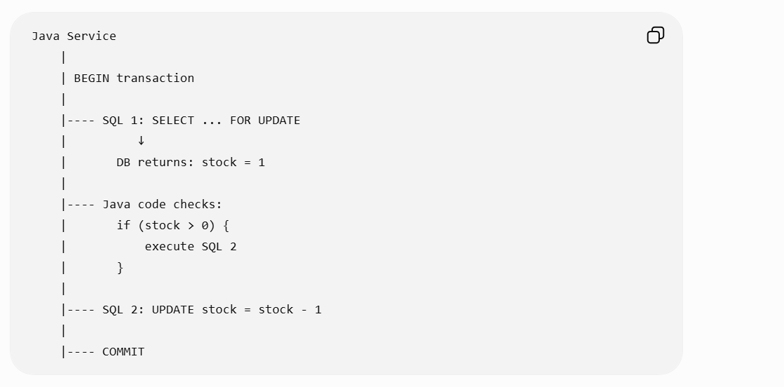

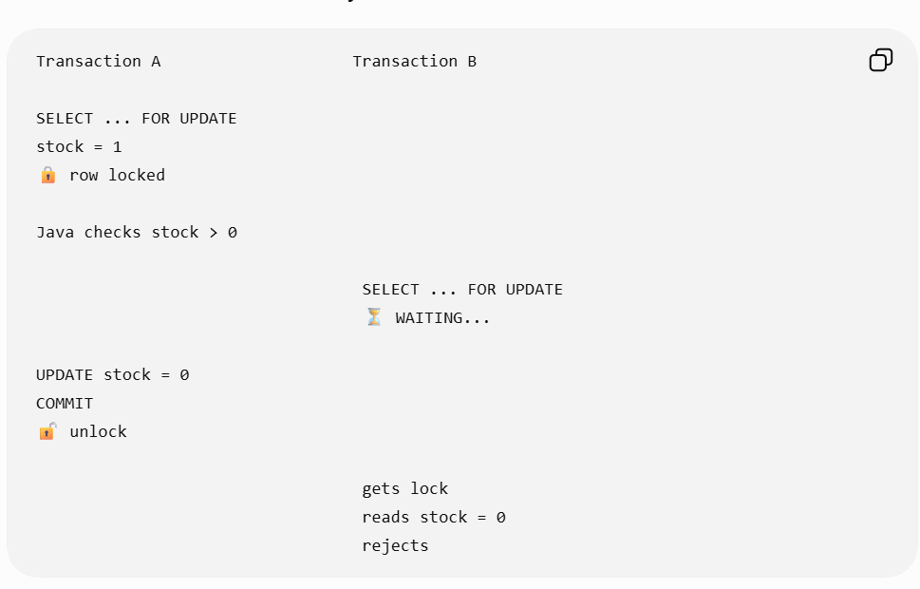

Atomic update
Alternatively, the cleaner approach is the atomic update:
UPDATE inventory
SET stock = stock - 1
WHERE product_id = 101
AND stock > 0;

Then check the affected row count. This avoids needing a separate read/check.

Pessimistic Locking
Assumes conflict is highly likely. It explicitly locks the target record (or table) at the database level when reading, preventing all other transactions from reading or modifying it until the lock is released.
Best Use Case: High-write, high-concurrency environments with zero tolerance for conflict (e.g., banking transactions, stock trading, flight seat bookings).
Example :
SELECT * FROM inventory
WHERE product_id = 101
FOR UPDATE;

Optimistic Locking
Assumes conflict is rare. Instead of locking a record when reading it, it tracks a version number or timestamp. When updating, it checks if the version has changed. If another process modified the data in the meantime, the update fails or retries.
Best Use Case: High-read, low-write environments (e.g., e-commerce product listings, editing user profile settings).

Example:
UPDATE inventory
SET stock = 9, version = 6
WHERE id = 101
AND version = 5;

If 0 rows updated → someone changed it first → conflict → retry/reject.

Idempotency with sensitive transactions
How do you achieve idempotency with sensitive transactions like credit / debit ?
For credit/debit transactions, achieve idempotency using an idempotency key + database constraint + atomic transaction.

Client sends:
POST /transfer
Idempotency-Key: TXN-12345

Store the key with the transaction:
transaction_id | idempotency_key | status | amount
----------------------------------------------------
T1001 | TXN-12345 | SUCCESS| 500

Then:
- First request → process debit/credit and save TXN-12345.
- Retry with same key → detect existing key and return the previous result without applying the debit/credit again.
- Put a UNIQUE constraint on idempotency_key so concurrent duplicate requests cannot both process it.
- Perform balance update + transaction record + idempotency record in one DB transaction.

