Striver SDE Sheet
1 Arrays I 3
1.1 Set Matrix Zeroes 3
1.2 Pascal's Triangle 5
1.3 Next Permutation 6
1.4 Kadane’s Algorithm 7
1.5 Sort an array of 0s, 1s and 2s 9
1.6 Stock Buy And Sell 10
2 Arrays II 11
2.1 Rotate Image by 90 degrees 11
2.2 Merge Overlapping Sub-intervals 11
2.3 Find the duplicate in an array of N+1 integers 12
2.4 Merge two Sorted Arrays Without Extra Space 17
2.5 Repeating and Missing numbers 18
2.6 Count inversions in an array 20
3 Arrays III 22
3.1 Search in a sorted 2D matrix 22
3.2 Implement Pow(x,n) | X raised to the power N 24
3.3 Find the Majority Element that occurs more than N/2 times 24
3.4 Majority Elements(>N/3 times) 25
3.5 Grid Unique Paths 26
3.6 Count Reverse Pairs 27
4 Arrays IV 29
4.1 Two Sum 29
4.2 3Sum | Find triplets that add up to a target value 30
4.3 4 Sum | Find Quads that add up to a target value 31
4.4 Longest Consecutive Sequence in an Array 33
4.5 Length of the longest subarray with zero Sum 34
4.6 Count the number of subarrays with given xor K 36
4.7 Longest Substring Without Repeating Characters 38
4.8 Trapping Rainwater 41
4.9 Remove Duplicates in-place from Sorted Array 42
4.10 Count Maximum Consecutive One's 43

Arrays I

Set Matrix Zeroes
Problem Statement : Given a matrix if an element in the matrix is 0 then you will have to set its entire column and row to 0 and then return the matrix.
https://github.com/PSesharao/sde_preparation/blob/master/DSA/JavaStriverDSA/Arrays/Arrays-I/set_matrix_zeros.java

Brute Force :
Traverse through the matrix and if you find an element with value 0, then change all the elements in its row and column to -1, except when an element is 0. The reason for not changing other elements to 0, but -1, is because that might affect other columns and rows. Now traverse through the matrix again and if an element is -1 change it to 0.
Time Complexity: O((N*M)*(N + M)). O(N*M) for traversing through each element and (N+M) for traversing to row and column of elements having value 0.
Space Complexity: O(1)
Better :
Take two dummy array one of size of row and other of size of column. Now traverse through the array. If matrix[i][j]==0 then set dummy1[i]=0(for row) and dummy2[j]=0(for column).Now traverse through the array again and if dummy1[i]==0 || dummy2[j]==0 then arr[i][j]=0,else continue.
Time Complexity: O(N*M + N*M) for two times traversing the matrix .
Space Complexity: O(N) for the two dummy arrays.
Optimal :
Instead of taking two separate dummy array, take first row and column of the matrix as the array for checking whether the particular column or row has the value 0 or not.

Essentially , when we make any value like on first row matrix[0][j] to 0 ,we are preparing to set all the values corresponding to that column ‘j’ to 0 during next run.
Likewise , when we make any value like on first column matrix[i][0] to 0 ,we are preparing to set all the values corresponding to that row ‘i’ to 0 during next run.

Since matrix[0][0] are overlapping. Therefore take separate variable col0(say) to check if the 0th column has 0 or not and use matrix[0][0] to check if the 0th row has 0 or not.

Now traverse from last element to the first element and check if matrix[i][0]==0 || matrix[0][j]==0 and if true set matrix[i][j]=0,else continue.
Note : While traversing for the second time the first row and column will be computed first, which will affect the values of further elements that’s why we traversing in the reverse direction.
Take below example to understand reverse case
1 1 1
0 1 1
1 1 1
Time Complexity: O(2*(N*M)), as we are traversing two times in a matrix,
Space Complexity: O(1).

( OR )
Instead of using separate arrays, we use the first row and first column of the matrix itself to store whether a row or column needs to be zeroed. We also store two flags:
- firstRowZero: Was the first row supposed to be all zero?
- firstColZero:Was the first column supposed to be all zero?
Then:
- First pass: Mark zeros in the first row and column for any zero found in the rest of the matrix.
- Second pass: Use those markers to set rows and columns to zero.
Finally, handle the first row and column separately based on the flags. This is super space-efficient because we’re reusing the input matrix itself to store markers.
- Check if the first row has any zero and store in a boolean flag.
- Check if the first column has any zero and store in a boolean flag.
- Traverse the rest of the matrix:
  - If a cell is zero, mark its row in the first column and its column in the first row as zero.
- Traverse again (excluding first row and column), setting cells to zero if their row marker or column marker is zero.
- Finally, update the first row and first column based on the stored flags.

Pascal's Triangle
https://github.com/PSesharao/sde_preparation/blob/master/DSA/JavaStriverDSA/Arrays/Arrays-I/pascal_triangle.java
Approach : Straight forward

vector<vector<int>> generate(int numRows) {
vector<vector<int>> pascalMat ;
for(int r=0 ; r<numRows ; r++ ){
vector<int> currentRow(r+1,0) ;
currentRow[0] = currentRow[r] = 1 ;
for(int c=1 ; c<=r-1 ; c++ ){
currentRow[c] = pascalMat[r-1][c-1] + pascalMat[r-1][c] ;
}
pascalMat.push_back(currentRow) ;
}

return pascalMat ;
}

Time Complexity: We are creating a 2D array of size (numRows * numCols) (where 1 <= numCols <= numRows), and we are traversing through each of the cells to update it with its correct value, so Time Complexity = O(numRows2).
Space Complexity: Since we are creating a 2D array, space complexity = O(numRows2).

Next Permutation
Problem Statement: Given an array Arr[] of integers, rearrange the numbers of the given array into the lexicographically next greater permutation of numbers.
If such an arrangement is not possible, it must rearrange it as the lowest possible order (i.e., sorted in ascending order).
https://github.com/PSesharao/sde_preparation/blob/master/DSA/JavaStriverDSA/Arrays/Arrays-I/next_permutation.java
Brute Force :
Find all possible permutations of elements present and store them. Search input from all possible permutations. Print the next permutation present right after it.
Time Complexity :
For finding, all possible permutations, it is taking N!xN. N represents the number of elements present in the input array. Also for searching input arrays from all possible permutations will take N!. Therefore, it has a Time complexity of O(N!xN).
Space Complexity :
Since we are not using any extra spaces except stack spaces for recursion calls. So, it has a space complexity of O(1).
Optimal :
For any dictionary order , it will be always increasing from the back (at least 1 element should follow this pattern Ex in 1 2 3 , ‘3’ is such pattern ) and
For 1 3 5 4 2 , ‘5 4 2' is such a pattern , this indicates that pattern part is in its max possible cannot derive the next greater number from this pattern . To do so we need to start involving before digit where the pattern breaks first (from the back) , here it is at ‘3’ .
i.e bp = A[i] < A[i+1] , now we have ‘1’ and ‘3 5 4 2’ , now second part can be used to generate the next greater number. We know that ’5 4 2’ is in increasing order from back , we just need to find out digit which is just greater than ‘3’ in this pattern so that we can swap with that.
A[sw] > A[bp] , ‘4’ is such number ( we are taking this just greater for generating the immediate next lexicographical number ).
After swapping it will look like ‘4 5 3 2’ , but this is not actually the immediate next lexicographical number as ‘5 3 2’ still in increasing order from back . so here we should reverse this.
We’ll get ‘4 2 3 5’ and finally ‘1 4 2 3 5’ is our answer.
Edge case : If the whole number is already greater like ‘3 2 1’ , there is no break point simply reverse whole number.
Time Complexity: This sums up to 3*O(N) which is approximately O(N).
Space Complexity: Since no extra storage is required. Thus, its complexity is O(1).

Kadane’s Algorithm
Problem Statement: Given an integer array arr, find the contiguous subarray (containing at least one number) which has the largest sum and return its sum and print the subarray.
(Need to ask the interviewer that if we have to return 0 incase all the elements are negative)
https://github.com/PSesharao/sde_preparation/blob/master/DSA/JavaStriverDSA/Arrays/Arrays-I/kadane_algorithm.java
Brute Force:
We can do this problem using nested for loop maintaining two variables i and j to find the sum of every possible slice of the array and then find the maximum sum.
Time Complexity: O(N^2)
Space Complexity: Since no extra storage is required. Thus, its complexity is O(1).
Best Approach: Using Kadanes Algorithm.
Take two variables max_so_far and curr_max (or max_ending_here).
Here max_so_far will return the final answer. We can initialize both max_so_far , curr_max to the first element of the array.
max_so_far = curr_max = arr[0] , but in case we need to return the 0 for all the -ve elements in the array we can initialize max_so_far =0
For every incoming element in the array starting from the index 1, we need to see if adding arr[i], to the
curr_max will be better than arr[i] itself if so, we will continue the streak, otherwise we need to break the streak and start considering the curr_max from arr[i].
when to break streak?
If the curr_max is already negative no matter what incoming element arr[i], we should break the streak.
As long as curr_max is positive we will continue the streak even if incoming element arr[i] is negative (we hope for the better sum in the coming sequence)
At every step we need to recalculate max_so_far, by looking at the curr_max if that better our answer.

int maxSubArray(vector<int>& nums) {

int max_so_far = nums[0];
int curr_max = nums[0];

for (int i = 1; i < nums.size(); i++)
{
curr_max = max(nums[i], curr_max+nums[i]);
max_so_far = max(max_so_far, curr_max);
}
return max_so_far;
}

Time Complexity: O(N)
Space Complexity: O(1)

Sort an array of 0s, 1s and 2s
Problem Statement: Given an array consisting of only 0s, 1s and 2s. Write a program to in-place sort the array without using inbuilt sort functions. (Expected: Single pass-O(N) and constant space)
https://github.com/PSesharao/sde_preparation/blob/master/DSA/JavaStriverDSA/Arrays/Arrays-I/sort_0_1_2.java
Brute Force:
Sorting (even if it is not the expected solution here but it can be considered as one of the approaches).
Time Complexity: O(N x Log N) or O(N^2)
Space Complexity:O(1)
Better Approach: Keeping count of values
Since in this case there are only 3 distinct values in the array so it’s easy to maintain the count of all, Like the count of 0, 1, and 2. This can be followed by overwriting the array based on the frequency(count) of the values.
Time Complexity: O(N) + O(N)
Space Complexity: O (1)
Best Approach: Dutch National flag algorithm (3 pointer approach)
Here we will maintain three pointers
next_zero -> represents the index where the next zero should be placed
next_two -> represents the index where the next two should be placed
curr_pos-> this is an iterator for the array and will traverse from start.
The primary goal here is to move 0s to the left and 2s to the right of the array and at the same time all the 1s shall be in the middle region of the array and hence the array will be sorted.
Whenever we encounter 0 at curr_pos, we swap it with next_zero index and increment next_zero by 1.
No need to decrement curr_pos as we are traversing from the begining only we would have
known that already for sure that it is 1.
Whenever we encounter 2 at curr_pos, we swap it with next_two index and decrement next_two by 1.
We need to decrement curr_pos since we dont know what is already there in next_two position (0 or 1) that's why we need to re visit that curr_pos again.
We will continue this process till curr_pos cross over the next_two , because if we continue curr_pos going till N , as there might already be some 2 placed and we don’t want to swap them again to front.
We should do the check curr_pos <= next_two , the equal check is important, consider the case (A = [1,2,0] ) for understanding this.

Stock Buy And Sell
Problem Statement: You are given an array of prices where prices[i] is the price of a given stock on an ith day.
You want to maximize your profit by choosing a single day to buy one stock and choosing a different day in the future to sell that stock. Return the maximum profit you can achieve from this transaction. If you cannot achieve any profit, return 0.
https://github.com/PSesharao/sde_preparation/blob/master/DSA/JavaStriverDSA/Arrays/Arrays-I/stock_buy_and_sell.java
Brute Force:
We can simply use 2 loops and track of tranaction difference (If arr[j] > arr[i]) and maintain a variable maxPro to contain the max value among all transactions.
Time complexity: O(n^2)
Space Complexity: O (1)
Optimal/Best solution:
Intuition: We will linearly travel the array. We can maintain a minimum from the starting of the array and compare it with every element of the array, if it is greater than the minimum then takes the difference and maintain it in max, otherwise update the minimum.
Here min_val should always preceed the curr_pos element, means should be always likely to be subtracted, as that makes the difference positive.
Time complexity: O(n)
Space Complexity: O (1)

Find 2nd largest number in an array
int A[] = { 7 , 9 , 5 , 4 , 11 , 11 } ;
largest = 11 , secondLargest = 9

Arrays II

Rotate Image by 90 degrees
Problem Statement: Given a matrix, your task is to rotate the matrix 90 degrees clockwise.
https://github.com/PSesharao/sde_preparation/blob/master/DSA/JavaStriverDSA/Arrays/Arrays-II/rotate_matrix.java
Naive approach : Taking the help of dummy auxiliary matrix.
Time Complexity: O(N*N) to linearly iterate and put it into some other matrix.
Space Complexity: O(N*N) to copy it into some other matrix.
Best approach:
Intuition: By observation, we see that the first column of the original matrix is the reverse of the first row of the rotated matrix, so that’s why we transpose the matrix and then reverse each row, and since we are making changes in the matrix itself space complexity gets reduced to O(1).
Time Complexity: O(N*N) + O(N*N).One O(N*N) for transposing the matrix and the other for reversing.
Space Complexity: O(1).

Merge Overlapping Sub-intervals
Problem Statement: Given an array of intervals, merge all the overlapping intervals and return an array of non-overlapping intervals.
Input: intervals = [[1,3],[2,6],[8,10],[15,18]]
Output: [[1,6],[8,10],[15,18]]
Explanation: Since intervals [1,3] and [2,6] overlap, merge them into [1,6].
https://github.com/PSesharao/sde_preparation/blob/master/DSA/JavaStriverDSA/Arrays/Arrays-II/merge_overlapping_intervals.java
Best solution: ( brute force was also very close to this approach )
First ask interviewer if the intervals are already sorted on starting time, if not we need to sort them. we can use comparator function as an argument to sort if needed.
Intuition: Since we have sorted the intervals, the intervals which will be merging are bound to be adjacent. We kept on merging simultaneously as we were traversing through the array and when the element was non-overlapping, we simply inserted the element in our data structure.
Take two variables merge_start, merge_end initially representing first interval, we need to traverse the remaining list of intervals from the first index of interval list.
The overlapping condition will be current_start <= merge_end in which case we need to check for which is greater between merge_end, current_end, because cases like { [1,10] , [2 , 6 ] , [3 ,8] } also possible.
So, merge_end = max (merge_end, current_end).
So the variable merge_end alone keeps changing while we traverse.
In case of non overlapping condition , we simply insert the sofar formed merged interval { merge_start, merge_end } to our answer and reset their values to the current non overlapping interval.
At the end we just need to insert the pair {merge_start, merge_end } to our answer as the loop finishes, this pair will still remain.
Time Complexity: O( N logN ) + O(N). O( N logN ) for sorting and O(N) for traversing through the array.
Space Complexity: O(N) to return the answer of the merged intervals.

Find the duplicate in an array of N+1 integers
Problem Statement: Given an array of N + 1 size, where each element is between 1 and N. Assuming there is only one duplicate number, your task is to find the duplicate number.
All the integers in array appear only once except for precisely one integer which appears two or more times.
https://github.com/PSesharao/sde_preparation/blob/master/DSA/JavaStriverDSA/Arrays/Arrays-II/find_duplicate_in_array.java
Proof :
According to the Pigeonhole Principle, n+1 integers , placed in an array of length n , at least 1 integer will be repeated.
Brute Force:
Sort the array. After that, if there is any duplicate number they will be adjacent. So we simply have to check if arr[i]==arr[i+1] and if it is true, arr[i] is the duplicate number.
Time Complexity(Nlogn + N)
Reason: NlogN for sorting the array and O(N) for traversing through the array and checking if adjacent elements are equal or not. But this will distort the array.
Space Complexity: O(1)
Better Approach:
i)Using frequency array : Here since we know that the elements are within the range of 1 to N we can make use of that fact . Take a frequency array of size N+1 and initialize it to 0. Now traverse through the array and if the frequency of the element is 0 increase it by 1, else if the frequency is not 0 then that element is the required answer.
Time Complexity: O(N), as we are traversing through the array only once.
Space Complexity: O(N), as we are using extra space for frequency array.
ii)Use map or set: We can traverse through the array if we find that an element does not exist in the map, just push that to it, but if it does it is our duplicate.
Time Complexity: O(N), as we are traversing through the array only once.
Space Complexity: O(N), as we are using extra space for map.

Best Approach:
i)Using xor method: since we know elements lie in range 1 to N, first we can take xor of all 1 to N elements and then we traverse the array of N+1 elements and keep adding the elements to the xor result therefore, all the same pairs will get cancelled and the duplicate element will remain as xor result.
Time Complexity: O(N) + O (N), as we are traversing through the array once and for finding xor of 1 to N second time.
This will only work if we have ONLY 1 duplicate ( should not repeat more than twice. )
Space Complexity: O(1), as we are using constant space.
ii)Using cycle detection method:
As the size of the array is N+1 and the elements will be from [1, N] the indices should be from [0, N] , so the elements can be indexable.
Intuition: Since there is a duplicate number, we can always say that cycle will be formed.
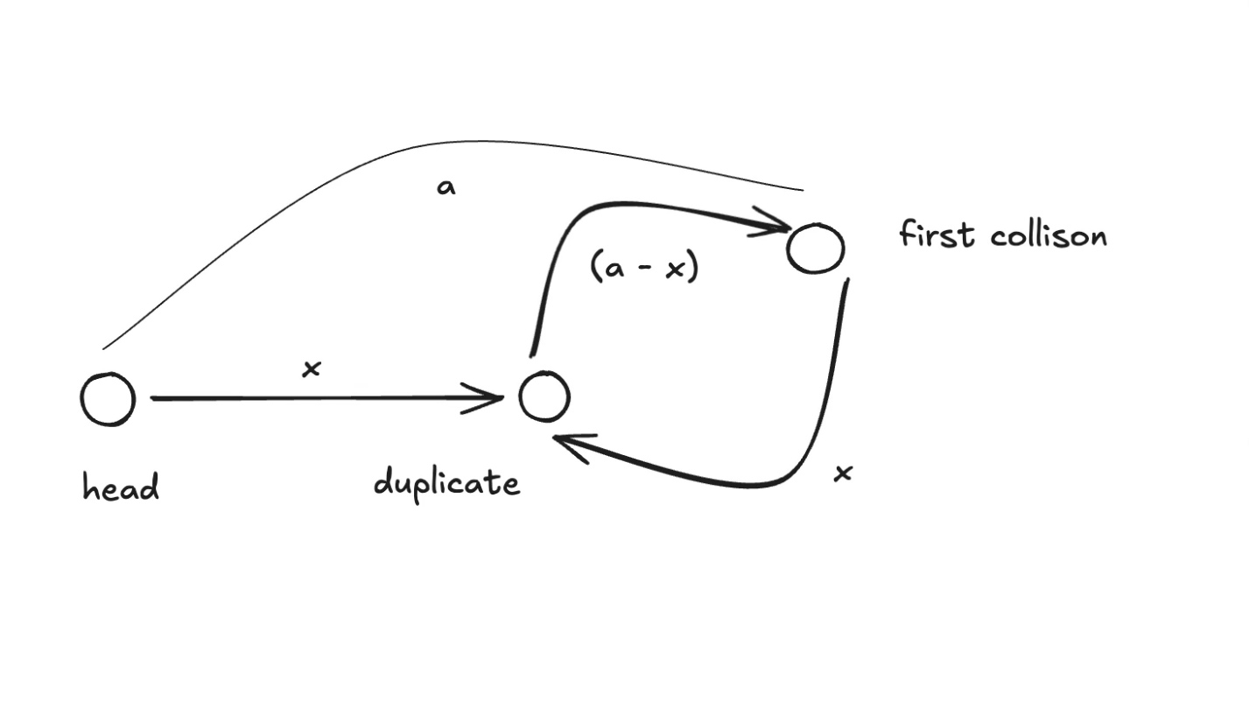
The slow pointer moves by one step and the fast pointer moves by 2 steps and there exists a cycle so the first collision is bound to happen.
Let’s assume the distance between the first element and the first collision is ‘a’. So slow pointer has travelled ‘a’ distance while fast ( since moving 2 steps at a time) has travelled ‘2a’ distance. For slow and a fast pointer to collide 2a-a=a should be multiple of the length of cycle. a= nC ( C is the length of the loop/cycle ).Now we place a fast pointer to start. ( we can place either of the fast/slow ptr it’s just that we need to two pointers to be moving along one step each )
Assume the distance between the start and duplicate to be x. So now the distance between slow and duplicate shows also to be x, as seen from the diagram, and so now fast and slow pointer both should move by one step.
Explanation :
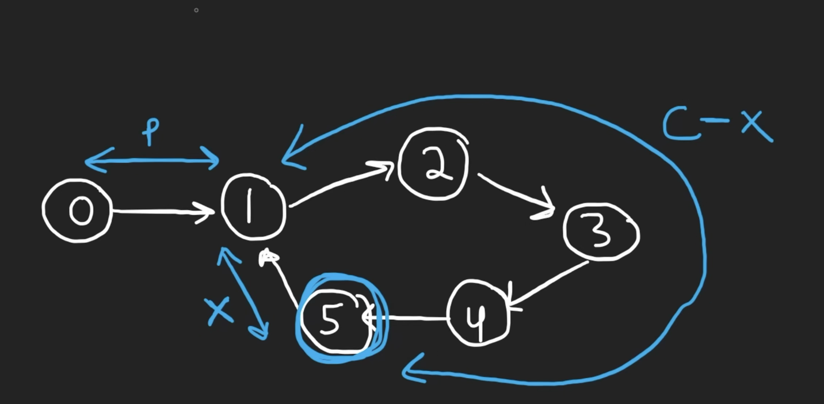

From the above diagram,
P -> distance between head (0) and start of the loop.
X -> distance between the first intersection point of slow and fast pointers(5) to the start of the loop (1).
C -> length of the loop/cycle.

Let's draw some equations here:

Till we reach the first intersection point '5’,
slow pointer would have travelled P + (C-X).
fast pointer would have travelled more than slow pointer , the only way it could have done is through that extra cycle P + (C-X) + C
We have the equation like
2 x slow_ptr = fast_ptr
2 x (P + (C-X) ) = P + (C-X) + C
2P + 2C - 2X = P + 2C -X
2P - P + 2C - 2C - 2X + X = 0
P - X = 0
P = X
In short:
1)Find the first collision.
2)Reset fast_ptr to begin from start and slow_ptr from the collision(which is already at the collision point ) and travel by one step until they collide which is out duplicate.
Example :
Take the array [1,3,4,2,2] as an example, here we'd have the indices
[0,1, 2,3,4].
We need to treat the input array as a linked list.
0→1→3→2→4→2→4→2→…
Here 2→4 is a cycle, then this linked list can be abstracted as the following figure:
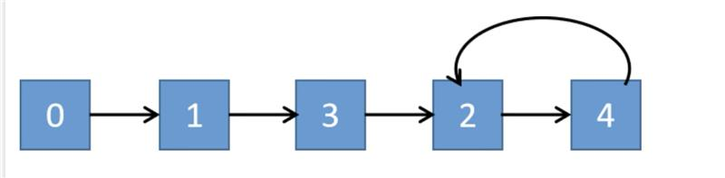

Merge two Sorted Arrays Without Extra Space
Problem statement: Given two sorted integer arrays nums1 and nums2, merge both the arrays into a single array sorted in non-decreasing order. The final sorted array should be stored inside the array nums1 and it should be done in-place.Array nums1 has a length of m + n, where the first m elements denote the elements of nums1 and rest are 0s whereas nums2 has a length of n.
https://github.com/PSesharao/sde_preparation/blob/master/DSA/JavaStriverDSA/Arrays/Arrays-II/merge_sorted_arrays.java
Brute Force :
We can use a new array of size n+m and put all elements of arr1 and arr2 in it, and sort it. After sorting it, put back all the elements in arr1.
Time complexity: O((m+n)*log(m+n))+O(m)+O(n)
Space Complexity: O(m+n)
Better Approach:
Use the technique followed in the merge sort, while merging two sorted arrays. Use variables i, j and k.
Use a temp array to store the merge of the elements and put back elements in arr1 after merging.
Time complexity: O(m+n)
Space Complexity: O(m+n)
Best Approach: Without using space
i)Gap Method or Shell sorting method
Just assume that we are traversing the single array of length (m+n).
Approach:
- Initially take the gap as (m+n)/2;
- Take as a pointer1 = 0 and pointer2 = gap.
- Run a loop from pointer1 & pointer2 to m+n and whenever arr[pointer2]<arr[pointer1], just swap those.
- After completion of the loop reduce the gap as gap=gap/2.
- Repeat the process until gap>0.
Time complexity: O(m+n) (log(m+n)) as we are dividing the array of size (m+n) at every stage by 2 and iterating the whole.
Space complexity: O (1)
ii)Compare from the back
Intuition: To compare two sorted arrays [7, 9, 0, 0, 0] and [1, 2, 8] If we compare from end, we would be able to fill up the last 0's spaces with greater elements and at last whatever left in arr2 can be copied to the front of arr1.

Repeating and Missing numbers
You are given an array of size ‘N’. The elements of the array are in the range from 1 to ‘N’. Ideally, the array should contain elements from 1 to ‘N’. But due to some miscalculations, there is a number R in the range [1, N] which appears in the array twice and another number M in the range [1, N] which is missing from the array.
Your task is to find the missing number (M) and the repeating number (R).
https://github.com/PSesharao/sde_preparation/blob/master/DSA/JavaStriverDSA/Arrays/Arrays-II/repeat_and_missing_number.java
Naive approach: Using frequency array.
Since the numbers are from 1 to N in the array arr []
- Take a frequency array of size N+1 and initalize it with 0.
- Traverse the given array and increase the value of frequency[arr[i]] by one.
- Then again traverse the frequency array starting from index 1 to N.
If you find any index value greater than 1 that is repeating element A. If you find any index value = 0 then that is the missing element B.
Time Complexity: O(N)
Space Complexity: O(N) As we are making new frequency array
Best approach:
Here the cyclic method does not work in finding the duplicate number because, it is possible that
N = 6 and at same time 6 also present in the array, if we had to look for nums [6] would throw array out of bound
Also, we cannot find the duplicate number by using the xor method either because here unlike the case of N+1 elements where each number from 1 to N appear at least once, we cannot guarantee that here in case of N elements from [1, N-1] only exist as it is possible that N itself can exist.
Approach:
Let us take N=3 and arr = [1, 3 ,3], if we take xor between sets [1,2,3] and [1,3,3], it will come out to be 2^3, which is nothing but xor of M ^ R.
Let us say findXOR = M ^ R.
All the set bits in findXOR will be in either the missing number or the repeating number (because only 0 ^ 1 or 1 ^ 0 will make it 1 which is set bit). Using any set bit in the findXOR, let's say the rightmost set bit, we can divide the elements of the given array in two sets.
- In the first set, we have the elements with the same bit set.
- In the second set, we have all the elements with the same bit not set.
How to find the rightmost set bit number, let us say if findXOR = 12 => 1 1 0 0, take ~findXor => 0 0 1 1
-findXor is (take 2’s complement) 0 0 1 1 + 1 => 0 1 0 0
now findXOR & (-findXor) => ((1 1 0 0) & (0 1 0 0)) => 0 1 0 0 which is the right most set bit number.

Initialize two variables, ‘bitSet’ and ‘bitNotSet’ with 0.
Traverse the given array and if the element belongs to the first set, take its XOR with bitSet else take its XOR with bitNotSet.
Traverse from 1 to n, and if the number belongs to the first set, take its XOR with bitSet else take its XOR with bitNotSet.
Now, we have our missing and repeating numbers stored in bitSet and bitNotSet (since there will be double instances of every number in each bucket except them), but we do not know which one is missing and which one is repeating.
To find which one is repeating, we will again traverse the given array and if ‘bitSet’ is present in the array, it means ‘bitSet’ is our repeating number and ‘bitNotSet’ is our missing number. We will store ‘bitSet’ in the variable ‘R’ and ‘bitNotSet’ in the variable ‘M’. If ‘bitNotSet’ is present in the array, it means ‘bitNotSet’ is our repeating number and ‘bitSet’ is our missing number. We will store ‘bitSet’ in the variable ‘M’ and ‘bitNotSet’ in the variable ‘R’.
Example:
Take [1 1 2 4]
findXOR =[1 1 2 4] xor [1 ,2 ,3 ,4 ] => 1 ^ 3 => 0 0 1 0 whose first set bit number is also 0 0 1 0.
First let us iterate through array and divide it.
bitSet = 2, bitNotSet = 1^1^4
Next, let us iterate through [1,2,3,4] and divide it.
bitSet = (2) ^ (2 ^ 3 ) bitNotSet = (1^1^4) ^ (1^4)
bitSet =3 , bitNotSet = 1 which are our answers.

Count inversions in an array
Problem Statement: Given an array of N integers, count the inversion of the array (using merge-sort).
What is an inversion of an array? Definition: for all i & j < size of array, if i < j then you have to find pair (A[i],A[j]) such that A[j] < A[i].
https://github.com/PSesharao/sde_preparation/blob/master/DSA/JavaStriverDSA/Arrays/Arrays-II/count_inversions.java
Brute Force :
Use the nested for loop and maintain the variables i,j.
Like for(i=0 ; i< n ; i++)
for(j=i+1 ; j<n ; j++)
if( arr[i] > arr[j] )

Time Complexity: O(N^2)
Space Complexity: O (1)
Best Approach: Using merge sort
In the merge sort, we divide the array down into halves and build again up into the one single array.
When we go deep down into one single element, we compare two elements (calculate inversion counts)
and put it in a new array in sorted order.

Note: Here we should not worry about change in the order of the array.
Another point is when we are comparing one element in left sorted array with another element in right sorted array all the indices in left array is less than right array indices i.e always ( left_index < right_index )
so the condition that we need to check is ( left_array[left_index] > right_array[right_index] )
left_array right_array
[10 15 18 ] [9 20 25]
let us say left_index =0 , right_index =0 and 10 > 9 , here this implicitly mean that remaining all the elements in left_array also greater than 9.
so , inversion_count += left_array_size - left_index ;
Time Complexity: O (n logn) for merge sort algo
Space Complexity: O(n) for the auxiliary space required for two arrays.

Arrays III

Search in a sorted 2D matrix
Problem Statement: Given an m*n 2D matrix and an integer, write a program to find if the given integer exists in the matrix.
Given matrix has the following properties:
Integers in each row are sorted from left to right. The first integer of each row is greater than the last integer of the previous row.
https://github.com/PSesharao/sde_preparation/blob/master/DSA/JavaStriverDSA/Arrays/Arrays-III/search_2d_matrix.java
Naive Approach:
We can traverse through every element that is present in the matrix and return true if we found any element in the matrix is equal to the target integer. If the traversal is finished, we can directly return false as we did not find any element in the matrix to be equal to the target integer.
Time complexity: O(m*n)
Space complexity: O (1)
Best Approach: Using binary search
Here we need to consider the 2D array as the single 1D array
Initially have a low index as the first index of the considered 1D matrix(i.e: 0)
and high index as the last index of the considered 1D matrix(i.e: (R*C)-1).

Get the middle index as (low+high)/2.We can get the element at middle index
using matrix[middle/C][middle%C].

Example :

[0,0] 0
[0,1] 1
[0,2] 2
[0,3] 3

[1,0] 4
[1,1] 5
[1,2] 6
[1,3] 7

[2,0] 8
[2,1] 9
[2,2] 10
[2,3] 11
Time complexity: O(log(m*n))
Space complexity: O(1)
Another Best Approach :
We need to first find which row the target would fit in , since each of the row is sorted , and it is guaranteed that the first integer of each row is greater than the last integer of the previous row.
One by one row we can check if target possibly exists , i.e if target is between the first and last elements of the row , then we can do binary search on that row alone , otherwise move on to the next row.
Time complexity : O(m) + O(log(n)) [ O(m) as possibly we need to look for all the rows , once we find the row it will be O(log(n)) for binary search on that specific row. ]
Space complexity: O(1)

Implement Pow(x,n) | X raised to the power N
Problem Statement: Given a double x and integer n, calculate x raised to power n. Basically Implement pow(x, n).
https://github.com/PSesharao/sde_preparation/blob/master/DSA/JavaStriverDSA/Arrays/Arrays-III/my_pow.java
Brute force : Looping from 1 to n and keeping a ans(double) variable. Now every time your loop runs, multiply x with ans. At last, we will return the ans.
Now if n is negative we must check if n is negative, if it is negative divide 1 by the end.
Time Complexity: O(N)
Space Complexity: O(1)
Binary exponentiation :
While calculating (n^k), binary exponentiation relies on whether k is even or odd.
If k is even (n^k) can be written as (n^2)^k/2. As we can see that computation steps were reduced from k to k/2 in just one step. If k is odd (n^k) can be written as n.(n)^k-1, so now (k-1) is even.
Time Complexity: O(logn).
Space Complexity: O(1)

Find the Majority Element that occurs more than N/2 times
Problem Statement: Given an array of N integers, write a program to return an element that occurs more than N/2 times in the given array. You may consider that such an element always exists in the array.
https://github.com/PSesharao/sde_preparation/blob/master/DSA/JavaStriverDSA/Arrays/Arrays-III/majority_element.java
Brute force: Find the frequency of each element in the array check if the value is greater than the floor of N/2.
Time Complexity: O(N)-> Frequency array or O(N log N) -> HashMap
Space Complexity: O(N)
Best Approach: Moore’s Voting Algorithm
The question clearly states that the nums array has a majority element. Since it has a majority element, we can say definitely the count is more than N/2.
Majority element count = N/2 + x;
Minority/Other elements = N-( N/2 + x) = N/2 – x;
Where x is the number of times it occurs after reaching the minimum value N/2.
We can use this fact to keep track a Count , Element variable
- If Count is 0 then initialize the current traversing integer of array as Element
- If the traversing integer of array and Element are same increase Count by 1
- If they are different decrease Count by 1
The integer present in Element is the result we are expecting , as we have for the count after it gets cancelled with the minority elements , remaining are all majority only.

Majority Elements(>N/3 times)
Problem Statement: Given an array of N integers. Find the elements that appear more than N/3 times in the array. If no such element exists, return an empty vector.
https://github.com/PSesharao/sde_preparation/blob/master/DSA/JavaStriverDSA/Arrays/Arrays-III/majority_element_II.java
Brute-Force :
Simply count the no. of appearance for each element using nested loops and whenever you find the count of an element greater than N/3 times, that element will be our answer.
Time Complexity: O(n^2)
Space Complexity: O(n)
Best Approach : Extended Moore’s Voting Algorithm
We are sure that there will be a max of 2 elements(at most) which occurs > N/3 times, extend the algorithm for 2 values.
Time Complexity: O(n)
Space Complexity: O(1)

Grid Unique Paths
Problem Statement: Given a matrix m X n, count paths from left-top to the right bottom of a matrix with the constraints that from each cell you can either only move to the rightward direction or the downward direction.
https://github.com/PSesharao/sde_preparation/blob/master/DSA/JavaStriverDSA/Arrays/Arrays-III/grid_unique_paths.java
Brute force :
The problem states that we can either move rightward or downward direction. So, we recursively try out all the possible combinations.

Time complexity : The time complexity of this recursive solution is exponential. O(2^(m+n))
Space complexity : it is determined by the maximum depth of the recursive call stack. Since each call to uniquePaths(m, n) results in two additional calls, the maximum depth of the stack is equal to m+n-2. Therefore, the space complexity of this solution is O(m+n)
Better Approach: Use DP
Time complexity: O(n*m)
Space complexity: O(n*m)
Best Approach: Combinatorics Solution
Each time we are taking an exactly m+n-2 number of steps to reach the end.
Out of these m+n-2 steps, n-1 rightward direction steps and m-1 downward direction steps, so if we calculate here the combinations ( ie: m+n-2Cn-1 or m+n-2Cm-1) we’ll get the total number of paths.
Time Complexity: The time complexity of this solution will be O(n-1) or O(m-1) depending on the formula we are using.
Space Complexity: As we are not using any extra space the space complexity of the solution will be O(1).
(Thought process: Assume the straight line of m+n-2 bricks, the is can be bent in any such ways so that each bent structure should have n-1 right units and m-1 down units).

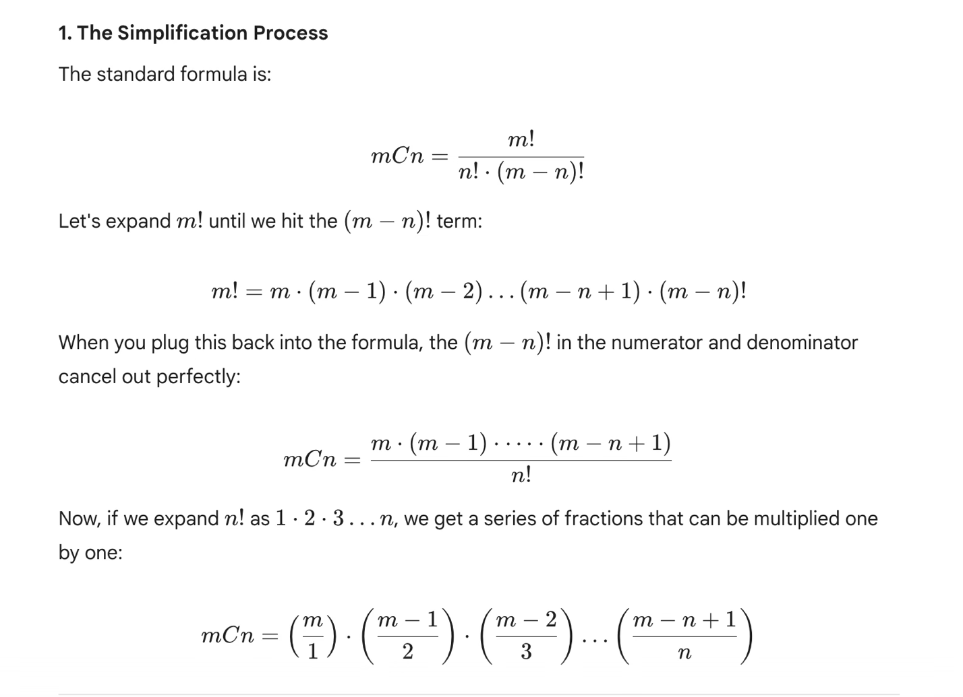

Count Reverse Pairs
Problem Statement: Given an array of numbers, you need to return the count of reverse pairs. Reverse Pairs are those pairs where i<j and arr[i]>2*arr[j].

Brute Force: As we can see from the given question that i < j, so we can just use 2 nested loops and check for the given condition which is arr [i] > 2* arr[j]
Time Complexity: O (N^2) (Nested Loops)
Space Complexity: O (1)
Best Approach: Use merge sort technique
We will need to find the count before the merging (unlike while merging as suited for count inversions problem earlier)
// calculating the inversion count O(n) operation

for(left_index =0 ; left_index < left_array_size ; left_index ++ ){
while((right_index < right_array_size) and (left_array[left_index] > 2LL * right_array[right_index]) )
right_index ++ ;
inversion_count += (right_index) ;
}
The inner loop increments right_index as long as left_array[left_index] > 2LL * right_array[right_index], meaning as long as the current element from the left subarray is greater than twice the current element from the right subarray. When this condition is no longer true, it means that right_index represents the count of reverse pairs for the current element in the left subarray, which is added to the overall count.
Example :
[3 , 4 , 11 ] [1 , 4, 5]
first pass
(3 , 1 )
2nd pass
(4 , 1)
3rd pass
(11 ,1 ) (11 , 4) (11 , 5)
Time Complexity : O( N log N ) + O (N) + O (N)
Reason : O(N) – Merge operation , O(N) – counting operation ( at each iteration of i , j doesn’t start from 0 . Both of them move linearly )
Space Complexity : O(N)
Reason : O(N) – Temporary vector

Arrays IV

Two Sum
Problem Statement: Given an array of integers nums [] and an integer target, return indices of the two numbers such that their sum is equal to the target.
Note: Assume that there is exactly one solution, and you are not allowed to use the same element twice. Example: If target is equal to 6 and num [1] = 3, then nums [1] + nums [1] = target is not a solution.
https://github.com/PSesharao/sde_preparation/blob/master/DSA/JavaStriverDSA/Arrays/Arrays-IV/two_sum.java
Brute Force: Use nested for loop with variables i, j.
Time Complexity: O(N2)
Space Complexity: O (1)
Better Approach: Two-Pointer Approach
Given array, nums = [2,1,3,4], target = 4
- First, we sort the array. So nums after sorting is [1,2,3,4]
- We take two pointers, i and j. i points to index 0 and j points to index 3.
- Now we check if nums[i] + nums[j] == target. In this case, they don’t sum up, and nums[i] + nums[j] > target, so we will reduce j by 1.
- Now, i = 0, j=2
- Here, nums[i] + nums[j] == 1 + 3 == 4, which is the required target, so we store both the elements and break the loop.
- Now, we run another loop to find the indices of the elements in the actual array, i.e [2,1,3,4]
- Then, return the actual indices, [1,2].
Time Complexity: O(NlogN)
Space Complexity: O(N)
Best Approach: Hashing (Most efficient)
We can solve this problem efficiently by using hashing. We’ll use a hash-map to see if there exists a value target – x for each value x. If target – x is found in the map, can return current element x’s index and (target-x)’s index.
Time Complexity: O(N)
Space Complexity: O(N)

3Sum | Find triplets that add up to a target value
Problem Statement: Given an integer array nums, return all the triplets [nums[i], nums[j], nums[k]] such that i != j, i != k, and j != k, and nums[i] + nums[j] + nums[k] == 0.
Notice that the solution set must not contain duplicate triplets.

Brute Force : Run a 3 nested loop
Time Complexity: O (N ^ 3)
Space Complexity: O (1)
Better approach: Using 2 pointers and Binary Search
Time Complexity: O(N log N + N^2 log N)
Reason: Sorting the array takes N log N and two nested loops will be taking N^2 and for binary search, it takes another log N.
Space Complexity: O(N), for the extra set data structure we are taking to avoid the duplicates.
(Generally, the space complexity that is used to return the answer is ignored)
Best Approach : Single loop and two-pointer
Time Complexity: O(N log N + N^2 )
Reason: Sorting the array takes N log N and taking N^2 for nested loop (single loop and nested two-pointer)
Space Complexity: O(1), as the array is sorted , we can skip the duplicates as they tend to be on side by side after sorting.

4 Sum | Find Quads that add up to a target value
Problem Statement: Given an array of N integers, your task is to find unique quads that add up to give a target value. In short, you need to return an array of all the unique quadruplets [arr[a], arr[b], arr[c], arr[d]] such that their sum is equal to a given target.
Note:
- 0 <= a, b, c, d < n
- a, b, c, and d are distinct.
- arr[a] + arr[b] + arr[c] + arr[d] == target
https://github.com/PSesharao/sde_preparation/blob/master/DSA/JavaStriverDSA/Arrays/Arrays-IV/four_sum.java
Brute Force: Run a 4 nested loop, to avoid the duplicate solutions use a set data structure.
Time Complexity: O (N ^ 4)
Space Complexity: O(N), for the extra set data structure we are taking to avoid the duplicates.
Since in the problem they are not asking for the indices of the solutions, we can use sorting.
Better approach: Using 3 pointers and Binary Search
The main idea is to sort the array, and then we can think of searching in the array using the binary search technique. Since we need the 4 numbers which sum up to target. So, we will fix three numbers as nums[i], nums[j] and nums[k], and search for the remaining (target – (nums[i] + nums[j] + nums[k])) in the array. Since we sorted the array during the start, we can apply binary search to search for this value, and if it occurs, we can store them. In order to get the unique quads, we use a set data structure to store them.
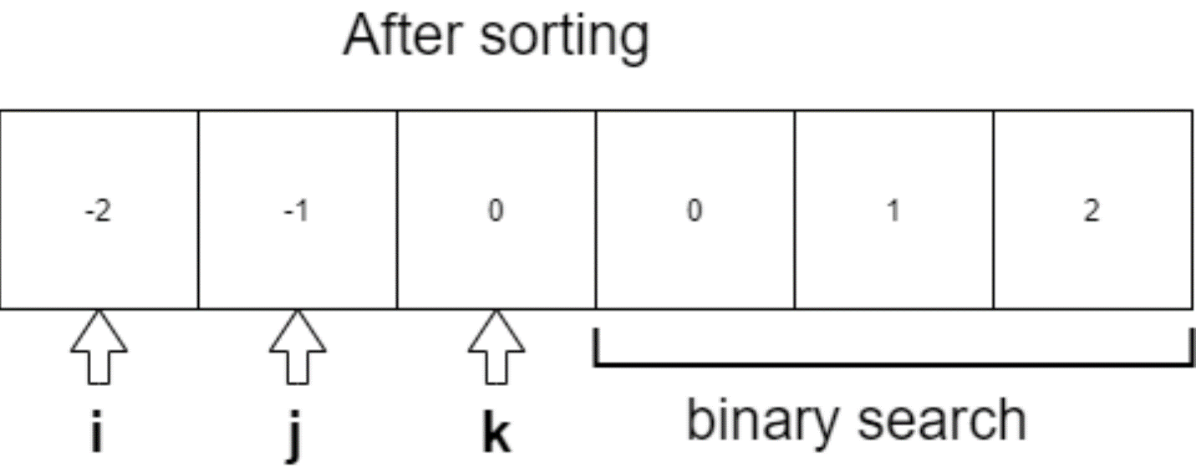

Time Complexity: O(N log N + N³ logN)
Reason: Sorting the array takes N log N and three nested loops will be taking N³ and for binary search, it takes another log N.
Space Complexity: O(N), for the extra set data structure we are taking to avoid the duplicates.
(Generally, the space complexity that is used to return the answer is ignored)
Best Approach: In the previous approach we have run a 3 nested loop and did a binary search to find the fourth. Over here we will run a 2 nested loop and then find the remaining two elements using two pointer technique as the array will be sorted at first.
Sort the array, and run a 2 nested loop for first 2 quads, so the remaining sum will be (target – (nums[i] + nums[j])). Now we can fix two-pointers, one front, and another back, and easily use a two-pointer to find the remaining two numbers of the quad. In order to avoid duplications, we jump the duplicates, because taking duplicates will result in repeating quads. We can easily jump duplicates, by skipping the same elements by running a loop.
Time Complexity: O(N log N + n³)
Reason: There are 2 nested loops and the two pointer (Third nested loop)
Space Complexity: O(1) as we are not taking any extra set data structure to avoid the duplicates , as we will be skipping/jumping over them.
, (Generally, the space complexity that is used to return the answer is ignored)

Longest Consecutive Sequence in an Array
Problem Statement: You are given an array of ‘N’ integers. You need to find the length of the longest sequence which contains the consecutive elements.
https://github.com/PSesharao/sde_preparation/blob/master/DSA/JavaStriverDSA/Arrays/Arrays-IV/longest_consecutive_sequence.java
Brute Force:
As you iterate through each number in the array, begin by checking if consecutive numbers like (x+1, x+2, x+3), and so on, exist in the array.
The occurrence of the next consecutive number can be checked by using a linear search.
When you find consecutive numbers, start counting them using a counter. Increment this counter each time you find the next consecutive number in the sequence.
The max value of all the counters will be our answer.
Time Complexity: O(n^2) This is because for each element, we may need to perform a linear search through the entire array to find consecutive numbers.
Space Complexity: O(1).
Better Approach:
If they are asking to find this in the un-sorted array only, first sort the given array.
Begin by sorting the entire array in ascending order. This step helps group consecutive numbers together, simplifying the sequence detection process.
Use a loop to iterate through each element of the sorted array.

There are 3 cases that may need to be handled.
- prev and curr elements are consecutive. (increase the count)
- prev and curr are non-consecutive and different. ( reset count to 1)
- prev and curr are non-consecutive but equal. (continue to skip the duplicates.)

Time Complexity: We are first sorting the array which will take O(N * log(N)) time and then we are running a for loop which will take O(N) time. Hence, the overall time complexity will be O(N * log(N)) + O(N).
Space Complexity: The space complexity for the above approach is O(1) because we are not using any auxiliary space.
Best Approach:
If sorting were to be used in the above approach, we can follow this approach
We will first push all are elements in the HashSet. Then we will run a for loop and check for any number(x) if it is the starting number of the consecutive sequence by checking if the HashSet contains (x-1) or not. If ‘x’ is the starting number of the consecutive sequence we will keep searching for the numbers y = x+1, x+2, x+3, …... And stop at the first ‘y’ which is not present in the HashSet. Using this we can calculate the length of the longest consecutive subsequence.
Time Complexity: The time complexity of the above approach is O(N) because we traverse each consecutive subsequence only once. (assuming HashSet takes O(1) to search)
Space Complexity: The space complexity of the above approach is O(N) because we are maintaining a HashSet.

Length of the longest subarray with zero Sum
Problem Statement: Given an array containing both positive and negative integers, we have to find the length of the longest subarray with the sum of all elements equal to zero.
https://github.com/PSesharao/sde_preparation/blob/master/DSA/JavaStriverDSA/Arrays/Arrays-IV/longest_subarray_with_k_sum.java
Brute Force: Run a nested for loop
- Initialize a variable max = 0, which stores the length of the longest subarray with sum 0.
- Traverse the array from start and initialize a variable sum = 0 which stores the sum of the subarray starting with the current index
- Traverse from the next element of current_index up to the end of the array, each time add the element to the sum and check if it is equal to 0.
- If sum = 0, check if the length of the subarray so far is > max and if yes update max
- Now keep adding elements and repeat step 3 a.
- After the outer loop traverses all elements return max
Time Complexity: O(N^2) as we have two loops for traversal
Space Complexity: O (1) as we aren’t using any extra space.
Best Approach: Prefix sum
Now let’s say we know that the sum of subarray(i, j) = S, and we also know that sum of subarray(i, x) = S where i < x < j. We can conclude that the sum of subarray (x+1, j) = 0.
Let us understand the above statement clearly

So in this problem, we’ll store the prefix sum of every element, and if we observe that 2 elements have same prefix sum, we can conclude that the 2nd part of this subarray sums to zero.
- First let us initialise a variable say sum = 0 which stores the sum of elements traversed so far and another variable say max = 0 which stores the length of longest subarray with sum zero.
- Declare a HashMap<Integer, Integer> which stores the prefix sum of every element as key and its index as value.
- Now traverse the array, and add the array element to our sum.
- (i) If sum = 0, then we can say that the subarray until the current index has a sum = 0, so we update max with the maximum value of (max, current_index+1) , current_index+1 represents the size of the array till then.
- (ii) If sum is not equal to zero then we check hashmap if we’ve seen a subarray with this sum before
- if HashMap contains sum -> this is where the above-discussed case occurs (subarray with equal sum), so we update our max (max, current_index – previous_prefix_index)
- else -> Insert (sum, current_index) into hashmap to store prefix sum until current index
- After traversing the entire array our max variable has the length of longest substring having sum equal to zero, so return max.

NOTE:
- we do not update the index of a sum if it’s seen again because we require the length of the longest subarray.
- We do not need to enter the index of the 0 sum because, even if we see 0 sum again we will take the length upto that directly , as we are looking for a sum of 0 itself.
Time Complexity: O(N), as we are traversing the array only once
Space Complexity: O(N), in the worst case we would insert all array elements prefix sum into our hashmap

Count the number of subarrays with given xor K
Problem Statement: Given an array of integers A and an integer B. Find the total number of subarrays having bitwise XOR of all elements equal to B.
https://github.com/PSesharao/sde_preparation/blob/master/DSA/JavaStriverDSA/Arrays/Arrays-IV/no_of_subarray_with_xor.java
Brute force: Run a nested for loop
We'll need to consider the xor of every possible subarray , and from there we need to count only those which can fit into our answer.
for(int i=0 ; i<n ; i++ )
for(int j=i ; j<n ; j++) or for(int j=0 ; j<=i ; j++)
Time Complexity: O(N^2) as we have two loops for traversal
Space Complexity: O (1) as we aren’t using any extra space.
Best Approach: Prefix xor
Let us say that ‘xorr’ is the running xor from the beginning (prefix xor) , let us say if it comprises of two parts the ‘k’ that we are looking for and the other part ‘y’ .
So the count is dependent on no of ‘y’ divisions at a given point of time.
For example
Let's take [4 2 2 6 4 ] , k = 6
xorr = [4 2 2 6] currently ,
then y = xorr ^ k
- [4 2 2 6] ^ 6
- 4
y =4, if we see that for the span of xorr [4 , 2 ,2 , 6 ]
there can be two possible divisions for y =4 , they are
- y = 4 , k = [2 2 6]
- y = [4 2 2] , k = 6

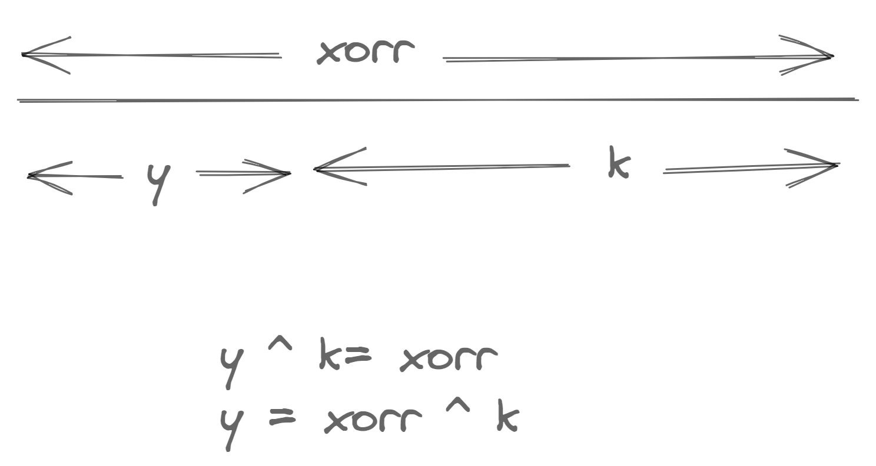

Algorithm :
- We will maintain a running xorr , and a hash map for maintaining the frequencies of every prefix xor (running xorr).
- First check if xorr itself equals to k, If so increase the count by 1 , y for this case would be 0.
- We will need to find y using y = xorr ^ k , check for its frequency in the map , and add it to count.
- update the frequency map for running xorr.

Longest Substring Without Repeating Characters
Problem Statement: Given a String, find the length of longest substring without any repeating character.
https://github.com/PSesharao/sde_preparation/blob/master/DSA/JavaStriverDSA/Arrays/Arrays-IV/longest_substring_without_repeat.java
Example 1:
Input: s = "abcabcbb"
Output: 3
Explanation: The answer is "abc", with the length of 3.
Example 2:
Input: s = "bbbbb"
Output: 1
Explanation: The answer is "b", with the length of 1.
Example 3:
Input: s = "pwwkew"
Output: 3
Explanation: The answer is "wke", with the length of 3.
Notice that the answer must be a substring, "pwke" is a subsequence and not a substring.
Brute force :This approach consists of taking the two loops one for traversing the string and another loop – nested loop for finding different substrings and after that, we will check for all substrings one by one and check for each and every element if the element is not found then we will store that element in HashSet otherwise we will break from the loop and count it.
Time Complexity: O( N^2 )
Space Complexity: O(N) where N is the size of HashSet taken for storing the elements.
Better Approach: Sliding Window
The algorithm treats the window like an accordion that expands to the right until it hits a duplicate, then shrinks from the left until that duplicate is gone.

- Expansion (r++): The right pointer moves forward to explore new characters. If the character isn't in our set, it means our current window [l, r] is valid (no duplicates). We update our maximum length (ans).

- Contraction (l++): If the character at r is already in the set, the window is now "invalid." We must slide the left pointer l forward, removing characters from the set one by one until the duplicate character is removed.

The idea behind this approach is to maintain a window (substring) of characters that does not contain any repeating characters, and then slide the window over the input string, updating the window's contents as necessary to maintain the constraint that there are no repeating characters.
We will have two pointers left and right. Pointer ‘left’ is used for maintaining the starting point of substring while ‘right’ will maintain the endpoint of the substring.’ right’ pointer will move forward and check for the duplicate occurrence of the current element if found then ‘left’ pointer will be shifted ahead so as to delete that duplicate element.

Time Complexity: O( 2*N )
(Sometimes left and right both have to travel complete array)
Space Complexity: O(N) where N is the size of HashSet taken for storing the elements.
Best Approach: Sliding Window Better
This is a slight betterment of above approach , we are directly bypassing to the range in between left and right with one hop/jump also we are updating left only if we see the duplicate between left and right window

Let us take
0 1 2 3 4 5 6 7
a b c a a b c d
By the time 'right' reaches index 3 , we realize that it is a duplicate(a) as it is found at index 0 already, hence we move our 'left' pointer to go pass that i.e left = 1 ,
lastSeenIndex[a] = 3
now when 'right' reaches index 4 , we found 'a' again there now we need to move past it is lastSeenIndex
so, left = 4
lastSeenIndex[a] = 4
now when 'right' reaches index 5 , we found 'b' whose lastSeenIndex was 1 , but we should not take our left again back to 2 which is it's next index , as we can see 2 is not in range of [left , right ] = [4 , 5]
therefore, we should leave 'left' as it is.
Time Complexity: O (N)
Space Complexity: O(N) where N represents the size of
HashSet where we are storing our elements.

Trapping Rainwater
Given an array of non-negative integers representation elevation of ground. Your task is to find the water that can be trapped after rain.
https://github.com/PSesharao/sde_preparation/blob/master/DSA/JavaStriverDSA/Arrays/Arrays-IV/trapping_rainwater.java
Input :
height = [0,1,0,2,1,0,1,3,2,1,2,1]
Output : 6
Explanation : Water is trapped in the dips between bars. The total trapped water units add up to 6 (1+1+2+1+1).
Input : height = [4,2,0,3,2,5]
Output : 9
Explanation : The elevation map traps 9 units of water in total, as water fills the spaces between higher bars on both sides.
General Approach :
To find how much water can be trapped on top of each bar, you need to know the highest bar on the left and the highest bar on the right of that position. The water trapped depends on the smaller of these two heights minus the height of the current bar. If the current bar is taller than both sides, no water can be trapped there. This needs to be done for every bar in the array.

Brute Force :
For each bar, we scan all bars to its left and right to find the maximum height, resulting in nested loops.
Time Complexity: O(n²)
Space Complexity: O(1)

Better Approach :
We can calculate/maintain prefix for left and suffix for right arrays upfront for finding the maximum element so far from left and from right for the given bar , so that we can avoid the nested loops.
Here , we can start finding this from 2nd element and go till last but element , because the 1st and the last bars does not hold anything water.
Time Complexity: O(n)
Space Complexity: O(2*n)

Best Approach :
We can initialize maxLeft and maxRight to the first and last elements of the array , and for the in between bars we can have 2 pointers left and right , at any of the point if maxLeft < maxRight , then , there is a chance that height[left] can hold the water if it is less than maxLeft also , if height[left] > maxLeft , we can update the maxLeft to height[left] which is found so far on left side.
Similar logic can be applied on the right side on the else condition as well.
Time Complexity: O(n) because the two pointers traverse the array only once, each pointer moving inward and covering the entire array in total linear time.
Space Complexity: O(1) as only constant extra space is used for pointers and variables, regardless of input size.

Remove Duplicates in-place from Sorted Array
Given an integer array sorted in non-decreasing order, remove the duplicates in place such that each unique element appears only once. The relative order of the elements should be kept the same. If there are k elements after removing the duplicates, then the first k elements of the array should hold the final result. It does not matter what you leave beyond the first k elements.
Input: arr[]=[1,1,2,2,2,3,3]
Output: [1,2,3,_,_,_,_]
https://github.com/PSesharao/sde_preparation/blob/master/DSA/JavaStriverDSA/Arrays/Arrays-IV/remove_duplicates_from_sorted_array.java
Explanation: Total number of unique elements are 3, i.e[1,2,3] and therefore return 3 after assigning [1,2,3] in the beginning of the array.
Input: arr[]=[1,1,1,2,2,3,3,3,3,4,4]
Output: [1,2,3,4,_,_,_,_,_,_,_]
Explanation: Total number of unique elements are 4, i.e[1,2,3,4] and therefore return 4 after assigning [1,2,3,4] in the beginning of the array.
Brute Force :
Maintain a set , and iterate the array through each element , if it is already exists in the set , then it’s a duplicate we don’t want to put that element in the at the beginning of array when we are building one , otherwise it is not a duplicate and we need to put this in the array at beginning and also in the set to avoid processing that in the next time.
Time Complexity: O(N), We traverse the entire array and insert elements into set.
Space Complexity: O(N), additional space used to store elements in set.
Best Approach:
Since the array is sorted, we know that all the duplicate values will be adjacent to each other, we can check nums[i] != nums[i-1] , then we can put nums[i-1] at the beginning of the array.
At last, we need to put last element in the array always, no matter what, because that is always going to be unique if we put.
Time Complexity: O(N), We traverse the entire original array only once.
Space Complexity: O(1), constant additional space is used to check unique elements.

Count Maximum Consecutive One's
Given an array that contains only 1 and 0 return the count of maximum consecutive ones in the array.
Input: prices = {1, 1, 0, 1, 1, 1}
Output: 3
Explanation: There are two consecutive 1’s and three consecutive 1’s in the array out of which maximum is 3.
https://github.com/PSesharao/sde_preparation/blob/master/DSA/JavaStriverDSA/Arrays/Arrays-IV/find_max_consecutive_ones.java
Approach 1
While looping through the array, whenever we find a 1 , we can check consecutively with next elements if there is 1 (by running a while loop) , so this way we can keep counting the chunks of 1’s and take max of all them.
If it is not 1, we can simply skip all such numbers from processing.
Time Complexity: O(N), including processing 1’s and skipping others we will be traversing the array only once.
Space Complexity: O(1), as only constant extra variables are used.

Approach 2
This is even easier to think and implement also, simple idea is to traverse the array while maintaining a counter. Every time we encounter a 1, we increase the counter. If we encounter a 0, the streak breaks, we check if the count so far can be of max length and reset the counter to 0.
At end of loop (after loop completion), we need to do this check for max counter again as that’s going to be missing for the last element if it is 1 specially (as we don’t go to else block).
Time Complexity: O(N), since we scan the array once.
Space Complexity: O(1), as only constant extra variables are used.

