Crew Scheduling Architecture

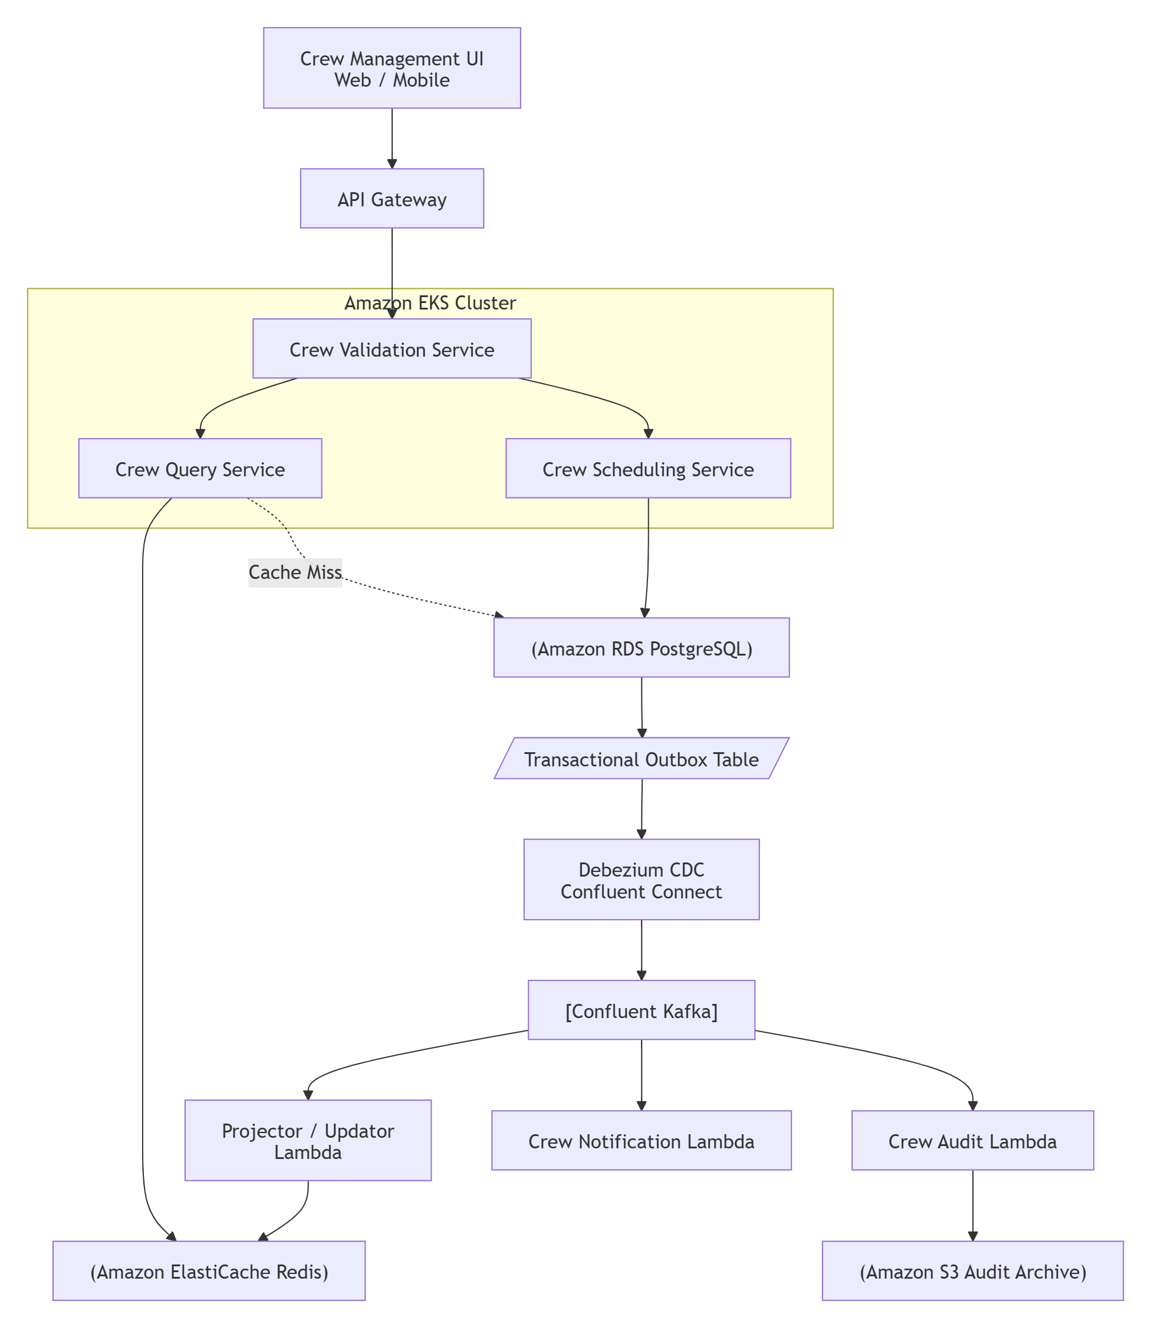

Crew Validation Service
It checks for all the regulatory compliance rules like Qualification, License, Medical, Duty Time / Rest periods, Availability at Base etc.

Crew Schedule Service
This service is responsible for creating / managing crew roaster like
Assignments, Trips, Flight Legs, Duty Periods.

Crew Query Service
To access crew member assignments for a specific calendar month/date.

Where did we use CQRS model in this architecture context ?
CQRS is implemented by separating the Crew Scheduling Service (Command Model) from the Crew Query Service (Read Model).

The Scheduling Service manages normalized entities ( models )such as Assignments, Trips, Flight Legs, and Duty Periods in PostgreSQL.

While the Query Service reads denormalized Redis projections ( models ) from Projector (or Updator) Lambda.

A Transactional Outbox Table (event data) ensures that if the schedule is successfully committed to PostgreSQL, the corresponding event also persisted and can later be published to Kafka via Debezium CDC, preventing lost or inconsistent events.

A Projector (or Updator) Lambda updates the Redis cache with the latest read-model data in case of schedule updates.

What is PostgreSQL WAL?
WAL = Write-Ahead Log
Before PostgreSQL permanently updates a table, it first writes the change to a log called the WAL. This allows PostgreSQL to recover committed transactions after crashes and also enables replication and CDC (Change Data Capture ) solutions such as Debezium.

How Does Debezium Connect to PostgreSQL WAL ?
Debezium acts as the Outbox Publisher, eliminating the need to build and maintain a custom polling service.
Debezium does not poll / execute SELECT * FROM outbox_events
repeatedly.
Instead, Debezium uses PostgreSQL's Logical Replication capability.
AWS RDS PostgreSQL supports logical replication, which Debezium can consume through a replication slot.
The replication slot maintains a precise pointer called the Log Sequence Number (LSN), useful in the cases of the Debezium crash for recovery.

PostgreSQL ( outbox table )
│
▼
WAL Stream
│
▼
Replication Slot
│
▼
Debezium

Confluent handles the entire Kafka ecosystem, including Kafka Connect and Debezium management.
Confluent Kafka Connect is runtime for Debezium CDC , it does not need to be maintained in a separated EKS service.

Reduced p95 API latency from 420 ms to 170 ms by adding Redis caching, optimizing slow SQL queries, and tuning JVM garbage collector settings.

What is p95 latency?

- 100 requests hit the API
- p95 = 420 ms means:
  - When we have 95 concurrent requests in a pod
  - 95 th request completed within 420 ms

Why Redis here? why not the Ehcache ?

Redis is a distributed data store used to share cached data across multiple application instances.( used in microservice architectures)

Ehcache, is an local Java cache (stored inside JVM ). It is used for single-node apps, Java-monoliths ( used in Hibernate ORM ) , we can use this when the date allowed to be cased for long time which is not shared between other services.

Where is the issue happening ?
We have seen that the issues is happening at Crew Query Service

Each instance of the service (EKS) pod is configured to handle
100 concurrent requests at max tomcat servlet requests.

How does Tomcat handle incoming requests ?

Tomcat uses a thread pool to process incoming HTTP requests. When a request arrives,
a worker thread from the pool is assigned to handle it, execute the application logic,
and return the response. Once completed, the thread is returned to the pool for reuse.

How do we handle concurrent requests and is there a limit ?

Concurrent requests are handled by Tomcat's worker threads. We can configure limits such as:

server.tomcat.threads.max=100

This means Tomcat can process up to 100 requests concurrently per instance.
Requests exceeding this limit are queued and may eventually time out or be rejected if the queue becomes full.

We had set the timeout per request to be 200ms as our service level objective (SLO)
When there were around 95 concurrent requests per pod , we have started seeing these requests taking more than 400 ms ,
hence they got timedout.

i)How do we calculate the request time ( time taken per request completion ) using prometheus ?

Using Prometheus HTTP request duration metrics (e.g., http_server_requests_seconds )

ii) How did we exactly able to see , this timeout is happening per pod when we have exactly
95 concurrent requests ?

Calculated p95 latency using histogram quantiles to be displayed on Graphana. This gave us the request completion
time distribution and p95 response time per API and per pod.
( Graph on x request completion time axis , y no of requests )

Why is this happening ?

#i)
Due to JPA lazy loading, a single repository lookup for a crew member triggered N+1 query problem.
This has resulted in hibernating approximately 109 database queries to retrieve the data spanning 3 Assignments, 15 Trips, 90 Flight Legs, and 180 Duty Period records.

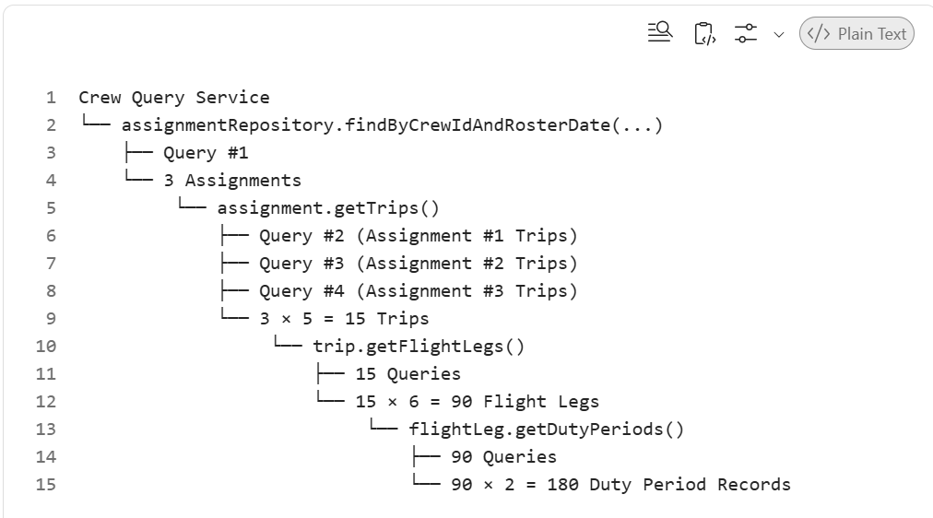

Query Count Breakdown
1 + 3 + 15 + 90 = 109 SQL Queries

This pattern has caused excessive database round trips, significantly increased API latency.

i)How did we solve this N+1 problem?
We used eager fetching with JPA Entity Graphs so that hibernate has converted this into a single optimized query to fetch the required hierarchy in one database call instead of triggering multiple lazy-loaded queries.

ii)How redis caching helps solve this problem?
Redis cache helped to avoid repeated database lookups for same query.
When the tables grew more than 10k records, the db queries resulted to larger result sets holding more than 30k records.
This has increased the object creation in heap, causing GC pauses , Heap OOM issues in pod.

For limiting large result sets fetch
We have applied pagination and date-based filters to fetch only the latest crew assignments which truncated the older entries from result set.
How/what can we tune the JVM settings to fix.
i)GC pauses
Tuning G1GC (divides the heap into multiple regions and prioritizes collecting regions with the most reclaimable memory first, rather than scanning the entire heap.)
(-XX:+UseG1GC, -XX:MaxGCPauseMillis=200) significantly reduces GC frequency and pause times.

ii)Heap OOM per pod
We can tune JVM heap sizing (-Xms, -Xmx) within the pod memory limits.

Cut Sev‐1 incidents by 60% (from 10 to 4 per quarter) by introducing circuit breakers with Resilience4j, timeouts, and SLO‐based alerts in Prometheus/Grafana across 6 services.

Business Context:
A Sev-1 (Severity-1) incident: critical system outage that brings core operations to a halt.

a) How exactly circuit breakers help to prevent the service degradation and cut the severity-1 incidents ?
( in this particular context crew query service is the one which got impacted and getting timed out ).

When the Crew Query Service started timing out due to high DB latency ,
the circuit breaker ( at previous hop validation service ) quickly stopped sending additional requests to this failing dependency instead of waiting for repeated timeouts.

So , this helped to reduce the further requests from timing out ( as circuit breaker provide fallback response 503 ( fail fast mechanism ) , thus the SLO based alerts as well from Grafana.

b) How are we able to send the SLO based alerts through Prometheus/Grafana ? ( As we mentioned earlier the SLO alert
is based on the configured timed out of 200ms per request in crew query service ).

As we previously exposed the API latency metrics to Grafana ( p95 ) , whenever the Crew Query Service exceeded the SLO threshold of 200 ms , it triggers the alert to the operations team.

Migrated 3 legacy monolith modules to Spring Boot microservices on Kubernetes, reducing deployment time from 55 minutes to 12 minutes and enabling 4x faster release cycles.

a)How are the existing monoliths are built or deployed ?
We had a big monolith service dependent on the several core libraries ( validation , schedule , query ) like in a chained dependent way.

In order to get the build version we need to sequentially build all the modules in the chain to get the final build version for the main crew orchestration service.

b) What are the problems with this monolith approach ?

All these libraries are
  - tightly coupled ( chained dependencies )
  - shared the same codebase and runtime

This has led to

- Long deployment time (~55 minutes) : even small fixes/changes required building/deploying entire application.
- Slow-Release Cycles : this delayed the feature delivery and release coordination also became difficult.
- Slow application startup : Due to the large artifact size , application startup is very slow.
- Scaling Problems : Scaling individual modules was impossible.

c) How did we approach this activity? like how we made that this switch over from monolith to microservice
architecture is being done smoothly without disrupting the current live services? (like in what phases exactly? )
We followed the Strangler Pattern approach.
First, we identified and extracted one module at a time, exposed it through APIs, and deployed it alongside the monolith.
Traffic was gradually shifted using routing rules and feature flags while running both systems in parallel.
We ensured functional parity before fully decommissioning/retiring the monolith module.
This approach ensured seamless migration with the zero disruption to the production/live traffic.
Containerization Using Docker
Each microservice packaged as Docker container.

Kubernetes Deployment

CI/CD Automation
Removed manual deployment activities.

Git Commit
↓
Build
↓
Unit Tests
↓
Docker Build
↓
Push Image
↓
Kubernetes Deploy

A GitHub Actions workflow is a configurable automated process that you can set up in your repository to build, test, package, release, or deploy any project on GitHub, also can automate code quality steps like run linters, security scanners, and format check tools.

Core Components of a Workflow

Events (Triggers): The specific activity that kicks off the workflow. This can be an internal GitHub event ( like a push or pull_request ), a manual button clicks.

Jobs: A set of steps executed on the exact same runner. By default, multiple jobs within a single workflow run in parallel, though you can configure them to run sequentially if one task depends on another.

Runners: The virtual machine or server provided by the platform (running Ubuntu Linux, Windows, or macOS) that executes the code.

Steps: Individual tasks inside a job that execute sequentially.

Example work flow
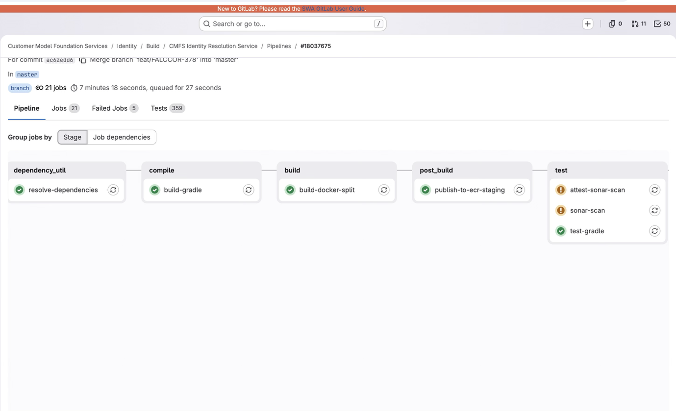

7)Rolling Deployments (Instead of stopping all old instances and then starting new ones, Kubernetes gradually replaces the old Pods with new Pods, ensuring the application remains available throughout the deployment.)

Kubernetes rolling updates allowed:
- zero/minimal downtime deployments
Instead of:
- full application restart

This has helped to achieve 55 mins → 12 mins reduced deployment time and release cycles become 4x faster.

Reduced monthly AWS compute cost by 20% by right‐sizing EC2/EKS pods, enabling autoscaling, and decommissioning 3 legacy worker services after profiling.

Business Context:
We had a cloud-native microservices platform running on EKS with self-managed EC2 instance groups for worker nodes.
(one instance -> one worker node)

Problems Observed

Over-Provisioned EC2 Instances
Instances sized for peak traffic but running near-idle most of the day , t3.xlarge CPU instance only 60 - 65 % utilization on sustained load.

Incorrect Kubernetes Pod Sizing
Some pods had request ( minimum guaranteed resources ) over provisioned.

This caused:
- wasted node capacity
- fewer pods per node

No Autoscaling

Traffic fluctuated:
- high during operational windows
- low during off-hours

But infrastructure remained fixed 24/7.

Legacy Worker Services

Some old background services:

- continuously running
- barely processing jobs
- duplicated functionality
- consumed EC2 resources unnecessarily

Why this activity became important?

AWS monthly compute costs kept increasing.

Management wanted:
- cost optimization
- better utilization
- operational efficiency

without affecting:
- performance
- availability
- SLAs

How Does the Optimization Work ?

Right-Sizing EC2 and EKS Pods

A t3.xlarge running at 40% CPU for weeks is a candidate to drop to t3.medium.

Pod-Level Right-Sizing Strategies

Adjusting CPU and memory requests/limits for individual pods based on actual usage.

Autoscaling
Kubernetes can scale automatically using Horizontal Pod Autoscaler (HPA).

Example:

CPU > 80%
Increase Pods from 3 → 10

Scales pod replicas based on metrics (CPU, memory )

Horizontal Pod Autoscaler (HPA)
Scales pod replicas based on metrics (CPU, memory )

Node-Level Scaling (Infrastructure)

Karpenter :
- Intelligent node provisioning: Right-sized nodes for pending pods
- Consolidation: Removes underutilized nodes
- Spot instance support: Automatic spot/on-demand mixing

Decommissioning Legacy Worker Services

Example : Legacy Report Generation Worker

Analyzed request logs ( Prometheus , Grafana , AWS CloudWatch ) to confirm a service is receiving zero meaningful traffic. After a safe observation window, drain the service, archive the code, and delete the infrastructure.

How did we estimate an AWS cost?
By giving each resource group, a tag like for EC2 , S3 , DynamoDB , RDS etc in a AWS billing cost dashboard.

Increased test coverage from 62% to 83% by introducing unit, integration, and contract tests, reducing escaped production defects by 35% over 12 months.

Existing Problems

Although developers were writing some tests, they were mostly limited to happy-path scenarios.

There were several quality issues:
- Low unit test coverage (~62%)
- Almost no integration testing
- No API contract validation between microservices
- Bugs were only discovered during UAT or production

Example

developer changed duty-hour calculation logic.

Old rule: Maximum duty = 12 hours
New implementation: Maximum duty = 14 hours

Unit tests were missing, hence production allowed illegal crew scheduling.

Root Cause Analysis

We found that:

- Business logic wasn't thoroughly unit tested.
- Microservice interactions weren't verified.
- Teams deployed independently without validating API compatibility.

This allowed defects to "escape" into production.

How Did I Find the issue ?

Analyzed code coverage reports.

Using:
- JaCoCo

We identified :

- Services with poor coverage
- Untested business logic
- Critical workflows

How Did I Measure Coverage ?

Using JaCoCo

How Did We Measure Escaped Defects ?

Measured using:
- Jira defects
- Production incident reports

Optimized Hibernate L2 caching and HikariCP connection pooling to support a 60% increase in peak concurrent users, handling 5K+ transactions per second.

Every database request needs a connection.
Opening a new connection every time is expensive.

Without pooling:

Open Connection
Authenticate
Execute Query
Close Connection

Repeated thousands of times.

With Connection Pool Instead:

Pre-create 40 connections

Store them
↓
Requests borrow one
↓
Return it after use

Refactored resource‐heavy batch jobs using Spring Batch and AWS Lambda, reducing monthly cloud infrastructure costs by $1,200 (1.5% total spend).

Jobs like roster report generation, notification dispatch, and audit log archival. Many of these jobs were running as dedicated Spring Boot worker services on EC2 or Kubernetes, which meant compute resources remained allocated 24×7 even though some jobs only executed for a few minutes each day.

Example services:

Report generation jobs
Notification jobs

Each worker service was:

- Always running
- Reserved CPU and memory
- Available 24×7

Even though many jobs only executed:
- once every hour
- once every night
- once every day

Problems We Observed

1)Idle Infrastructure

CrewReportWorker

Runs:
12:00 AM → 12:20 AM

Idle:
23 hours 40 minutes

Yet the EC2 instance or Kubernetes pod remained running all day.

Root Cause

Several jobs were:
- short-lived
- event-driven
- infrequently executed

How Does the Solution Work?

Job Type | Decision
Long-running batch | Spring Batch
Short scheduled jobs ( < 15 mins ) | Lambda
Event-driven | Lambda

Used Spring Batch in cases where

- Large-volume processing
- Chunk-based execution
- Processing millions of records

What Triggers a Spring Batch Job ?

Scheduled (Most Common)
Kubernetes CronJob
AWS Batch

Used Lambda in cases where:
- Short execution
- Event-driven
- Low memory
- Infrequent

Current Project

Current project :
This is a green field and scratch project we are building.

Problem : Customer data lives across multiple disconnected systems (account profiles, trip bookings, etc.)
Goal : Need to build a single, unified view of each customer — one "Identity" .

Microservices :

1) source-processor :

- data collection and normalization
- listens to raw events coming from various source systems ( account updates , trip records )
- transforms them into a standardized "Identity" format & publishes those cleaned records to a central Kafka topic.

2) resolution-service :

- figures out "is this the same customer we already know about?"
- matching and merging.
- consolidates the profile per customer across all their systems.

Technical architecture :
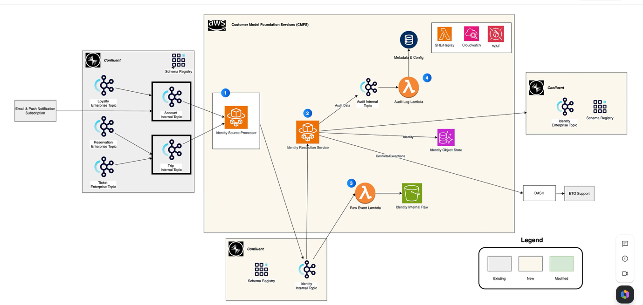

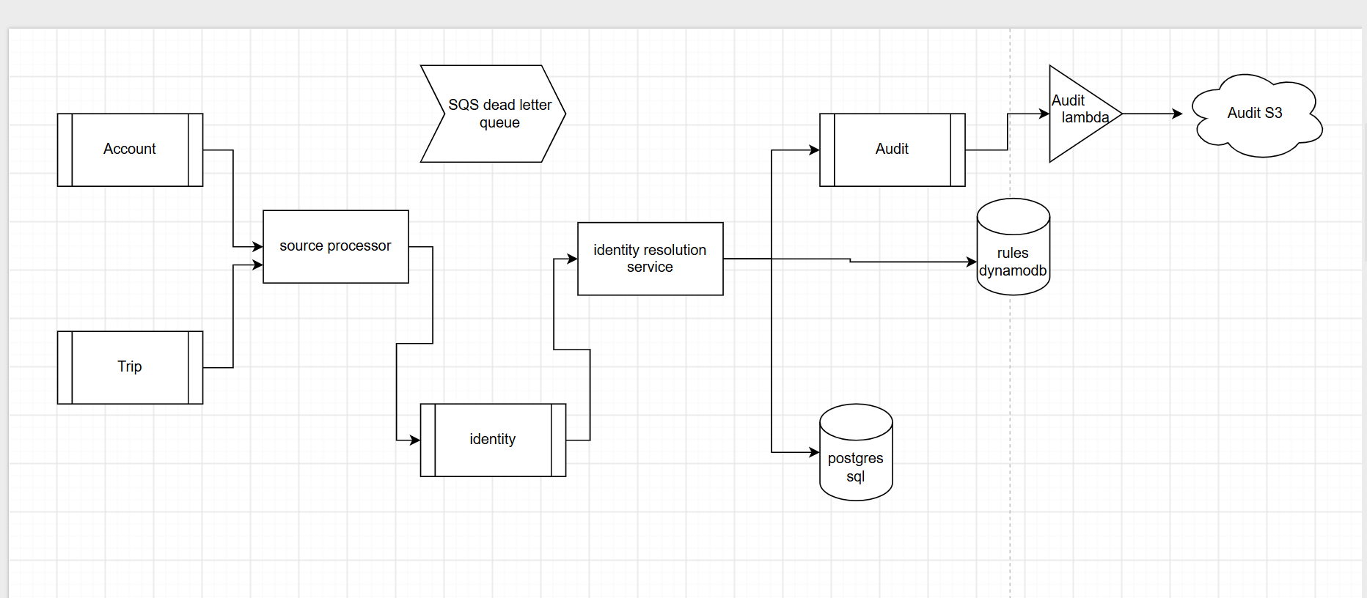

It is a Kafka event driven and cloud native microservices architecture , where

We get customer related information ( trip , account ) from upstream systems kafka topics which will get consumed by the microservices.

Throughput estimate:

The polling interval is 1 sec , and the batch size is 200 records/poll.

so under the sustained load , it would be 200 records per service instance ( ECS task )

At prod , auto scaling is enabled , so it would be ~ 10 instances of the service , which is 2k records per second.

Architecture

What exactly the source processor do ?
i) It will separately consume from the Account and Trip topics which are raw events.
ii) It will look for and pick certain attributes / data points ( tokens ) from these 2 topics and prepare the identity message so that it cleanse the unwanted information/noise and prepare selective tokens to the identity topic.
iii) It will not merge from both the topics , separately process them to identity topic.

The tokens are

- Rapid rewards number
- Social security number
- Known Travel number
- Passport
- Email
- Phone Number
- Ticket Number
- Social Media Handles

iv) Let's say if we have 10 messages from Account and 10 messages from Trip, we will have 20 messages to the identity topic.
What does identity resolution service exactly do?
i) It reads from the identity topic and analyze the tokens will do matching and merging.
ii) It has a decision tree which handles several cases like
CREATE , ADD , REFRESH , MERGE , CONFLICT
iii) Dynamodb rules will drive the decision tree logic.
iv) Tokens are part of bundle, and each bundle represent a customer.

Dynamo DB
Rules table that will drive the decision tree logic , for example the configuration rules for the tokens like what are allowed to be multiple , unique , reusable , non-sharable etc.

Postgres SQL
Stores the customer related data, tokens and bundle information.

SQS dead letter queue ( DLQ )
For storing the information about the unprocessed events

topic
partition
offset
exception
retry count

Audit topic
Typically contains what action was taken by the decision tree ( either of CREATE , ADD , REFRESH , MERGE , CONFLICT ) what tokens are part of it.

Audit lambda
For storing the audited information from the audit topic into S3 bucket as Json file dump.

CloudWatch
Used for logging and monitoring purposes.

Why should there an intermediate identity topic ? Why can't source processor directly post to the identity resolution service ?basically why we need this extra hop ?

The problem with this approach is
If there is direct interaction, there will be tight coupling ( no buffer ) which is a major architectural drift from existing architecture.
It is okay during normal traffic / load with one service instance of identity resolution, but when there is spike in traffic/need to scale the identity resolution, we need to introduce application load balancer etc.

It is difficult to reprocess during the failure of the event( when id res service is down).

Why do we have the separate dynamodb database for rules ? and Why it has to be a NoSQL dynamodb ? Why can't we maintain the rules table in the Postgres SQL itself ?

One reason is that we wanted to separate the customer data from the business rules data.
This rule configuration will be evolving over time which could be DDL (schema level ) changes also like addition of a new rule column, we need to have a flexible schema which supports this case , so we chose NoSQL as option.
DynamoDB provides lower latency for simple key-based lookups.
Because , the access pattern is simple: ( Partition Key → Value )
PostgreSQL is generally for complex queries, joins, aggregations, transactions, and reporting which takes more query time.

Confluent kafka is not part of AWS environment, how the AWS services ( ECS tasks , lambda) can communicate with this ? how is it whitelisted?
The Confluent brokers expose endpoints that are reachable from AWS.
Network Level: Security group firewall rules like allowed IP ranges, ingress rules.
Kafka Level: SASL_SSL authorization ( read / write permissions ) using Confluent API Key and Secret stored in secret manager.

How does a lambda pull data from the kafka topic ( in this case the audit topic data) ? does it have to poll continuously from the kafka topic?
No, the Lambda does not continuously poll Kafka itself. AWS continuously polls the Audit topic on behalf of the Lambda service, batches the records, and invokes the Lambda with those messages. So the polling responsibility is handled by AWS ( through Event Source Mapping (ESM) mechanism) , not by our application code.

Project specific design patterns

Static

Used static final for Kafka topics, event names, cache keys, timeout values, and other application constants.

public static final String SCHEDULE_CREATED = "ScheduleCreated";
public static final String CREW_ASSIGNED = "CrewAssigned";
public static final int MAX_CONCURRENT_REQUESTS = 100;
public static final Duration CACHE_TTL = Duration.ofMinutes(30);

Inheritance
Used inheritance through JpaRepository for CRUD functionalities.

public interface AssignmentRepository extends JpaRepository<Assignment, Long> {
}

Used inheritance to model different crew types such as Pilot, First Officer, and Cabin Crew while sharing common crew attributes in the parent CrewMember class.

public abstract class CrewMember {
private String crewId;
private String name;
}

public class Pilot extends CrewMember {}
public class FirstOfficer extends CrewMember {}
public class CabinCrew extends CrewMember {}

Singleton Pattern
Used the Singleton pattern for all Spring-managed beans and logger instances ensuring only one shared instance per class is used across the application lifecycle.

private static final Logger log =
LoggerFactory.getLogger(CrewQueryService.class);

Note : In this case , this involves the Factory design pattern as well like
LoggerFactory decides which concrete logger implementation to return between SLF4J or Log4j2 etc.
Dynamo DB rules table loading
Since the rules table is relatively small and changes infrequently, a common approach is to load the entire rules configuration from DynamoDB into an in-memory cache during service startup. The cache can be implemented as a Singleton bean.
So , that the entire application instance can reuse this instead of querying DynamoDB for every such request , reducing latency and database load.

Strategy Pattern

In the project:
Factory creates the appropriate validator object, and Strategy contains the validation algorithm for that token.

Factory and Strategy patterns are related, but they solve different problems.

Which algorithm/business logic should I execute?
Strategy Pattern = Behavior/Algorithm Selection

Strategy Interface
public interface TokenValidator {
boolean validate(String value);
}
Concrete Strategies
EmailValidator
public class EmailValidator implements TokenValidator {
@Override
public boolean validate(String email) {
return email.contains("@");
}
}
PhoneValidator

public class PhoneValidator implements TokenValidator {

@Override
public boolean validate(String phone) {
return phone.matches("\\d{10}");
}
}

Factory Pattern

Which object should I create?
Factory Pattern = Object Creation

public class TokenValidatorFactory {

public static TokenValidator getValidator(
TokenType tokenType) {

switch(tokenType) {

case EMAIL:
return new EmailValidator();

case PHONE:
return new PhoneValidator();

default:
throw new IllegalArgumentException(
"Unsupported token");
}
}
}

// In the service
TokenValidator validator =
TokenValidatorFactory.getValidator(tokenType);

boolean valid =
validator.validate(tokenValue);

Builder Pattern

Used the Builder pattern to construct ErrorResponse and Kafka event objects with multiple optional fields while avoiding large constructors.

Error Response Object
ErrorResponse.builder()
.errorCode("CREW_001")
.message("Crew not qualified")
.correlationId(requestId)
.timestamp(Instant.now())
.build();

Schedule Event
CrewAssignedEvent.builder()
.crewId("CREW001")
.flightId("WN123")
.eventType("CrewAssigned")
.build();

Observer Pattern

Crew Scheduling Service
↓
Confluent Kafka
↓
Projector Lambda
Notification Lambda
Audit Lambda
``
Used the Observer pattern through Kafka event-driven architecture, where ScheduleCreated and ScheduleUpdated events notified multiple independent consumers such as Projector, Notification, and Audit services.

