Reduced p95 API latency from 420 ms to 170 ms by adding Redis caching, optimizing slow SQL queries, and tuning JVM garbage collector settings.

Business Context :
At South West Airlines , we had a REST API responsible for serving passenger trip related queries , under production load ( ~ 5k passengers ) 1 in 20 requests ( 5/100 )experienced severe delays. This caused visible UI lag for end passengers and cascading timeouts in downstream services that depended on our API.

What is p95 latency ?

- 100 requests hit the API
- p95 = 420 ms means:
  - 95 requests completed within 420 ms
  - 5 requests took longer
This metric is important because averages(p50) can hide slow requests(at the end).

How did we identify the issue ?

We used:
- Prometheus + Grafana dashboards
- Distributed tracing (Zipkin/OpenTelemetry)

We observed:

- Repeated DB reads for same data (Trip catalog)
- unnecessary DB hits
- connection pool exhaustion ( for every db call it needs to open a connection )

Solution :
We used Redis as an in-memory cache (much faster than disk/database )

Why Redis here? why not the Ehcache ?

Redis is a distributed data store used to share cached data across multiple application instances.( used in microservice architectures)

Ehcache, is an local Java cache (stored inside JVM ). It is used for single-node apps, Java-monoliths ( used in Hibernate ORM )

- Slow joins and missing indexes

Problems
- scanned large tables
- had inefficient joins (joining 4 to 5 relations)
- lacked indexes
- fetched unnecessary columns (this will cause slow joins)

b.Solution
- Added indexes ( on frequent where columns like date of trip , report time )
- removed N+1 queries (Trip data -> Segment / Leg , Reservations)
- reduced unnecessary joins ( bypassing relations and connecting directly using connector table )
- avoided SELECT *

- Frequent JVM GC pauses under load

Under high load :
- object creation increased ( storing large trip entity info )
- GC pauses increased
- stop-the-world events affected latency

Identified using :
- GC logs
- JVisualVM/JConsole
- Grafana JVM metrics

Solution :
Tuned JVM garbage collection using G1GC and optimized heap settings to reduce pause times under load.

Cut Sev‐1 incidents by 60% (from 10 to 4 per quarter) by introducing circuit breakers with Resilience4j, timeouts, and SLO‐based alerts in Prometheus/Grafana across 6 services.

Business Context:
A Sev-1 (Severity-1) incident: critical system outage that brings core operations to a halt.

Sev‐1 incident: Crew Management System (backend handling crew rostering pilots and flight attendants cannot be assigned or verified )

Crew Management UI
↓
API Gateway
↓
Crew Rostering Service
↓
Crew Validation Service
↓
Scheduling Service
↓
Notification Service
↓
Audit Service

What Happened?

Crew Scheduling Service became unhealthy

- responded very slowly
- some requests timed out completely
- upstream services waited indefinitely
- thread pools got exhausted
- requests piled up
- APIs became unresponsive

Eventually:
- caused cascading failures
- UI became unusable
- operations team could not assign crews

How Did We Identify the Root Cause?

Using:
- Prometheus/Grafana SLO based alerts / incidents
- logs

How did we implement?

The solution had 3 major components:

- Circuit Breakers
- Timeouts
- SLO-based Alerting
What is the fallback response we are providing ?
Crew scheduling service is down and unavailable. ( 503 code )

SLO = Service Level Objective

A Service Level Objective (SLO) is a specific, measurable target set for the reliability and performance of a service.

Example:

99% requests should complete under 300 ms
or
Error rate should remain below 1%

How did we implement the alerts?

We tracked metrics error rates, timeout counts, and circuit breaker states.
Prometheus + Grafana Alerts (to email DL )

How did we derive “60% Reduction”?

Using:
- incident management records (based on Prometheus / Grafana alerts )
- RCA reports

How did we test this and validate?

We validated the implementation through load testing and failure injection scenarios by simulating slow downstream services and outages.

Over time, Sev-1 incidents reduced from 10 to 4 per quarter, significantly improving production stability and recovery behavior.

Migrated 3 legacy monolith modules to Spring Boot microservices on Kubernetes, reducing deployment time from 55 minutes to 12 minutes and enabling 4x faster release cycles.

Business Context:
We had a big monolith service which covers functionalities
like crew scheduling, validation, and notification

It dependent on the several core libraries like in a chained dependent way

- deployed together
- shared same codebase
- shared same runtime
- tightly coupled

Major Operational Problems

Long Deployment Time: ~55 minutes

- entire monolith needed rebuilding
- large artifact size
- application startup slow
- multiple environment validations needed

Slow-Release Cycles

Even small fixes required deploying entire application
- fewer releases
- delayed feature delivery
- release coordination became difficult

Scaling Problems
- scaling individual modules was impossible

How did we implement migration?

1)Identify Monolith Boundaries

We first analyzed:
- business domains
- module dependencies
- database interactions

2)Create Independent Spring Boot Services

3)API Communication
through asynchronous messaging where needed ( kafka )

4)Containerization Using Docker
Each microservice packaged as Docker container.

5)Kubernetes Deployment

6)CI/CD Automation
Removed manual deployment activities.

Git Commit
↓
Build
↓
Unit Tests
↓
Docker Build
↓
Push Image
↓
Kubernetes Deploy

A GitHub Actions workflow is a configurable automated process that you can set up in your repository to build, test, package, release, or deploy any project on GitHub, also can automate code quality steps like run linters, security scanners, and format check tools.

Core Components of a Workflow

Events (Triggers): The specific activity that kicks off the workflow. This can be an internal GitHub event ( like a push or pull_request ), a manual button clicks.

Jobs: A set of steps executed on the exact same runner. By default, multiple jobs within a single workflow run in parallel, though you can configure them to run sequentially if one task depends on another.

Runners: The virtual machine or server provided by the platform (running Ubuntu Linux, Windows, or macOS) that executes the code.

Steps: Individual tasks inside a job that execute sequentially.

Example work flow
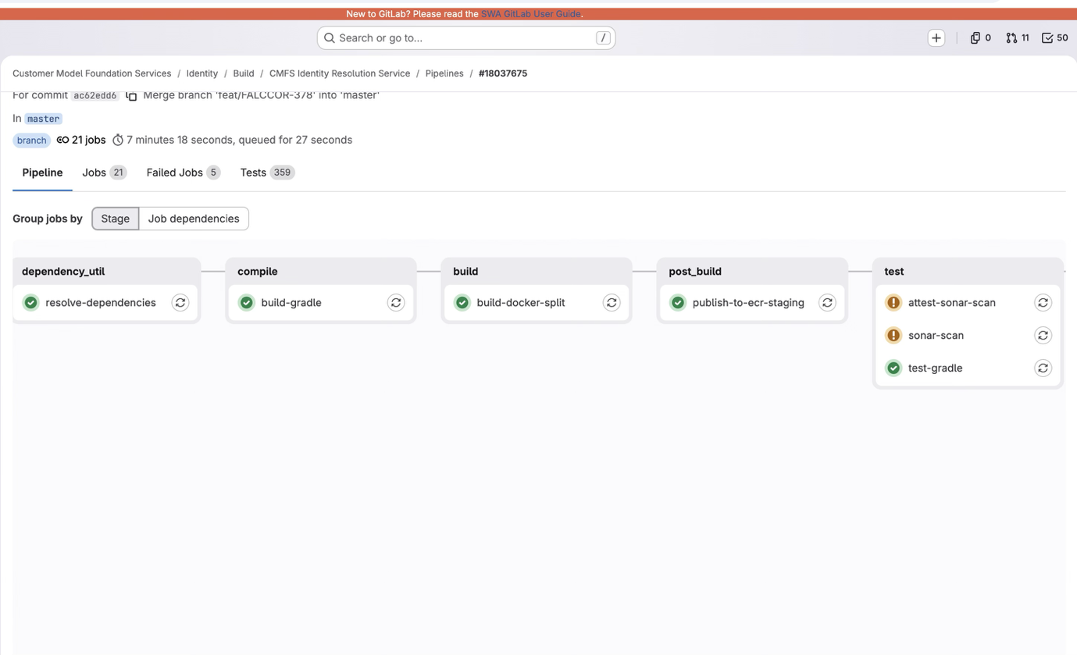

7)Rolling Deployments (Instead of stopping all old instances and then starting new ones, Kubernetes gradually replaces the old Pods with new Pods, ensuring the application remains available throughout the deployment.)

Kubernetes rolling updates allowed:
- zero/minimal downtime deployments
Instead of:
- full application restart

This has helped to achieve 55 mins → 12 mins reduced deployment time and release cycles become 4x faster.

Reduced monthly AWS compute cost by 20% by right‐sizing EC2/EKS pods, enabling autoscaling, and decommissioning 3 legacy worker services after profiling.

Business Context:
We had a cloud-native microservices platform running on EKS with self-managed EC2 instance groups for worker nodes.
(one instance -> one worker node)

Problems Observed

Over-Provisioned EC2 Instances
Instances sized for peak traffic but running near-idle most of the day , t3.xlarge CPU instance only 60 - 65 % utilization on sustained load.

Incorrect Kubernetes Pod Sizing
Some pods had request ( minimum guaranteed resources ) over provisioned.

This caused:
- wasted node capacity
- fewer pods per node

No Autoscaling

Traffic fluctuated:
- high during operational windows
- low during off-hours

But infrastructure remained fixed 24/7.

Legacy Worker Services

Some old background services:

- continuously running
- barely processing jobs
- duplicated functionality
- consumed EC2 resources unnecessarily

Why this activity became important?

AWS monthly compute costs kept increasing.

Management wanted:
- cost optimization
- better utilization
- operational efficiency

without affecting:
- performance
- availability
- SLAs

How Does the Optimization Work ?

Right-Sizing EC2 and EKS Pods

A t3.xlarge running at 40% CPU for weeks is a candidate to drop to t3.medium.

Pod-Level Right-Sizing Strategies

Adjusting CPU and memory requests/limits for individual pods based on actual usage.

Autoscaling
Kubernetes can scale automatically using Horizontal Pod Autoscaler (HPA).

Example:

CPU > 80%
Increase Pods from 3 → 10

Scales pod replicas based on metrics (CPU, memory )

Horizontal Pod Autoscaler (HPA)
Scales pod replicas based on metrics (CPU, memory )

Node-Level Scaling (Infrastructure)

Karpenter :
- Intelligent node provisioning: Right-sized nodes for pending pods
- Consolidation: Removes underutilized nodes
- Spot instance support: Automatic spot/on-demand mixing

Decommissioning Legacy Worker Services

Example : Legacy Report Generation Worker

Analyzed request logs ( Prometheus , Grafana , AWS CloudWatch ) to confirm a service is receiving zero meaningful traffic. After a safe observation window, drain the service, archive the code, and delete the infrastructure.

How did we estimate an AWS cost?
By giving each resource group, a tag like for EC2 , S3 , DynamoDB , RDS etc in a AWS billing cost dashboard.

Increased test coverage from 62% to 83% by introducing unit, integration, and contract tests, reducing escaped production defects by 35% over 12 months.

Existing Problems

Although developers were writing some tests, they were mostly limited to happy-path scenarios.

There were several quality issues:
- Low unit test coverage (~62%)
- Almost no integration testing
- No API contract validation between microservices
- Bugs were only discovered during UAT or production

Example

developer changed duty-hour calculation logic.

Old rule: Maximum duty = 12 hours
New implementation: Maximum duty = 14 hours

Unit tests were missing, hence production allowed illegal crew scheduling.

Root Cause Analysis

We found that:

- Business logic wasn't thoroughly unit tested.
- Microservice interactions weren't verified.
- Teams deployed independently without validating API compatibility.

This allowed defects to "escape" into production.

How Did I Find the issue ?

Analyzed code coverage reports.

Using:
- JaCoCo

We identified :

- Services with poor coverage
- Untested business logic
- Critical workflows

How Did I Measure Coverage ?

Using JaCoCo

How Did We Measure Escaped Defects ?

Measured using:
- Jira defects
- Production incident reports

Optimized Hibernate L2 caching and HikariCP connection pooling to support a 60% increase in peak concurrent users, handling 5K+ transactions per second.

Every database request needs a connection.
Opening a new connection every time is expensive.

Without pooling:

Open Connection
Authenticate
Execute Query
Close Connection

Repeated thousands of times.

With Connection Pool Instead:

Pre-create 40 connections

Store them
↓
Requests borrow one
↓
Return it after use

Refactored resource‐heavy batch jobs using Spring Batch and AWS Lambda, reducing monthly cloud infrastructure costs by $1,200 (1.5% total spend).

Jobs like roster report generation, notification dispatch, and audit log archival. Many of these jobs were running as dedicated Spring Boot worker services on EC2 or Kubernetes, which meant compute resources remained allocated 24×7 even though some jobs only executed for a few minutes each day.

Example services:

Report generation jobs
Notification jobs

Each worker service was:

- Always running
- Reserved CPU and memory
- Available 24×7

Even though many jobs only executed:
- once every hour
- once every night
- once every day

Problems We Observed

1)Idle Infrastructure

CrewReportWorker

Runs:
12:00 AM → 12:20 AM

Idle:
23 hours 40 minutes

Yet the EC2 instance or Kubernetes pod remained running all day.

Root Cause

Several jobs were:
- short-lived
- event-driven
- infrequently executed

How Does the Solution Work?

Job Type | Decision
Long-running batch | Spring Batch
Short scheduled jobs ( < 15 mins ) | Lambda
Event-driven | Lambda

Used Spring Batch in cases where

- Large-volume processing
- Chunk-based execution
- Processing millions of records

What Triggers a Spring Batch Job ?

Scheduled (Most Common)
Kubernetes CronJob
AWS Batch

Used Lambda in cases where:
- Short execution
- Event-driven
- Low memory
- Infrequent

Current Project

Current project :
This is a green field and scratch project we are building.

Problem : Customer data lives across multiple disconnected systems (account profiles, trip bookings, etc.)
Goal : Need to build a single, unified view of each customer — one "Identity" .

Microservices :

1) source-processor :

- data collection and normalization
- listens to raw events coming from various source systems ( account updates , trip records )
- transforms them into a standardized "Identity" format & publishes those cleaned records to a central Kafka topic.

2) resolution-service :

- figures out "is this the same customer we already know about?"
- matching and merging.
- consolidates the profile per customer across all their systems.

Technical architecture :
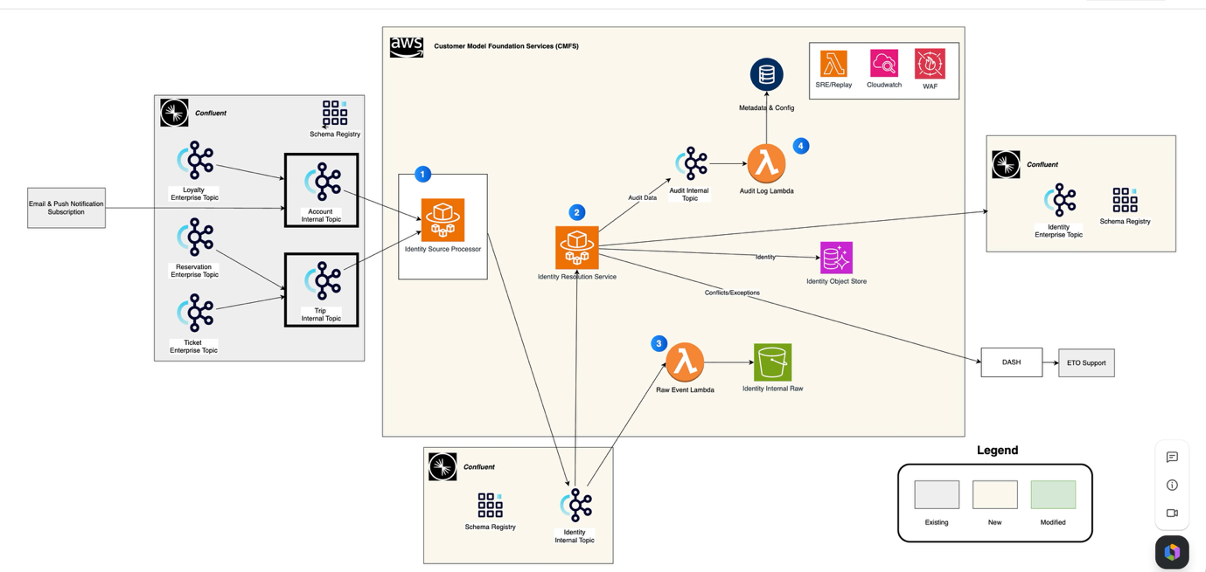

It is a Kafka event driven and cloud native microservices architecture , where

We get customer related information ( trip , account ) from upstream systems kafka topics which will get consumed by the microservices.

Throughput estimate :

The polling interval is 1 sec , and the batch size is 200 records/poll.

so under the sustained load , it would be 200 records per service instance ( ECS task )

At prod , auto scaling is enabled , so it would be ~ 10 instances of the service , which is 2k records per second.

Architecture

DB - Postgres RDS instance where , customer related bundles / token are stored.

Audit - S3 bucket ( A lambda uploads to the # S3 ).

DynamoDB - For storing the correlation id's of the audited information.

DLQ - SQS as DLQ for capturing the failed messages and sending to the DASH ( service now portal and email distribution service ) .

