Step 1:- Execute all files in windows command prompt by command- javac *.java

This executes all the required functions present in the java files.

1st command: javac BlockChain.java

Next command: java BlockChain

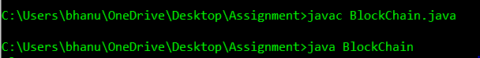

Step 2:-It asks to enter voter number and valid voter number list is present in voterlist.txt.

In voterlist.txt take a value from the first column.



After entering the valid voter number it shows the values of ‘g’ and ‘p’ as a part of Zero Knowledge Proof (in our project g=9381 p=19793393)

Now, we have to calculate the value of h, by using h=g^r mod p

Where r is any random number.

To compute this use the following link. -<https://www.mtholyoke.edu/courses/quenell/s2003/ma139/js/powermod.html>

Step 3:-Now enter the value h



Now it shows the value of b = ( 0 or 1) using this value compute the value of r+bx mod p-1 and enter it.

In equation r+bx the x value of the particular voter is taken with the value of respective y in voterlist.txt, x is present in x_yvalue.txt.

Repeat this process for 5 times

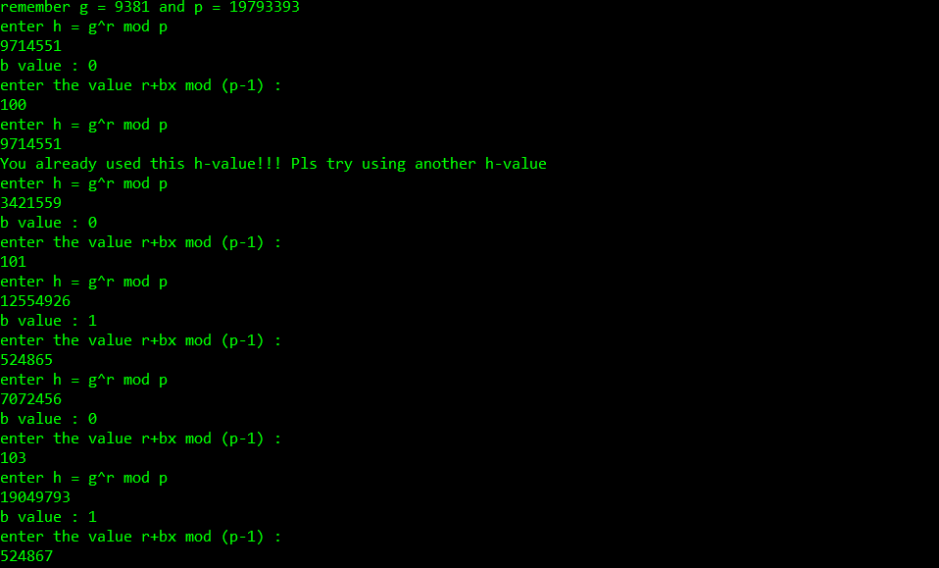

During 5 times of calculating ‘h’, we have to use different values of r randomly and find the corresponding h value and enter them.

Among the five steps if you enter same h value it asks to choose other random value of r (that is indirectly different ‘h’ value)

Now the zero knowledge proof is completed.

Step 4:-Now the list of all parties will appear now enter a serial number of the party.

After voting the party number, number of each party gets displayed.

And automatically gets summed up after each vote.

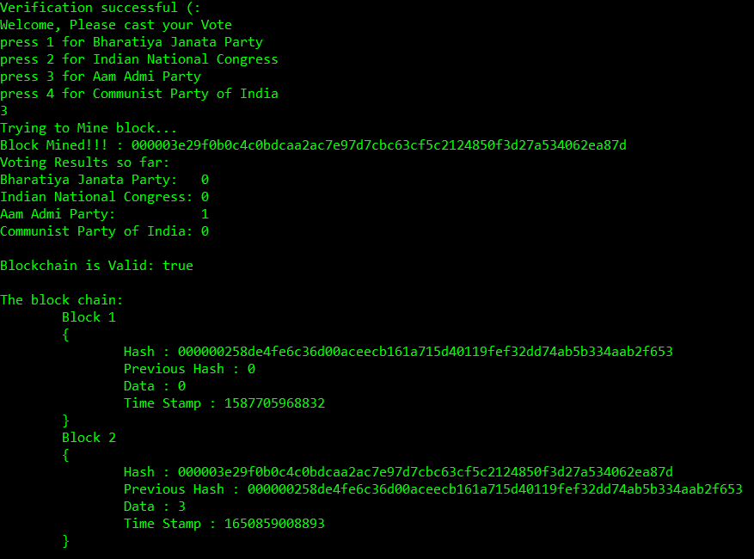

Note:-

* If we try to re-vote it displays the following message i.e. if we enter the same voter id then it displays the time and date of the vote casted by the voter and doesn't allow us to change the vote.

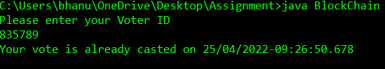

* If you enter a invalid voter number which is not present in voterlist.txt.

It shows an invalid result.

