DOCUMENTATIE

TEMA NUMARUL_1

NUME STUDENT: Tanasă Adrian-Cristian
GRUPA: 8

CUPRINS
DOCUMENTATIE 1
TEMA NUMARUL_1 1
CUPRINS 2
1.Obiectivul temei 3
2.Analiza problemei, modelare, scenarii, cazuri de utilizare 3
3.Proiectare 3
4.Implementare 5
1. Rezultate 11
2. Concluzii 11
3. Bibliografie 11

1.Obiectivul temei
Obiectivul temei este acela de a implementa si proiecta un calculator cu polinoame, facand doua polinoame sa efectueze operatiile de: adunare, scadere si inmultire. De asemenea efectuare integrarii si a derivarii unui singur polinom.

Pe langa partea de back-end, avem si o implementare a unei interfete GUI (MVG) primita la laborator de catre profes

2.Analiza problemei, modelare, scenarii, cazuri de utilizare
Un polinom este o multime de mai multe monoame cu diferit grad (exponent) si constanta.
Forma generala a unui polinom este :
a - contsanta
x - numarul necunoscut
n - exponentul

Modelul cu care am implementat acest proiect a fost cu un polinom care are un HashMap de monoame, care puteau fi introduse in cele doua TextField-uri . Dar ca sa indeplinesc acest lucru a trebuit sa implementez niste functii de parsare in care sa separ un string ca si monom pentru a fi identificate coeficientii si exponentii acestora.

3.Proiectare
Proiectul are urmatoarele clase : Main, Polynomial, View, Controller.
Le-am structurat astfel incat sa fie cat mai usor de citit posibill.

In clasa Main, am create un JFRAME pe care l-am apelat cu contructorul View si setarea acestuia care il face vizibil. Initial am folosit aceasta clasa ca sa verific daca metodele pe care le-am facut in clasa cea mai importanta, Polynomial (cele cu operatiile matematice ) functioneaza, afisand rezultatul corect in consola.

In clasa Polynomial a fost dat ca atribut o colectie de obiecte implementata cu HashMap( HashMap fiind o colectia unei clase din Java collections framework care asigura functionalitatea unui hashtable intr-o structura de date).
HashMap retine elemente ca o pereche precum <key,value>, in cazul codului meu key = exponent, value = constanta monomului.
Tot aici gasim metoda toString, cat si metodele de: - adunare: public Polynomial add(Polynomial other)
-scadere: public Polynomial substract(Polynomial other)
-inmultire: public Polynomial multiply(Polunomial other)
-derivare: public Polynomial derivative()
-integrare: public Polynomial integrate()
In clasa View am luat interfata MVG, sugerata la laborator de catre profesorul laborant, intrucat sa nu ma mai ocup de parte de front-end.

In clasa Controller am definit cum se parseaza datele de intrare de tip String din (basically , sa parsez un monom sau polinom din interfata)

Diagrama UML generata de Intellij este :
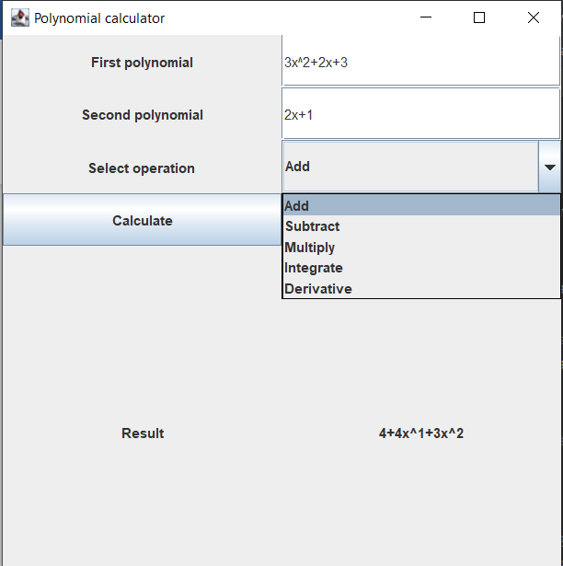
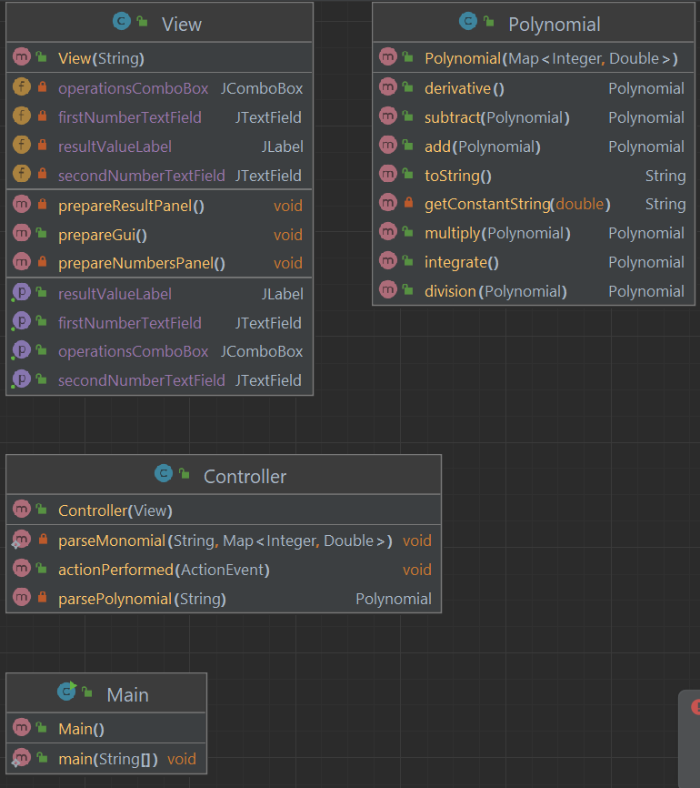

Interfata:
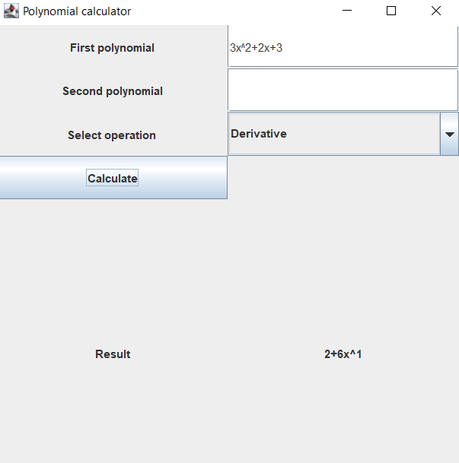

Algoritmi folositi al metodelor sunt proiectati astfel incat sa se efectueze operatiile de adunare, scadere si inmultire adaugand in Map o cheie si o valoare a unui polinom. Un set de monoame care sunt salvate intr-un HaspMap formand astfel un polinom, care au grade similare, iar indeplinind aceasta conditie sa se efectueze scaderea si adunarea lor. La inmultire, am reusit sa fac parcurgerea cu 2 for-uri astfel parcurgand fiecare element din poinomul other, inmultind constantele (coeficientii) si adunand exponentii. La derivare am parcurs fiecare element din polinom ( adica fiecare monom) si i-am derivat pe rand facand un if cu conditia ca exponentul sa fie diferit de 0, coefticientul sa se inmulteasca cu exponentul, iar exponentul sa scada cu 1. Iar la integrare la fel ca si la derivare doar ca if-ul sa aibe conditia ca coeficientul sa fie diferit de 0, coeficientul sa fie egal cu un coeficient/ exponent +1, iar exponentul sa creasca cu 1, motiv pentru care nu am stiu cum sa le fac ca sa ramana fractii, am creat un Double, care daca de exemplu pun 1/x , ar arata 0,5x, care de asemenea este echivalent in matematica punand mai greu in valoare parte fractionala.

4.Implementare

Polynomial
Are ca atribut 2 variabile de tip Integer si, Double unde reprezinta cheia si valoarea unui Map, care face referire la exponentii si coeficientii polinoamelor. Metodele de adunare, scadere, inmultire, au nevoie de doua polinoame declarate pentru a efectua operatia. Metoda de derivare si integrare au la baza parcurgerea unui polinom pe segmente ( ca si un monom), aceste metode au nevoie doar de un singur polinom.

public class Polynomial {
private final Map<Integer, Double> polynomialValues;
public Polynomial(Map<Integer, Double> polynomialValues) {
this.polynomialValues = polynomialValues;
}
//.....................adunare............................................
public Polynomial add(Polynomial other) {
Map<Integer, Double> result = new HashMap<>(this.polynomialValues);
for (Map.Entry<Integer, Double> entry : other.polynomialValues.entrySet()) {
Integer key = entry.getKey();
Double value = entry.getValue();
Double newValue = result.getOrDefault(key, 0d) + value;
result.put(key, newValue);
}
return new Polynomial(result);
}
//.............................scadere..................................
public Polynomial subtract(Polynomial other) {
Map<Integer, Double> result = new HashMap<>(this.polynomialValues);
for (Map.Entry<Integer, Double> entry : other.polynomialValues.entrySet()) {
Integer key = entry.getKey();
Double value = entry.getValue();
Double newValue = result.getOrDefault(key, 0d) - value;
result.put(key, newValue);
}
return new Polynomial(result);
}
//.........................inmultire.............................................
public Polynomial multiply(Polynomial other) {
Map<Integer, Double> result = new HashMap<>();
for (Map.Entry<Integer, Double> entry : this.polynomialValues.entrySet()) {
for (Map.Entry<Integer, Double> entry2 : other.polynomialValues.entrySet()) {
int exponent = entry.getKey() + entry2.getKey();
Double constant = entry.getValue() * entry2.getValue();
Double newValue = result.getOrDefault(exponent, 0d) + constant;
result.put(exponent, newValue);
}
}
return new Polynomial(result);
}
//.........................derivare.............................................
public Polynomial derivative() {
Map<Integer, Double> result = new HashMap<>();
for (Map.Entry<Integer, Double> entry : this.polynomialValues.entrySet()) {
if (entry.getKey() != 0) {
Double newConstantD = entry.getValue() * entry.getKey();
Integer newExponentD = entry.getKey() - 1;
result.put(newExponentD, newConstantD);
}
}
return new Polynomial(result);
}
//.....................integrare.........................................
public Polynomial integrate() {
Map<Integer, Double> result = new HashMap<>();
for (Map.Entry<Integer, Double> entry : this.polynomialValues.entrySet()) {
if (entry.getValue() != 0) // x^n = (x^(n+1))/
// (n+1)
{
Double newConstantI = entry.getValue() / (entry.getKey() + 1);
Integer newExponentI = entry.getKey() + 1;
result.put(newExponentI, newConstantI);
}
}
return new Polynomial(result);
}
@Override
public String toString() {
String result = "";
for (Map.Entry<Integer, Double> entry : this.polynomialValues.entrySet()) {
int exponent = entry.getKey();
Double constant = entry.getValue();
if (result.isEmpty()) { //la inceputul polinomului nu pune "+"
result += getConstantString(constant);
if (exponent != 0) {
result += "x^" + exponent;
}
} else {
if (constant > 0) { //daca constanta e pozitiva pune si semnul
result += "+";
}
result += getConstantString(constant) + "x^" + exponent;
}
}
return result;
}
private String getConstantString(double constant) {
if (constant == (int) constant) //daca constanta e nr intreg nu afisa partea fractionala
return String.format("%d", (int) constant);
else
return String.valueOf(constant);
}
}

View
Aceasta clasa reprezinta cum arata interfata, in mare parte m-am folosit de librariile:

-import javax.swing.*;
-import java.awt.*;

Pentru a reusit sa fac un buton un JComboBox cu care pot sa aleg operatia matematica, un JButton, niste JFrames si JTextFields.
public class View extends JFrame {
private JPanel contentPane;
private JPanel numbersPanel;
private JLabel firstNumberLabel;
private JTextField firstNumberTextField;
private JLabel secondNumberLabel;
private JTextField secondNumberTextField;
private JLabel operationsLabel;
private JComboBox operationsComboBox;
private JButton computeButton;
private JPanel resultPanel;
private JLabel resultLabel;
private JLabel resultValueLabel;
Controller controller = new Controller(this);
public View(String name) {
super(name);
this.prepareGui();
}
public void prepareGui() {
this.setSize(500, 500);
this.setDefaultCloseOperation(EXIT_ON_CLOSE);
this.contentPane = new JPanel(new GridLayout(2, 2));
this.prepareNumbersPanel();
this.prepareResultPanel();
this.setContentPane(this.contentPane);
}
private void prepareResultPanel() {
this.resultPanel = new JPanel();
this.resultPanel.setLayout(new GridLayout(1, 1));
this.resultLabel = new JLabel("Result", JLabel.CENTER);
this.resultValueLabel = new JLabel("", JLabel.CENTER);
this.resultPanel.add(this.resultLabel);
this.resultPanel.add(this.resultValueLabel);
this.contentPane.add(this.resultPanel);
}
private void prepareNumbersPanel() {
this.numbersPanel = new JPanel();
this.numbersPanel.setLayout(new GridLayout(5, 2));
this.firstNumberLabel = new JLabel("First polynomial", JLabel.CENTER);
this.numbersPanel.add(this.firstNumberLabel);
this.firstNumberTextField = new JTextField();
this.numbersPanel.add(this.firstNumberTextField);
this.secondNumberLabel = new JLabel("Second polynomial", JLabel.CENTER);
this.numbersPanel.add(secondNumberLabel);
this.secondNumberTextField = new JTextField();
this.numbersPanel.add(secondNumberTextField);
this.operationsLabel = new JLabel("Select operation", JLabel.CENTER);
this.numbersPanel.add(this.operationsLabel);
String[] operations = new String[]{"Add", "Subtract", "Multiply", "Integrate", "Derivative"};
this.operationsComboBox = new JComboBox(operations);
this.numbersPanel.add(operationsComboBox);
this.computeButton = new JButton("Compute");
this.computeButton.setActionCommand("COMPUTE");
this.computeButton.addActionListener(this.controller);
this.numbersPanel.add(this.computeButton);
this.contentPane.add(this.numbersPanel);
}
public JTextField getFirstNumberTextField() {
return firstNumberTextField;
}
public JTextField getSecondNumberTextField() {
return secondNumberTextField;
}
public JComboBox getOperationsComboBox() {
return operationsComboBox;
}
public JLabel getResultValueLabel() {
return resultValueLabel;
}
}

Controller

package polinom;
import java.awt.event.ActionEvent;
import java.awt.event.ActionListener;
import java.util.Collections;
import java.util.HashMap;
import java.util.Map;

M-am folosit de aceste librarii pentru functionalitate obiectelor de pe interfata. Cum apeleaza operatiile de adunare, scadere, integrare, derivare, inmultire, facand butonul sa execute una din aceste operatii daca JComboBox este selectata pe operatia dorita.

De asemenea, tot pe aceasta clasa am implementat functiile de parsare a unui polinom si a unui monom.

public class Controller implements ActionListener {
private View view;
public Controller(View v) {
this.view = v;
}
public void actionPerformed(ActionEvent e) {
String command = e.getActionCommand();
if (command.equals("COMPUTE")) {
Polynomial p1 = parsePolynomial(view.getFirstNumberTextField().getText());
Polynomial p2 = parsePolynomial(view.getSecondNumberTextField().getText());
String operation = String.valueOf(view.getOperationsComboBox().getSelectedItem());
Polynomial result;
switch (operation) {
case "Add" -> result = p1.add(p2);
case "Subtract" -> result = p1.subtract(p2);
case "Multiply" -> result = p1.multiply(p2);
case "Integrate" -> result = p1.integrate();
case "Derivative" -> result = p1.derivative();
default -> result = new Polynomial(Collections.emptyMap());
}
view.getResultValueLabel().setText(String.valueOf(result));
}
}
private Polynomial parsePolynomial(String text) {
Map<Integer, Double> polynomialValues = new HashMap<>();
text = text.replace("+", "~+");
text = text.replace("-", "~-");
String[] monomials = text.split("~");
for (String monomial : monomials) {
parseMonomial(monomial, polynomialValues);
}
return new Polynomial(polynomialValues);
}
private static void parseMonomial(String monomial, Map<Integer, Double> polynomialValues) {
if (monomial.isEmpty()) { //daca incepe cu minus primul String va fi "" si trebuie sa trecem la urmatorul
return;
}
if (!monomial.contains("x")) {
Double newConstant = Double.parseDouble(monomial);
polynomialValues.put(0, newConstant);
} else {
if (!monomial.contains("^")) {
String constantString = monomial.replace("x", "");
// TODO sa gestionez cazul in care monomul e doar "x" ca da empty string acum
Double newConstant = Double.parseDouble(constantString);
polynomialValues.put(1, newConstant);
} else {
String[] mono = monomial.split("x\\^"); //trebuie \\ pt ca ^ e caracter special in regex
Double newConstant = Double.parseDouble(mono[0]);
int newExponent = Integer.parseInt(mono[1]);
polynomialValues.put(newExponent, newConstant);
}
}
}
}

Main

Am create aceasta clasa pentru a crea interfata JFrame, si pentru a testa cu niste afisari daca metodele din clasa Polynomial functioneaza, ca pe urma sa le sterg si sa le efectuez pe interfata.

5.Rezultate
Am testat cu ajutorul JUnite-ului si codului gasit in ajutorul temei , partea a 3-a.
Am pus la fiecare operatie , primul si al doilea polinom predefinit, testand operatiile de adunare, scadere, inmultire, derivare si integrare.
import org.junit.jupiter.api.Test;
import polinom.Polynomial;
import java.util.HashMap;
import java.util.Map;
import static org.junit.Assert.assertEquals;
public class OperatiiTest {
@Test
public void testAdd() {
// p1
Map<Integer, Double> poly1 = new HashMap<>();
poly1.put(2, 3d);
poly1.put(1, 4d);
poly1.put(0, 1d);
Polynomial p1 = new Polynomial(poly1);
// p2
Map<Integer, Double> poly2 = new HashMap<>();
poly2.put(3, 2d);
poly2.put(2, 1d);
poly2.put(0, 5d);
Polynomial p2 = new Polynomial(poly2);
Polynomial result = p1.add(p2);
Map<Integer, Double> expected = new HashMap<>();
Polynomial expected1 = new Polynomial(expected);
assertEquals("6+4x^1+4x^2+2x^3", result.toString());
}
@Test
public void testSub() {
Map<Integer, Double> poly1 = new HashMap<>();
poly1.put(2, 3d);
poly1.put(1, 4d);
poly1.put(0, 1d);
Polynomial p1 = new Polynomial(poly1);
Map<Integer, Double> poly2 = new HashMap<>();
poly2.put(3, 2d);
poly2.put(2, 1d); //3.0x^2+4x^1+1 2.0x^
poly2.put(0, 5d);
Polynomial p2 = new Polynomial(poly2);
Polynomial result = p1.subtract(p2);
Map<Integer, Double> expected = new HashMap<>();
Polynomial expected2 = new Polynomial(expected);
assertEquals("-4+4x^1+2x^2-2x^3", result.toString());
}
@Test
public void testMultiply() {
Map<Integer, Double> poly1 = new HashMap<>();
poly1.put(2, 3d);
poly1.put(1, 4d);
poly1.put(0, 1d);
Polynomial p1 = new Polynomial(poly1);
Map<Integer, Double> poly2 = new HashMap<>();
poly2.put(3, 2d);
poly2.put(2, 1d); //3.0x^2+4x^1+1 2.0x^
poly2.put(0, 5d);
Polynomial p2 = new Polynomial(poly2);
Polynomial result = p1.multiply(p2);
Map<Integer, Double> expected = new HashMap<>();
Polynomial expected3 = new Polynomial(expected);
assertEquals("5+20x^1+16x^2+6x^3+11x^4+6x^5", result.toString());
}
@Test
public void testDeriv() {
Map<Integer, Double> poly1 = new HashMap<>();
poly1.put(2, 3d);
poly1.put(1, 4d);
poly1.put(0, 1d);
Polynomial p1 = new Polynomial(poly1);
Polynomial result = p1.derivative();
Map<Integer, Double> expected = new HashMap<>();
Polynomial expected4 = new Polynomial(expected);
assertEquals("4+6x^1", result.toString());
}
@Test
public void testIntegr() {
Map<Integer, Double> poly1 = new HashMap<>();
poly1.put(2, 3d);
poly1.put(1, 4d);
poly1.put(0, 1d);
Polynomial p1 = new Polynomial(poly1);
Polynomial result = p1.integrate();
Map<Integer, Double> expected = new HashMap<>();
Polynomial expected5 = new Polynomial(expected);
assertEquals("1x^1+2x^2+1x^3", result.toString());
}
}

6.Concluzii
In concluzie, acest proiect m-a facut sa inteleg mai multe lucruri pe care nu le-am inteles initial la acest limbaj de programar si de asemenea sa inteleg cum sa ii spun calculatorului sa rezolve niste operatii, afisandu-le ulterior pe o interfata. Totodata acest proiect mi se pare interesant pentru elevi, deoarece pot accelera procesul de verificare a unei operatii dintre polinoame.

7.Bibliografie
www.stackoverflow.com
www.google.com
www.w3school.com

