DOCUMENTATION

ASSIGNMENT 3

STUDENT NAME: Cosma Felicia - Iulia
GROUP: 30431

CONTENTS

1. Assignment Objective 3
2. Problem Analysis, Modeling, Scenarios, Use Cases 3
3. Design 3
4. Implementation 3
5. Results 3
6. Conclusions 3
7. Bibliography 3

Assignment Objective
- Main objective: develop an Orders Management application for processing client orders for a warehouse.
- Sub-objectives:
  - Design and implement model classes for storing data (Client, Product, Order).
  - Implement business logic classes to handle application logic.
  - Develop data access classes for interacting with the database.
  - Use relational databases to store the application data.
  - Implement a graphical user interface with windows for client and product operations.
  - Allow creating product orders by selecting existing products and clients.
  - Decrement product stock after finalizing an order.
  - Utilize reflection techniques to generate table headers and populate tables.
  - Ensure code quality, adherence to Java naming conventions, and follow specified class and method size limits.
  - Generate JavaDoc documentation for the code.
  - Provide a SQL dump file with table creation and data population statements.
  - Create a layered architecture following the package structure (dataAccess, businessLogic, model, presentation).
  - Use reflection techniques to dynamically generate DB queries for accessing objects.

Problem Analysis, Modeling, Scenarios, Use Cases
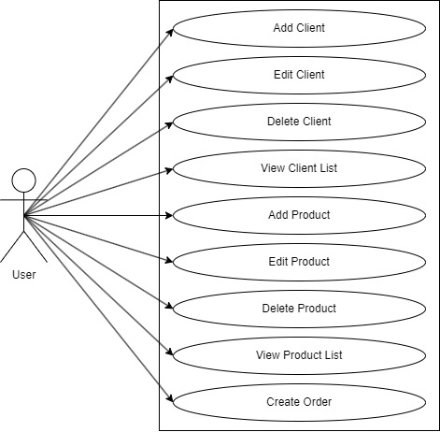

- Add Client
Actor: User
Description: This use case allows the user to add a new client to the system.
Basic Flow:
- The user selects the option to add a new client.
- The system displays a form for the user to enter the client’s details.
- The user fills in the required fields and submits the form.
- The system validates the input and creates a new client record in the database.

- Edit Client
Actor: User
Description: This use case allows the user to edit an existing client's information.
Basic Flow:
- The user selects the option to edit an existing client.
- The system displays a form for the user to enter the id of the client to edit.
- The user selects the client to be edited, by writing their id and submitting.
- The system retrieves the client's current information and presents it in an editable form.
- The user modifies the desired fields and submits the updated information.
- The system validates the input and updates the client record in the database.
- Delete Client
Actor: User
Description: This use case allows the user to delete an existing client from the system.
Basic Flow:
- The user selects the option to delete an existing client.
- The system displays a form for the user to enter the id of the client to delete.
- The user selects the client to be deleted, by writing their id and submitting.
- The system removes the client record from the database and confirms the successful deletion.

- View All Clients
Actor: User
Description: This use case allows the user to view a list of all clients in the system.
Basic Flow:
- The user selects the option to view all clients.
- The system retrieves all client records from the database.
- The system displays the list of clients in a table format, including id, name, address and email.

- Add Product
Actor: User
Description: This use case allows the user to add a new product to the system.
Basic Flow:
- The user selects the option to add a new product.
- The system displays a form for the user to enter the product’s details.
- The user fills in the required fields and submits the form.
- The system validates the input and creates a new product record in the database.

- Edit Product
Actor: User
Description: This use case allows the user to edit an existing product’s information.
Basic Flow:
- The user selects the option to edit an existing product.
- The system displays a form for the user to enter the id of the product to edit.
- The user selects the product to be edited, by writing its id and submitting.
- The system retrieves the product’s current information and presents it in an editable form.
- The user modifies the desired fields and submits the updated information.
- The system validates the input and updates the product record in the database.

- Delete Product
Actor: User
Description: This use case allows the user to delete an existing product from the system.
Basic Flow:
- The user selects the option to delete an existing product.
- The system displays a form for the user to enter the id of the product to delete.
- The user selects the product to be deleted, by writing its id and submitting.
- The system removes the product record from the database and confirms the successful deletion.

- View All Products
Actor: User
Description: This use case allows the user to view a list of all products in the system.
Basic Flow:
- The user selects the option to view all products.
- The system retrieves all product records from the database.
- The system displays the list of products in a table format, including id, name, address and email.

- Create Order
Actor: User
Description: This case allows the user to add an order in the system.
Basic Flow:
- The user selects the option to create an order.
- The system displays a form for the user to select an existing client, an existing product and a desired quantity.
- The user fills in the available fields and submits the form.
- The system checks that the quantity is valid and adjust the stock of the product in the database, by subtracting the quantity entered by the user.
- The system creates a new order in the database.

Design
The following should be presented: OOP design of the application, UML package and class diagrams, used data structures, defined interfaces and used algorithms (if it is the case).
model Classes:
- Client: Represents a client and contains properties such as client ID, name, address, contact information, etc.
- Product: Represents a product and contains properties such as product ID, name, price, quantity in stock, etc.
- Order: Represents an order and contains properties such as order ID, client ID, product ID, quantity, order date, etc.

businessLogic Classes:
- ClientController: Contains the application logic for managing clients, such as adding a new client, editing client details, deleting a client, and retrieving client information.
- ProductController: Contains the application logic for managing products, such as adding a new product, editing product details, deleting a product, and retrieving product information.
- OrderController: Contains the application logic for creating product orders, including validating the availability of products in stock, decrementing the product stock after an order is finalized, etc.

dataAccess Classes:
- AbstractDAO: A generic class that contains the methods for accessing the database, such as creating, editing, deleting, and finding objects. It uses reflection techniques to generate queries dynamically based on the object properties.
- ClientDAO: Extends AbstractDAO and provides specific methods for accessing the Client table in the database.
- ProductDAO: Extends AbstractDAO and provides specific methods for accessing the Product table in the database.
- OrderDAO: Extends AbstractDAO and provides specific methods for accessing the Order table in the database.

connection Classes:
- ConnectionFactory: Handles the connection to the database.

presentation Classes:
- ClientGUI: Represents the graphical user interface for client operations, such as adding a new client, editing client details, deleting a client, and displaying all clients in a table (JTable).
- ProductGUI: Represents the graphical user interface for product operations, such as adding a new product, editing product details, deleting a product, and displaying all products in a table (JTable).
- OrderGUI: Represents the graphical user interface for creating product orders, allowing the user to select an existing product, select an existing client, and insert a desired quantity for the product to create a valid order. It displays an under-stock message if there are not enough products in stock.
- InitialGUI: Represents the initial graphical user interface of the application.
- ImagePanel: A custom panel that can display images.
- Table: A custom table component for displaying data.

The application follows a layered architecture pattern with four packages: businessLogic, connection, dataAccess, and presentation. Each package contains classes responsible for specific tasks, promoting separation of concerns and modularity.

JavaDoc is used for documenting the classes, and the corresponding JavaDoc files can be generated. Reflection techniques are employed in the AbstractDAO class to dynamically generate and execute queries based on the object properties for all tables except the Log table.

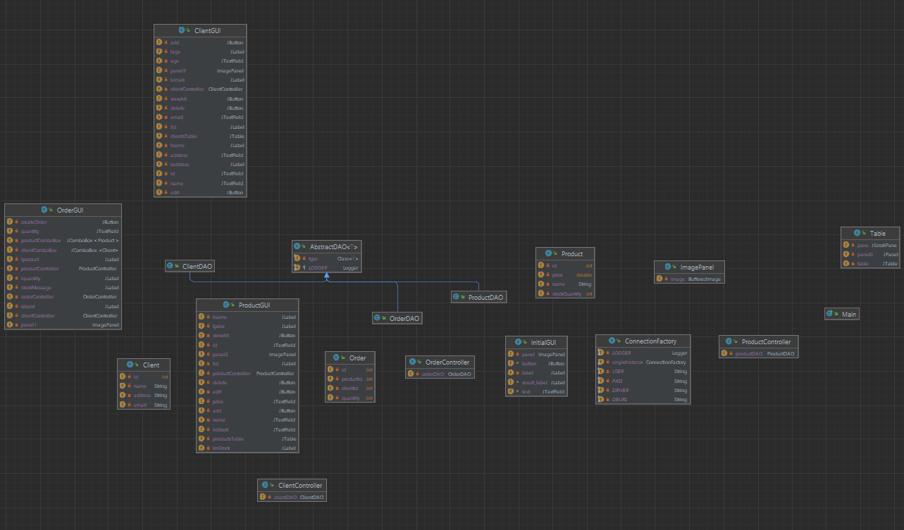
Class Diagram

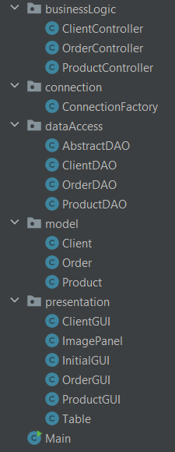 Packages
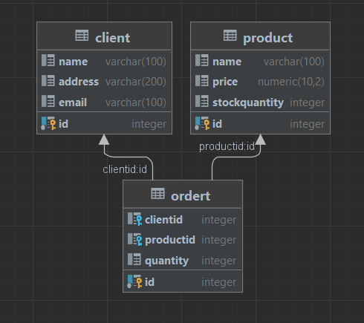 Database Tables

Implementation
- businessLogic package

The ClientController class is a part of a business logic component in an application. It provides methods for managing clients by interacting with a data source through a ClientDAO object.
The class includes the following methods:
- fetch: Retrieves all clients from the data source and returns them as a list.
- addClient: Adds a new client to the data source.
- deleteClientById: Deletes a client from the data source based on its ID.
- fetchClientById: Retrieves a client from the data source based on its ID.
- updateClient: Updates a client in the data source.
These methods allow for basic CRUD (Create, Read, Update, Delete) operations on client data. The ClientController acts as an intermediary between the data access layer (represented by ClientDAO) and the user interface or other components that require client-related functionality.

The OrderController class is another component of the business logic layer in an application. It is responsible for managing orders and interacts with a data source through an OrderDAO object.
The class provides the following methods:
- fetch: Retrieves all orders from the data source and returns them as a list.
- addOrder: Adds a new order to the data source.
These methods enable basic operations related to orders, such as fetching all orders or adding a new order. The OrderController serves as a bridge between the data access layer (represented by OrderDAO) and other parts of the application, such as user interfaces or other components that require order management functionality.

The ProductController class is a component of the business logic layer in an application. It facilitates the management of products and interacts with a data source through a ProductDAO object.

The class provides the following methods:
- fetch: Retrieves all products from the data source and returns them as a list.
- addProduct: Adds a new product to the data source.
- deleteProductById: Deletes a product from the data source based on its ID.
- fetchProductById: Retrieves a product from the data source based on its ID.
- updateProduct: Updates a product in the data source.
These methods enable basic CRUD (Create, Read, Update, Delete) operations on product data. The ProductController serves as an intermediary between the data access layer (represented by ProductDAO) and other components or user interfaces that require product-related functionality.

- connection package

The ConnectionFactory class is responsible for establishing a connection to a PostgreSQL database and managing the lifecycle of the database connection, statements, and result sets.
Key features of the ConnectionFactory class are as follows:
- It uses the PostgreSQL driver (org.postgresql.Driver) to establish a connection to the database.
- The connection details such as the URL, username, and password are provided as constants.
- The class follows the Singleton pattern with a private constructor to ensure only a single instance of the ConnectionFactory is created.
- The createConnection method is used to create a new database connection using the provided connection details.
- The getConnection method returns the database connection instance.
- The close methods are provided to properly close the database connection, statement, and result set, respectively.
Overall, the ConnectionFactory class encapsulates the database connection logic and provides methods for obtaining and releasing connections to the PostgreSQL database.

- dataAccess package

The AbstractDAO class is a generic class that provides common functionality for data access objects (DAOs) in an application. It is designed to work with a variety of entity types by utilizing generics.
Key features of the AbstractDAO class are as follows:
- It includes a logger (LOGGER) for logging messages related to the DAO operations.
- The class uses the ConnectionFactory class to obtain and manage database connections.
- The class is parameterized with the type T, representing the entity type handled by the DAO.
- The constructor allows specifying the type of entity to be handled by the DAO.
- The createObjects method converts ResultSet data into a list of objects of type T.
- The convertValue method converts values retrieved from the database to the specified target types.
- The executeStatement method executes a given SQL statement with the specified parameters.
- The doFetchAll method retrieves all objects of type T from the database.
- The doDelete method deletes objects of type T from the database.
- The getLastId method retrieves the last ID from a specified table in the database.
Overall, the AbstractDAO class provides a foundation for implementing specific DAOs by handling common database operations, such as fetching, deleting, and executing SQL statements, for different entity types.

The ClientDAO class is a specific implementation of a data access object (DAO) for the Client entity in an application. It extends the AbstractDAO class, which provides common functionality for data access.
Key features of the ClientDAO class are as follows:
- The class extends the AbstractDAO<Client> class, specifying Client as the entity type.
- The constructor initializes the ClientDAO and sets the entity type to Client.
- The createClient method creates a new client in the database by executing an SQL INSERT statement with the client's information.
- The deleteClientById method deletes a client from the database based on the specified client ID by executing an SQL DELETE statement.
- The updateClient method updates the information of an existing client in the database by executing an SQL UPDATE statement.
Overall, the ClientDAO class provides specific database operations for managing clients, such as creating, deleting, and updating client records. It utilizes the common functionality provided by the AbstractDAO class, allowing for code reuse and abstraction of database operations.

The OrderDAO class is a specific implementation of a data access object (DAO) for the Order entity in an application. It extends the AbstractDAO class, which provides common functionality for data access.
Key features of the OrderDAO class are as follows:
- The class extends the AbstractDAO<Order> class, specifying Order as the entity type.
- The constructor initializes the OrderDAO and sets the entity type to Order.
- The createOrder method creates a new order in the database by executing an SQL INSERT statement with the order's information.
- The getNewId method retrieves a new ID for the order by counting the existing orders in the database. It executes an SQL SELECT statement to fetch the orders, creates a list of Order objects from the result set using the createObjects method inherited from AbstractDAO, and counts the number of orders in the list to determine the new ID.
- The getNewId method returns the new ID for the order.
Overall, the OrderDAO class provides specific database operations for managing orders, such as creating new orders and retrieving a new ID for orders. It utilizes the common functionality provided by the AbstractDAO class, allowing for code reuse and abstraction of database operations.

The ProductDAO class is a specific implementation of a data access object (DAO) for the Product entity in an application. It extends the AbstractDAO class, which provides common functionality for data access.
Key features of the ProductDAO class are as follows:
- The class extends the AbstractDAO<Product> class, specifying Product as the entity type.
- The constructor initializes the ProductDAO and sets the entity type to Product.
- The createProduct method creates a new product in the database by executing an SQL INSERT statement with the product's information.
- The deleteProductById method deletes a product from the database based on the specified product ID. It executes an SQL DELETE statement with the provided ID.
- The updateProduct method updates the information of an existing product in the database. It executes an SQL UPDATE statement with the updated product information.
- All the database operations (createProduct, deleteProductById, and updateProduct) are performed using the executeStatement method inherited from the AbstractDAO class.
Overall, the ProductDAO class provides specific database operations for managing products, such as creating new products, deleting products by ID, and updating product information. It leverages the common functionality provided by the AbstractDAO class, allowing for code reuse and abstraction of database operations.

- model package

The Client class represents a client entity in an application. It encapsulates the information of a client, including their ID, name, address, and email.
Key features of the Client class are as follows:
- The class provides constructors to create a Client object with the specified ID, name, address, and email, or with default values.
- Private instance variables are used to store the ID, name, address, and email of the client.
- Getter and setter methods are provided for accessing and modifying the attributes of the client.
- The toString method overrides the default implementation and returns a string representation of the Client object, including all its attributes.
Overall, the Client class serves as a model for representing client entities, allowing for the storage and manipulation of client information within the application.

The Order class represents an order entity in an application. It contains information about an order, such as its unique ID, the ID of the client associated with the order, the ID of the product in the order, and the quantity of the product.
Key features of the Order class are as follows:
- The class provides constructors to create an Order object with the specified ID, client ID, product ID, and quantity, or with default values.
- Private instance variables are used to store the ID, client ID, product ID, and quantity of the order.
- Getter and setter methods are provided for accessing and modifying the attributes of the order.
- The toString method overrides the default implementation and returns a string representation of the Order object, including all its attributes.
Overall, the Order class serves as a model for representing order entities, enabling the management and manipulation of order information within the application.

The Product class represents a product entity in an application. It encapsulates information about a product, including its unique ID, name, price, and stock quantity.
Key features of the Product class are as follows:
- The class provides constructors to create a Product object with the specified ID, name, price, and stock quantity, or with default values.
- Private instance variables are used to store the ID, name, price, and stock quantity of the product.
- Getter and setter methods are provided for accessing and modifying the attributes of the product.
- The decrementStock method allows for decreasing the stock quantity of the product by a specified value.
- The toString method overrides the default implementation and returns a string representation of the Product object, including all its attributes.
Overall, the Product class serves as a model for representing product entities, enabling the management and manipulation of product information within the application. It provides essential functionality such as retrieving and updating product details, as well as adjusting the stock quantity when needed.

- presentation

The ClientGUI class represents a graphical user interface for managing client operations in an application. It extends the JFrame class and provides functionality for adding, editing, deleting, and viewing clients.
Key features of the ClientGUI class are as follows:
- The class contains various Swing components such as buttons, labels, text fields, and a table for displaying client information.
- The constructor initializes the GUI by setting up the frame, creating the necessary components, and adding event listeners.
- The addClient method displays a dialog to enter client details and creates a new Client object. It then adds the new client using the ClientController.
- The editClient method allows for editing an existing client. It retrieves the client by ID, displays a dialog to enter updated details, and updates the client using the ClientController.
- The deleteClient method prompts the user for a client ID and deletes the corresponding client using the ClientController.
- The viewAll method fetches a list of all clients from the ClientController and displays them in a table format using the Table class.
- The ClientGUI class interacts with the ClientController to perform various client-related operations.
Overall, the ClientGUI class provides a user-friendly interface for managing clients, allowing users to add, edit, delete, and view client information within the application.

The OrderGUI class represents a graphical user interface for creating orders in an application. It extends the JFrame class and provides functionality for selecting a product, client, and quantity to create an order.
Key features of the OrderGUI class are as follows:
- The class contains various Swing components such as combo boxes, labels, text fields, and a button for creating orders.
- The constructor initializes the GUI by setting up the frame, creating the necessary components, and adding event listeners.
- The loadProducts method fetches the list of products from the ProductController and populates the product combo box with the retrieved products.
- The loadClients method fetches the list of clients from the ClientController and populates the client combo box with the retrieved clients.
- The createOrder method is invoked when the user clicks the "Send order" button. It retrieves the selected product, client, and quantity, validates the order, updates the product's stock quantity if valid, saves the order using the OrderController, and displays a success message or an error message accordingly.
- The clearForm method resets the combo boxes and quantity field, clearing the form for creating a new order.
Overall, the OrderGUI class provides a user interface for creating orders by selecting a product, client, and quantity. It ensures the validity of the order, updates the product's stock quantity, and saves the order using the OrderController.

The ProductGUI class represents a graphical user interface for performing various operations on products in an application. It extends the JFrame class and provides functionality for adding, editing, deleting, and viewing products.
Key features of the ProductGUI class are as follows:
- The class contains Swing components such as buttons, labels, text fields, and a table for displaying products.
- The constructor initializes the GUI by setting up the frame and creating the necessary components.
- The addProduct method displays a dialog to enter product details and creates a new Product object based on the entered information. It adds the new product using the ProductController. If the product ID already exists, an error message is displayed.
- The editProduct method allows the user to edit an existing product. It prompts the user to enter the product ID to be edited and retrieves the corresponding product. The dialog is displayed to enter the updated product details, and the product is updated using the ProductController.
- The deleteProduct method prompts the user to enter the product ID to be deleted and deletes the product using the ProductController.
- The viewAll method fetches the list of products from the ProductController and displays them in a table format using the Table class.
Overall, the ProductGUI class provides a user interface for performing operations on products, including adding, editing, deleting, and viewing the product list. It interacts with the ProductController to handle the product-related functionality.

The InitialGUI class represents the initial graphical user interface of an application. It extends the JFrame class and provides options for client operations, product operations, and creating orders.
Key features of the InitialGUI class are as follows:
- The constructor initializes the GUI by setting up the frame and creating the necessary components.
- The openClient method opens the client GUI window when the corresponding button is clicked.
- The openProducts method opens the product GUI window when the corresponding button is clicked.
- The openOrders method opens the order GUI window when the corresponding button is clicked.
- The actionPerformed method is implemented from the ActionListener interface but does not have any functionality in this class.
Overall, the InitialGUI class provides a simple starting point for the application, allowing users to choose between client operations, product operations, and creating orders. It creates instances of the respective GUI classes (ClientGUI, ProductGUI, and OrderGUI) when the corresponding buttons are clicked, enabling users to interact with different functionalities of the application.

The ImagePanel class is a custom Swing component that extends JPanel and provides functionality for displaying an image as the background of the panel.
Key features of the ImagePanel class are as follows:
- The constructor takes a layout manager and an image file path as parameters.
- The image file is loaded using the ImageIO.read method and stored as a BufferedImage object.
- If the image file path is not valid or an error occurs while reading the image, an error message is displayed and the application exits.
- The paintComponent method is overridden to paint the image on the panel using the drawImage method of the Graphics object.
- The ImagePanel can be used as a regular JPanel and added to other Swing components.
Overall, the ImagePanel class provides a convenient way to display an image as the background of a panel in Swing-based GUI applications. It allows developers to create visually appealing interfaces by incorporating images seamlessly into the user interface.

The Table class is a Swing component that extends JFrame and provides functionality for displaying tabular data in a table format.
Key features of the Table class are as follows:
- The constructor takes an array of column names and a list of string arrays representing attribute values for each row as parameters.
- The table is displayed within a scrollable pane using the JTable and JScrollPane components.
- The JTable is initialized with the attribute values and column names provided.
- The table is added to a JPanel with a GridLayout of 1 row and 1 column.
- The panel is added to the frame's content pane.
- The frame is set to be visible.
Overall, the Table class provides a convenient way to display tabular data in a graphical table format using Swing components. It allows developers to present data in a structured and organized manner, making it easier for users to read and interact with the information.

- Main Class

The Main class serves as the entry point for the application. It contains the main method, which is the starting point of execution when the program is run.
Key features of the Main class are as follows:
- The main method creates an instance of the InitialGUI class, which represents the initial graphical user interface of the application.
- The InitialGUI class is responsible for displaying the main menu and providing options for client, product, and order operations.
- The InitialGUI object is created and assigned to the gui variable.
- The gui variable initializes the initial graphical user interface and starts the application.
Overall, the Main class initializes the application's graphical user interface by creating an instance of the InitialGUI class, allowing users to interact with the different features and functionalities provided by the application.

Results
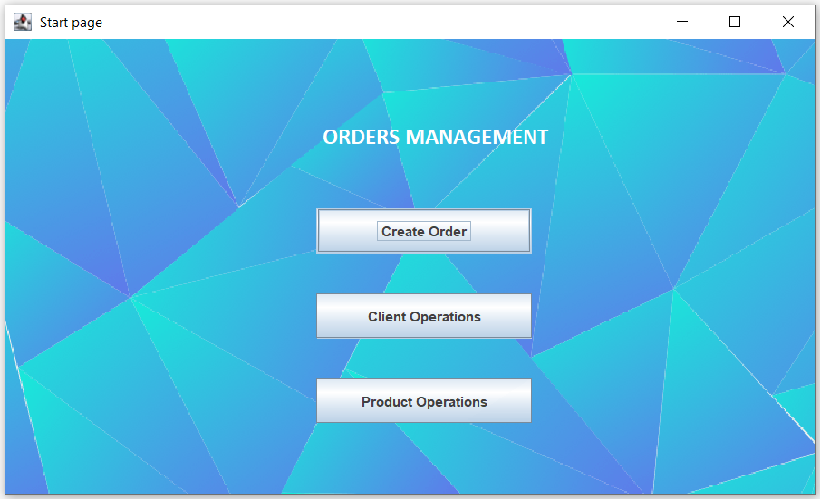

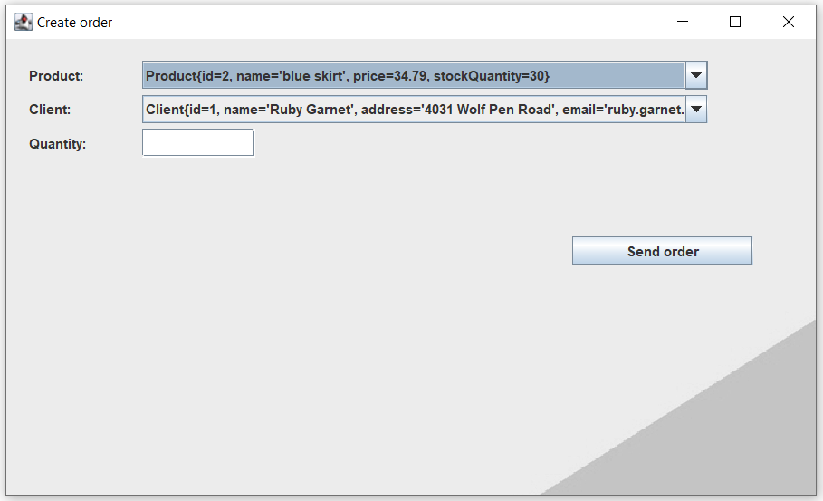

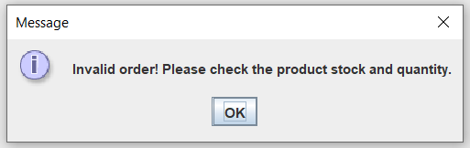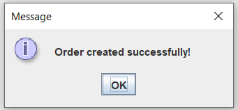
This messages are for invalid stock request, respectively for confirming registering a new order.

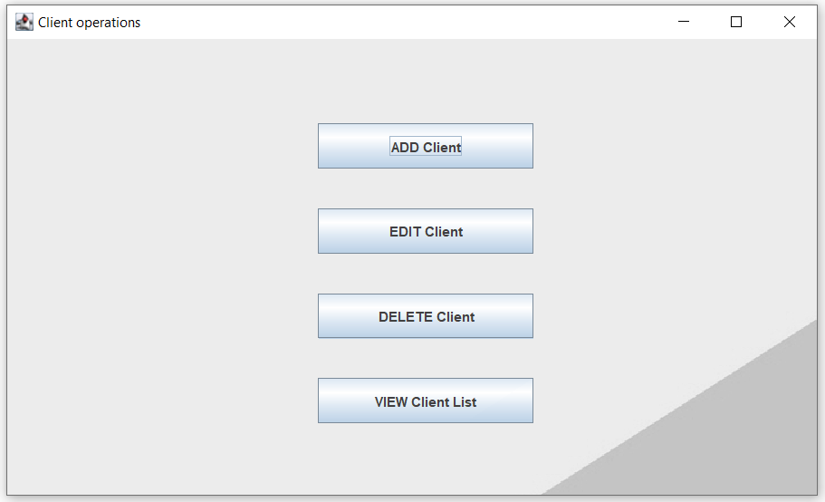

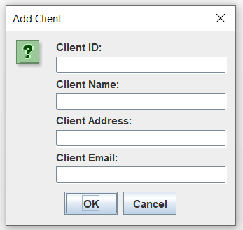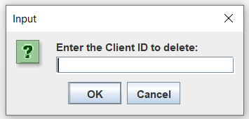
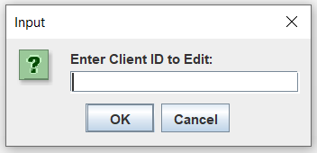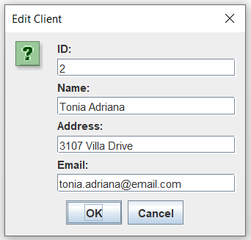

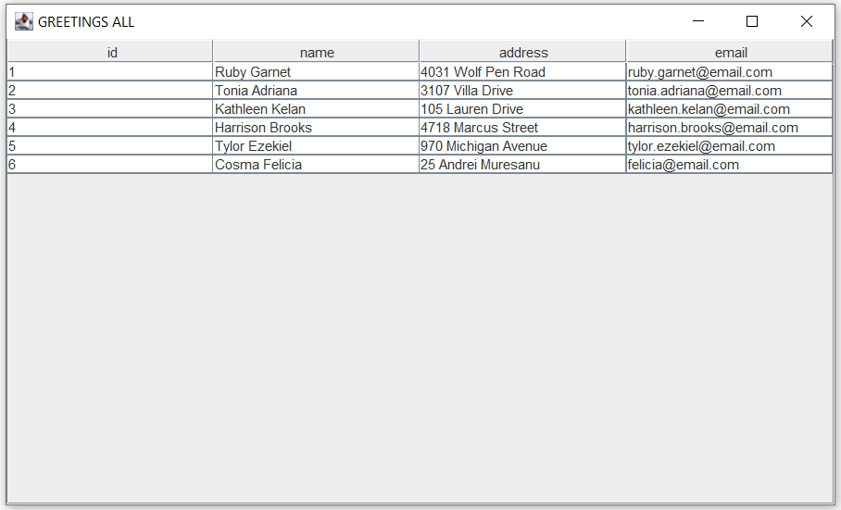

Analog, the windows for Product operations are similar, except the operations are done on a different table in the database.

Conclusions
The assignment involves developing a Java application for managing orders, clients, and products. It utilizes a graphical user interface (GUI) to provide an interactive experience for the user.
Conclusions:
- The application follows object-oriented principles by utilizing classes to encapsulate related functionality and data.
- The application utilizes various GUI components such as JFrame, JButton, JLabel, JTextField, JTable, and JOptionPane to create a user-friendly interface.
- The implementation demonstrates the use of event handling, where actions like button clicks trigger corresponding methods for performing operations.
- The application maintains a separation of concerns by using different classes for data access, business logic, and presentation layers.
- The implementation shows the usage of layouts (e.g., BorderLayout, GridLayout) to organize and position the GUI components.
- The application employs exception handling to catch and handle potential errors, such as invalid input or file loading failures.
Future developments and enhancements for this application could include:
- Enhancing validation and error handling: Adding further validation checks for user input, such as data format validation and range checks, can improve the robustness of the application. Additionally, providing more informative error messages to users would enhance the user experience.
- Implementing user authentication and authorization: If the application is intended for multiple users, incorporating user authentication and authorization mechanisms would ensure secure access to the application's functionalities.
- Improving the overall user interface and user experience: Enhancing the application's visual design, usability, and responsiveness can greatly improve the user experience. This could involve refining the layout, adding icons or images, and optimizing performance.

Bibliography
- https://www.baeldung.com/java-jdbc
- https://mkyong.com/jdbc/how-to-connect-to-mysql-with-jdbc-driver-java/
- https://dzone.com/articles/layers-standard-enterprise
- https://jenkov.com/tutorials/java-reflection/index.html
- https://dev.mysql.com/doc/workbench/en/wb-admin-export-import-management.html
- https://www.baeldung.com/javadoc
- https://www.geeksforgeeks.org/java-swing-jcombobox-examples/

