DOCUMENTATION

ASSIGNMENT 3

STUDENT NAME: CHICHIȘAN ȘTEFAN
GROUP: 30441

CONTENTS

1. Assignment Objective 3
2. Problem Analysis, Modeling, Scenarios, Use Cases 3
3. Design 3
4. Implementation 3
5. Results 3
6. Conclusions 3
7. Bibliography 3

Assignment Objective
- Main objective
  - Implementation of an application of type Order Management, used for processing customer orders for a warehouse, with the usage of relational databases, which are meant to store the products, the clients, and the orders. The application allows processing commands from GUI, performs the requested operations available on the GUI and saves the data in the database.
- Secondary objectives
  - Implementation of the required tasks:
    - Object-oriented programming design
    - Implementation of classes with maximum 300 lines
    - Implementation of methods with maximum 30 lines
    - Usage of Java naming conventions
    - Usage of Javadoc for documenting classes and generating the corresponding JavaDoc files
    - Usage of relational databases for storing the data for the application, minimum three tables: Client, Product and Order
    - Create a graphical user interface for client operations, order operations and product operations
    - Use reflection technique

Problem Analysis, Modeling, Scenarios, Use Cases
- Use-cases

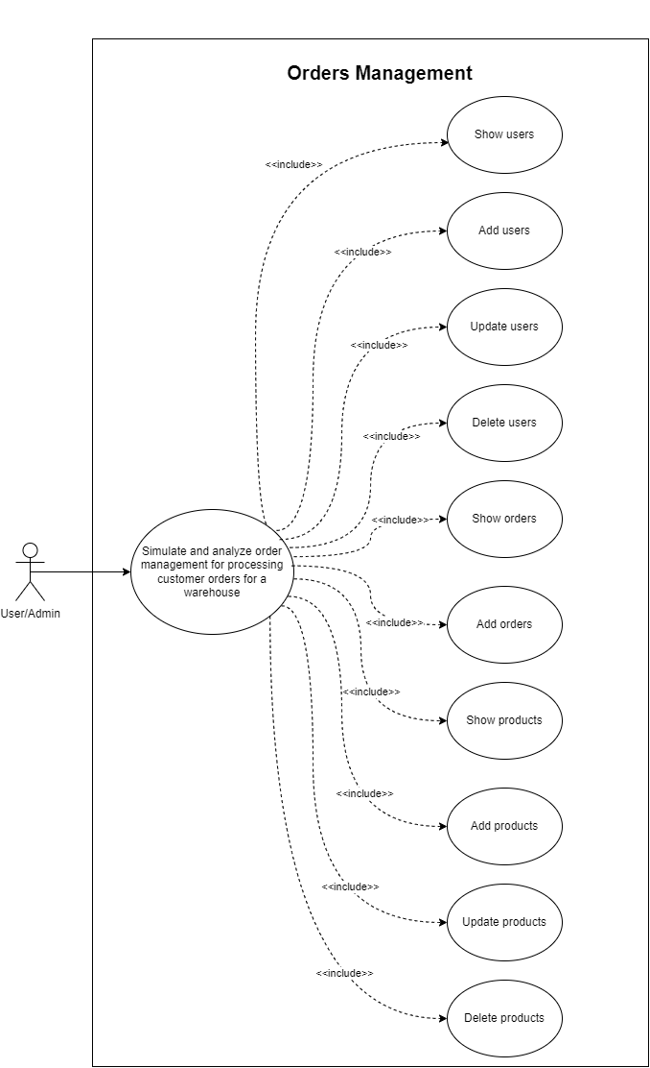
Use-case diagram

  - Use-case #1: simulate and analyze order management for processing customer orders for a warehouse
    - Primary actor: user
    - Main success scenario:
      - The application is starting
      - Select which menu you want to open (Clients, Orders, Products)
      - After entering a particular menu, select the actions which you want to take (Show, Add/Update, Back)
      - If deletion is required, press the Show button and then pick one from the table generated and press delete button
  - Use-case #2: simulate and analyze order management for processing customer orders for a warehouse
    - Primary actor: user
    - Alternative sequences:
      - Input format is wrong when the addition of a user or product in the database is wrong.
      - If quantity exceeds the available amount of product, then a message dialog is displayed on screen.

Design
- Packages
  - UML Package Diagram
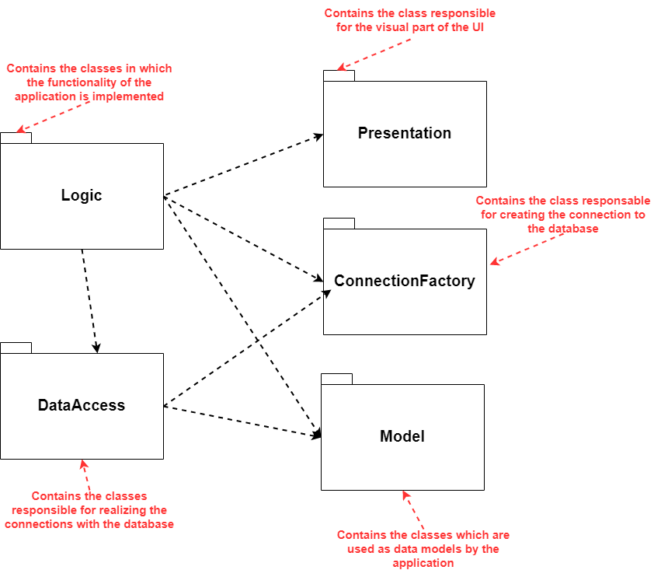
    - Organized based on the Layered Architecture architectural pattern

  - Packages
    - Model
      - Contains the application’s dynamic data structure, independent of the user interface, managing the data, logic, and rules of the application.
      - Contains the classes: Client.java, Order.java, Product.java and ParentModel.java

    - Logic
      - Functionality of application
      - Contains the ClientBLL.java, OrderBLL.java and ProductBLL.java class
    - Presentation
      - Responsible for the visual implementation of the application
      - Contains the ClientFrame.java, GenerateTable.java, MainFrame.java, OrderFrame.java and ProductFrame.java
    - ConnectionFactory
      - Responsible for creating the connection to the database
      - Contains ConnectionFactory.java class
    - DataAccess
      - Responsible for realizing the connections and manipulate the data with the database
      - Contains the AbstractDAO.java, ClientDAO.java, OrderDAO.java and ProductDAO.java

- Design of the application
  - Using the application requires to run the application from the IDE.
  - It is used the Layered Architecture pattern for a better visibility of the classes and packages.
  - It is used reflection technique for both GUI and back-end part. Reflection is important since it lets you write programs that do not have to “know” everything at compile time, making them more dynamic, since they can be tied together at runtime. Lots of modern frameworks use reflection extensively for this reason.

  - In the design of the application the approach involved the use of 17 main classes:

    - Client.java, Product.java, Order.java, ParentModel.java (Model package)
      - The fields required to store information about customers, products and orders are declared.
    - ConnectionFactory.java (Connection package)
      - Makes the connection with MySQL database.
      - Uses Singleton design pattern.
    - AbstractDAO.java, ClientDAO.java, OrderDAO.java, ProductDAO.java (DAO package)
      - Implements the queries and the database connection.
      - It uses reflection techniques to create a generic class that contains the methods for accessing the database: create object, edit object, delete object, and find object.
      - The queries for accessing the database for a specific object that corresponds to a table will be generated dynamically through reflection.
    - ClientBLL.java, OrderBLL.java, ProductBLL.java (BLL packages)
      - Implementation of insert, update, list and delete.
      - Taking care of several exceptions that could arise.
    - ClientFrame.java, GenerateTable.java, MainFrame.java, OrderFrame.java, ProductFrame.java (Presentation package)
      - Implementation of the graphical user interface
      - Using Java Swing as a library for user interface
      - For each model is created a different graphical user interface and they have a parent main menu
      - For GenerateTable.java class, is used reflection to build up the table with the contents. It receives a list of objects and generates the header of the table by extracting through reflection the object properties and then populates the table with the values of the elements from the list.

- UML Class Diagram

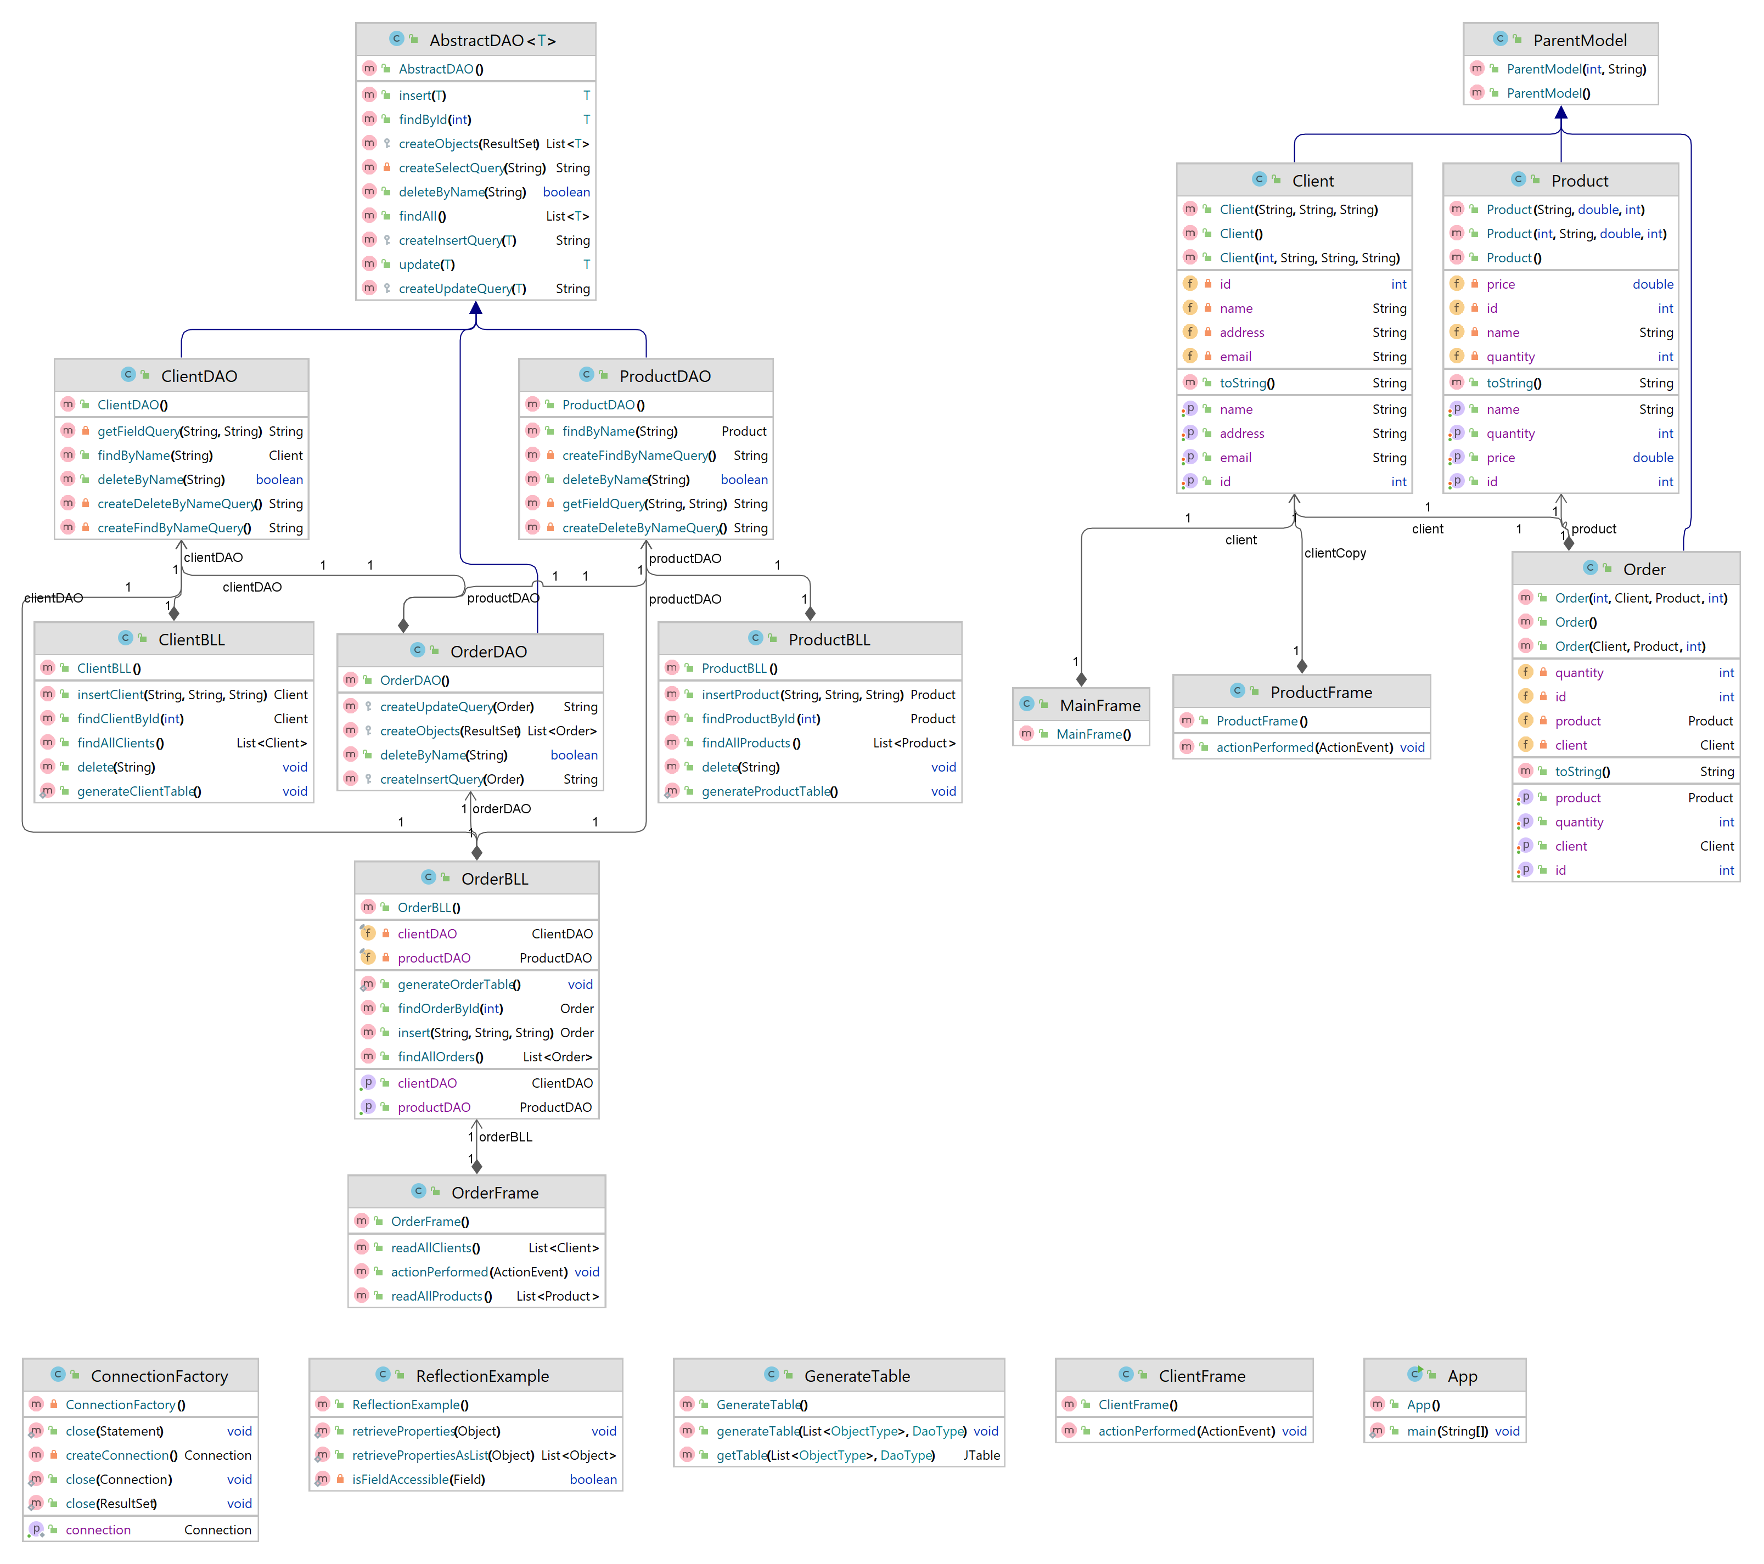

Implementation
- Model package
  - Client class
    - Simple class, used in mapping the attributes to the databases tables
    - Contains simple constructors, getters, setters and toString method
    - The following structure is used for the other classes present in the Model package
  - Order class
    - Simple class, used in mapping the attributes to the database tables
    - Contains simple constructors, getters, setters, toString method
  - Product class
    - Simple class, used in mapping the attributes to the database tables
    - Contains simple constructors, getters, setters, toString method
  - ParentModel class
    - This class is used when implementing the GenerateTable class, I used it due to generics to know which field to take.
    - It has the common field found in the other classes.

- Connection package
  - ConnectionFactory class
    - Used to make the corresponding correlations between the Java application and the data stored in the database, in MySQL.
    - Uses Singleton, a creational design pattern that lets you ensure that a class has only one instance, while providing a global access point to this instance. This results in a unique connection to the database, made only once throughout the entire project.
    - Contains constants in String form for the name of the driver, url, user and password, which will later contribute in settling the connection to the database; in addition to this, a Logger is used for stating the errors and warnings, when present, and displaying them.
    - Contains private methods for:
      - Creating a connection
      - Getting a connection
      - Closing a connection
      - Closing a statement
      - Closing a result set

- DAO package
  - AbstractDAO class
    - The AbstractDAO class represents a generic implementation of the Data Access Object (DAO) pattern for performing CRUD operations on database tables.
    - It is designed to work with any table in the database by using generics to handle different types of objects.
    - The class uses reflection to dynamically generate SQL queries based on the structure of the generic type.
    - The class provides methods for creating select, insert, update, and delete queries.
    - The findAll method retrieves all records from the table and returns a list of objects of the generic type.
    - The findById method searches for a record in the table based on the provided ID and returns the corresponding object.
    - The insert method inserts a new record into the table and returns the inserted object with the generated ID.
    - The update method updates an existing record in the table based on the provided object.
    - The deleteByName method is a placeholder method that can be implemented in subclasses to delete records based on specific criteria.
    - The class uses a ConnectionFactory to establish and close database connections.
    - The createObjects method uses reflection to dynamically create objects of the generic type and populate their fields based on the database result set.
    - Overall, the AbstractDAO class provides a reusable and extensible implementation for performing common database operations on different tables using the DAO pattern.

  - ClientDAO class
    - The ClientDAO class extends the AbstractDAO class and provides specific CRUD methods for the Client entity.
    - It inherits the basic CRUD functionality from the superclass and adds client-specific queries.
    - The class uses the ConnectionFactory to establish and close database connections.
    - The getFieldQuery method is a utility method that generates a query format based on the provided prefix and field name.
    - The createFindByNameQuery method generates a specific query to search for a client by name in the database.
    - The findByName method executes the generated query and returns the Client object with the specified name if it exists, or null otherwise.
    - The createDeleteByNameQuery method generates a specific query to delete a client by name from the database.
    - The deleteByName method executes the generated query and returns true if the client was successfully deleted, or false otherwise.
    - Overall, the ClientDAO class extends the generic functionality of the AbstractDAO class to provide client-specific operations for searching and deleting clients by name. It utilizes the superclass's methods and adds specific query generation methods to handle client-related tasks.

  - OrderDAO class
    - The OrderDAO class extends the AbstractDAO class and provides specific CRUD methods for the Order entity.
    - It uses the ConnectionFactory to establish and close database connections.
    - The class has private instances of ClientDAO and ProductDAO for handling relationships with clients and products.
    - The constructor initializes the clientDAO and productDAO instances.
    - The class overrides three methods from the superclass: createInsertQuery, createUpdateQuery, and createObjects.
    - The createInsertQuery method generates an SQL query for inserting an order into the database using the client ID, product ID, and quantity.
    - The createUpdateQuery method generates an SQL query for updating an order in the database using the client ID, product ID, quantity, and order ID.
    - The createObjects method takes a ResultSet containing query results and creates a list of Order objects. It uses the clientDAO and productDAO instances to retrieve the associated Client and Product objects.
    - The deleteByName method is overridden from the superclass, but it returns false since it doesn't apply to the Order entity.
    - Overall, the OrderDAO class extends the generic functionality of the AbstractDAO class to provide order-specific operations for inserting, updating, and retrieving orders. It utilizes the clientDAO and productDAO instances to handle the relationships with clients and products.

  - ProductDAO class
    - The ProductDAO class extends the AbstractDAO class and provides specific CRUD methods for the Product entity.
    - It uses the ConnectionFactory to establish and close database connections.
    - The class overrides two methods from the superclass: createInsertQuery and createObjects.
    - The constructor initializes the ProductDAO instance.
    - The class has private methods getFieldQuery, createFindByNameQuery, and createDeleteByNameQuery to generate specific queries based on the field name.
    - The getFieldQuery method builds a query string to search for or delete a product based on a specified field name.
    - The createFindByNameQuery method generates a SELECT query to search for a product by its name.
    - The createDeleteByNameQuery method generates a DELETE query to delete a product by its name.
    - The findByName method searches for a product with a specified name in the database by executing the generated query.
    - The deleteByName method deletes a product with a specified name from the database by executing the generated query.
    - The createInsertQuery method is overridden from the superclass but is not used in the ProductDAO class.
    - Overall, the ProductDAO class extends the generic functionality of the AbstractDAO class to provide product-specific operations for searching and deleting products by name. It utilizes the getFieldQuery method to generate queries dynamically based on the specified field name.

- BLL package
  - ClientBLL class
    - The ClientBLL class is responsible for handling the processing of data related to clients.
    - It imports the ClientDAO, Client, and GenerateTable classes.
    - The class has a private instance variable clientDAO of type ClientDAO, which is used to interact with the database and perform CRUD operations on clients.
    - The constructor initializes the clientDAO instance.
    - The findAllClients method retrieves a list of all clients from the database using the findAll method of clientDAO. If no clients are found, it throws a NoSuchElementException with an appropriate message.
    - The findClientById method finds a client in the database by their ID using the findById method of clientDAO. If the client is not found, it throws a NoSuchElementException with an appropriate message.
    - The insertClient method either creates a new client or updates an existing client based on the provided name. It first checks if a client with the given name already exists by calling the findByName method of clientDAO. If the client doesn't exist, a new Client instance is created. The method then sets the properties of the client with the provided name, address, and email. If the client already exists, it calls the update method of clientDAO to update the client in the database. Otherwise, it calls the insert method of clientDAO to insert the new client.
    - The delete method deletes a client from the database by name using the deleteByName method of clientDAO.
    - The generateClientTable method generates a client table using the GenerateTable class. It retrieves all clients from the database using the findAll method of clientDAO and passes them to the generateTable method of GenerateTable to generate the table. The method also sets additional properties (name1 and id1) on each client object before generating the table.
    - Overall, the ClientBLL class provides methods to interact with clients in the database, such as retrieving all clients, finding a client by ID, inserting, or updating a client, deleting a client, and generating a client table. It utilizes the ClientDAO class to perform the database operations and the GenerateTable class to generate a table of clients.

  - OrderBLL class
    - The OrderBLL class is responsible for handling the processing of data related to orders.
    - It imports the ClientDAO, OrderDAO, ProductDAO, Order, and GenerateTable classes.
    - The class has three private instance variables: orderDAO of type OrderDAO, clientDAO of type ClientDAO, and productDAO of type ProductDAO. These variables are used to interact with the database and perform CRUD operations on orders, clients, and products.
    - The constructor initializes the orderDAO, clientDAO, and productDAO instances.
    - The getClientDAO and getProductDAO methods are getter methods for the clientDAO and productDAO variables, respectively.
    - The findOrderById method finds an order in the database by its ID using the findById method of orderDAO. If the order is not found, it throws a NoSuchElementException with an appropriate message.
    - The findAllOrders method retrieves a list of all orders from the database using the findAll method of orderDAO. If no orders are found, it throws a NoSuchElementException with an appropriate message.
    - The insert method inserts a new order into the database. It first retrieves the product with the specified name using the findByName method of productDAO. If the product is not found, it throws a NoSuchElementException with an appropriate message. It then checks if there is enough stock of the product by comparing the quantity requested with the quantity available. If there is not enough stock, it returns null. Otherwise, it creates a new Order instance and sets the client, product, and quantity properties. It inserts the order into the database using the insert method of orderDAO. If the insertion is successful, it updates the quantity of the product by subtracting the ordered quantity from the available quantity and updates the product in the database using the update method of productDAO. Finally, it returns the inserted order.
    - The generateOrderTable method generates an order table using the GenerateTable class. It retrieves all orders from the database using the findAll method of orderDAO and passes them to the generateTable method of GenerateTable to generate the table.
    - Overall, the OrderBLL class provides methods to interact with orders in the database, such as finding an order by ID, retrieving all orders, inserting a new order, and generating an order table. It utilizes the OrderDAO, ClientDAO, and ProductDAO classes to perform the database operations and the GenerateTable class to generate a table of orders.

  - ProductBLL class
    - The ProductBLL class is responsible for handling the processing of data related to products.
    - It imports the ProductDAO, Product, and GenerateTable classes.
    - The class has one private instance variable: productDAO of type ProductDAO. This variable is used to interact with the database and perform CRUD operations on products.
    - The constructor initializes the productDAO instance.
    - The findProductById method finds a product in the database by its ID using the findById method of productDAO. If the product is not found, it throws a NoSuchElementException with an appropriate message.
    - The findAllProducts method retrieves a list of all products from the database using the findAll method of productDAO. If no products are found, it throws a NoSuchElementException with an appropriate message.
    - The insertProduct method inserts a new product into the database. It first retrieves the product with the specified name using the findByName method of productDAO. If the product is not found, it creates a new Product instance. It then updates the name, price, and quantity properties of the product based on the provided parameters. If the product already exists, it updates the existing product in the database using the update method of productDAO. Otherwise, it inserts the new product into the database using the insert method of productDAO. Finally, it returns the inserted or updated product.
    - The delete method deletes a product from the database by its name using the deleteByName method of productDAO.
    - The generateProductTable method generates a product table using the GenerateTable class. It retrieves all products from the database using the findAll method of productDAO, sets additional properties (name1 and id1) for each product, and passes the products to the generateTable method of GenerateTable to generate the table.
    - Overall, the ProductBLL class provides methods to interact with products in the database, such as finding a product by ID, retrieving all products, inserting a new product, deleting a product, and generating a product table. It utilizes the ProductDAO class to perform the database operations and the GenerateTable class to generate a table of products.

- Presentation package
  - Mostly, all the classes in this package do the same thing.
  - Organizes all the UI elements on the frame and provides the functionality with the back-end part using action listeners.
  - GenerateTable class, on the other hand, it is a little bit different because it uses reflection technique to generate dynamically the data from the database.
    - The class imports AbstractDAO and ParentModel.
    - The generateTable method generates a table based on the provided list of objects and DAO. It takes two generic types: DaoType, which extends AbstractDAO, and ObjectType, which extends ParentModel. The method creates a JTable by calling the getTable method, passing the list of objects and DAO. It then creates a JFrame to display the generated table and sets up the necessary components. The table is wrapped in a JScrollPane and added to a JPanel. A "Delete" button is also added to the panel, which allows deleting selected rows from the table. When the button is clicked, it retrieves the selected row, deletes the corresponding object from the database using the DAO's deleteByName method, removes the object from the list, generates a new table, updates the panel with the new table, and revalidates the frame. Finally, the frame is displayed.
    - The getTable method generates a JTable based on the provided list of objects and DAO. It takes the generic types DaoType and ObjectType. It retrieves the class of the first object in the list and obtains its declared fields using reflection. It creates an array of column names based on the field names. It then creates a 2D array data to hold the object data. It iterates over the list of objects and fields, retrieving the field values for each object and populating the data array. Finally, it creates a DefaultTableModel with the data and columnNames arrays and returns a new JTable with the model.
    - Overall, the GenerateTable class provides a convenient way to generate and display a table based on a list of objects and their corresponding DAO. It utilizes Swing components such as JTable, JFrame, JPanel, and JScrollPane to create the graphical interface for the table, as well as reflection to dynamically retrieve the object fields and populate the table data.

Results
- The application will run and simulate the storage database.
- To test various actions, you may enter the Client, Order or Product menus:
  - There you can test the add, update, delete and list all actions.
  - Also, a back button exists to take you back to the main menu.

Conclusions
- Aspects learnt
  - Additional work with databases, resulted in a better understanding of data management throughout external applications which deal with relational databases(connecting to a database, executing several queries, accessing information from database tables and certain records based on a given criteria(for example, finding a client or a product based on name or id))
  - The concept of Singleton design pattern
  - Concepts regarding dividing the project, accordingly, based on Layered Architecture principles, contributing to a more effective hierarchy of the implemented application
  - Working with reflection technique in Java and generics.

- Future project development
  - A much better code organization; good and clean code.
  - Implementation of a Bill class to generate bills.
  - A better approach for this project.

Bibliography
- Laboratory resources
- https://dzone.com/articles/layers-standard-enterprise
- https://www.baeldung.com/javadoc
- https://stackoverflow.com/
- https://www.youtube.com/watch?v=fVMeQHsrSxI
- https://www.youtube.com/watch?v=fAQB556HtiI&t=250s

