2D Java Game

Mariș Rafail

**Short project description:**

A 2D game made using Java Swing, combined with Google’s Static street map API. Artwork inspired by Minecraft’s art style and music provided by youtube. Login credentials are kept in a Postgresql database, password hashing being that of mindrot’s jBCrypt™. User scores are updated dynamically and the size of the database is kept relative to the amount of users.

Github link: [https://github.com/PT2024-30423-Maris Rafail/2DJavaGame/tree/main](https://github.com/PT2024-30423-Maris%20Rafail/2DJavaGame/tree/main)

**Implementation details**

1. Login / Register

* Made using Intellij’s GUI designer. Some problems arose from the fact that the size of the images couldn’t be modified, so resizing was necessary, reducing the quality. Action Listeners were implemented for the buttons (Login, register, confirm register, back to login). In case of faulty user input, windows appear informing the user of the mistake that has occurred (ex: password miss-match, taken username, invalid username etc).

1. The player

* Bears a strong resemblance to Grian’s (Minecraft Youtuber) skin
* Does not resemble a hit box by himself, but just a rectangle with coordinates given. Several values were tested, but the current ones fit the best.
* Main methods: isOutsideOfBounds, movePlayer, updatePlayerWithBoolean
* For updating: a state machine was implemented, but was running slower than simply acting on Boolean values, so that was changed
* Outside of bounds: teleporting to start is done except for the tiles around the portal, to allow the player to actually enter it from a bit of an angle (speedrun strategies)
* Item pick-up: compass pick up triggers specific events
* Moving to map 2: done if we have the compass and reach the portal

1. Game Panel

* Tiles are hand drawn. The first map was randomly generated and then changed to add the main bridge and the places for keys to be placed.
* The second map is randomly generated using BFS. A dfs version is also implemented, depending on user taste
* Items are placed on the map: on the first map on pre-specified locations and on the 2nd randomly, searching for empty places that can be accessed (are paths)

1. Geoguesser

* An API key is provided, with a limited amount of free access. It gets necessary photos from street view and displays them according to a slider that the user can act upon
* KNOW ISSUE: fast access can glitch and shown some images of the previous location.
* If the correct guess is provided, a suitable sound is played, same for wrong guesses
* To search for actually available locations is hard, since randomly getting coordinates doesn’t work: you can go into the middle of the Pacific Ocean. Some locations were hard coded in the database and are selected at each round. Several rounds can have the same locations, for more memorization. The same round always has different locations.

1. Music

* Copyrighted:)
* Java clip allows for the playing of .wav files only, so conversions had to be done.
* States have different sounds / soundtracks based on the overall vibe

1. Database management

* Done with the connection class. Has 4 connector classes for each specific usage of the connector

1. Game logic

* Collision: when moving, the player can enter at most 2 tiles at the same time.
* FPS: 60 => movement is achieved
* We only draw the tiles on the screen and immediately near the screen, to avoid computation overload.
* Updates of the panel are done using a delta method. I chose this instead of the thread.sleep() since it seems that sleeping has a delay of a couple milliseconds, thus making this more efficient =>

The drawInterval is 0.166 seconds. At each iteration, the elapsed time (currentTime-lastTime) is added to delta, and, when delta is >=1, it means enough time has passed for the update, so we perform the update, repaint operations.

* The player was, firstly, the one that moved, but that was inefficient and hard to implement, so I made the map move according to the player’s direction
* An admin account exists, which allows the bypassing of collision and just quick testing of the working of the geoguessing. It’s score isn’t shown in the top 10.

**Gameplay**

Login step:

Users are prompted to create an account / login. Suitable messages are displayed as a text box in case something goes wrong. (Image 1, Image 2). User is greeted and required to press the Enter key (Image 3).

The player is spawned in a dark map, symbolizing the name of the game: “Lost”. The UI offers some information regarding directions of movement: North, South. (Image 4)

In conformity to From Software’s style, the player isn’t directed on the colored yellow tile, but he can choose to step on it, action to which he is prompted with a sound that asks of him to take a “leap of faith”. Upon doing so, and completing the invisible maze, the player obtains the true compass, unlocking the door. (Image 5, Image 6)

Another compass can be obtained immediately from the start, which disables collisions, also enabling portal access.

In the second map, the user must collect fragments, which help him recall certain aspects of his past and visualize locations which he feels like he knows. (Image 7, image 8)

In case the black compass was chosen, the user can freely run around the maze, collecting and guessing, but he will soon realize it is all in vain, since no amount of knowledge gained can help him escape the nightmare that is the feeling inside him. The yellow compass, however, is issued as a symbol of (entrusting yourself to the voices in your head) making the hard decision to explore the hardships of the void.

The black compass, gameplay wise, is a way of exercising the different locations that can appear in the game, while the yellow one is for competing with other players for the leaderboard. Once 4 fragments are collected, the user’s time is registered and the top 10 best scores are shown. (Image 10, Image 11).

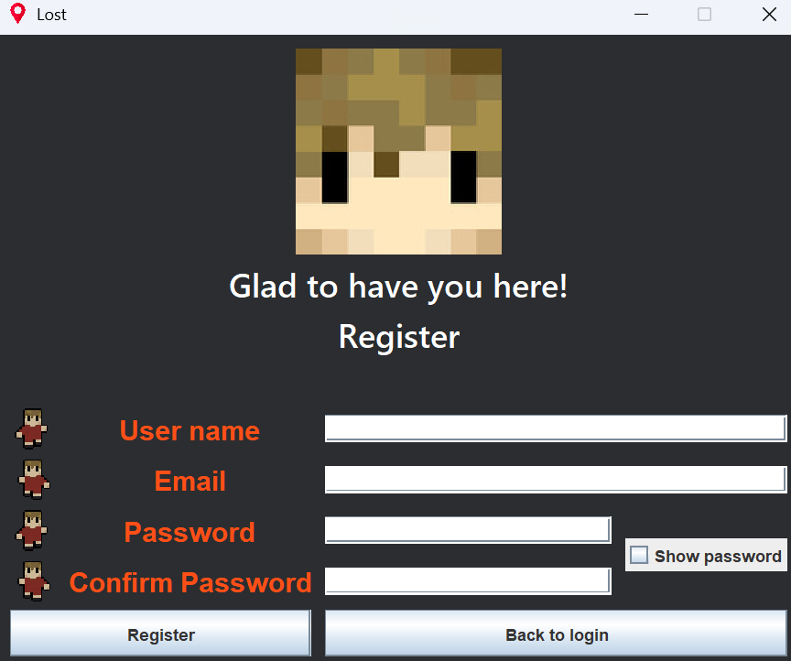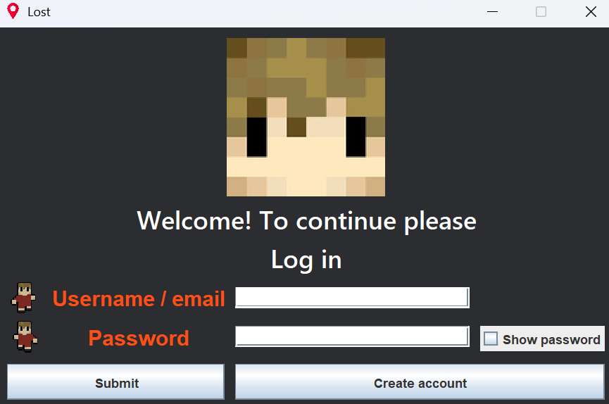During the gameplay, the user can press the “Enter” keyword to display several funny references.

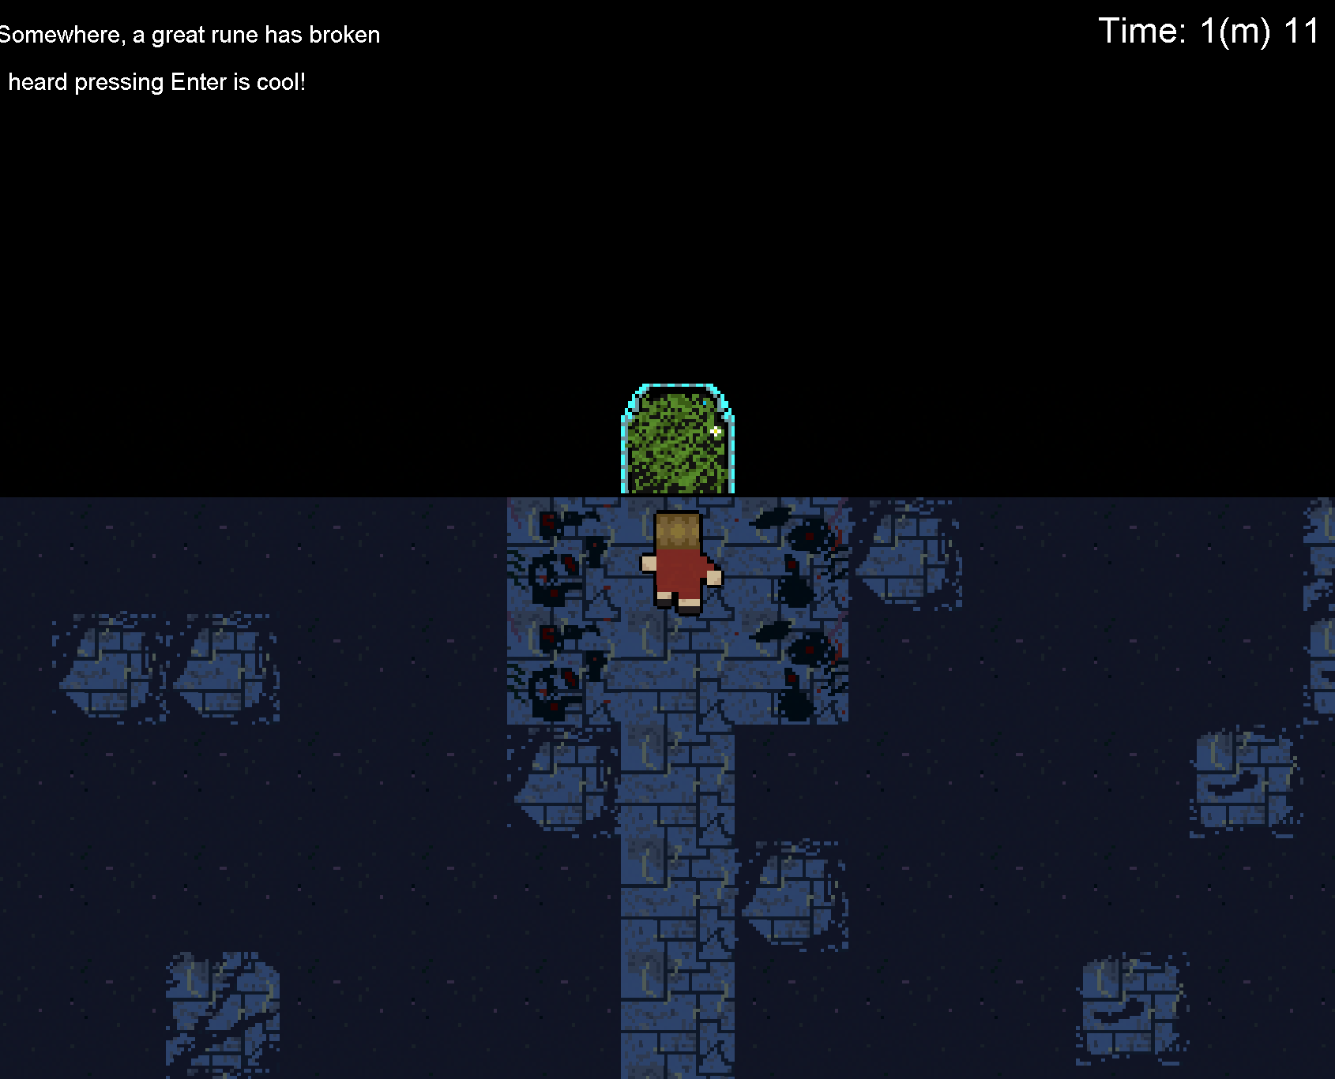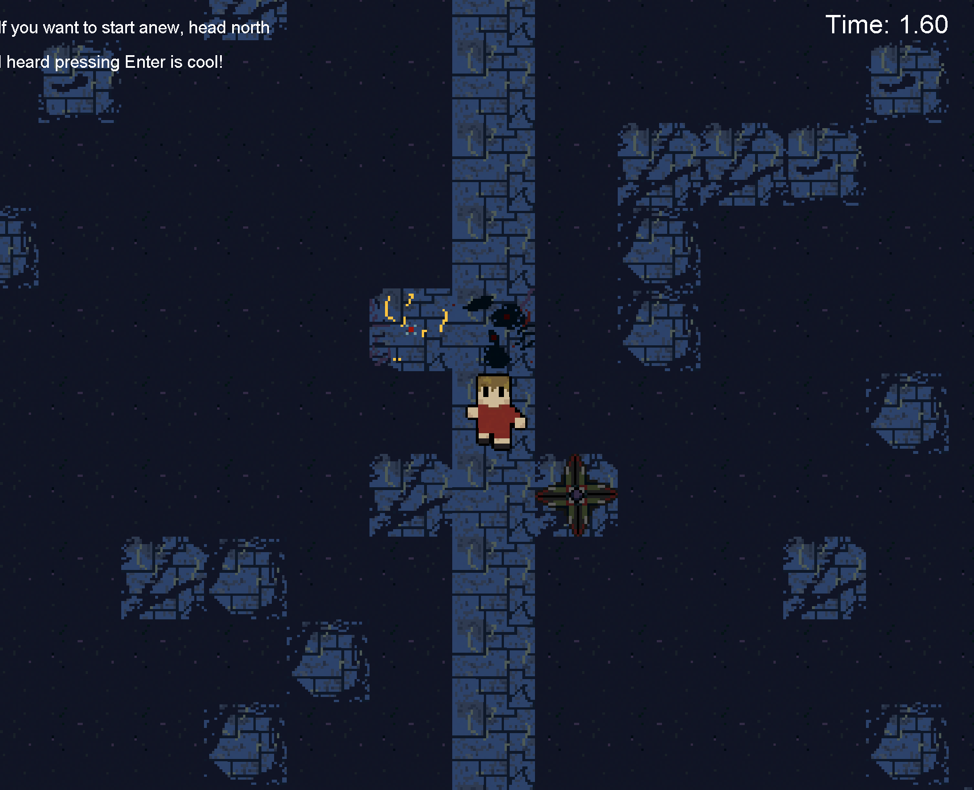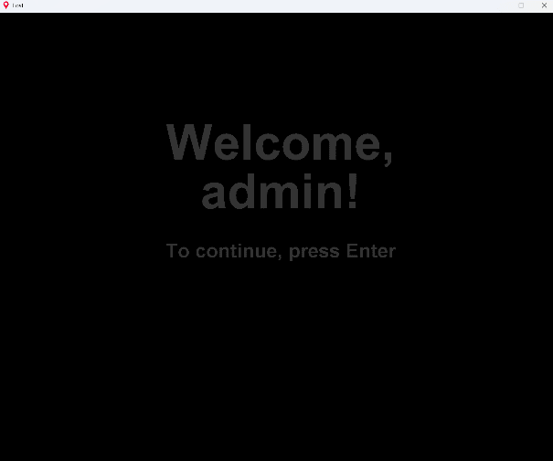

Image 2. Register

Image 1. Login Screen

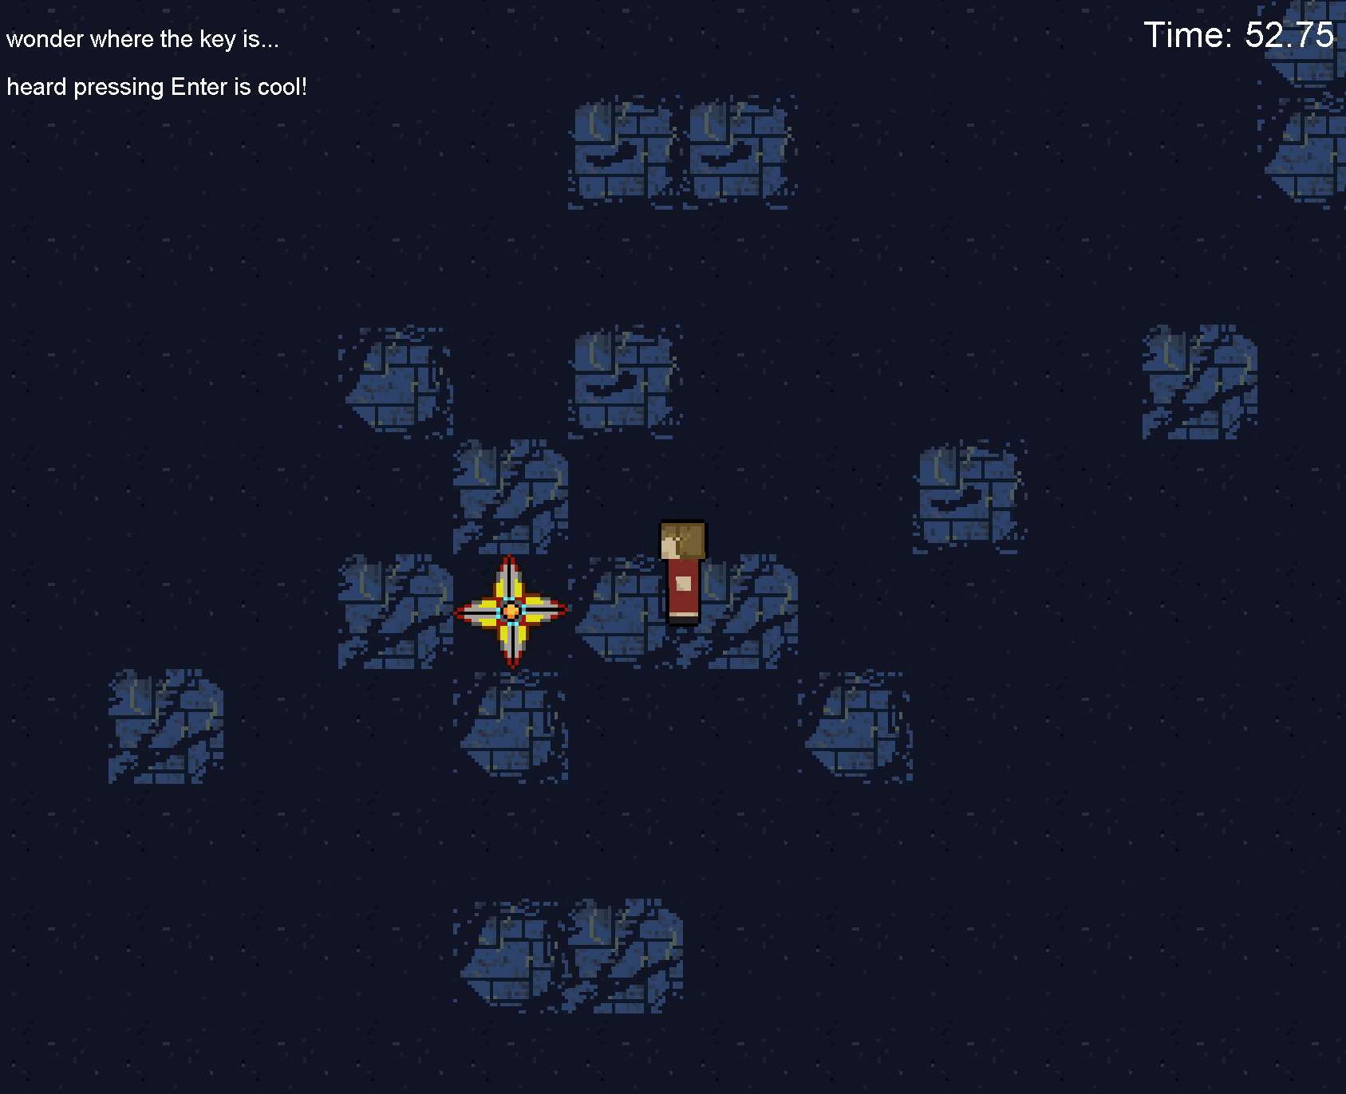

Image 6. Exit reached

Image 5. Compass found

Image 4. Game start

Image 3. Greeting

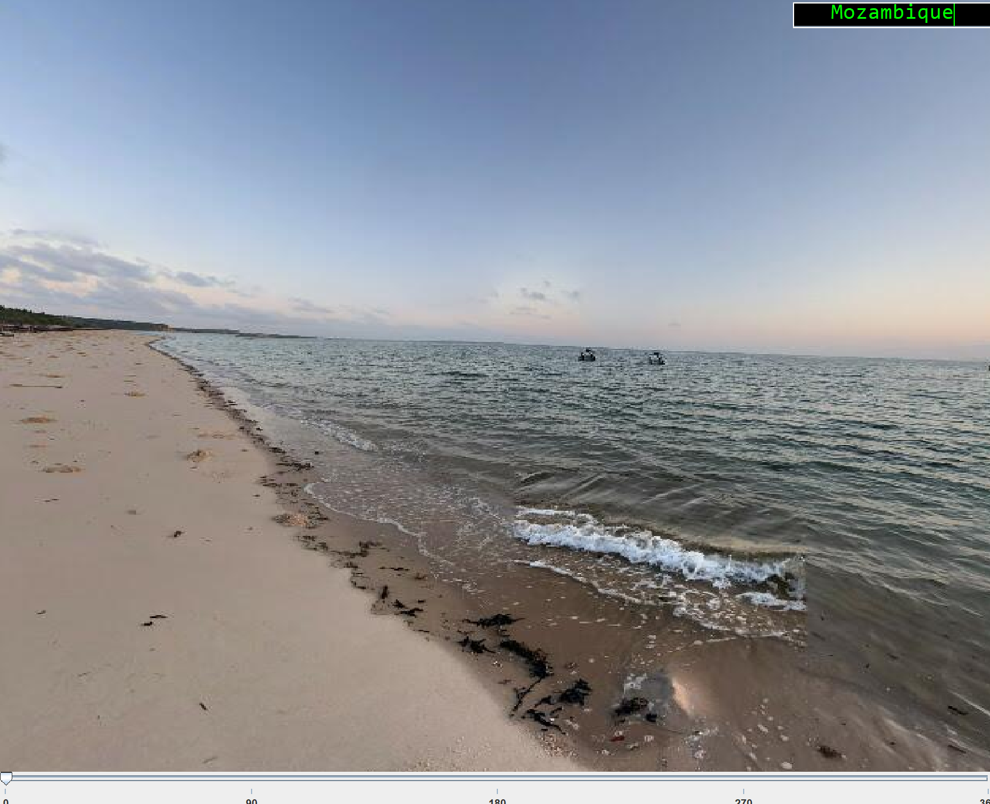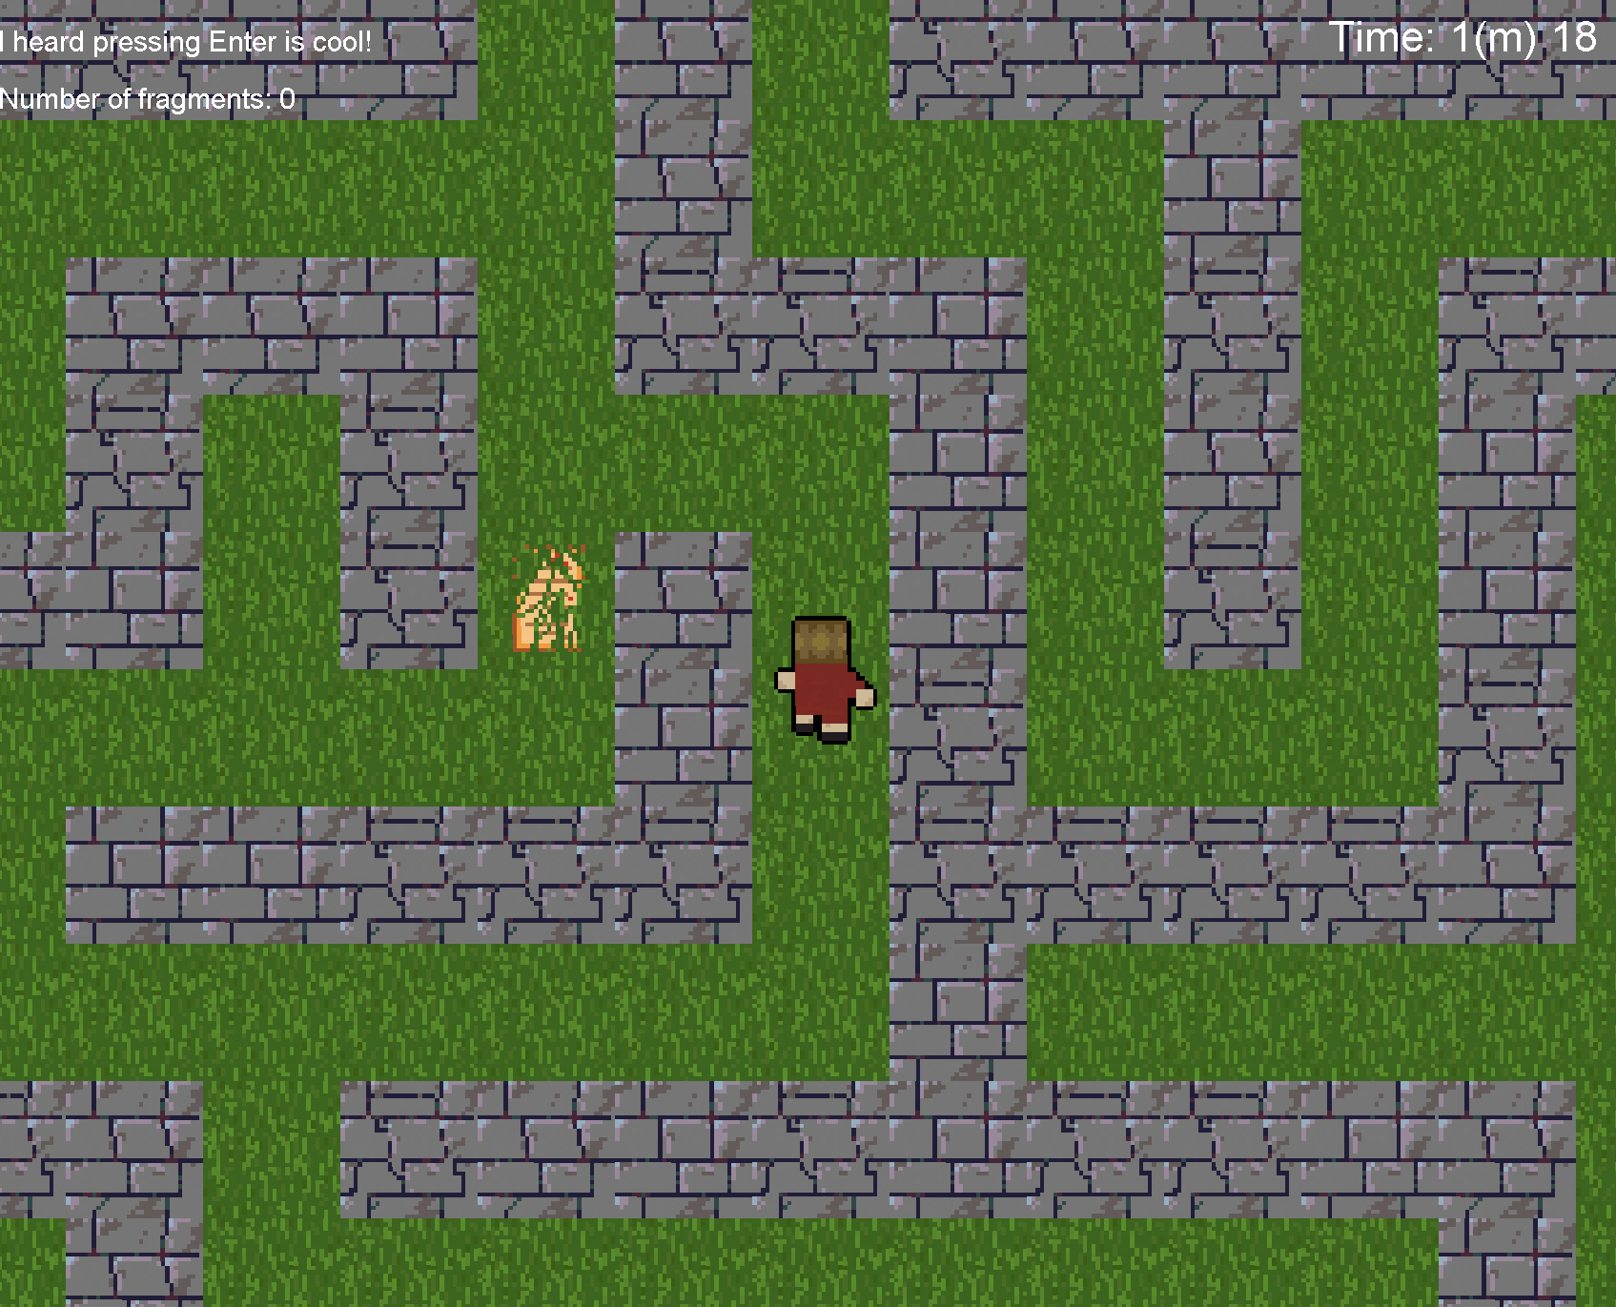

Image 8. Guessing game

Image 7. 2nd Map

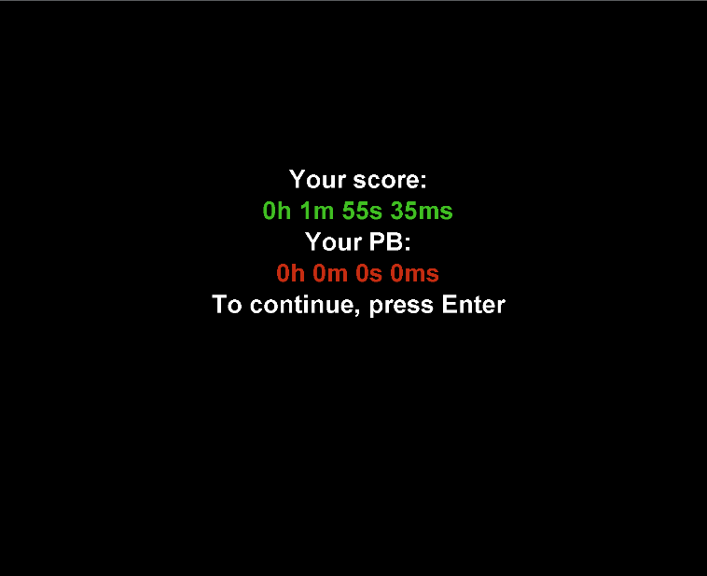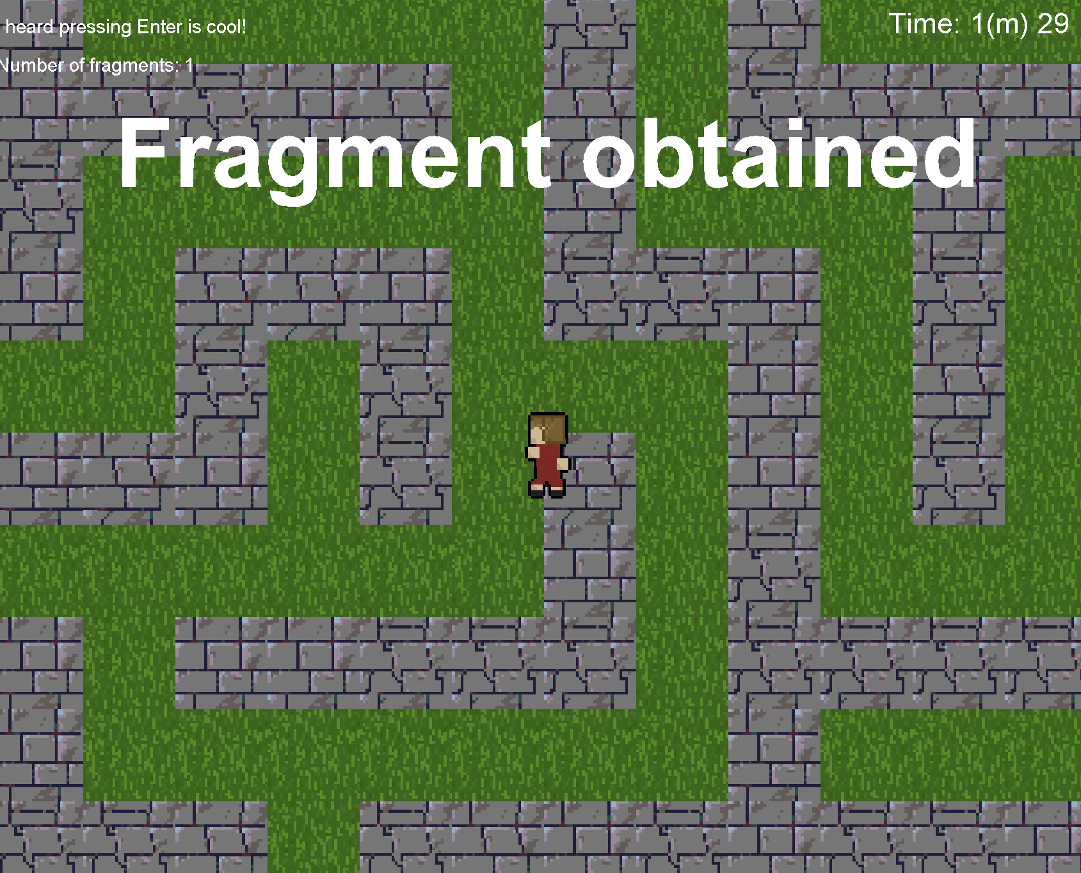

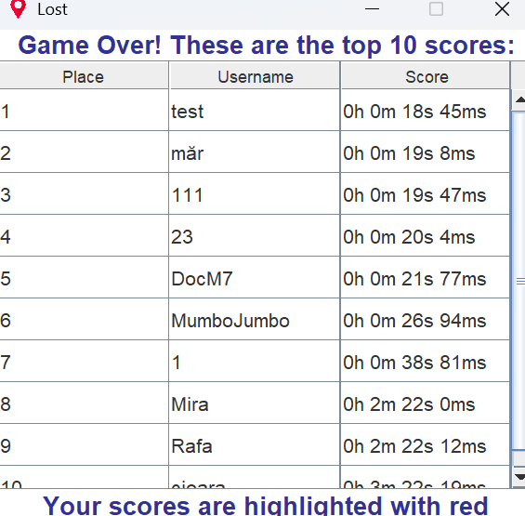

Image 11. Top 10 table

Image 10. Score report

Image 9. Congratulations