電通二乙微處理器實驗 實驗結報

實驗名稱 | Lab06-Music
組別 |  | 組員 | 吳泯鴻

- 實驗目的
如何使 Arduino 發出特定旋律的聲音?
1.Arduino 接喇叭如何接線?
2.如何使用 tone library?
3.如何演奏一段音樂?
4.如何使用 4x4 鍵盤演奏音樂?
5.如何發報摩斯電碼?

- 實驗步驟
Arduino 演奏一段特定的音樂, 旋律不得是小蜜蜂
使用 4x4 鍵盤演奏音樂
發報摩斯電碼

- 程式碼
1
- #define c 261
- #define d 294
- #define e 329
- #define f 349
- #define g 392
- #define a 440
- #define b 493
- #define c1 523
- #define d1 554
- #define e1 659
- #define f1 698
- #define g1 784
- #define a1 880
- #define b1 988
- #define WHOLE 0.25
- #define HALF 0.25
- #define QUARTER 0.25
- #define EIGHTH 0.125
- #define SIXTEENTH 0.0625
- int tune[] ={e,f,g,e1,c1,d1,c1,c1,b1,b1,d,e,f,d,b,c1,a,a,g,g,e,f,g,c1,d1,e1,d1,c1,a,d1,e1,f1,e1,d1,g,f1,e1,d1,c1,c1};
- float duration[] = {WHOLE,WHOLE,WHOLE,WHOLE,WHOLE,WHOLE,WHOLE,WHOLE,WHOLE,WHOLE,WHOLE,WHOLE,WHOLE,WHOLE,WHOLE,WHOLE,WHOLE,WHOLE,WHOLE,WHOLE,WHOLE,WHOLE,WHOLE,WHOLE,WHOLE,WHOLE,WHOLE,WHOLE,WHOLE,WHOLE,WHOLE,WHOLE,WHOLE,WHOLE,WHOLE,WHOLE,WHOLE,WHOLE,WHOLE,WHOLE};
- int length;
- void setup() {
- pinMode(8, OUTPUT);
- length = sizeof(tune) / sizeof(tune[0]);

- }

- void loop() {
- for (int x=0; x<length; x++) {
- tone(8, tune[x]);
- delay(2500 *duration[x]);
- noTone(8);
- }
- delay(5000);

- }
2
#include<Keypad.h>
#define c 261
#define d 294
#define e 329
#define f 349
#define g 392
#define a 440
#define b 493
#define C 523
#define D 554
#define E 659
#define F 698
#define G 784
#define A 880
#define B 988
const byte ROWS=4;
const byte COLS=4;
char keys[ROWS][COLS]={{'7','8','9','C'},{'4','5','6','D'},{'1','2','3','E'},{'0','A','B','F'}};
byte rowPins[ROWS]={11,10,9,8};
byte colPins[COLS]={15,14,13,12};
int tune[] ={c,d,e,f,g,a,b,C,D,E,F,G,A,B,c,d};
Keypad keypad = Keypad(makeKeymap(keys),rowPins,colPins,ROWS,COLS);

void setup() {
pinMode(5, OUTPUT);
Serial.begin(9600);
}

void loop() {
int cc;
char key =keypad.getKey();
if(key!=NO_KEY){
if(key>='0'&&key<='9')
cc=key-'0';
else
cc=key-'A'+10;
tone(5,tune[cc]);
delay(500);
Serial.println(cc);
}
noTone(5);
}
3
char*morse[]={"01","1000","1010","100",
"0","0010","110","0000",
"00","0111","101","0100",
"11","10","111","0110",
"1101","010","000","1",
"001","0001","11","1001",
"1011","1100"};
char*ptr;
char chr,index;
void setup() {
pinMode(5, OUTPUT);
Serial.begin(9600);
}

void loop() {
if(Serial.available()){
chr=Serial.read();
Serial.println(chr);
if((chr-'A')>=0&&(chr-'Z')<=0)
{
index =chr-'A';
ptr=morse[index];
while(*ptr!='\0'){
if(*ptr=='0'){
tone(5,440,100);
delay(100);
}
else{
tone(5,440,300);
delay(100);
}
ptr++;
delay(100);
}
delay(300);

}
}
}

實驗結果及分析
Arduino能夠演奏一段特定的音樂
能夠使用 4x4 鍵盤演奏音樂
能夠發報摩斯電碼
心得討論
今次實驗學習到如何依靠程式碼控制 4x4 鍵盤跟隨所輸入的字號演奏音樂, 實驗十分有趣好玩
修正電路圖
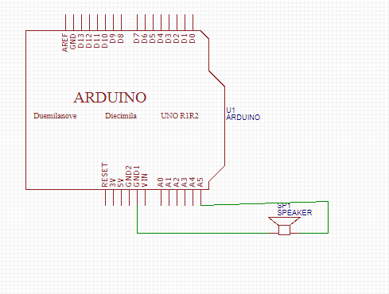
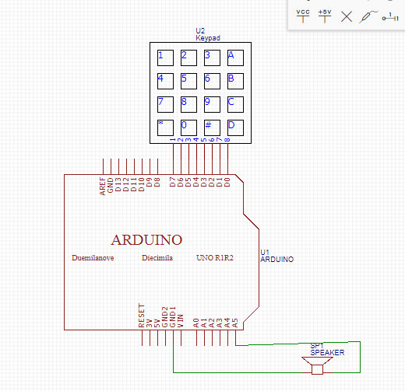

- 修正程式碼

