電通二乙微處理器實驗 實驗結報

實驗名稱 | LAB12
組別 |  | 組員 | 吳泯鴻

- 實驗目的
1. DHT-11可以一直量溫濕度
2. 組合timer DHT11量溫濕度
3. 使用timer 10S溫濕度上載mcs
- 實驗步驟
- MCS 新增溫濕度 顯示器各一個
- 將 溫濕度 電阻值上傳
- 程式碼
#include "DHT.h"
#include "Arduino.h"
#include "LTimer.h"
#include <LWiFi.h>
#include <WiFiClient.h>
#include "MCS.h"
#define _SSID "PT3Bear"
#define _KEY "hk051444"
#define DHTPIN 2
#define DHTTYPE DHT11
MCSDevice mcs("DGq75J4d", "NmchZT5FqPvtH2lH");
MCSDisplayInteger w("2");
MCSDisplayFloat C("1");
LTimer timer1(LTIMER_1);
DHT dht(DHTPIN, DHTTYPE);
float h,t,f,hif,hic;
void setup() {
Serial.begin(9600);
while(WL_CONNECTED != WiFi.status())
{
WiFi.begin(_SSID, _KEY);
}
Serial.println("WiFi connected !!");
mcs.addChannel(C);
mcs.addChannel(w);
while(!mcs.connected())
{
Serial.println("MCS.connect()...");
mcs.connect();
}
Serial.println("MCS connected !!");

Serial.println(F("DHTxx test!"));
dht.begin();
timer1.begin();
timer1.start(10000, LTIMER_REPEAT_MODE, abc, NULL);

}

void loop() {

dht.readHumidity();
mcs.process(100);
w.set(hic);
C.set(t);
}
void abc(void *usr_data)
{
h = dht.readHumidity();
t = dht.readTemperature();
f = dht.readTemperature(true);
if (isnan(h) || isnan(t) || isnan(f)) {
Serial.println(F("Failed to read from DHT sensor!"));
return;
}
hif = dht.computeHeatIndex(f, h);
hic = dht.computeHeatIndex(t, h, false);

Serial.print(F("Humidity: "));
Serial.print(h);
Serial.print(F("% Temperature: "));
Serial.print(t);
Serial.print(F("'C "));
Serial.print(f);
Serial.print(F("'F Heat index: "));
Serial.print(hic);
Serial.print(F("'C "));
Serial.print(hif);
Serial.println(F("'F"));

}

- 實驗結果及分析
溫濕度能夠上載MCS
MCS溫濕度顯示

- 心得討論
今次實驗學習到如何依靠程式碼控制 7697跟隨MCS控制 上載溫濕度值實驗十分有趣好玩

6.

- 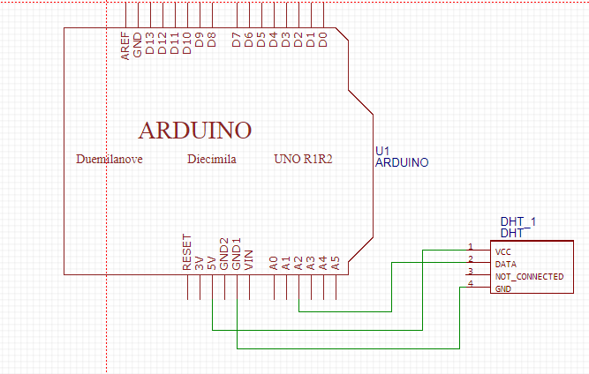
修正程式碼

