Group Project Documentation   
Building Cross-Platform Back-End Application With .NET

*IT Salary Management System*

**Prepared by Secret Billionaire**

***Phạm Phú Hưng***

***Phạm Thanh Kiên***

***Phạm Đức Hưng***

***Hoàng Đăng Khoa***

**Ho Chi Minh City, 2023**

**Table of Contents**

**Table of Contents ii**

**Revision History ii**

**1.** **Project Introduction 1**

1.1 Product Perspective 1

1.2 User Classes and Characteristics 1

**2.** **Database Design 1**

**3.** **System Architecture 1**

**4.** **Implementation 2**

4.1. Deployment Considerations 2

4.2. Screenshots and explanations 2

**5.** **References 2**

**Revision History**

| **Name** | **Date** | **Reason For Changes** | **Version** |
| --- | --- | --- | --- |
| *Kiên* | *25 May 2023* | *Initial document* | *1.0* |
|  |  |  |  |
|  |  |  |  |
|  |  |  |  |

# Project Introduction

## Product Perspective

This project focuses on developing a salary management application specifically designed for an IT company, called IT Salary Management System. The goal of the system is to provide a comprehensive platform for managing important aspects

## User Classes and Characteristics

1. **Administrator:**

* Role: Responsible for managing various aspects of the system
* Characteristics:
* Login, logout
* Manages position: Can add, edit, view, search, and remove position
* Manages level: Can add, edit, view, search, and remove level
* Manages employee: Can add, edit, view, search, filter and remove employee
* Manages contract: Can add, edit, view, search, and remove contract
* Manages attendance: Can filter, approve, edit, and remove attendance of specific employee
* Manages take leave: Can filter, approve, edit, and remove take leave of specific employee
* Manages payroll: Can create payroll for specific user or list of users in a specific time, edit and remove payroll
* Overview about the system: View the total number of employees, unapproved attendances, unapproved take leaves, and employee are not calculated salary yet.

1. **Employee:**

* Role:
* Characteristics:
* Login, logout
* Manage information: Can edit, view information
* Manage log attendance: Can add, edit, and remove attendance
* Manage log take leave: Can add, edit, remove take leave
* Manage their payroll: Can view and filter payroll by month, year
* Manage contract: Can view contract
* Can overview about total hours working hours in the week, month
  1. **Business Process**

1. **Administrator:**

* Admin login to web
* Admin can manage level
  + Create: LevelName field unallow duplicated
  + Update: LevelName field unallow duplicated
  + Delete: Can perform only when current Level doesn’t belongs to any contract
* Admin can manage position
  + Create: PositionName field unallow duplicated
  + Update: PositionName field unallow duplicated
  + Delete: Can perform only when current Position doesn’t belongs to any contract
* Admin can manage employee
* Create
  + Generates EmployeeCode based on format SD[xxxx], xxxx is number auto increasing start from 0000 to 9999
  + Generates password based on format [FirstName with uppercase first letter + LastName]@[DoB] (eg: Hungphamphu@18102001)
  + Generates email base on format [lowercase FirstName + first character of each word in LastName]@projectx.com, if email generated already existed then add increasing number start from 1 (eg: hungpp@projectx.com, in case already existed email will be hungpp1@projectx.com)
  + Default status is Active
  + Default IsFirstLogin is true
  + CreatedDate is current date of system when handle this request
* Update
  + All field except these fields Email, Password, Employee Code, IsFirstLogin, CreatedDate)
* Delete
  + Can only perform when User doesn’t have any contract
* Admin can manage contact
  + Create
    - Can only perform create new Contract if don’t have any contract. In case already have a contract, if the current contract is still active then StartDate and EndDate must not overlap the StartDate and EndDate of that contract)
    - BaseSalary must be greater than 0
    - EndDate must be greater than StartDate
    - DateOffPerYear must be greater than 0
    - If Type is FullTime then must fill fields TaxRate and InsuranceRate
    - Default status: if StartDate is the current date then Active else WAITING
  + Edit
  + Delete
* Admin can manage take leave
  + Create
* Types of leave(paid leave and unpaid leave) based on DayOffPerYear field in the latest contract.
* Required not existing approved leave within a specified time period
* Required not existing approved attendance within a specified time period
* Required existing active contract
* Required request with leaveDays > 0 (leaveDays not counting Saturday, Sunday and holiday)
* Status set default is WAITING
  + Update
    - Change status from WAITING to APPROVED/REJECTED
    - Required not existing approved attendance within a specified time period
    - Required not existing another approved leave within a specified time period
    - Required existing active contract
  + Delete
    - Change status to DELETED if status is WAITING
* Admin can manage attendance
  + Create:
    - If already exist Take Leave(employeeId, DateTime, status: #=Reject) can not perform create this Date, empID
    - Create attendance in week,
    - Unique [DateTime, employeeId]
    - Hour in range from 1 - 8
    - OTHour in range from 0 - 8
    - Status set default is WAITING
  + Update attendance:
    - Update attendance in week
    - Cannot update Datetime
    - Hour in range from 1 - 8
    - OTHour in range from 0 - 8
    - Status set default is WAITING
  + Verify request attendance of employee
    - If the request is out this week, can not perform action.
    - Update only status from WAITING to others
  + Delete attendance of employee
    - Change status to DELETED
* Admin can manage payroll
  + Create payroll
* Calculates based on Attendance and TakeLeave has been approved (has status APPROVED)
* Update, Delete

1. **Employee:**

* Employee login
* Account with status Deactive can’t access to system
* First-time login need to change password
* Create attendance
* Required valid contract
* Create take leave
* Required valid contract
* View payroll
* Accept payroll and filter payroll
* View Contracts and search contracts
* View report working hours
* Attendance
  + Create
    - Create request for attendance in day, if not can not action
    - Create update request in week()
  + View list attendances
  + Delete attendance request (on status Waiting)

# Class Diagram

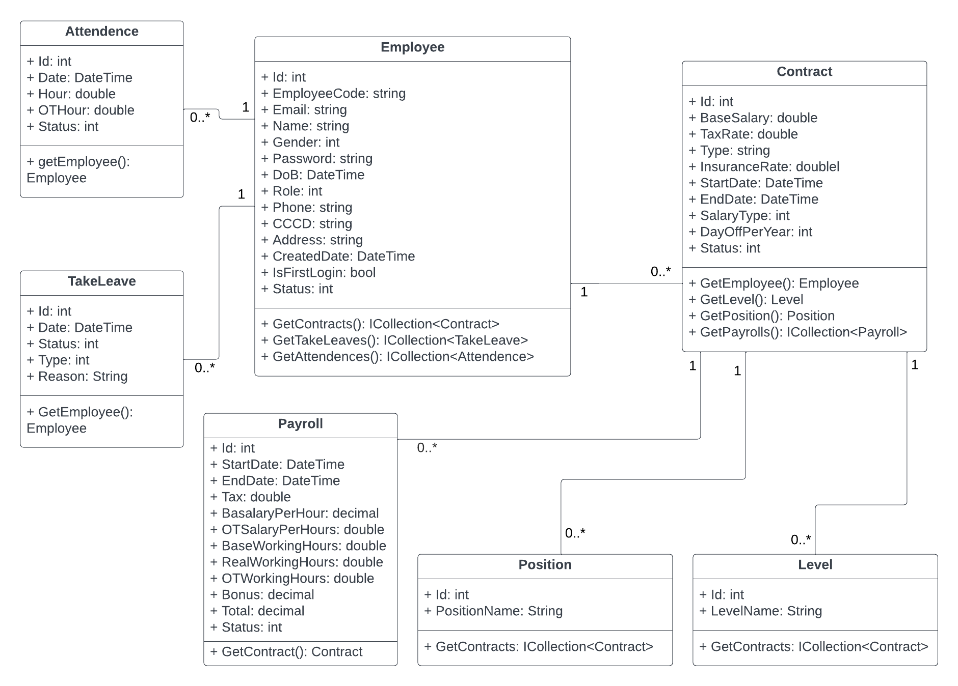

# System Architecture

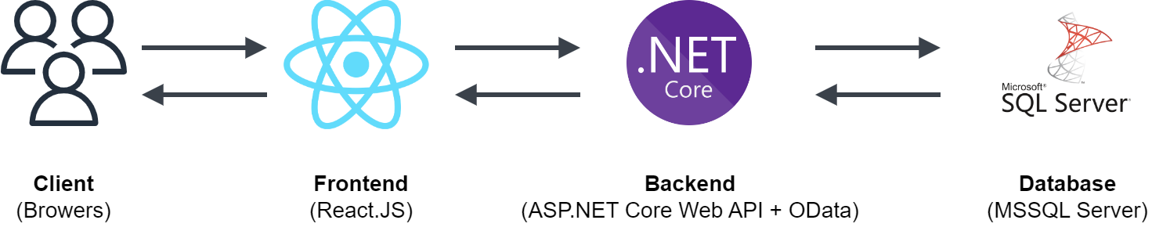

# Implementation

## Deployment Considerations

*Updating…*

## Screenshots and explanations

* + 1. **Screen Flow**

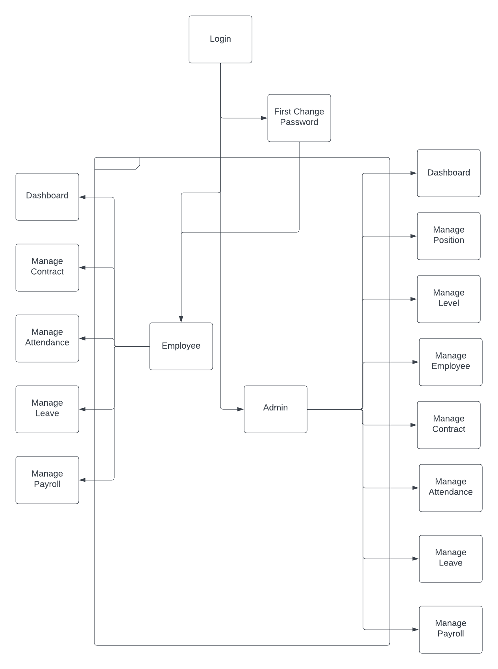

* + 1. **Screenshots and explanation**
       1. **Login**

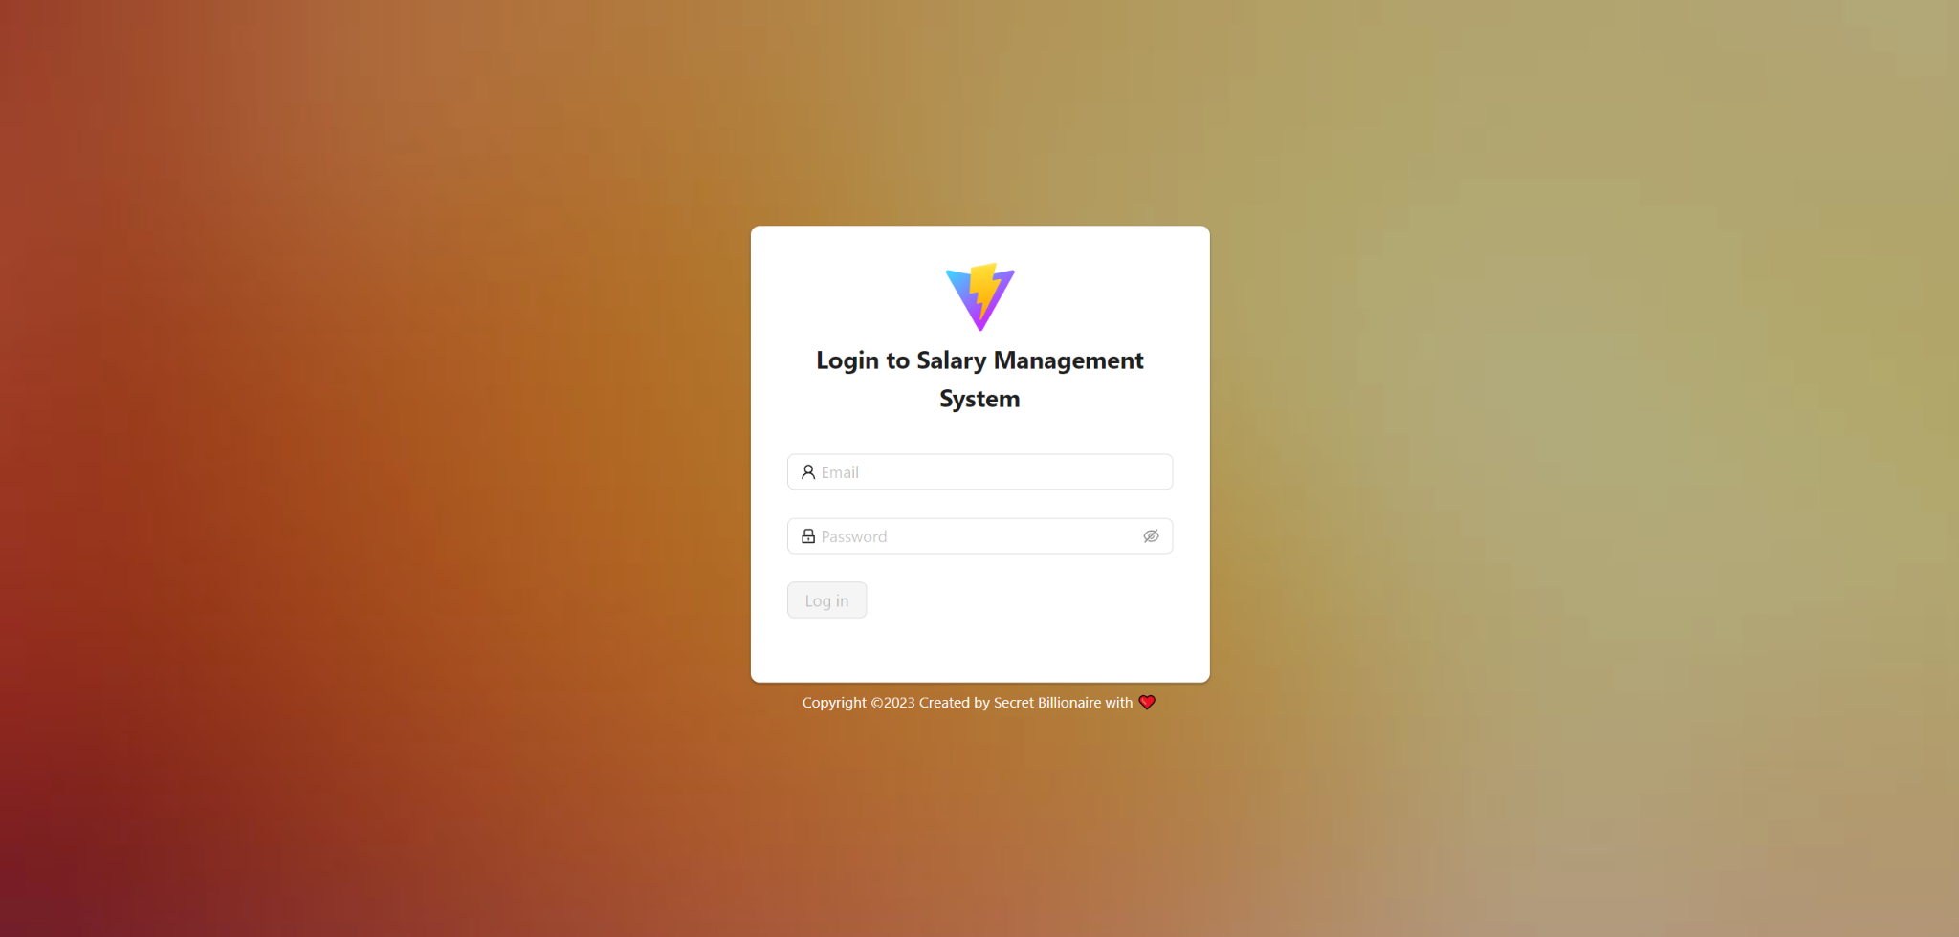

This screen is for all users to use their account logging into system, including requirements:

* Email field: required
* Password field: required, at least 6 characters
  + - 1. **Change password**

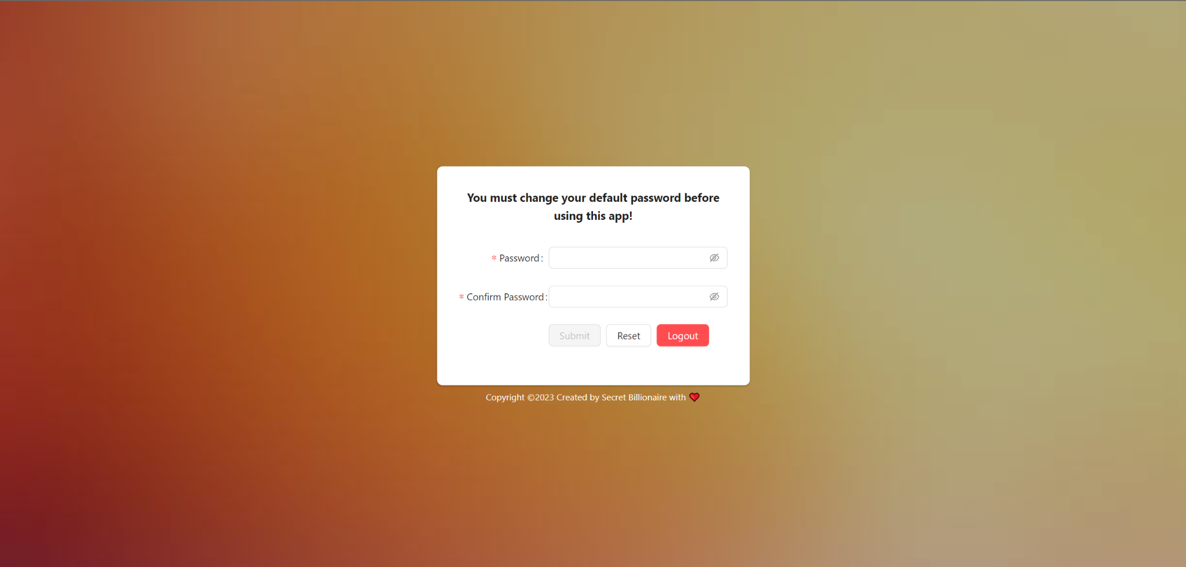

This screen is for all users when they first-time login into the system, including requirements:

* Password field: required, min length is 6
* Confirm Password: required, must match Password
  + - 1. **Admin - Dashboard**

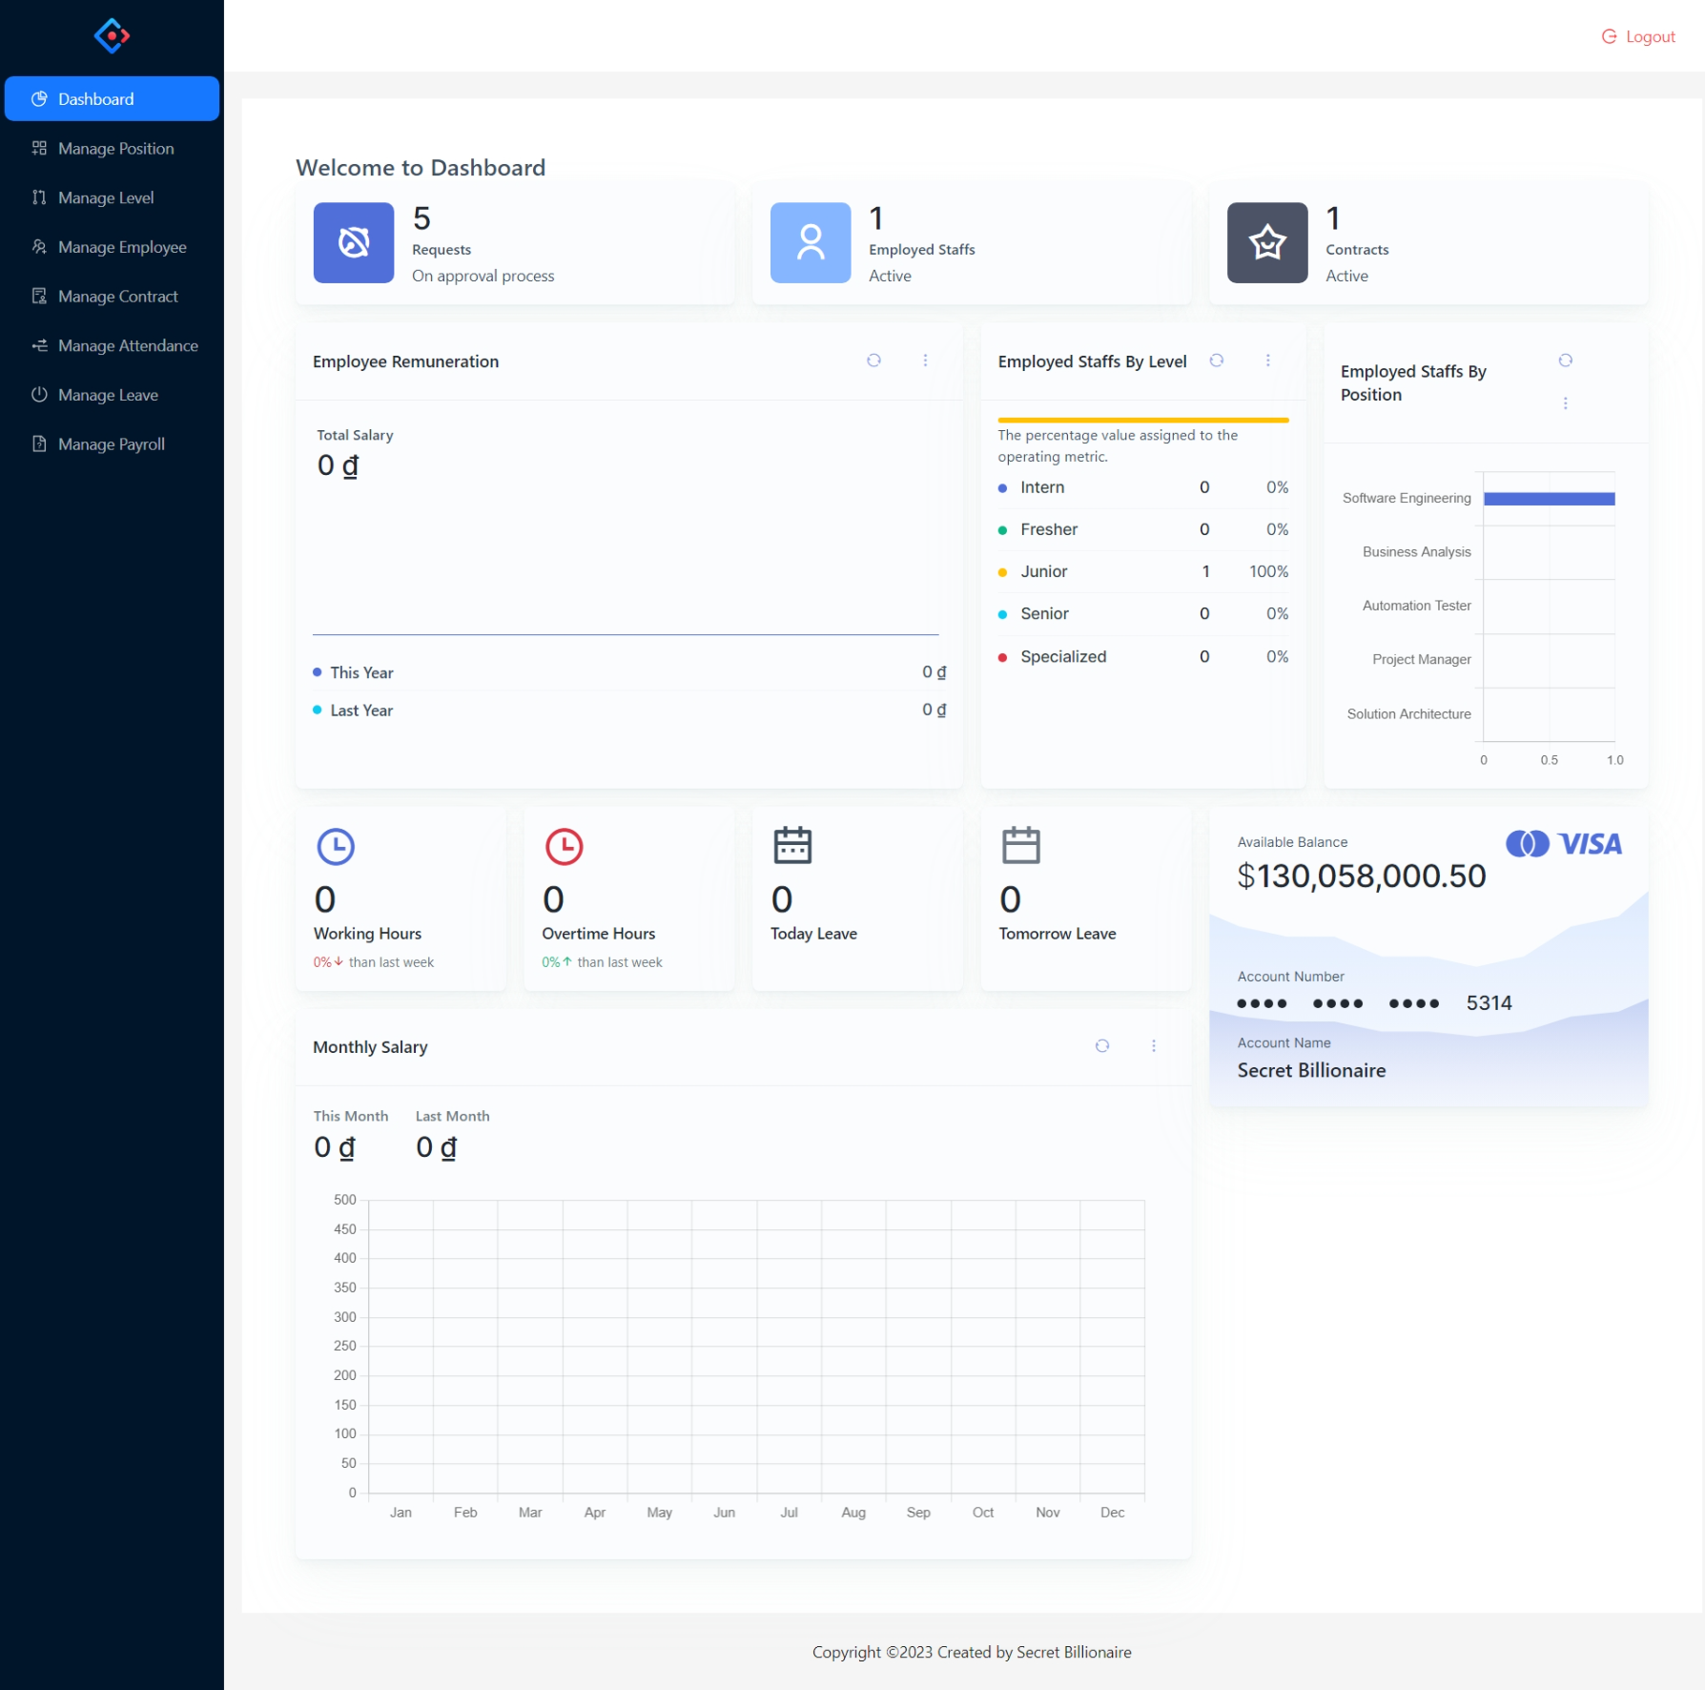

The admin dashboard is presented with an overview of the system's key metrics, such as total request on approval process, total users, contracts, this week working/overtime hours, today leave and tomorrow leave.

Visual representations like charts, graphs, or tables used to present the data effectively:

-The "Employee by Levels" chart provides an overview of the distribution of employees based on their levels within the organization. It visually represents the number or percentage of employees at each level.

-The "Employee by Positions" chart provides an overview of the distribution of employees based on their positions within the organization. It visually represents the number of employees at each position.

- The "Monthly Salary" chart provides an overview of the salary distribution among employees for each month throughout a year. It visually represents the salary for each month.

- The "Employee Remuneration" chart provides a comparison of the salary for each month in the current year and the previous year. It visually represents the salary trends for both years.

* + - 1. **Admin - Manage Position**

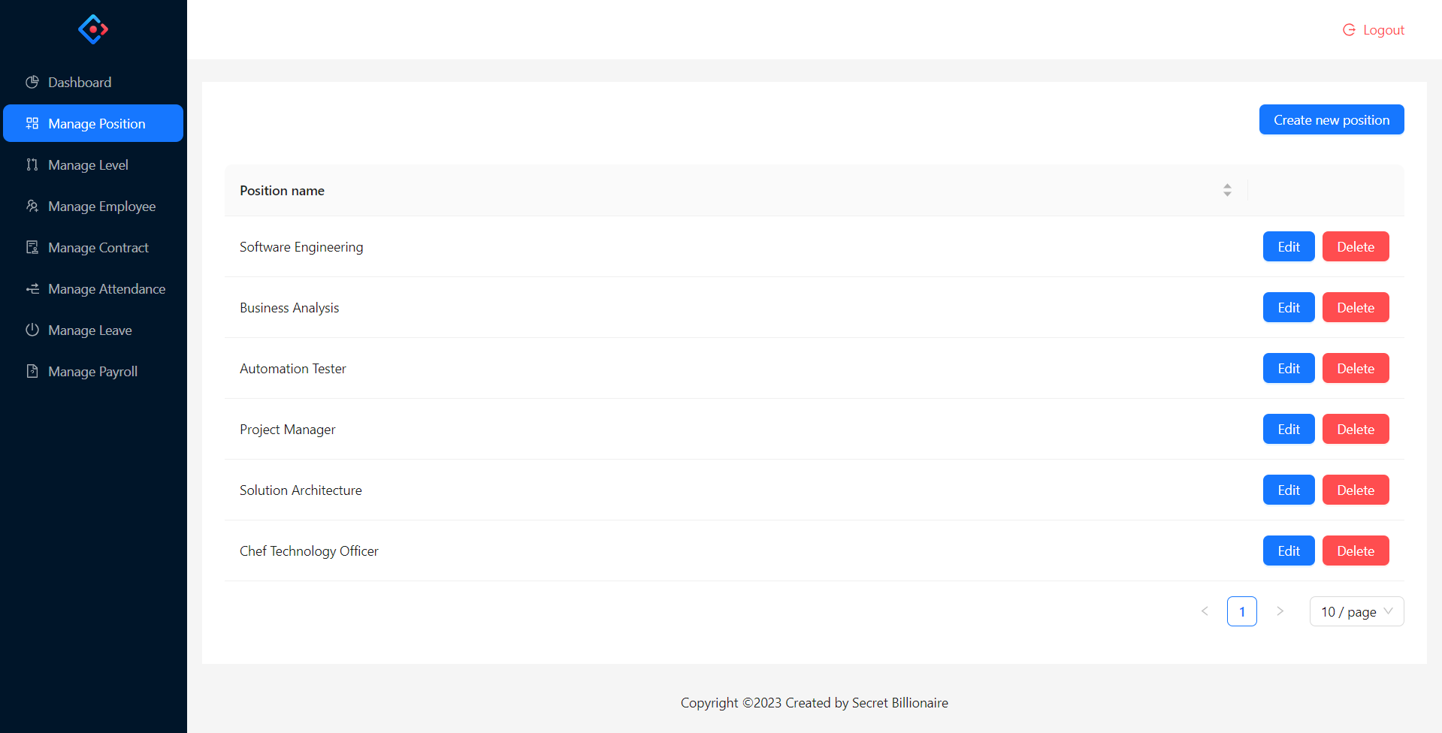

This screen is for admin to view list of positions, include the following elements:

* "Create new position" button.
* List of positions (Position Name)
* “Edit”, “Delete” button
  + - * 1. **Admin - Manage Position - Create new position**

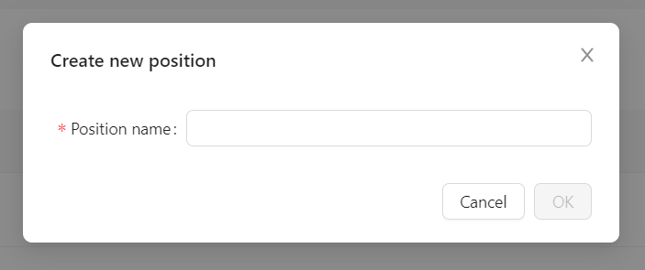

When clicking “Create new position” button, a modal create will show for admin to perform create new position, include the following elements:

* Position name field is required
* Create successfully only when Position Name doesn’t exist in system
  + - * 1. **Admin - Manage Position - Edit position**

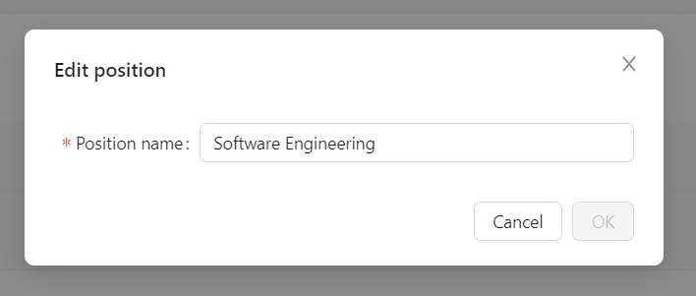

When clicking “edit” button, a modal edit will show for admin to perform update position, include the following elements:

* Position name field is required
* Update successfully only when new Position Name doesn’t exist in system
  + - * 1. **Admin - Manage Position - Delete position**

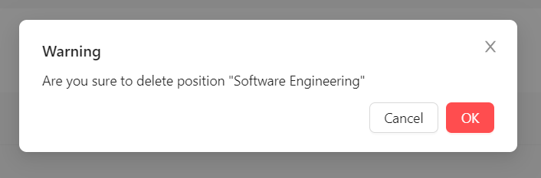

When clicking “delete” button, a modal delete will show for admin to perform delete position, include the following elements:

* Delete successfully only when current Position doesn’t belong to any Contract
  + - 1. **Admin - Manage Level**

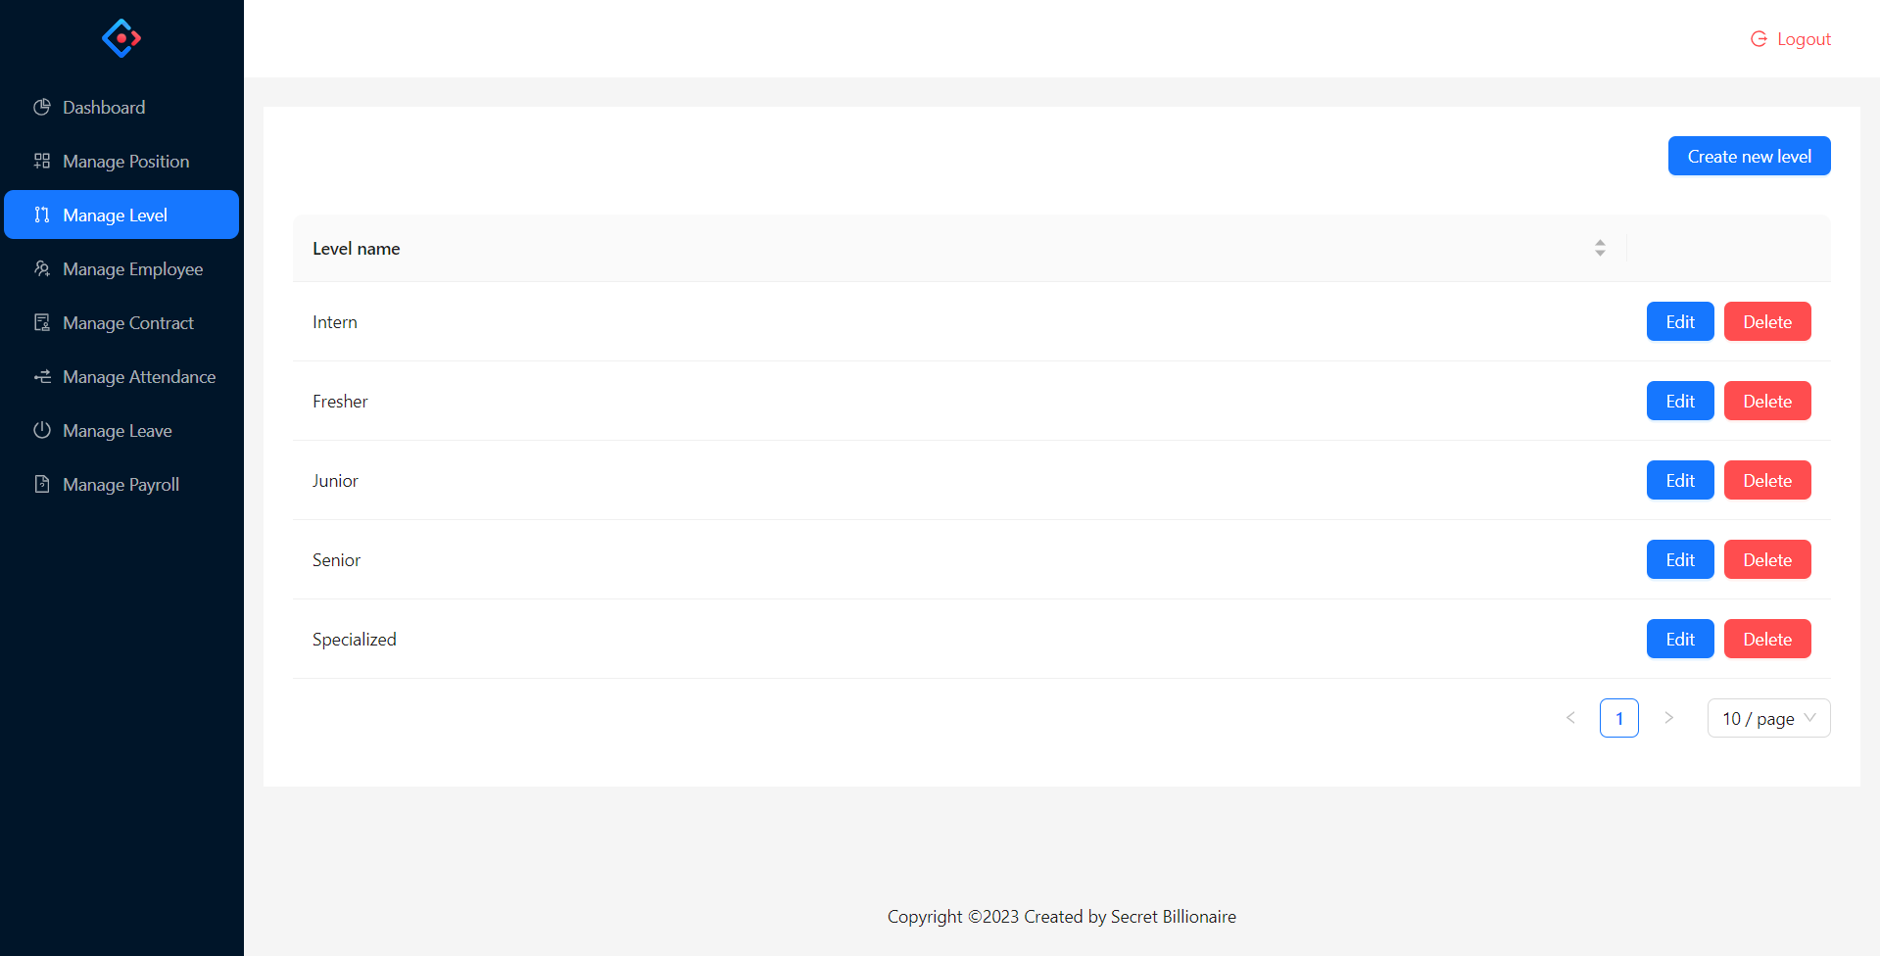

This screen is for admin to view list of levels, include the following elements:

* "Create new level" button.
* List of levels (Level Name)
* “Edit”, “Delete” button
  + - * 1. **Admin - Manage Level - Create new level**

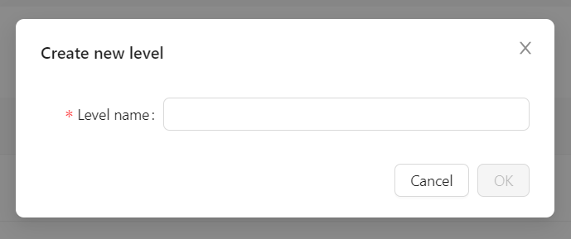

When clicking “Create new level” button, a modal create will show for admin to perform create new level, include the following elements:

* Level name field is required
* Create successfully only when Level Name doesn’t exist in system
  + - * 1. **Admin - Manage Level - Edit level**

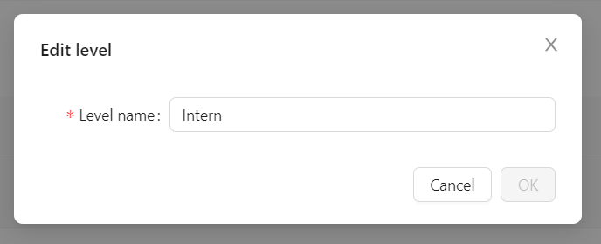

When clicking “edit” button, a modal edit will show for admin to perform update level, include the following elements:

* Level name field is required
* Update successfully only when new Level Name doesn’t exist in system
  + - * 1. **Admin - Manage Level - Delete level**

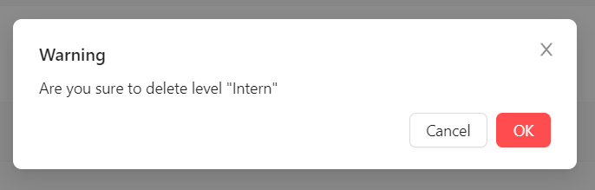

When clicking “delete” button, a modal delete will show for admin to perform delete level, include the following elements:

* Delete successfully only when current Level doesn’t belong to any Contract
  + - 1. **Admin - Manage Employee**

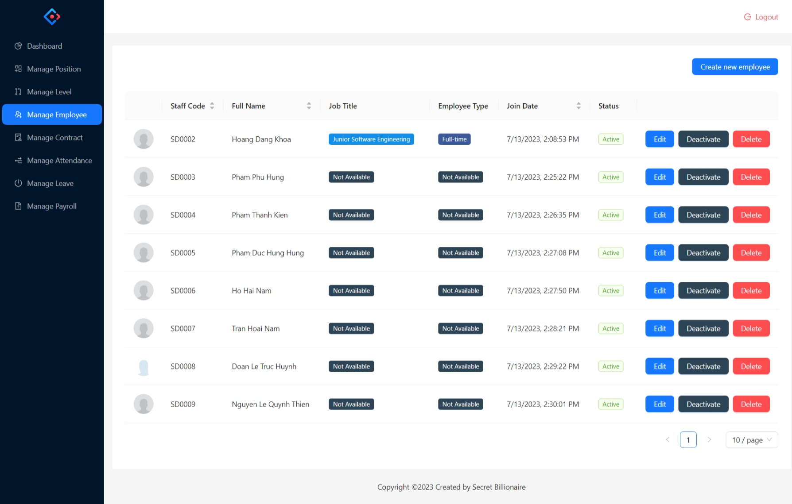

This screen is for admin to view list of employees, include the following elements:

* "Create new employee" button.
* List of employees (Avatar, Staff Code, Full Name, Job Title, Employee Type, Join Date, Status)
* “Edit”, “Active” (shows when Status is Deactivate), “Deactivate” (shows when Status is Activate), and “Delete” button
  + - * 1. **Admin - Manage Employee - Create new employee**

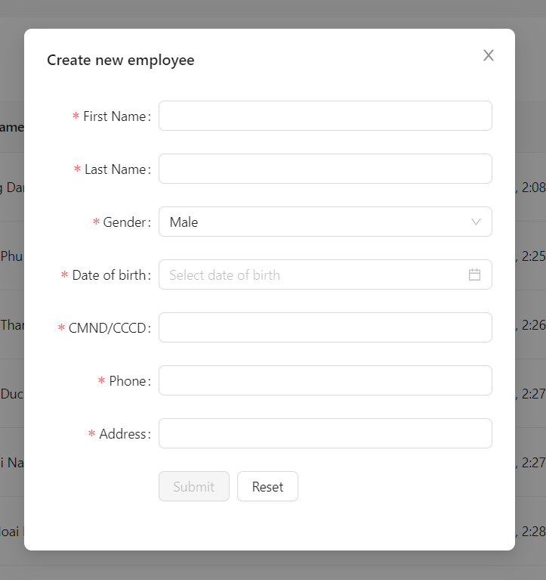

When clicking “Create new employee” button, a modal create will show for admin to perform create new employee, include the following elements:

* First Name field is required
* Last Name field is required
* Gender field is required (has 3 options: Male, Female and Others)
* Date of birth field is required (must be 18 years old)
* CCCD field is required (string length must be 9 or 12 and does not duplicated)
* Phone field is required (validate follows Vietnam phone number standard)
* Address field is required
* Email is generated automatically based on format: [FirstName with uppercase first letter + LastName]@[DoB] (eg: Hungphamphu@18102001)
* Password is generated automatically based on format: [lowercase FirstName + first character of each word in LastName]@projectx.com, if email generated already existed then add increasing number start from 1 (eg: hungpp@projectx.com, in case already existed email will be hungpp1@projectx.com)
* Create successfully only when satisfies all above requirements, and modal will be closed.
  + - * 1. **Admin - Manage Employee - Edit employee**

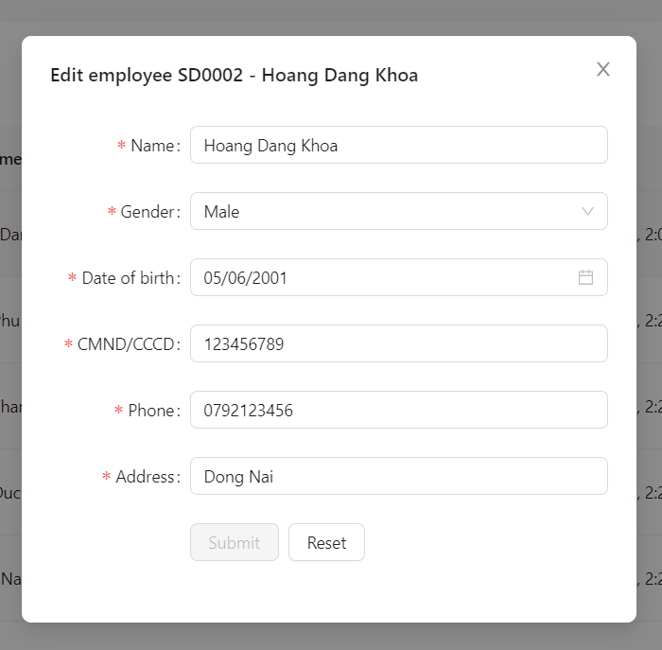

When clicking “edit” button, a modal edit will show for admin to perform update employee, include the following elements:

* Name is required
* Gender field is required (has 3 options: Male, Female and Others)
* Date of birth field is required (must be 18 years old)
* CCCD field is required (string length must be 9 or 12 and new CCCD does not duplicated)
* Phone field is required (validate follows Vietnam phone number standard)
* Address field is required
* Update successfully only when satisfies all above requirements, and modal will be closed.
  + - * 1. **Admin - Manage Employee - Delete employee**

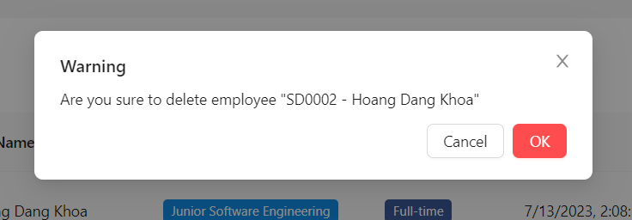

When clicking “delete” button, a modal delete will show for admin to perform delete employee, include the following elements:

* Delete successfully only when current employee doesn’t have any Contract
  + - * 1. **Admin - Manage Employee - Employee Detail**

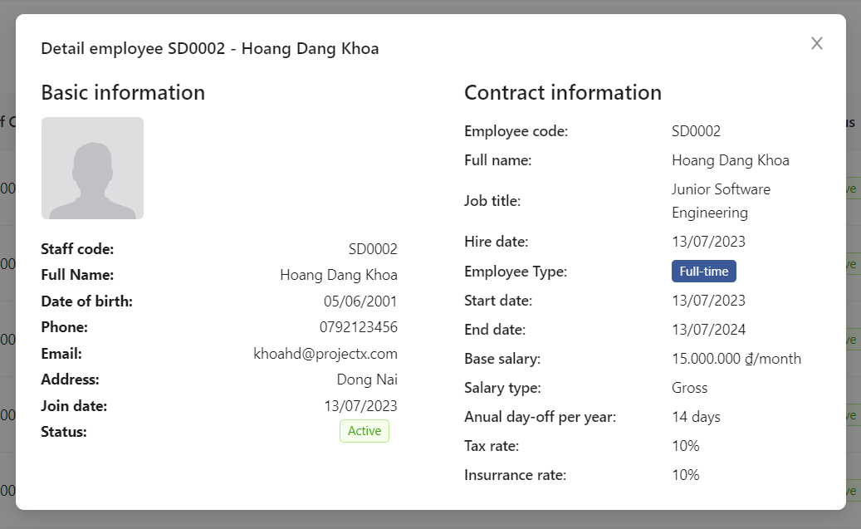

When clicking on a row, a modal detail will show for admin to view specific employee and their contract information

* + - * 1. **Admin - Manage Employee - Activate Employee**

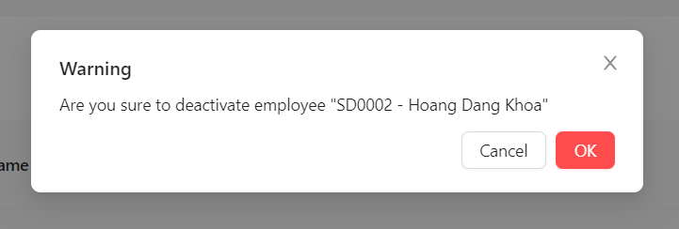

When clicking “Activate” button, a modal activate will show for admin to perform activate employee, include the following elements:

* When active successfully then password will be reset to default and isFirstLogin will be set to true
  + - * 1. **Admin - Manage Employee - Deactivate Employee**

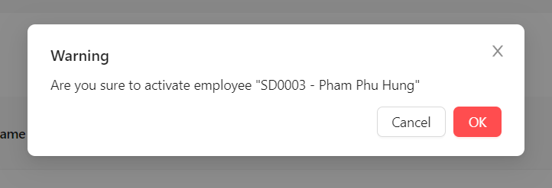

When clicking “Deativate” button, a modal deactivate will show for admin to perform deactivate employee, include the following elements:

* Deactivate successfully only when user doesn’t have any Active contract
  + - 1. **Admin - Manage Contract**

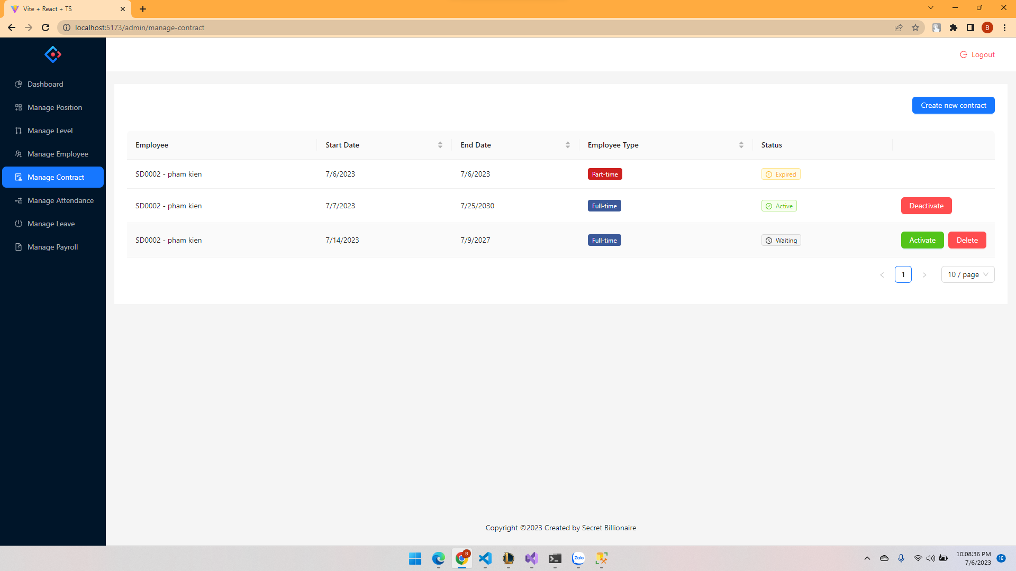

This screen is for admin to view list of contracts, include the following elements:

* "Create new contract" button.
* List of contracts (Employee, Start Date, End Date, Employee Type, Status)
* “Active” (shows when Status is Waiting), “Deactive” (shows when Status is Active), and “Delete” button (shows when Status is Waiting)
  + - * 1. **Admin - Manage Contract - Create new contract**

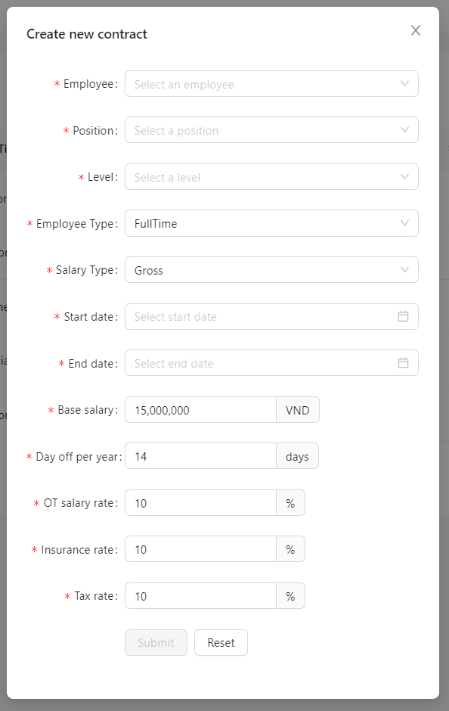

When clicking “Create new contract” button, a modal create will show for admin to perform create new contract, include the following elements:

* Employee field is required (Select one employee from list of employees in system)
* Position field is required (Select one position from list of positions in system)
* Level field is required (Select one level from list of levels in system)
* Employee Type field is required (has 2 options: Full-time and Part-time)
* Salary Type field is required (has 2 options: Gross and Net)
* Start Date field is required (must be equal or greater than today)
* End Date field is required (must be equal or greater than Start Date)
* Base Salary field is required (must be greater than 0)
* Day off per year field is only required when Employee Type is Full-time and must be greater than 0
* OT Salary rate field is only required when Employee Type is Full-time, must be greater than 0 and equal or lower than 100
* Insurrance rate field is only required when Salary Type is Gross, must be greater than 0 and equal or lower than 100
* Tax rate field is only required when Salary Type is Gross, must be greater than 0 and equal or lower than 100
* Create successfully only when satisfies all above requirements, and modal will be closed.
  + - * 1. **Admin - Manage Contract - Active contract**

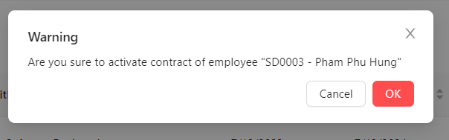

When clicking “Activate” button, a modal activate will show for admin to perform activate contract, include the following elements:

* Activate successfully only when this employee doesn’t have any active contract
  + - * 1. **Admin - Manage Contract - Deactivate contract**

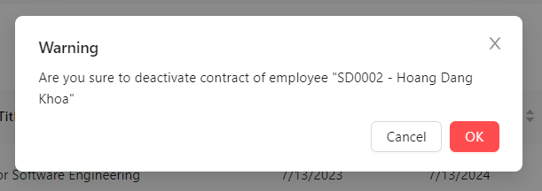

When clicking “Deactivate” button, a modal deactivate will show for admin to perform deactivate contract, include the following element:

* The End Date will be the date that admin perform deactivate
  + - * 1. **Admin - Manage Contract - Delete contract**

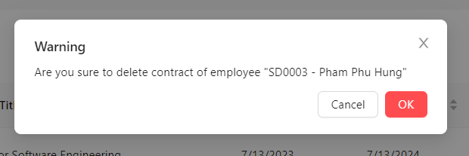

When clicking “Delete” button, a modal delete will show for admin to perform delete contract, include the following element:

* Delete successfully only when Status of contract is waiting

# Admin - Manage Attendance

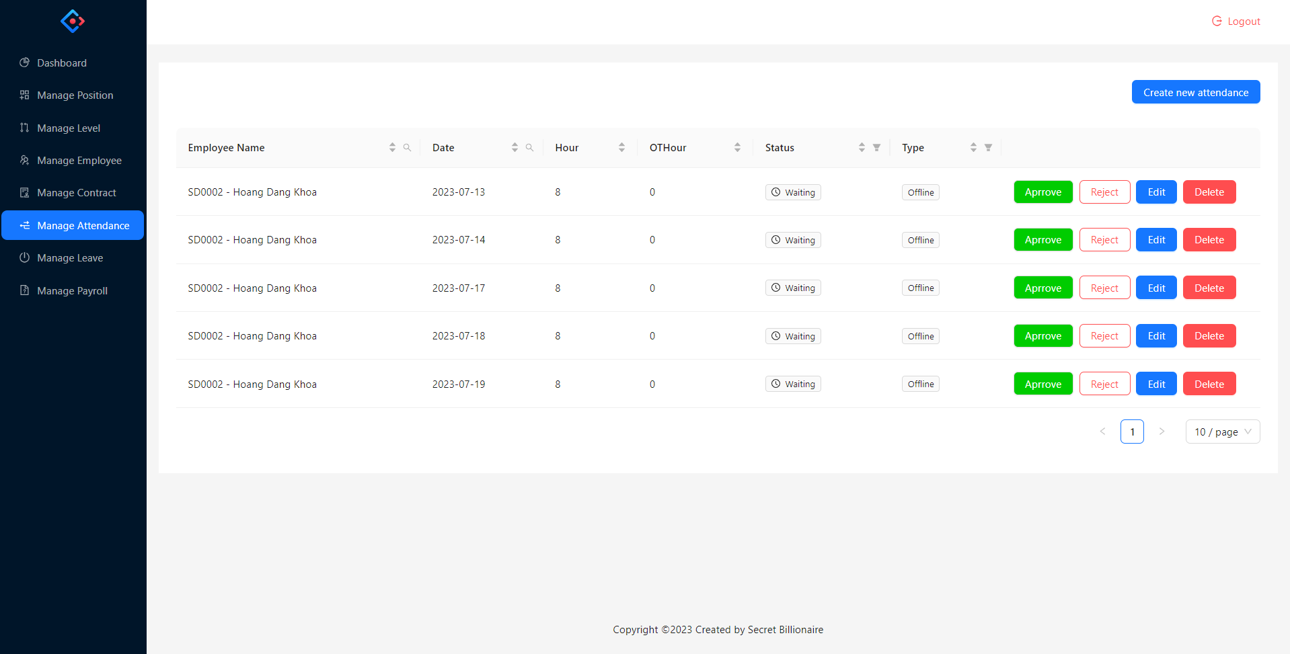

This screen is for admin to view list of attendance, include the following elements:

1. "Create new attendance" button.
2. List of attendances(Employee Name, Date, Number of hours work, Number of hours work over time, Status, Type)
3. Action button
   1. “Approve”, “Reject”, “Edit”, “Delete” (shows when Status is Waiting)
   2. “Delete” shows when status is Rejected.
   3. When status is Approved, it does not show any action.
      * + 1. **Admin - Manage Attendance - Create new attendance**

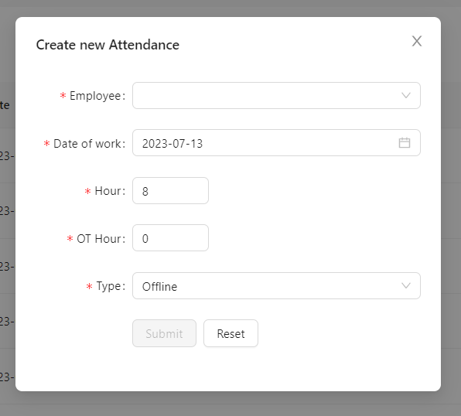

When admin click on button “Create new attendance”

The model will show up for admin to perform action create new attendance, include elements:

1. Employee (employee have status is active)
2. Date of work (From Monday to Friday, the time is from this week to future and is not past)
3. Hour (from 1 - 8)
4. OT Hour (from 0 to 8)
5. Type (Online - Offline)

All fields are required, then the admin clicks the create button, the modal is close and new attendance will create.

* + - * 1. **Admin - Manage Attendance - Approve**

When admin click on button “Approve”, this attendance’s status change to Approved

* + - * 1. **Admin - Manage Attendance - Reject**

When admin click on button “Reject”, this attendance’s status change to Rejected

* + - * 1. **Admin - Manage Attendance - Edit**

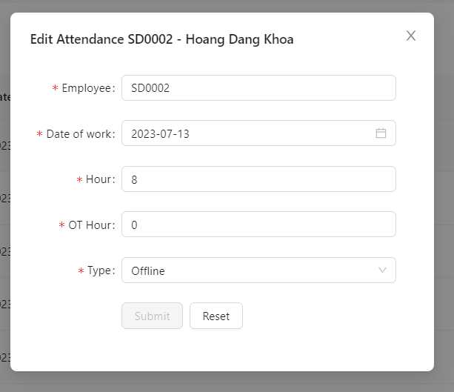

When admin click on button “Edit”

The model will show up for admin to perform action edit attendance, include elements:

1. Employee (show the employee you select to edit)
2. Date of work (From Monday to Friday, the time is from this week to future and is not past)
3. Hour (from 1 - 8)
4. OT Hour (from 0 to 8)
5. Type (Online - Offline)

All fields are required, then the admin clicks the submit button, the modal will close and attendance will be edited with new data.

* + - * 1. **Admin - Manage Attendance - Delete**

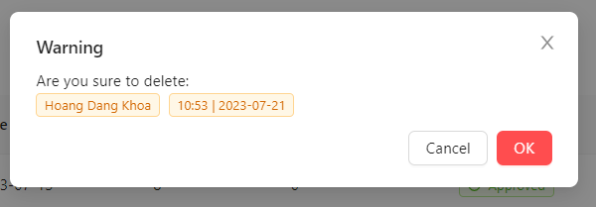

When admin click on button “Delete”

The mode confirm will show up for the admin to delete attendance. When the admin clicks on “Delete” button, the delete action will perform, attendance removed.

* + - 1. **Admin - Manage Leave**

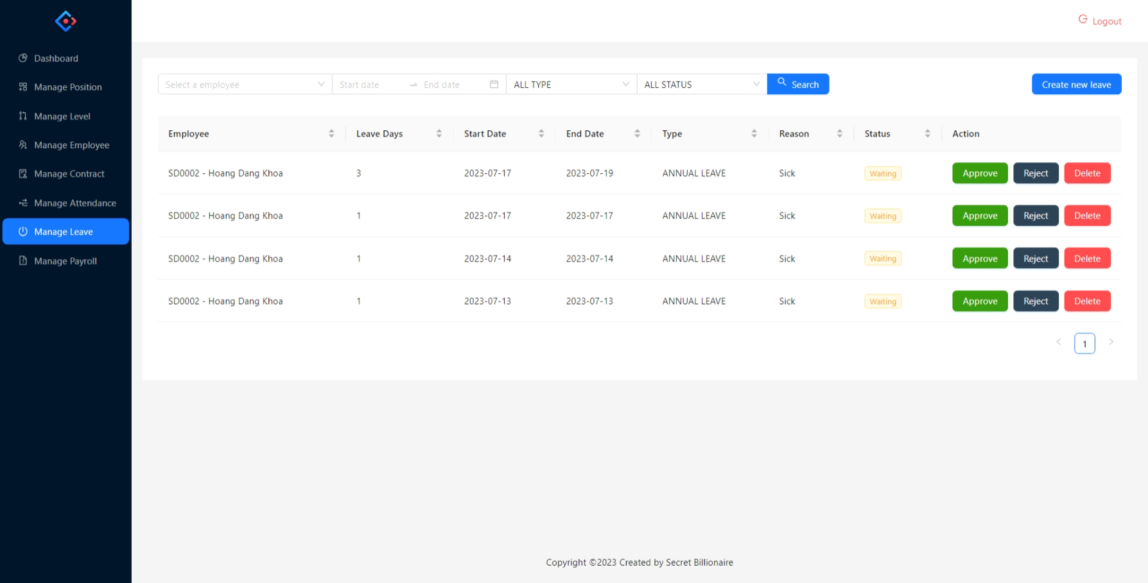

The admin navigates to the "Leave Management" section.

The system displays a list of existing leave records.

Each leave request typically includes details such as employee name, leaveDays, startDate, type, reason status.

The admin can filter or search for specific requests based on employee name, date range, type or status.

Upon reviewing a leave request, the admin can mark it as approved or rejected.

If rejected or waiting, the admin can delete the leave.

* + - * 1. **Admin - Manage Leave - Create new leave**

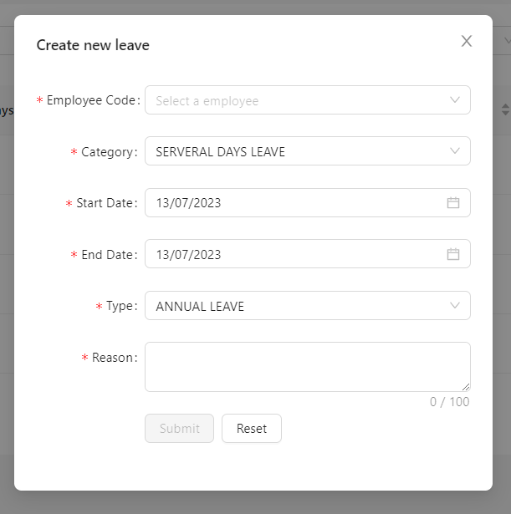

This function is for admin to create a new leave, clicks on the "Create New Leave" button including requirements:

- Admin has to input/select required fields: EmployeeCode, Category (ONE_DAY_LEAVE, SERVERAL_DAYS_LEAVE), StartDate, Type (ANNUAL_LEAVE, MATERNITY_LEAVE, PATERNITY_LEAVE, BEREAVEMENT_LEAVE, PUBLIC_HOLIDAY, UNPAID_LEAVE), Reason

-Admin has to input/select EndDate whether Category SERVERAL_DAYS_LEAVE selected.

- Required not existing approved leave within a specified time period to create leave.

- Required not existing approved attendance within a specified time period to create leave.

- Required existing active contract to create leave.

- Required leaveDays on leave > 0 to create leave, the system automatically deducts the corresponding leave days.

- There was a maximum limit on the number of annual leave days an employee can accumulate based on the latest contract.

If any errors are found, appropriate error messages are displayed. If the form submission is successful, the system displays a confirmation message.

* + - * 1. **Admin - Manage Leave - Approve**

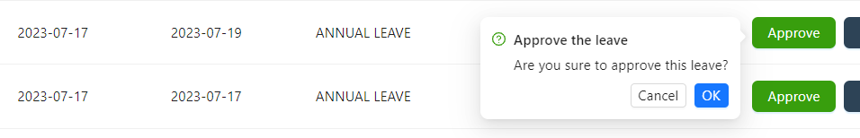

This function is for admin to select a leave request from the list to approve it, clicks on the "Approve" button including requirements:

- The system automatically deducts the corresponding leave days from the employee's leave balance, requiring leaveDays on leave > 0.

- Required not existing approved leave within a specified time period.

- Required not existing approved attendance within a specified time period.

- Required existing active contract.

If any errors are found, appropriate error messages are displayed. If the form submission is successful, the system displays a confirmation message.

* + - * 1. **Admin - Manage Leave - Reject**

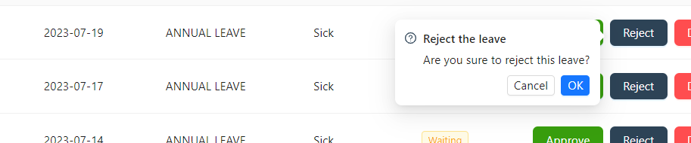

This function is for the admin to select a waiting leave request from the list to reject it, clicks on the "Reject" button.

If any errors are found, appropriate error messages are displayed. If the form submission is successful, the system displays a confirmation message.

* + - * 1. **Admin - Manage Leave - Delete**

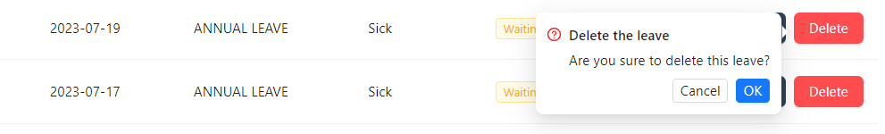

This function is for the admin to select a waiting/rejected leave request from the list to delete it, clicks on the "Delete" button.

If any errors are found, appropriate error messages are displayed. If the form submission is successful, the system displays a confirmation message.

* + - 1. **Admin - Manage Payroll**

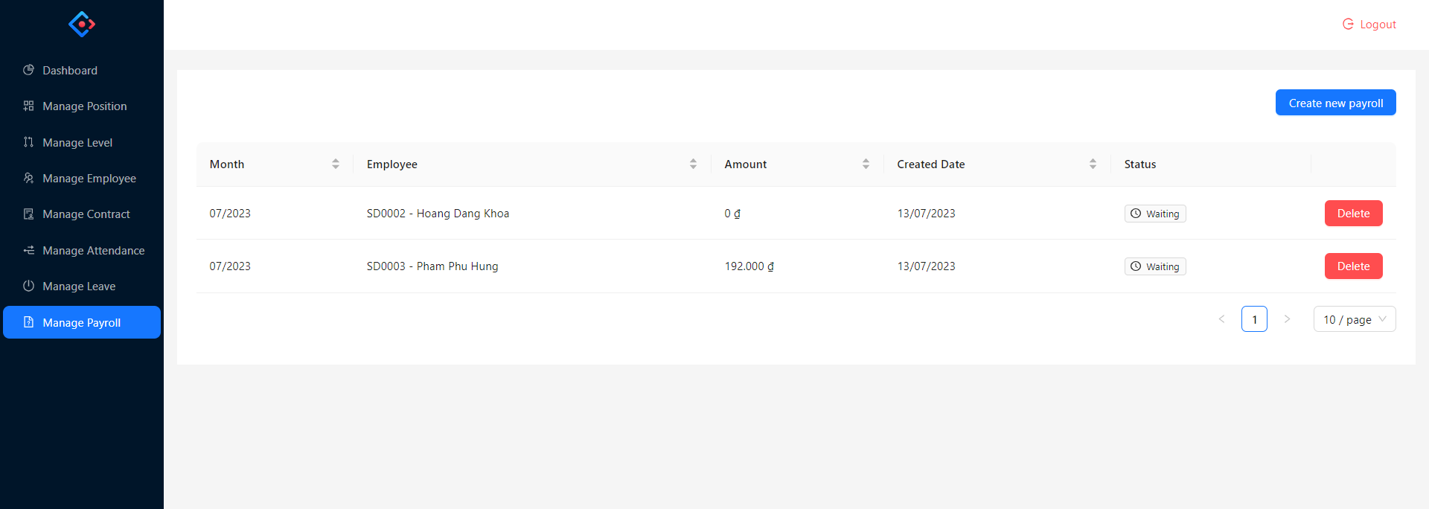

This screen is for admin to view list of payrolls, include the following elements:

* "Create new payroll" button.
* List of payrolls(Month, Employee, Amount, Created Date, Status)
* “Delete” button (shows when Status is Waiting)
  + - * 1. **Admin - Manage Payroll - Create new payroll**

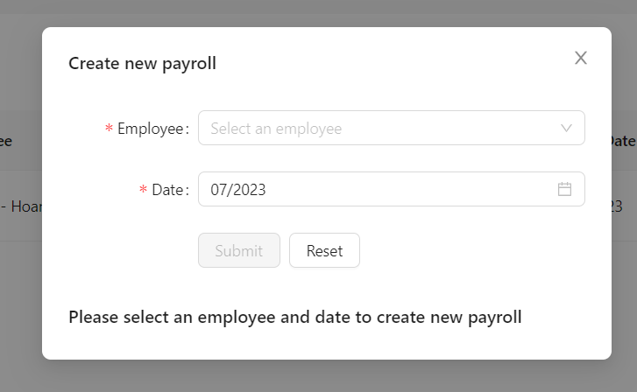

* + - * 1. **Admin - Manage Payroll - Payroll Detail**

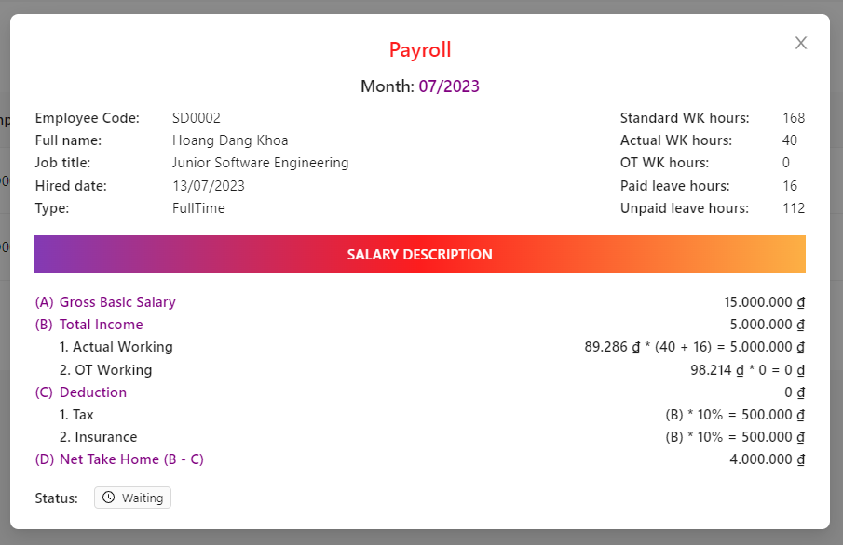

* + - * 1. **Admin - Manage Payroll - Delete**

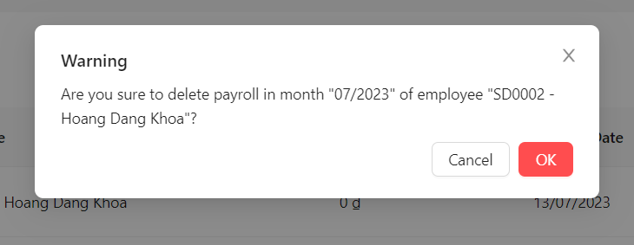

# Employee - Dashboard

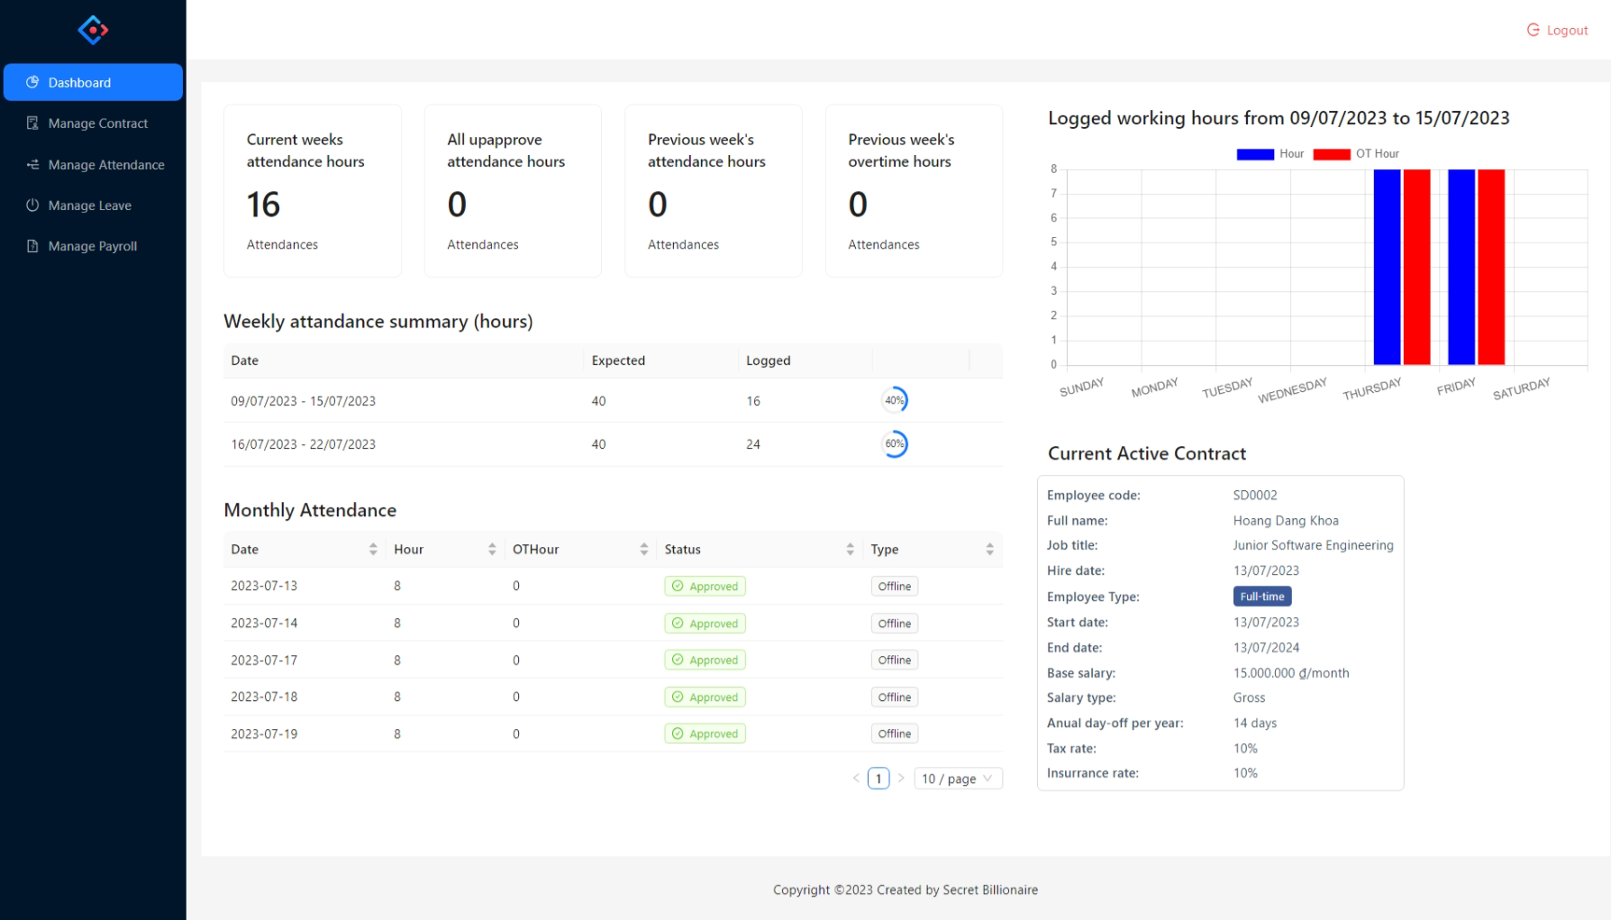

This screen is for employee to view report statics of employee’s working, include thefollowing elements:

1. View report time working in current week, previous week
2. View current contract
3. View static time in current week
4. View table report weekly summary
5. View table report monthly summary
   * + 1. **Employee - Manage Contract**

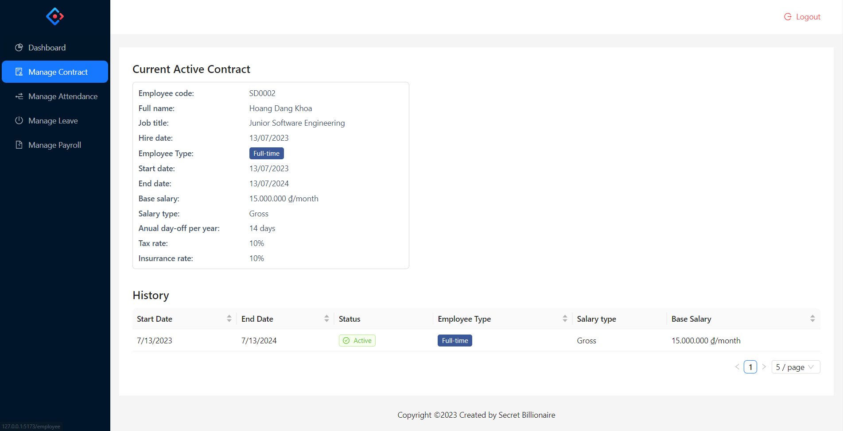

# Employee - Manage Attendance

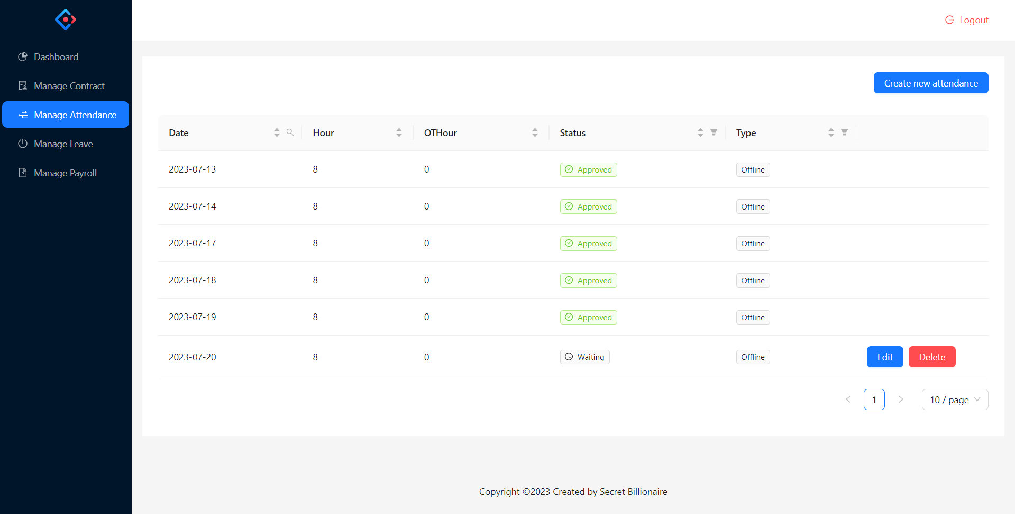

This screen is for employee to view list of attendance, include the following elements:

* "Create new attendance" button.
* List of attendances (Employee Name, Date, Number of hours work, Number of hours work over time, Status, Type)
* Action button
  + “Edit”, “Delete” (shows when Status is Waiting)
  + “Delete” shows when status is Rejected.
  + When status is Approved, it does not show any action.
    - * 1. **Employee - Manage Attendance - Create new attendance**

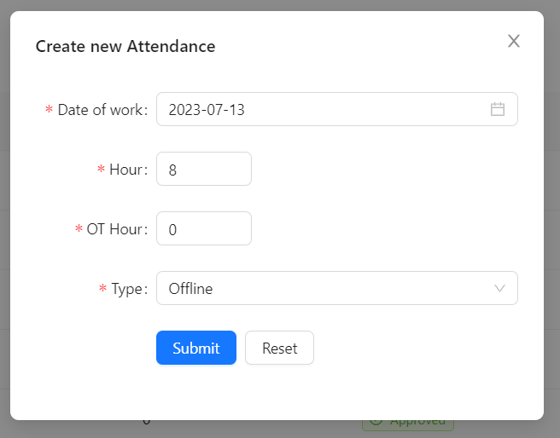

When employee click on button “Create new attendance”

The model will show up for employee to perform action create new attendance, include elements:

1. Date of work (From Monday to Friday, the time is from this week to future and is not past)
2. Hour (from 1 - 8)
3. OT Hour (from 0 to 8)
4. Type (Online - Offline)

All fields are required, then the employee clicks the create button, the modal is close and new attendance will create.

* + - * 1. **Employee - Manage Attendance - Delete**

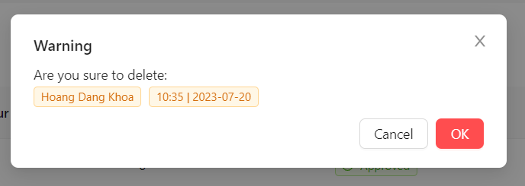

When employee click on button “Delete” then the mode confirm will show up for the employee to delete attendance. When the employee clicks on “Delete” button, the delete action will perform, attendance removed.

* + - 1. **Employee - Manage Leave**

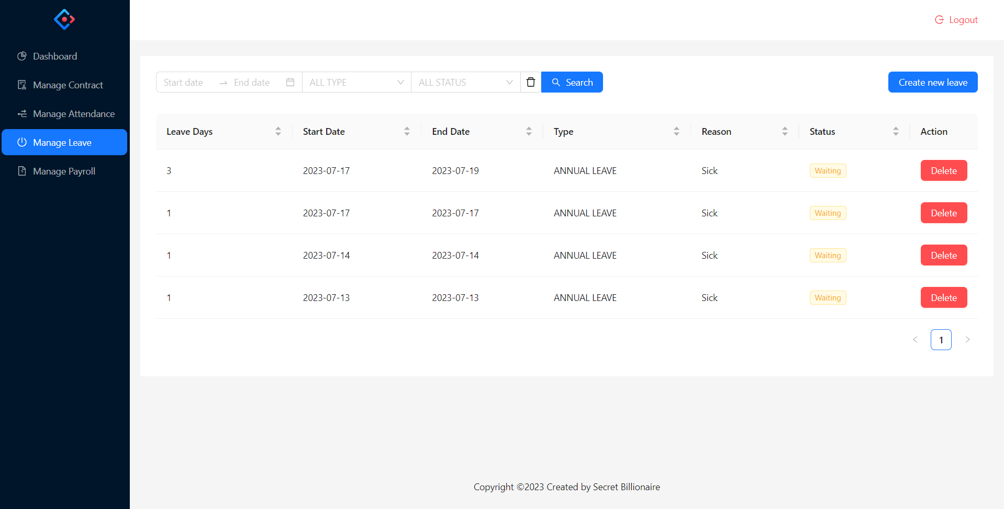

The employee navigates to the "Leave Management" section.

The system displays a list of existing leave records.

Each leave request typically includes details such as employee name, leaveDays, startDate, type, reason status.

The employee can filter or search for specific requests based on date range, type or status.

If rejected or waiting, the employee can delete the leave.

* + - * 1. **Employee - Manage Leave - Create new leave**

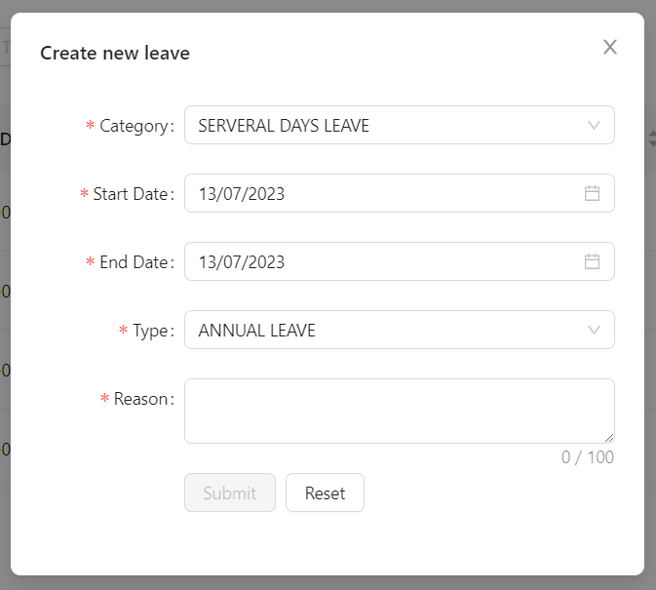

This function is for employee to create a new leave, clicks on the "Create New Leave" button including requirements:

- Employee has to input/select required fields: EmployeeCode, Category (ONE_DAY_LEAVE, SERVERAL_DAYS_LEAVE), StartDate, Type (ANNUAL_LEAVE, MATERNITY_LEAVE, PATERNITY_LEAVE, BEREAVEMENT_LEAVE, PUBLIC_HOLIDAY, UNPAID_LEAVE), Reason

-Employee has to input/select EndDate whether Category SERVERAL_DAYS_LEAVE selected.

- Required not existing approved leave within a specified time period to create leave.

- Required not existing approved attendance within a specified time period to create leave.

- Required existing active contract to create leave.

- Required leaveDays on leave > 0 to create leave, the system automatically deducts the corresponding leave days.

- There was a maximum limit on the number of annual leave days an employee can accumulate based on the latest contract.

If any errors are found, appropriate error messages are displayed. If the form submission is successful, the system displays a confirmation message.

* + - * 1. **Employee - Manage Leave - Delete**

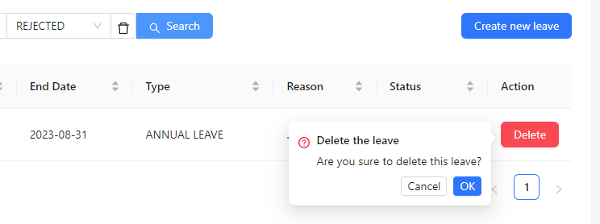

This function is for the employee to select a waiting/rejected leave request from the list to delete it, clicks on the "Delete" button.

If any errors are found, appropriate error messages are displayed. If the form submission is successful, the system displays a confirmation message.

* + - 1. **Employee - Manage Payroll**

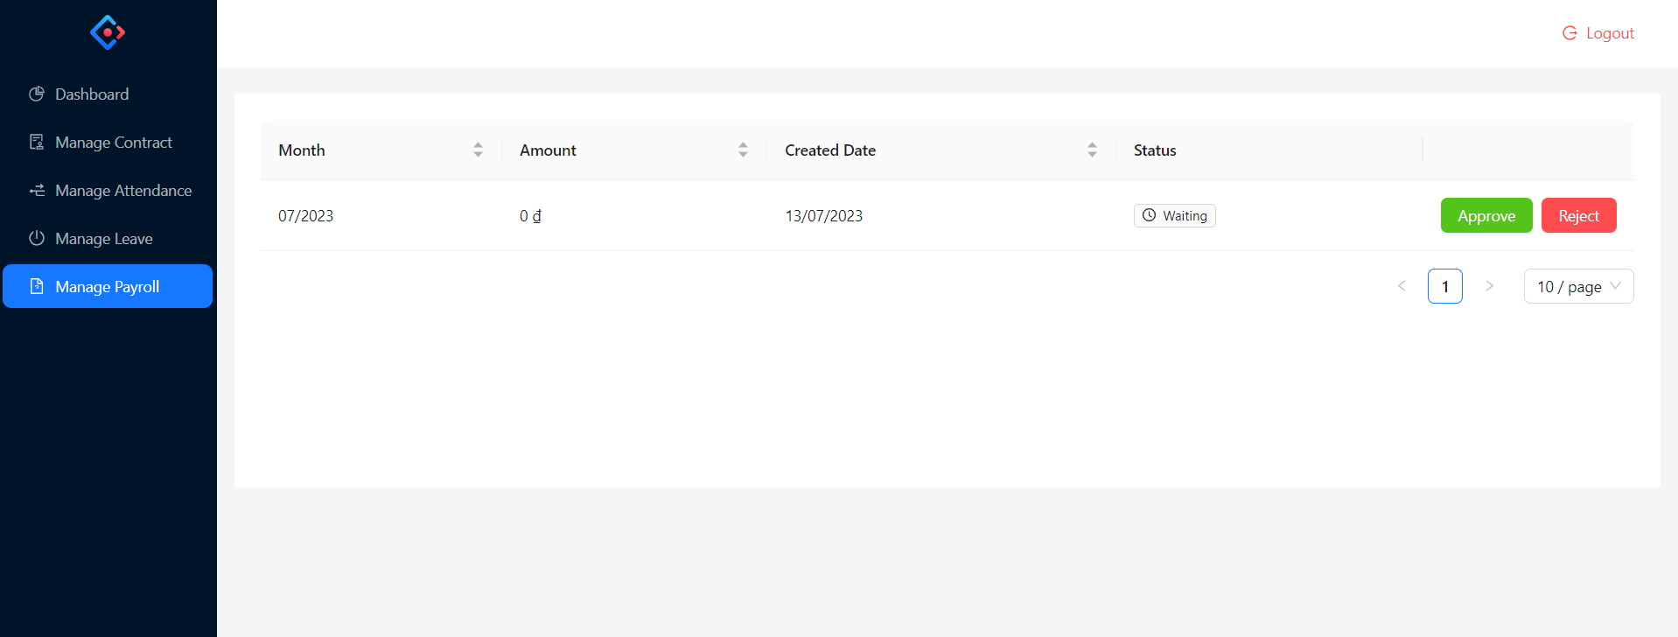

* + - * 1. **Employee - Manage Payroll - Approve**

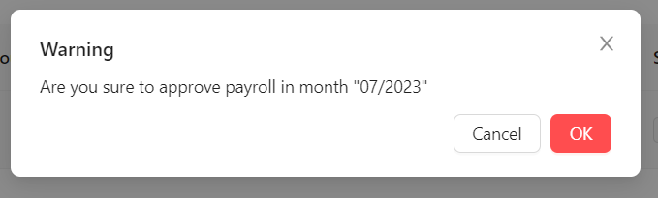

* + - * 1. **Employee - Manage Payroll - Reject**

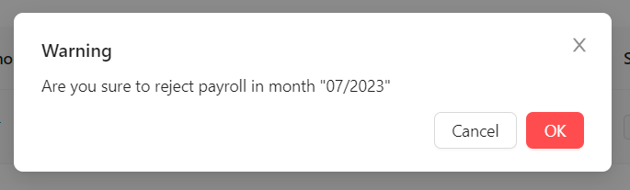

* + - * 1. **Employee - Manage Payroll - Payroll Detail**



# References