ĐỀ 2
Câu 1: n=1500
#include <iostream>
#include <math.h>
using namespace std;

void primeFactors(int n, int p[5000], int m[5000], int *l)
{
int i=1;
p[0]=1;
m[0]=1;
m[i]=0;
if(n%2 == 0)
{
p[i]=2;
while(n%2 == 0)
{
n=n/2;
m[i]++;
}
i++;
}

for(int j=3; j<=sqrt(n); j+=2)
{
if(n%j == 0)
{
p[i]=j;
m[i]=0;
while(n%j == 0)
{
n=n/j;
m[i]++;
}
i++;
}
}
if(n>2)
{
p[i]=n;
m[i]++;
i++;
}
*l = i;
}
int Tong(int p[5000], int m[5000], int l, int n)
{
int s=1;
for(int i=1; i<l; i++)
{
s*=(pow(p[i],m[i]+1) - 1) / (p[i] - 1);
}
return s;
}
int main()
{
int n, p[5000], m[5000], l;
cout <<"CAU 1\n";
cout <<"Nhap n: ";
cin >>n;

primeFactors(n,p,m,&l);
cout <<"\na) PHAN TICH THUA SO NGUYEN TO\n";
cout <<n <<" = ";
for(int k=1; k<l; k=k+1)
{
cout <<p[k] <<"^" <<m[k] <<" ";
}

cout <<"\n\nb) TINH TONG CAC UOC SO\n";
cout <<"Tong cac uoc so cua " <<n <<" la: " <<Tong(p,m,l,n);
return 0;
}
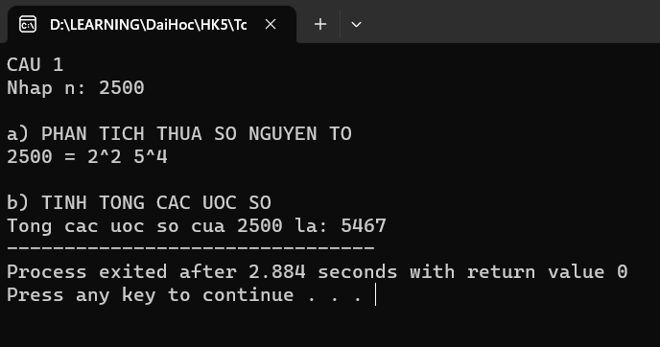

Câu 2:
X=2 mod 5
X=4 mod 7
X=6 mod 9
#include <iostream>
#include <math.h>
using namespace std;

int ModularInverse(int x, int m)
{
int k=0;
while((1 + k*m) % x != 0)
{
k++;
}
return (1 + k*m)/x;
}
int Tich(int p[], int n)
{
double t=1;
for(int i=1; i<=n; i++)
{
t*=p[i];
}
return t;
}
void Show(int a[], int m[], int n)
{
for(int i=1; i<=n; i++)
{
cout <<"\n x = " <<a[i] <<" mod " <<m[i];
}
}
void chinese(int a[10], int m[10], int n)
{
int x0[10], x1[10], x = 0;
int t = Tich(m, n);
for(int i=1; i<=n; i++)
{
x0[i] = t/m[i];
x1[i] = ModularInverse(x0[i],m[i]);
x += a[i]*x0[i]*x1[i];
}
x = x % t;
cout <<"\n\n => x = " <<x <<" (mod " <<t <<")";
}
int main()
{
int max = 10;
int n, a[max], m[max], x0[max], x1[max], x = 0;
cout <<"Cau2: CHINESE REMAINDER THEOREM\n";
cout <<"Nhap n = ";
cin >>n;
for(int i=1; i<=n; i++)
{
cout <<"Nhap a[" <<i <<"] = ";
cin >>a[i];
cout <<"Nhap m[" <<i <<"] = ";
cin >>m[i];
}
Show(a,m,n);
chinese(a,m,n);
return 0;
}
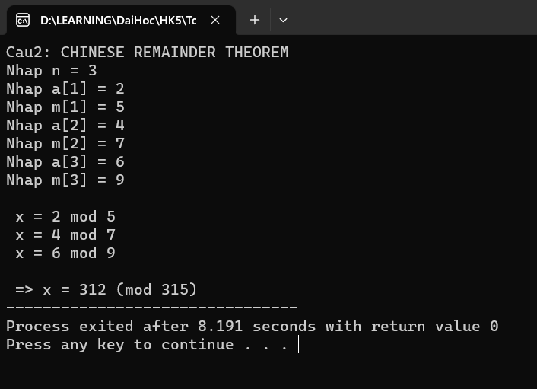

Câu 3:
a)
#include<math.h>
#include <iostream>
#include <stdio.h>
#include <iomanip>
using namespace std;
#define max 1000

int lower[max][max]={0},lowerT[max][max]={0},y[max][max]={0};
int x[max][max],mt[max][max],kq[max][max];
int D[max] = {0};
int m,n;

void input()
{
cout << "Enter number of rows: " ; cin >> m;
cout << "Enter number of columns: " ; cin >> n;
// ktra ma tran vuong
while (m!=n)
{
cout << "THIS IS NOT A SQUARE MATRIX SO CAN NOT DECOMPOSE! PLEASE RE-ENTER!" << endl;
cout << "Enter number of rows: " ; cin >> m;
cout << "Enter number of columns: " ; cin >> n;
}
cout << "Enter value: " << endl;
for (int i=1; i<=n; i++)
{
for (int j=1; j<=n; j++)
{
cout << "x[" << i << "]" << "["<< j << "]" << " = ";
cin >> x[i][j];
}
}
}

void output(int a[][max], int n)
{
int i,j;
cout << endl;
for(i=1;i<=n;i++)
{
for (j=1;j<=n;j++)
{
cout << setw(5) << a[i][j];
}
cout << endl;
}
}

int compareMatrix(int a[][max], int b[][max], int n){
for(int i=1; i <= n ;i ++ )
{
for(int j=1;j <=n ;j++)
{
if(b[i][j] != a[i][j]) return 0;
}
}
return 1;
}

void proMatrix(int a[][max], int b[][max],int c[][max], int n)
{
int i,j,k;
for (i=1;i<=n;i++)
{
for(j=1;j<=n;j++)
{
c[i][j]=0;
for(k=1;k<=n;k++)
{
c[i][j]+=a[i][k]*b[k][j];
}
}
}
}

void VariantDecomposition(int a[][max], int n)
{
// ktra ma tran doi xung
for (int i=1; i<=n; i++)
{
for (int j=1; j<=n; j++)
{
if (i!=j)
{
if (x[i][j]!=x[j][i])
{
cout << endl << "MATRIX IS NOT SYMMETRIC! CAN NOT DECOMPOSE!";
exit(0);
}
}
}
}
// phan ra ma tran
for (int i=1; i<=n; i++)
{
lower[i][i] = 1;
}
int sum = 0;
for (int i=1; i<=n; i++)
{
sum = 0;
for (int k=1; k<=i; k++)
sum += pow(lower[i][k], 2) * D[k];
D[i] = x[i][i] - sum;
for (int j=i+1; j<=n; j++)
{
sum = 0;
for (int k=1; k<=i; k++)
sum += lower[j][k] * lower[i][k] * D[k];
lower[j][i] = (x[j][i] - sum) / D[i];
}
}
for (int i=1; i<=n; i++)
{
y[i][i] = D[i];
}
// xuat
cout << endl << "Lower Triangular"
<< setw(36) << "Diagonal Matrix"
<< setw(28) << "Transpose" << endl;
for (int i=1; i<=n; i++)
{
for (int j=1; j<=n; j++)
{
cout << lower[i][j] << "\t";
lowerT[i][j] = lower[j][i];
}
cout << "\t";
for (int j=1; j<=n; j++)
{
cout << setw(6) << y[i][j] << "\t";
}
cout << "\t";

for (int j=1; j<=n; j++)
cout << setw(6) << lower[j][i] << "\t";
cout << endl;
}

proMatrix(lower,y,mt,n);
proMatrix(mt,lowerT,kq,n);
if(compareMatrix(x,kq,n))
cout << endl << "Check result: TRUE";
else cout << endl << "Check result: FALSE";
}

int main()
{
cout <<"Cau 3:\na)CHOLESKY BIEN THE\n";
input();
output(x,n);
VariantDecomposition(x,n);

return 0;
}
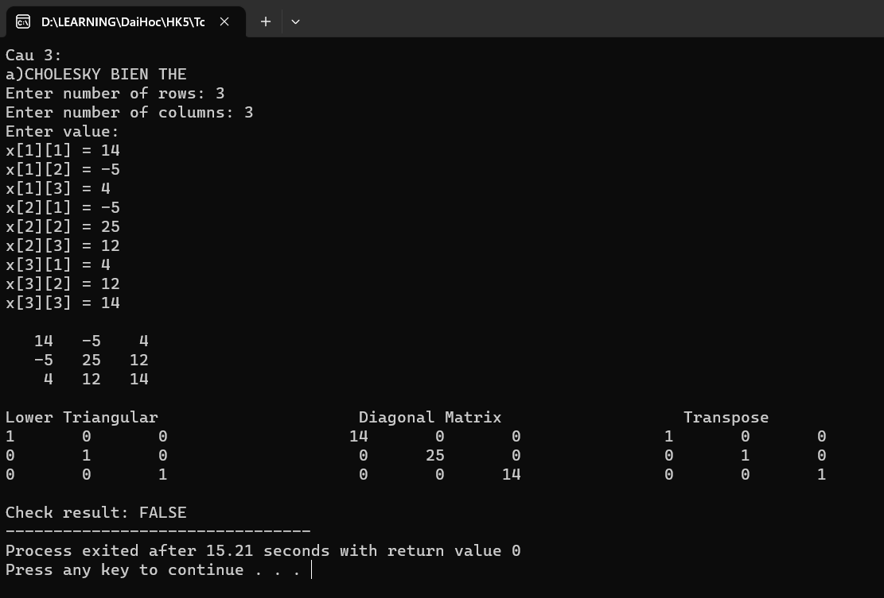

b)
#include <stdio.h>
#include <math.h>
#include <conio.h>
#include <iostream>
#include <iomanip>
#include <Eigen/Dense>
using Eigen::MatrixXd;
using namespace Eigen;
using namespace std;
void input(float a[][10], int n)
{
for(int i=0; i<n; i++)
{
for(int j=0; j<n; j++)
{
cout <<"a[" <<i <<"][" <<j <<"] = ";
cin >>a[i][j];
}
}
}
void output(float a[][10], int n)
{
for(int i=0; i<n; i++)
{
for(int j=0; j<n; j++)
{
cout << setw(8) << setprecision(2) << fixed <<a[i][j];
}
cout <<"\n";
}
}
void saochep (float a[][10], float b[][10], int n)
{
for (int i=0;i<n; i++){
for (int j=0; j<n; j++){
b[i][j]=a[i][j];
}
}
}
void nhan(float a[][10], float b[][10], float c[][10], int n)
{
int i,j,k;
for (i=0;i<n;i++)
for (j=0;j<n;j++)
{
c[i][j]=0;
for (k=0;k<n;k++)
c[i][j]+=a[i][k]*b[k][j];
}
}
void swap(int &xp, int &yp)
{
int temp = xp;
xp = yp;
yp = temp;
}
void selectionSort(float arr[], int n)
{
int i, j, k;
for (i = 0; i < n-1; i++)
{
k = i;
for (j = i+1; j < n; j++)
{
if (arr[j] > arr[k])
{
k = j;
}
}
swap(arr[k], arr[i]);
}
}
//Tim tri rieng _ Vector rieng
void Cal_Eival_Eivec(float s[][10], int r, int c, float lamda[10], float v[][10])
{
MatrixXf Ae;
Ae.resize(r, c);
for (int i = 0; i < r; i++)
{
for (int j = 0; j < c; j++)
{
Ae(i, j) = s[i][j];
}
}
EigenSolver<MatrixXf> k(Ae);
VectorXcf kEigenvalue = k.eigenvalues();
for (int i = 0; i < kEigenvalue.size(); i++)
{
lamda[i] = kEigenvalue(i).real();
}
MatrixXcf kEigenvector = k.eigenvectors();
for (int i = 0; i < r; i++)
{
for (int j = 0; j < c; j++)
{
if (j%2==0)
{
v[i][j] = - kEigenvector(i, j).real();
}
else
v[i][j] = kEigenvector(i, j).real();
}
}
output(v,r);
// Sap xep lai eigenValues, eigenVector
for (int i = 0; i < c - 1; i++)
{
for (int j = i + 1; j < c; j++)
{
if (lamda[i] < lamda[j])
{
float temp = lamda[i];
lamda[i] = lamda[j];
lamda[j] = temp;
for (int k = 0; k < c; k++)
{
float temp2 = v[k][i];
v[k][i] = v[k][j];
v[k][j] = temp2;
}
}
}
}
}
void matranTamgiac(float a[][10], int n)
{
double m;
for(int c=0; c<n-1; c++) //cot
{
for(int h=c+1; h<n; h++) //hang
{
m = a[h][c]/a[c][c];
for(int k=c; k<n; k++)
{
a[h][k] -= m*a[c][k];
}
}
}
}
double det(float a[][10], int n)
{
double d=1;
float b[10][10];
saochep(a,b,n);
matranTamgiac(b,n);
for(int i=0; i<n; i++)
{
d*=b[i][i];
}
return d;
}
void cutMatrix(float a[][10], float t[][10], int r, int c, int n)
{
int p,q;
p=0;
for(int i=0; i<n; i++)
{
if(i!=r)
{
q=0;
for(int j=0; j<n; j++)
{
if(j!=c)
{
t[p][q]=a[i][j];
q++;
}
}
p++;
}
}
}
void chuyenvi(float a[][10], float aT[][10], int r, int c)
{
for (int i=0;i<r; i++)
{
for (int j=0; j<c; j++)
{
aT[j][i]=a[i][j];
}
}
}
void nghichdao(float a[][10], float a1[][10], int n)
{
float t[10][10], at[10][10];
float d = det(a,n);
if(d==0)
{
cout <<"\nMatran khong kha nghich\n";
return;
}
if (n == 1)
{
a1[0][0] = 1;
return;
}
for(int i=0; i<n; i++)
{
for(int j=0; j<n; j++)
{
cutMatrix(a,t,i,j,n);
at[i][j] = ((i + j) % 2 == 0) ? 1 : -1;
at[i][j] *= det(t,n-1)/d;
}
}
chuyenvi(at,a1,n,n);
}
void cheohoa(float a[][10], int n)
{
float p[10], x[4], P[10][10]={0}, D[10][10]={0}, P1[10][10]={0}, lamda[10];
int i, j;
Cal_Eival_Eivec(a,n,n,lamda,P);
cout <<"\nTri rieng cua ma tran A: ";
for (int i=0; i<n; i++)
{
D[i][i] = lamda[i];
cout <<lamda[i] <<" ";
}
nghichdao(P,P1,n);
cout <<"\nMatran P:\n";
output(P,n);
cout <<"\nMatran duong cheo chinh D:\n";
output(D,n);
cout <<"\nMatran nghich dao P^(-1):\n";
output(P1,n);
}
int main()
{
int n, i, j;
float a[10][10];
cout <<"Cau 3:\nb) EIGEN DECOMPOSITION\n";
cout <<"Nhap so phan tu ma tran vuong: ";
cin >>n;
input(a,n);
output(a,n);
cheohoa(a,n);
return 0;
}
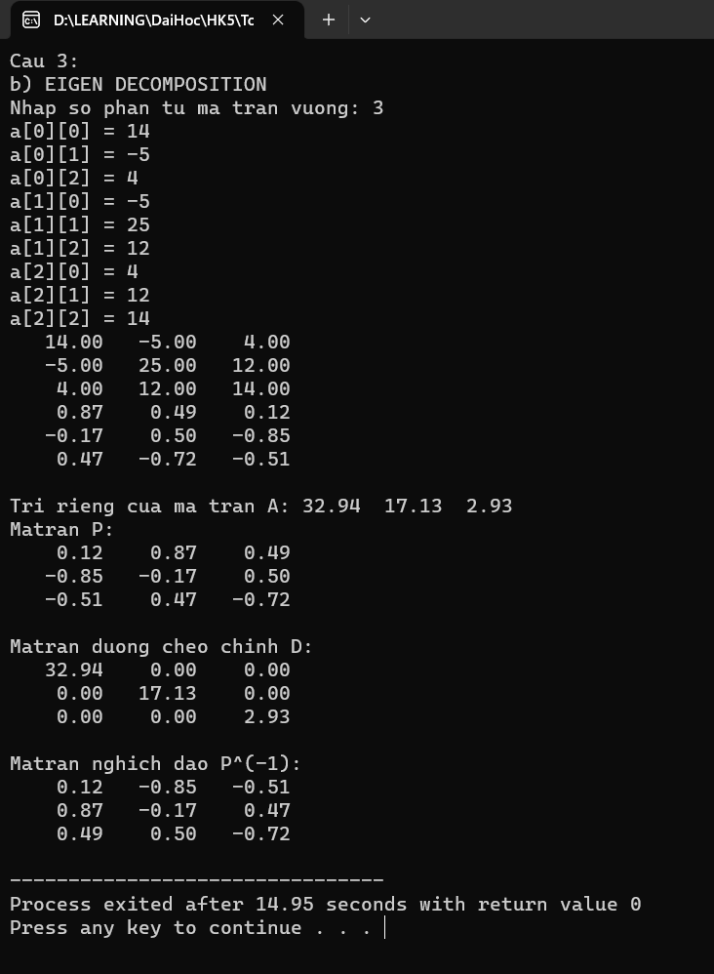
Câu 4:
#include <stdio.h>
#include <math.h>
#include <conio.h>
#include <iostream>
#include <iomanip>
#include <Eigen/Dense>
using Eigen::MatrixXd;
using namespace Eigen;
using namespace std;

void input(float a[][10], int r, int c)
{
for(int i=0; i<r; i++)
{
for(int j=0; j<c; j++)
{
cout <<"a[" <<i <<"][" <<j <<"] = ";
cin >>a[i][j];
}
}
}
void output(float a[][10], int r, int c)
{
for(int i=0; i<r; i++)
{
for(int j=0; j<c; j++)
{
cout << setw(8) << setprecision(2) << fixed <<a[i][j];
}
cout <<"\n";
}
}
void saochep(float a[][10], float b[][10], int r, int c)
{
for (int i=0;i<r; i++)
{
for (int j=0; j<c; j++)
{
b[i][j]=a[i][j];
}
}
}
void nhan(float a[][10], int r1, int c1, float b[][10], int r2, int c2, float t[][10])
{
int i,j,k;
if(c1!=r2)
{
cout <<"\nKhong the nhan 2 ma tran!\n";
return;
}
for (i=0;i<r1;i++)
for (j=0;j<c2;j++)
{
t[i][j]=0;
for (k=0;k<c1;k++)
t[i][j]+=a[i][k]*b[k][j];
}
}
void chuyenvi(float a[][10], float aT[][10], int r, int c)
{
for (int i=0;i<r; i++)
{
for (int j=0; j<c; j++)
{
aT[j][i]=a[i][j];
}
}
}
//Tim tri rieng _ Vector rieng
void Cal_Eival_Eivec(float s[][10], int r, int c, float lamda[10], float v[][10])
{
MatrixXf Ae;
Ae.resize(r, c);
for (int i = 0; i < r; i++)
{
for (int j = 0; j < c; j++)
{
Ae(i, j) = s[i][j];
}
}
EigenSolver<MatrixXf> k(Ae);
VectorXcf kEigenvalue = k.eigenvalues();
for (int i = 0; i < kEigenvalue.size(); i++)
{
lamda[i] = kEigenvalue(i).real();
}
MatrixXcf kEigenvector = k.eigenvectors();
for (int i = 0; i < r; i++)
{
for (int j = 0; j < c; j++)
{
if (j%2==0)
{
v[i][j] = - kEigenvector(i, j).real();
}
else
v[i][j] = kEigenvector(i, j).real();
}
}
// Sap xep lai eigenValues, eigenVector
for (int i = 0; i < c - 1; i++)
{
for (int j = i + 1; j < c; j++)
{
if (lamda[i] < lamda[j])
{
float temp = lamda[i];
lamda[i] = lamda[j];
lamda[j] = temp;
for (int k = 0; k < c; k++)
{
float temp2 = v[k][i];
v[k][i] = v[k][j];
v[k][j] = temp2;
}
}
}
}
}
void findSigmaMatrix(float lamda[10], float sigma[][10], int r, int c)
{
for (int i=0; i<r; i++)
{
sigma[i][i] = sqrt(lamda[i]);
}
}
void findUMatrix(float sigma[][10], float a[][10], float v[][10], float u[][10], int r, int c){
for(int i=0; i<r; i++)
{
float ui[10][10];
float sigmai = sigma[i][i];
float vi[10][10];
for(int j=0; j<c; j++)
{
vi[j][0] = v[j][i];
}
nhan(a,r,c,vi,c,1,ui);
for(int j=0; j<r; j++)
{
ui[j][0] /= sigmai;
u[j][i] = ui[j][0];
}
}
}
int main()
{
float a[10][10], aT[10][10], s[10][10], lamda[10], v[10][10], sigma[10][10], vT[10][10], u[10][10];
int r, c;
cout <<"Cau4: SINGULAR VALUE DECOMPOSITION\n";
cout <<"\nNhap kich thuoc matran a: \n";
cout <<"Nhap so hang: ";
cin >>r;
cout <<"Nhap so cot: ";
cin >>c;
cout <<"\nNhap matran A: \n";
input(a,r,c);
cout <<"\nMatran A:\n";
output(a,r,c);

chuyenvi(a,aT,r,c);
nhan(aT,c,r,a,r,c,s);
Cal_Eival_Eivec(s,c,c,lamda,v);
cout <<"\nTri rieng cua ma tran S: ";
for (int i=0; i<c; i++)
{
cout <<lamda[i] <<" ";
}
cout <<endl;
cout <<"Vector rieng cua ma tran S:\n";
output(v,c,c);

findSigmaMatrix(lamda,sigma,r,c);
cout <<"\nMa tran Sigma:\n";
output(sigma,r,c);

chuyenvi(v,vT,c,c);
cout <<"\nMa tran v^T:\n";
output(vT,c,c);

findUMatrix(sigma,a,v,u,r,c);
cout <<"\nMa tran U:\n";
output(u,r,r);

return 0;
}
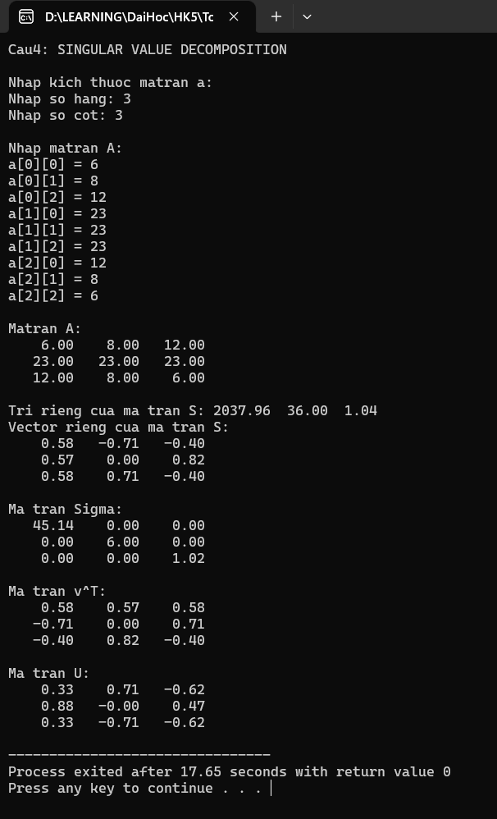9

