#include <iostream>
#include <cmath>
using namespace std;

double learningRate = 0.001; // Learning rate
double momentum = 0.1; // He so momentum
int maxIterations = 1000; // So lan lap toi da
double epsilon = 1e-5; // Sai so dung

// Gia tri ham so f(x)
double f(double x)
{
return pow((exp(2 * x) + x - 10), 2) + 2 * pow((x + 1), 2);
}
// Ðao ham bac 1 cua f(x)
double df(double x)
{
return (exp(2 * x) + x - 10) * (4.0 * exp(2 * x) + 2) + 4.0 * (x + 1);
}
// Ðao ham bac 2 cua f(x)
double dff(double x)
{
return 2*pow((2 * exp(2*x) + 1), 2) + 8 * exp(2*x) * (exp(2*x) + x - 10) + 4;
}

// Gradient descent
double gradientDescent(double initialX)
{
double x = initialX;
double v = 0.0;
for (int i = 0; i < maxIterations; i++)
{
double gradient = df(x);
v = gradient;
x -= learningRate * v;
if (abs(gradient) < epsilon)
{
break;
}
}
return x;
}
// Gradient Descent voi Momentum
double gradientDescentWithMomentum(double initialX)
{
double x = initialX;
double velocity = 0.0;
for (int i = 0; i < maxIterations; i++)
{
double gradient = df(x);
velocity = momentum * velocity + (1.0 - momentum) * gradient;
x -= learningRate * velocity;
if (abs(gradient) < epsilon)
{
break;
}
}
return x;
}
// Newton's Method
double newtonMethod(double initialX)
{
double x = initialX;
for (int i = 0; i < maxIterations; i++)
{
double gradient = df(x);
double hessian = dff(x);
x -= gradient / hessian;
if (abs(gradient) < epsilon)
{
break;
}
}
return x;
}
int main() {
double x ; // Gia tri ban dau cua x
cout <<"f1(x) = (e^(2x) + x - 10)^2 + 2*(x + 1)^2";
cout <<"\n----------BT1----------\n";
cout <<"Nhap gia tri x: " ;
cin >>x;
cout <<"f(x)= " <<f(x) <<endl;
cout <<"f'(x)= " <<df(x) <<endl;
cout <<"f''(x)= " <<dff(x) <<endl;

cout <<"\n----------BT2----------\n";
cout <<"-----GRADIENT DESCENT-----\n";
double rs1 = gradientDescent(x);
cout <<"Gia tri x toi uu: " <<rs1 <<endl;
cout <<"Gia tri f(x) toi uu: " <<f(rs1) <<endl;

cout <<"\n-----GRADIENT DESCENT WITH MOMENTUM-----\n";
double result = gradientDescentWithMomentum(x);
cout <<"Gia tri x toi uu: " <<result <<endl;
cout <<"Gia tri f(x) toi uu: " <<f(result) <<endl;

cout <<"\n-----NEWTON'S METHOD-----\n";
double newtonResult = newtonMethod(x);
cout <<"Gia tri x toi uu: " <<newtonResult <<endl;
cout <<"Gia tri f(x) toi uu: " <<f(newtonResult) <<endl;

return 0;
}
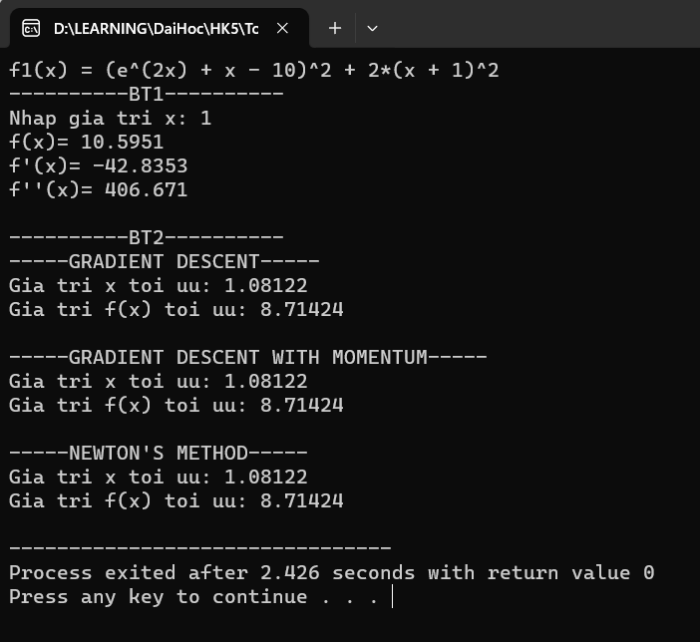

#include <iostream>
#include <cmath>
using namespace std;

double learningRate = 0.001; // Learning rate
double momentum = 0.1; // He so momentum
int maxIterations = 1000; // So lan lap toi da
double epsilon = 1e-5; // Sai so dung

// Gia tri ham so f(x)
double f(double x)
{
return pow(exp(2*pow(x,2) + 1) - 2*x + 1, 2) - 5*pow(x+1, 3);
}
// Ðao ham bac 1 cua f(x)
double df(double x)
{
double a = exp(2*x*x+1);
return 2*(a-2*x+1)*(4*x*a-2) - 15*(x+1)*(x+1);
}
// Ðao ham bac 2 cua f(x)
double dff(double x)
{
double a = exp(2*x*x+1);
return (2*a-4*x+2)*(4*a+16*x*x*a) + 2*(4*x*a-2)*(4*x*a-2) - 30*(x+1);
}

// Gradient descent
double gradientDescent(double initialX)
{
double x = initialX;
double v = 0.0;
for (int i = 0; i < maxIterations; i++)
{
double gradient = df(x);
v = gradient;
x -= learningRate * v;
if (abs(gradient) < epsilon)
{
break;
}
}
return x;
}
// Gradient Descent voi Momentum
double gradientDescentWithMomentum(double initialX)
{
double x = initialX;
double velocity = 0.0;
for (int i = 0; i < maxIterations; i++)
{
double gradient = df(x);
velocity = momentum * velocity + (1.0 - momentum) * gradient;
x -= learningRate * velocity;
if (abs(gradient) < epsilon)
{
break;
}
}
return x;
}
// Newton's Method
double newtonMethod(double initialX)
{
double x = initialX;
for (int i = 0; i < maxIterations; i++)
{
double gradient = df(x);
double hessian = dff(x);
x -= gradient / hessian;
if (abs(gradient) < epsilon)
{
break;
}
}
return x;
}
int main() {
double x ; // Gia tri ban dau cua x
cout <<"f2(x) = (e^(2x^2 + 1) - 2x + 1)^2 - 5*(x + 1)^3";
cout <<"\n----------BT1----------\n";
cout <<"Nhap gia tri x: " ;
cin >>x;
cout <<"f(x)= " <<f(x) <<endl;
cout <<"f'(x)= " <<df(x) <<endl;
cout <<"f''(x)= " <<dff(x) <<endl;

cout <<"\n----------BT2----------\n";
cout <<"-----GRADIENT DESCENT-----\n";
double rs1 = gradientDescent(x);
cout <<"Gia tri x toi uu: " <<rs1 <<endl;
cout <<"Gia tri f(x) toi uu: " <<f(rs1) <<endl;

cout <<"\n-----GRADIENT DESCENT WITH MOMENTUM-----\n";
double result = gradientDescentWithMomentum(x);
cout <<"Gia tri x toi uu: " <<result <<endl;
cout <<"Gia tri f(x) toi uu: " <<f(result) <<endl;

cout <<"\n-----NEWTON'S METHOD-----\n";
double newtonResult = newtonMethod(x);
cout <<"Gia tri x toi uu: " <<newtonResult <<endl;
cout <<"Gia tri f(x) toi uu: " <<f(newtonResult) <<endl;

return 0;
}
