- Thực hiện phân rã SVD
#include <stdio.h>
#include <math.h>
#include <conio.h>
#include <iostream>
#include <iomanip>
#include <Eigen/Dense>
using Eigen::MatrixXd;
using namespace Eigen;
using namespace std;

void input(float a[][10], int r, int c)
{
for(int i=0; i<r; i++)
{
for(int j=0; j<c; j++)
{
cout <<"a[" <<i <<"][" <<j <<"] = ";
cin >>a[i][j];
}
}
}
void output(float a[][10], int r, int c)
{
for(int i=0; i<r; i++)
{
for(int j=0; j<c; j++)
{
cout << setw(8) << setprecision(2) << fixed <<a[i][j];
}
cout <<"\n";
}
}
void saochep(float a[][10], float b[][10], int r, int c)
{
for (int i=0;i<r; i++)
{
for (int j=0; j<c; j++)
{
b[i][j]=a[i][j];
}
}
}
void nhan(float a[][10], int r1, int c1, float b[][10], int r2, int c2, float t[][10])
{
int i,j,k;
if(c1!=r2)
{
cout <<"\nKhong the nhan 2 ma tran!\n";
return;
}
for (i=0;i<r1;i++)
for (j=0;j<c2;j++)
{
t[i][j]=0;
for (k=0;k<c1;k++)
t[i][j]+=a[i][k]*b[k][j];
}
}
void chuyenvi(float a[][10], float aT[][10], int r, int c)
{
for (int i=0;i<r; i++)
{
for (int j=0; j<c; j++)
{
aT[j][i]=a[i][j];
}
}
}
//Tim tri rieng _ Vector rieng
void Cal_Eival_Eivec(float s[][10], int r, int c, float lamda[10], float v[][10])
{
MatrixXf Ae;
Ae.resize(r, c);
for (int i = 0; i < r; i++)
{
for (int j = 0; j < c; j++)
{
Ae(i, j) = s[i][j];
}
}
EigenSolver<MatrixXf> k(Ae);
VectorXcf kEigenvalue = k.eigenvalues();
for (int i = 0; i < kEigenvalue.size(); i++)
{
lamda[i] = kEigenvalue(i).real();
}
MatrixXcf kEigenvector = k.eigenvectors();
for (int i = 0; i < r; i++)
{
for (int j = 0; j < c; j++)
{
if (j%2==0)
{
v[i][j] = - kEigenvector(i, j).real();
}
else
v[i][j] = kEigenvector(i, j).real();
}
}
// Sap xep lai eigenValues, eigenVector
for (int i = 0; i < c - 1; i++)
{
for (int j = i + 1; j < c; j++)
{
if (lamda[i] < lamda[j])
{
float temp = lamda[i];
lamda[i] = lamda[j];
lamda[j] = temp;
for (int k = 0; k < c; k++)
{
float temp2 = v[k][i];
v[k][i] = v[k][j];
v[k][j] = temp2;
}
}
}
}
}
void findSigmaMatrix(float lamda[10], float sigma[][10], int r, int c)
{
for (int i=0;i<r; i++)
{
for (int j=0; j<c; j++)
{
sigma[i][j] = 0;
}
}
for (int i=0; i<r; i++)
{
sigma[i][i] = sqrt(fabs(lamda[i]));
}
}
void findUMatrix(float sigma[][10], float a[][10], float v[][10], float u[][10], int r, int c){
for(int i=0; i<r; i++)
{
float ui[10][10];
float sigmai = sigma[i][i];
float vi[10][10];
for(int j=0; j<c; j++)
{
vi[j][0] = v[j][i];
}
nhan(a,r,c,vi,c,1,ui);
for(int j=0; j<r; j++)
{
ui[j][0] /= sigmai;
u[j][i] = ui[j][0];
}
}
}
int main()
{
float a[10][10], aT[10][10], s[10][10], lamda[10], v[10][10], sigma[10][10], vT[10][10], u[10][10], M1[10][10], M2[10][10];
int r, c;
cout <<"SINGULAR VALUE DECOMPOSITION\n";
cout <<"\nNhap kich thuoc matran a: \n";
cout <<"Nhap so hang: ";
cin >>r;
cout <<"Nhap so cot: ";
cin >>c;
cout <<"\nNhap matran A: \n";
input(a,r,c);
cout <<"\nMatran A:\n";
output(a,r,c);

chuyenvi(a,aT,r,c);
nhan(aT,c,r,a,r,c,s);
Cal_Eival_Eivec(s,c,c,lamda,v);
cout <<"\nTri rieng cua ma tran S: ";
for (int i=0; i<c; i++)
{
cout <<lamda[i] <<" ";
}
cout <<endl;
cout <<"Vector rieng cua ma tran S:\n";
output(v,c,c);

findSigmaMatrix(lamda,sigma,r,c);
cout <<"\nMa tran Sigma:\n";
output(sigma,r,c);

chuyenvi(v,vT,c,c);
cout <<"\nMa tran v^T:\n";
output(vT,c,c);

findUMatrix(sigma,a,v,u,r,c);
cout <<"\nMa tran U:\n";
output(u,r,r);

nhan(u,r,r,sigma,r,c,M1);
nhan(M1,r,c,vT,c,c,M2);
cout<<"\nCheck: U.Sigma.V^T (= A)\n";
output(M2,r,c);
return 0;
}

A₁(4x4)
-18 13 -4 4
2 19 -4 12
-14 11 -12 8
-2 21 4 8
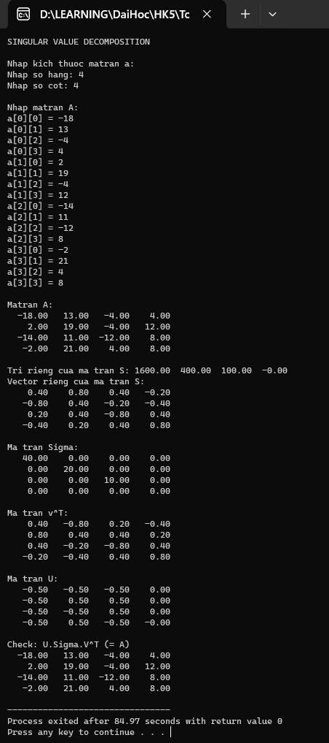

A₂(4x5)
6 -8 -4 5 -4
2 7 -5 -6 4
0 -1 -8 2 2
-1 -2 4 4 -8
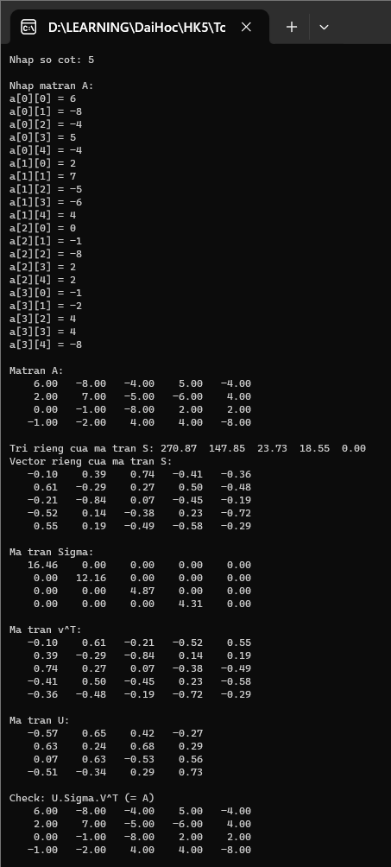
- Cho chuỗi Markov có ma trận chuyển sau
(4x4)
0 0.75 0.2 0.05
0.05 0.2 0.3 0.45
0.1 0.4 0.3 0.2
0 0.15 0.3 0.55
a) Vẽ đồ thị
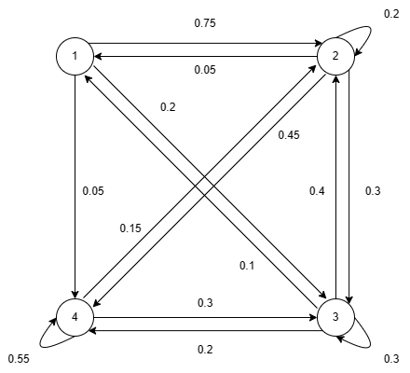
b) Giả sử hệ đang ở trạng thái 2, Tìm xác suất làm việc của hệ sau:
1 bước – 2 bước – 3 bước
#include <stdio.h>
#include <math.h>
#include <conio.h>
#include <iostream>
#include <iomanip>
#include <Eigen/Dense>
using Eigen::MatrixXd;
using namespace Eigen;
using namespace std;
void input(float a[][10], int n)
{
for(int i=0; i<n; i++)
{
for(int j=0; j<n; j++)
{
cout <<"a[" <<i <<"][" <<j <<"] = ";
cin >>a[i][j];
}
}
}
void output(float a[][10], int n)
{
for(int i=0; i<n; i++)
{
for(int j=0; j<n; j++)
{
cout << setw(8) << setprecision(2) << fixed <<a[i][j];
}
cout <<"\n";
}
}
void saochep (float a[][10], float b[][10], int n)
{
for (int i=0;i<n; i++){
for (int j=0; j<n; j++){
b[i][j]=a[i][j];
}
}
}
void nhan(float a[][10], float b[][10], float c[][10], int n)
{
int i,j,k;
for (i=0;i<n;i++)
for (j=0;j<n;j++)
{
c[i][j]=0;
for (k=0;k<n;k++)
c[i][j]+=a[i][k]*b[k][j];
}
}

//Tim tri rieng _ Vector rieng
void Cal_Eival_Eivec(float s[][10], int r, int c, float lamda[10], float v[][10])
{
MatrixXf Ae;
Ae.resize(r, c);
for (int i = 0; i < r; i++)
{
for (int j = 0; j < c; j++)
{
Ae(i, j) = s[i][j];
}
}
EigenSolver<MatrixXf> k(Ae);
VectorXcf kEigenvalue = k.eigenvalues();
for (int i = 0; i < kEigenvalue.size(); i++)
{
lamda[i] = kEigenvalue(i).real();
}
MatrixXcf kEigenvector = k.eigenvectors();
for (int i = 0; i < r; i++)
{
for (int j = 0; j < c; j++)
{
if (j%2==0)
{
v[i][j] = - kEigenvector(i, j).real();
}
else
v[i][j] = kEigenvector(i, j).real();
}
}
// output(v,r);
// Sap xep lai eigenValues, eigenVector theo thu tu tang dan
for (int i = 0; i < c - 1; i++)
{
for (int j = i + 1; j < c; j++)
{
if (lamda[i] < lamda[j])
{
float temp = lamda[i];
lamda[i] = lamda[j];
lamda[j] = temp;
for (int k = 0; k < c; k++)
{
float temp2 = v[k][i];
v[k][i] = v[k][j];
v[k][j] = temp2;
}
}
}
}
}
void matranTamgiac(float a[][10], int n)
{
double m;
for(int c=0; c<n-1; c++) //cot
{
for(int h=c+1; h<n; h++) //hang
{
m = a[h][c]/a[c][c];
for(int k=c; k<n; k++)
{
a[h][k] -= m*a[c][k];
}
}
}
}
double det(float a[][10], int n)
{
double d=1;
float b[10][10];
saochep(a,b,n);
matranTamgiac(b,n);
for(int i=0; i<n; i++)
{
d*=b[i][i];
}
return d;
}
void cutMatrix(float a[][10], float t[][10], int r, int c, int n)
{
int p,q;
p=0;
for(int i=0; i<n; i++)
{
if(i!=r)
{
q=0;
for(int j=0; j<n; j++)
{
if(j!=c)
{
t[p][q]=a[i][j];
q++;
}
}
p++;
}
}
}
void chuyenvi(float a[][10], float aT[][10], int r, int c)
{
for (int i=0;i<r; i++)
{
for (int j=0; j<c; j++)
{
aT[j][i]=a[i][j];
}
}
}
void nghichdao(float a[][10], float a1[][10], int n)
{
float t[10][10], at[10][10];
float d = det(a,n);
if(d==0)
{
cout <<"\nMatran khong kha nghich\n";
return;
}
if (n == 1)
{
a1[0][0] = 1;
return;
}
for(int i=0; i<n; i++)
{
for(int j=0; j<n; j++)
{
cutMatrix(a,t,i,j,n);
at[i][j] = ((i + j) % 2 == 0) ? 1 : -1;
at[i][j] *= det(t,n-1)/d;
}
}
chuyenvi(at,a1,n,n);
}
void MatrixMultiply(float A[][10], float B[][10], int a, int p, int b, float C[][10])
{
double temp[10][10];

for (int i = 0; i < a; i++)
{
for (int j = 0; j < b; j++)
{
temp[i][j] = 0;

for (int m = 0; m < p; m++)
{
temp[i][j] += A[i][m] * B[m][j];
}
}
}

for (int i = 0; i < a; ++i)
for (int j = 0; j < b; ++j)
C[i][j] = temp[i][j];
}
void markov(float a[][10], int n)
{
float p[10], x[4], P[10][10]={0}, D[10][10]={0}, P1[10][10]={0}, lamda[10], M1[10][10], A[10][10];
int i, j;
Cal_Eival_Eivec(a,n,n,lamda,P);
cout <<"\nTri rieng cua ma tran A: ";
for (int i=0; i<n; i++)
{
D[i][i] = lamda[i];
cout <<lamda[i] <<" ";
}
nghichdao(P,P1,n);
cout <<"\nMatran P:\n";
output(P,n);
cout <<"\nMatran duong cheo chinh D:\n";
output(D,n);
cout <<"\nMatran nghich dao P^(-1):\n";
output(P1,n);
cout<<"\nCheck: PDP^-1 (= A)\n";
nhan(P,D,M1,n);
nhan(M1,P1,A,n);
output(A,n);

float Dn[10][10];
float S[][10] =
{
{0, 1, 0, 0 }
};
for (int i = 0; i < n; ++i)
for (int j = 0; j < n; ++j)
{
if (i == j)
Dn[i][i] = 1;
else
Dn[i][j] = 0;
}

cout << "\nTrang thai sau n buoc:\n";
for (int i = 1; i <= 3; ++i)
{
for (int k = 0; k < n; ++k)
{
Dn[k][k] *= D[k][k];
}
cout << "\tTrang thai sau " << i << " buoc:\n";

float Pn[10][10], temp[10][10];
float Sn[10][10];

MatrixMultiply(P, Dn, n, n, n, temp);
MatrixMultiply(temp, P1, n, n, n, Pn);
MatrixMultiply(S, Pn, 1, n, n, Sn);

cout << "\t";
int rS = 1;
for (int j = 0; j < n; ++j)
std::cout << Sn[0][j] << " ";
cout << "------- Xac suat cua trang thai " << rS << " la: " << Sn[0][rS - 1] << "\n";
}
}
int main()
{
int n, i, j;
float a[10][10];
cout <<"MARKOV:\n";
cout <<"Nhap so phan tu ma tran vuong: ";
cin >>n;
input(a,n);
cout <<"\nMa tran A:\n";
// output(a,n);
markov(a,n);
return 0;
}
