#include <iostream>
#include <math.h>
using namespace std;
int p[100], m[100], l;

void primeFactors(int n)
{
int i=1;
p[0]=1;
m[i]=0;
if(n%2 == 0)
{
p[i]=2;
while(n%2 == 0)
{
n=n/2;
m[i]++;
}
i++;
}

for(int j=3; j<=sqrt(n); j+=2)
{
if(n%j == 0)
{
p[i]=j;
m[i]=0;
while(n%j == 0)
{
n=n/j;
m[i]++;
}
i++;
}
}
if(n>2)
{
p[i]=n;
m[i]++;
i++;
}
l = i;
}
int gcd1(int a, int b)
{
if(b==0) return a;
else return gcd1(b, a%b);
}

int gcd2(int a, int b)
{
while(a!=b)
{
if(a>b) a = a-b;
else b = b-a;
}
return a;
}

int NumberOfCoprime(int n)
{
int pn=1;
primeFactors(n);
for(int i=1; i<l; i++)
{
pn*=pow(p[i], m[i]-1)*(p[i]-1);
}
return pn;
}
void CoprimeN(int n)
{
cout <<"\nThe number coprime to n: ";
for(int i=1; i<n; i++)
{
if(gcd1(n,i)==1) cout <<i <<" ";
}
}
bool checkPrime(int n)
{
if(NumberOfCoprime(n) == n-1) return 1;
return 0;
}
int main()
{
int a, b, n;
cout <<"\nBT1: GREATEST COMMON DIVISOR\n";
cout <<"Nhap a = ";
cin >>a;
cout <<"Nhap b = ";
cin >>b;
cout <<"gcd1(" <<a <<" ," <<b <<") = ";
if(a>b) cout <<gcd1(a,b);
else cout <<gcd1(b,a);
cout <<"\ngcd2(" <<a <<" ," <<b <<") = " <<gcd2(a,b);

cout <<"\nBT2: EULER'S TOTIENT FUNCTION(1)\n";
cout <<"Nhap n = ";
cin >>n;
cout <<"The number of coprime numbers to " <<n <<" between 1 and " <<n <<" is " <<NumberOfCoprime(n);
CoprimeN(n);

cout <<"\nBT3: EULER'S TOTIENT FUNCTION(2)\n";
cout <<"Nhap n = ";
cin >>n;
if(checkPrime(n)) cout <<n <<" is Prime\n";
else cout <<n <<" is not Prime\n";

return 0;
}

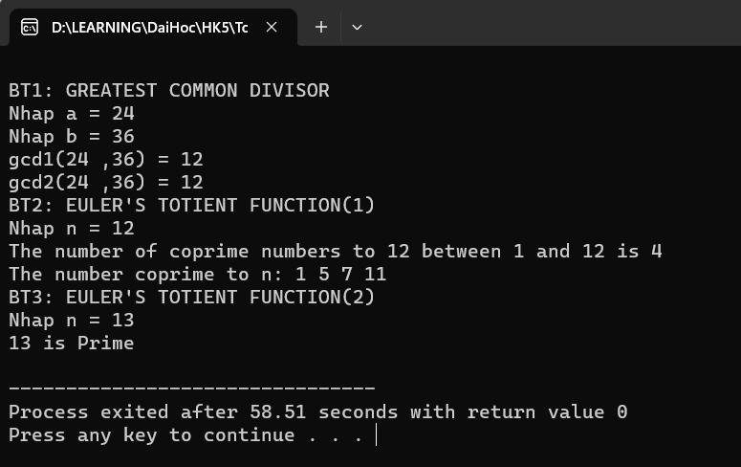

#include <iostream>
#include <math.h>
using namespace std;

int modpow(int x, int n, int m)
{
if(n == 0) return 1%m;
long long u = modpow(x, n/2, m);
u = (u*u)%m;
if(n%2 == 1) u = (u*x)%m;
return u;
}
void check(int x, int y, int m, int n)
{
cout <<"(x+y) % m == (x % m + y % m) % m): ";
if((x+y) % m == (x % m + y % m) % m) cout <<"True\n"; else cout <<"False\n";
cout <<"(x-y) % m == (x % m - y % m) % m): ";
if((x-y) % m == (x % m - y % m) % m) cout <<"True\n"; else cout <<"False\n";
cout <<"(x*y) % m == (x % m * y % m) % m): ";
if((x*y) % m == (x % m * y % m) % m) cout <<"True\n"; else cout <<"False\n";
cout <<"x^n % m == (x % m)^n % m): ";
if(modpow(x, n, m) == modpow((x % m), n, m)) cout <<"True\n"; else cout <<"False\n";
}
int ModularInverse(int x, int m)
{
int k=0;
while((1 + k*m) % x != 0)
{
k++;
}
return (1 + k*m)/x;
}
int main()
{
int x, y, m, n;
cout <<"BT4: MODULAR ARITHMETIC\n";
cout <<"Nhap x = ";
cin >>x;
cout <<"Nhap y = ";
cin >>y;
cout <<"Nhap m = ";
cin >>m;
cout <<"Nhap n = ";
cin >>n;
check(x,y,m,n);

cout <<"BT5: MODULAR INVERSE\n";
cout <<"Nhap x = ";
cin >>x;
cout <<"Nhap m = ";
cin >>m;
cout <<"The inverse of x modulo m is x^(-1) = " <<ModularInverse(x,m);
return 0;
}
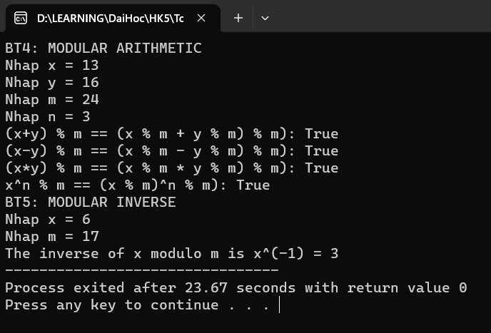

#include <iostream>
#include <math.h>
using namespace std;

int ModularInverse(int x, int m)
{
int k=0;
while((1 + k*m) % x != 0)
{
k++;
}
return (1 + k*m)/x;
}
int Tich(int p[], int n)
{
double t=1;
for(int i=1; i<=n; i++)
{
t*=p[i];
}
return t;
}
void Show(int a[], int m[], int n)
{
for(int i=1; i<=n; i++)
{
cout <<"\n x = " <<a[i] <<" mod " <<m[i];
}
}
int main()
{
int max = 10;
int n, a[max], m[max], x0[max], x1[max], x = 0;
cout <<"BT6: CHINESE REMAINDER THEOREM\n";
cout <<"Nhap n = ";
cin >>n;
for(int i=1; i<=n; i++)
{
cout <<"Nhap a[" <<i <<"] = ";
cin >>a[i];
cout <<"Nhap m[" <<i <<"] = ";
cin >>m[i];
}
Show(a,m,n);
int t = Tich(m, n);
for(int i=1; i<=n; i++)
{
x0[i] = t/m[i];
x1[i] = ModularInverse(x0[i],m[i]);
x += a[i]*x0[i]*x1[i];
}
x = x % t;
cout <<"\n\n => x = " <<x <<" (mod " <<t <<")";
return 0;
}
