MONOTUNECHAIN
#include <bits/stdc++.h>
using namespace std;
#define MAX 100

struct Point
{
int x, y;
bool operator < (Point p)
{
return x < p.x || (x == p.x && y < p.y);
}
bool operator == (Point p)
{
return x == p.x && y == p.y;
}
};
bool checkP(Point p[], int n, Point pn)
{
int i=0;
while(i<n)
{
if((p[i].x == pn.x) && (p[i].y == pn.y))
{
cout<<"Da ton tai diem nay: P["<<i<<"] = ("<<p[i].x<<", "<<p[i].y<<")\n";
cout<<"Vui long nhap lai diem khac\n";
return 1;
}
i=i+1;
}
return 0;

}
void input(Point p[], int n)
{
cout<<"Point[0].x = ";
cin>>p[0].x;
cout<<"Point[0].y = ";
cin>>p[0].y;
for(int i=1; i<n; i++)
{
do
{
cout<<"Point[" <<i <<"].x = ";
cin>>p[i].x;
cout<<"Point[" <<i <<"].y = ";
cin>>p[i].y;
}while(checkP(p, i, p[i]));
}
}
void inputRandom(Point p[], int n)
{
srand(time(NULL));
p[0].x = rand() % 10 + 1;
p[0].y = rand() % 10 + 1;
for(int i=1; i<n; i++)
{
do
{
p[i].x = rand() % 10 + 1;
p[i].y = rand() % 10 + 1;
}
while(checkP(p, i, p[i]));
}
}
void output(Point p[], int n)
{
for(int i=0; i<n; i++)
{
cout<<"(" <<p[i].x <<", " <<p[i].y <<")\n";
}
}
void copyMatrix(Point a[], Point b[], int n)
{
for(int i=0; i<n; i++)
{
b[i].x = a[i].x;
b[i].y = a[i].y;
}
}
double cross_product(Point p, Point q, Point r)
{
return (q.y - p.y) * (r.x - q.x) - (q.x - p.x) * (r.y - q.y);
}
void sort(Point p[], int n)
{
// selectionSort ascending x
int i, j, min;
for (i = 0; i < n - 1; i++)
{
min = i;
for (j = i + 1; j < n; j++)
{
if (p[j] < p[min])
{
min = j;
}
}
swap(p[min], p[i]);
}
}
void convexHull_Mono(Point p[], int n, Point r[MAX], int *len)
{
Point points[MAX];
copyMatrix(p,points,n);
if(n < 3)
{
cout<<"\nThere must be at least 4 points!";
return;
}
sort(points, n);

int k = 0;
r[k++] = points[0];

// Build upper hull
for(int i=1; i<n; i++)
{
while((k >= 2) && (cross_product(r[k-2], r[k-1], points[i]) <= 0))
{
k--;
}
r[k++] = points[i];
}

// Build lower hull
for(int i=n-2, t=k+1; i>=0; i--)
{
while((k >= t) && (cross_product(r[k-2], r[k-1], points[i]) <= 0))
{
k--;
}
r[k++] = points[i];
}
k--;
*len=k;
}
int orientation(Point p, Point q, Point r)
{
// Compare slope of line segment => orientation
int val = (q.y - p.y) * (r.x - q.x) - (q.x - p.x) * (r.y - q.y);
if (val == 0) return 0; // collinear
return (val > 0)? 1: 2; // clock or counterclock wise
}
double dist(Point p1, Point p2)
{
return sqrt((p1.x - p2.x)*(p1.x - p2.x) + (p1.y - p2.y)*(p1.y - p2.y));
}

void distMin(Point p[], int n, Point r[])
{
double min= dist(p[0], p[1]);
int i=1, dmin = 0;
while(i<n-1)
{
if(min > dist(p[i], p[i+1]))
{
min = dist(p[i], p[i+1]);
dmin = i;
}
i++;
}
if(min > dist(p[i], p[0]))
{
r[0] = p[i];
r[1] = p[0];
return;
}
r[0] = p[dmin];
r[1] = p[dmin + 1];
}
double polygonArea(Point p[], int n)
{
double area = 0.0;
int j = n - 1;
for (int i = 0; i < n; i++)
{
area += (p[j].x + p[i].x) * (p[j].y - p[i].y);
j = i;
}
return abs(area / 2.0);
}
void getPointInConvexHull(Point p[], int n, Point p1[MAX], int len, Point r[MAX])
{
int l=0;
for(int i=0; i<n; i++)
{
int j=0;

while(j<len && !(p[i] == p1[j]))
{
j++;
}
if(j==len)
{
r[l].x = p[i].x;
r[l].y = p[i].y;
l++;
}
}
}
void closestPair(Point p[], int n, Point r[])
{
int i;
Point v[n];
for (i = 0; i < n; i++)
{
v[i].x = p[i].x;
v[i].y = p[i].y;
}
sort(v, n);
double d = INT_MAX;

// Keeping the points in
// increasing order
Point st[MAX];
st[0].x = v[0].x;
st[0].y = v[0].y;

int j = 0;
for (i = 1; i < n; i++)
{
while (j >= 0 && v[i].y - st[j].y >= d)
{
j--;
}
if (j >= 0)
{
double dis = (v[i].x - st[j].x)
* (v[i].x - st[j].x)
+ (v[i].y - st[j].y)
* (v[i].y - st[j].y);

// Updating the minimum
// distance dis
if (d > dis)
{
d = dis;
r[0].x = v[i].x;
r[0].y = v[i].y;
r[1].x = st[j].x;
r[1].y = st[j].y;
}
}
j++;
st[j] = { v[i].x, v[i].y };
}
}
int main()
{
Point p[MAX], r[MAX], d[MAX], pin[MAX], rpin[MAX];
int n, len=0;
cout<<"n = ";
cin>>n;
input(p,n);
//inputRandom(p,n);
cout<<"-------------------------------------------\n";
cout<<"\nYour input points:\n";
output(p,n);
cout<<"-------------------------------------------\n";
cout<<"\nPoints of the convex hull MONOTUNECHAIN:\n";
convexHull_Mono(p,n,r,&len);
output(r,len);
cout<<"Canh nho nhat cua bao loi: ";
distMin(r,len,d);
cout<<dist(d[0],d[1])<<endl;
cout<<"--------------------\n";
cout<<"Dien tich cua bao loi: ";
cout<< polygonArea(r,len)<<endl;
cout<<"--------------------\n";
cout<<"Cac diem nam trong bao loi: \n";
getPointInConvexHull(p,n,r,len,pin);
output(pin,n-len);
cout<<"--------------------\n";
cout<<"Cap diem gan nhau nhat nam ben trong bao loi: \n";
closestPair(pin,n-len,rpin);
output(rpin,2);

return 0;
}
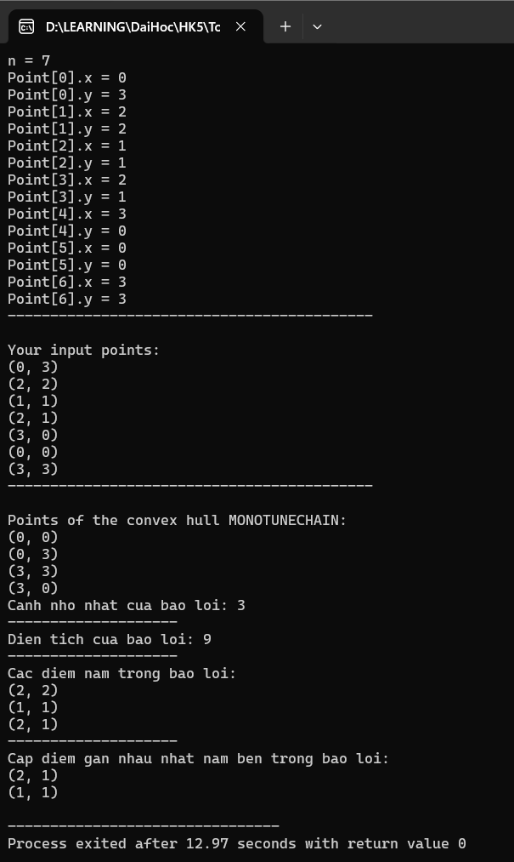

GRAHAM
#include <bits/stdc++.h>
using namespace std;
#define MAX 100

struct Point
{
int x, y;
bool operator < (Point p)
{
return x < p.x || (x == p.x && y < p.y);
}
bool operator == (Point p)
{
return x == p.x && y == p.y;
}
};
bool checkP(Point p[], int n, Point pn)
{
int i=0;
while(i<n)
{
if((p[i].x == pn.x) && (p[i].y == pn.y))
{
cout<<"Da ton tai diem nay: P["<<i<<"] = ("<<p[i].x<<", "<<p[i].y<<")\n";
cout<<"Vui long nhap lai diem khac\n";
return 1;
}
i=i+1;
}
return 0;

}
void input(Point p[], int n)
{
cout<<"Point[0].x = ";
cin>>p[0].x;
cout<<"Point[0].y = ";
cin>>p[0].y;
for(int i=1; i<n; i++)
{
do
{
cout<<"Point[" <<i <<"].x = ";
cin>>p[i].x;
cout<<"Point[" <<i <<"].y = ";
cin>>p[i].y;
}while(checkP(p, i, p[i]));
}
}
void inputRandom(Point p[], int n)
{
srand(time(NULL));
p[0].x = rand() % 10 + 1;
p[0].y = rand() % 10 + 1;
for(int i=1; i<n; i++)
{
do
{
p[i].x = rand() % 10 + 1;
p[i].y = rand() % 10 + 1;
}
while(checkP(p, i, p[i]));
}
}
void output(Point p[], int n)
{
for(int i=0; i<n; i++)
{
cout<<"(" <<p[i].x <<", " <<p[i].y <<")\n";
}
}
void copyMatrix(Point a[], Point b[], int n)
{
for(int i=0; i<n; i++)
{
b[i].x = a[i].x;
b[i].y = a[i].y;
}
}
void sort(Point p[], int n)
{
// selectionSort ascending x
int i, j, min;
for (i = 0; i < n - 1; i++)
{
min = i;
for (j = i + 1; j < n; j++)
{
if (p[j] < p[min])
{
min = j;
}
}
swap(p[min], p[i]);
}
}
int orientation(Point p, Point q, Point r)
{
// Compare slope of line segment => orientation
int val = (q.y - p.y) * (r.x - q.x) - (q.x - p.x) * (r.y - q.y);
if (val == 0) return 0; // collinear
return (val > 0)? 1: 2; // clock or counterclock wise
}
double dist(Point p1, Point p2)
{
return sqrt((p1.x - p2.x)*(p1.x - p2.x) + (p1.y - p2.y)*(p1.y - p2.y));
}

int compare(Point p0, Point p1, Point p2)
{
int o = orientation(p0, p1, p2);
if(o == 0) return (dist(p0, p2) >= dist(p0, p1)) ? -1:1;
return (o == 2) ? -1:1;
}
void sortGraham(Point p[], int n)
{
// selectionSort ascending x
int i, j, min;
for (i = 1; i < n - 1; i++)
{
min = i;
for (j = i + 1; j < n; j++)
{
if (compare(p[0], p[j], p[min]) == -1)
{
min = j;
}
}
swap(p[min], p[i]);
}
}
void convexHull_Graham(Point p[], int n, Point r[MAX], int *len)
{
Point points[MAX];
copyMatrix(p,points,n);
if(n < 3)
{
cout<<"\nThere must be at least 3 points!";
return;
}
// Find the bottommost point
int ymin = points[0].y, min = 0;
for (int i = 1; i < n; i++)
{
if ((points[i].y < ymin) || ((points[i].y == ymin) && (points[i].x < points[min].x)))
{
ymin = points[i].y;
min = i;
}
}
swap(points[0], points[min]);
// Sort n-1 points with respect to the first point
sortGraham(points, n);

// If two or more points make same angle with p0,
// Remove all but the one that is farthest from p0
int m = 1;
for(int i=1; i<n; i++)
{
while((i < n-1) && (orientation(points[0], points[i], points[i+1]) <= 0))
{
i++;
}
points[m++] = points[i];
}

int k = 0;
r[k++] = points[0];

// Graham
for(int i=1; i<m; i++)
{
while((k >= 2) && (orientation(r[k-2], r[k-1], points[i]) != 2))
{
k--;
}
r[k++] = points[i];
}
*len = k;
}

void distMin(Point p[], int n, Point r[])
{
double min= dist(p[0], p[1]);
int i=1, dmin = 0;
while(i<n-1)
{
if(min > dist(p[i], p[i+1]))
{
min = dist(p[i], p[i+1]);
dmin = i;
}
i++;
}
if(min > dist(p[i], p[0]))
{
r[0] = p[i];
r[1] = p[0];
return;
}
r[0] = p[dmin];
r[1] = p[dmin + 1];
}
double polygonArea(Point p[], int n)
{
double area = 0.0;
for (int i = 0; i < n; i++)
{
area += (p[i].x + p[i+1].x) * (p[i-1].y - p[i].y);
}
return fabs(area / 2.0);
}
void getPointInConvexHull(Point p[], int n, Point p1[MAX], int len, Point r[MAX])
{
int l=0;
for(int i=0; i<n; i++)
{
int j=0;

while(j<len && !(p[i] == p1[j]))
{
j++;
}
if(j==len)
{
r[l].x = p[i].x;
r[l].y = p[i].y;
l++;
}
}
}
void closestPair(Point p[], int n, Point r[])
{
int i;
Point v[n];
for (i = 0; i < n; i++)
{
v[i].x = p[i].x;
v[i].y = p[i].y;
}
sort(v, n);
double d = INT_MAX;

// Keeping the points in
// increasing order
Point st[MAX];
st[0].x = v[0].x;
st[0].y = v[0].y;

int j = 0;
for (i = 1; i < n; i++)
{
while (j >= 0 && v[i].y - st[j].y >= d)
{
j--;
}
if (j >= 0)
{
double dis = (v[i].x - st[j].x)
* (v[i].x - st[j].x)
+ (v[i].y - st[j].y)
* (v[i].y - st[j].y);

// Updating the minimum
// distance dis
if (d > dis)
{
d = dis;
r[0].x = v[i].x;
r[0].y = v[i].y;
r[1].x = st[j].x;
r[1].y = st[j].y;
}
}
j++;
st[j] = { v[i].x, v[i].y };
}
}
int main()
{
Point p[MAX], r[MAX], d[MAX], pin[MAX], rpin[MAX];
int n, len=0;
cout<<"n = ";
cin>>n;
input(p,n);
//inputRandom(p,n);
cout<<"-------------------------------------------\n";
cout<<"\nYour input points:\n";
output(p,n);
cout<<"-------------------------------------------\n";
cout<<"\nPoints of the convex hull GRAHAM:\n";
convexHull_Graham(p,n,r,&len);
output(r, len);
cout<<"Canh nho nhat cua bao loi: ";
distMin(r,len,d);
cout<<dist(d[0],d[1])<<endl;
cout<<"--------------------\n";
cout<<"Dien tich cua bao loi: ";
cout<< polygonArea(r,len)<<endl;
cout<<"--------------------\n";
cout<<"Cac diem nam trong bao loi: \n";
getPointInConvexHull(p,n,r,len,pin);
output(pin,n-len);
cout<<"--------------------\n";
cout<<"Cap diem gan nhau nhat nam ben trong bao loi: \n";
closestPair(p,n,rpin);
output(rpin,2);

return 0;
}
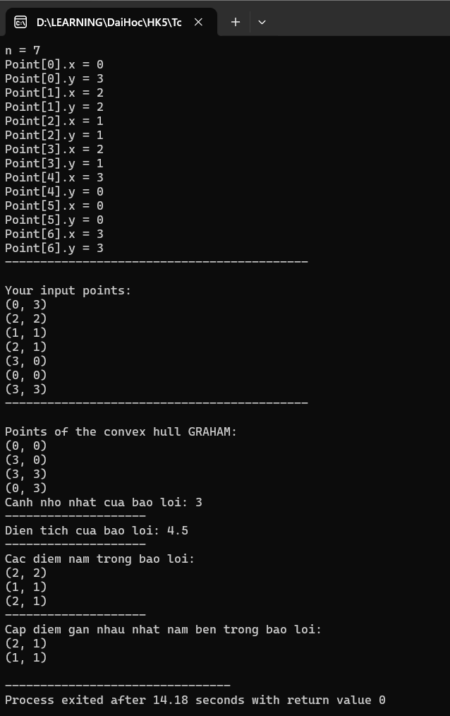

JARVIS
#include <bits/stdc++.h>
using namespace std;
#define MAX 100

struct Point
{
int x, y;
bool operator < (Point p)
{
return x < p.x || (x == p.x && y < p.y);
}
bool operator == (Point p)
{
return x == p.x && y == p.y;
}
};
bool checkP(Point p[], int n, Point pn)
{
int i=0;
while(i<n)
{
if((p[i].x == pn.x) && (p[i].y == pn.y))
{
cout<<"Da ton tai diem nay: P["<<i<<"] = ("<<p[i].x<<", "<<p[i].y<<")\n";
cout<<"Vui long nhap lai diem khac\n";
return 1;
}
i=i+1;
}
return 0;

}
void input(Point p[], int n)
{
cout<<"Point[0].x = ";
cin>>p[0].x;
cout<<"Point[0].y = ";
cin>>p[0].y;
for(int i=1; i<n; i++)
{
do
{
cout<<"Point[" <<i <<"].x = ";
cin>>p[i].x;
cout<<"Point[" <<i <<"].y = ";
cin>>p[i].y;
}while(checkP(p, i, p[i]));
}
}
void inputRandom(Point p[], int n)
{
srand(time(NULL));
p[0].x = rand() % 10 + 1;
p[0].y = rand() % 10 + 1;
for(int i=1; i<n; i++)
{
do
{
p[i].x = rand() % 10 + 1;
p[i].y = rand() % 10 + 1;
}
while(checkP(p, i, p[i]));
}
}
void output(Point p[], int n)
{
for(int i=0; i<n; i++)
{
cout<<"(" <<p[i].x <<", " <<p[i].y <<")\n";
}
}
void copyMatrix(Point a[], Point b[], int n)
{
for(int i=0; i<n; i++)
{
b[i].x = a[i].x;
b[i].y = a[i].y;
}
}
double cross_product(Point p, Point q, Point r)
{
return (q.y - p.y) * (r.x - q.x) - (q.x - p.x) * (r.y - q.y);
}
void sort(Point p[], int n)
{
// selectionSort ascending x
int i, j, min;
for (i = 0; i < n - 1; i++)
{
min = i;
for (j = i + 1; j < n; j++)
{
if (p[j] < p[min])
{
min = j;
}
}
swap(p[min], p[i]);
}
}

int orientation(Point p, Point q, Point r)
{
// Compare slope of line segment => orientation
int val = (q.y - p.y) * (r.x - q.x) - (q.x - p.x) * (r.y - q.y);
if (val == 0) return 0; // collinear
return (val > 0)? 1: 2; // clock or counterclock wise
}
double dist(Point p1, Point p2)
{
return sqrt((p1.x - p2.x)*(p1.x - p2.x) + (p1.y - p2.y)*(p1.y - p2.y));
}

void convexHull_Jarvis(Point p[], int n, Point r[MAX], int *k)
{
Point points[MAX];
copyMatrix(p,points,n);
if(n < 3)
{
cout<<"\nThere must be at least 3 points!";
return;
}
int len = 0;
sort(points, n);
// Find the leftmost point
int l = 0;
for(int i=1; i<n; i++)
{
if(points[i].x < points[l].x)
{
l = i;
}
}

// Jarvis' Algorithm - Wrapping
int cp = l, np; // index of current - next point
do
{
r[len++] = points[cp];
np = (cp + 1) % n;
for(int i=0; i<n; i++)
{
if(orientation(points[cp], points[i], points[np]) == 2)
{
np = i;
}
}
cp = np;
} while(cp != l);

int m = 1;
for(int i=1; i<len; i++)
{
while((m >= 2) && (cross_product(r[m-2], r[m-1], r[i]) == 0))
{
m--;
}
r[m++] = r[i];
}
*k=m;
}
void distMin(Point p[], int n, Point r[])
{
double min= dist(p[0], p[1]);
int i=1, dmin = 0;
while(i<n-1)
{
if(min > dist(p[i], p[i+1]))
{
min = dist(p[i], p[i+1]);
dmin = i;
}
i++;
}
if(min > dist(p[i], p[0]))
{
r[0] = p[i];
r[1] = p[0];
return;
}
r[0] = p[dmin];
r[1] = p[dmin + 1];
}
double polygonArea(Point p[], int n)
{
double area = 0.0;
int j = n - 1;
for (int i = 0; i < n; i++)
{
area += (p[j].x + p[i].x) * (p[j].y - p[i].y);
j = i;
}
return abs(area / 2.0);
}
void getPointInConvexHull(Point p[], int n, Point p1[MAX], int len, Point r[MAX])
{
int l=0;
for(int i=0; i<n; i++)
{
int j=0;

while(j<len && !(p[i] == p1[j]))
{
j++;
}
if(j==len)
{
r[l].x = p[i].x;
r[l].y = p[i].y;
l++;
}
}
}
void closestPair(Point p[], int n, Point r[])
{
int i;
Point v[n];
for (i = 0; i < n; i++)
{
v[i].x = p[i].x;
v[i].y = p[i].y;
}
sort(v, n);
double d = INT_MAX;

// Keeping the points in
// increasing order
Point st[MAX];
st[0].x = v[0].x;
st[0].y = v[0].y;

int j = 0;
for (i = 1; i < n; i++)
{
while (j >= 0 && v[i].y - st[j].y >= d)
{
j--;
}
if (j >= 0)
{
double dis = (v[i].x - st[j].x)
* (v[i].x - st[j].x)
+ (v[i].y - st[j].y)
* (v[i].y - st[j].y);

// Updating the minimum
// distance dis
if (d > dis)
{
d = dis;
r[0].x = v[i].x;
r[0].y = v[i].y;
r[1].x = st[j].x;
r[1].y = st[j].y;
}
}
j++;
st[j] = { v[i].x, v[i].y };
}
}
int main()
{
Point p[MAX], r[MAX], d[MAX], pin[MAX], rpin[MAX];
int n, len=0;
cout<<"n = ";
cin>>n;
input(p,n);
//inputRandom(p,n);
cout<<"-------------------------------------------\n";
cout<<"\nYour input points:\n";
output(p,n);

cout<<"-------------------------------------------\n";
cout<<"\nPoints of the convex hull JARVIS:\n";
convexHull_Jarvis(p,n,r,&len);
output(r, len);
cout<<"Canh nho nhat cua bao loi: ";
distMin(r,len,d);
cout<<dist(d[0],d[1])<<endl;
cout<<"--------------------\n";
cout<<"Dien tich cua bao loi: ";
cout<< polygonArea(r,len)<<endl;
cout<<"--------------------\n";
cout<<"Cac diem nam trong bao loi: \n";
getPointInConvexHull(p,n,r,len,pin);
output(pin,n-len);
cout<<"--------------------\n";
cout<<"Cap diem gan nhau nhat nam ben trong bao loi: \n";
closestPair(pin,n-len,rpin);
output(rpin,2);
return 0;
}
