Notes for Joseph

Notes:
- If you’re ever curious about what a component does you need to go to the documents!
**Special Note** As a coder or an engineer, reading documentation is a key component of your job. Once you understand the logic behind how to code, all you really need to advance your skills is how to use more complex code bases, libraries, etc. To understand these you need to get used to reading… A LOT!

Instructions:
- Follow all the steps below to set-up the physical build of your device.
- Copy the code into your Interactive Developer Environment (IDE).

Step 0: Getting Set-up Arduino on Computer
**Special Note** We’ll go over this if you want, but in coding we often start counting with the number 0 rather than 1.
- Drivers are pieces of software that allow your computer to speak to your physical device. Think of it like a translator. Without the right drivers installed,
- Download Driver and Install IDE Video: https://youtu.be/7-XKZOTyW9Y
- Link to Arduino IDE Download: https://www.arduino.cc/en/software
- Link to Arduino Driver Download: https://cdn.shopify.com/s/files/1/0750/1787/9870/files/WINDOWS-INVENTR-USB-DRIVERS.EXE?v=1717744722

Step 1: The Soil Sensor
Components:
- Soil Sensor: https://components101.com/modules/soil-moisture-sensor-module
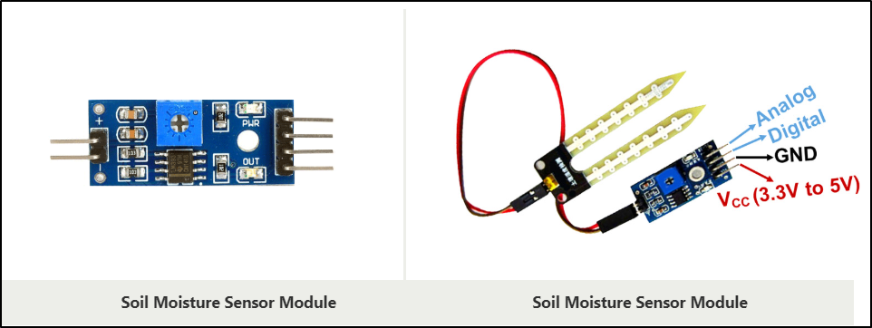
- No water = 1024 (~974 after several weeks no watering)
- All Water = 300-350
We can test this by the following code:
And the following diagram:
void setup() {
// put your setup code here, to run once:
Serial.begin(9600);
}

void loop() {
// put your main code here, to run repeatedly:
checkMoisture();
}

void checkMoisture(){
int moisture = analogRead(A1);

Serial.println("Moisutre Sensor Value:");
Serial.println(moisture);
delay(5000);
}

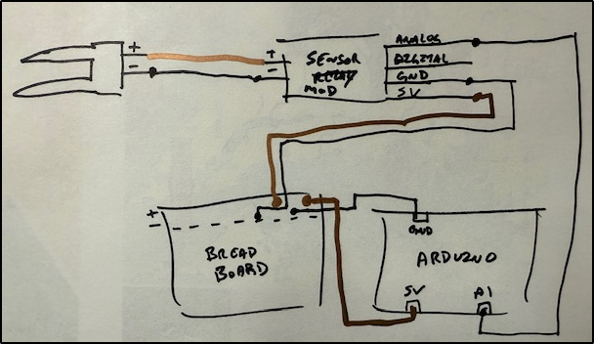
Once you have this setup you’ll hold the sensor in air (which should be all resistance) and in a bucket of water (all conductance). You’ll monitor the serial output of the Arduino program to see how this compares to what you have.
**Special Note** This is a part of coding. You build concepts in small parts and TEST them before moving onto the next step to ensure things are working as expected. Remind me to talk more to you about this.

Step 2: The Water Pump
Components:
- Water Pump w/ Tube
- Relay
- Battery Casing
- 3 AA Batteries

Diagrams:
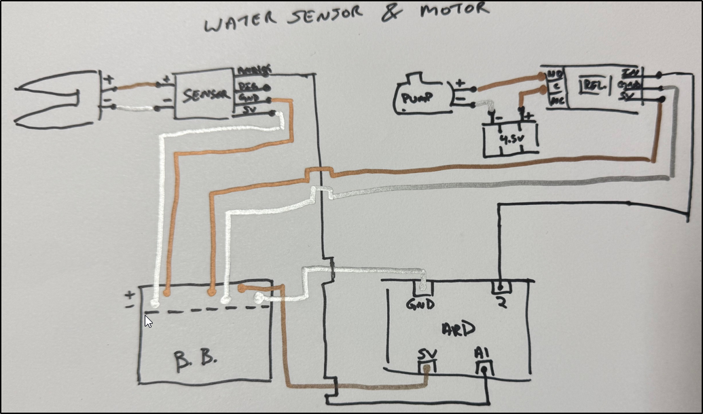
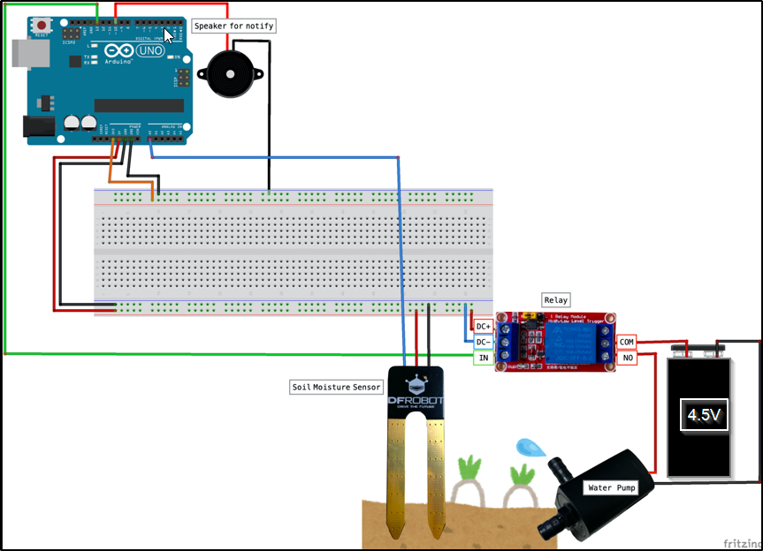
The water pump requires its own electrical source for the entire system to function properly. Otherwise, when the pump turns on it prevents the sensor from continuing to work and breaks the loop you wrote in your code.
How do relays work?
https://www.youtube.com/watch?v=ZbBQZV7oljk
https://forum.arduino.cc/t/relay-songle-srd-05vdc-sl-c-10a/574537
Basically, there’s constant power going through the relay, but when a certain condition is met the relay switches. It allows you to control greater power sources than what the Arduino offers naturally.
**Special note for coding** The importance of checking sources.
- I spent 5 hours trying to figure out why my code wasn’t working. When the pump was supposed to be on it was off and vice versa. This is because I copied code from here: https://projecthub.arduino.cc/lc_lab/automatic-watering-system-for-my-plants-e4c4b9, but the author was using a different relay than ours. Our relay is “ACTIVE LOW” rather than the author’s “ACTIVE HIGH” relay.

Step 3: The Ultra-Sonic Sensor (Check Water Levels)
Components:
- Ultrasonic Sensor
- Information on the sensor: https://cdn.sparkfun.com/datasheets/Sensors/Proximity/HCSR04.pdf
- LED
- Something to Hold the Sensor (I used a piece of cardboard with enough space to hold

Measurements I used when writing code:
Height of Sensor to bottom of bucket: 14.5 cm
Height I want to refill water at: 5cm
**NOTE** Your code will change based on your own measurements. Make sure to measure in centimeters.

