# By UTD Spring 2024 AR Project Batch

# 

**By UTD Spring 2024 AR Project Batch 1**

**Grafana Setup 1**

Introduction 1

Security Groups related to Grafana 2

Local Installing Grafana - Docker build 2

AWS Installation 2

Consume AR API from Grafana 2

Configure AR API Server 2

Consume API Query 2

Connecting Grafana to Postgres - Local Docker environment 3

Install grafana 3

Obtain docker container IP 3

Connecting postgres DataSource 4

Importing Dashboards 5

Consume Cloud Watch metrics from Grafana 6

IAM Policy 6

Create policy 6

Sample Policy 6

Connecting CloudWatch to Grafana 7

Create Cloud-Watch connection 7

Import Ec2 metrics Dashboards 8

**Pending DevOps Items 8**

**Final step 9**

Validate all data sources 9

Dashboards 9

# 

# Grafana Setup

## Introduction

This document outlines creating dashboards in Grafana using the following datasources

* AR JSON API
* Postgress
* CloudWatch

## Security Groups related to Grafana

Port 3000 to access grafana.

We can change the port as needed.

Update docker-compose.yaml - Section:grafana or other installation mop.

## Local Installing Grafana - Docker build

Local development - see the docker file. Refer docker-compose.yml - Grafana Section

## AWS Installation

Refer to Grafana-installation_V1

## Consume AR API from Grafana

### Configure AR API Server

The following steps are required,

1.Install JSON API plugin

2. Configure JSON API plugin with Connection URL. https://{AR_API_URL}}

Example; https://api.athletereserve.com

2a) Http Headers: AR API is secured via “x-api-key”. Http Headers - provide the header -x-api-key and value from “????????” Refer API AR to find the latest API KeY

Local Installation: http://web.8000 ( local installation). Ensure docker network is created.

### Consume API Query

3.Grafana: Query tab

Path=\api\athletes

field= $..first_name

You see the table data. If you want to perform transformation , go transformation tab.

A sample FAQ is updated in GIT\server\grafana\AR-JSONAPI.ppt

4. Import AR_API_Dashboards.json.

5. Updated/delete dashboard as needed.

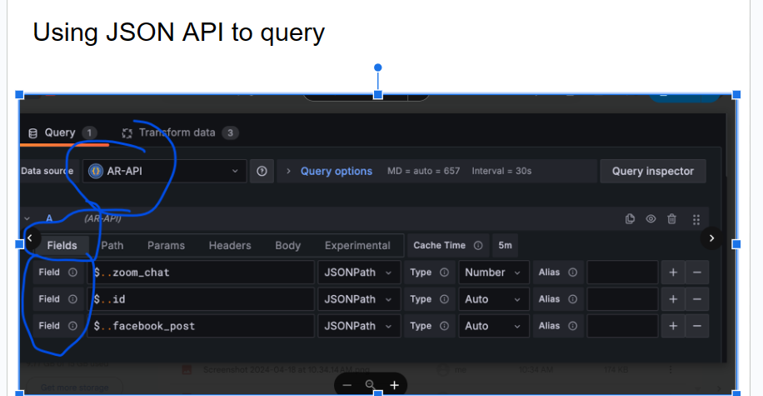

## Connecting Grafana to Postgres - Local Docker environment

### Install grafana

* Docker-compose build
* Docker-compose up

### Obtain docker container IP

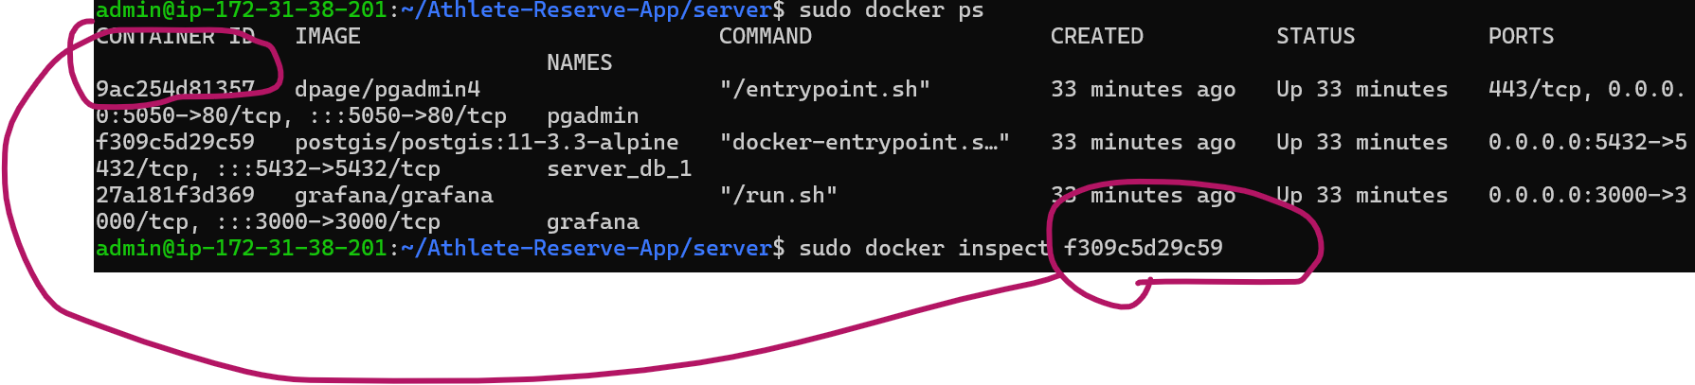

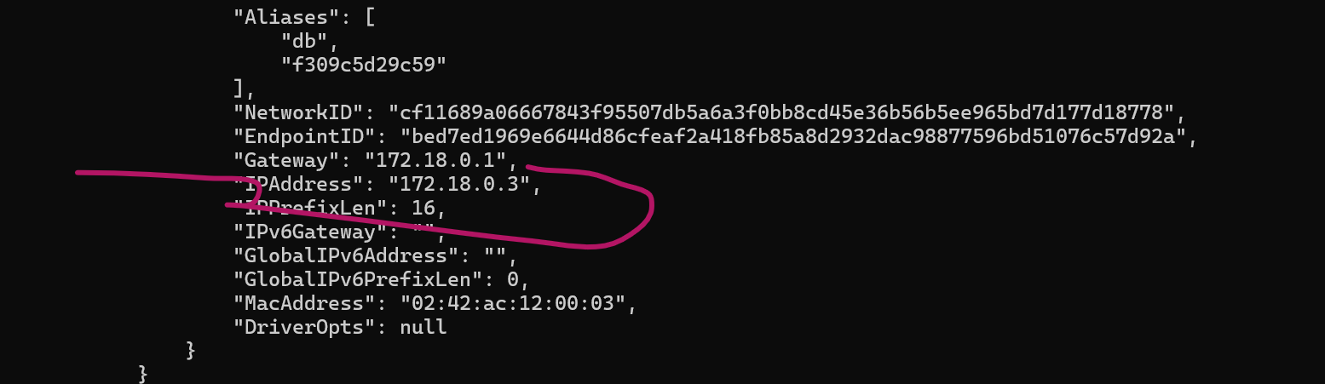

### Connecting postgres DataSource

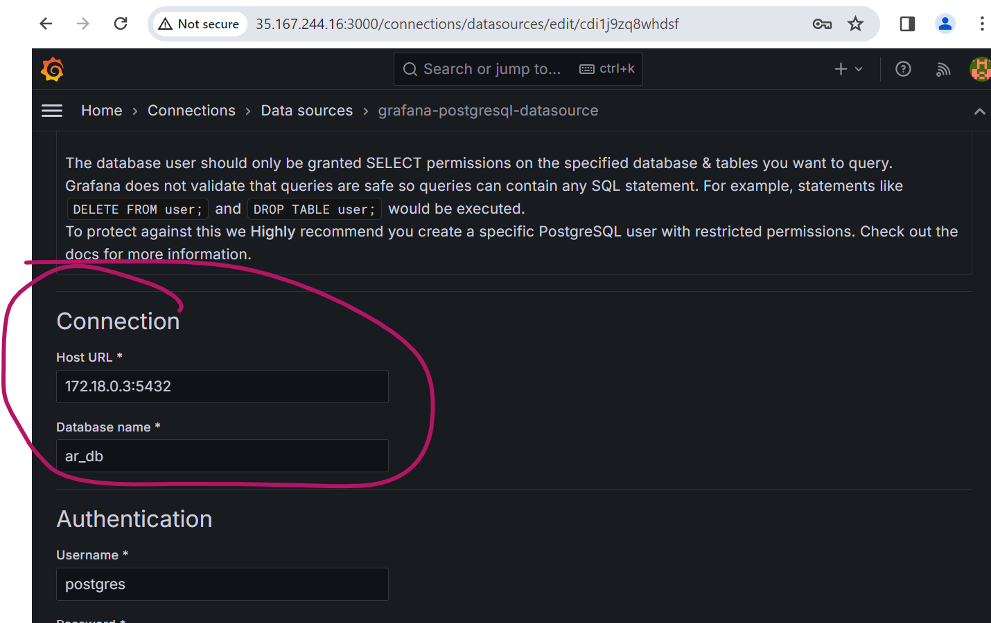

### Importing Dashboards

Import->Upload JSON File("\server\grafana\AR_BusinessMetrics.json , AR_CampaignMetrics.json)

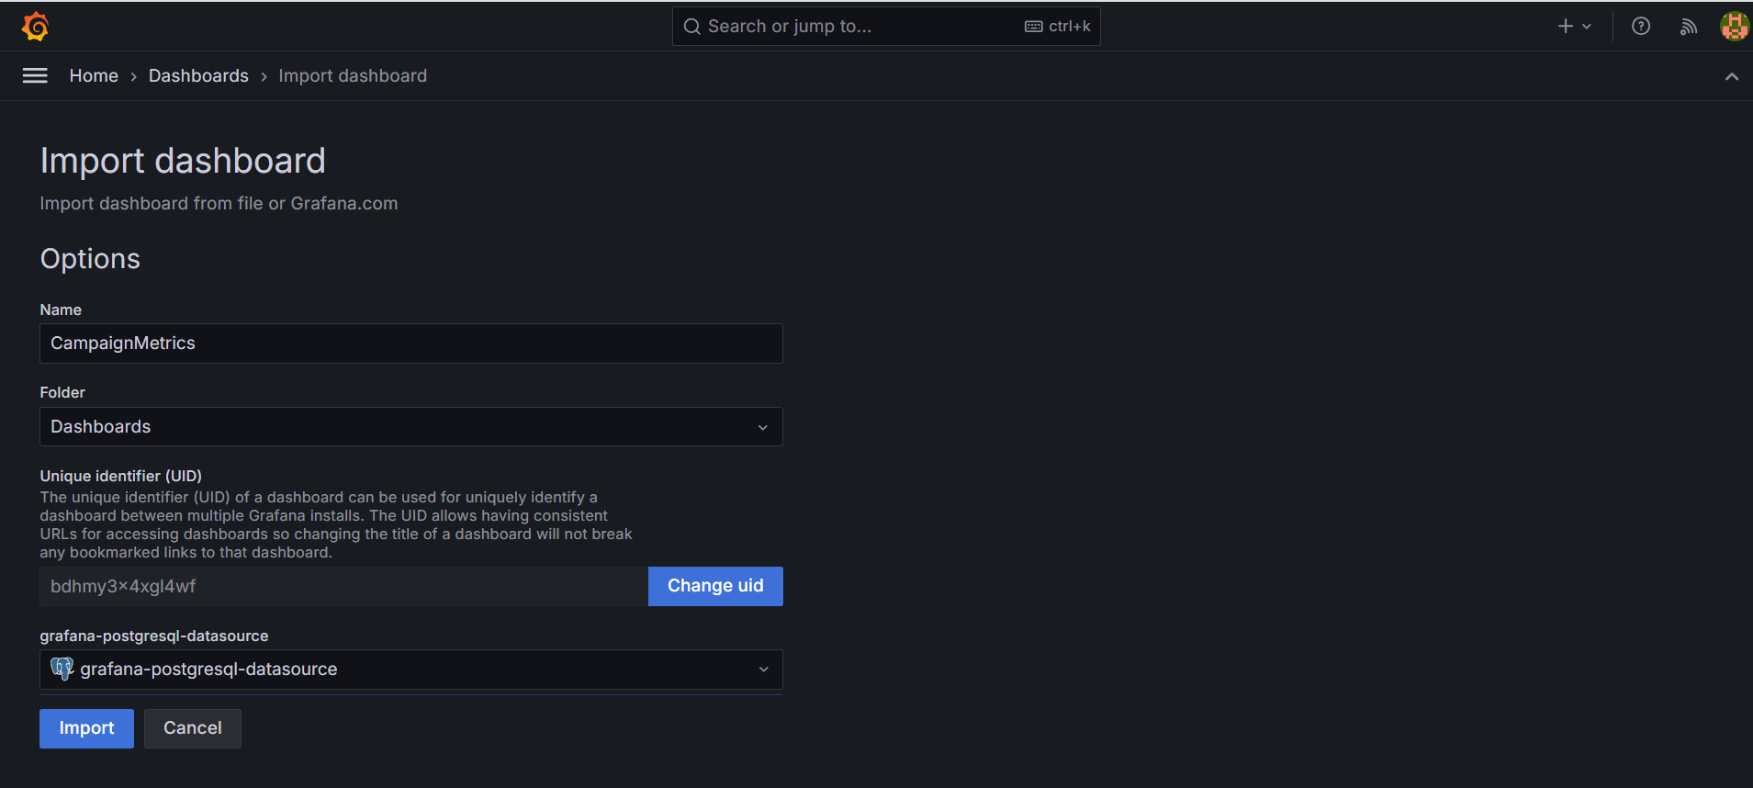

## Consume Cloud Watch metrics from Grafana

### IAM Policy

An IAM policy is required for Grafana to consume Cloud Watch Metrics.

#### Create policy

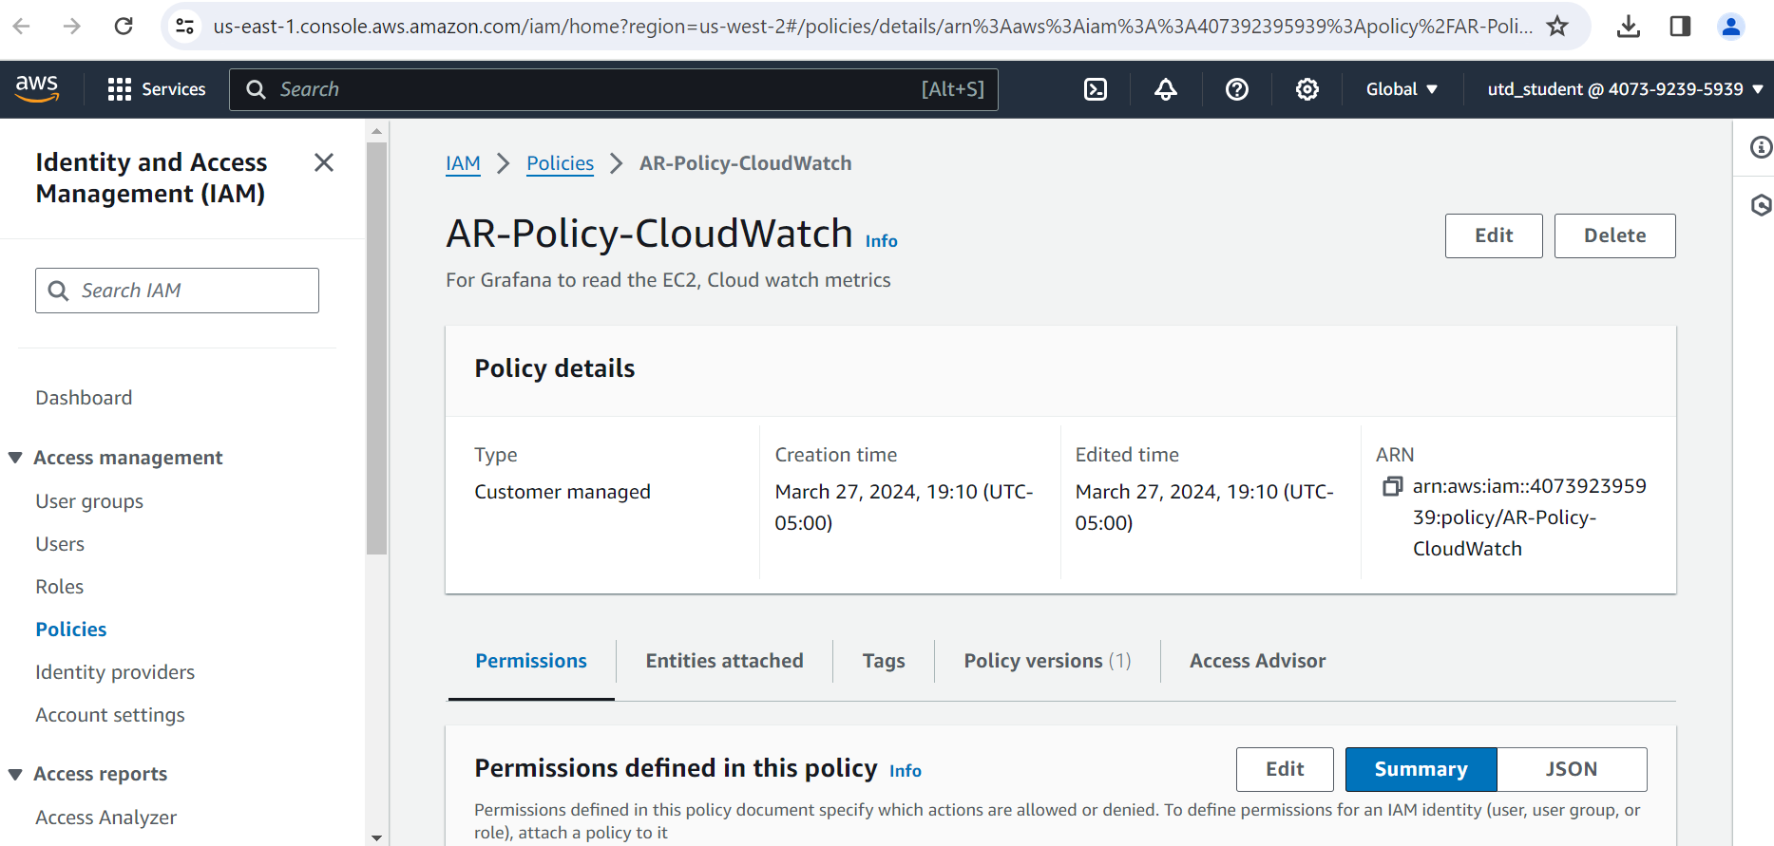

#### Sample Policy

{

"Version": "2012-10-17",

"Statement": [

{

"Sid": "AllowReadingMetricsFromCloudWatch",

"Effect": "Allow",

"Action": [

"cloudwatch:ListMetrics",

"cloudwatch:GetMetricStatistics",

"cloudwatch:GetMetricData"

],

"Resource": "*"

},

{

"Sid": "AllowReadingTagsInstancesRegionsFromEC2",

"Effect": "Allow",

"Action": [

"ec2:DescribeTags",

"ec2:DescribeInstances",

"ec2:DescribeRegions"

],

"Resource": "*"

}

]

}

### Connecting CloudWatch to Grafana

#### Create Cloud-Watch connection

Keep handy Access and Secret key.

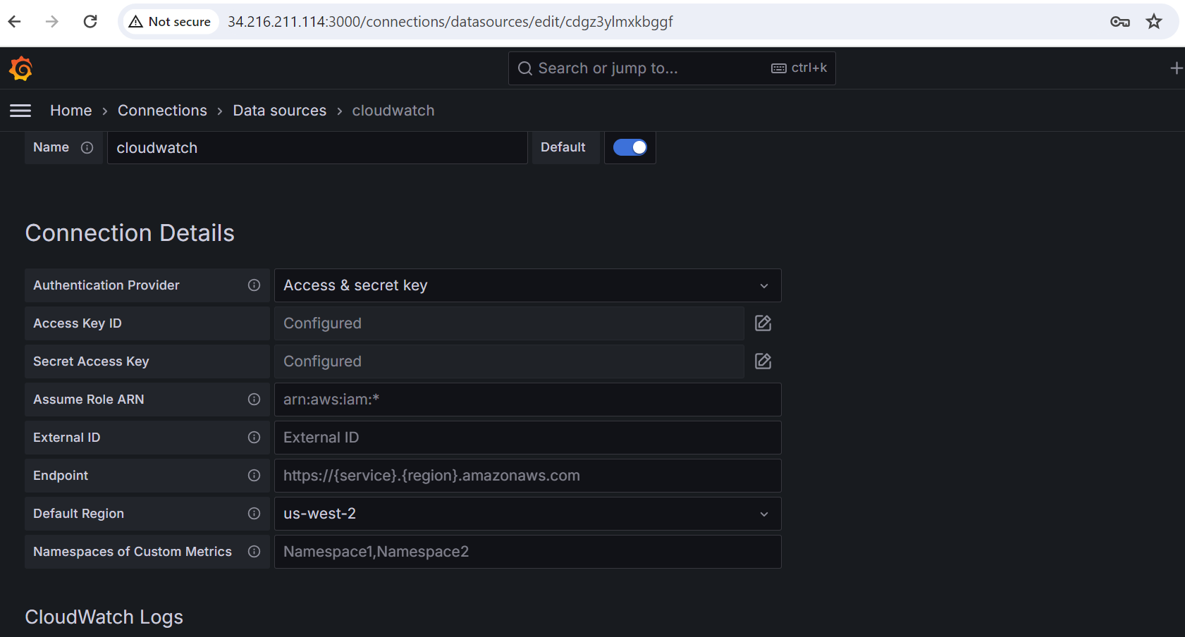

### Import Ec2 metrics Dashboards

* Import the gitProject\..\server\grafana\AR-EC2-SystemMetrics.json

# 

# Pending DevOps Items

* Automate iam policy
* Automate sg groups related to grafana
* Automate creations of connections
* Automate installing dashboards in server/grafana/*.json files

# 

# Final step

## Validate all data sources

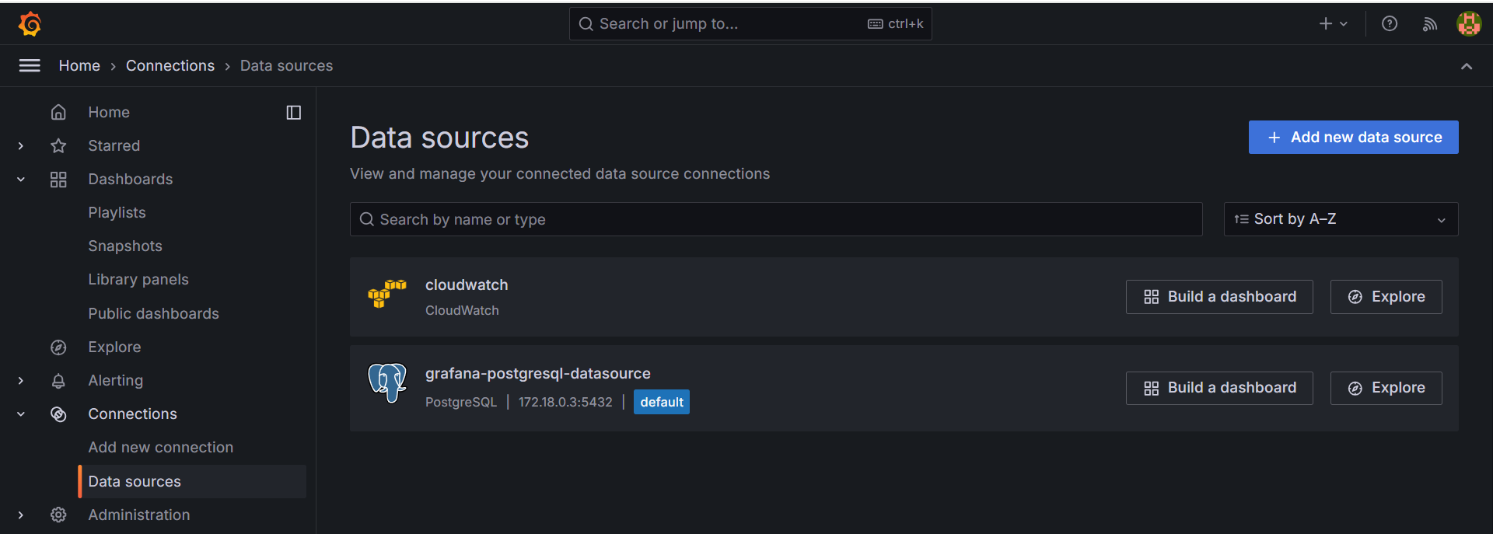

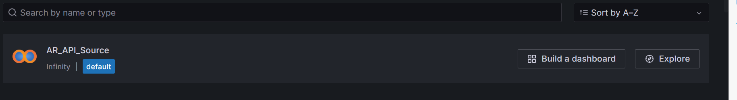

## Dashboards

Import all json listed in server/grafana/*.json



 

 