ARMA Processes
Pinar TUNCBILEK
ID.No : 148072
2025-11-26
Table of Contents
Theoretical Foundations 2
1. Introduction 2
White Noise Definition 2
White Noise Plot (50 Random Values) 2
2. Autoregressive (AR) Models 3
AR(1) Process (Order 1) 3
AR(p) Process (Order p) 4
3. Moving Average (MA) Models 4
4. The Combined ARMA Model 5
Parameter Estimation and Model Selection 6
1. Parameter Estimation (Known Model Order) 6
Methods for AR(p) (Simpler): 6
a) Yule–Walker (YW) Estimators (for AR(p) - Use sample autocovariances. 6
b) Conditional Least-Squares (CLS) Estimators - Minimize squared residuals 7
c) Maximum-Likelihood (ML) Estimator - Uses full probability structure 7
Model Diagnostics – Residual Analysis 8
1. Residual Analysis 9
1a) Check Independence 9
1b) Check Normality 10
1c) Check Homoscedasticity (Constant Variance) 11
Summary 11
2. Model Order Selection (Unknown Model Order) 12
Akaike Information Criterion (AIC) 12
Bayesian Information Criterion (BIC) 12
3. Practical Steps and Residual Analysis 12
4. Conclusion 12

Theoretical Foundations

1. Introduction
Today I will give a concise overview of ARMA processes, including their key formulas, intuition, properties, estimation methods, and model selection tools. The goal is to understand how ARMA models capture both persistence and shock patterns in time series.
Goal: To model time series data where the current value is related to past values and past random errors.ARMA models capture this dependence.
Let’s begin with the foundation: White Noise.

White Noise Definition
White Noise (WN): White Noise is a sequence of uncorrelated random variables with mean zero and constant variance.This is the basic, unpredictable shock in our model.The fundamental input for all ARMA models. It represents the random shock or ‘innovation’ at time $t$.
We write: $ε_{t}∼WN\left(0,σ^{2}\right)$
This means: $E\left[ε_{t}\right]=0$
$Var\left(ε_{t}\right)=σ^{2}$ No correlation across time.
White noise represents pure randomness, and it is the building block of AR, MA, and ARMA processes.

White Noise Plot (50 Random Values)
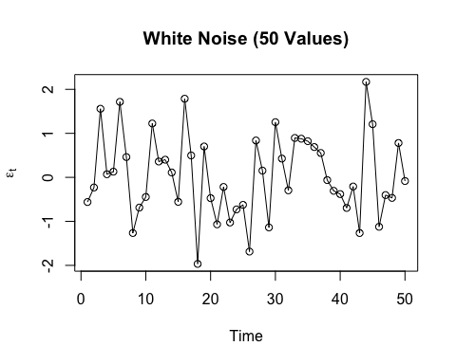
Properties: A series $\{X_{t}:t∈Z\}$ is called WN if:
$$E\left(X_{t}\right)=0 \text{(Zero Mean)}$$
$$Var\left(X_{t}\right)=σ^{2} \text{(Constant Variance)}$$
$$Cov\left(X_{i},X_{j}\right)=0 \text{for }i≠j \text{(No Autocorrelation)}$$

2. Autoregressive (AR) Models
Intuition: The current value ($X_{t}$) linearly on its own past values plus a random shock ($ϵ_{t}$)..

AR(1) Process (Order 1)
An AR(1) process models the current value using its past value plus white noise. It is the simplest case, depending only on the previous period:
$$X_{t}=α_{1}X_{t-1}+ϵ_{t}, ϵ_{t}∼WN$$
Parameter $α_{1}$: Measures how strongly the previous period’s value ($X_{t-1}$) influences the current value ($X_{t}$).
Stationarity Condition: The process is stationary if $\left|α_{1}\right|<1$. If $\left|α_{1}\right|≥1$, the past influence explodes, and the process is non-stationary (Unit Root if $α_{1}=1$).
Causal Solution (Condition $\left|α_{1}\right|<1$):
$$X_{t}=\sum_{v=0}^{∞}{α_{1}^{v}}ϵ_{t-v}$$
Stationarity: The process is stationary if the parameter $\left|α_{1}\right|<1$.
Unit Root: If $α_{1}=1$, the process has a unit root and is non-stationary.We have a unit root, which means a random walk.
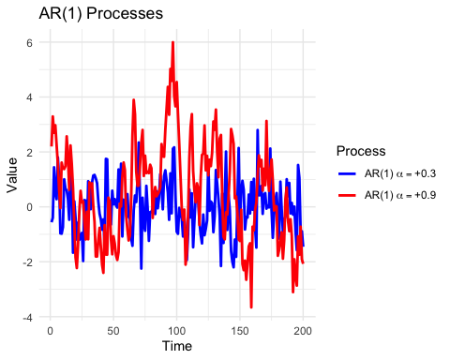
Graph Interpretation
AR(1) process with $α=0.3$: - Less persistent. - Shocks decay quickly. - The series is more volatile and returns to the mean faster. - Fluctuations are short-lived.
AR(1) process with $α=0.9$: - Highly persistent. - Shocks have a long-lasting effect. - The series returns to the mean more slowly. - Fluctuations are wide and long-lasting, resembling a “rolling trend”.
Key difference:
The closer $α$ is to 1, the more persistent and shock-sensitive the process becomes.
Smaller values of $α$ lead to a faster mean-reverting behavior.

AR(p) Process (Order p)
Extends AR(1) to $p$ past values (p lags) and depends on $p$ past values:
$$X_{t}=μ+\sum_{v=1}^{p}{α_{v}}\left(X_{t-v}-μ\right)+ϵ_{t}, ϵ_{t}∼WN$$
Stationarity Condition: Is the system stable? Now , instead of looking back 1 day, we look back p days.Things get complicated here. We no longer have just one coefficient ; we have many coefficients (like α1,α2 .) To control mechanism ,we use schur Polinomials. The polynomial
$$1-\sum_{v=1}^{p}{α_{v}}z^{v}≠0$$
for $\left|z\right|≤1$ (This is called a Schur polynomial condition). All roots must lie inside the “Unit Circle.” If they do, the shocks from the past fade away, and the system remains stable.
Key Tool: Yule–Walker Equations: These equations link the AR parameters ($α_{v}$) to the theoretical autocovariances ($γ_{h}$). If we know the autocovariences then we can calculate α .This relationship is key for parameter estimation:
$$γ_{h}=\sum_{v=1}^{p}{α_{v}}γ_{h-v}, h≥1 , γ_{0}=\sum_{v=1}^{p}{α_{v}}γ_{v}+σ^{2}$$
Let p=2 then
$$γ_{h}=α_{1}γ_{h-1}+α_{2}γ_{h-2}, h≥2 , ρ_{1}=\frac{α_{1}}{1-α_{2}}, ρ_{h}=α_{1}ρ_{h-1}+α_{2}ρ_{h-2}$$

3. Moving Average (MA) Models
MA(q) Process: The current value ($X_{t}$) depends linearly on the current and past random shocks (White Noise errors).
$$X_{t}=μ+\sum_{v=0}^{q}{β_{j}}ϵ_{t-j}, β_{0}=1, ϵ_{t}∼WN$$
Parameter $β_{j}$: Measures how strongly the past shocks ($ϵ_{t-j}$) influence the current value.
Stationarity: MA processes are always stationary because they are simply a finite, weighted sum of WN terms.
MA($∞$) (Linear Process): Stationary if
$$\sum_{i=0}^{∞}{\left|β_{i}\right|}<∞$$

4. The Combined ARMA Model
ARMA(p,q) Process: The general model that includes both AR and MA components for maximum flexibility. It models the current value based on both its own past values (AR part) and past White Noise shocks (MA part).
$$X_{t}=μ+\sum_{v=1}^{p}{α_{v}}\left(X_{t-v}-μ\right) +\sum_{j=0}^{q}{β_{j}}ϵ_{t-j} β_{0}=1, ϵ_{t}∼WN$$
Example: ARMA(1,1):
$$X_{t}=α_{1}X_{t-1}+ϵ_{t}+β_{1}ϵ_{t-1}$$
Key Property: The ARMA process has a causal stationary solution if the AR part is stationary ($\left|α_{1}\right|<1$ for ARMA(1,1)).Means ; When $|α_{1}|<1$, the AR component dampens past effects geometrically, preventing the process from depending on future values. Since the MA component already depends solely on past innovations, the entire model can be expressed purely in terms of past shocks. This implies that the process is causal.
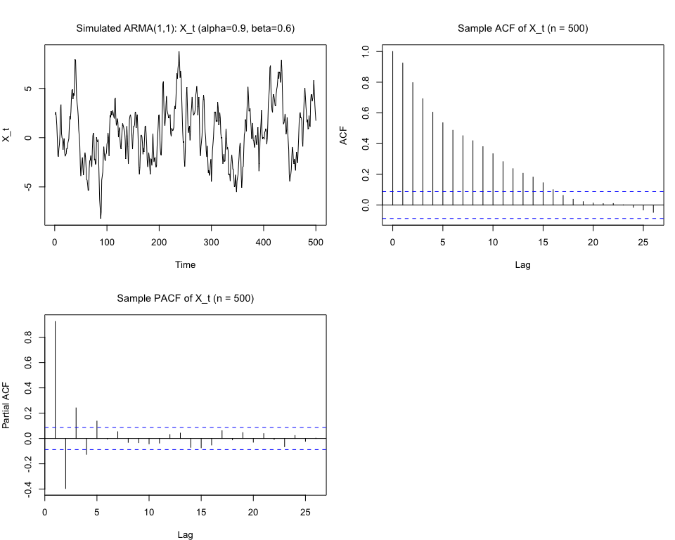
1) Time series plot (X_t)
- You will see a stationary-looking series fluctuating around zero (no obvious trend).
- Because $α=0.9$ is fairly large (but less than 1), the series shows high persistence: shocks create noticeable, slowly-decaying deviations from 0. So episodes of being above (or below) zero last several periods.
2) Sample ACF
- The ACF will show a slow, roughly geometric decay across lags (consistent with the AR(1) persistence).
- The presence of the MA(1) term with $β=0.6$ will alter the shape: you may see a strong spike at lag 1 (because the MA part contributes directly at lag 1) and then the ACF decays roughly exponentially thereafter.
3) Sample PACF
- The PACF typically shows a large spike at lag 1 and then quickly becomes small (cutting off rapidly). In a process that is mostly AR(1) but has a small MA(1) component, the PACF mainly highlights the AR(1) behavior — meaning the only strong spike appears at lag 1.
Short analytical note
- The process is stationary and causal because $\left|α\right|=0.9<1$.
- The relatively large AR coefficient (0.9) gives strong persistence — shocks last many periods.
- The MA coefficient ($β=0.6$) boosts the immediate (lag-1) impact of shocks.
- In practice you will see: a persistent series with a big short-run response to shocks and smooth decay afterward.
As a summary ; we use ARMA models to capture complex dependencies in data.
The goal is to find the best $p$ and $q$ orders and estimate the parameters ($α$ and $β$) that fit our data.
Next, we’ll look at the methods used to estimate these parameters and choose the right model order in practice

Parameter Estimation and Model Selection
Once the ARMA structure is chosen, we estimate parameters.

1. Parameter Estimation (Known Model Order)
Goal: Find the best estimates for the parameters coefficients ($α_{v}$, $β_{j}$, and the noise variance $σ^{2}$) when $p$ and $q$ are already known (selected).

Methods for AR(p) (Simpler):

a) Yule–Walker (YW) Estimators (for AR(p) - Use sample autocovariances.
Simple, based on substituting sample autocovariances (${\hat{γ}}_{h}$) into the Yule–Walker equations. (Fast, but sometimes less efficient).
Idea: Replace the theoretical autocovariances ($γ_{h}$) in the Yule–Walker equations with the sample estimates (${\hat{γ}}_{h}$) from the data.
Conceptually, the estimator works as follows: the total variance of the series is ${\hat{γ}}_{0}$, and the portion of variance explained by the AR($p$) model is $\sum_{v=1}^{p}{{\hat{α}}_{v}}{\hat{γ}}_{v}$. Subtracting the explained variance from the total variance yields ${\hat{σ}}^{2}$, the residual variance.
In other words, this formula quantifies the unexplained variability of the series after fitting an AR($p$) model.
Variance Estimator:
$${\hat{σ}}^{2}={\hat{γ}}_{0}-\sum_{v=1}^{p}{{\hat{α}}_{v}}{\hat{γ}}_{v}$$
(Note: ${\hat{σ}}^{2}$ may sometimes be negative, which is a disadvantage.)

b) Conditional Least-Squares (CLS) Estimators - Minimize squared residuals
Conditional Least Squares (CLS) is a method used to estimate the parameters of AR(p) models. Its goal is to make the model’s predictions, based on past observations, fit the actual data as closely as possible.
Idea: Minimizes the sum of squared errors, $∑ϵ_{t}^{2}$, where the errors at time $t$ are defined by the model equation:
$$ϵ_{t}=X_{t}-μ-\sum_{i=1}^{p}{α_{i}}\left(X_{t-i}-μ\right),$$
and CLS minimizes the sum of squared errors
$$S\left(α_{1},…,α_{p}\right)=\sum_{t=p+1}^{n}{ϵ_{t}^{2}},$$
to find the best-fitting parameters.
The mean $μ$ is typically estimated by the sample average:
$$\hat{μ}=\overset{‾}{X}=\frac{1}{n}\sum_{t=1}^{n}{X_{t}}.$$
The autoregressive coefficients $α_{i}$ are obtained by solving the linear system that minimizes the squared errors:
$$\sum_{t=p+1}^{n}{\left(X_{t-i}-\overset{‾}{X}\right)} ϵ_{t}=0, i=1,…,p.$$
Finally, the variance of the error term is estimated as
$${\hat{σ}}^{2}=\frac{\sum_{t=p+1}^{n}{{\hat{ϵ}}_{t}^{2}}}{n-p}.$$
In summary, CLS takes the sample mean as the baseline, makes predictions based on past values, minimizes the squared errors, and thus provides estimates for both the autoregressive coefficients $α_{i}$ and the error variance $σ^{2}$.

c) Maximum-Likelihood (ML) Estimator - Uses full probability structure
Assumes a distribution (often Normal) for the White Noise and finds the parameters that maximize the probability of observing the data. (Generally preferred for good properties, even with small samples).
Idea: Finds the parameters that maximize the Likelihood function (the joint density of the data, often assuming a Normal distribution).
Advantage: MLEs generally perform well, even with small data sizes.
For ARMA(p,q) models, ML and CLS are the only methods we can use, because other methods do not work (for example, Yule–Walker cannot be used because the equations become non-linear). But ML and CLS are still difficult to calculate, because they also need solving non-linear equations.

Model Diagnostics – Residual Analysis
First, we simulate a standard Autoregressive process of order 1. The mathematical formulation for an AR(1) process is:
$$x_{t}=α_{1}x_{t-1}+ϵ_{t}$$
Where:
- $α_{1}=0.7$ (Autoregressive coefficient)
- $ϵ_{t}∼N\left(0,1\right)$ (White noise error term)
The below simulated graph represents that the time series fluctuates over time. Because $α=0.7$, there is significant autocorrelation; past values clearly affect current values.
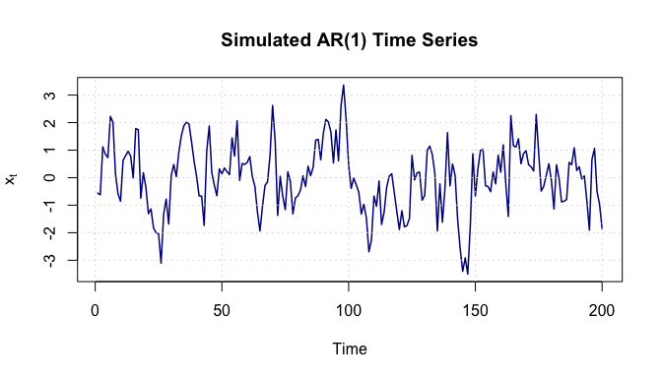
We fit an ARIMA(1,0,0) model to the simulated data to estimate the parameter $α$.
## ar1
## 0.6367051
Analysis:
- What we do: Fit an AR(1) model to the series using Maximum Likelihood Estimation.
- Why we do it: To estimate the AR(1) coefficient ($\hat{α}$) and calculate the residuals (${\hat{ϵ}}_{t}$).
- Interpretation: The estimated $\hat{α}$ is 0.637, which is very close to the true value of 0.7, suggesting a good fit.

1. Residual Analysis
Diagnostic checking is crucial to ensure the model has captured the information in the data. We analyze the residuals:
$${\hat{ϵ}}_{t}=x_{t}-\hat{α}x_{t-1}$$

1a) Check Independence
We use the Autocorrelation Function (ACF) and the Ljung-Box test
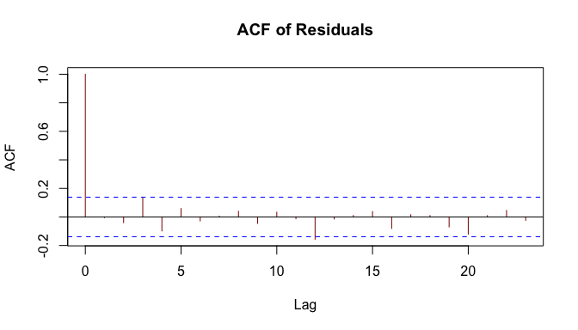
## Box-Ljung test
## data: res
## X-squared = 0.0046639, df = 1, p-value = 0.9456
## Box-Ljung test
## data: res
## X-squared = 7.8303, df = 10, p-value = 0.6454
Analysis:
- What we do:
  - acf(res): Check autocorrelation of residuals.
  - Box.test(): Statistical test for independence (Joint hypothesis).
- Why we do it: ARMA models assume residuals are independent white noise. If not, the model is missing patterns.
- Interpretation:
  - ACF Plot: No significant spikes outside the confidence bounds implies residuals are independent.
  - Box Test: A p-value > 0.05 confirms we cannot reject the null hypothesis of independence.

1b) Check Normality
We check if residuals follow a Normal distribution: $ϵ_{t}∼N\left(0,σ^{2}\right)$.
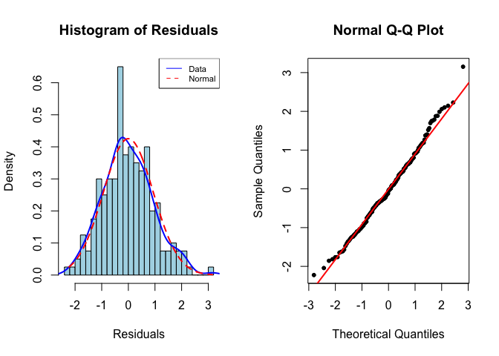
##
## Asymptotic one-sample Kolmogorov-Smirnov test
##
## data: res
## D = 0.048987, p-value = 0.7232
## alternative hypothesis: two-sided
Analysis:
- What we do: Compare empirical distribution (Histogram/QQ-plot) with the theoretical normal distribution and perform the KS (Kolmogorov-Smirnov) test.
- Why we do it: Normality is required for valid confidence intervals and hypothesis tests.
- Interpretation:
  - Histogram: Roughly bell-shaped.
  - QQ-plot: Points follow the red line closely.
  - KS Test: p-value > 0.05 suggests normality is acceptable ,we do not reject the null hypothesis,Residuals follow a normal distribution

1c) Check Homoscedasticity (Constant Variance)
We examine if the variance of residuals changes over time (Volatility clustering).
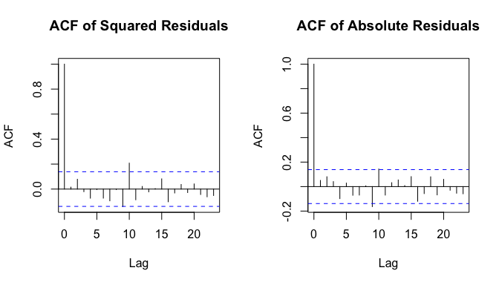
Analysis:
- What we do: Examine autocorrelation of squared ($ϵ_{t}^{2}$) and absolute ($\left|ϵ_{t}\right|$) residuals.
- Why we do it: ARMA models assume constant variance ($σ^{2}$). If variance depends on past values (spikes in these plots), ARCH/GARCH models might be needed.
- Interpretation: No significant autocorrelations indicate variance is roughly constant.

Summary
Below is the summary of our diagnostic steps.
Step | What we do | Why we do it | Interpretation
Model Fit | Fit AR(1) model | Estimate coefficient, calculate residuals | $α≈0.7$, model captures main pattern
Independence | ACF + Ljung-Box | Check residuals are uncorrelated | No autocorrelation $→$ residuals independent
Normality | Hist + QQ + KS test | Residuals should be normal | Residuals roughly normal $→$ forecasts reliable
Constant Variance | ACF of $res^{2}$ and $\left|res\right|$ | To ensure residual var is stable over time | No strongautocorrelation→var stable

2. Model Order Selection (Unknown Model Order)
The Problem: How do we choose the best $p$ and $q$ for real data? In real data, we don’t know the true orders $p$ and $q$. We need a systematic way to choose them.
The Trade-Off: We want a model that is:
Accurate: Fits the data well (low error/variance, ${\hat{σ}}^{2}$).
Simple: Uses few parameters (low $p+q$).
Information Criteria (ICs): We calculate these criteria for many different $\left(k_{1},k_{2}\right)$ orders and choose the model that gives the minimum value. These formulas reward model fit and penalize complexity. We choose the model that minimizes the IC value.

Akaike Information Criterion (AIC)
$$AIC\left(k_{1},k_{2}\right)=log\hat{σ}{\left(k_{1},k_{2}\right)}^{2}+2\left(k_{1}+k_{2}+1\right)\frac{1}{n}$$
Property: Tends to select larger models (it can overestimate the true order). Good for prediction.AIC tends to overestimate the true model order.

Bayesian Information Criterion (BIC)
$$BIC\left(k_{1},k_{2}\right)=log\hat{σ}{\left(k_{1},k_{2}\right)}^{2}+\left(k_{1}+k_{2}+1\right)\frac{logn}{n}$$
Property: Stronger penalty for complexity due to $log\left(n\right)$. Tends to select smaller models (it is consistent). Better for finding the “true” underlying process.BIC provides a consistent estimator (it selects the true order more reliably as $n→∞$).

3. Practical Steps and Residual Analysis
Step 1: Fix upper bounds for $p$ and $q$ (e.g., max $p=5$, max $q=5$).
Step 2: Calculate AIC/BIC for all possible combinations $\text{ARMA}\left(k_{1},k_{2}\right)$ within those bounds.
Step 3: Select the model that minimizes the chosen criterion.
Step 4: Residual Diagnostics: After fitting, the residuals (the ${\hat{ϵ}}_{t}$ errors) must resemble White Noise.
Check the Autocorrelation Function (ACF) of the residuals. They should be close to zero.
Check the ACF of the squared residuals (${\hat{ϵ}}_{t}^{2}$). If these are non-zero, it suggests that the variance is changing over time (a sign that an ARCH/GARCH model might be needed).

4. Conclusion
ARMA models are powerful for modeling linear time dependencies.
We use MLE for parameter estimation and AIC/BIC for choosing the model structure.
Remember to always check your residuals! They must be White Noise for the model to be valid.

