**THÊM – XÓA – SỬA – LISTVIEW**

1. **Thêm cách 1**
2. **DEMO APP Thêm bằng menu**

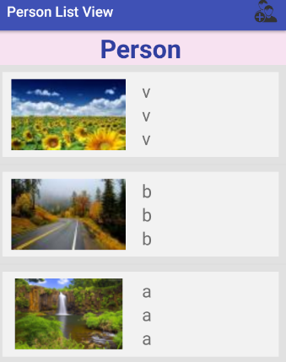 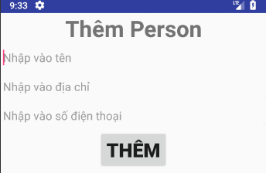

1. **Nhánh thư mục**

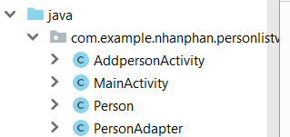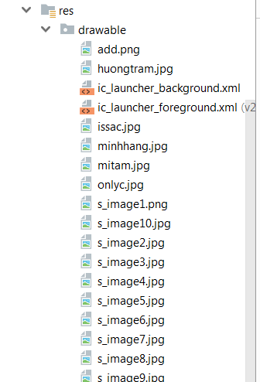

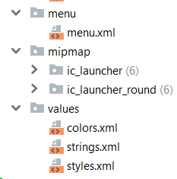 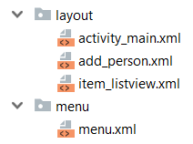

1. **Menu**

 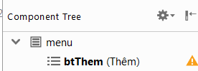

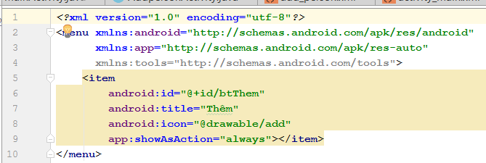

1. **GUI**
2. **Activity_main.xml**

* **Layout**

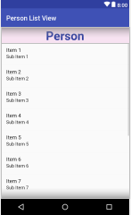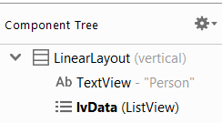

* **Code**

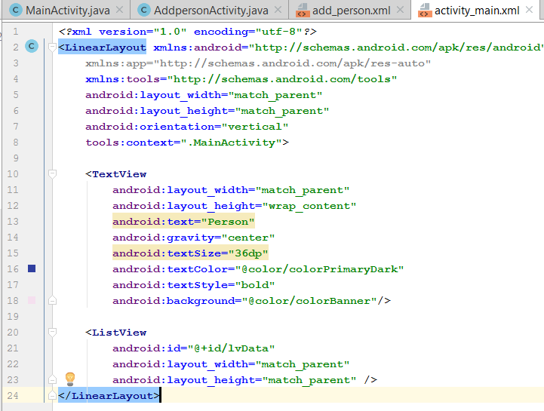

1. **Item_listView**

* **Layout**

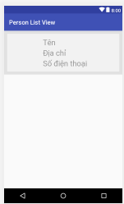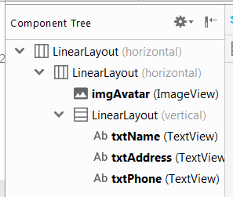

* **Code**

|  |
| --- |
| *<?***xml version="1.0" encoding="utf-8"***?>* <**LinearLayout xmlns:android="http://schemas.android.com/apk/res/android"  android:layout_width="match_parent"  android:layout_height="wrap_content"  android:background="#e1e1e1"  android:orientation="horizontal"  android:padding="10dp"**>  <**LinearLayout  android:layout_width="match_parent"  android:layout_height="match_parent"  android:background="#f2f2f2"**>  <**ImageView  android:id="@+id/imgAvatar"  android:layout_width="wrap_content"  android:layout_height="match_parent"  android:layout_weight="1"  android:padding="10dp"** />  <**LinearLayout  android:layout_width="0dp"  android:layout_height="wrap_content"  android:layout_weight="3"  android:orientation="vertical"  android:padding="10dp"**>  <**TextView  android:id="@+id/txtName"  android:layout_width="match_parent"  android:layout_height="wrap_content"  android:hint="Tên"  android:textSize="25sp"** />  <**TextView  android:id="@+id/txtAddress"  android:layout_width="match_parent"  android:layout_height="wrap_content"  android:hint="Địa chỉ"  android:textSize="25sp"** />  <**TextView  android:id="@+id/txtPhone"  android:layout_width="match_parent"  android:layout_height="wrap_content"  android:hint="Số điện thoại"  android:textSize="25sp"** />  </**LinearLayout**>  </**LinearLayout**> </**LinearLayout**> |

1. **Add_person.xml**

* **Layout**

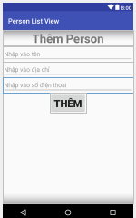 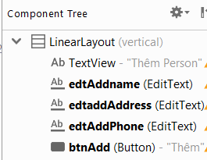

* **Code**

|  |
| --- |
| *<?***xml version="1.0" encoding="utf-8"***?>* <**LinearLayout xmlns:android="http://schemas.android.com/apk/res/android"  android:layout_width="match_parent"  android:layout_height="match_parent"  android:gravity="center_horizontal"  android:orientation="vertical"**>  <**TextView  android:layout_width="match_parent"  android:layout_height="wrap_content"  android:gravity="center"  android:text="Thêm Person"  android:textSize="35sp"  android:textStyle="bold"** />  <**EditText  android:id="@+id/edtAddname"  android:layout_width="match_parent"  android:layout_height="wrap_content"  android:hint="Nhập vào tên"** />  <**EditText  android:id="@+id/edtaddAddress"  android:layout_width="match_parent"  android:layout_height="wrap_content"  android:hint="Nhập vào địa chỉ"** />  <**EditText  android:id="@+id/edtAddPhone"  android:layout_width="match_parent"  android:layout_height="wrap_content"  android:hint="Nhập vào số điện thoại"** />  <**Button  android:id="@+id/btnAdd"  android:layout_width="wrap_content"  android:layout_height="wrap_content"  android:text="Thêm"  android:textSize="30sp"  android:textStyle="bold"** /> </**LinearLayout**> |

1. **CODE**
2. **Person – class**

|  |
| --- |
| **package** com.example.nhanphan.personlistview;  **import** java.io.Serializable;  **public class** Person **implements** Serializable {  **int code**;  **private int avatar**;  **private** String **name**;  **private** String **address**;  **private** String **phone**;   **public** Person() { }  **public** Person(**int** code, **int** avatar, String name, String address, String phone) {  **this**.**code** = code;  **this**.**avatar** = avatar;  **this**.**name** = name;  **this**.**address** = address;  **this**.**phone** = phone;  }  **public int** getCode() {  **return code**;  }  **public void** setCode(**int** code) {  **this**.**code** = code;  }   **public int** getAvatar() {  **return avatar**;  }   **public void** setAvatar(**int** avatar) {  **this**.**avatar** = avatar;  }   **public** String getName() {  **return name**;  }   **public void** setName(String name) {  **this**.**name** = name;  }   **public** String getAddress() {  **return address**;  }   **public void** setAddress(String address) {  **this**.**address** = address;  }   **public** String getPhone() {  **return phone**;  }   **public void** setPhone(String phone) {  **this**.**phone** = phone;  } } |

1. **PersonAdapter – class**

|  |
| --- |
| **package** com.example.nhanphan.personlistview;   **import** android.content.Context; **import** android.view.LayoutInflater; **import** android.view.View; **import** android.view.ViewGroup; **import** android.widget.BaseAdapter; **import** android.widget.ImageView; **import** android.widget.TextView;  **import** java.util.ArrayList;  **public class** PersonAdapter **extends** BaseAdapter {  ArrayList<Person> **listData**;  LayoutInflater **inflater**;  ImageView **imgAvatar**;  TextView **txtName**, **txtAddress**, **txtPhone**;   **public** PersonAdapter(ArrayList<Person> listData, Context context){  **this**.**listData** = listData;  **inflater** = (LayoutInflater) context.getSystemService(context.***LAYOUT_INFLATER_SERVICE***);  }  **public** ArrayList<Person> getListData() {  **return listData**;  }   **public void** setListData(ArrayList<Person> listData) {  **this**.**listData** = listData;  }   @Override  **public int** getCount() {  **return listData**.size();  }   @Override  **public** Person getItem(**int** position) {  **return listData**.get(position);  }   @Override  **public long** getItemId(**int** position) {  **return** 0;  }   @Override  **public** View getView(**int** position, View convertView, ViewGroup parent) {  **if** (convertView == **null**)  convertView = **inflater**.inflate(R.layout.***item_listview***, **null**); *// Gọi và gán layout* **imgAvatar** = (ImageView) convertView.findViewById(R.id.***imgAvatar***);  **txtName** = (TextView) convertView.findViewById(R.id.***txtName***);  **txtAddress** = (TextView) convertView.findViewById(R.id.***txtAddress***);  **txtPhone** = (TextView) convertView.findViewById(R.id.***txtPhone***);   Person person = getItem(position);  **imgAvatar**.setImageResource(person.getAvatar());  **txtName**.setText(person.getName().toString());  **txtAddress**.setText(person.getAddress().toString());  **txtPhone**.setText(person.getPhone().toString());  **return** convertView;  } } |

1. **AddpersonActivity**

|  |
| --- |
| **package** com.example.nhanphan.personlistview;  **import** android.content.Intent; **import** android.support.v7.app.AppCompatActivity; **import** android.os.Bundle; **import** android.view.View; **import** android.widget.Button; **import** android.widget.EditText; **import** android.widget.TextView;  **public class** AddpersonActivity **extends** AppCompatActivity {  TextView **edtAddName**, **edtAddAddress**, **edtAddphone**;  Button **btnAdd**;  **int pos**;  Integer[] **Hinhnho** = {R.drawable.***s_image1***,R.drawable.***s_image2***,R.drawable.***s_image3***,R.drawable.***s_image4***,  R.drawable.***s_image5***,R.drawable.***s_image6***,R.drawable.***s_image7***,R.drawable.***s_image8***,R.drawable.***s_image9***};  @Override  **protected void** onCreate(Bundle savedInstanceState) {  **super**.onCreate(savedInstanceState);  setContentView(R.layout.***add_person***); *// thay layout* getSupportActionBar().hide();  Intent intent = getIntent();  **pos** = intent.getIntExtra(**"pos"**,0);  initview();  }  **public void** initview(){  **edtAddName** = (EditText) findViewById(R.id.***edtAddname***);  **edtAddAddress** = (TextView) findViewById(R.id.***edtaddAddress***);  **edtAddphone** = (TextView) findViewById(R.id.***edtAddPhone***);  **btnAdd** = (Button) findViewById(R.id.***btnAdd***);  **btnAdd**.setOnClickListener(**new** View.OnClickListener() {  @Override  **public void** onClick(View v) {  Person person = **new** Person(**pos**, **Hinhnho**[**pos**++], **edtAddName**.getText().toString(),  **edtAddAddress**.getText().toString(), **edtAddphone**.getText().toString());  Intent intent = **new** Intent(AddpersonActivity.**this**, MainActivity.**class**);  intent.putExtra(**"ADD"**,person);  setResult(100, intent);  finish();  }  });  }  } |

1. **MainACtivity**

|  |
| --- |
| **package** com.example.nhanphan.personlistview;  **import** android.content.Intent; **import** android.support.v7.app.AppCompatActivity; **import** android.os.Bundle; **import** android.view.Menu; **import** android.view.MenuItem; **import** android.view.View; **import** android.widget.AdapterView; **import** android.widget.GridView; **import** android.widget.ImageView; **import** android.widget.ListView; **import** android.widget.Toast;  **import** java.util.ArrayList; **import** java.util.MissingFormatArgumentException; **import** java.util.zip.Inflater;  **public class** MainActivity **extends** AppCompatActivity {   PersonAdapter **adapter**;  ArrayList<Person> **listData**;  ListView **lvData**;  ImageView **imgAddPerson**;  **int pos**=0;  @Override  **protected void** onCreate(Bundle savedInstanceState) {  **super**.onCreate(savedInstanceState);  setContentView(R.layout.***activity_main***);  *//getSupportActionBar().hide();  // Gọi phương thức getData và initView* getData();  initView();  }   **private void** initView() {  **adapter** = **new** PersonAdapter(**listData**, MainActivity.**this**);  **lvData** = (ListView) findViewById(R.id.***lvData***);  **lvData**.setAdapter(**adapter**);  **adapter**.notifyDataSetChanged();   *// imgAddPerson = (ImageView) findViewById(R.id.imgAddPerson);* }   **private void** getData() {  **listData** = **new** ArrayList<>();   }    @Override  **protected void** onActivityResult(**int** requestCode, **int** resultCode, Intent data) {  **switch** (requestCode){  **case** 10:  **if** (data != **null**){  Person person = (Person) data.getSerializableExtra(**"ADD"**);  **if** (resultCode == 100){  person.setCode(**adapter**.getCount() + 1);  **adapter**.getListData().add(0,person);  **adapter**.notifyDataSetChanged();  Toast.*makeText*(MainActivity.**this**, **"Thêm thành công!"**, Toast.***LENGTH_SHORT***).show();  }**else** {  Toast.*makeText*(MainActivity.**this**, **"Có lỗi xảy ra, vui lòng thử lại!"**, Toast.***LENGTH_SHORT***).show();  }  **break**;  }  **case** 20:  **if** (data != **null**){  Person seclect = (Person) data.getSerializableExtra(**"EDIT"**);  **if** (resultCode == 200){  **for** (Person item:**adapter**.getListData()){  **if** (item.getCode() == seclect.getCode()){  item.setAvatar(seclect.getCode());  item.setName(seclect.getName());  item.setAddress(seclect.getAddress());  item.setPhone(seclect.getPhone());  **break**;  }  }  **adapter**.notifyDataSetChanged();  **break**;  }**else if** (resultCode == 300){  **int** ID = data.getExtras().getInt(**"DEL"**);  **int** position = -1;  **for** (**int** i = 0; i < **adapter**.getCount(); i++){  **if** (**adapter**.getItem(i).getCode() == ID){  position = i;  **break**;  }  }  **if** (position < 10){  Toast.*makeText*(MainActivity.**this**,**"Không xác định được vị trí"**, Toast.***LENGTH_SHORT***).show();  }**else** {  **adapter**.getListData().remove(position);  **adapter**.notifyDataSetChanged();  Toast.*makeText*(MainActivity.**this**, **"Đã xóa thành công!"**, Toast.***LENGTH_SHORT***).show();  }  }  }  }  *// super.onActivityResult(requestCode, resultCode, data);* }  *//* @Override  **public boolean** onCreateOptionsMenu(Menu menu) {  getMenuInflater().inflate(R.menu.***menu***,menu);  **return super**.onCreateOptionsMenu(menu);  }   @Override  **public boolean** onOptionsItemSelected(MenuItem item) {  **int** id = item.getItemId();  **if** (id == R.id.***btThem***){  Intent inte = **new** Intent(MainActivity.**this**, AddpersonActivity.**class**);  inte.putExtra(**"pos"**, **pos**++);  startActivityForResult(inte, 10);  }  **return super**.onOptionsItemSelected(item);  } } |

1. **Thêm cách 2**
2. **Demo app nhấn thêm bằng img**

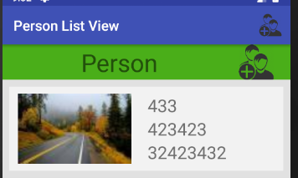 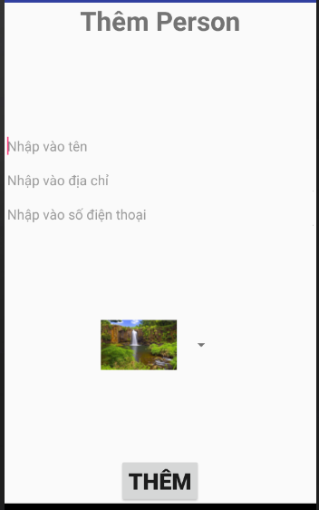

1. **Nhánh thư mục:** màu đỏ là thêm nội dung vào đây

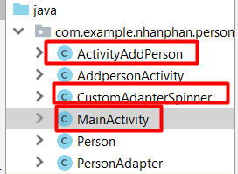 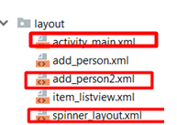

1. **Menu: tương tự**
2. **GUI**
3. **Activity_main.xml**

* **Layout**

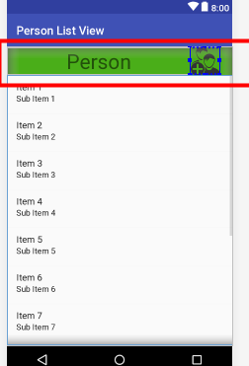 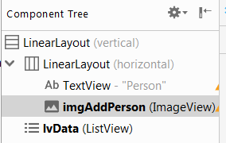

* **Code**

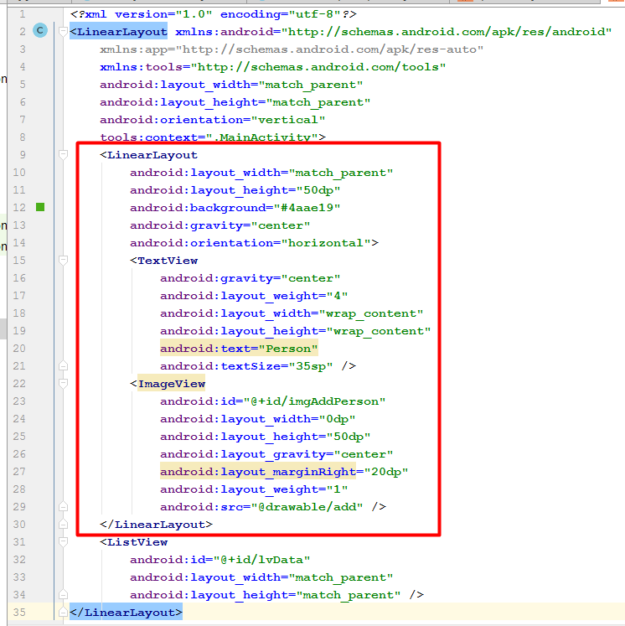

1. **Add_person2.xml**

**Layout**

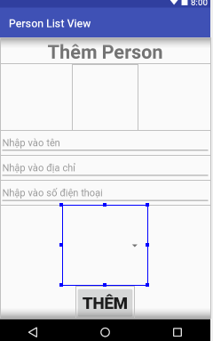 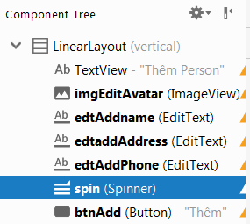

**Code**

|  |
| --- |
| *<?***xml version="1.0" encoding="utf-8"***?>* <**LinearLayout xmlns:android="http://schemas.android.com/apk/res/android"  android:layout_width="match_parent"  android:layout_height="match_parent"  android:gravity="center_horizontal"  android:orientation="vertical"**>   <**TextView  android:layout_width="match_parent"  android:layout_height="wrap_content"  android:gravity="center"  android:text="Thêm Person"  android:textSize="35sp"  android:textStyle="bold"** />  <**ImageView  android:id="@+id/imgEditAvatar"  android:layout_width="120dp"  android:layout_height="120dp"** />  <**EditText  android:id="@+id/edtAddname"  android:layout_width="match_parent"  android:layout_height="wrap_content"  android:hint="Nhập vào tên"** />   <**EditText  android:id="@+id/edtaddAddress"  android:layout_width="match_parent"  android:layout_height="wrap_content"  android:hint="Nhập vào địa chỉ"** />   <**EditText  android:id="@+id/edtAddPhone"  android:layout_width="match_parent"  android:layout_height="wrap_content"  android:hint="Nhập vào số điện thoại"** />   <**Spinner  android:id="@+id/spin"  android:layout_width="156dp"  android:layout_height="124dp"  android:layout_gravity="center"  android:layout_weight="1"**>   </**Spinner**>  <**Button  android:id="@+id/btnAdd"  android:layout_width="wrap_content"  android:layout_height="wrap_content"  android:text="Thêm"  android:textSize="30sp"  android:textStyle="bold"** /> </**LinearLayout**> |

1. **Spinner.xml**

**Code**

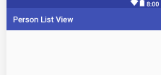 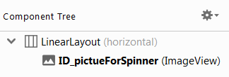

**Layout**

|  |
| --- |
| *<?***xml version="1.0" encoding="utf-8"***?>* <**LinearLayout  xmlns:android="http://schemas.android.com/apk/res/android" android:layout_width="match_parent"  android:layout_height="match_parent"**>   <**ImageView  android:id="@+id/ID_pictueForSpinner"  android:layout_width="wrap_content"  android:layout_height="wrap_content"** /> </**LinearLayout**> |

1. **Code**
2. **C****ustomAdapterSpinner**

|  |
| --- |
| **package** com.example.nhanphan.personlistview;  **import** android.content.Context; **import** android.view.LayoutInflater; **import** android.view.View; **import** android.view.ViewGroup; **import** android.widget.BaseAdapter; **import** android.widget.ImageView;  **public class** CustomAdapterSpinner **extends** BaseAdapter {  **private** Context **context**;  **private int layout**;  **private int**[] **picture**;   **public** CustomAdapterSpinner(Context context, **int** layout, **int**[] picture) {  **this**.**context** = context;  **this**.**layout** = layout;  **this**.**picture** = picture;  }  @Override  **public int** getCount() {  **return picture**.**length**;  }   @Override  **public** Object getItem(**int** position) {  **return null**;  }   @Override  **public long** getItemId(**int** position) {  **return** 0;  }   @Override  **public** View getView(**int** position, View view, ViewGroup parent) {  LayoutInflater layoutInflater = (LayoutInflater) **context**.getSystemService(Context.***LAYOUT_INFLATER_SERVICE***);  view = layoutInflater.inflate(**layout**,**null**);   ImageView img = (ImageView)view.findViewById(R.id.***ID_pictueForSpinner***);  img.setImageResource(**picture**[position]);  **return** view;  } } |

1. **ActivityAddPerson**

|  |
| --- |
| **package** com.example.nhanphan.personlistview;  **import** android.content.Intent; **import** android.support.v7.app.AppCompatActivity; **import** android.os.Bundle; **import** android.view.View; **import** android.widget.AdapterView; **import** android.widget.Button; **import** android.widget.EditText; **import** android.widget.ImageView; **import** android.widget.Spinner; **import** android.widget.TextView;  *// Là một activity* **public class** ActivityAddPerson **extends** AppCompatActivity {  TextView **edtAddName**, **edtAddAddress**, **edtAddphone**;  Button **btnAdd**;  **int pos**;  Spinner **spinner**;  ImageView **imgEditAvatar**;  **int pathImg**;  **int**[] **Hinhnho** = {R.drawable.***s_image1***,R.drawable.***s_image2***,R.drawable.***s_image3***,R.drawable.***s_image4***,  R.drawable.***s_image5***,R.drawable.***s_image6***,R.drawable.***s_image7***,R.drawable.***s_image8***,R.drawable.***s_image9***};  @Override  **protected void** onCreate(Bundle savedInstanceState) {  **super**.onCreate(savedInstanceState);  setContentView(R.layout.***add_person2***); *// Cách 2* **imgEditAvatar** = (ImageView) findViewById(R.id.***imgEditAvatar***);  **spinner** =(Spinner) findViewById(R.id.***spin***);  CustomAdapterSpinner customAdapterSpinner = **new** CustomAdapterSpinner(ActivityAddPerson.**this**,R.layout.***spinner_layout***,**Hinhnho**);  **spinner**.setAdapter(customAdapterSpinner);  **spinner**.setOnItemSelectedListener(**new** AdapterView.OnItemSelectedListener() {  @Override  **public void** onItemSelected(AdapterView<?> parent, View view, **int** position, **long** id) {  **pathImg** = **spinner**.getSelectedItemPosition();  }   @Override  **public void** onNothingSelected(AdapterView<?> parent) {  }  });  getSupportActionBar().hide();  Intent intent = getIntent();  **pos** = intent.getIntExtra(**"pos"**, 0);  initview();  }  **private void** initview() {  **edtAddName** = (EditText) findViewById(R.id.***edtAddname***);  **edtAddAddress** = (TextView) findViewById(R.id.***edtaddAddress***);  **edtAddphone** = (TextView) findViewById(R.id.***edtAddPhone***);  **btnAdd** = (Button) findViewById(R.id.***btnAdd***);  **btnAdd**.setOnClickListener(**new** View.OnClickListener() {  @Override  **public void** onClick(View v) {   Person person = **new** Person(**pos**++, **Hinhnho**[**pathImg**], **edtAddName**.getText().toString(),  **edtAddAddress**.getText().toString(), **edtAddphone**.getText().toString());  Intent intent = **new** Intent(ActivityAddPerson.**this**, MainActivity.**class**);  intent.putExtra(**"ADD"**, person);  setResult(100, intent);  finish();   }  });  } } |

1. **MainActivity**

|  |
| --- |
| **package** com.example.nhanphan.personlistview;  **import** android.content.Intent; **import** android.support.v7.app.AppCompatActivity; **import** android.os.Bundle; **import** android.view.Menu; **import** android.view.MenuItem; **import** android.view.View; **import** android.widget.AdapterView; **import** android.widget.GridView; **import** android.widget.ImageView; **import** android.widget.ListView; **import** android.widget.Toast;  **import** java.util.ArrayList; **import** java.util.MissingFormatArgumentException; **import** java.util.zip.Inflater;  **public class** MainActivity **extends** AppCompatActivity {   PersonAdapter **adapter**;  ArrayList<Person> **listData**;  ListView **lvData**;  ImageView **imgAddPerson**;  **int pos**=0;  @Override  **protected void** onCreate(Bundle savedInstanceState) {  **super**.onCreate(savedInstanceState);  setContentView(R.layout.***activity_main***);  *//getSupportActionBar().hide();  // Gọi phương thức getData và initView* getData();  initView();  }  View.OnClickListener **Add_Click** = **new** View.OnClickListener() { *// Cách 2* @Override  **public void** onClick(View v) {  Intent inte = **new** Intent(MainActivity.**this**, ActivityAddPerson.**class**);  inte.putExtra(**"pos"**, **pos**++);  startActivityForResult(inte, 10);  }  };  **private void** initView() {  **adapter** = **new** PersonAdapter(**listData**, MainActivity.**this**);  **lvData** = (ListView) findViewById(R.id.***lvData***);  **lvData**.setAdapter(**adapter**);  **adapter**.notifyDataSetChanged();  **imgAddPerson** = (ImageView) findViewById(R.id.***imgAddPerson***); *// Cách 2* **imgAddPerson**.setOnClickListener(**Add_Click**); *// Cách 2* }  **private void** getData() {  **listData** = **new** ArrayList<>();   }   @Override  **protected void** onActivityResult(**int** requestCode, **int** resultCode, Intent data) {  **switch** (requestCode){  **case** 10:  **if** (data != **null**){  Person person = (Person) data.getSerializableExtra(**"ADD"**);  **if** (resultCode == 100){  person.setCode(**adapter**.getCount() + 1);  **adapter**.getListData().add(0,person);  **adapter**.notifyDataSetChanged();  Toast.*makeText*(MainActivity.**this**, **"Thêm thành công!"**, Toast.***LENGTH_SHORT***).show();  }**else** {  Toast.*makeText*(MainActivity.**this**, **"Có lỗi xảy ra, vui lòng thử lại!"**, Toast.***LENGTH_SHORT***).show();  }  **break**;  }  **case** 20:  **if** (data != **null**){  Person seclect = (Person) data.getSerializableExtra(**"EDIT"**);  **if** (resultCode == 200){  **for** (Person item:**adapter**.getListData()){  **if** (item.getCode() == seclect.getCode()){  item.setAvatar(seclect.getCode());  item.setName(seclect.getName());  item.setAddress(seclect.getAddress());  item.setPhone(seclect.getPhone());  **break**;  }  }  **adapter**.notifyDataSetChanged();  **break**;  }**else if** (resultCode == 300){  **int** ID = data.getExtras().getInt(**"DEL"**);  **int** position = -1;  **for** (**int** i = 0; i < **adapter**.getCount(); i++){  **if** (**adapter**.getItem(i).getCode() == ID){  position = i;  **break**;  }  }  **if** (position < 10){  Toast.*makeText*(MainActivity.**this**,**"Không xác định được vị trí"**, Toast.***LENGTH_SHORT***).show();  }**else** {  **adapter**.getListData().remove(position);  **adapter**.notifyDataSetChanged();  Toast.*makeText*(MainActivity.**this**, **"Đã xóa thành công!"**, Toast.***LENGTH_SHORT***).show();  }  }  }  }  *// super.onActivityResult(requestCode, resultCode, data);* }  *//* @Override  **public boolean** onCreateOptionsMenu(Menu menu) {  getMenuInflater().inflate(R.menu.***menu***,menu);  **return super**.onCreateOptionsMenu(menu);  }   @Override  **public boolean** onOptionsItemSelected(MenuItem item) {  **int** id = item.getItemId();  **if** (id == R.id.***btThem***){  Intent inte = **new** Intent(MainActivity.**this**, AddpersonActivity.**class**);  inte.putExtra(**"pos"**, **pos**++);  startActivityForResult(inte, 10);  }  **return super**.onOptionsItemSelected(item);  } } |

1. **Sửa và xóa**
2. **Demo Sửa/xóa**
3. **Nhánh thư mục**
4. **GUI**
5. **Code**