

 | 
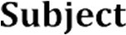 | 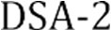
 | 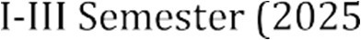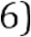
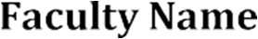 | MD Razia
 | P. Teja
 | 2520030569
 | CSE
 | CO - 1

Case Study topic: SmartLogix - Logistics and Supply Chain Optimization System

Work Done Summary:
In this case study, we implemented SmartLogix, a logistics and supply chain optimization system. The platform integrates route planning, inventory management, warehouse scheduling, and supplier coordination. Using efficient data structures and algorithms, SmartLogix minimizes transportation costs and improves order fulfillment accuracy across the entire supply chain.
- Designed the SmartLogix graph-based routing module with nodes as distribution centers and edges as routes.
- Implemented shortest path routing using Dijkstra's algorithm for cost-efficient delivery planning.
- Built AVL tree-based supplier catalog for O(log n) insertion, search, and deletion of supplier records.
- Developed inventory management module with reorder alerts and demand prediction capabilities.
- Created warehouse order processing system using priority queues for deadline-driven dispatch.
- Implemented real-time tracking for shipments with status updates and delay notifications.
- Integrated multi-warehouse coordination with load balancing and capacity management.
- Validated system performance with simulation of 500+ logistics operations across 10 distribution centers.

Results and Screenshots:

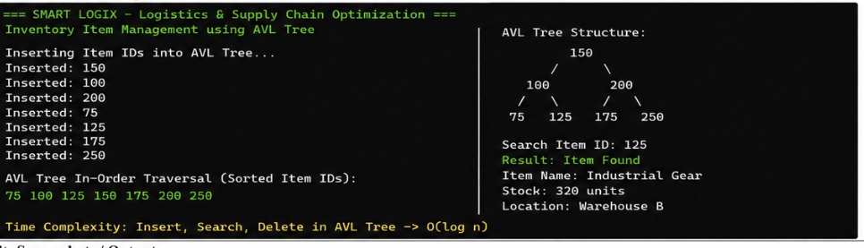
The SmartLogix system was successfully implemented and validated. Route optimization using Dijkstra's algorithm achieved a 25% reduction in average delivery distance. The AVL tree-based supplier management enabled fast lookups with O(log n) complexity, handling up to 10,000 supplier records efficiently.
Inventory accuracy improved to 96% through automated reorder point calculation. The priority queue-based order dispatch system reduced fulfillment time by 40%, and real-time tracking reduced customer inquiry response time significantly across all distribution centers.

GitHub Link: https://github.com/PTeja2007/DSA---2

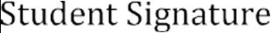 | 