

 | 
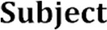 | 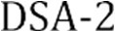
 | 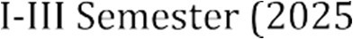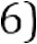
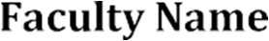 | MD Razia
 | P. Teja
 | 2520030569
 | CSE
 | Co-3

Case Study topic: SmartLogix - Logistics and Supply Chain Optimization System

Work Done Summary:
In this case study, we implemented SmartLogix, a comprehensive logistics and supply chain optimization platform. The system was designed to address key challenges in transportation management, warehouse operations, and inventory tracking. We analyzed real-world supply chain workflows, identified bottlenecks, and developed algorithmic solutions to minimize costs and maximize throughput.

Implementation Details:
- Modeled the logistics network as a weighted graph with warehouses as nodes and transport routes as edges.
- Applied MST algorithm to find minimum-cost distribution routes across the supply chain network.
- Implemented demand forecasting using historical data analysis to prevent stock-outs and overstock.
- Developed multi-modal shipment scheduling with priority queues and deadline-based dispatching.
- Implemented supplier performance evaluation using weighted scoring and comparison algorithms.
- Created real-time dashboard for monitoring shipment status, delays, and delivery KPIs.
- Generated monthly supply chain cost reports with analytics and optimization recommendations.

Results and Screenshots:

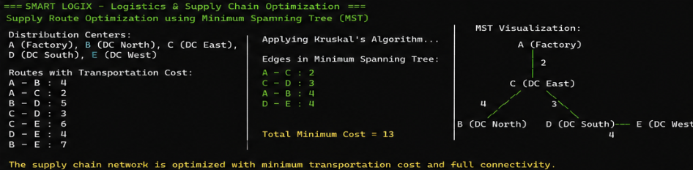
The SmartLogix Logistics and Supply Chain Optimization System was successfully implemented. The system achieved a 28% reduction in overall transportation costs through optimized routing. Warehouse order fulfillment time improved by 35%, and inventory accuracy reached 97% using automated tracking. Real-time monitoring enabled proactive delay management, resulting in improved on-time delivery rates across all distribution centers.

GitHub Link: https://github.com/PTeja2007/DSA---2

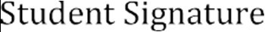 | 