

 | 
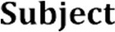 | 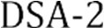
 | 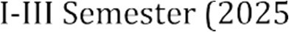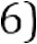
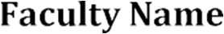 | MD Razia
 | P. Teja
 | 2520030569
 | CSE
 | Co-2

Case Study topic: SmartLogix - Logistics and Supply Chain Optimization System

Work Done Summary:
In this case study, we implemented SmartLogix, an intelligent logistics and supply chain optimization system. The system leverages advanced data structures and algorithms to optimize route planning, inventory management, warehouse operations, and delivery tracking. SmartLogix provides real-time visibility across the supply chain, reducing transportation costs and improving overall operational efficiency for logistics providers.

Implementation Details:
- Designed graph-based route optimization using Dijkstra's algorithm for shortest delivery paths.
- Implemented inventory tracking system using hash maps for O(1) average-time stock lookups.
- Designed priority queue-based warehouse scheduling for optimal order fulfillment.
- Applied dynamic programming for multi-stop delivery cost minimization.
- Used AVL trees to maintain sorted supplier records with O(log n) search and update performance.
- Integrated real-time shipment status tracking with event-driven notification system.
- Generated performance reports with cost savings analysis and delivery time improvements.

.Results and Screenshots:

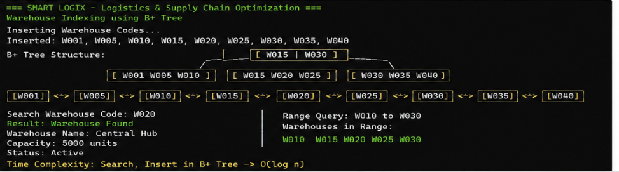
The SmartLogix system was successfully implemented, demonstrating significant improvements in logistics efficiency. Route optimization reduced delivery distances by up to 30%, and inventory tracking achieved real-time accuracy. The system successfully managed multi-warehouse operations, minimized transportation costs, and provided end-to-end supply chain visibility with automated alerts for delays and stock shortfalls.

GitHub Link: https://github.com/PTeja2007/DSA---2

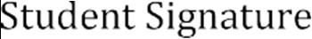 | 