Page 1
Classification: Public

Employee Leave Management System
(ELMS)

Streamlining Leave Approvals and Policy Queries with Microservices and AI
Submitted as Final Report, in fulfillment for the award of
TATA TECHNOLOGIES Pathway Internship Program

By:
Employee Name: Shreyash Jaiswal
Employee ID: 933511
LoB: CEIT



Page 2
Classification: Public

© Copyright 2025 Tata Technologies. All rights reserved. All other trademarks are trademarks of their respective owners
Page 2 of 33
CERTIFICATE

This is to certify that project report titled “Employee Leave Management System”

Has been successfully completed and submitted by Shreyash Jaiswal (Emp-ID – 933511) under the guidance
of Mr. Kishore Mistry at Tata Technologies Ltd.

The project report is Bonafide work carried out and submitted in partial fulfillment of the requirement
for the compliment of the internship program.

Signature

Signature

Signature

Mr. Kishore Mistry

Supriya Choudhary

Ms. Anuja Singh

Tech Lead

HRBP

Engagement Manager

Page 3
Classification: Public

© Copyright 2025 Tata Technologies. All rights reserved. All other trademarks are trademarks of their respective owners
Page 3 of 33

ACKNOWLEDGEMENTS

First and foremost, I wish to express our deepest gratitude to TATA Technologies, especially the dedicated
team. Their unwavering support, both financially and in terms of infrastructure, played a pivotal role in
the interim success of our project.
Special thanks are due to Kishore Mistry Sir, Tech Lead and Anuja Singh Ma’am, Engagement Manager.
Their insights, expertise, and continuous encouragement have been invaluable. RM1 not only provided
technical guidance but also readily stepped in whenever logistical challenges arose, ensuring the
smooth progression of our project. Anuja Singh Maam’s in-depth knowledge and constructive feedback
have greatly enriched the development process, for which we are profoundly thankful. Additionally, we
would like to acknowledge the team TechVarsity for operationally guiding us through our internship
journey. Its availability and ease of access significantly facilitated our data collection and validation
processes, proving instrumental in enhancing our software’s efficacy.

By :
Employee Name: Shreyash Jaiswal
Employee ID : 933511
LoB : CEIT

TATA Technologies
Blue Ridge Town Pune, Phase 1, Hinjawadi Rajiv Gandhi Infotech Park Hinjawadi,
Pimpri-ChinchwadMaharashtra, 411057

Page 4
Classification: Public

© Copyright 2025 Tata Technologies. All rights reserved. All other trademarks are trademarks of their respective owners
Page 4 of 33

TABLE OF CONTENTS

1.
Table of Contents……………………………………………………………………………………………………..Pg. 03
2.
List of Tables…………………………………………………………………………………………………………….Pg. 04
3.
List of Figures……………………………………………………………………………………………………………Pg. 05
4.
List of Abbreviations…………………………………………………………………………………………………Pg. 06
5.
List of Symbols………………………………………………………………………………………………………….Pg. 07
6.
Abstract……………………………………………………………………………………………………………………Pg. 08
7.
Introduction & Problem Statement…………………………………………………………………………..Pg. 09
8.
Industry Overview…………………………………………………………………………………………………….Pg. 10
9.
Work Responsibility during Internship………………………………………………………………………Pg. 11
10. Literature Survey………………………………………………………………………………………………………Pg. 12
11. Design Methodology………………………………………………………………………………………………..Pg. 14
12. Results…………………………………………………………………………………………………….……………….Pg. 19
13. Conclusion………………………………………………………………………………….……………………………Pg. 28
14. Summary………………………………………………………………………………………………………………….Pg. 29
15. References (Technical Journals / website the interns have referenced in the report) …………………………...............Pg. 30
16. Bibliography (study material read to gain background knowledge) ………………………….………………………………...Pg. 31
17. Annexure – Interim Report……………………………………………………………………………………….Pg. 32

Page 5
Classification: Public

© Copyright 2025 Tata Technologies. All rights reserved. All other trademarks are trademarks of their respective owners
Page 5 of 33
2. LIST OF TABLES

Table No.
Table Title
Page No.
10.1
Existing Leave Management System
Pg. 12
10.2
Technology Stack and Justification
Pg. 12
11.3.1
Table auth_users
Pg. 16
11.3.2
Table user_profiles
Pg. 16
11.3.3
Table leave_requests
Pg. 16
11.3.4
Table leave_balances
Pg. 16
11.4
Role-Based Access Control Matrix
Pg. 17
11.5
Application Routing and Navigation
Pg. 17
12.1
Functional Test Results
Pg. 19

Page 6
Classification: Public

© Copyright 2025 Tata Technologies. All rights reserved. All other trademarks are trademarks of their respective owners
Page 6 of 33
3. LIST OF FIGURES

Figure No.
Figure Title
Page No.
11.2
High Level System Architecture Design
Pg. 14
11.3
Database Entity Relationship Diagram
Pg. 15
11.6
Component Architecture
Pg. 17
12.2.1
Login Page
Pg. 20
12.2.2
Register Page
Pg. 20
12.2.3
Employee’s Dashboard
Pg. 21
12.2.4
Apply Leave
Pg. 21
12.2.5
My Leaves
Pg. 22
12.2.6
Employee’s Leave Balance
Pg. 22
12.2.7
ChatBot
Pg. 23
12.2.8
ChatBot Response
Pg. 23
12.2.9
Manager’s Dashboard
Pg. 24
12.2.10
My Team
Pg. 24
12.2.11
Pending Leaves
Pg. 25
12.2.12
Admin Dashboard
Pg. 25
12.2.13
Initialize Balance
Pg. 26
12.2.14
Employee Directory
Pg. 26
12.2.15
Admin’s Chatbot PDF Upload and Response
Pg. 27

Page 7
Classification: Public

© Copyright 2025 Tata Technologies. All rights reserved. All other trademarks are trademarks of their respective owners
Page 7 of 33
4. LIST OF ABBREVIATIONS

Abbreviation
Full Form
API
Application Programming Interface
AI
Artificial Intelligence
CRUD
Create, Read, Update, Delete
ELMS
Employee Leave Management System
HRMS
Human Resource Management System
JSON
JavaScript Object Notation
JWT
JSON Web Token
RDBMS
Relational Database Management System
RBAC
Role-Based Access Control
REST
Representational State Transfer
SPA
Single Page Application
UI/UX
User Interface / User Experience

Page 8
Classification: Public

© Copyright 2025 Tata Technologies. All rights reserved. All other trademarks are trademarks of their respective owners
Page 8 of 33
5. LIST OF SYMBOLS

Symbol
Description
→
Indicates state transition in leave lifecycle or microservice communication
✓
Test case passed
✗
Test case failed

Page 9
Classification: Public

© Copyright 2025 Tata Technologies. All rights reserved. All other trademarks are trademarks of their respective owners
Page 9 of 33
6. ABSTRACT

Managing employee leaves, tracking balances, and navigating complex HR policies are critical but often
cumbersome processes for large organizations. Traditional methods involving email chains, spreadsheets, or
monolithic legacy systems lead to delays in approvals, confusion regarding policy rules, and a lack of
transparency for employees and managers alike.

This project presents the design and development of the Employee Leave Management System (ELMS), a
highly scalable, web-based platform built on a modern Microservices architecture. The system enables
employees to manage leave balances and apply for time off, allows managers to review department-specific
requests, and provides administrators with comprehensive organizational oversight.

The application is architected with a React.js Single Page Application (SPA) on the frontend and a suite
of Spring Boot Microservices (User Service, Leave Service, Auth Service, API Gateway, and Eureka Discovery
Server) on the backend. Data is reliably stored using a relational MySQL database, while secure identity
management is handled via JWT (JSON Web Tokens). Role-Based Access Control (RBAC) ensures distinct,
secure experiences for Users (Employees), Managers, and Administrators.

A standout feature of ELMS is the AI-powered Chatbot, integrated via the NVIDIA NIM API. This intelligent
assistant uses Retrieval-Augmented Generation (RAG) to parse uploaded HR PDF policies and securely accesses
real-time database context (e.g., pending leaves, team directories) through backend services. This allows
employees to ask complex policy questions or check their status conversationally.
The system was developed iteratively, tested for functional integration, and features a modern, modern, light-
themed UI utilizing animated gradient backgrounds and glassmorphism aesthetics. Results demonstrate a
highly responsive, scalable, and intelligent HR tool capable of modernizing the leave management lifecycle.

Keywords: Leave Management System, Microservices, Spring Boot, React.js, MySQL, AI Chatbot, Generative AI,
RAG, API Gateway, JWT Authentication.

Page 10
Classification: Public

© Copyright 2025 Tata Technologies. All rights reserved. All other trademarks are trademarks of their respective owners
Page 10 of 33
7. INTRODUCTION & PROBLEM STATEMENT

7.1 Introduction
In modern enterprises, workforce management—specifically the tracking and approval of employee time off—
demands a streamlined, transparent, and accurate system. Tata Technologies, with its extensive global
workforce, requires internal systems that not only record data but actively assist employees and managers in
adhering to company policies.
Human Resource Management Systems (HRMS) are evolving from static data repositories to intelligent
platforms. A modern leave management system must provide real-time balances, enforce role-based
hierarchical approvals, and offer immediate answers to policy-related queries without burdening the HR
department. By adopting a microservices architecture, organizations can achieve the high availability, fault
tolerance, and independent scalability required for enterprise applications.
This project focuses on building ELMS (Employee Leave Management System) from the ground up, moving
away from monolithic designs to a distributed Spring Boot backend, coupled with an AI-driven assistant to
elevate the employee experience.

7.2 Problem Statement
The current processes for leave management face the following challenges:
1. Lack of Centralized, Real-Time Tracking: Leave requests managed via email or disparate tools lack a
unified dashboard, leading to miscalculated leave balances and scheduling conflicts.
2. Policy Confusion and HR Overhead: Employees frequently have questions regarding leave policies (e.g.,
"Can I carry forward casual leave?"). Finding answers in lengthy PDF manuals is tedious, resulting in
repetitive queries to HR.
3. Monolithic Architecture Limitations: Legacy systems are difficult to scale or update. If the reporting
module fails, the entire application goes down.
4. Poor Managerial Visibility: Managers lack department-scoped dashboards that easily group their
team's pending requests, slowing down the approval pipeline.

7.3 Objectives
The primary objectives of this project are:
•
To design a highly scalable, distributed backend using Spring Boot microservices, Eureka Server, and an
API Gateway.
•
To implement Role-Based Access Control (RBAC) tailored for Employees, Managers, and Admins using
secure JWT authentication.
•
To develop a dynamic React.js frontend with intuitive dashboards and cascading department-based
views.
•
To integrate an intelligent AI Chatbot capable of reading HR policy PDFs and interacting with real-time
user database context to answer queries accurately.
•
To ensure persistent, reliable data storage using a relational MySQL database.

7.4 Scope
The scope of this project encompasses:
•
Development of a React.js-based SPA with modern UI/UX principles.
•
Development of independent Spring Boot microservices (Auth, User, Leave, AI).
•
Integration with MySQL for relational data management (User profiles, Leave requests, Balances).
•
Implementation of an AI chat interface communicating with NVIDIA NIM API.
•
Out of scope: Payroll integration and advanced multi-level HR escalations (identified as future
enhancements).

Page 11
Classification: Public

© Copyright 2025 Tata Technologies. All rights reserved. All other trademarks are trademarks of their respective owners
Page 11 of 33
8. INDUSTRY OVERVIEW

8.1 HR Tech and Human Capital Management (HCM) Industry
The global Human Resource Technology and Human Capital Management (HCM) market has experienced
unprecedented growth, driven by digital transformation initiatives and the global shift toward hybrid work
environments. According to industry reports, the core HR software market was valued at approximately USD 24
billion in 2023 and is projected to grow at a Compound Annual Growth Rate (CAGR) of over 10% through 2030.
This growth is heavily fueled by organizations seeking to replace legacy, paper-based processes with
automated, cloud-based workflow orchestration tools that enhance employee experience and reduce
administrative bottlenecks.

8.2 Enterprise HR Systems Landscape
The enterprise HR software landscape is dominated by comprehensive commercial solutions such as Workday,
SAP SuccessFactors, BambooHR, and Oracle HCM. These platforms offer end-to-end capabilities spanning
recruitment, payroll, performance management, and leave tracking. However, they frequently entail
substantial licensing costs, rigid implementation timelines, and complex feature sets that far exceed the
specific, lightweight requirements of internal leave management use cases. Organizations often find that
forcing simple internal processes into heavy, vendor-locked ecosystems reduces agility and increases
operational overhead.

8.3 Tata Technologies Context
Tata Technologies Limited is a premier global product engineering and digital services company serving the
automotive, aerospace, and industrial heavy machinery sectors. With a workforce of over 12,500 employees
distributed across 27 countries, the organization demands highly efficient, customized internal service
management systems to support its operations. The Employee Leave Management System (ELMS) project was
specifically conceptualized and developed to provide a lightweight, purpose-built, and cost-effective alternative
to commercial HRMS platforms, tailored exactly to the organizational structure, departmental hierarchy, and
specific HR functions of the company.

8.4 Technology Trends
Key technology trends influencing the architecture and design of this project include:
•
Microservices Architecture: The industry is rapidly shifting away from monolithic backends toward
distributed, independently deployable microservices (e.g., using Spring Boot and Netflix Eureka). This
ensures high fault tolerance, isolated scaling, and easier maintenance.
•
Component-Based Frontend Architecture: Modern frameworks like React.js enable modular,
maintainable User Interface (UI) development through reusable components, declarative rendering, and
efficient state management without full page reloads.
•
Generative AI & RAG (Retrieval-Augmented Generation): Enterprise applications are increasingly
integrating Large Language Models (LLMs) to provide intelligent conversational interfaces. RAG allows
these models to securely reference proprietary internal data (like HR PDFs and real-time database
context) to provide highly accurate, hallucination-free assistance.
•
Modern UI/UX Principles: Contemporary enterprise applications are adopting bright, clean aesthetics
with dynamic animated gradient backgrounds, glassmorphism aesthetics, and responsive micro-
animations to reduce visual fatigue, improve user engagement, and deliver a consumer-grade
experience in workplace tools.

Page 12
Classification: Public

© Copyright 2025 Tata Technologies. All rights reserved. All other trademarks are trademarks of their respective owners
Page 12 of 33
9. WORK RESPONSIBILITY – INTERNSHIP PERIOD

9.1 Overview of Responsibilities
During the internship period at Tata Technologies, the following responsibilities were undertaken:

Phase
Duration
Activities
Phase 1: Research & Planning
Week 1
Requirements gathering, technology stack
selection (Spring Boot, React, MySQL),
architectural design of microservices, and setting
up the development environment.
Phase 2: Core Backend
Microservices
Week 1-2
Developed auth-service (JWT generation), user-
service (Profile management, MySQL
integration), and leave-service (Leave logic,
balances, status tracking). Configured Eureka
Server and Spring Cloud API Gateway for routing.
Phase 3: Frontend Development
Week 3
Built React components: Authentication flows,
Employee Dashboard, Manager "My Team" view
with cascading department logic, and Admin
Directory.
Phase 4: AI & Advanced
Integration
Week 4
Developed ai-service in Spring Boot. Integrated
PDF parsing and real-time context fetching (inter-
service communication via RestTemplate).
Connected frontend chat UI to Nvidia NIM API for
intelligent responses.
Phase 5: Testing & Deployment
Week 4
End-to-end integration testing, resolving CORS
and gateway routing issues, UI polishing (light
theme, animated backgrounds, glassmorphism),
and documenting the final report.

9.2 Key Deliverables
1. Fully functional ELMS web application with a React.js frontend.
2. Distributed backend architecture comprising 5 Spring Boot applications.
3. Relational MySQL database schemas for secure data persistence.
4. Role-based dashboards featuring department-scoped data viewing for Managers.
5. Context-aware AI Chatbot capable of reading HR policies and user data.

Page 13
Classification: Public

© Copyright 2025 Tata Technologies. All rights reserved. All other trademarks are trademarks of their respective owners
Page 13 of 33
10. LITERATURE SURVEY

10.1 Existing Leave Mangement Systems

Feature
Workday / SAP SuccessFactors
BambooHR
ELMS (This Project)
Deployment
Cloud/On-Prem
Cloud
Cloud-Ready Microservices
Cost
High (Enterprise)
Medium (SMB)
Custom/In-house
Architecture
Monolithic / SOA
Monolithic
Microservices
AI Integration
Add-on modules
Basic chatbots
Deep contextual RAG AI
Customization
Complex
Moderate
Fully Custom (Code-level)
Database
Proprietary
Relational
MySQL

10.2 Technology Stack and Justification

Component
Technology
Justification
Frontend
React.js
Component-based architecture,
efficient virtual DOM, wide
community support.
Backend Framework
Spring Boot (Java)
Enterprise-grade, rapid
development, robust security, and
native microservices support.
Service Discovery
Netflix Eureka
Dynamic service registration and
discovery, eliminating hardcoded
IPs.
API Gateway
Spring Cloud Gateway
Centralized routing, single entry
point, and global security filtering.
Database
MySQL
Relational integrity, ACID
compliance, excellent for
structured transactional data
(users, leaves).
Authentication
JWT (JSON Web Tokens)
Stateless, scalable, secure token-
based authentication across
microservices.
AI Integration
NVIDIA NIM API
High-performance, secure
inference for Large Language
Models.

Page 14
Classification: Public

© Copyright 2025 Tata Technologies. All rights reserved. All other trademarks are trademarks of their respective owners
Page 14 of 33
10.3 React.js as a Frontend Framework
React.js, developed and maintained by Meta, is an open-source JavaScript library for building user interfaces
based on a component-based architecture. Key advantages include:
•
Virtual DOM: React maintains a virtual representation of the DOM, enabling efficient reconciliation and
minimizing costly direct DOM manipulations.
•
Component Reusability: Encapsulated components with defined props and state enable modular
development and code reuse across the dashboards.
•
Declarative Rendering: UI state is expressed declaratively, making the code more predictable and easier
to debug during state transitions.

10.4 Spring Boot and Microservices Architecture
Spring Boot is an extension of the Spring framework that simplifies the setup and development of robust,
enterprise-grade Java applications. By utilizing a Microservices architecture, the backend is divided into loosely
coupled services (auth-service, user-service, leave-service, ai-service). Key advantages include:
•
Fault Tolerance & Isolation: If the AI module crashes, core leave approval functionality remains fully
operational.
•
Service Discovery (Eureka): Netflix Eureka allows services to find each other dynamically without
hardcoded IP addresses, enabling seamless scaling.
•
API Gateway: Spring Cloud Gateway acts as a single-entry point, handling routing, Cross-Origin
Resource Sharing (CORS), and centralized JWT token validation.

10.5 MySQL as a Relational Database
MySQL is a widely adopted open-source Relational Database Management System (RDBMS). It was selected for
this project because HR and leave management data (users, balances, request states) are highly structured and
require strict ACID (Atomicity, Consistency, Isolation, Durability) compliance to prevent anomalies like over-
deducting leave balances.

10.6 Role-Based Access Control (RBAC) & JWT Security
RBAC is a security paradigm that restricts system access based on assigned roles. In ELMS, this ensures:
•
Least Privilege: Employees only access their own data, Managers access their department's data, and
Admins have global read/write access.
•
Stateless Security via JWT: JSON Web Tokens are generated by the auth-service upon login. The API
Gateway validates these tokens on every subsequent request without needing to query a session
database, vastly improving backend performance.

10.7 NVIDIA NIM & Generative AI (RAG)
The system integrates the NVIDIA NIM API to provide an intelligent conversational interface. Using the
Retrieval-Augmented Generation (RAG) pattern, the system retrieves real-time JSON data from the database
and extracted text from HR policy PDFs, injecting it directly into the LLM's system prompt. This ensures the
chatbot provides highly accurate, hallucination-free answers based strictly on organizational data.

10.8 Modern UI/UX Design Principles
Contemporary web application design emphasizes:
•
Dynamic Backgrounds & Light Theme: Utilizes animated gradient bars and a clean white aesthetic to
create a vibrant, engaging interface that feels significantly more modern than legacy enterprise tools.
•
Glassmorphism: A design trend featuring frosted-glass effects achieved through background blur and
transparency, creating depth and visual hierarchy.
•
Responsive Design: Ensuring consistent functionality and aesthetics across desktop and tablet
interfaces.

Page 15
Classification: Public

© Copyright 2025 Tata Technologies. All rights reserved. All other trademarks are trademarks of their respective owners
Page 15 of 33
11. DESIGN METHODOLOGY

11.1 Software Development Methodology
The project followed an Agile development methodology. Development was broken down into iterative
sprints, starting with core database design, moving to individual microservice creation, followed by frontend
consumption, and culminating in advanced AI integration.

11.2 System Architecture
ELMS utilizes a Microservices Architecture.
1. Frontend (React.js): Communicates exclusively with the API Gateway.
2. API Gateway (Port 8080): Routes requests (/auth/**, /users/**, /leaves/**, /ai/**) to the appropriate
backend service. Validates JWT tokens for secured routes.
3. Eureka Server (Port 8761): Acts as a registry. All microservices register themselves here on startup.
4. Microservices:
•
auth-service: Handles login/registration and issues JWTs.
•
user-service: Manages employee profiles and department structures (MySQL).
•
leave-service: Handles leave applications, balance deductions, and manager approvals (MySQL).
•
ai-service: Aggregates data from leave-service and user-service, parses PDFs, and constructs
prompts for the NVIDIA LLM.

Figure 11.2 High Level System Design Architecture

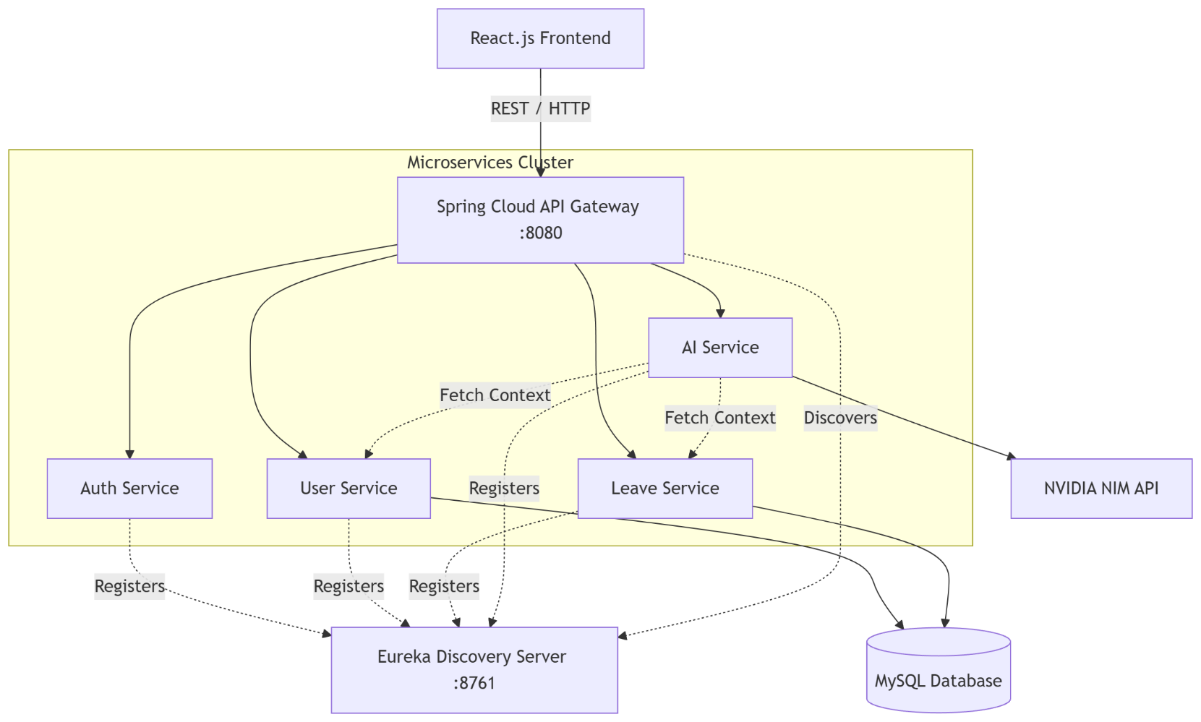

Page 16
Classification: Public

© Copyright 2025 Tata Technologies. All rights reserved. All other trademarks are trademarks of their respective owners
Page 16 of 33
11.3 Database Design (MySQL Schema)
The database schema is heavily normalized to ensure data integrity across the user-service and leave-service.

Figure 11.3 Data base ER-Diagram

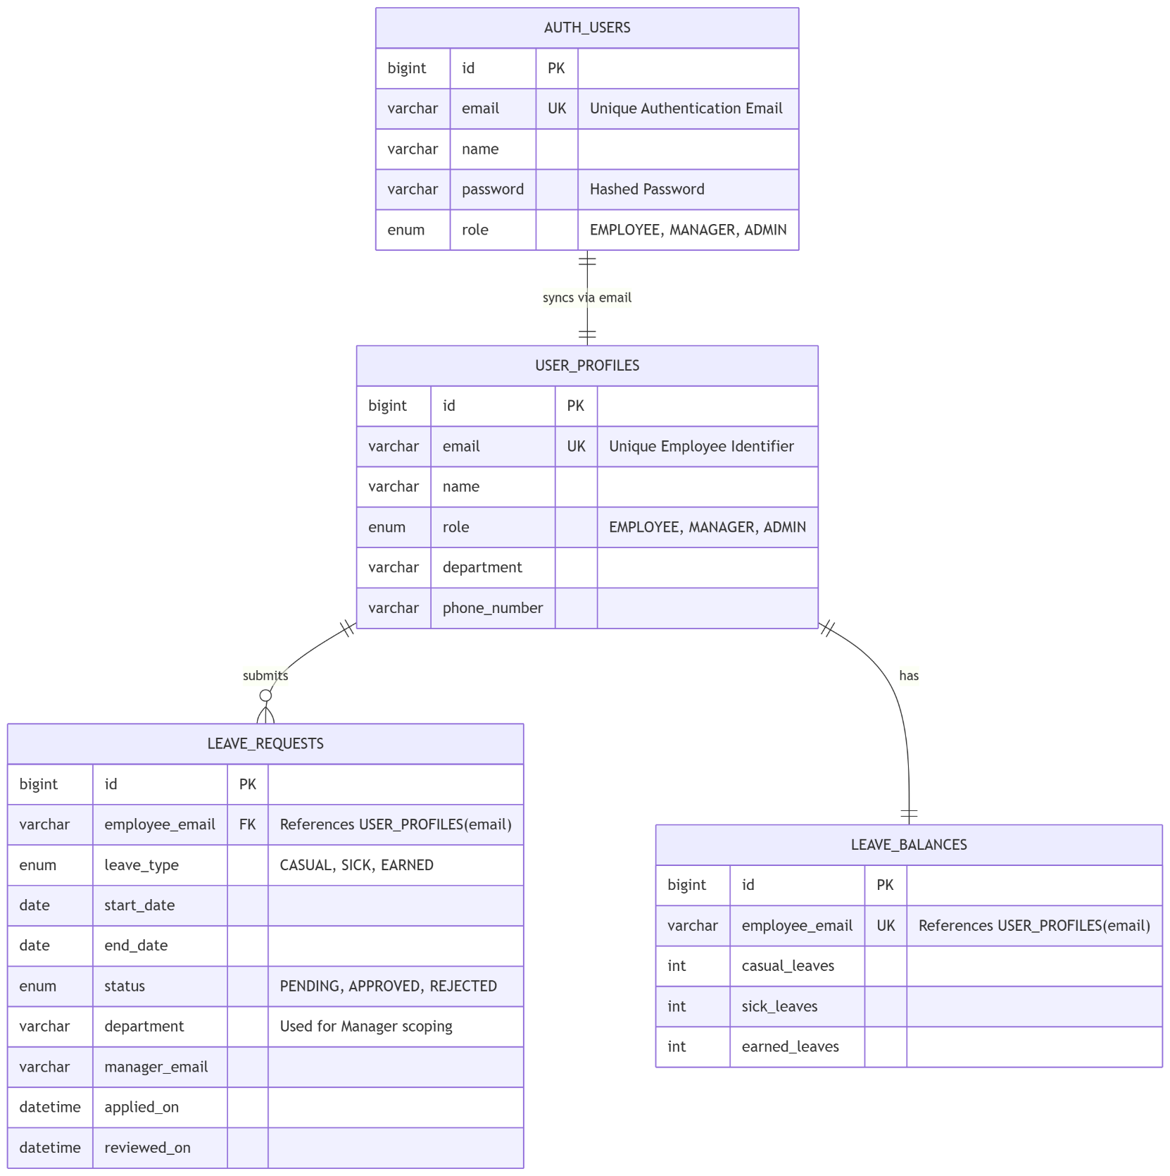

Page 17
Classification: Public

© Copyright 2025 Tata Technologies. All rights reserved. All other trademarks are trademarks of their respective owners
Page 17 of 33
11.3.1 Table auth_users (in auth_db)

Field
Type
Description
id
Big Int (PK)
Auto-generated unique credential identifier
email
Varchar (UK)
Employee email address used for login
name
Varchar
Employee full name
password
Varchar
Securely hashed password
role
Enum
"EMPLOYEE", "MANAGER", or "ADMIN"

11.3.2 Table user_profiles (in user_db)

Field
Type
Description
id
Big Int (PK)
Auto-generated unique user identifier
email
Varchar (UK)
Employee email address (Used for
auth/identification)
name
Varchar
Employee full name
role
Enum
"EMPLOYEE", "MANAGER", or "ADMIN"
department
Varchar
Department or LoB (Used for manager scoping)
phone_number
Varchar
10-digit contact number

11.3.3 Table leave_requests

Field
Type
Description
id
Big Int (PK)
Auto-generated unique leave request identifier
employee_email
Varchar (FK)
Email of the person raising the request
leave_type
Enum
"CASUAL", "SICK", or "EARNED"
start_date
Date
Start date of the leave
end_date
Date
End date of the leave
status
Enum
"PENDING", "APPROVED", or "REJECTED"
department
Varchar
Department of the employee (used for routing to
manager)
manager_email
Varchar
Email of the manager who reviewed the request
applied_on
Datetime
Server-side creation timestamp
reviewed_on
Datetime
Resolution timestamp (null until reviewed)

11.3.4 Table leave_balances

Field
Type
Description
id
Big Int (PK)
Auto-generated unique record identifier
employee_email
Varchar (UK)
Email of the employee
casual_leaves
Int
Remaining casual leave balance
sick_leaves
Int
Remaining sick leave balance
earned_leaves
Int
Remaining earned leave balance

Page 18
Classification: Public

© Copyright 2025 Tata Technologies. All rights reserved. All other trademarks are trademarks of their respective owners
Page 18 of 33

11.4 Role-Based Access Control (RBAC) Matrix

Capability
Employee
Manager
Admin
Apply for Leave
✓
✓
✗
View Own Leaves & Balance
✓
✓
✗
View Pending Leaves
✗
✓ (Department only)
✓ (All)
Approve/Reject Leaves
✗
✓ (Department only)
✓ (All)
View Employee Directory
✗
✓ (Department only)
✓ (All)
AI Chatbot Access
✓ (Personal context)
✓ (Team context)
✓ (Global context)

11.5 Application Routing and Navigation

Route
Component
Access
/
Home (Landing Page)
Public
/login
Login
Public
/register
Register
Public
/employee-dashboard
EmployeeDashboard
Authenticated (role: EMPLOYEE)
/manager-dashboard
ManagerDashboard
Authenticated (role: MANAGER)
/admin-dashboard
AdminDashboard
Authenticated (role: ADMIN)
/apply-leave
LeaveApplicationForm
Authenticated (role: EMPLOYEE, MANAGER)

11.6 Component Architecture

Figure 11.6 Component Architecture

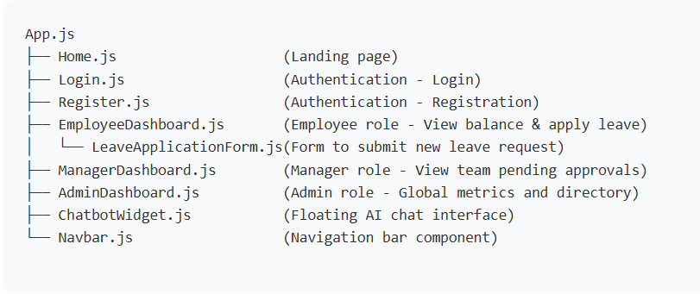

Page 19
Classification: Public

© Copyright 2025 Tata Technologies. All rights reserved. All other trademarks are trademarks of their respective owners
Page 19 of 33

11.7 Authentication Flow
1. Registration: User enters Name, Email, Password, Department, and Role. The auth-service securely
hashes the password and stores credentials in auth_db. Simultaneously, the user-service creates a
corresponding business profile in user_db.
2. Login: User enters Email and Password. The auth-service validates credentials and generates a secure
JSON Web Token (JWT) signed with a private secret key.
3. Session Management: The JWT is stored in the browser's localStorage. For every subsequent API call
(e.g., fetching leave balances), the frontend attaches the JWT as a Bearer token in the HTTP
Authorization header.
4. Gateway Validation: The Spring Cloud API Gateway intercepts the request, verifies the JWT signature,
and routes the authenticated request to the appropriate microservice.
5. Logout: The JWT is cleared from localStorage and the user is redirected to the login page.

Page 20
Classification: Public

© Copyright 2025 Tata Technologies. All rights reserved. All other trademarks are trademarks of their respective owners
Page 20 of 33
12. RESULTS

12.1 Functional Test Results

t ID
Test Case
Expected Output
Actual Output
Status
TC-01
User registration
Profile created in
user-service,
credentials in auth-
service
Created
successfully
✓ Pass
TC-02
Login with valid
credentials
API Gateway
returns valid JWT
token
Token received
✓ Pass
TC-03
Apply for leave
(sufficient balance)
Leave created as
PENDING, balance
deducted
Stored in MySQL
✓ Pass
TC-04
Apply for leave
(insufficient
balance)
System blocks
request, returns
HTTP 400 Bad
Request
Error displayed
✓ Pass
TC-05
Manager views
pending queue
API returns only
leaves matching
Manager's
department
Filtered correctly
✓ Pass
TC-06
Inter-service
communication
leave-service
successfully fetches
department from
user-service via
RestTemplate
Data retrieved
✓ Pass
TC-07
Chatbot: Policy
query
AI reads PDF
context and
answers correctly
Accurate response
✓ Pass
TC-08
Chatbot: Context
query (Manager)
AI successfully lists
team members by
querying user-
service
Accurate response
✓ Pass

Page 21
Classification: Public

© Copyright 2025 Tata Technologies. All rights reserved. All other trademarks are trademarks of their respective owners
Page 21 of 33

12.2 Dashboard Screenshots

Figure 12.2.1 Login Page :

Figure 12.2.2 Register Page:

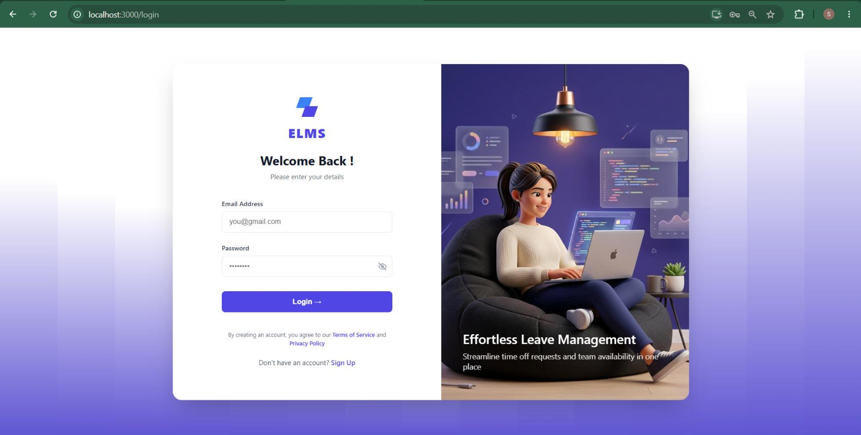

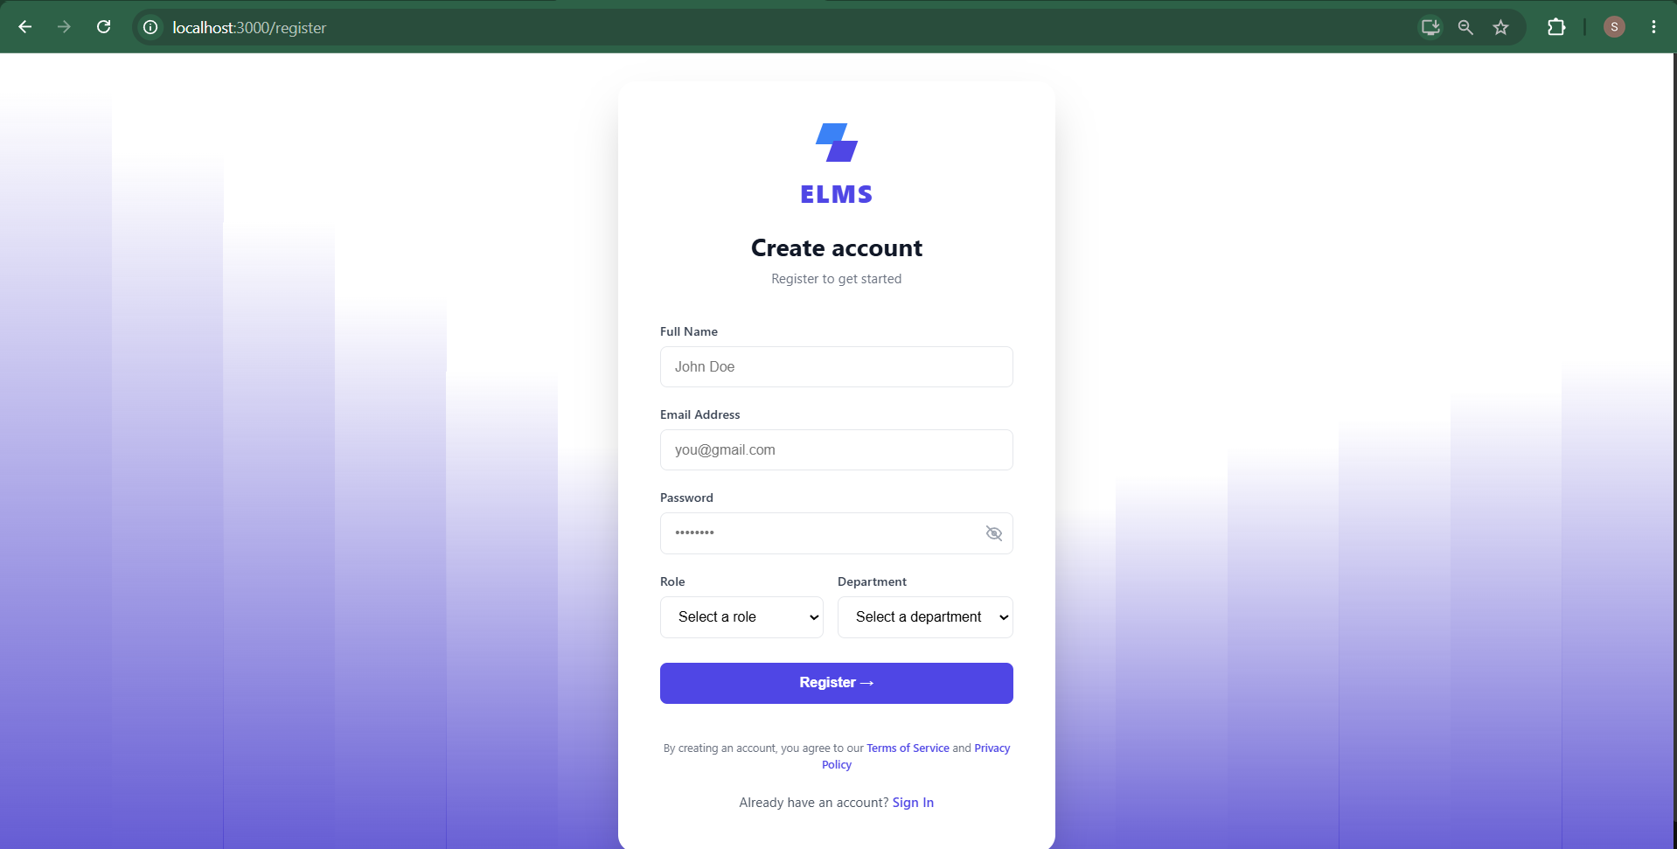

Page 22
Classification: Public

© Copyright 2025 Tata Technologies. All rights reserved. All other trademarks are trademarks of their respective owners
Page 22 of 33

Figure 12.2.3 Employee’s Dashboard :

Figure 12.2.4 Apply Leave:

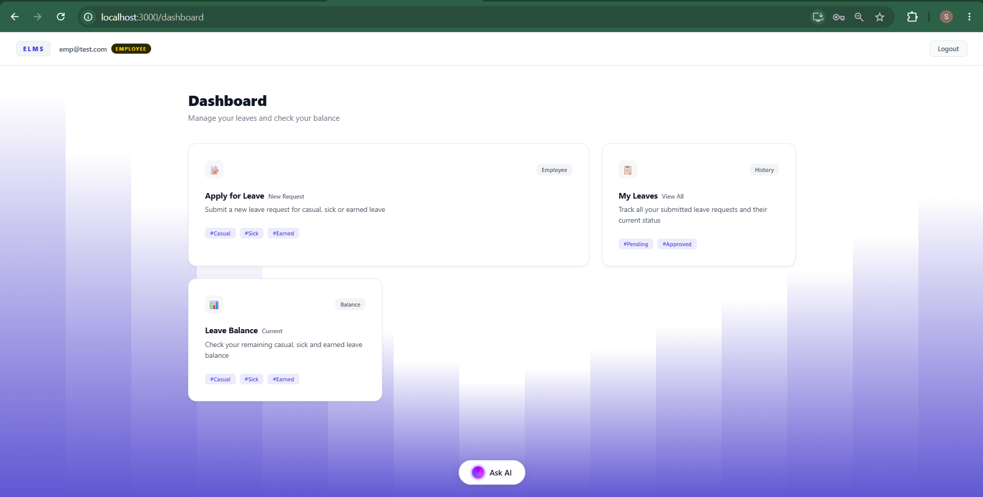

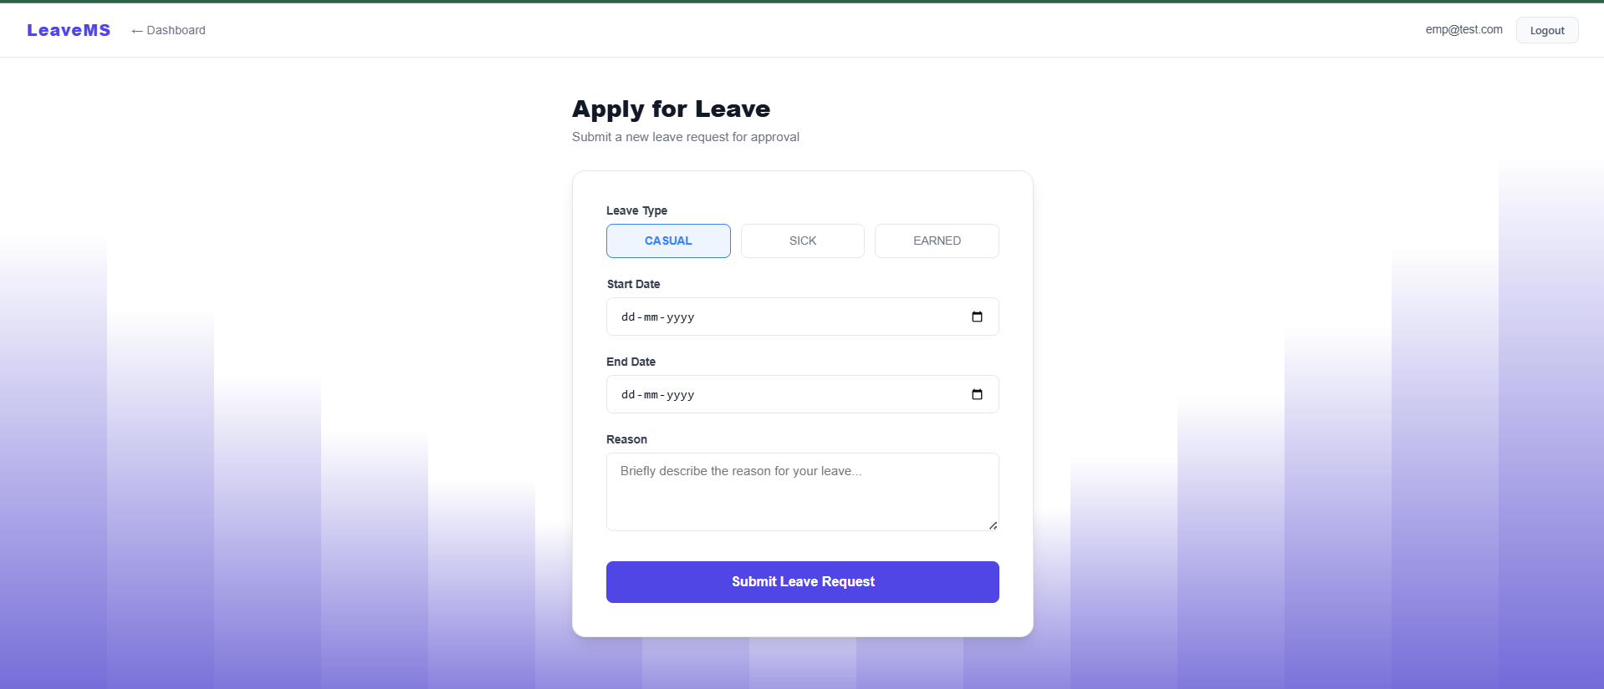

Page 23
Classification: Public

© Copyright 2025 Tata Technologies. All rights reserved. All other trademarks are trademarks of their respective owners
Page 23 of 33
Figure 12.2.5 My Leaves:

Figure 12.2.6 Employee’s Leave Balance :

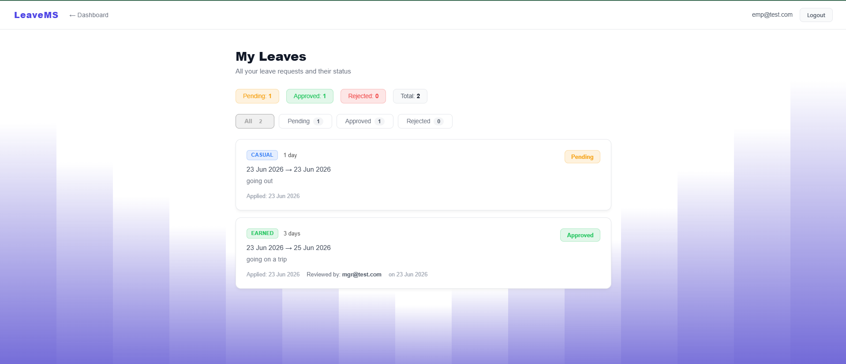

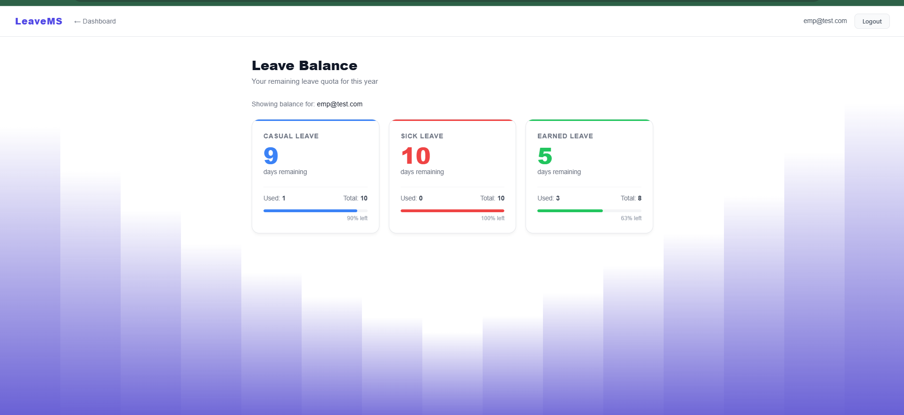

Page 24
Classification: Public

© Copyright 2025 Tata Technologies. All rights reserved. All other trademarks are trademarks of their respective owners
Page 24 of 33
Figure 12.2.7 ChatBot:

Figure 12.2.8 ChatBot Response:

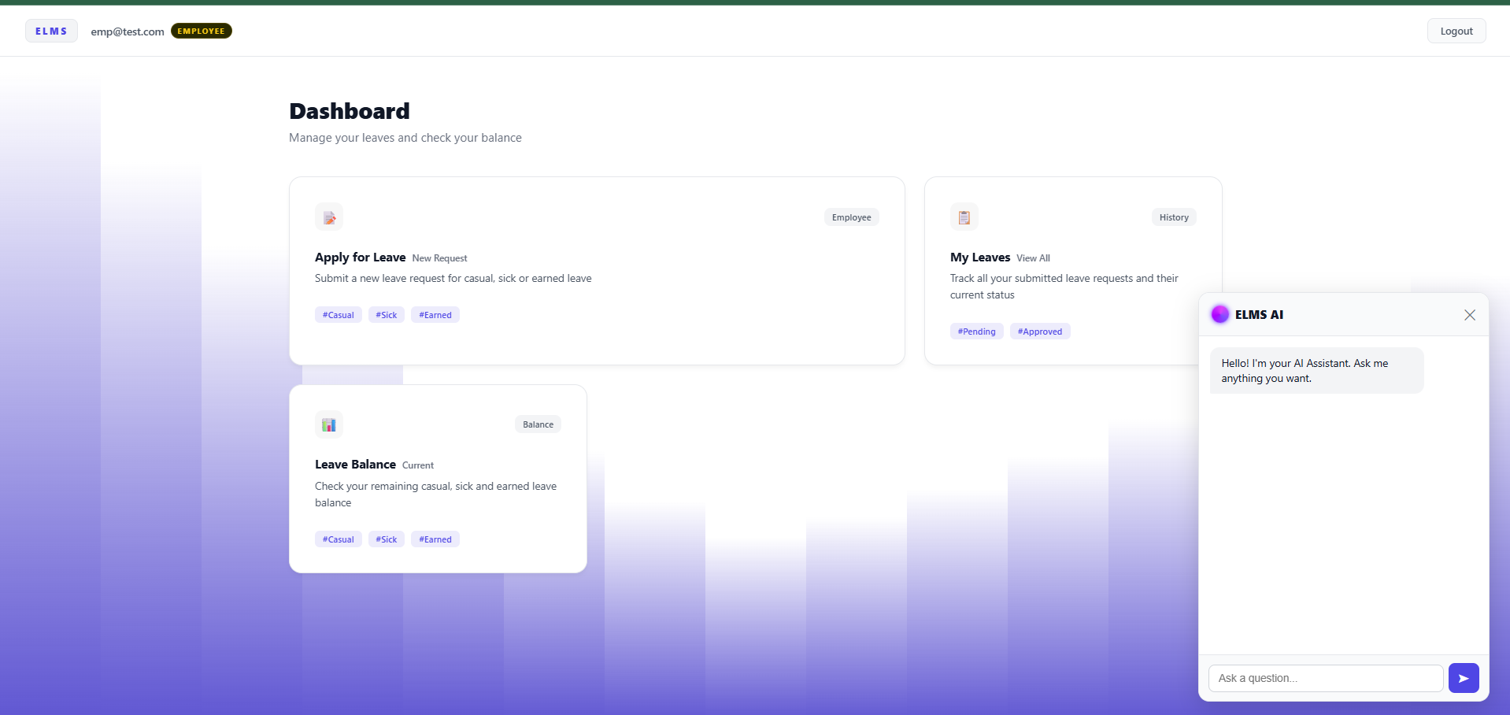

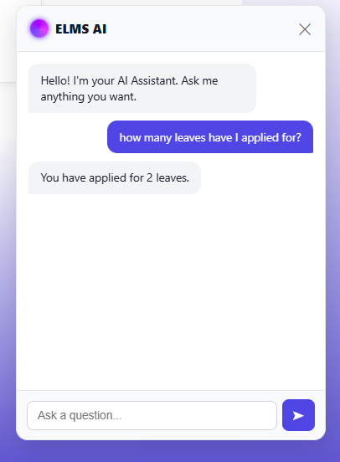

Page 25
Classification: Public

© Copyright 2025 Tata Technologies. All rights reserved. All other trademarks are trademarks of their respective owners
Page 25 of 33
Figure 12.2.9 Manager’s Dashboard:

Figure 12.2.10 My Team:

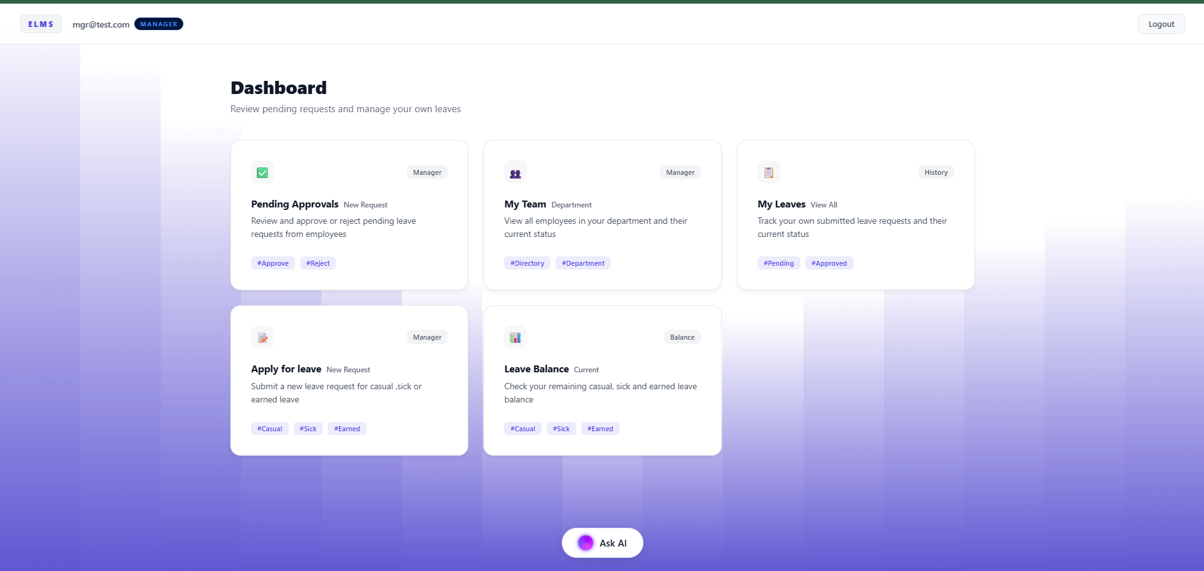

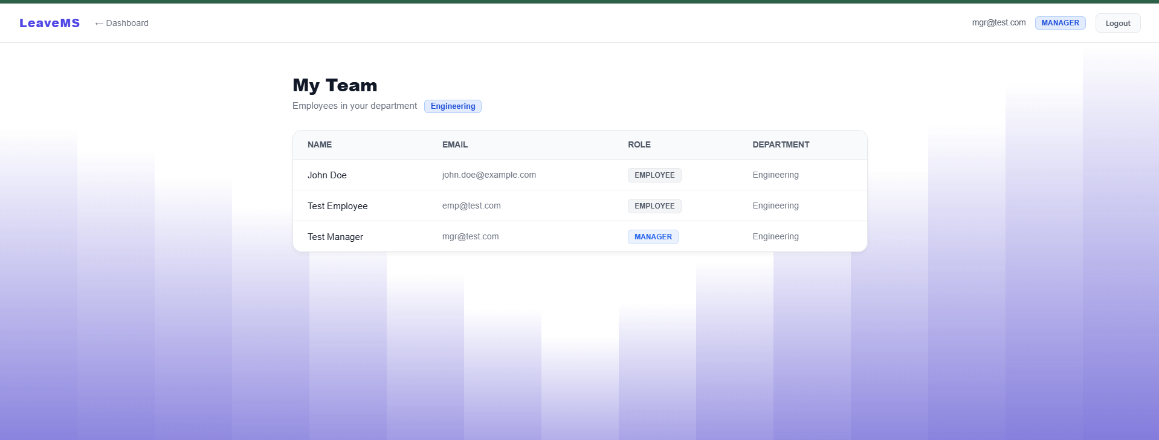

Page 26
Classification: Public

© Copyright 2025 Tata Technologies. All rights reserved. All other trademarks are trademarks of their respective owners
Page 26 of 33
Figure 12.2.11 Pending Approvals:

Figure 12.2.12 Admin Dashboard:

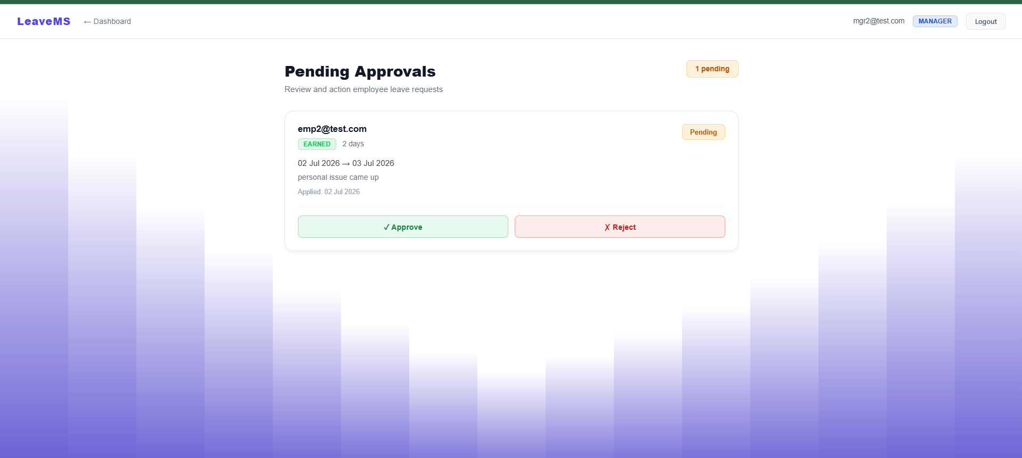

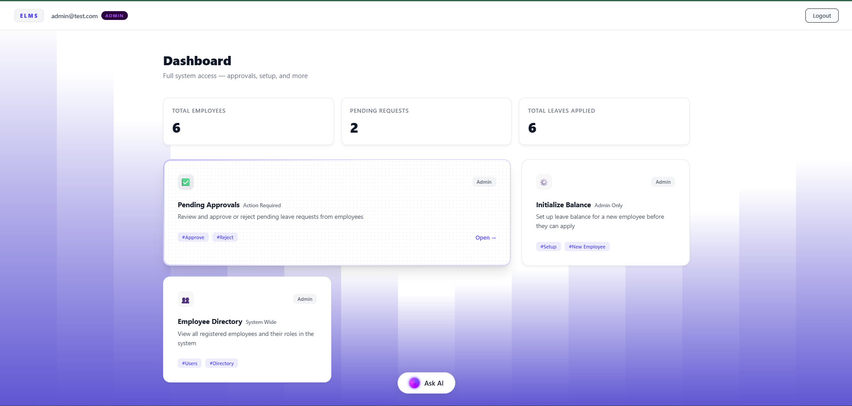

Page 27
Classification: Public

© Copyright 2025 Tata Technologies. All rights reserved. All other trademarks are trademarks of their respective owners
Page 27 of 33
Figure 12.2.13 Initialize Balance:

Figure 12.2.14 Employee Directory:

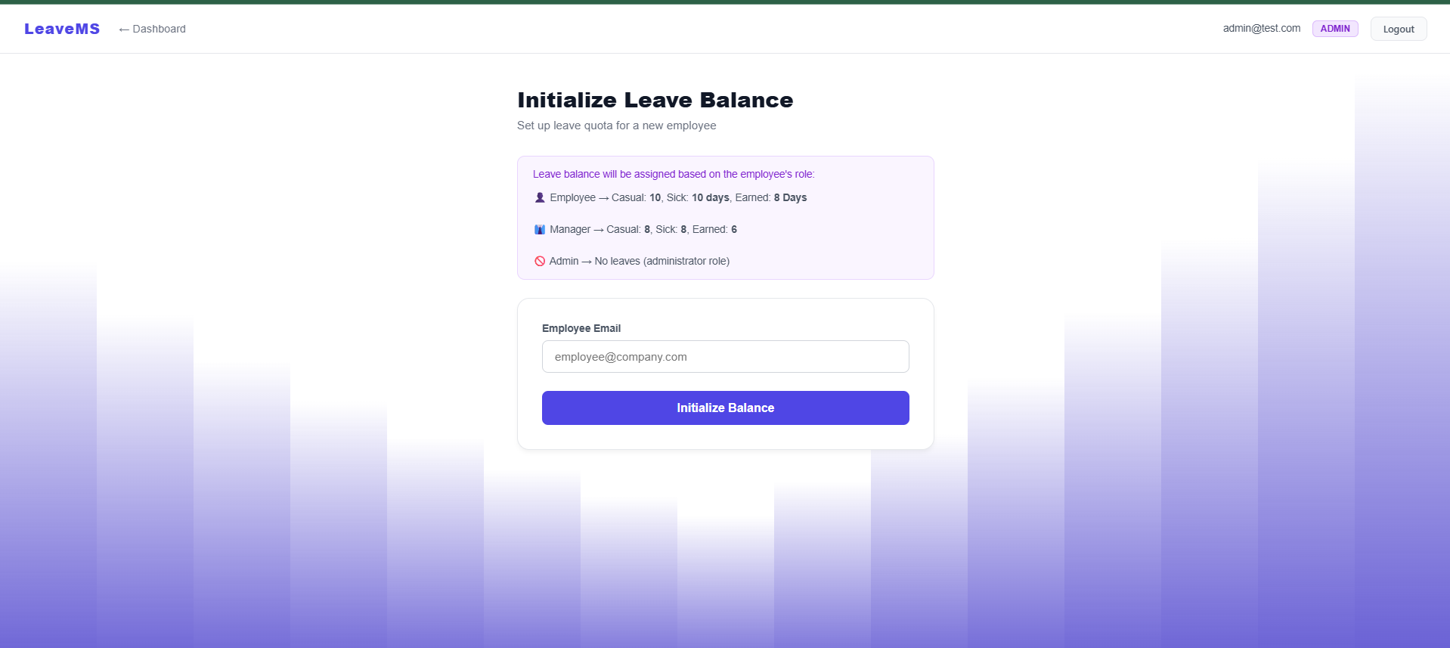

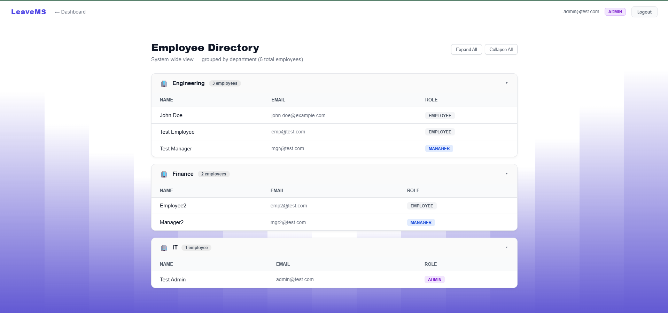

Page 28
Classification: Public

© Copyright 2025 Tata Technologies. All rights reserved. All other trademarks are trademarks of their respective owners
Page 28 of 33

Figure 12.2.15 Admin’s ChatBot PDF Upload and Response:

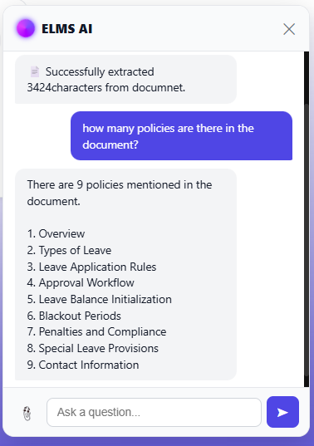

Page 29
Classification: Public

© Copyright 2025 Tata Technologies. All rights reserved. All other trademarks are trademarks of their respective owners
Page 29 of 33
13. CONCLUSION

The Employee Leave Management System (ELMS) project was successfully designed, developed, and tested as
a comprehensive enterprise web application. By shifting away from traditional monolithic designs, the
application fulfills all objectives outlined in the problem statement through modern architectural paradigms:
1. Microservices Scalability: The separation of concerns into distinct Spring Boot services (Auth, User,
Leave, AI) ensures the system is fault-tolerant and highly scalable. The integration of Eureka and an API
Gateway establishes a robust networking foundation.
2. Data Integrity: The use of MySQL provides rigid relational structure, ensuring leave balances and
hierarchical data remain consistent and ACID-compliant.
3. Role-Based Accountability: The three-tier RBAC model ensures clear ownership. The dynamic
department-scoping allows managers to see exactly what they need to manage their specific teams
efficiently.
4. Intelligent Assistance: The integration of the AI Chatbot utilizing Nvidia NIM and RAG methodology
bridges the gap between static data and user experience. Employees can interact conversationally to
understand policies or check statuses, drastically reducing the administrative burden on HR.
5. Modern User Experience: The React.js frontend delivers a responsive, light-themed UI with dynamic
animated backgrounds, consumer-grade experience for enterprise software.

The project demonstrates the viability and immense value of combining robust backend microservices with
cutting-edge Generative AI to modernize internal enterprise workflows.

Page 30
Classification: Public

© Copyright 2025 Tata Technologies. All rights reserved. All other trademarks are trademarks of their respective owners
Page 30 of 33
14. SUMMARY

This project delivered a fully functional web application, ELMS, for Tata Technologies. Built using React.js for
the frontend and Spring Boot Microservices backed by MySQL for the backend, the application solves the
problem of fragmented leave tracking and tedious policy navigation.

Key accomplishments include:
•
A Distributed Backend utilizing Netflix Eureka for service discovery and Spring Cloud Gateway for
centralized API routing and security.
•
Secure Authentication using JWTs, ensuring stateless and scalable session management across all
microservices.
•
Relational Database Design using Spring Data JPA and MySQL to handle complex entities (Users,
Leaves, Balances) securely.
•
Role-Based Access Control tailored for Employees, Managers, and Admins, featuring department-level
data filtering for middle management.
•
An AI Chatbot built on a custom Spring Boot service that utilizes RestTemplate for inter-service data
gathering and Nvidia NIM for LLM inference, providing context-aware answers to users.
•
A Single Page Application featuring clean aesthetics, robust form validation, and real-time state
management.

Future enhancements identified include:
•
Implementation of email/SMS notifications on ticket status changes.
•
Advanced data visualization and analytics dashboards for Administrators.
•
Integration with organizational LDAP/SSO for enterprise-grade identity management.

Page 31
Classification: Public

© Copyright 2025 Tata Technologies. All rights reserved. All other trademarks are trademarks of their respective owners
Page 31 of 33
15. REFERENCES

Ref ID
Reference Details
Used in Pg#
1.
React.js Official Documentation, "Getting Started with React," Meta Platforms,
Inc. Available: https://react.dev/
[Pg. 13 ,
(Sec 10.3
Frontend)]
2.
Spring Boot Reference Guide, "Building an Application with Spring Boot,"
VMware, Inc. Available: https://docs.spring.io/spring-boot/
[Pg. 13,14
(Sec 10.4 &
11.2
Architecture)]
3.
Spring Cloud Gateway Documentation, VMware, Inc.
Available: https://docs.spring.io/spring-cloud-gateway/
[Pg. 13, 14
(Sec 10.4 &
11.2 API
Gateway)]
4.
Netflix Eureka Documentation, "Service Discovery: Eureka," Spring Cloud Netflix.
Available: https://docs.spring.io/spring-cloud-netflix/
[Pg. 13, 14
(Sec 10.4 &
11.2 Service
Discovery)]
5.
MySQL Documentation, "MySQL 8.0 Reference Manual," Oracle Corporation.
Available: https://dev.mysql.com/doc/refman/8.0/en/
[Pg. 13, 15
(Sec 10.5 &
11.3 DB
Design)]
6.
JSON Web Tokens (JWT), "Introduction to JSON Web Tokens," Auth0.
Available: https://jwt.io/introduction
[Pg. 13, 18
(Sec 10.6 &
11.7 Auth
Flow)]
7.
NVIDIA API Catalog, "NVIDIA NIM Documentation and API Reference," NVIDIA
Corporation. Available: https://build.nvidia.com/
[Pg. 13
(Sec 10.7
Generative AI
RAG)]
8.
Framer Motion, "A production-ready motion library for React," Framer.
Available: https://www.framer.com/motion/
[Pg. 13
(Sec 10.8
UI/UX
Design)]
9.
Axios Documentation, "Promise based HTTP client for the browser."
Available: https://axios-http.com/docs/intro
[Pg. 17
(Sec 11.6
Component
Architecture)]

Page 32
Classification: Public

© Copyright 2025 Tata Technologies. All rights reserved. All other trademarks are trademarks of their respective owners
Page 32 of 33
16. BIBLIOGRAPHY

1. Walls, C., "Spring in Action," 6th Edition, Manning Publications, 2022.
2. Newman, S., "Building Microservices: Designing Fine-Grained Systems," 2nd Edition, O'Reilly Media,
2021.
3. Flanagan, D., "JavaScript: The Definitive Guide," 7th Edition, O'Reilly Media, 2020.
4. Stefanov, S., "React: Up & Running," O'Reilly Media, 2nd Edition, 2022.
5. GeeksforGeeks, "ReactJS Tutorial," Available: https://www.geeksforgeeks.org/react/
6. Baeldung, "Spring Cloud Tutorial," Available: https://www.baeldung.com/spring-cloud-series
7. Pressman, R. S., "Software Engineering: A Practitioner's Approach," 9th Edition, McGraw-Hill, 2020.

Page 33
Classification: Public

© Copyright 2025 Tata Technologies. All rights reserved. All other trademarks are trademarks of their respective owners
Page 33 of 33
17. ANNEXURE - INTERIM REPORT

1. Project Title: Employee Leave Management System (ELMS)
2. Intern Name: SHREYASH JAISWAL
3. Reporting Period: 1 Month of Internship
4. Project Overview: The objective of this project is to develop a highly scalable, role-based Employee Leave
Management System for Tata Technologies. The system is designed to streamline leave applications,
hierarchical approvals, and policy queries using a distributed Spring Boot Microservices architecture and an AI-
powered conversational interface.
5. Work Completed During the Interim Period (Weeks 1-4):
•
Requirement Analysis & Technology Selection: Finalized the tech stack (React.js for frontend, Spring
Boot and MySQL for the backend). Conducted a literature survey of existing HR/Leave Management
solutions.
•
System Architecture & Database Design: Designed the client-server microservices architecture and
drafted the relational database schema for user profiles, leave requests, and balances.
•
Backend Setup: Configured the Spring Boot projects, set up the Netflix Eureka Discovery Server,
configured the Spring Cloud API Gateway, and implemented secure JWT (JSON Web Token)
authentication.
•
Initial Frontend Prototypes: Scaffolded the React.js Single Page Application and created the initial UI
layouts for the Login/Signup pages and the basic navigation structure.
6. Challenges Faced:
•
Orchestrating inter-service communication (e.g., leave-service securely querying user-service) and
maintaining JWT context across API Gateway routes.
•
Designing the prompt engineering logic for the AI Chatbot to reliably retrieve real-time JSON database
context and answer strictly based on organizational HR policies.

