**PRACTICAL EXAMINATION**Subject code: FER202m – BLOCK 5 - SP 2024   
Duration: 85 minutes

**Notice for students:**

+ Using React version 18

+ Only using Internet in order to download packages/modules

+ Student put the code of the app on 1 zip file, named the file with the meaningful words: **ChatRoom_code**.zip (please avoid using the student’s name or student ID and do not compress node-modules folder)

**Questions:**

A chat room app enables users to type and send messages to the chat room, which are then displayed to all other participants.

The student should put the code of the app in a zip file named "**ChatRoom_code.zip**"   
(please avoid using the student's name or ID).

The student can write the code based on the specific tasks (if using Redux architecture and Redux Toolkit, student will get full 10 marks, otherwise 9 marks):

1. Create the component **Home** to render the information of Home page. (1 marks)



1. Create the component **ChatRoom** to render the information of messages. (2 marks)

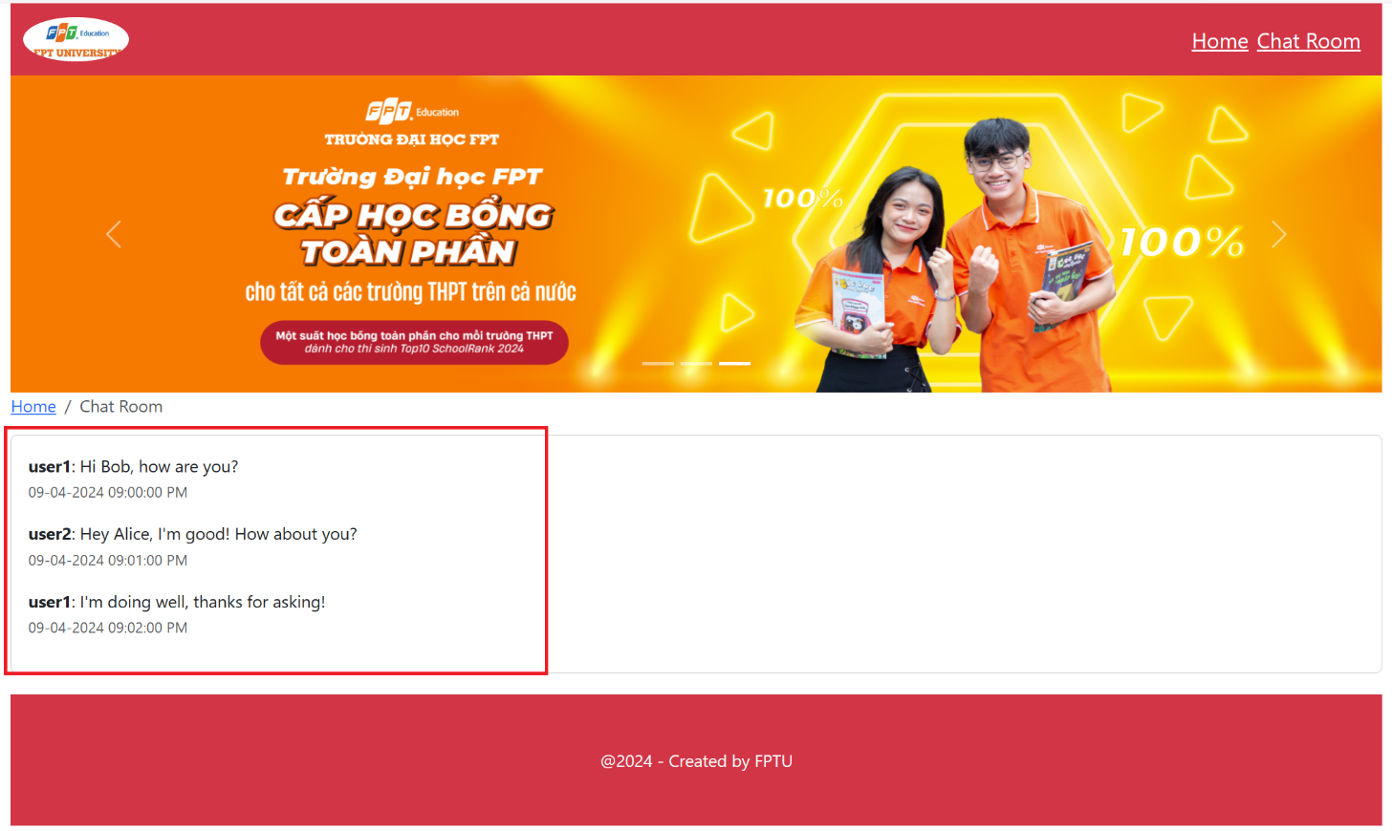

1. Add PropTypes for the chatroom prop in the ChatRoom component. The chatroom prop is expected to be an object with required text (string) and senderId (number) properties. (1 marks)
2. Add Message Form in chatroom in order to add new message in the conversation (assuming user1 is a sender) (2 marks)

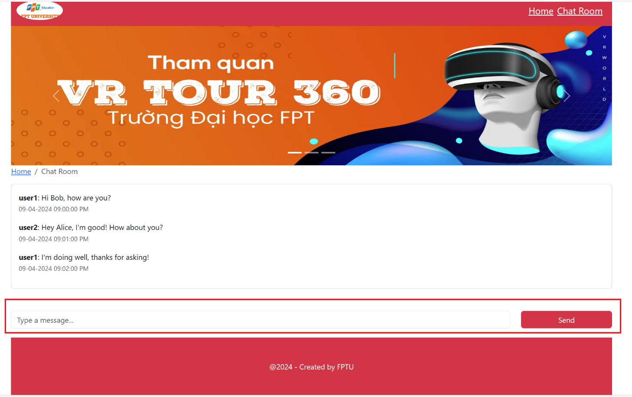

After sending a message

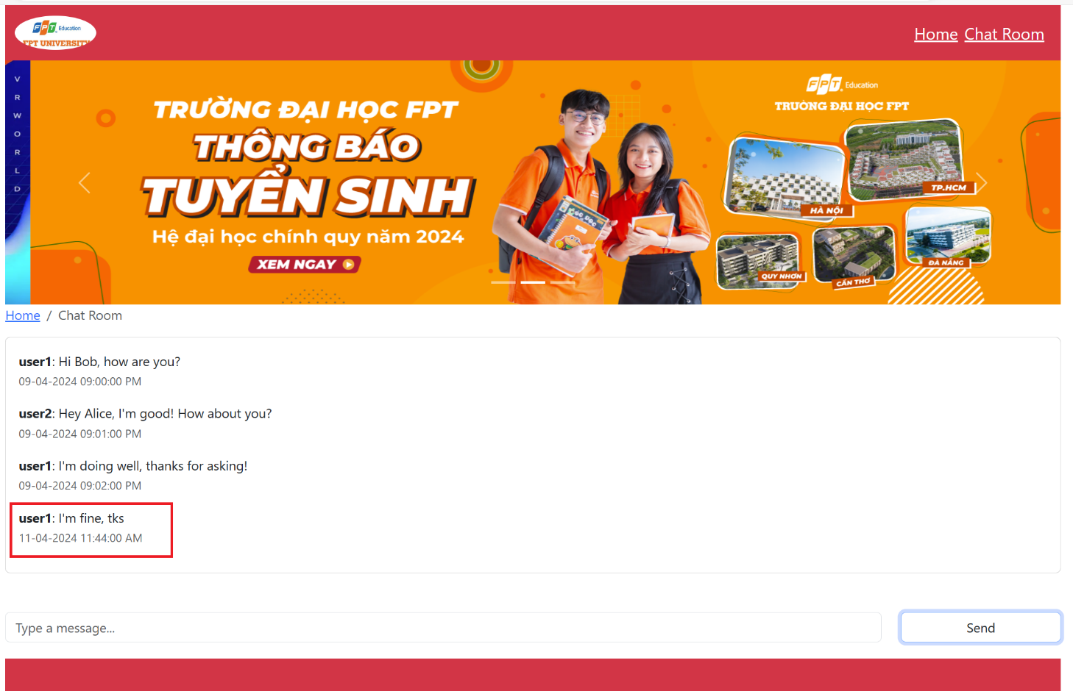

1. Fetching data from json-server (1 mark)

Hint: Create a file named db.json to perform the initialization of a virtual server using json-server, with the sample data below

1. Use the React Router to configure and set up navigation among two pages (**Home** and **Chat**) in a ChatRoom application (1 mark)
2. Create a beautiful interface using Bootstrap. (1 marks)

The materials that the student must submit to the lsmdn system for marking include: ChatRoom_code.zip

**Note:**

* The chat.js file are located in the paper, which students can use for test.
* During the file compression for submission, please exclude the node_modules folder.
* The interface should be able to be responsive on different device platforms, such as laptop, mobile.

**chat.js**

export const ChatRoom = {

"id": "room1",

"name": "Demo Chat",

"participants": ["user1", "user2"],

"messages": [

{

"id": "message1",

"text": "Hi Bob, how are you?",

"senderId": "user1",

"timestamp": "09-04-2024 09:00:00 PM"

},

{

"id": "message2",

"text": "Hey Alice, I'm good! How about you?",

"senderId": "user2",

"timestamp": "09-04-2024 09:01:00 PM"

},

{

"id": "message3",

"text": "I'm doing well, thanks for asking!",

"senderId": "user1",

"timestamp": "09-04-2024 09:02:00 PM"

}

]

}