**CSC1023 Part B Report**

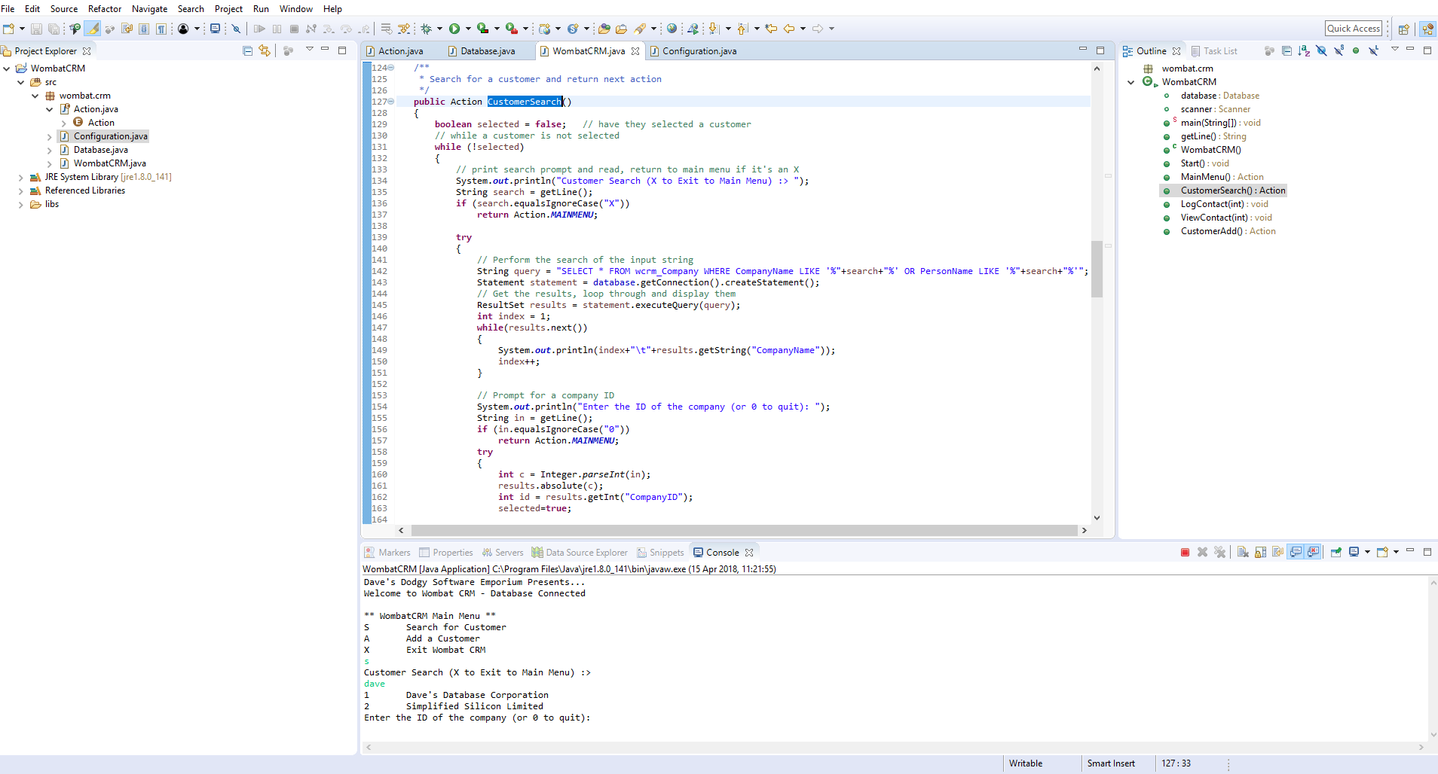For Task 1, I update the customerSearch function to include PersonName as shown:

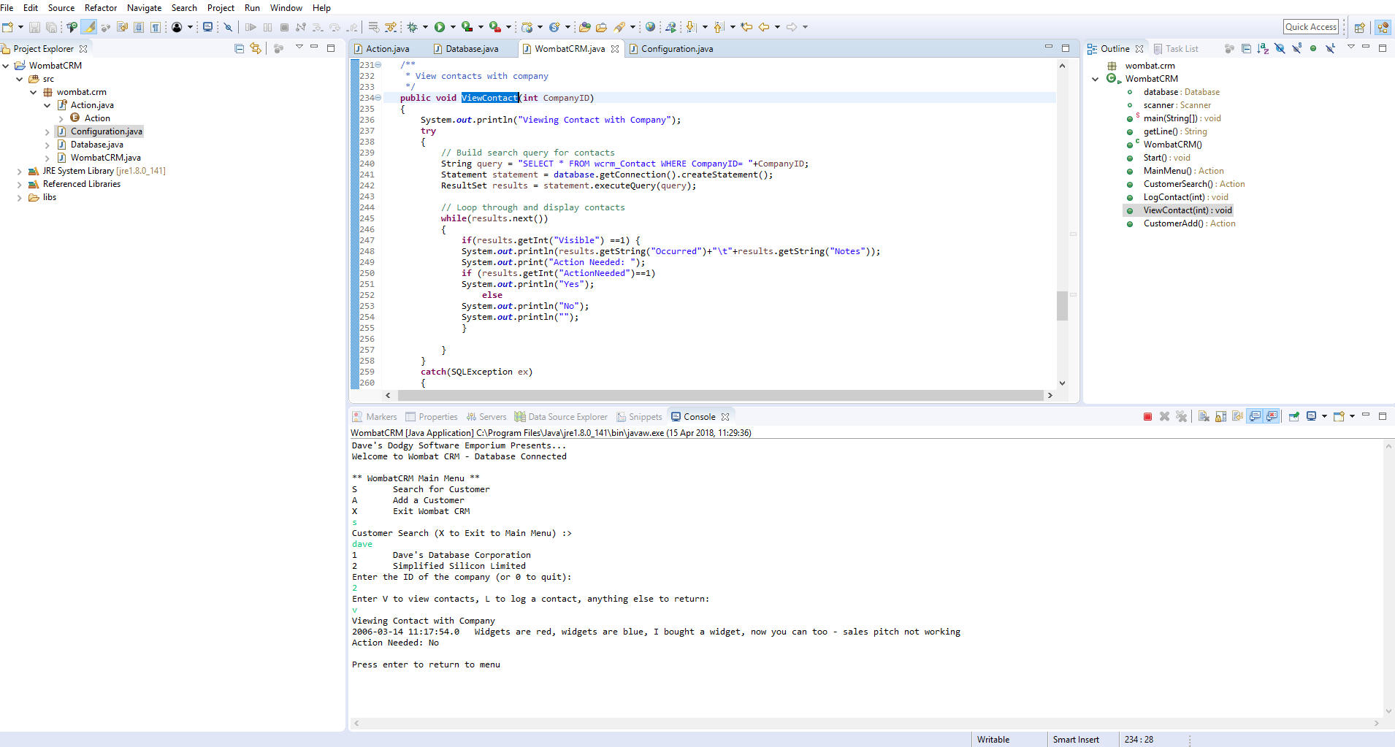For Task 2, I modified the code to only print if `Visible` is set to 1:

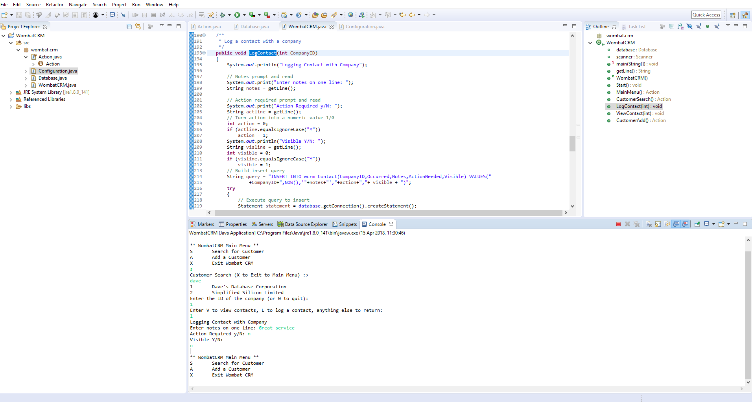For Task 3, I added a question to set the contact to visible, and updated the INSERT statement:

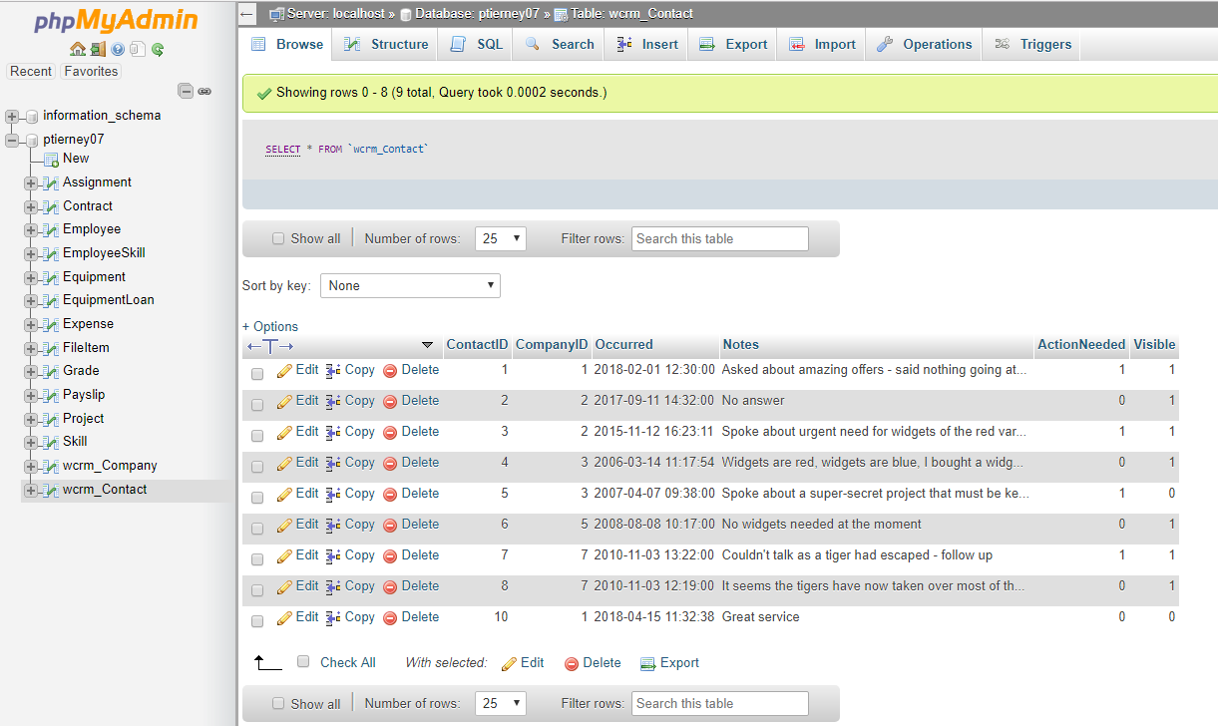Here is the resulting change that occurs in the database: