國 立 中 央 大 學

資 訊 工 程 學 系 軟 體 工 程

碩 士 班

碩 士 論 文

基因演算法運用於特徵挑選解決財務危機預測問題

Using genetic algorithm for feature selection in financial distress problem

研 究 生：歐 嘉 文

指導教授：梁 德 容 博士

中 華 民 國 101年 10月

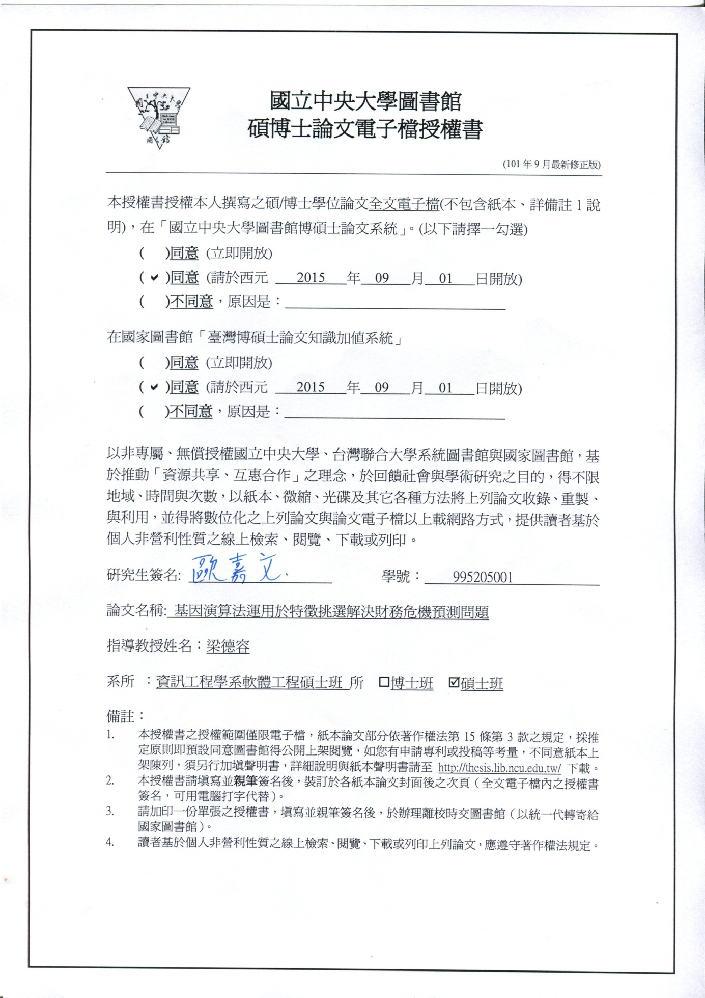





# 中文摘要

財務危機預測長久以來都是一個重要且常被廣泛討論的主題，發展出好的財務危機預警模型可以有效幫助，銀行決策。影響整個財務危機預警流程主要有兩個議題分別是特徵挑選(Feature selection)與分類器演算法(Classifier algorithm)，過去研究顯示，單純改良分類器演算法，準確率很難有顯著的提升。本論文將目標放在另一個議題特徵挑選，我們觀察到財務比率數量會隨著年代大幅成長，如何在大量的財務比率下挑選出重要的財務比率，變成很重要的議題，近幾年，研究顯示基因演算法應用於特徵挑選在單一特定的資料集下表現相當好，我們知道特徵集合成長速度相當的快速，如果只驗證基因演算法在單一特定的特徵集合的效果是不足夠的，本論文模擬了特徵集合越來越大的情況，觀察基因演算法表現情形，最後觀察出基因演算法在不加入公司治理的特徵情況下，當特徵集合越來越大，基因演算法挑選出來的特徵組合，準確率還是能夠穩定成長而且較其他特徵挑選方法穩定。

關鍵字: 特徵挑選(Feature selection)、財務危機預測(Financial Distressed prediction)、wrapper method、基因演算法(genetic algorithm)

# Abstract

Financial distress problem has been important and widely studied topic, development of good financial analysis model can help bank to decisions. There are two major factors, namely feature selection and classifier algorithm, influencing financial distressed prediction. Previous researches show that the forecasting accuracy is very difficult to have significant improvement by improving classification algorithm only; therefore, our research focus on the feature selection issue. Over time，we observed financial ratio growing quickly, that mean feature selection become more important, In recent years, Previous researches have shown genetic algorithm applied to feature selection in unique feature set have good performance, but we know feature size growing quickly, it is not enough to prove genetic algorithm in unique feature set. In our research, we simulate ratio growing situation, consider genetic algorithm performance. Finally, if we exclude corporate governance, we discover genetic algorithm predict performance become well when feature size larger.

Keyword: Feature selection、Financial Distressed prediction、wrapper method、genetic algorithm

# 誌謝

感謝梁德容老師兩年來的教導，讓我學習到解決事情的能力，譬如當一個未知的問題來臨時，如何分析問題以及該做哪些事，才能對這個問題得出一個完整的結論以及較佳的處理方法，另一方面，還有學習到如何規劃時間安排Schedule，將時間做最有效的利用。這兩年來，我經常試著順著老師的邏輯去思考事情，思考為什麼有些想法老師想的到而我卻想不到，到底是缺少哪方面的能力，導致我沒辦法與老師看到相同的東西，到現在要畢業了，可能各方面能力還需要再加強，但是我認為我比兩年前剛進研究所實力增強了很多，在研究所的生涯並沒有虛度光陰。謝謝老師兩年來的教導，我定會貢獻我的所學，運用在未來的職場就業上。

感謝實驗室的成員，建呈與青翰學長每當我困惑的時後能適時的給我一些意見做為參考以及討論，祝福你們未來的研究也能夠順順利利。另一方面，也很高興能與振揚，宗杰以及順雄成為研究所同學，與你們相處相當開心，祝福你們未來發展一路順風。還有要祝福升上碩二的學弟們，安傑，嘉偉，崧軒，信廷，祝福你們未來在研究上能夠一切順利，還要感謝一些研究所認識的人，能與你們相遇是我的榮幸。最後，謝謝我的家人在背後的支持，有你們的支持我才能專心完成學業。

兩年來的研究所生涯已經告一個段落，接下是另一階段的開始，我認為我還有許多方面還需要加強，未來我打算出國練習英文，以及順便看看國外的文化，增廣見聞。最後祝大家身體健康，以及台灣電子資訊業能夠更進步，能夠在國際上佔有一席之地。

目錄

中文摘要 iv

Abstract v

誌謝 vi

一、 緒論 1

1-1. 研究背景 1

1-2. 研究動機 3

1-3. 論文架構 4

二、 文獻探討 5

2-1 Financial crises and financial features 5

2-2 Feature selection 10

2-3 Genetic algorithms concept 12

2-4 Genetic algorithms parameter 13

2-5 Genetic algorithms apply in financial prediction review 15

三、 實驗設計 17

3-1 資料來源 17

3-2 資料前置處理 18

3-3 實驗假設 18

3-4 實驗流程 19

3-4-1 GA Wrapper 實驗設計 20

3-4-2 Stepwise Logistic Regression & Stepwise Discriminant Analysis實驗設計 24

3-4-3 Altman，Ohlson 專家實驗設計 25

四、 實驗結果 26

4-1 實驗結果與分析 26

五、 結論及未來展望 35

5-1 結論與未來展望 35

參考文獻 37

附錄一 40

附錄二 45

附錄三 49

圖目錄

Fig. 1 影響財務預測兩個主要議題 1

Fig. 2 各時期被提出的財務比率 3

Fig. 3 1968~2006常用的財務比率數量統計 3

Fig. 4 filter approach 演算法流程 10

Fig. 5 wrapper approach 演算法 11

Fig. 6 Genetic algorithms basic concept [38] 12

Fig. 7 GA Wrapper 每次演化訓練與測試情形 14

Fig. 8 假設一實驗流程圖 19

Fig. 9 GA Wrapper 實驗流程圖 20

Fig. 10 Stepwise Logistic Regression、Stepwise Discriminant Analysis 實驗流程 24

Fig. 11 專家實驗流程 25

Fig. 12 GA Wrapper 預測危機前一年，各時期成長情形 31

Fig. 13 GA Wrapper 預測危機前二年，各時期成長情形 32

Fig. 14 GA Wrapper 預測危機前三年，各時期成長情形 32

Fig. 15 各特徵挑選方法Type I 與 Type II在預測危機前一年成長情形 33

Fig. 16各特徵挑選方法Type I 與 Type II在預測危機前二年成長情形 33

Fig. 17各特徵挑選方法Type I 與 Type II在預測危機前三年成長情形 33

Fig. 18 GA Wrapper 未來可以發展的方向 35

表目錄

Table 1. 應用於財務預常用的分類器演算 2

Table 2. 本研究所使用的財務比率集合(附錄三列出財務比率相關出處) 7

Table 3. 本研究所使用的公司治理特徵(附錄三列出公司治理相關出處) 8

Table 4. filter approach 與 wrapper approach比較. 11

Table 5. 交配機率與突變機率適用情況 13

Table 6. 交配方式適用情況 13

Table 7. GA Wrapper 先前研究 15

Table 8. The pseudo code of GA-BASE Wrapper 22

Table 9. GA Wrapper 實驗參數設定 23

Table 10. GA Wrapper 執行所花的時間 23

Table 11. GA Wrapper 在25 ratio 準確率、Type I、Type II 比較與顯著性比較 26

Table 12. GA Wrapper 在45 ratio 準確率、Type I、Type II 比較與顯著性比較 26

Table 13. GA Wrapper 在95 ratio 準確率、Type I、Type II 比較與顯著性比較 26

Table 14. GA Wrapper 在190 ratio 準確率、Type I、Type II 比較與顯著性比較 26

Table 15. 專家指標表現 27

Table 16. GA Wrapper 與專家顯著性比較 27

Table 17. GA Wrapper 在 25 個ratios 推薦出來的特徵 profile analysis. 28

Table 18. GA Wrapper 在25個ratio 推薦出來的特徵做能力分布的分析 29

Table 19. GA Wrapper 在45個ratio 推薦出來的特徵做能力分布的分析 29

Table 20. GA Wrapper 在95個ratio 推薦出來的特徵做能力分布的分析 29

Table 21. GA Wrapper 在190個ratio 推薦出來的特徵做能力分布的分析 29

Table 22. GA Wrapper 在25特徵集合，最終推薦特徵 30

Table 23. GA Wrapper 在45特徵集合，最終推薦特徵 30

Table 24. GA Wrapper 在95特徵集合，最終推薦特徵 30

Table 25. GA Wrapper 在190特徵集合，最終推薦特徵 30

Table 26. P-value for pairwise comparison of accuracy in 1-year ahead forecast 31

Table 27. P-value for pairwise comparison of accuracy in 2-year ahead forecast 32

Table 28. P-value for pairwise comparison of accuracy in 3-year ahead forecast 32

Table 29. 預測危機前一到三年所使用的公司 33

Table 30. GA Wrapper 與 Stepwise LR、Stepwise DA執行時間比較 34

# 緒論

本章節主要說明本論文的研究背景、研究動機以及整篇論文的主要架構。分別於1-1節中說明研究背景，1-2節中敘述研究動機，最後於1-3節對本論文的架構做介紹。

## 研究背景

近年來每當企業爆發財務危機都會造成全球龐大的經濟損失，為了降低企業倒閉所帶來的經濟損失，企業、銀行、政府、投資人以及學術研究者開始探討有什麼方法可以提早發現企業潛在的財務危機。財務危機預測為一個典型的二元分類的問題(binary classification problem)，一般財務危機預警模型流程如Fig. 1所示，主要影響整個財務危機預警流程兩個議題分別是特徵挑選(Feature selection)與分類器演算法(Classifier algorithm)。

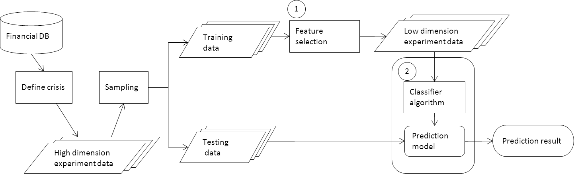

Fig. 1 影響財務預測兩個主要議題

財務危機預警模型的建立始於Fitzpatrick(1932)單變量分析，之後許多學者也分別提出各種不同的統計方法建立財務危機預警模型像是Beaver(1966)[1]單變量分析、Altman(1968)[2]區別分析法、Ohlson[3](1980)logit分析法，而近年來，許多不同的機器學習演算法被提出來，例如: Decision Tree[4]; Neural Network [5, 4]; Support vector Machine (SVM) [6-11]; Case-Based Reasoning[8, 12, 13] 。早期學者主要著重於分類器演算法的探討，期望能夠發展出好的分類器演算法，有效提升準確率。Table 1，我們整理了各種不同的分類器演算法運用於財務危機預測，有研究顯示，在過去十幾年來，有研究顯示單純改良分類器演算法，並沒有辦法對準確率顯著的提升[14]。

Table 1. 應用於財務預常用的分類器演算

|  |  |
| --- | --- |
| Classifiers | Paper Studied |
| MDA | Altman, 1968; Beaver, 1966; Chuvakhin, 2003 |
| Logit Regression | Olson,1980; Tam & Kiang,1992;Zmijewski, 1984;Hua et al.,2004 |
| Neural Network | Lee, 1996; Shin et al., 2005; Tam & Kiang, 1992 |
| Decision Tree | Tam & Kiang, 1992 |
| Support Vector  Machine | Shin et al.,2005; Wu et al., 2007; Hua et al., 2007; Ding et al., 2008;  Chandra et al., 2009 |
| Case-Based Reasoning | Jo& Han, 1996; Sun &Hui, 2006; Li & Sun, 2009; Li et al., 2009;Li &  Sun, 2008 |

本論文將目標放在另一個議題特徵挑選，早期在特徵挑選主要是由學者利用專業的知識，提出許多重要的財務比率特徵，然而隨著時間推移之下，專家們提出來的財務比率越來越多，而要分析這些大量的財務比率必需要花費大量的人力成本，所以如何挑選重要的財務比率演變成很重要的課題。

## 研究動機

Fig. 2整理了1968~2006一些重要財務比率演化的情形，我們統計了1968年之前著名專家Altman, Beaver[15, 2, 1]分析的重要財務比率，整理了大約25個特徵，1968到1980年Ohlson提出了全新的成長能力概念的財務比率，同時也有許多屬於償債能力的新財務比率被提出來[15-19, 3]，總共整理了約45個特徵，1980到了1990年許多學者開始探討有關於現金流量能力裡的cash flow from operation的概念[15, 20, 14, 21, 4, 22]，整理了約95個特徵，到了最近2006年則是有大量的公司治理特徵被提出來[15]，總共整理了約190個特徵。根據上面的統計，我們發現其實在時間的推移之下，專家提出來的財務比率成長的相當快，如Fig. 3所示。

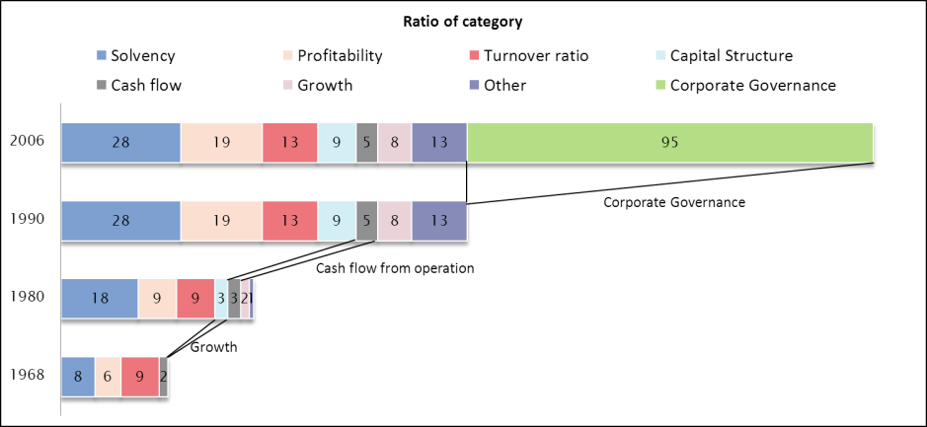

Fig. 2 各時期被提出的財務比率

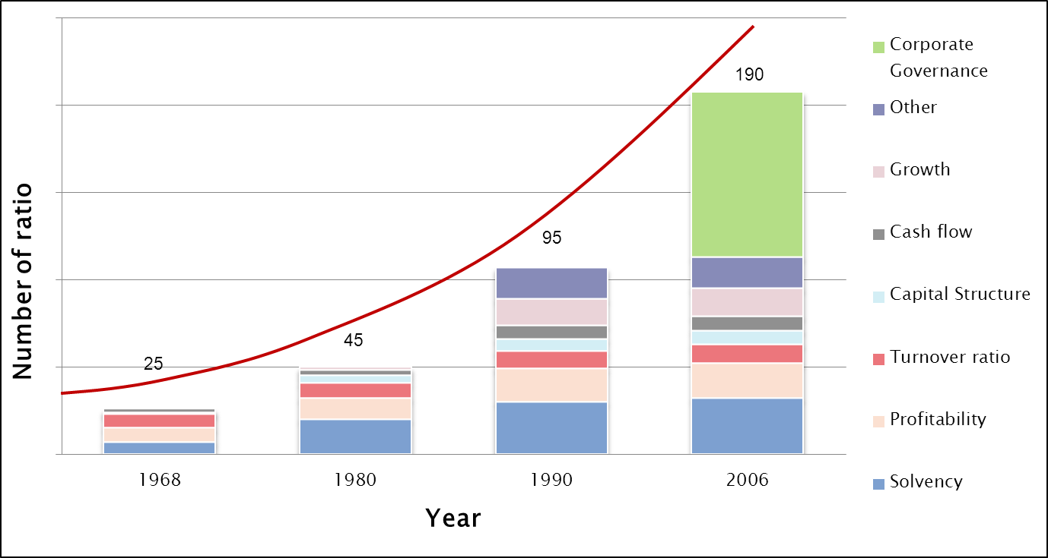

Fig. 3 1968~2006常用的財務比率數量統計

特徵挑選(Feature selection)在財務危機預警流程是一個相當重要的議題，特徵挑選主要有三個好處(1)提升整體的預測準確率(2)除去累贅的特徵增加建模的效率(3)對於推薦出來的特徵比較能夠解釋為什麼會有好的效果[23]。從文獻探討中，前人告訴我們在固定特徵集合情況下，基因演算法運用於特徵挑選(GA Wrapper)效果會比其他常用的特徵挑選方法好[24-27]，但是我們從Fig. 3 可以知道特徵數量會隨著年代演進逐漸增多，如果只驗證單一特定的特徵集合不夠全面，無法看出來GA Wrapper在特徵越來越多的情況下，是不是還是也能夠有好的效果。所以我們想要探討GA Wrapper在特徵集合越來越大的時後，是不是能夠穩定優於其他常用的特徵挑選方式。

## 論文架構

本論文共分五個章節，在第一章緒論，主要講述本研究基本概念，介紹目前財務預測的研究背景以及研究動機。第二章的部份，主要講述基因演算法概念與常用特徵挑方式的相關文獻探討。第三章的部份主要是探討如何設計實驗架構將基因演算法運用於特徵挑選。第四章的部份主要是呈現實驗結果以及探討實驗結果是否符合實驗假設。第五章的部份，主要是闡述本論文的貢獻與未來展望。

# 文獻探討

## Financial crises and financial features

企業危機預測一直是一個具有挑戰性的議題，經過前人的努力，已有許多重要的研究成果。一般財務危機定義有很多種，通常比較嚴謹的定義是，企業破產(bankruptcy)或是倒閉(shut-down)，而比較廣泛的定意則有企業失敗(failure)，衰弱(decline)和危機(distress)。根據Beaver(1966)文獻，危機定義為企業破產宣告(bankruptcy)、公司債券違約(bound default)、發生鉅額銀行帳戶透支(over-drawn bank account)或是未支付特別股股利(nonpayment of preferred stock dividends)。

早期學者將財務比率分成各種不同的能力，獲利能力、償債能力、經營能力等等，藉由,各種不同能力觀察這間公司的財務狀況以及經營情況。

下列我們對各種不同能力做介紹[28]。

* 償債能力(Solvency): 指企業用其[資產](http://wiki.mbalib.com/zh-tw/%E8%B5%84%E4%BA%A7)償還[長期債務](http://wiki.mbalib.com/zh-tw/%E9%95%BF%E6%9C%9F%E5%80%BA%E5%8A%A1)與[短期債務](http://wiki.mbalib.com/zh-tw/%E7%9F%AD%E6%9C%9F%E5%80%BA%E5%8A%A1)的能力。企業有無支付現金的能力和償還債務能力，是企業能否健康生存和發展的關鍵。
* 獲利能力(Profitability): 獲利能力就是企業資金增值的能力，通常表現為企業收益數額的大小與水平的高低
* 經營能力(Turnover): 企業對包括內部條件及其發展潛力在內的[經營戰略](http://wiki.mbalib.com/zh-tw/%E7%BB%8F%E8%90%A5%E6%88%98%E7%95%A5)與計劃的[決策能力](http://wiki.mbalib.com/zh-tw/%E5%86%B3%E7%AD%96%E8%83%BD%E5%8A%9B)，以及企業上下各種生產經營活動的[管理能力](http://wiki.mbalib.com/zh-tw/%E7%AE%A1%E7%90%86%E8%83%BD%E5%8A%9B)的總和。
* 財務結構(Capital structure): 財務結構是指企業全部資產是如何籌資取得的，也就是企業全部資產的對應項目，是指[資產負債表](http://wiki.mbalib.com/zh-tw/%E8%B5%84%E4%BA%A7%E8%B4%9F%E5%80%BA%E8%A1%A8)右邊的全部項目是如何構成的，及它們之間的比例關係等等。
* 現金流量(Cash flow): 是指企業在一定[會計期間](http://wiki.mbalib.com/zh-tw/%E4%BC%9A%E8%AE%A1%E6%9C%9F%E9%97%B4)按照現金[收付實現制](http://wiki.mbalib.com/zh-tw/%E6%94%B6%E4%BB%98%E5%AE%9E%E7%8E%B0%E5%88%B6)，通過一定經濟活動(包括經營活動、[投資](http://wiki.mbalib.com/zh-tw/%E6%8A%95%E8%B5%84)活動、[籌資](http://wiki.mbalib.com/zh-tw/%E7%AD%B9%E8%B5%84)活動和[非經常性項目](http://wiki.mbalib.com/zh-tw/%E9%9D%9E%E7%BB%8F%E5%B8%B8%E6%80%A7%E9%A1%B9%E7%9B%AE))而產生的[現金流入](http://wiki.mbalib.com/zh-tw/%E7%8E%B0%E9%87%91%E6%B5%81%E5%85%A5)、[現金流出](http://wiki.mbalib.com/zh-tw/%E7%8E%B0%E9%87%91%E6%B5%81%E5%87%BA)及其總量情況的總稱。企業一定時期的現金和現金等價物的流入和流出的數量。
* 成長能力(Growth): 指企業未來發展趨勢與[發展速度](http://wiki.mbalib.com/zh-tw/%E5%8F%91%E5%B1%95%E9%80%9F%E5%BA%A6)，包括企業規模的擴大，[利潤](http://wiki.mbalib.com/zh-tw/%E5%88%A9%E6%B6%A6)和[所有者權益](http://wiki.mbalib.com/zh-tw/%E6%89%80%E6%9C%89%E8%80%85%E6%9D%83%E7%9B%8A)的增加。企業成長能力是隨著市場環境的變化，企業資產規模、盈利能力、市場占有率持續增長的能力，反映了企業未來的發展前景。
* 公司治理(Corporate governance): 公司治理可以分為狹義的公司治理和廣義的公司治理兩個層次。狹義的公司治理，是指所有者(主要是[股東](http://wiki.mbalib.com/zh-tw/%E8%82%A1%E4%B8%9C))對經營者的一種監督與制衡機制，即通過一種制度安排，來合理地界定和配置所有者與經營者之間的權利與責任關係。公司治理的目標是保證股東利益的最大化，防止經營者與所有者利益的[背離](http://wiki.mbalib.com/zh-tw/%E8%83%8C%E7%A6%BB)。其主要特點是通過[股東大會](http://wiki.mbalib.com/zh-tw/%E8%82%A1%E4%B8%9C%E5%A4%A7%E4%BC%9A)、[董事會](http://wiki.mbalib.com/zh-tw/%E8%91%A3%E4%BA%8B%E4%BC%9A)、[監事會](http://wiki.mbalib.com/zh-tw/%E7%9B%91%E4%BA%8B%E4%BC%9A)及經理層所構成的[公司治理結構](http://wiki.mbalib.com/zh-tw/%E5%85%AC%E5%8F%B8%E6%B2%BB%E7%90%86%E7%BB%93%E6%9E%84)的內部治理。廣義的公司治理是指通過一整套包括正式或非正式的、內部的或外部的制度來協調公司與[所有利益相關者](http://wiki.mbalib.com/zh-tw/%E6%89%80%E6%9C%89%E5%88%A9%E7%9B%8A%E7%9B%B8%E5%85%B3%E8%80%85)之間(股東、[債權人](http://wiki.mbalib.com/zh-tw/%E5%80%BA%E6%9D%83%E4%BA%BA)、職工、潛在的[投資者](http://wiki.mbalib.com/zh-tw/%E6%8A%95%E8%B5%84%E8%80%85)等)的[利益關係](http://wiki.mbalib.com/zh-tw/%E5%88%A9%E7%9B%8A%E5%85%B3%E7%B3%BB)，以保證公司決策的科學性、有效性，從而最終維護公司各方面的利益。

Table 2與Table 3為GA Wrapper 所使用的特徵集合，公式詳見[15]

Table 2註釋 :

Table 2. 本研究所使用的財務比率集合(附錄三列出財務比率相關出處)

|  |  |  |  |  |  |
| --- | --- | --- | --- | --- | --- |
| Variable | | meaning | Variable | | meaning |
| Solvency | | | X50 | total assets to GNP price b, c, d | |
| X1 | Cost of Interest-Bearing Debt c, d | | Profitability | | |
| X2 | Cash Reinvestment Ratio c, d | | X51 | Return On Total Assets(C) a, b, c, d | |
| X3 | Current Ratio a, b, c, d | | X52 | Return On Total Assets(A)c, d | |
| X4 | Acid Test a, b, c, d | | X53 | Return On Total Assets(B) a, b, c, d | |
| X5 | Interest Expense /Total Revenue b, c, d | | X54 | Gross Profit /Net Sales a, b, c, d | |
| X6 | Total Liabilities/Equity Ratio b, c, d | | X55 | Realized Gross Profit /Net Sale b, c, d | |
| X7 | Liabilities /Total Assets a, b, c, d | | X56 | Operating Income /Net Sale c, d | |
| X8 | Interest-Bearing Debt /Equity c, d | | X57 | Pre-Tax Income /Net Sale c, d | |
| X9 | Contingent Liability /Equity c, d | | X58 | Net Income /Net Sale a, b, c, d | |
| X10 | Operating Income/Capital c, d | | X59 | Net Non-operating Income Ratio c, d | |
| X11 | Pretax Income/Capital c, d | | X60 | Net Income -Exclude Disposal Gain or Loss /Net Sale c, d | |
| X12 | working capital to total assets a, b, c, d | | X61 | EPS-Net Income b, c, d | |
| X13 | Quick asset/Total asset a, b, c, d | | X62 | Pretax Income Per Share c, d | |
| X14 | current assets/total assets a, b, c, d | | X63 | Retained Earnings to Total assets a, b, c, d | |
| X15 | cash / total assets a, b, c, d | | X64 | total income to total expense c, d | |
| X16 | Quick asset/current liabilities c, d | | X65 | total expense to assets c, d | |
| X17 | cash / current liability c, d | | X66 | net income to total assets a, b, c, d | |
| X18 | current liability to assets c, d | | X67 | Gross profit to Sales c, d | |
| X19 | operating funds to liability b, c, d | | X68 | Net income to Equity c, d | |
| X20 | Inventory/working capital b, c, d | | X69 | one if net income was negative for the last two year, zero otherwise b, c, d | |
| X21 | Inventory/current liability b, c, d | | Turnover ratios | | |
| X22 | current liability / liability c, d | | X70 | (Inventory +Accounts Receivables) /Equity c, d | |
| X23 | working capital/equity c, d | | X71 | Total Asset Turnover a, b, c, d | |
| X24 | current liability/equity b, c, d | | X72 | Accounts Receivables Turnover a, b, c, d | |
| X25 | long-term liability to current assets b, c, d | | X73 | Days Receivables Outstanding c, d | |
| X26 | current liabilities to current assets c, d | | X74 | Inventory Turnover c, d | |
| X27 | one if total liabilities exceeds total assets, zero otherwise b, c, d | | | | |
| X28 | equity to liability a, b, c, d | | X75 | Fixed Asset Turnover c, d | |
| Capital Structure ratios | | | X76 | Equity Turnover a, b, c, d | |
| X29 | Equity/Total Assets c, d | | X77 | Current assets a, b, c, d | |
| X30 | (Long-term Liability+ Equity) /Fixed Assets b, c, d | | X78 | Quick assets to sales a, b, c, d | |
| X31 | fix assets to assets c, d | | X79 | Working capital to sales a, b, c, d | |
| X32 | current liability to liability c, d | | X80 | Cash to sales a, b, c, d | |
| X33 | current liability to equity c, d | | X81 | Cash flow to Sales a, b, c, d | |
| X34 | equity to long-term liability b, c, d | | X82 | No-credit interval a, b, c, d | |
| X35 | liability to equity b, c, d | | Cash flow ratios | | |
| X36 | Degree of financial leverage c, d | | X83 | Cash Flow from Operating /Current Liabilities c, d | |
| X37 | Interest coverage ratio c, d | | X84 | Cash flow to total assets a, b, c, d | |
| Others | | | X85 | cash flow to liability a, b, c, d | |
| X38 | cash flow to equity c, d | | X86 | CFO to ASSETS c, d | |
| X39 | (Research and Develope Expense) /Net Sales c, d | | | | |
| X40 | Effective Tax Rate c, d | | X87 | cash flow to equity b, c, d | |
| X41 | Book Value Per Share(B) c, d | | Growth | | |
| X42 | Book Value Per Share(A) c, d | | X88 | Realized Gross Profit Growth Rate c, d | |
| X43 | Book Value Per Share(C)c, d | | X89 | Operation Income Growth c, d | |
| X44 | Cash Flow Per Share c, d | | X90 | Net Income Growth b, c, d | |
| X45 | Sales Per Share c, d | | X91 | Continuing Operating Income After Tax Growth b, c, d | |
| X46 | Operating Income Per Share c, d | | X92 | Net Income -Exclude Disposal Gain or Loss Growth c, d | |
| X47 | Sales Per Employee c, d | | X93 | Total Assets Growth c, d | |
| X48 | Operation Income Per Employee c, d | | X94 | Total Equity Growth c, d | |
| X49 | Fixed Assets Per Employee c, d | | X95 | Return on Total Asset Growth c, d | |

Table 3. 本研究所使用的公司治理特徵(附錄三列出公司治理相關出處)

|  |  |  |  |  |  |
| --- | --- | --- | --- | --- | --- |
| Variable | | meaning | Variable | | meaning |
| Corporate governance | | |  | | |
| X96 | Number of seats in board | | X144 | Shareholding ratio of foreign director and supervisor | |
| X97 | Number of directors | | X145 | Seats of director and supervisor foreigner serve | |
| X98 | Number of supervisors | | X146 | Seats of director foreigner serve | |
| X99 | Shareholding ratio of board | | X147 | Seats of supervisor foreigner serve | |
| X100 | Shareholding ratio of directors | | X148 | Control seats. Seats of director and supervisor the ultimate controller control | |
| X101 | Shareholding ratio of supervisors | | X149 | Seats of director the ultimate controller control | |
| X102 | Shareholding ratio of main shareholders | | X150 | Seats of supervisor the ultimate controller control | |
| X103 | Seats of ultimate controller served as individual director | | X151 | X148 / X103 | |
| X104 | Seats of ultimate controller served as individual supervisor | | X152 | X149 / X103 | |
| X105 | Seats of director which is served by ultimate controller through unlisted company | | X153 | X150 / X103 | |
| X106 | Seats of supervisor which is served by ultimate controller through unlisted company | | X154 | Shareholding ratio control by ultimate controller | |
| X107 | Seats of director which is served by ultimate controller through foundation | | X155 | X121+X122+X123 | |
| X108 | Seats of supervisor which is served by ultimate controller through foundation | | X156 | X124+X125 | |
| X109 | Seats of director which is served by ultimate controller through list company | | X157 | Cash flow rights of ultimate controller, excluding shares owner by foundation of allied group | |
| X110 | Seats of supervisor which is served by ultimate controller through list company | | X158 | X154－X157 | |
| X111 | Seats of director which is served by company manager or group manager | | X159 | X157 / X154 | |
| X112 | Seats of supervisor which is served by company manager or group manager | | X160 | X154 / X157 | |
| X113 | Seats of director which is served by outside individual | | X161 | X151－X157 | |
| X114 | Seats of supervisor which is served by outside individual | | X162 | X157 / X151 | |
| X115 | Seats of director which is served by unlisted company not controlled by ultimate controller | | | | |
| X116 | Seats of supervisor which is served by unlisted company not controlled by ultimate | | X163 | X151 / X157 | |
| X117 | Seats of director which is served by foundation not controlled by ultimate controller, | | X164 | X151－X154 | |
| X118 | Seats of supervisor which is served by foundation not controlled by ultimate controller | | X165 | X154 / X151 | |
| X119 | Seats of director which is served by list company not controlled by ultimate controller | | X166 | X151 / X154 | |
| X120 | Seats of supervisor which is served by list company not controlled by ultimate controller | | X167 | Seats of directors serve as managers | |
| X121 | Shareholding ratio of ultimate controller through individual | | X168 | X167－X97 | |
| X122 | Shareholding ratio of ultimate controller through unlisted company | | X169 | Seats of directors serve as managers | |
| X123 | Shareholding ratio of ultimate controller through foundation | | X170 | X169 / X98,, | |
| X124 | Shareholding ratio of ultimate controller through list company | | X171 | Shareholding ratio of alliance juridical person | |
|  |  | |  |  | |
| X125 | Shareholding ratio of company manager and group manager | | X172 | Shareholding ratio of alliance juridical person who serve director or supervisor | |
| X126 | Shareholding ratio of ultimate controller through juridical person | | X173 | X171－X172 | |
| X127 | Shareholding ratio of ultimate controller through juridical person who serve director and supervisor | | X174 | Shareholding ratio of outside juridical person | |
| X128 | X126－X127 | | X175 | Shareholding ratio of outside juridical person who serve director or supervisor | |
| X129 | Shareholding ratio of outside person | | X176 | X174－X175 | |
| X130 | Shareholding ratio of outside unlisted company | | X177 | Amount of investments in other enterprises divided by stockholder’s equity | |
| X131 | Shareholding ratio of outside Foundation | | X178 | Number of times financial forecast published in a year | |
| X132 | Shareholding ratio of outside list company | | X179 | Number of times the financial report restate in a year | |
| X133 | The group the largest outside shareholder belong | | X180 | Number of times CPA was switched in the last three years, | |
| X134 | Seats of director and supervisor the largest outside shareholder serve | | X181 | Turnover of chairman within 3 years | |
| X135 | Seats of director the largest outside shareholder serve | | X182 | Turnover of CEO within 3 years | |
| X136 | Seats of supervisor the largest outside shareholder serve | | X183 | Turnover of CFO within 3 years | |
| X137 | Shareholding ratio of alliance group | | X184 | Turnover of spokesman within 3 years | |
| X138 | Seats of director and supervisor alliance group serve | | X185 | Turnover of internal audit within 3 years | |
| X139 | Seats of director alliance group serve | | X186 | Turnover of chairman within a month | |
| X140 | Seats of supervisor alliance group serve | | X187 | Turnover of CEO within a month | |
| X141 | Seats of independent director and supervisor | | X188 | Turnover of CFO within a month | |
| X142 | Seats of independent director | | X189 | Turnover of spokesman within a month | |
| X143 | Seats of independent supervisor | | X190 | Turnover of internal audit within a month | |
|  |  | |  |  | |

## Feature selection

特徵挑選(Feature selection)在財務危機預警流程是一個相當重要的議題，特徵挑選主要有三個好處(1)提升整體的預測準確率(2)除去累贅的特徵增加建模的效率(3)對於推薦出來的特徵比較能夠解釋為什麼會有好的效果[23]。

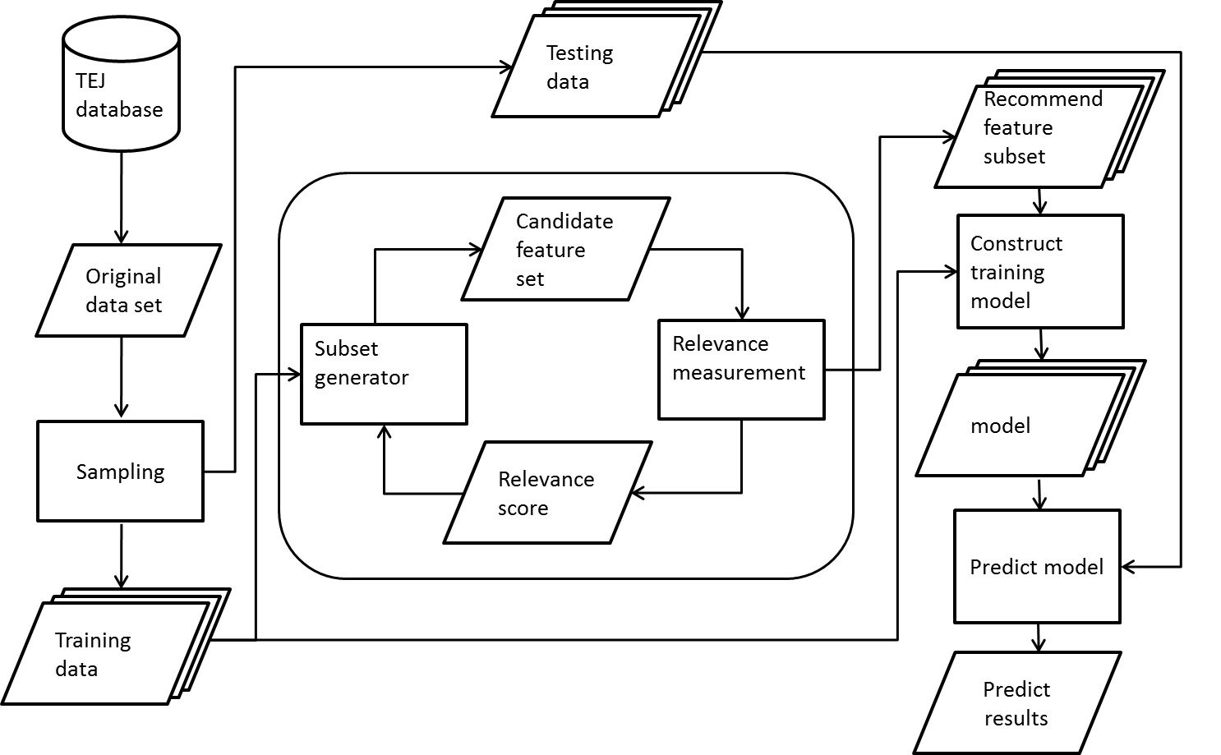

Fig. 4 filter approach 演算法流程

早期運用於財務危機特徵挑選方法有ANOVA[29]，T-test[21]，Stepwise Selection[12, 30, 31]。這些統計的特徵挑選方法在機器學習理論(Machine Learning Theory)中被分類在Filter approach[32, 33]，Fig. 4，filter approach 主要概念是從較大的特徵集合中，利用統計方法對特徵計算相關性找出對training data有最顯著幫助的特徵。Filter approach 是一個pre-processing 的動作，與分類器演算法獨立。

Filter approach在特徵集合大的情況下，通常計算效率高而且本身具有延展性[32, 23]，另一方面，filter approach通常推薦出來的特徵的準確率偏低[34]。其中一個原因可能是filter approach 並沒有與分類器演算法結合，最近的研究顯示相關性高並不代表在預測會有最好的效果[33]。另一個原因可能是filter approach並沒有考慮到特徵之間的關聯性。另外，Guyon and Elisseeff 指出有些特徵單獨表現並不是很好，但是與其他特徵結合確可以顯著改善整體預測效果，完全相關的兩個特徵組合起來確實不會獲得額外的資訊，但是兩個高相關的特徵並不意味他們不會互補[23]。

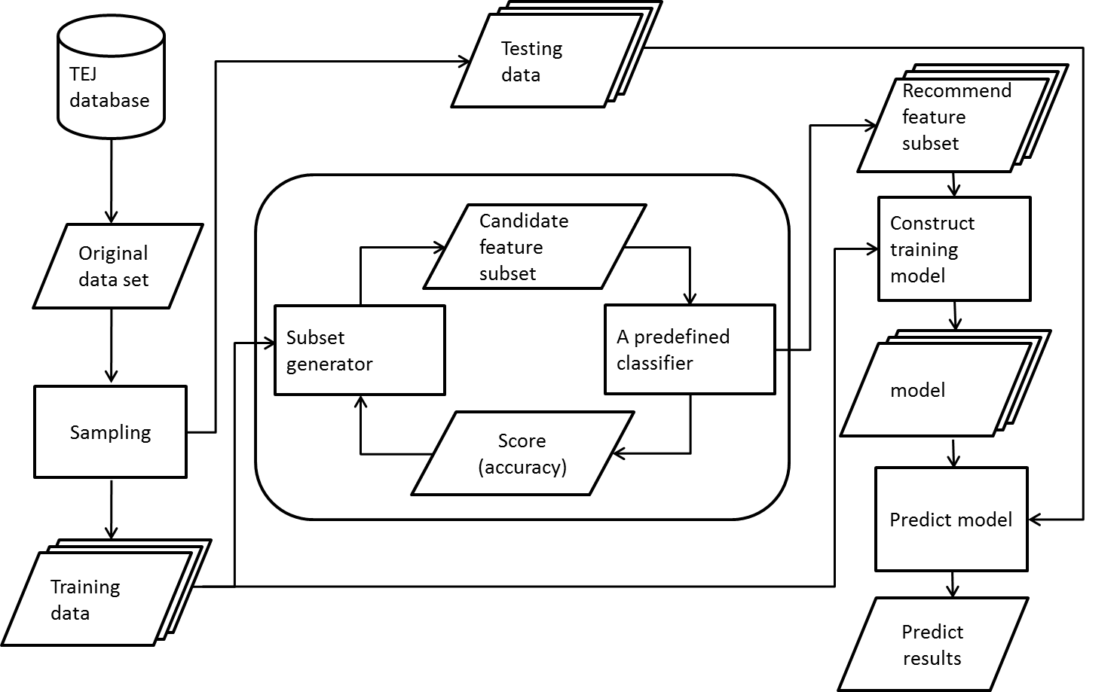

Fig. 5 wrapper approach 演算法

相對於filter approach，Wrapper approach從另一個角度解決特徵挑選的問題[32, 33]，Wrapper approach主要的目的是利用分類器演算法比較各種不同特徵子集合在training data的效果(I.e. 準確率)，最後尋找出效果最好的特徵組合，如Fig. 5所示。通常這種方法需要設計搜尋演算法加速找到最好的特徵子集合，由於需要搜尋，所以也會牽扯到大量的計算[23, 35]。舉例如果我們使用exhausted search找出最佳特徵組合，根據exhausted search演算法，我們會列出所有特徵組合，這時在特徵集合大的情況下會變的相當棘手，因為搜尋空間會隨者特徵集合大小成指數成長，所以exhausted search只適用於小量特徵集合。所以為了改善大量運算的缺點，現在大部份wrapper approach 採用 heuristic search 縮小搜尋的範圍。像是Sequential forward selection[36]，Sequential backward selection[36]，Randomized hill climbing[33]和Genetic algorithms(or GA)[37]。Wrapper approach的總架構是由search strategy，evaluation function和halting criteria所組成[32]。另一方面，Wrapper approach 普遍都會遇到overfitting的問題。Table 4呈現了filter approach 與 wrapper approach 特性。

Table 4. filter approach 與 wrapper approach比較.

|  |  |  |  |
| --- | --- | --- | --- |
|  | Advantages | Disadvantages | Examples |
| Filter | 1.Fast  2.Scalable  3.Independentof  classifier | 1.Ignores feature  dependencies  2.Ignores interaction  with the classifier | ANOVA[GH87]  Stepwise Logit Regression [KK94]  Discriminant Analysis [wil80]  Iterative RELIEF [Sun07] |
| Wrapper | 1.Interacts with  classifier  2.Models feature  dependencies | 1.Computationally  intensive  2.Classifier dependent  selection  3.Risk of overfitting | Sequential forward selection[Kit78]  Sequential backward selection[Kit78]  Randomized hill climbing[KJ97]  Genetic algorithms[Gol89] |

## Genetic algorithms concept

基因演算法是一種演化式計算，最早由John Holland(1975)[37]提出，而近幾年已經應用於各種不同的研究領域，有許多學者將基因演算法應用於財務危機的特徵挑選，而且實驗都有蠻好的效果[24-27]。

|  |
| --- |
| Simple Genetic Algorithms  {  Initialize population;  Evaluation population;  While termination criteria not reached  {  Select solutions for next population;  Perform crossover and mutation;  Evaluate population;  }  } |

Fig. 6 Genetic algorithms basic concept [38]

上Fig. 6是一般的基因演算法流程，主要概念是仿效生物界裡物競天擇，自然進化的法則。基因演算法首先要初始化族群(Population)，而族群是由許多染色體所組成而且每一條染色體都是獨立的，在本論文每一條染色體分別代表一組特徵的子集合，每一條染色體由0與1組成(1代表這個特徵是被選取、0則代表沒有被選取)。

初始化完族群，我們要對每條染色體計算適應值(Fitness value)，進行選擇(Selection)的步驟，目的是要將較優良的染色體存活下來，使整個族群朝更好的方向發展，而目前常用的Selection方式有，輪盤法 (Roulette wheel selection)、競爭法(Tournament selection)及等級輪盤法(Rank Based Wheel Selection)。

經過Selection步驟後，我們要對族群做交配(Crossover)，目的是要產生更好的子代。而目前常用的交配方式為單點交配(one-point crossover)、雙點交配(two-point crossover)與均衡交配(uniform crossover)。

經過Crossover步驟後，我們要將染色體做突變(Mutation)的動作，目的是希望增加族群的多樣性，使族群朝向不同的方向發展，而不是局限少數的個體上。而目前常用的突變方式為Bit string mutation、Flip Bit mutation、Boundary mutation、Uniform mutation。

經過了Selection、Crossover及Mutation三個過程之後，利用新的族群(Population)做重新再做下一次的Selection、Crossover及Mutation的動作直到達到設定演化次數。

## Genetic algorithms parameter

基因演算法中有主要有七個參數需要設定，分別為初始族群大小(Population Size)、選擇方式(Selection Method)、交配方式(Crossover Method)、交配機率(Crossover Rate)、突變方式(Mutation Method)、突變機率(Mutation Rate)以及演化的次數(Generation)。選擇適當的參數其實會影響GA Wrapper 整體搜尋的效果，而這些參數的設定我們主要是參考[38]。

Table 5. 交配機率與突變機率適用情況

|  |  |  |  |
| --- | --- | --- | --- |
|  | SGA [37] | [38] | [38] |
| Population size | 30~200 | 100 | 30 |
| Crossover rate | 0.5~1.0 | 0.6 | 0.9 |
| Mutation rate | 0.001~0.005 | 0.001 | 0.01 |

Table 6. 交配方式適用情況

|  |  |
| --- | --- |
| Population size [38] | Crossover method |
| Small | uniform crossover |
| Large | two-point crossover |

SGA 由 John Holland在1978年提出，而當初John Holland在Population pool設定範圍大約在30~200，交配機率大約在0.5~1.0，突變機率則是在0.001~0.005，[38]告訴我們當族群大小為100時交配機率0.6與突變機率0.001會有比較好的效果，而當族群大小為30時，交配機率0.9與突變機率0.01會有比較好的效果，如Table 5所示。我們再來要觀察哪一種Crossover Method表現效果會比較好，[38]說明當族群小時，採用uniform crossover 會有比較好的效果反之當族群大的時後two-point crossover 會有比較好的效果，如Table 6所示。再來我們要選擇恰當Selection Method ，Selection Method 主要有兩種方式，Roulette wheel selection 與Tournament selection ，[38]列出Roulette wheel selection許多缺點，所以我們認為大家最常用的Tournament selection效果會比較好。

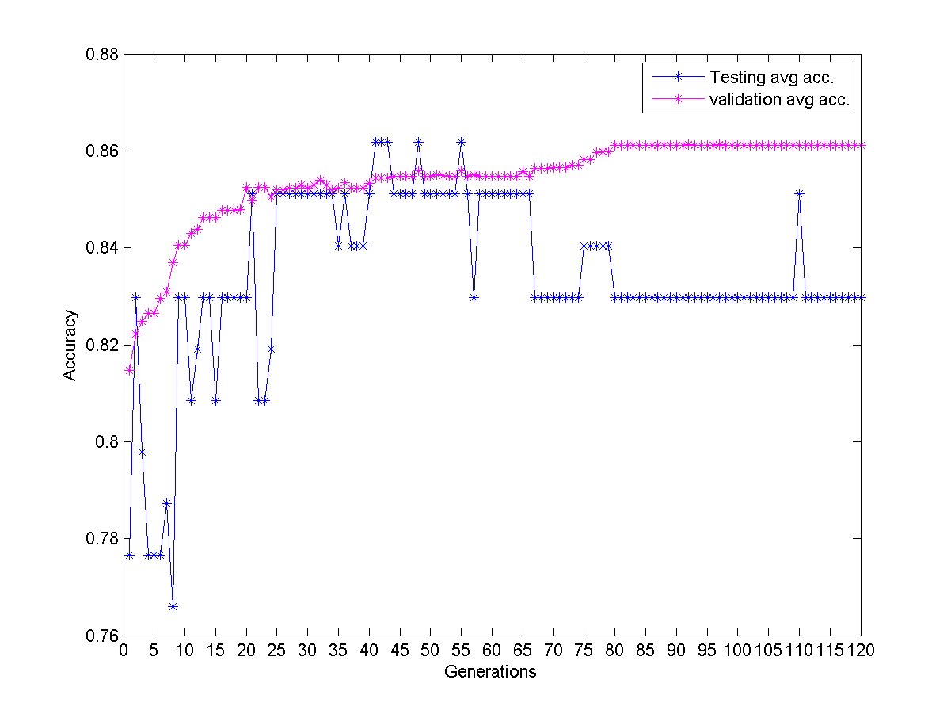

Fig. 7 GA Wrapper 每次演化訓練與測試情形

演化次數參數設定，我們觀察了GA Wrapper在訓練過程如Fig. 7所示，我們可以觀察到演化越多次 validation set 平均準確率可以訓練的更高但是testing set平均準確率反而降低，觀察到這個結果，我們認為演化太多次有可能會造成over fitting 的問題，所以在演化的次數設定上我們採用動態收斂，當validation set 平均準確率收斂差不多的時後就停止演化。

## Genetic algorithms apply in financial prediction review

基因演算法運用於財務危機預測特徵挑選的概念從1996就有被提出來，而之後也成為各國學者熱門討論的議題，[24]利用芬蘭37間危機公司和31個財務比率，驗證GA Wrapper搭配 Neural network 準確率優於 stepwise discriminant analysis與stepwise logistic regression，[25]則是利用台灣證券交易所提供的44間危機公司與48個財務比率，驗證GA Wrapper 效果優於Altman指標以及gain ratio attribute evaluator，[27]則是利用美國的137間危機銀行公司與54財務比率，探討GA Wrapper在銀行破產預測效果優於categorical learning network，[26]則利用未經會計師認證的307間韓國公司與32個財務比率，驗證GA Wrapper 搭配 SVM 效果優於 stepwise discriminant analysis與stepwise logistic regression，Table 7整理了前人研究成果。

Table 7. GA Wrapper 先前研究

|  |  |
| --- | --- |
| Paper | Contribution |
| [24] | 1. Topics: bankruptcy prediction; 2. Data preparation: 37(bankrupted)+37 firm from Finland,1986-1989 3. Feature(ratio) set: 31 financial ratio 4. Feature selection: stepwise discriminant analysis (SDA),   stepwise logistic regression (SLR) and genetic algorithm (GA);   1. Classification Algorithm: discriminant analysis, logistic regression, and   neural networks(NN);   1. GA/NN is able to achieve 97% accuracy 1 year prior to failure. |
| [25] | 1. Financial distress prediction on listed companies, 2. Data preparation:44 (bankrupted)+88 healthy firms from TSE  (Taiwan Stock Exchange); 3. Feature(ratio) set: 48 financial ratio 4. Feature selection: proposed GA vs. Altman and *gain ratio attribute evaluator*(WEKA); 5. Classifier: SVM-RBF; 6. Validation: GA > *gain ratio attribute evaluator* > Altman in all years-ahead forecast. |
| [27] | 1. Topics: bankruptcy prediction on banks; 2. Data preparation: 137 (bankrupted)+ 941 US banks in 1989 obtained from a Big 4 accounting firm; 3. Features: 54 ratios specific for banking industry, from that CPA firm; 4. Feature selection techniques: GA vs. CATLRN (the categorical learning network [ES97]); 5. Classification Algorithm: MLP-NN; 6. GA is better than CARTLRN after 30 holdouts |
| [26] | 1. Topics: bankruptcy prediction; 2. Non-audited medium-size light industry ﬁrms.  307 companies went bankrupt and ﬁled for bankruptcy between 1999 and 2002 from Korean 3. 32 ﬁnancial ratios categorized as stability, proﬁtability, growth, activity and cash ﬂow 4. Feature selection: stepwise discriminant analysis (SDA), stepwise logistic regression (SLR) and genetic algorithm (GA); 5. Classifier: LR, NN, pure SVM 6. GA-SVM signiﬁcantly outperforms the other models |

我們可以看到前人的研究，使用的財務比率數量並不大，大約在55個以下，而且都只驗證單一的特徵集[24] [25] [26] [27]，從GA Wrapper演算法來看，GA Wrapper其實在特徵數量不大的情況下表現會比較有利的，所以在本論文我們模擬了特徵成長情形，觀查GA Wrapper 在25到190個特徵底下表現的情形。另外，我們可以看到前人使用的公司資料集[24] [25] [27]，危機公司數量並不多而且有些使用的是未經過會計師認證的資料集[26]，而在我們研究中，使用了239間危機公司與239間搭配的正常公司，從實驗的公司數量上，我們實驗公司數量是多於前人的實驗資料集並且為公開的資料集，所以可信度也相對較高，另一方面，我們可以看到前人的研究，GA Wrapper與各種不同的特徵挑選方法做比較，而其中最常拿來比較的是Stepwise Logistic Regression與Stepwise Discriminant Analysis[24] [26]，所以在本論文我們比較對象也是以這兩種方法為主，並且與一些著名的專家提出來的財務指標比較。

# 實驗設計

本章主要分為四節，3-1節主要是說明我們實驗的公司來源，3-2節說明實驗資料前置處理方式，3-3節說明我們的實驗假設，3-4說明我們如何設計實驗，驗證我們的假設。

## 資料來源

本研究使用台灣證券交易所提供的資料，1999~2010年台灣上市、上櫃及興櫃發生財務危機的公司共239間危機公司與239間正常公司，財務比率數量為190個，本論文採用的財務危機定義根據「台灣證券交易所股份有限公司營業細則」[39]所規定為範疇，總共分為以下九大類。(詳細實驗資料請參考附錄一)

1. 跳票擠兌－公司跳票、或銀行擠兌。
2. 倒閉破產－宣告倒閉、惡性倒閉、或破產。
3. 繼續經營疑慮－會計師對其繼續經營假設提出疑慮、就重大科目作保留、出具無法表示意見或否定意見等。
4. 重整－聲請重整。
5. 紓困-財危－向財政部申請紓困、或向銀行要求展延、減息並掛帳、個別要求或召開債權人會議，全面要求都算。與銀行之展延，原則上以見報曝光、或財報上明確寫明「展延」者為限。 若僅向銀行要求降息，暫不列為財務危機。
6. 接管－雖未跳票，但原經營者下台。看似沒有違約之事，但接管後多半會跟銀行協商展延債務，還是會演變為5.類狀況。
7. 全額下市－轉列全額交割股、或下市 。此類處分原因主要有3種：Ⅰ財務危機；或Ⅱ虧損過鉅以致每股淨值不及5元；或Ⅲ違反資訊揭露、不在期限內召開股東會、改選董事其中，第Ⅲ項屬經營代理成本過高之疑慮，看似與違約無關，但事後多半會發展為財務危機。
8. 財務吃緊停工－停工未必涉及違約，但若停工消息見報時，已確定是因財務吃緊，則續後必發展成財務危機。
9. 淨值為負－公司淨值為負數，且經營層無增資打算。

## 資料前置處理

原始資料集中，財務比率在部份公司並沒有提供數據，所以我們盡量保留重要的財務比率為準則，選擇此財務比率有值的公司，反之如果是不重要的特徵，我們則盡量多保留一些危機公司樣本為準則。我們採用階層式抽樣法(Stratified sampling)，根據同產業，年度，以及資產總額相近，將危機公司與正常公司1:1搭配。經過我們的篩選，我們最終保留了239間危機公司、239間正常公司以及190個財務比率。(公司列於附錄一)

為了避免特徵之間的數值範圍落差太大，我們將所有特徵做正規化處理，將值正規化到0~1區間，正規化公式如下。

## 實驗假設

我們從Fig. 3 可以知道特徵數量會隨著年代演進逐漸增多，如果只驗證單一特定的特徵集合不夠全面，無法看出來GA Wrapper在特徵越來越多的情況下，是不是還是也能夠有好的效果，所以我們想要驗證GA Wrapper隨著年代演進，特徵集合逐漸變大的情況下，GA Wrapper平均準確率與平均 Type I error rate能夠顯著優於其他常用的特徵挑選方式(假設一)，並且會隨著時間差距越來越顯著。(假設二)

## 實驗流程

假設一，實驗架構如Fig. 8所示，我們將初始資料集分別輸入到各特徵挑選方式，經過特徵挑選步驟後，大家都使用相同的建模演算法，分別預測各方法推薦出來的特徵平均準確率。

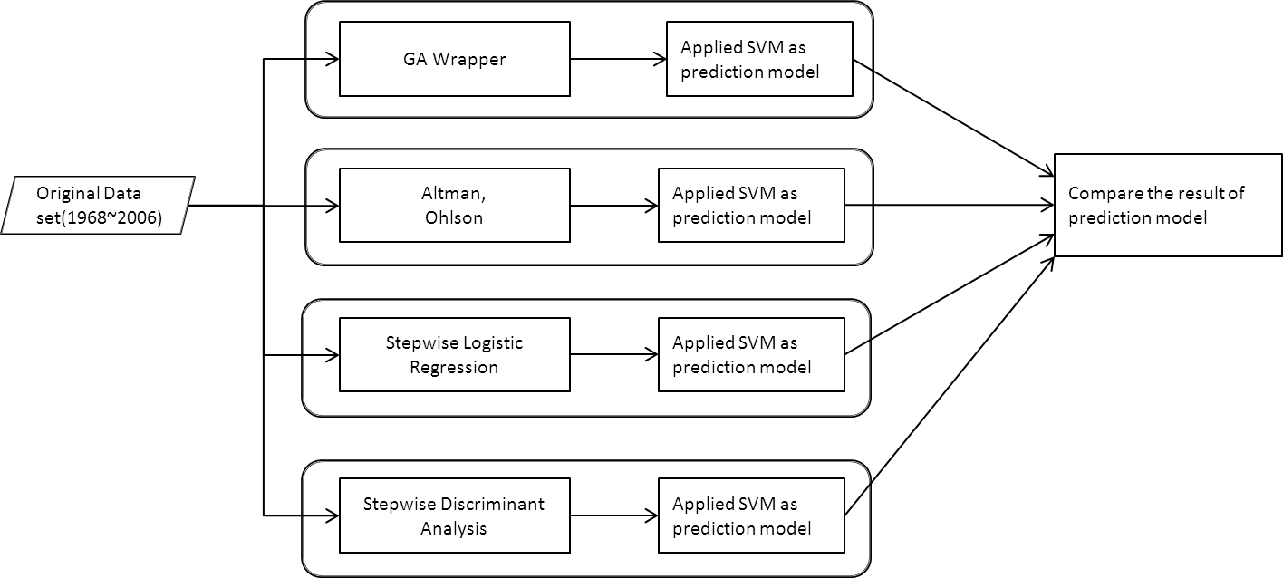

Fig. 8 假設一實驗流程圖

我們分三個小節各別介紹假設一所使用到的特選方式，GA Wrapper、Stepwise Logistic Regression(Stepwise LR)、Stepwise Discriminant Analysis(Stepwise DA) 以及專家細部實驗設計。3-4-1 介紹 GA Wrapper 細部實驗流程，3-4-2介紹最常被使用特徵挑選方式Stepwise Logistic Regression以及Stepwise Discriminant Analysis 實驗流程，3-4-3 介紹最著名的幾位專家Altman，Ohlson 實驗流程。

* + 1. GA Wrapper 實驗設計

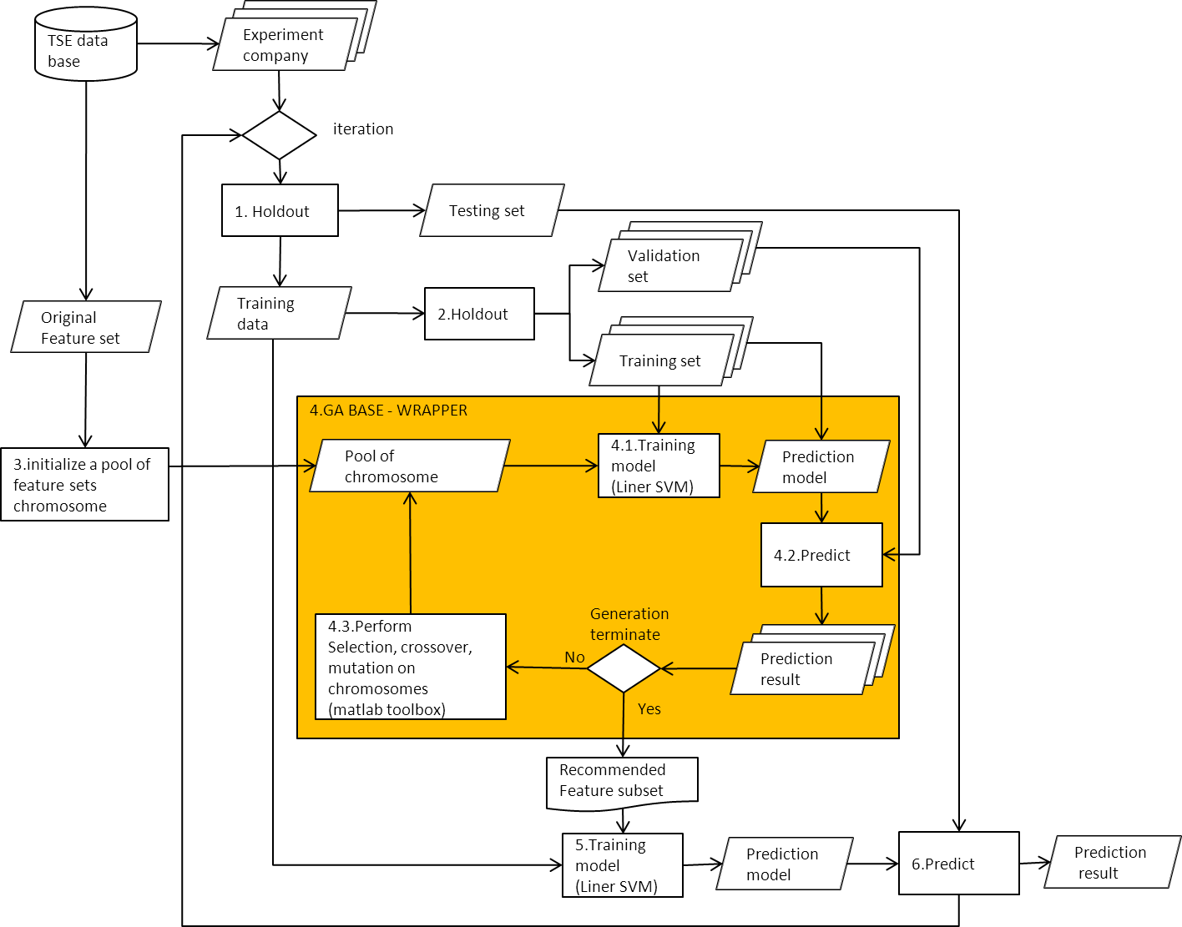

Fig. 9 GA Wrapper 實驗流程圖

GA Wrapper 演算法主要分為六個步驟，Fig. 9所示

1. 對實驗公司進行抽樣，將實驗公司分為多組Training data 以及

Testing set

1. 對Training data進行抽樣，分為多組的 Training set以及

Validation set

1. 初始化 Population pool，每一組chromosome 都是特徵組合
2. GA BASE-Wrapper 核心，詳細 pseudo code 如Table 8所示
3. 將population pool每一條chromosome利用多組

training set建立多個training model

1. 再利用training set 相對應的validation set驗證平均準確率
2. 執行基因演算法，計算每一條chromosome 分數，進行

Selection、Crossover、Mutation動作，取代現在

Population pool。(核心的基因演算法，我們使用

Matlab ga toolbox[40])

1. 重覆執行Step 4.1 直到達到演化的停止條件
2. 挑選出在validation set平均準確率最高的chromosome，再利用

training data 建立 training model

1. 最後使用testing set 驗證最終推薦出來的特徵組合的training model

平均準確率，重覆執行 Step 1 直到達到設定的GA Wrapper次數

Table 8. The pseudo code of GA-BASE Wrapper

|  |
| --- |
| GA-BASE Wrapper algorithms |
| Input :  *f* Feature set(25 ,45, 95, 190)  *𝛼* Size of population pool(60)  *𝛽* Rate of crossover(0.7)  *𝛾* Rate of mutation(0.005),  *ω* Number of GA generation(generation ≧ 20 && average accuracy 8 times repeat)  *ε* Elite chromosome(2)  Output :  *S*\* best chromosome |
| 1. Generate 𝛼 *chromosome* randomly and Save them in the population *Pop*; 2. *for* *i*=1 to *ω* do 3. *nEliteKids*=*ε*; 4. *nXoverKids*=round(*𝛽*×*𝛼*－nEliteKids); 5. *nMutateKids*=𝛼－nEliteKids－nXoverKids; 6. *nParents*=2×*nXoverKids* +*nMutateKids*; 7. *for* *i*=1 to size of *Pop* do 8. *chromosomeLength =* number of feature selected by *chromosomej* 9. *if chromosomeLength* larger than 30 10. *penalty*=*chromosomeLength*－30; 11. *Endif* 12. Use training data and chromosome to construct training model then use validation set to predict 13. average accuracy 14. *fitness value=*average accuracy of *chromosomej*－*penalty*; 15. *endfor* 16. *for* *i* =1 to *nParents* do 17. Use tournament selection chooses *parents* for the next generation. Tournament size is 4; 18. *endfor* 19. *for* *i*=1 to *nXoverKids* do 20. Randomly select two parents from *parents* do uniform crossover to generate offspring 21. then save offspring to *xoverKids;* 22. *endfor* 23. *for* *i* = 1 to *nMutateKids* 24. Randomly select a parent from parents do uniform mutation to generate offspring then 25. save offspring to *mutateKids;* 26. *endfor* 27. *elitekids* = best *ε* chromosomes in *Pop;* 28. *Pop* = *eliteKids*∪*xoverKids*∪*mutateKids;* 29. *endfor* 30. Return the recommended ratio subset *S*\* based on the best chromosome in *Pop* |

Table 9. GA Wrapper 實驗參數設定

|  |  |
| --- | --- |
| GA Wrapper parameter | recommended |
| Objective Function | if Chromosome Length>30  penalty = (ChromosomeLength-30);  Fitness Value = average Accuracy- penalty; |
| Selection | Tournament Selection |
| Crossover Method | Uniform crossover |
| Mutation Method | Uniform mutation |
| Generation | Generation ≧ 20 && average accuracy 8 times repeat |
| Population Size | 60 |
| Crossover rate(PC) | 0.7 |
| Mutation rate (PM) | 0.005 |
| Elite chromosome | 2 |

Table 9呈現我們GA Wrapper所採用的參數設定，基本上我們是參考上述推薦的參數設定，其中Objective Function會設定懲罰權重是因為我們想降低GA Wrapper 最終推薦特徵數量，如果推薦特徵數量過多會導致分析的困難度，所以我們設定只要推薦的特徵個數超過30個就給予懲罰，只要多出上限一個準確率就扣1%，利用這個方法控制最終推薦的特徵數量，另外還有一個參數是 Elite 這個參數是保留最佳基因個數，被保留的基因完全不會參與交配，突變，而是直接加入下次演化的Population pool。

在Population pool size設定中，我們從文獻探討[38]告訴我們當族群大小為100時交配機率0.6與突變機率0.001會有比較好的效果，而當族群大小為30時，交配機率0.9與突變機率0.01會有比較好的效果。由Table 10所示，我們可以看到GA Wrapper 本身在做演化計算需要很長一段時間，所以我們Population pool size不能設定太大，我們將Population pool size設定在60，而交配機率以及突變機率也設在上述推薦範圍中間值。

Table 10. GA Wrapper 執行所花的時間

|  |  |  |
| --- | --- | --- |
| Population generation | 60 | 120 |
| 60 | 15hr | 30hr |
| 100 | 24hr | 48hr |

hr: hours

* + 1. Stepwise Logistic Regression & Stepwise Discriminant Analysis實驗設計

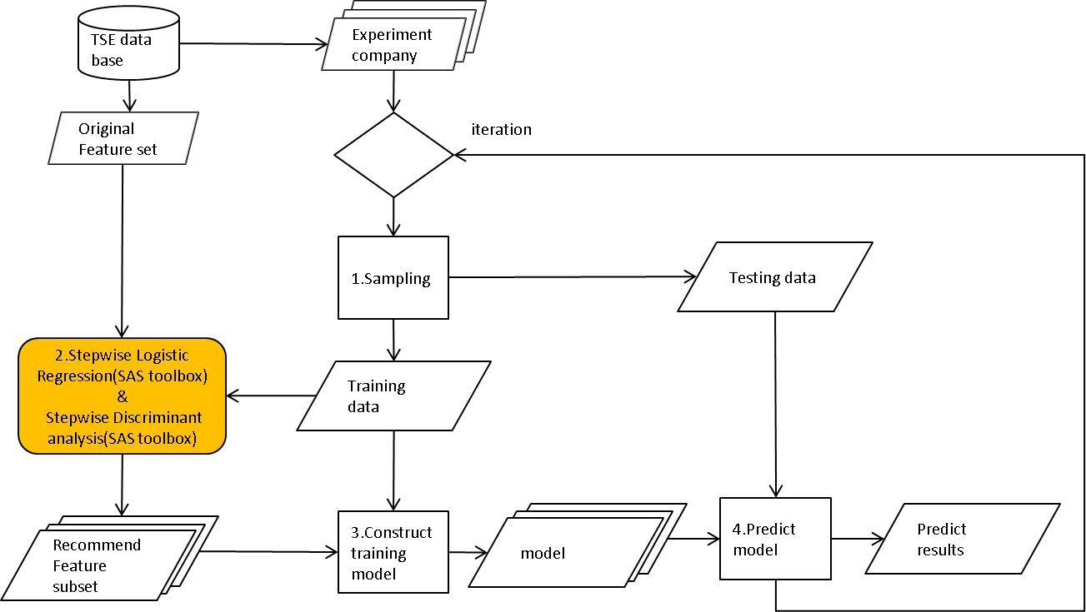

Fig. 10 Stepwise Logistic Regression、Stepwise Discriminant Analysis 實驗流程

演算法主要有四個步驟，Fig. 10所示

1. 針對實驗公司進行抽樣，將實驗公司分為多組Training data 以及

Testing set

1. 利用Training data 以及 Original feature set，輸入到

Stepwise Logistic Regression和Step Discriminant analysis。

(這兩種特徵挑選方式，我們使用常用的統計軟體SAS toolbox[41])

1. 將推薦的特徵，利用Training data 建立 training model
2. 再利用 Testing data測試training model準確率，重覆 Step 1 直到

達到要執行的次數

* + 1. Altman，Ohlson 專家實驗設計

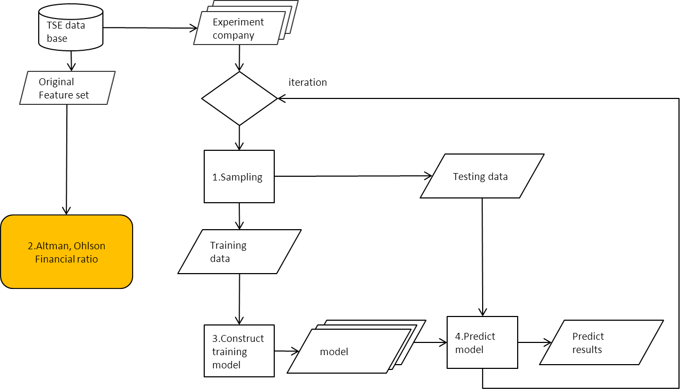

Fig. 11 專家實驗流程

演算法主要有四個步驟，Fig. 11所示

1. 針對實驗公司進行抽樣，將實驗公司分為多組Training data 以及

Testing set

1. 從原始特徵集選出專家的推薦的特徵
2. 利用專家推薦的特徵與Training data 建立Training model
3. 利用 Testing data 測試 Training model 準確率，重覆 Step 1 直到

達到要執行的次數

# 實驗結果

本章節重點主要呈現各種不同實驗結果圖表，探討我們的實驗結果是否有滿足我們的實驗假設，4.1呈現實驗數據與分析。

## 實驗結果與分析

對於假設一，我們列出了四個時期實驗結果，分別驗證GA Wrapper在四個時期平均準確率與平均type I error rate是否都優於其他常用的特徵挑選方法。Table 11到

Table 25為驗證假設一的實驗數據

Table 11. GA Wrapper 在25 ratio 準確率、Type I、Type II 比較與顯著性比較

|  |  |  |  |
| --- | --- | --- | --- |
| Feature selection  method | Accuracy | Type I error | Type II error |
| Stepwise LR | 80.07% | 19.49% | 20.36% |
| Stepwise DA | 80.45% | 19.94% | 19.17% |
| GA Wrapper | 81.43% | 17.87% | 19.28% |

|  |  |  |
| --- | --- | --- |
| GA Wrapper | Stepwise LR | Stepwise DA |
| Accuracy | 0.005849** | 0.062109 |
| Type I | 0.036046* | 0.00757** |
| Type II | 0.164731 | 0.896635 |

**Significant at the level of 1%, *Significant at the level of 5%

Table 12. GA Wrapper 在45 ratio 準確率、Type I、Type II 比較與顯著性比較

|  |  |  |  |
| --- | --- | --- | --- |
| Feature selection  method | Accuracy | Type I error | Type II error |
| Stepwise LR | 78.97% | 20.15% | 21.91% |
| Stepwise DA | 76.39% | 28.89% | 18.32% |
| GA Wrapper | 81.57% | 18.77% | 18.09% |

|  |  |  |
| --- | --- | --- |
| GA Wrapper | Stepwise LR | Stepwise DA |
| Accuracy | 3.07E-07** | 7.37E-20** |
| Type I | 0.083008 | 1.43E-24** |
| Type II | 1.73E-07** | 0.747524 |

**Significant at the level of 1%, *Significant at the level of 5%

Table 13. GA Wrapper 在95 ratio 準確率、Type I、Type II 比較與顯著性比較

|  |  |  |  |
| --- | --- | --- | --- |
| Feature selection  method | Accuracy | Type I error | Type II error |
| Stepwise LR | 80.04% | 20.43% | 19.49% |
| Stepwise DA | 77.62% | 24.91% | 19.85% |
| GA Wrapper | 82.06% | 18.74% | 16.89% |

|  |  |  |
| --- | --- | --- |
| GA Wrapper | Stepwise LR | Stepwise DA |
| Accuracy | 0.000448** | 1.59E-13** |
| Type I | 0.049** | 4.5E-12** |
| Type II | 0.0014** | 0.000142** |

Table 14. GA Wrapper 在190 ratio 準確率、Type I、Type II 比較與顯著性比較

|  |  |  |  |
| --- | --- | --- | --- |
| Feature selection  method | Accuracy | Type I error | Type II error |
| Stepwise LR | 78.72% | 24.47% | 18.09% |
| Stepwise DA | 78.46% | 22.30% | 20.79% |
| GA Wrapper | 81.45% | 19.28% | 17.83% |

|  |  |  |
| --- | --- | --- |
| GA Wrapper | Stepwise LR | Stepwise DA |
| Accuracy | 1.94E-06** | 7.8E-07** |
| Type I | 1.79E-08** | 0.001182** |
| Type II | 0.736 | 0.000329** |

**Significant at the level of 1%, *Significant at the level of 5%

Table 15. 專家指標表現

|  |  |  |  |
| --- | --- | --- | --- |
| Feature selection  method | Accuracy | Type I error | Type II error |
| Altman | 76.10% | 24.40% | 21.81% |
| Ohlson | 77.29% | 30.30% | 16.11% |

Table 16. GA Wrapper 與專家顯著性比較

|  |  |  |  |
| --- | --- | --- | --- |
| GA Wrapper | | Altman | Ohlson |
| Ratios 25 | Accuracy | 2.71606E-14** | 1.31E-13** |
| Type I | 9.62513E-13** | 1.19E-29** |
| Type II | 0.002503957** | 4.20666E-05** |
| Ratios 45 | Accuracy | 7.22904E-16** | 5.55E-15** |
| Type I | 2.30174E-10** | 4.01E-27** |
| Type II | 8.27685E-06** | 0.008226** |
| Ratios 95 | Accuracy | 2.521E-16** | 1.3E-15** |
| Type I | 7.985E-10** | 3.52E-26** |
| Type II | 1.831E-08** | 0.306 |
| Ratios 190 | Accuracy | 5.3E-13** | 1.63369E-15** |
| Type I | 1.6E-07** | 2.3568E-28** |
| Type II | 1.73E-06** | 0.013* |

從Table 11到Table 16，我們可以看到GA Wrapper 在企業爆發危機前一年，四個時期平均準確率都有達到81%以上，而且在各時期GA Wrapper平均準確率都可以優於Stepwise Discriminant Analysis, Stepwise Logistic Regression以及各專家至少1% 以上，再來我們觀察平均準確率在統計標準上是否有達到顯著差異，從Table 11到Table 16，我們可以看到除了在1968年顯著水準在0.06之外，其他時期顯著性都有達到0.05水準，從上述幾點來看我們可以知道GA Wrapper 在財務危機預測上效果是優於其他特徵挑選方法。另一方面，在財務危機預測這個領域中，大家不只有探討平均準確率，還有探討平均 Type I error rate，Type I error rate 定義是將危機公司誤判成正常公司的比率，這種類型的錯判會造成投資人龐大的損失，所以我們會希望GA Wrapper 平均Type I error rate表現也能夠優於其他特徵挑選方法，我們從Table 11到Table 16，可以看到GA Wrapper 在預測危機發生前一年，平均type I error rate表現也都是優於Stepwise Discriminant Analysis, Stepwise Logistic Regression以及各專家，這意味GA Wrapper 在抓危機公司能效果也是優於其他特徵挑選方法。

Table 17. GA Wrapper 在 25 個ratios 推薦出來的特徵 profile analysis.

|  |  |  |  |  |  |  |  |  |
| --- | --- | --- | --- | --- | --- | --- | --- | --- |
| Features | | Firm Type | | | | Difference | | T-Test |
| Distressed firms | | Non-distressed firms | | p-value |
| variable | meaning | Mean | Std. Dev. | Mean | Std. Dev. | Mean | Std. Dev. | (p<0.01) |
| Solvency ratios | |  |  |  |  |  |  |  |
|  | Liabilities /Total Assets | 6.19E+01 | 1.94E+01 | 3.98E+01 | 1.69E+01 | -2.21E+01 | -2.47E+00 | 1.74E-34** |
|  | equity to liability | 1.11E+00 | 3.76E+00 | 2.29E+00 | 2.26E+00 | 1.18E+00 | -1.50E+00 | 4.11E-05** |
| Profitability ratios | |  |  |  |  |  |  |  |
|  | Return On Total Assets(C) | -7.92E+00 | 1.65E+01 | 6.84E+00 | 1.17E+01 | 1.48E+01 | -4.76E+00 | 5.72E-26** |
|  | Gross Profit /Net Sales | 7.99E+00 | 2.01E+01 | 1.91E+01 | 1.80E+01 | 1.11E+01 | -2.12E+00 | 4.52E-10** |
|  | Net Income /Net Sale | -6.31E+01 | 3.08E+02 | 4.16E-01 | 2.74E+01 | 6.35E+01 | -2.81E+02 | 1.71E-03** |
|  | net income to total assets | -1.70E-01 | 2.49E-01 | 1.99E-02 | 1.27E-01 | 1.90E-01 | -1.22E-01 | 1.44E-22** |
|  | Retained Earnings/Total assets | -2.44E-01 | 3.28E-01 | 1.33E-02 | 2.26E-01 | 2.57E-01 | -1.02E-01 | 3.58E-21** |
| Cash flow ratios | |  |  |  |  |  |  |  |
|  | Cash flow to total assets | -1.94E-02 | 8.76E-02 | 1.04E-02 | 7.67E-02 | 2.98E-02 | -1.10E-02 | 8.69E-05** |
|  | cash flow to liability | -8.77E-02 | 7.16E-01 | 4.00E-02 | 3.68E-01 | 1.28E-01 | -3.49E-01 | 1.47E-02* |
| Turnover ratios | |  |  |  |  |  |  |  |
|  | Total Asset Turnover | 7.01E-01 | 5.90E-01 | 8.81E-01 | 6.37E-01 | 1.80E-01 | 4.69E-02 | 1.45E-03* |
|  | Accounts Receivables Turnover | 1.72E+01 | 1.45E+02 | 1.22E+01 | 4.16E+01 | -5.08E+00 | -1.03E+02 | 6.02E-01 |
|  | Equity Turnover | 2.06E+00 | 2.61E+00 | 1.73E+00 | 2.20E+00 | -3.33E-01 | -4.16E-01 | 1.32E-01 |
|  | Working capital to sales | -2.09E-01 | 7.32E+00 | 3.86E-01 | 6.94E-01 | 5.95E-01 | -6.63E+00 | 2.12E-01 |
|  | No-credit interval | -4.04E+00 | 6.01E+01 | -3.03E-01 | 1.33E+01 | 3.74E+00 | -4.69E+01 | 3.49E-01 |

**Significant at the level of 1%, *Significant at the level of 5%

接下來，我們藉由P-value 探討GA Wrapper推薦的特徵危機公司與正常公司之間在統計上是否有顯著的差距，Table 17，在特徵數量為25時，GA Wrapper推薦的特徵大部份危機公司與正常公司都有顯著的差距，不過有少部份的特徵危機公司與正常公司沒有顯著差距，原因有可能是這個特徵單獨判斷的能力並不高，但是如果跟搭配其他特徵有機會使整體的準確率往上提升，這也是GA Wrapper最主要的精神。

Table 18. GA Wrapper 在25個ratio 推薦出來的特徵做能力分布的分析

|  |  |  |  |  |  |
| --- | --- | --- | --- | --- | --- |
|  | Altman | Ohlson | SLR | SDA | GA Wrapper |
| Solvency ratios | 1 | 4 | 3 | 3 | 2 |
| Cash flow ratios | 0 | 0 | 0 | 0 | 2 |
| Profitability ratios | 3 | 1 | 1 | 1 | 5 |
| Growth ratios | 0 | 2 | 1 | 1 | 5 |
| Turnover ratios | 1 | 0 | 3 | 3 | 2 |

Table 19. GA Wrapper 在45個ratio 推薦出來的特徵做能力分布的分析

|  |  |  |  |  |  |
| --- | --- | --- | --- | --- | --- |
|  | Altman | Ohlson | SLR | SDA | GA Wrapper |
| Solvency ratios | 1 | 4 | 2 | 5 | 8 |
| Cash flow ratios | 0 | 0 | 0 | 1 | 2 |
| Profitability ratios | 3 | 1 | 1 | 2 | 4 |
| Capital structure ratios | 0 | 1 | 0 | 0 | 2 |
| Growth ratios | 0 | 2 | 0 | 0 | 1 |
| Turnover ratios | 1 | 0 | 1 | 1 | 2 |
| Other ratios | 0 | 1 | 0 | 0 | 1 |

Table 20. GA Wrapper 在95個ratio 推薦出來的特徵做能力分布的分析

|  |  |  |  |  |  |
| --- | --- | --- | --- | --- | --- |
|  | Altman | Ohlson | SLR | SDA | GA Wrapper |
| Solvency ratios | 1 | 4 | 1 | 7 | 11 |
| Cash flow ratios | 0 | 0 | 1 | 2 | 1 |
| Profitability ratios | 3 | 1 | 1 | 3 | 4 |
| Capital structure ratios | 0 | 1 | 1 | 2 | 3 |
| Growth ratios | 0 | 2 | 0 | 2 | 1 |
| Turnover ratios | 1 | 0 | 2 | 3 | 4 |
| Other ratios | 0 | 1 | 0 | 3 | 1 |

Table 21. GA Wrapper 在190個ratio 推薦出來的特徵做能力分布的分析

|  |  |  |  |  |  |
| --- | --- | --- | --- | --- | --- |
|  | Altman | Ohlson | SLR | SDA | GA Wrapper |
| Solvency ratios | 1 | 4 | 1 | 4 | 5 |
| Cash flow ratios | 0 | 0 | 0 | 1 | 1 |
| Profitability ratios | 3 | 1 | 1 | 5 | 4 |
| Capital structure ratios | 0 | 1 | 1 | 2 | 1 |
| Growth ratios | 0 | 2 | 0 | 2 | 1 |
| Turnover ratios | 1 | 0 | 0 | 2 | 2 |
| Other ratios | 0 | 1 | 0 | 1 | 3 |
| Corporate governance | 0 | 0 | 4 | 20 | 13 |

Table 18到Table 21，我們可以觀察到GA Wrapper 挑出來的特徵平均散布在各個能力，以財經的觀點來看，不同的能力代表著從不同面向觀察這間公司的表現，所以GA Wrapper平均準確率能夠優於其他方法，另一個可能原因是推薦特徵均勻散布在各能力，經由上述的探討與觀察，我們認為GA Wrapper在假設一是成立的。

Table 22. GA Wrapper 在25特徵集合，最終推薦特徵

|  |  |
| --- | --- |
| Reference | Ratios used |
| Altman | [X12][X28][X51][X63][X71] |
| Ohlson | [X3][X7][X12][X19][X27][X50][X66][X69][X90] |
| Stepwise Logistic Regression | [X7][X12][X28][X51][X76] |
| Stepwise Discriminant Analysis | [X7][X12][X28][X51][X76] |
| GA Wrapper | [X7][X28][X51][X54][X58][X63][X68][X71][X72][X76][X79][X82][X84][X85] |

Table 23. GA Wrapper 在45特徵集合，最終推薦特徵

|  |  |
| --- | --- |
| Reference | Ratios used |
| Altman | [X12][X28][X51][X63][X71] |
| Ohlson | [X3][X7][X12][X19][X27][X50][X66][X69][X90] |
| Stepwise Logistic Regression | [X7][X28][X61][X76] |
| Stepwise Discriminant Analysis | [X61][X7][X76][X18][X20][X84][X28][X27][X69] |
| GA Wrapper | [X6][X7][X17][X19][X20][X21][X27][X28][X30][X33][X50][X54][X58][X61][X66]  [X76][X84][X81][X85][X90] |

Table 24. GA Wrapper 在95特徵集合，最終推薦特徵

|  |  |
| --- | --- |
| Reference | Ratios used |
| Altman | [X12][X28][X51][X63][X71] |
| Ohlson | [X3][X7][X12][X19][X27][X50][X66][X69][X90] |
| Stepwise Logistic Regression | [X83][X61][X29][X74][X76][X28] |
| Stepwise Discriminant Analysis | [X56][X39][X83][X61][X46][X95][X94][X29][X74][X76][X48][X17][X18][X19][X20][X18]  [X78][X87][X27][X36][X69][X28] |
| GA Wrapper | [X1][X4][X6][X7][X8][X16][X17][X20][X21][X23][X22][X53][X63][X65][X68][X84][X75]  [X76][X78][X79][X29][X30][X36][X92][X48] |

Table 25. GA Wrapper 在190特徵集合，最終推薦特徵

|  |  |
| --- | --- |
| Reference | Ratios used |
| Altman | [X12][X28][X51][X63][X71] |
| Ohlson | [X3][X7][X12][X19][X27][X50][X66][X69][X90] |
| Stepwise Logistic Regression | [X28][X29][X61][X101][X176][X179][X180] |
| Stepwise Discriminant Analysis | [X51][X52][X56][X39][X71][X94][X29][X70][X76][X99][X101][X102][X103]  [X113][X116][X123][X125][X128][X129][X142][X150][X167][X177][X178]  [X179][X180][X183][X184][X188][X12][X17][X20][X86][X27][X66][X36][X69] |
| GA Wrapper | [X7][X11][X18][X22][X26][X51][X58][X60][X68][X84][X77][X79][X36][X92][X41][X42][X48]  [X103][X104][X117][X125][X129][X142][X148][X165][X167][X174][X186][X188][X189] |

Table 22到Table 25為GA Wrapper在各時期挑選出來的特徵，我們可以使用GA Wrapper 推薦的特徵，作為預測模型使用的特徵，可以達到較好的預測效果。

對於假設二，我們觀察四個時期，驗證GA Wrapper平均準確率與平均 Type I error rate，四個時期是否都優於其他常用的特徵挑選方法而且隨著時間差距會越來越顯著。

驗證的實驗數據為Table 26到Table 28以及Fig. 12到Fig. 17

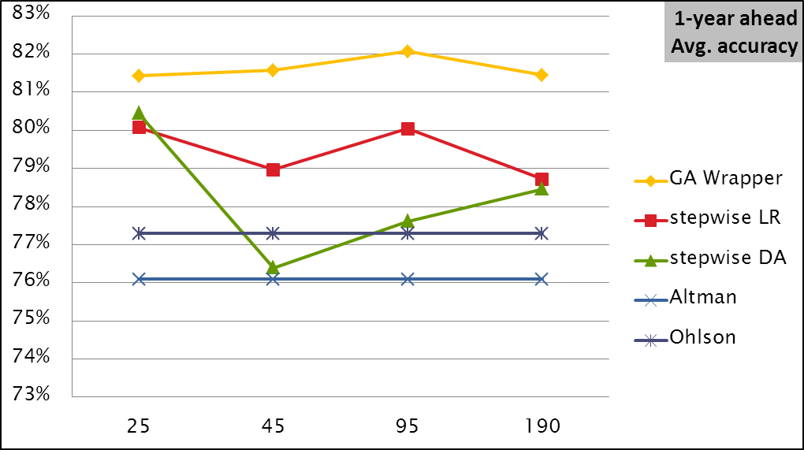

Fig. 12 GA Wrapper 預測危機前一年，各時期成長情形

Table 26. P-value for pairwise comparison of accuracy in 1-year ahead forecast

|  |  |  |  |  |
| --- | --- | --- | --- | --- |
|  | Ratios | | | |
| GA Wrapper vs.  models | 25 | 45 | 95 | 190 |
| Altman | 2.71606E-14** | 7.22904E-16** | 2.52178E-16** | 5.30401E-13** |
| Ohlson | 1.31302E-13** | 5.5473E-15** | 1.29763E-15** | 1.63369E-15** |
| SLR | 0.00584902** | 3.06941E-07** | 0.000448222** | 1.93949E-06** |
| SDA | 0.06210908 | 7.36853E-20** | 1.59139E-13** | 7.79709E-07** |

經由上述的驗證，我們得知GA Wrapper在單一特定的資料集表現都能優於其他特徵挑選方法，接下來我們利用Table 29實驗公司集驗證假設二。從Fig. 12與Table 26，我們可以看到GA Wrapper在預測企業爆發危機前一年，特徵集合由45增加到95，平均準確率由81.43% 提升到82.06%，且與其它方法有越來越顯著差距。這代表GA Wrapper確實會隨著特徵集合越大，準確率往上提升的現象，意味GA Wrapper 的確有能力從較大的特徵集合，找出一組更好的特徵組合幫助我們做財務危機的預測，不過並不是在任何情況下都成立，在2006公司治理加入，特徵數量增加到190，GA Wrapper表現則不如預期，預測的效果不升下降，這點比較奇怪，所以我們重新檢視實驗流程，觀察GA Wrapper在validation set 表現情形，我們發現GA Wrapper 在2006時期找到最佳的特徵組合在validation set 平均準確率其實是優於1990找到的最佳特徵組合，但是在Testing set 表現，2006年卻比1990年較差，我們推測有可能是演化太多次導致over fitting 現象發生，另一方面也有可能是因為公司治理特徵單獨判斷並不高，但是與其他特徵結合反而有更好的效果，導致更容易over fitting。

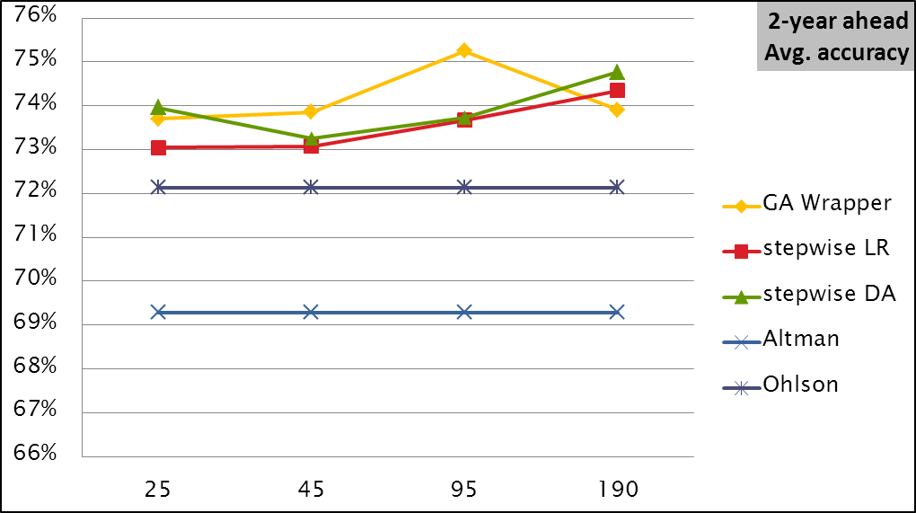

Fig. 13 GA Wrapper 預測危機前二年，各時期成長情形

Table 27. P-value for pairwise comparison of accuracy in 2-year ahead forecast

|  |  |  |  |  |
| --- | --- | --- | --- | --- |
|  | Ratios | | | |
| GA Wrapper vs.  models | 25 | 45 | 95 | 190 |
| Altman | 7.21959E-13** | 6.54798E-14** | 5.61142E-20** | 1.41465E-12** |
| Ohlson | 0.005641242** | 0.00198972** | 1.22714E-07** | 0.003378032** |
| SLR | 0.25342567 | 0.173854679 | 0.005671345** | 0.445854745 |
| SDA | 0.654070618 | 0.292789952 | 0.005132941** | 0.130697933 |

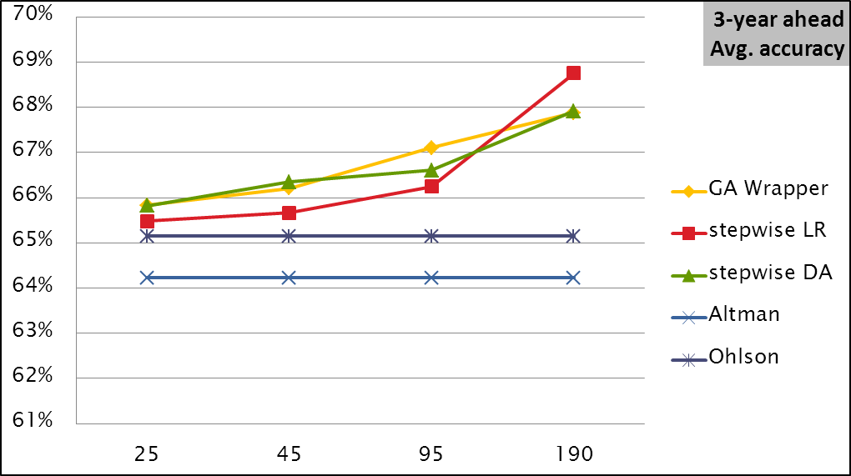

Fig. 14 GA Wrapper 預測危機前三年，各時期成長情形

Table 28. P-value for pairwise comparison of accuracy in 3-year ahead forecast

|  |  |  |  |  |
| --- | --- | --- | --- | --- |
|  | Ratios | | | |
| GA Wrapper vs.  models | 25 | 45 | 95 | 190 |
| Altman | 0.007269894** | 0.00041648** | 2.54354E-07** | 1.40754E-08** |
| Ohlson | 0.225202458 | 0.041726515* | 0.000139039** | 6.02178E-06** |
| SLR | 0.548438467 | 0.9535984 | 0.107539882 | 0.178623808 |
| SDA | 0.985446966 | 0.318308713 | 0.3599433 | 0.959751664 |

Fig. 13和Fig. 14呈現GA Wrapper在預測公司未來二到三年是否會爆發危機的表現情形，Fig. 13，GA Wrapper在不考慮公司治理情況下與也會滿足假設二，不過在加入公司治理後，效果也有下降的趨勢，Fig. 14，GA Wrapper預測三年後公司是否爆發危機的效果雖然無法優於其他特徵挑選方法，不過與其他方法擁有差不多的準確率。

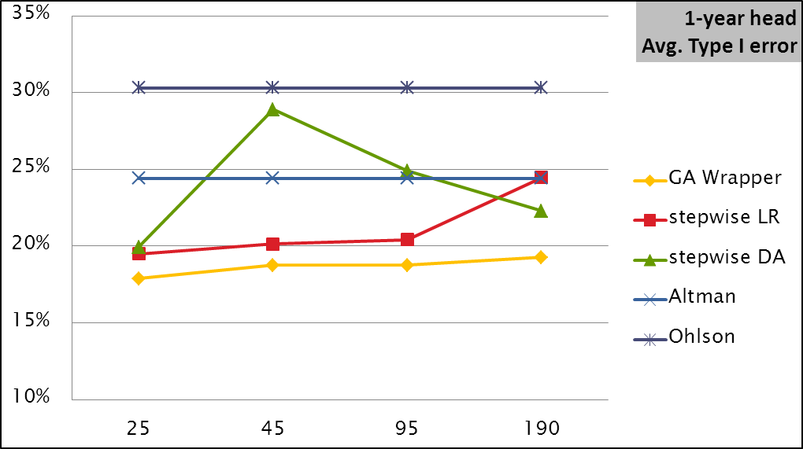 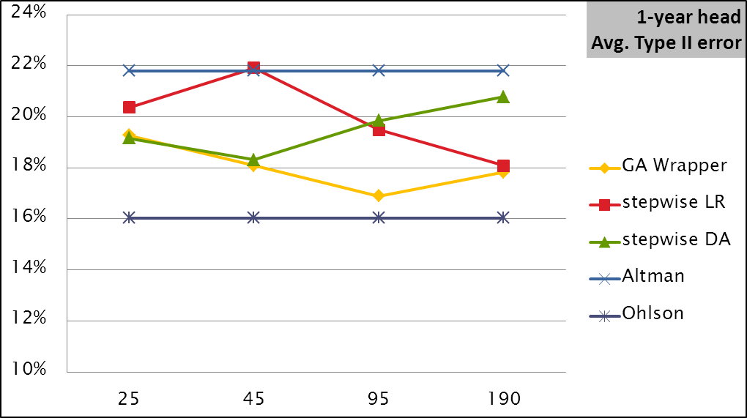

Fig. 15 各特徵挑選方法Type I 與 Type II在預測危機前一年成長情形

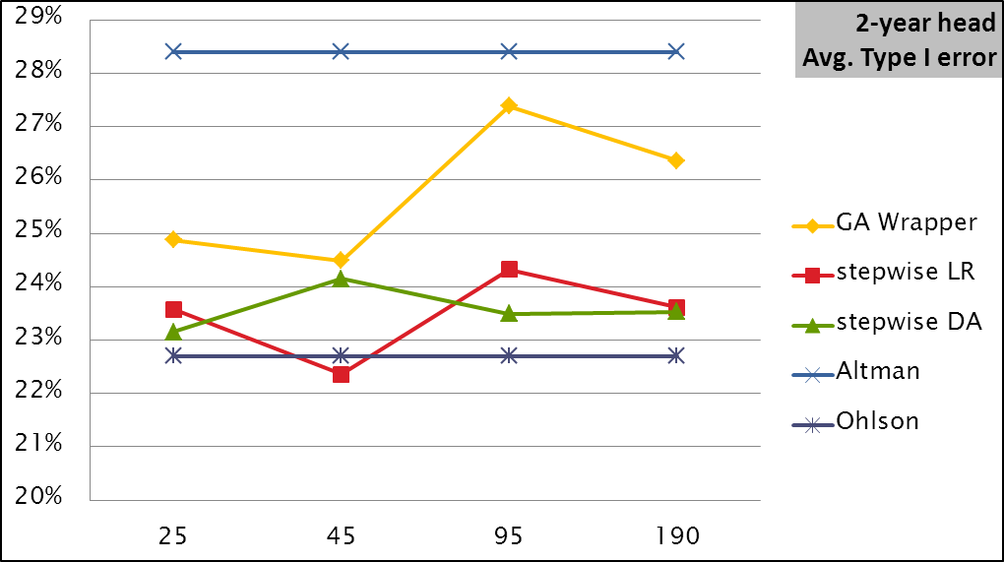 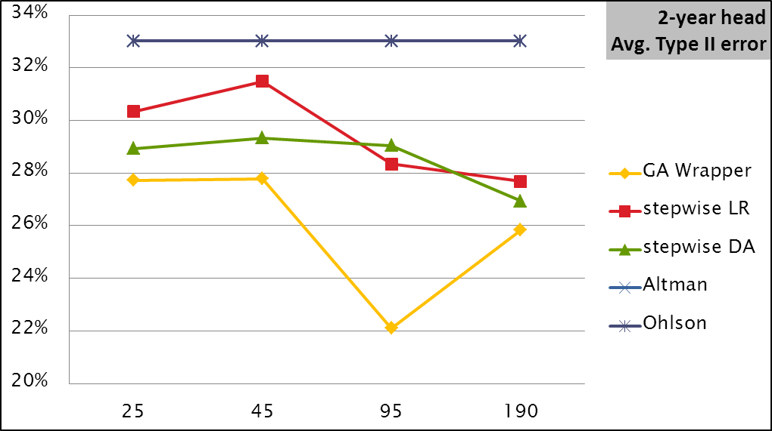

Fig. 16各特徵挑選方法Type I 與 Type II在預測危機前二年成長情形

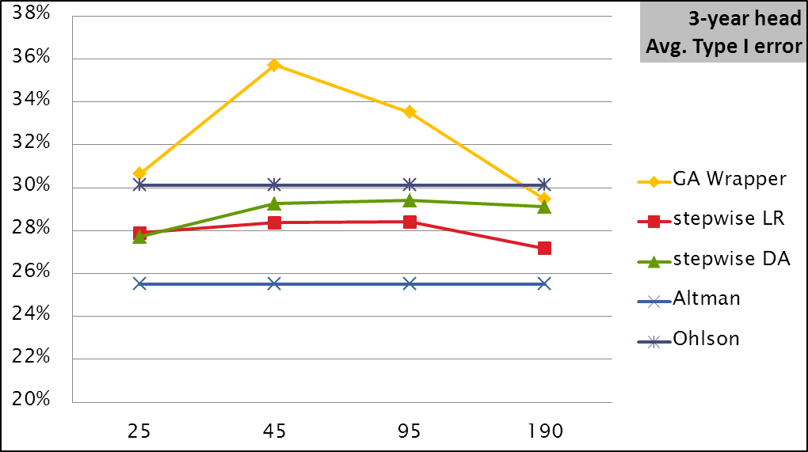 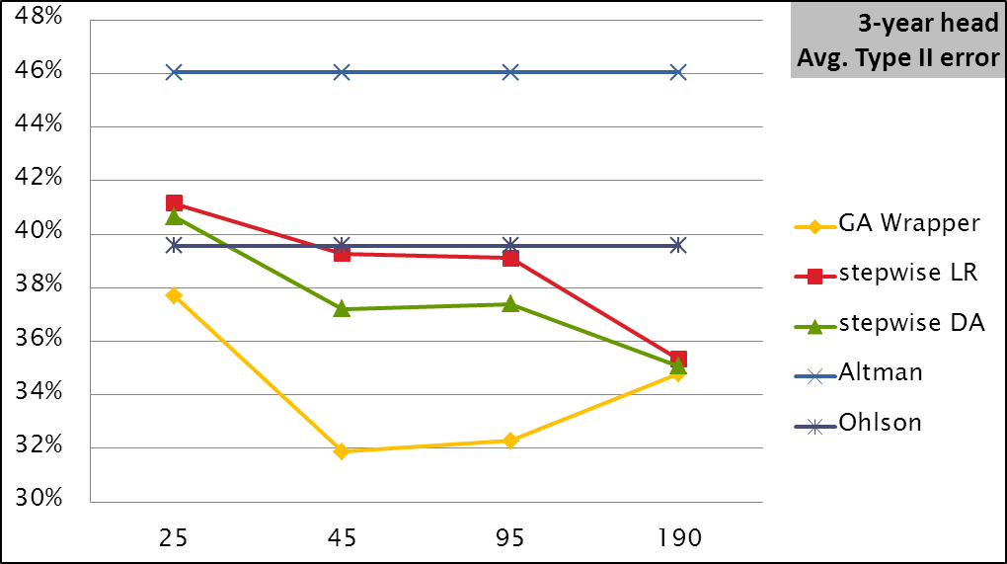

Fig. 17各特徵挑選方法Type I 與 Type II在預測危機前三年成長情形

另一方面，Fig. 15到Fig. 17，我們可以觀察到危機發生前一年，GA Wrapper 四個時期平均type I error rate 並沒有越來越低，但是都能夠優於其他方法，不過在危機發生前兩三年，GA Wrapper 在平均type II error rate 表現反而都優於其他方法，這有可能是因為在前兩年以及前三年危機並不明顯，導致GA Wrapper 在判斷正常公司誤判率低於危機公司。

Table 29. 預測危機前一到三年所使用的公司

|  |  |  |
| --- | --- | --- |
|  | Number of Distressed firms | Number of Non-distressed firms |
| 1-year-ahead | 239 | 239 |
| 2-year-ahead | 236 | 236 |
| 3-year-ahead | 233 | 233 |

GA Wrapper雖然預測效果是優於其他常用的特徵挑選方法，但是我們從Table 30可以看到，整體花費時間是比Stepwise Logistic Regression、Stepwise Discriminant Analysis長許多，而GA Wrapper所花費的時間主要在於搜尋，所以如何縮短搜尋的時間，也是GA Wrapper 可以探討的議題。

Table 30. GA Wrapper 與 Stepwise LR、Stepwise DA執行時間比較

|  |  |
| --- | --- |
|  | time |
| GA Wrapper | 24hr |
| Stepwise Logistic Regression | 0.73hr |
| Stepwise Discriminant Analysis | 0.85hr |

hr: hours

# 結論及未來展望

## 結論與未來展望

財務危機預測長久以來都是一個重要且常被廣泛討論的主題，銀行可以透過財務危機預警系統提供的資訊來輔助決策。經由上述的觀察，在不考慮公司治理情況下，我們發現GA Wrapper在特徵集合越來越大的情況下，能夠穩定優於Stepwise Discriminant Analysis, Stepwise Logistic Regression以及各個專家。

本論文另外發現一點，我們從Fig. 12到Fig. 14，可以看到GA Wrapper 跳動範圍是小於Filter，這意味Filter approach 表現其實是不穩定的，以平均準確率以及type I error rate、穩定度各方面的分析，我們認為GA Wrapper 特徵挑選方法整體而言是優於Filter approach。

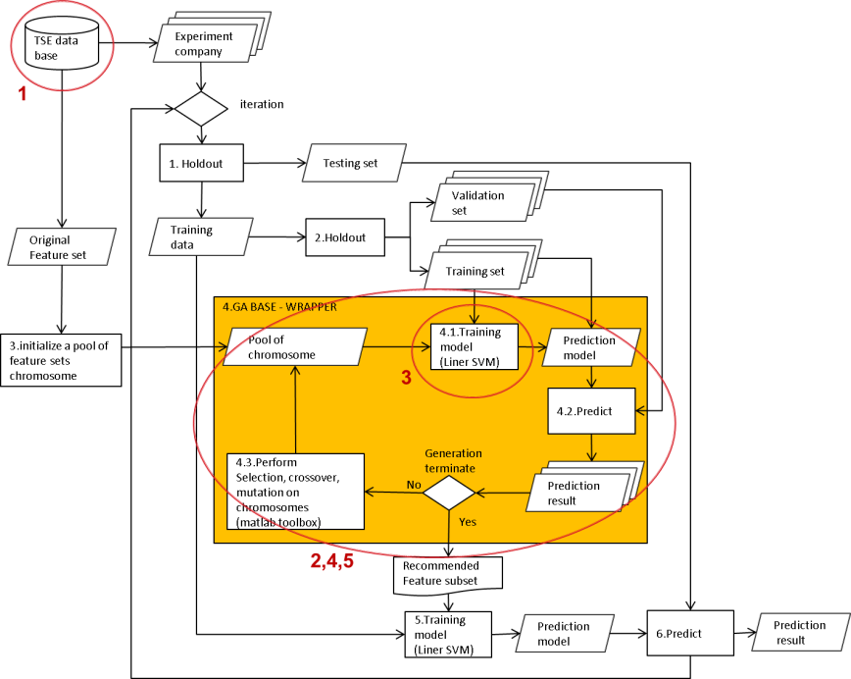

Fig. 18 GA Wrapper 未來可以發展的方向

在本論文研究過程中，還有許多可以進一步發展的方向，Fig. 18。

1. 目前探討GA Wrapper特徵挑選方法，尚未有人做跨國資料集，或許未來可以加入中華人民共合國(The People’s Republic of China P.R.C)的公司資料集;觀察GA Wrapper 在不同會計體制下是否都能夠有不錯的表現。
2. Fig. 12到Fig. 14，我們可以看到Stepwise Discriminant Analysis 在加入公司治理，都有往上提升的表現，或許可以將Stepwise Discriminant Analysis加入GA Wrapper 演算法裡，改善GA Wrapper加入公司治理表現不佳的情形。
3. 驗證GA Wrapper 搭配各種不同的分類器演算法(i.e. SVM, KNN, Neural network) ，是否都有穩定的表現，如果各分類器表現都差不多的話，代表發展出好的特徵挑選演算法對改善財務危機預測影響較大，而搭配的分類器其實影響不大。
4. 本論文目前只有比較傳統filter approach與早期的著名專家，而近年來有許多新的wrapper approach 特徵挑選方法被提出來，像是PSO，或許可以拿來與GA Wrapper比較看看哪一種演算法會有比較好的表現。
5. 由於GA Wrapper 演算法是搜尋出重要的特徵，但是混在這些重要特徵裡的一些沒幫助的特徵GA Wrapper 並無法過濾，未來可以針對GA Wrapper推薦的特徵，設計演算法將不重要的特徵過濾掉。

# 參考文獻

[1] W. H. Beaver, "Financial ratios as predictors of failure," *Journal of accounting research,* vol. 4, pp. 71-111, 1966.

[2] E. I. Altman, "Financial ratios, discriminant analysis and the prediction of corporate bankruptcy," *The journal of finance,* vol. 23, pp. 589-609, 1968.

[3] J. A. Ohlson, "Financial ratios and the probabilistic prediction of bankruptcy," *Journal of accounting research,* vol. 18, pp. 109-131, 1980.

[4] K. Y. Tam and M. Y. Kiang, "Managerial applications of neural networks: the case of bank failure predictions," *Management science,* vol. 38, pp. 926-947, 1992.

[5] M. O. E. Nur Ozkan-Gunay, "Prediction of bank failures in emerging ﬁnancial markets: an ANN approach," *Journal of Risk Finance,* vol. 8, pp. 465 - 480, 2007.

[6] D. K. Chandra, V. Ravi, and I. Bose, "Failure prediction of dotcom companies using hybrid intelligent techniques," *Expert Systems with Applications,* vol. 36, pp. 4830-4837, 2009.

[7] L. H. Chen and H. D. Hsiao, "Feature selection to diagnose a business crisis by using a real GA-based support vector machine: An empirical study," *Expert Systems with Applications,* vol. 35, pp. 1145-1155, 2008.

[8] Y. Ding, X. Song, and Y. Zen, "Forecasting financial condition of Chinese listed companies based on support vector machine," *Expert Systems with Applications,* vol. 34, pp. 3081-3089, 2008.

[9] Z. Hua, Y. Wang, X. Xu, B. Zhang, and L. Liang, "Predicting corporate financial distress based on integration of support vector machine and logistic regression," *Expert Systems with Applications,* vol. 33, pp. 434-440, 2007.

[10] K.-S. Shin, T. S. Lee, and H.-j. Kim, "An application of support vector machines in bankruptcy prediction model," *Expert Systems with Applications,* vol. 28, pp. 127-135, 2005.

[11] C.-H. Wu, G.-H. Tzeng, Y.-J. Goo, and W.-C. Fang, "A real-valued genetic algorithm to optimize the parameters of support vector machine for predicting bankruptcy," *Expert Systems with Applications,* vol. 32, pp. 397-408, 2007.

[12] H. Jo and I. Han, "Integration of case-based forecasting, neural network, and discriminant analysis for bankruptcy prediction," *Expert Systems with Applications,* vol. 11, pp. 415-422, 1996.

[13] H. Li and J. Sun, "Ranking-order case-based reasoning for financial distress prediction," *Knowledge-Based Systems,* vol. 21, pp. 868-878, 2008.

[14] S. Cho, J. Kim, and J. K. Bae, "An integrative model with subject weight based on neural network learning for bankruptcy prediction," *Expert Systems with Applications,* vol. 36, pp. 403-410, 2009.

[15] "台灣經濟新報. Available: <http://www.tej.com.tw/twsite/.>"

[16] M. Blum, "Failing company discriminant analysis," *Journal of Accounting Research,* vol. 12, pp. 1-25, 1974.

[17] P. D. Chant, "On the predictability of corporate earnings per share behavior," *The Journal of Finance,* vol. 35, pp. 13-21, 1980.

[18] E. B. Deakin, "A discriminant analysis of predictors of business failure," *Journal of Accounting Research,* vol. 10, pp. 167-179, 1972.

[19] J. E. Ketz, "The effect of general price-level adjustments on the predictive ability of financial ratios," *Journal of Accounting Research,* vol. 16, pp. 273-284, 1978.

[20] C. Casey and N. Bartczak, "Using Operating Cash Flow Data to Predict Financial Distress: Some Extensions," *Journal of Accounting Research,* vol. 23, pp. 384-401, 1985.

[21] M. J. Gombola, M. E. Haskins, J. E. Ketz, and D. D. Williams, "Cash flow in bankruptcy prediction," *Financial Management,* vol. 16, pp. 55-65, 1987.

[22] C. H. Wu, G. H. Tzeng, Y. J. Goo, and W. C. Fang, "A real-valued genetic algorithm to optimize the parameters of support vector machine for predicting bankruptcy," *Expert Systems with Applications,* vol. 32, pp. 397-408, 2007.

[23] I. Guyon and A. Elisseeff, "An introduction to variable and feature selection," *The Journal of Machine Learning Research,* vol. 3, pp. 1157-1182, 2003.

[24] B. Back, T. Laitinen, and K. Sere, "Neural networks and genetic algorithms for bankruptcy predictions," *Expert Systems with Applications,* vol. 11, pp. 407-413, 1996.

[25] P. W. Huang and C. L. Liu, "Using genetic algorithms for feature selection in predicting financial distresses with support vector machines," in *Systems, Man and Cybernetics, 2006. SMC '06. IEEE International Conference on*, 2006, pp. 4892-4897.

[26] S. H. Min, J. Lee, and I. Han, "Hybrid genetic algorithms and support vector machines for bankruptcy prediction," *Expert Systems with Applications,* vol. 31, pp. 652-660, 2006.

[27] R. S. Sexton, R. S. Sriram, and H. Etheridge, "Improving Decision Effectiveness of Artificial Neural Networks: A Modified Genetic Algorithm Approach," *Decision Sciences,* vol. 34, pp. 421-442, 2003.

[28] "MBA智庫百科. Avaliable: <http://wiki.mbalib.com/wiki/MBA.>"

[29] G. R. Iversen and H. Norpoth, *Analysis of variance*: Sage Publications, Inc, 1987.

[30] K. D. a. M. K, *Logistic regression A self-learning text*, 3 ed. New York Springer, 1994.

[31] J. Sun and H. Li, "Financial distress prediction based on serial combination of multiple classifiers," *Expert Systems with Applications,* vol. 36, pp. 8659-8666, 2009.

[32] A. L. Blum and P. Langley, "Selection of relevant features and examples in machine learning," *Artificial intelligence,* vol. 97, pp. 245-271, 1997.

[33] R. Kohavi and G. H. John, "Wrappers for feature subset selection," *Artificial intelligence,* vol. 97, pp. 273-324, 1997.

[34] Y. Saeys, I. Inza, and P. Larrañaga, "A review of feature selection techniques in bioinformatics," *Bioinformatics,* vol. 23, pp. 2507-2517, 2007.

[35] H. Liu and L. Yu, "Toward integrating feature selection algorithms for classification and clustering," *Knowledge and Data Engineering, IEEE Transactions on,* vol. 17, pp. 491-502, 2005.

[36] J. Kittler, "Feature set search algorithms," *Pattern recognition and signal processing,* vol. 41, p. 60, 1978.

[37] J. H. Holland, *Adaptation in natural and artificial systems*: University of Michigan press, 1975.

[38] M. Srinivas and L. M. Patnaik, "Genetic algorithms: A survey," *Computer,* vol. 27, pp. 17-26, 1994.

[39] "公開觀測資訊站. Available: <http://mops.twse.com.tw/mops/web/index.>"

[40] "Matlab ga tool box. Available: <http://www.mathworks.com/help/toolbox/gads/gaoptimset.html.>"

[41] "SAS toolbox. Available: <http://support.sas.com/documentation/cdl/en/statug/63033/HTML/default/viewer.htm#statug_logistic_sect052.htm.>"

[42] I. G. Dambolena and S. J. Khoury, "Ratio Stability and Corporate Failure," *The Journal of Finance,* vol. 35, pp. 1017-1026, 1980.

[43] K. Y. Tam and M. Y. Kiang, "Managerial Applications of Neural Networks: The Case of Bank Failure Predictions," *Management Science,* vol. 38, pp. 926-947, 1992.

[44] E. I. Altman, R. G. Haldeman, and P. Narayanan, "ZETATM analysis A new model to identify bankruptcy risk of corporations," *Journal of Banking &amp; Finance,* vol. 1, pp. 29-54, 1977.

[45] M. Blum, "Failing Company Discriminant Analysis," *Journal of Accounting Research,* vol. 12, pp. 1-25, 1974.

[46] M. J. Gombola, M. E. Haskins Jr, E. Ketz, and D. D. Williams, "Cash Flow in Bankruptcy Prediction," *Financial Management* vol. 16, pp. 55-65, Winter87 1987.

[47] C. L. N. a. R. E. Smith, "A Comparison of General Price Level and Historical Cost Financial Statements in the Prediction of Bankruptcy," *The Accounting Review,* vol. 54, pp. 72-87, 1979.

[48] H. Li and J. Sun, "Business failure prediction using hybrid2 case-based reasoning (H2CBR)," *Computers &amp; Operations Research,* vol. 37, pp. 137-151, 2010.

# 附錄一

|  |  |  |  |  |  |  |  |
| --- | --- | --- | --- | --- | --- | --- | --- |
| 財務比率 | | 中文 | 英譯 | 財務比率 | | 中文 | 英譯 |
| Solvency | | |  | X49 | 每人配備率 | | Fixed Assets Per Employee |
| X1 | 有息負債利率 | | Cost of Interest-Bearing Debt | X50 | total assets to GNP price | | total assets to GNP price |
| X2 | 現金再投資% | | Cash Reinvestment Ratio | Profitability | | |  |
| X3 | 流動比率 | | Current Ratio | X51 | ROA(C)稅前息前折舊前 | | Return On Total Assets(C) |
| X4 | 速動比率 | | Acid Test | X52 | ROA(A)稅後息前% | | Return On Total Assets(A) |
| X5 | 利息支出率 | | Interest Expense /Total Revenue | X53 | ROA(B)稅後息前折舊前 | | Return On Total Assets(B) |
| X6 | 總負債/總淨值 | | Total Liabilities/Equity Ratio | X54 | 營業毛利率 | | Gross Profit /Net Sales |
| X7 | 負債比率％ | | Liabilities /Total Assets | X55 | 已實現銷貨毛利率 | | Realized Gross Profit /Net Sale |
| X8 | 借款依存度 | | Interest-Bearing Debt /Equity | X56 | 營業利益率 | | Operating Income /Net Sale |
| X9 | 或有負債 /淨值 | | Contingent Liability /Equity | X57 | 稅前淨利率 | | Pre-Tax Income /Net Sale |
| X10 | 營業利益 /實收資本 | | Operating Income/Capital | X58 | 稅後淨利率 | | Net Income /Net Sale |
| X11 | 稅前純益 /實收資本 | | Pretax Income/Capital | X59 | 業外收支 /營收 | | Net Non-operating Income Ratio |
| X12 | working capital to total assets | | working capital to total assets | X60 | 常續利益率 (稅後) | | Net Income -Exclude Disposal Gain or Loss /Net Sale |
| X13 | Quick asset/Total asset | | Quick asset/Total asset | X61 | 近四季常續性EPS | | EPS-Net Income |
| X14 | current assets/total assets | | current assets/total assets | X62 | 每股稅前淨利(元) | | Pretax Income Per Share |
| X15 | cash / total assets | | cash / total assets | X63 | Retained Earnings to Total assets | | Retained Earnings to Total assets |
| X16 | Quick asset/current liabilities | | Quick asset/current liabilities | X64 | total income to total expense | | total income to total expense |
| X17 | cash / current liability | | cash / current liability | X65 | total expense to assets | | total expense to assets |
| X18 | current liability to assets | | current liability to assets | X66 | net income to total assets | | net income to total assets |
| X19 | operating funds to liability | | operating funds to liability | X67 | Gross profit to Sales | | Gross profit to Sales |
| X20 | Inventory/working capital | | Inventory/working capital | X68 | Net income to Equity | | Net income to stockholder's Equity |
| X21 | Inventory/current liability | | Inventory/current liability | X69 | one if net income was negative for the last two year, zero otherwise | | one if net income was negative for the last two year, zero otherwise |
| X22 | current liability / liability | | current liability / liability | Turnover ratios | | |  |
| X23 | working capital/equity | | working capital/equity | X70 | 存貨及應收帳款 /淨值 | | (Inventory +Accounts Receivables) /Equity |
| X24 | current liability/equity | | current liability/equity | X71 | 總資產週轉次數 | | Total Asset Turnover |
| X25 | long-term liability to current assets | | long-term liability to current assets | X72 | 應收帳款週轉次 | | Accounts Receivables Turnover |
| X26 | current liabilities to current assets | | current liabilities to current assets | X73 | 平均收帳天數 | | Days Receivables Outstanding |
| X27 | one if total liabilities exceeds total assets, zero otherwise | | one if total liabilities exceeds total assets,  zero otherwise | X74 | 存貨週轉率 (次) | | Inventory Turnover |
| X28 | equity to liability | | equity to liability | X75 | 固定資產週轉次數 | | Fixed Asset Turnover |
| Capital Structure ratios | | |  | X76 | 淨值週轉率 (次) | | Equity Turnover |
| X29 | 淨值 /資產 | | Equity/Total Assets | X77 | 流動資產周轉率 | | Current assets to sales |
| X30 | 長期資金適合率 (A) | | (Long-term Liability+Equity) /Fixed Assets | X78 | 速動資產周轉率 | | Quick assets to sales |
| X31 | fix assets to assets | | fix assets to assets | X79 | working capital周轉率 | | Working capital to sales |
| X32 | current liability to liability | | current liability to liability | X80 | 現金周轉率 | | Cash to sales |
| X33 | current liability to equity | | current liability to equity | X81 | Cash flow to Sales | | Cash flow to Sales |
| X34 | equity to long-term liability | | equity to long-term liability | X82 | No-credit interval | | No-credit interval |
| X35 | liability to equity | | liability to equity | Cash flow ratios | | |  |
| X36 | Degree of financial leverage | | Degree of financial leverage | X83 | 現金流量比率 | | Cash Flow from Operating /Current Liabilities |
| X37 | Interest coverage ratio | | Interest coverage ratio | X84 | Cash flow to total assets | | Cash flow to total assets |
| Others | | |  | X85 | cash flow to liability | | cash flow to liability |
| X38 | 營業費用率 | | Operating Expenses /Net Sales | X86 | CFO to ASSETS | | CFO to ASSETS |
| X39 | 研究發展費用率 | | (Research and Develope Expense) /Net Sales | X87 | cash flow to equity | | cash flow to equity |
| X40 | 稅率 (A) | | Effective Tax Rate | Growth | | |  |
| X41 | 每股淨值 (B) | | Book Value Per Share(B) | X88 | 已實現銷貨毛利成長率 | | Realized Gross Profit Growth Rate |
| X42 | 每股淨值 (A) | | Book Value Per Share(A) | X89 | 營業利益成長率 | | Operation Income Growth |
| X43 | 每股淨值 (C) | | Book Value Per Share(C) | X90 | 稅後淨利成長率 | | Net Income Growth |
| X44 | 每股現金流量 | | Cash Flow Per Share | X91 | 經常淨利成長率 | | Continuing Operating Income After Tax Growth |
| X45 | 每股營業額(元) | | Sales Per Share | X92 | 常續淨利成長率 | | Net Income -Exclude Disposal Gain or Loss Growth |
| X46 | 每股營業利益(元) | | Operating Income Per Share | X93 | 總資產成長率 | | Total Assets Growth |
| X47 | 每人營收 | | Sales Per Employee | X94 | 淨值成長率 | | Total Equity Growth |
| X48 | 每人營業利益 | | Operation Income Per Employee | X95 | 總資產報酬成長率 | | Return on Total Asset Growth |

|  |  |  |  |  |  |  |  |
| --- | --- | --- | --- | --- | --- | --- | --- |
| Variable | | meaning | 英譯 | Variable | | meaning | 英譯 |
| Corporate governance | | |  |  | | |  |
| X96 | 董監席次 | | Number of seats in board | X146 | 外國董事席次 | | Seats of director foreigner serve |
| X97 | 董事席次 | | Number of directors | X147 | 外國監事席次 | | Seats of supervisor foreigner serve |
| X98 | 監事席次 | | Number of supervisors | X148 | 控制席次 | | Control seats. Seats of director and supervisor the ultimate controller control |
| X99 | 董監持股% | | Shareholding ratio of board | X149 | 董事控制席次 | | Seats of director the ultimate controller control |
| X100 | 董事持股% | | Shareholding ratio of directors | X150 | 監事控制席次 | | Seats of supervisor the ultimate controller control |
| X101 | 監事持股% | | Shareholding ratio of supervisors | X151 | 席次控制% | | X148 / X103 |
| X102 | 大股東持股% | | Shareholding ratio of main shareholders | X152 | 董事席次控制% | | X149 / X103 |
| X103 | 最終控制者個人董事席次 | | Seats of ultimate controller served as individual director | X153 | 監事席次控制% | | X150 / X103 |
| X104 | 最終控制者個人監事席次 | | Seats of ultimate controller served as individual supervisor | X154 | 控制持股% | | Shareholding ratio control by ultimate controller |
| X105 | 集團未上市公司董事席次 | | Seats of director which is served by ultimate controller through unlisted company | X155 | 直接持股% | | X121+X122+X123 |
| X106 | 集團未上市公司監事席次 | | Seats of supervisor which is served by ultimate controller through unlisted company | X156 | 間接持股% | | X124+X125 |
| X107 | 集團基金會董事席次 | | Seats of director which is served by ultimate controller through foundation | X157 | 盈餘分配% | | Cash flow rights of ultimate controller, excluding shares owner by foundation of allied group |
| X108 | 集團基金會監事席次 | | Seats of supervisor which is served by ultimate controller through foundation | X158 | 股份盈餘偏離差 | | X154－X157 |
| X109 | 集團上市公司董事席次 | | Seats of director which is served by ultimate controller through list company | X159 | 盈餘股份偏離比 | | X157 / X154 |
| X110 | 集團上市公司監事席次 | | Seats of supervisor which is served by ultimate controller through list company | X160 | 股份盈餘偏離倍數 | | X154 / X157 |
| X111 | 經理人董事席次 | | Seats of director which is served by company manager or group manager | X161 | 席次盈餘偏離差 | | X151－X157 |
| X112 | 經理人監事席次 | | Seats of supervisor which is served by company manager or group manager | X162 | 盈餘席次偏離比 | | X157 / X151 |
| X113 | 外部個人董事席次 | | Seats of director which is served by outside individual | X163 | 席次盈餘偏離倍數 | | X151 / X157 |
| X114 | 外部個人監事席次 | | Seats of supervisor which is served by outside individual | X164 | 席次股份偏離差 | | X151－X154 |
| X115 | 外部未上市公司董事席次 | | Seats of director which is served by unlisted company not controlled by ultimate controller | X165 | 股份席次偏離比 | | X154 / X151 |
| X116 | 外部未上市公司監事席次 | | Seats of supervisor which is served by unlisted company not controlled by ultimate | X166 | 席次股份偏離倍數 | | X151 / X154 |
| X117 | 外部基金會董事席次 | | Seats of director which is served by foundation not controlled by ultimate controller, | X167 | 董事兼任經理人席次 | | Seats of directors serve as managers |
| X118 | 外部基金會監事席次 | | Seats of supervisor which is served by foundation not controlled by ultimate controller | X168 | 董事兼任占經理人比例 | | X167－X97 |
| X119 | 外部上市公司董事席次 | | Seats of director which is served by list company not controlled by ultimate controller | X169 | 監察人兼任經理人席次 | | Seats of directors serve as managers |
| X120 | 外部上市公司監事席次 | | Seats of supervisor which is served by list company not controlled by ultimate controller | X170 | 監察人兼任占經理人比例 | | X169 / X98 |
| X121 | 最終控制者個人持股% | | Shareholding ratio of ultimate controller through individual | X171 | 友好法人持股% | | Shareholding ratio of alliance juridical person |
| X122 | 集團未上市公司持股% | | Shareholding ratio of ultimate controller through unlisted company | X172 | 友好法人董監持股% | | Shareholding ratio of alliance juridical person who serve director or supervisor |
| X123 | 集團基金會持股% | | Shareholding ratio of ultimate controller through foundation | X173 | 友好法人非董監持股% | | X171－X172 |
| X124 | 集團上市公司持股% | | Shareholding ratio of ultimate controller through list company | X174 | 外部法人持股% | | Shareholding ratio of outside juridical person |
| X125 | 經理人持股% | | Shareholding ratio of company manager and group manager | X175 | 外部法人董監持股% | | Shareholding ratio of outside juridical person who serve director or supervisor |
| X126 | 集團法人持股% | | Shareholding ratio of ultimate controller through juridical person | X176 | 外部法人非董監持股% | | X174－X175 |
| X127 | 集團法人董監持股% | | Shareholding ratio of ultimate controller through juridical person who serve director and supervisor | X177 | 轉投資佔資產% | | Amount of investments in other enterprises divided by stockholder’s equity |
| X128 | 集團法人非董監持股% | | X126－X127 | X178 | 財測次數 | | Number of times financial forecast published in a year |
| X129 | 外部個人持股% | | Shareholding ratio of outside person | X179 | 當年度財報重編次數 | | Number of times the financial report restate in a year |
| X130 | 外部未上市公司持股% | | Shareholding ratio of outside unlisted company | X180 | 3年內CPA異動次數 | | Number of times CPA was switched in the last three years, |
| X131 | 外部基金會持股% | | Shareholding ratio of outside Foundation | X181 | 3年內董事長異動次數 | | Turnover of chairman within 3 years |
| X132 | 外部上市公司持股% | | Shareholding ratio of outside list company | X182 | 3年內總經理異動次數 | | Turnover of CEO within 3 years |
| X133 | 最大外部股東% | | The group the largest outside shareholder belong | X183 | 3年內財務主管異動次 | | Turnover of CFO within 3 years |
| X134 | 最大外部席次 | | Seats of director and supervisor the largest outside shareholder serve | X184 | 3年內發言人異動次數 | | Turnover of spokesman within 3 years |
| X135 | 最大外部董席 | | Seats of director the largest outside shareholder serve | X185 | 3年內內部稽核異動次 | | Turnover of internal audit within 3 years |
| X136 | 最大外部監席 | | Seats of supervisor the largest outside shareholder serve | X186 | 當月董事長異動次數 | | Turnover of chairman within a month |
| X137 | 友好集團持股% | | Shareholding ratio of alliance group | X187 | 當月總經理異動次數 | | Turnover of CEO within a month |
| X138 | 友好集團席次 | | Seats of director and supervisor alliance group serve | X188 | 當月財務主管異動次 | | Turnover of CFO within a month |
| X139 | 友好集團董席 | | Seats of director alliance group serve | X189 | 當月發言人異動次數 | | Turnover of spokesman within a month |
| X140 | 友好集團監席 | | Seats of supervisor alliance group serve | X190 | 當月內部稽核異動次 | | Turnover of internal audit within a month |
| X141 | 獨立董監席次 | | Seats of independent director and supervisor |  |  | |  |
| X142 | 獨立董事席次 | | Seats of independent director |  |  | |  |
| X143 | 獨立監事席次 | | Seats of independent supervisor |  |  | |  |
| X144 | 外國董監持股% | | Shareholding ratio of foreign director and supervisor |  |  | |  |
| X145 | 外國董監席次 | | Seats of director and supervisor foreigner serve |  |  | |  |

# 附錄二

|  |  |
| --- | --- |
| Feature | Reference |
| Return On Total Assets(C) | [1] |
| Return On Total Assets(A) | [1] |
| Return On Total Assets(B) | [1] |
| Gross Profit /Net Sales | [1] |
| Realized Gross Profit /Net Sale | [42] |
| Operating Income /Net Sale | [15] |
| Pre-Tax Income /Net Sale | [15] |
| Net Income /Net Sale | [1] |
| Net Non-operating Income Ratio | [15] |
| Net Income -Exclude Disposal Gain or Loss /Net Sale | [15] |
| Operating Expenses /Net Sales | [15] |
| (Research and Develope Expense) /Net Sales | [15] |
| Cash Flow from Operating /Current Liabilities | [20] |
| Cost of Interest-Bearing Debt | [15] |
| Effective Tax Rate | [15] |
| Book Value Per Share(B) | [15] |
| Book Value Per Share(A) | [15] |
| Book Value Per Share(C) | [15] |
| EPS-Net Income | [17] |
| Cash Flow Per Share | [15] |
| Sales Per Share | [15] |
| Operating Income Per Share | [15] |
| Pretax Income Per Share | [15] |
| Realized Gross Profit Growth Rate | [15] |
| Operation Income Growth | [15] |
| Net Income Growth | [3] |
| Continuing Operating Income After Tax Growth | [3] |
| Net Income -Exclude Disposal Gain or Loss Growth | [15] |
| Total Assets Growth | [15] |
| Total Equity Growth | [15] |
| Return on Total Asset Growth | [43] |
| Cash Reinvestment Ratio | [15] |
| Current Ratio | [1] |
| Acid Test | [1] |
| Interest Expense /Total Revenue | [44] |
| Total Liabilities/Equity Ratio | [45] |
| Liabilities /Total Assets | [1] |
| Equity/Total Assets | [1] |
| (Long-term Liability+Equity) /Fixed Assets | [42] |
| Interest-Bearing Debt /Equity | [15] |
| Contingent Liability /Equity | [15] |
| Operating Income/Capital | [15] |
| Pretax Income/Capital | [15] |
| (Inventory +Accounts Receivables) /Equity | [15] |
| Total Asset Turnover | [2] |
| Accounts Receivables Turnover | [1] |
| Days Receivables Outstanding | [15] |
| Inventory Turnover | [46] |
| Fixed Asset Turnover | [15] |
| Equity Turnover | [1] |
| Sales Per Employee | [15] |
| Operation Income Per Employee | [15] |
| Fixed Assets Per Employee | [15] |
| Number of seats in board | [15] |
| Number of directors | [15] |
| Number of supervisors | [15] |
| Shareholding ratio of board | [15] |
| Shareholding ratio of directors | [15] |
| Shareholding ratio of supervisors | [15] |
| Shareholding ratio of main shareholders | [15] |
| Seats of ultimate controller served as individual director | [15] |
| Seats of ultimate controller served as individual supervisor | [15] |
| Seats of director which is served by ultimate controller through unlisted company | [15] |
| Seats of supervisor which is served by ultimate controller through unlisted company | [15] |
| Seats of director which is served by ultimate controller through foundation | [15] |
| Seats of supervisor which is served by ultimate controller through foundation | [15] |
| Seats of director which is served by ultimate controller through list company | [15] |
| Seats of supervisor which is served by ultimate controller through list company | [15] |
| Seats of director which is served by company manager or group manager | [15] |
| Seats of supervisor which is served by company manager or group manager | [15] |
| Seats of director which is served by outside individual | [15] |
| Seats of supervisor which is served by outside individual | [15] |
| Seats of director which is served by unlisted company not controlled by ultimate controller | [15] |
| Seats of supervisor which is served by unlisted company not controlled by ultimate | [15] |
| Seats of director which is served by foundation not controlled by ultimate controller, | [15] |
| Seats of supervisor which is served by foundation not controlled by ultimate controller | [15] |
| Seats of director which is served by list company not controlled by ultimate controller | [15] |
| Seats of supervisor which is served by list company not controlled by ultimate controller | [15] |
| Shareholding ratio of ultimate controller through individual | [15] |
| Shareholding ratio of ultimate controller through unlisted company | [15] |
| Shareholding ratio of ultimate controller through foundation | [15] |
| Shareholding ratio of ultimate controller through list company | [15] |
| Shareholding ratio of company manager and group manager | [15] |
| Shareholding ratio of ultimate controller through juridical person | [15] |
| Shareholding ratio of ultimate controller through juridical person who serve director and supervisor | [15] |
| X126－X127 | [15] |
| Shareholding ratio of outside person | [15] |
| Shareholding ratio of outside unlisted company | [15] |
| Shareholding ratio of outside Foundation | [15] |
| Shareholding ratio of outside list company | [15] |
| The group the largest outside shareholder belong | [15] |
| Seats of director and supervisor the largest outside shareholder serve | [15] |
| Seats of director the largest outside shareholder serve | [15] |
| Seats of supervisor the largest outside shareholder serve | [15] |
| Shareholding ratio of alliance group | [15] |
| Seats of director and supervisor alliance group serve | [15] |
| Seats of director alliance group serve | [15] |
| Seats of supervisor alliance group serve | [15] |
| Seats of independent director and supervisor | [15] |
| Seats of independent director | [15] |
| Seats of independent supervisor | [15] |
| Shareholding ratio of foreign director and supervisor | [15] |
| Seats of director and supervisor foreigner serve | [15] |
| Seats of director foreigner serve | [15] |
| Seats of supervisor foreigner serve | [15] |
| Control seats. Seats of director and supervisor the ultimate controller control | [15] |
| Seats of director the ultimate controller control | [15] |
| Seats of supervisor the ultimate controller control | [15] |
| X148 / X103 | [15] |
| X149 / X103 | [15] |
| X150 / X103 | [15] |
| Shareholding ratio control by ultimate controller | [15] |
| X121+X122+X123 | [15] |
| X124+X125 | [15] |
| Cash flow rights of ultimate controller, excluding shares owner by foundation of allied group | [15] |
| X154－X157 | [15] |
| X157 / X154 | [15] |
| X154 / X157 | [15] |
| X151－X157 | [15] |
| X157 / X151 | [15] |
| X151 / X157 | [15] |
| X151－X154 | [15] |
| X154 / X151 | [15] |
| X151 / X154 | [15] |
| Seats of directors serve as managers | [15] |
| X167－X97 | [15] |
| Seats of directors serve as managers | [15] |
| X169 / X98 | [15] |
| Shareholding ratio of alliance juridical person | [15] |
| Shareholding ratio of alliance juridical person who serve director or supervisor | [15] |
| X171－X172 | [15] |
| Shareholding ratio of outside juridical person | [15] |
| Shareholding ratio of outside juridical person who serve director or supervisor | [15] |
| X174－X175 | [15] |
| Amount of investments in other enterprises divided by stockholder’s equity | [15] |
| Number of times financial forecast published in a year | [15] |
| Number of times the financial report restate in a year | [15] |
| Number of times CPA was switched in the last three years, | [15] |
| Turnover of chairman within 3 years | [15] |
| Turnover of CEO within 3 years | [15] |
| Turnover of CFO within 3 years | [15] |
| Turnover of spokesman within 3 years | [15] |
| Turnover of internal audit within 3 years | [15] |
| Turnover of chairman within a month | [15] |
| Turnover of CEO within a month | [15] |
| Turnover of CFO within a month | [15] |
| Turnover of spokesman within a month | [15] |
| Turnover of internal audit within a month | [15] |
| working capital to total assets | [1] |
| Quick asset/Total asset | [1] |
| current assets/total assets | [1] |
| cash / total assets | [1] |
| Quick asset/current liabilities | [18] |
| cash / current liability | [18] |
| current liability to assets | [1] |
| operating funds to liability | [19] |
| Inventory/working capital | [42] |
| Inventory/current liability | [42] |
| current liability / liability | [46] |
| working capital/equity | [45] |
| current liability/equity | [14] |
| long-term liability to current assets | [47] |
| Retained Earnings to Total assets | [2] |
| total income to total expense | [4] |
| total expense to assets | [4] |
| Current assets to sales | [1] |
| Quick assets to sales | [1] |
| Working capital to sales | [1] |
| Cash to sales | [1] |
| Cash flow to Sales | [1] |
| fix assets to assets | [48] |
| current liability to liability | [46] |
| current liability to equity | [42] |
| equity to long-term liability | [46] |
| Cash flow to total assets | [1] |
| cash flow to liability | [1] |
| CFO to ASSETS | [20] |
| cash flow to equity | [46] |
| current liabilities to current assets | [1] |
| one if total liabilities exceeds total assets, | [3] |
| net income to total assets | [3] |
| total assets to GNP price | [3] |
| No-credit interval | [1] |
| Gross profit to Sales | [11] |
| Net income to stockholder's Equity | [11] |
| liability to equity | [11] |
| Degree of financial leverage | [11] |
| Interest coverage ratio | [11] |
| one if net income was negative for the last two year, zero otherwise | [3] |
| equity to liability | [11] |

# 附錄三

|  |  |  |  |  |
| --- | --- | --- | --- | --- |
| 危機公司  代號 | 危機公司  名稱 | 危機發生日 | 搭配非危機  公司代號 | 搭配非危機  公司名稱 |
| 1207 | 嘉食化 | 2003/8/29 | 1239 | 味丹 |
| 1212 | 中日 | 2003/9/30 | 1227 | 佳格 |
| 1306 | 合發 | 2001/11/28 | 1316 | 上曜 |
| 1314 | 中石化 | 2001/4/16 | 1312 | 國喬 |
| 1407 | 華隆 | 2001/5/22 | 1434 | 福懋 |
| 1408 | 中紡 | 2001/4/2 | 1409 | 新纖 |
| 1438 | 裕豐 | 2001/8/10 | 1439 | 中和 |
| 1441 | 大東 | 2000/3/28 | 1419 | 新紡 |
| 1449 | 佳和 | 2009/4/20 | 1443 | 立益 |
| 1450 | 新藝 | 2001/8/24 | 1413 | 宏洲 |
| 1456 | 怡華 | 2009/5/27 | 1457 | 宜進 |
| 1462 | 東雲 | 2000/7/11 | 1434 | 福懋 |
| 1466 | 聚隆 | 2001/2/20 | 4401 | 東隆興 |
| 4402 | 福大 | 2009/3/31 | 1463 | 強盛 |
| 4414 | 如興 | 2008/12/31 | 1423 | 利華 |
| 1505 | 楊鐵 | 2000/9/6 | 1512 | 瑞利 |
| 1557 | 金豐 | 2007/6/7 | 1519 | 華城 |
| 1563 | 巧新 | 2009/1/8 | 4526 | 東台 |
| 4503 | 金雨 | 2008/11/30 | 3379 | 彬台 |
| 1602 | 太電 | 2002/9/6 | 1605 | 華新 |
| 1613 | 台一 | 2001/10/22 | 1608 | 華榮 |
| 2007 | 燁興 | 2001/7/5 | 2006 | 東鋼 |
| 2014 | 中鴻 | 2001/7/5 | 2008 | 高興昌 |
| 2023 | 燁輝 | 2001/7/5 | 2010 | 春源 |
| 2025 | 千興 | 2001/10/24 | 2022 | 聚亨 |
| 2028 | 威致 | 2000/10/31 | 2015 | 豐興 |
| 9957 | 燁聯 | 2001/7/5 | 2015 | 豐興 |
| 2517 | 長谷 | 2000/11/30 | 2511 | 太子 |
| 2518 | 長億 | 2000/9/6 | 2501 | 國建 |
| 2521 | 宏總 | 2000/7/29 | 5512 | 力麒 |
| 2528 | 皇普 | 2000/4/28 | 2504 | 國產 |
| 2530 | 華建 | 2001/6/2 | 5522 | 遠雄 |
| 2537 | 聯上發 | 2001/1/12 | 2548 | 華固 |
| 2540 | 金尚昌 | 2000/11/10 | 2526 | 大陸 |
| 2594 | 德利 | 2001/9/6 | 2520 | 冠德 |
| 5502 | 龍田 | 2001/8/28 | 2524 | 京城 |
| 5505 | 和旺 | 2001/4/2 | 5508 | 永信建 |
| 2633 | 高鐵 | 2009/2/6 | 2610 | 華航 |
| 9902 | 台火 | 2003/8/6 | 8916 | 光隆 |
| 2329 | 華泰 | 2003/6/30 | 2363 | 矽統 |
| 2342 | 茂矽 | 2009/2/28 | 2441 | 超豐 |
| 5346 | 力晶 | 2010/11/25 | 2303 | 聯電 |
| 5387 | 茂德 | 2008/12/10 | 2408 | 南科 |
| 2358 | 美格 | 2001/7/28 | 2380 | 虹光 |
| 2475 | 華映 | 2009/3/13 | 3481 | 奇美電 |
| 2491 | 吉祥全 | 2004/8/23 | 3049 | 和鑫 |
| 3051 | 力特 | 2008/9/30 | 8053 | 巨擘 |
| 2429 | 銘旺科 | 2006/8/30 | 1333 | 恩得利 |
| 5321 | 友銓 | 2005/4/20 | 2375 | 智寶 |
| 4303 | 信立 | 2004/2/27 | 1325 | 恒大 |
| 8027 | 鈦昇 | 2008/12/31 | 1541 | 錩泰 |
| 2101 | 南港 | 2000/9/6 | 2103 | 台橡 |
| 2318 | 佳錄 | 2001/9/28 | 5473 | 矽成 |
| 2435 | 台路 | 2001/12/31 | 8193 | 志合 |
| 3065 | 大眾電 | 2008/7/26 | 8172 | 勝開 |
| 3142 | 遠茂 | 2006/1/26 | 3007 | 綠點 |
| 3239 | 帝華 | 2002/6/30 | 6268 | 華普 |
| 3401 | 南曄 | 2007/1/31 | 3283 | 益進 |
| 6193 | 洪氏英 | 2004/11/17 | 5436 | 立生 |
| 8017 | 展茂 | 2007/2/12 | 2319 | 大眾 |
| 2506 | 太設 | 2001/10/16 | 2515 | 中工 |
| 2525 | 寶祥 | 2002/6/30 | 2516 | 新建 |
| 2533 | 昱成 | 2004/2/9 | 5514 | 三豐 |
| 9801 | 力霸 | 2003/8/29 | 2903 | 遠百 |
| 2904 | 匯僑 | 2004/8/17 | 8905 | 裕國 |
| 1718 | 中纖 | 2001/4/24 | 1717 | 長興 |
| 4910 | 陽慶 | 2004/12/30 | 1701 | 中化 |
| 2438 | 英誌 | 2008/7/14 | 2365 | 昆盈 |
| 2333 | 碧悠 | 2005/3/20 | 2489 | 瑞軒 |
| 5432 | 達威 | 2009/3/18 | 3285 | 微端 |
| 6114 | 翔昇 | 2007/5/17 | 1582 | 信錦 |
| 2418 | 雅新 | 2007/4/4 | 2312 | 金寶 |
| 1107 | 建台 | 2000/8/16 | 9941 | 裕融 |
| 1224 | 惠勝 | 2001/4/9 | 1236 | 宏亞 |
| 1458 | 嘉畜 | 2001/6/30 | 1416 | 廣豐 |
| 2407 | 欣煜 | 2005/1/19 | 2366 | 亞旭 |
| 1204 | 津津 | 2005/4/22 | 1213 | 大飲 |
| 4413 | 飛寶 | 2006/5/16 | 4419 | 松懋 |
| 1529 | 樂士 | 2007/3/30 | 1535 | 中宇 |
| 4502 | 源恆 | 2009/10/31 | 1521 | 大億 |
| 1601 | 台光 | 2006/3/20 | 1611 | 中電 |
| 3137 | 瑞積 | 2005/8/10 | 3147 | 大綜電腦 |
| 3184 | 微邦 | 2004/7/30 | 3076 | 亞通 |
| 3364 | 達康網 | 2006/8/22 | 8022 | 正航 |
| 6252 | 艾爾法 | 2005/2/28 | 3366 | 威播 |
| 2538 | 基泰 | 2002/4/29 | 2520 | 冠德 |
| 5213 | 亞昕國際 | 2005/10/28 | 3056 | 總太 |
| 5324 | 士開 | 2006/3/31 | 3056 | 總太 |
| 5506 | 長鴻 | 2008/10/27 | 4416 | 三圓 |
| 5532 | 竟誠建築 | 2006/10/14 | 5519 | 隆大 |
| 2628 | 正利 | 2000/4/5 | 2612 | 中航 |
| 8932 | 宏大 | 2005/10/22 | 2221 | 大甲 |
| 3252 | 海灣科 | 2008/4/21 | 3188 | 安茂 |
| 3397 | 協泰 | 2008/8/25 | 3014 | 聯陽 |
| 6103 | 合邦 | 2008/4/21 | 3169 | 亞信 |
| 6236 | 凌越 | 2006/8/31 | 3122 | 笙泉 |
| 8060 | 力竑 | 2007/4/25 | 3213 | 茂訊 |
| 3099 | 頂倫 | 2008/10/24 | 8924 | 鉅祥 |
| 5301 | 祥裕 | 2005/4/15 | 1333 | 恩得利 |
| 6174 | 安碁 | 2006/4/17 | 2059 | 川湖 |
| 6242 | 亨豐科 | 2008/10/29 | 3309 | 拓洋 |
| 6111 | 大宇資 | 2007/4/10 | 3085 | 久大 |
| 1805 | 寶徠 | 2009/3/31 | 3056 | 總太 |
| 2024 | 志聯 | 2001/8/28 | 1532 | 勤美 |
| 2335 | 清三 | 2004/3/12 | 3222 | 奇景 |
| 2341 | 英群 | 2008/10/31 | 2417 | 圓剛 |
| 2348 | 力廣 | 2009/8/21 | 3224 | 三顧 |
| 2410 | 鼎大 | 2006/8/31 | 8172 | 勝開 |
| 2494 | 廣業科 | 2004/4/15 | 3091 | 友傳 |
| 2496 | 卓越 | 2005/10/28 | 6263 | 普萊德 |
| 3018 | 同開 | 2007/4/26 | 2591 | 高逸 |
| 3096 | 碩良 | 2007/4/26 | 8157 | 宏麗 |
| 3159 | 彩華科 | 2001/4/21 | 6256 | 華傑 |
| 3328 | 亞微電 | 2005/8/23 | 2389 | 世昕 |
| 4118 | 友合生技 | 2005/3/12 | 1732 | 毛寶 |
| 4404 | 百成行 | 2003/4/17 | 1413 | 宏洲 |
| 4801 | 高盛電 | 2007/4/25 | 1809 | 中釉 |
| 4907 | 春雨開 | 2010/3/22 | 3166 | 偉僑 |
| 5204 | 得捷 | 2005/4/22 | 3346 | 麗清 |
| 5206 | 坤悅 | 2009/4/27 | 5209 | 新鼎 |
| 5310 | 天剛 | 2007/3/29 | 6140 | 訊達 |
| 5318 | 佳鼎 | 2006/8/28 | 8193 | 志合 |
| 5372 | 十美 | 2003/4/21 | 3091 | 友傳 |
| 5376 | 東正元 | 2004/10/26 | 8014 | 宏廣 |
| 5392 | 應華 | 2004/4/7 | 8266 | 中日新 |
| 5395 | 圓方 | 2006/1/16 | 3441 | 聯一光 |
| 5414 | 磐英 | 2006/7/25 | 3002 | 歐格 |
| 5467 | 聯福生 | 2005/8/18 | 3209 | 全科 |
| 5520 | 力泰 | 2005/10/28 | 2577 | 亞昕 |
| 6162 | 鴻源科 | 2005/4/20 | 3214 | 元砷 |
| 6238 | 勝麗 | 2007/4/24 | 8281 | 歐普羅 |
| 6241 | 易通展 | 2005/8/23 | 3163 | 波若威 |
| 6294 | 智基科 | 2006/10/30 | 2466 | 冠西電 |
| 8028 | 昇陽 | 2008/8/28 | 2436 | 偉詮電 |
| 8061 | 東聖科 | 2005/8/23 | 3117 | 年程 |
| 8130 | 聯達電 | 2008/4/26 | 8089 | 康全 |
| 8276 | 連邦 | 2007/8/30 | 8361 | 金協昌 |
| 8724 | 立大 | 2000/4/25 | 1219 | 福壽 |
| 8929 | 富堡 | 2005/8/19 | 8906 | 花王 |
| 8934 | 衡平 | 2005/8/26 | 9949 | 琉園 |
| 9936 | 欣錩 | 2004/10/21 | 8924 | 大田 |
| 1209 | 益華 | 2000/3/23 | 1218 | 泰山 |
| 1221 | 久津 | 2003/3/10 | 1702 | 南僑 |
| 1228 | 臺芳 | 2003/12/1 | 4207 | 環泰 |
| 1491 | 東榮工 | 2001/5/28 | 1474 | 弘裕 |
| 1606 | 歌林 | 2008/7/30 | 1604 | 聲寶 |
| 2058 | 彥武 | 2000/10/13 | 2008 | 高興昌 |
| 2512 | 寶建 | 2002/4/16 | 2536 | 宏普 |
| 2523 | 德寶 | 2006/4/28 | 3214 | 元砷 |
| 2569 | 開立 | 2006/9/4 | 1515 | 力山 |
| 2613 | 中櫃 | 2000/11/7 | 6701 | 達和 |
| 3021 | 衛展 | 2004/7/26 | 5478 | 智冠 |
| 3350 | 邰港 | 2008/11/10 | 4126 | 太醫 |
| 4113 | 聯上 | 2004/8/23 | 9946 | 金革 |
| 4424 | 民興 | 2000/9/6 | 1413 | 宏洲 |
| 5008 | 長銘 | 2000/10/23 | 2006 | 東鋼 |
| 5011 | 久陽 | 2002/9/5 | 2033 | 佳大 |
| 5017 | 新泰伸 | 2007/8/1 | 1532 | 勤美 |
| 5503 | 榮美開發 | 2001/7/18 | 2509 | 全坤建 |
| 5504 | 信南 | 2000/9/17 | 5514 | 三豐 |
| 5529 | 志嘉 | 2008/12/31 | 5530 | 龍巖 |
| 5605 | 遠航 | 2008/2/5 | 2617 | 台航 |
| 6149 | 禾鴻 | 2008/6/18 | 3086 | 華義 |
| 8094 | 卓立 | 2007/12/30 | 3025 | 星通 |
| 9906 | 興達 | 2000/10/27 | 9905 | 大華 |
| 1534 | 新企 | 2004/9/24 | 1525 | 江申 |
| 1585 | 鎧鉅 | 2008/11/7 | 3092 | 鴻碩 |
| 2326 | 亞瑟 | 2001/12/21 | 2394 | 普立爾 |
| 2334 | 國豐 | 2000/9/6 | 5343 | 矽豐 |
| 2479 | 和立 | 2005/10/14 | 8235 | 華亞 |
| 2490 | 皇統 | 2004/9/15 | 5473 | 矽成 |
| 3001 | 協和 | 2004/3/5 | 6157 | 一等 |
| 3039 | 宏傳 | 2005/1/24 | 8218 | 輝城 |
| 3053 | 鼎營 | 2003/4/26 | 2487 | 友立資 |
| 3179 | 華科 | 2006/11/28 | 6299 | 文麥 |
| 3190 | 新典 | 2007/11/15 | 3346 | 麗清 |
| 3258 | 誠洲 | 2001/7/28 | 2301 | 光寶科 |
| 3348 | 中華聯 | 2007/2/16 | 8219 | 光林電子 |
| 3369 | 鐵研 | 2008/9/15 | 3193 | 億力光電 |
| 3469 | 銓祐科 | 2008/11/6 | 8218 | 輝城 |
| 4304 | 勝昱 | 2006/7/6 | 3193 | 億力光電 |
| 4415 | 美嘉電 | 2011/9/7 | 3064 | 泰偉 |
| 5207 | 飛雅 | 2004/8/27 | 3270 | 威瀚 |
| 5307 | 耀文 | 2003/4/25 | 2366 | 亞旭 |
| 5313 | 皇旗 | 2000/9/6 | 2310 | 旭麗 |
| 5336 | 華特 | 2001/11/10 | 2544 | 益鼎光電 |
| 5385 | 瑩寶 | 2001/11/3 | 3007 | 綠點 |
| 6110 | 艾群 | 2007/10/26 | 2471 | 資通 |
| 6130 | 基因 | 2008/8/11 | 3530 | 晶相光 |
| 6132 | 銳普 | 2005/8/1 | 3270 | 威瀚 |
| 6137 | 新寶科 | 2005/9/26 | 2422 | 國聯 |
| 6232 | 仕欽 | 2008/6/20 | 2319 | 大眾 |
| 6249 | 蕃薯網 | 2005/12/16 | 8012 | 琭旦 |
| 6262 | 鼎太國際 | 2006/2/15 | 6297 | 祥德 |
| 8031 | 鉅業 | 2004/8/27 | 3185 | 廣鵬科技 |
| 8106 | 寰訊 | 2006/8/31 | 3355 | 美錡 |
| 8380 | 實健 | 2002/10/31 | 1435 | 中福 |
| 8720 | 元富 | 2001/3/26 | 1514 | 亞力 |
| 8722 | 尚德 | 2001/10/26 | 1233 | 天仁 |
| 8910 | 五洲 | 2001/1/31 | 1435 | 中福 |
| 1203 | 味王 | 2000/7/24 | 1210 | 大成 |
| 1206 | 台鳳 | 2000/5/5 | 1239 | 味丹 |
| 1222 | 源益 | 2000/11/2 | 1220 | 台榮 |
| 1225 | 福懋油 | 2000/9/7 | 1232 | 大統益 |
| 1707 | 葡萄王 | 2000/10/26 | 1731 | 美吾華 |
| 1806 | 冠軍 | 2000/4/19 | 1809 | 中釉 |
| 2019 | 桂宏 | 2000/9/16 | 2012 | 春雨 |
| 2206 | 三陽 | 2000/12/31 | 2207 | 和泰 |
| 2527 | 宏璟 | 2000/12/27 | 2536 | 宏普 |
| 2714 | 華國 | 2000/9/5 | 5701 | 劍湖山 |
| 2902 | 中信 | 2000/11/23 | 2908 | 特力 |
| 6702 | 復航 | 2000/11/25 | 2614 | 東森 |
| 1414 | 東和 | 2001/12/7 | 1455 | 集盛 |
| 5518 | 大日 | 2001/8/23 | 5511 | 德昌 |
| 2913 | 農林 | 2003/9/2 | 2912 | 統一超 |
| 5347 | 世界 | 2003/4/24 | 2454 | 聯發科 |
| 1464 | 得力 | 2004/6/25 | 1454 | 台富 |
| 3004 | 豐達科 | 2004/9/23 | 2031 | 新光鋼 |
| 1432 | 大魯閣 | 2005/4/4 | 1418 | 東華 |
| 1459 | 聯發 | 2005/11/25 | 1417 | 嘉裕 |
| 3295 | 宇極 | 2005/3/17 | 3217 | 優群科 |
| 2017 | 官田鋼 | 2000/7/27 | 2029 | 盛餘 |
| 8718 | 工礦 | 2000/11/23 | 5903 | 全家 |
| 1807 | 羅馬 | 2002/1/8 | 1809 | 中釉 |
| 5304 | 鼎創達 | 2002/6/6 | 2498 | 宏達電 |
| 5702 | 統合 | 2002/11/5 | 2706 | 第一店 |
| 8007 | 商合行 | 2002/8/31 | 5494 | 德鑫 |
| 5348 | 系通 | 2003/9/9 | 4908 | 前鼎 |
| 6145 | 勁永 | 2003/8/15 | 2425 | 承啟 |
| 2398 | 博達 | 2004/6/15 | 2416 | 世平 |
| 5325 | 大騰 | 2004/12/23 | 2366 | 亞旭 |
| 5364 | 浩騰 | 2004/8/24 | 3003 | 健和興 |
| 6250 | 宇加 | 2004/8/21 | 3207 | 耀勝 |
| 2396 | 精碟 | 2008/8/4 | 2340 | 光磊 |
| 3144 | 新揚科 | 2008/7/22 | 8022 | 正航 |
| 6101 | 弘捷 | 2009/2/16 | 2462 | 良得電 |
| 3084 | 光威 | 2005/5/5 | 8058 | 耐特 |
| 4532 | 瑞智 | 2005/1/10 | 1523 | 開億 |
| 6181 | 宇詮 | 2005/1/3 | 6178 | 振遠 |