**Workcase1**

**Yaroslav and Oleksandr**

**РПЗ-93а**

1. GitHub is a code hosting platform for version control and collaboration. It lets you and others work together on projects from anywhere. It is used to collectively perform a specific task. It allows write certain pieces of code to each participant.
2. To perform the work, each team member created his personal account on the platform https://github.com/. A separate repository has been created to discuss work in the discipline of operating systems.



Oleksandr`s account

Yaroslav`s account

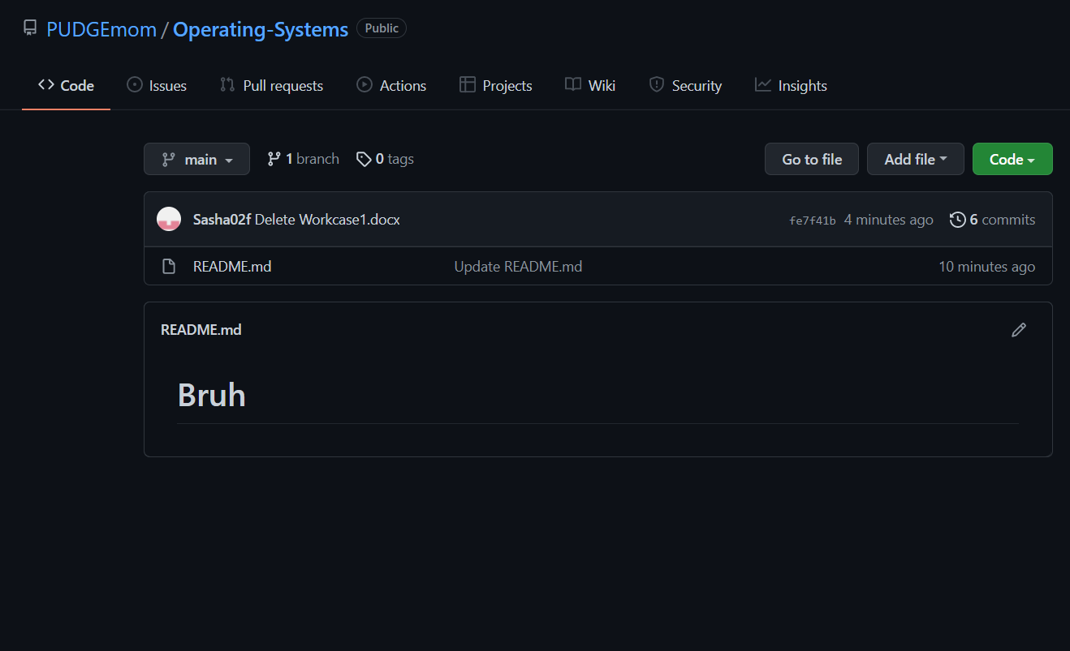

Screenshot of our repository