**Topics: Descriptive Statistics and Probability**

1. **\*\*Look at the data given below. Plot the data, find the outliers and find out $μ, σ, σ^{2}$**

|  |  |
| --- | --- |
| **Name of company** | **Measure X** |
| **Allied Signal** | **24.23%** |
| **Bankers Trust** | **25.53%** |
| **General Mills** | **25.41%** |
| **ITT Industries** | **24.14%** |
| **J.P.Morgan& Co.** | **29.62%** |
| **Lehman Brothers** | **28.25%** |
| **Marriott** | **25.81%** |
| **MCI** | **24.39%** |
| **Merrill Lynch** | **40.26%** |
| **Microsoft** | **32.95%** |
| **Morgan Stanley** | **91.36%** |
| **Sun Microsystems** | **25.99%** |
| **Travelers** | **39.42%** |
| **US Airways** | **26.71%** |
| **Warner-Lambert** | **35.00%** |

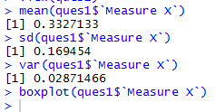

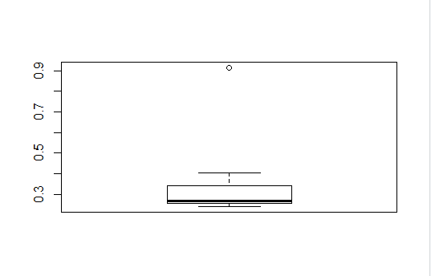



**Answer the following three questions based on the box-plot above.**

1. **What is inter-quartile range of this dataset? (please approximate the numbers) In one line, explain what this value implies.**

Ans 5-9

1. **What can we say about the skewness of this dataset?**

Ans 7-12

1. **If it was found that the data point with the value 25 is actually 2.5, how would the new box-plot be affected?**

**Ans:**



**Answer the following three questions based on the histogram above.**

1. **Where would the mode of this dataset lie?**

Ans21

1. **Comment on the skewness of the dataset.**

Ans Positive skewness skewness is right side

1. **Suppose that the above histogram and the box-plot in question 2 are plotted for the same dataset. Explain how these graphs complement each other in providing information about any dataset.**

**Ans: above graph is normal distribution.**

**4 AT&T was running commercials in 1990 aimed at luring back customers who had switched to one of the other long-distance phone service providers. One such commercial shows a businessman trying to reach Phoenix and mistakenly getting Fiji, where a half-naked native on a beach responds incomprehensibly in Polynesian. When asked about this advertisement, AT&T admitted that the portrayed incident did not actually take place but added that this was an enactment of something that “could happen.” Suppose that one in 200 long-distance telephone calls is misdirected. What is the probability that at least one in five attempted telephone calls reaches the wrong number? (Assume independence of attempts.)**

**One wrong number out of 200**

**Prob. Is= 1/200=0.005**

**Prob. All five telephone call is wrong=1-p(wrong)*5**

**=1-0.005*5**

**=0.975**

**Prob at least one in five wrong=1-0.975**

**=0.024**

**5 Returns on a certain business venture, to the nearest $1,000, are known to follow the following probability distribution**

|  |  |
| --- | --- |
| **x** | **P(x)** |
| **-2,000** | **0.1** |
| **-1,000** | **0.1** |
| **B 0** | **0.2** |
| **1000** | **0.2** |
| **2000** | **0.3** |
| **3000** | **0.1** |

1. **What is the most likely monetary outcome of the business venture?**

0.3

1. **Is the venture likely to be successful? Explain**

Yes, because positive probability is grater then Negtive probability

1. **What is the long-term average earning of business ventures of this kind? Explain**

-2000*0.1+(-1000*0.1)+0*0.2+1000*0.2+2000*0.3+3000*0.1

=800

**6) What is the good measure of the risk involved in a venture of this kind? Compute this measure**

**ans sd=**0.081