**ELECTROCARDIOGRAPHY**

**INTRODUCTION**

Electrocardiography (ECG or EKG[a]) is the process of recording the electrical activity of the heart over a period of time using electrodes placed on the skin. These electrodes detect the tiny electrical changes on the skin that arise from the heart muscle's electrophysiologic pattern of depolarizing and repolarizing during each heartbeat. It is a very commonly performed cardiology test.

Electrocardiography

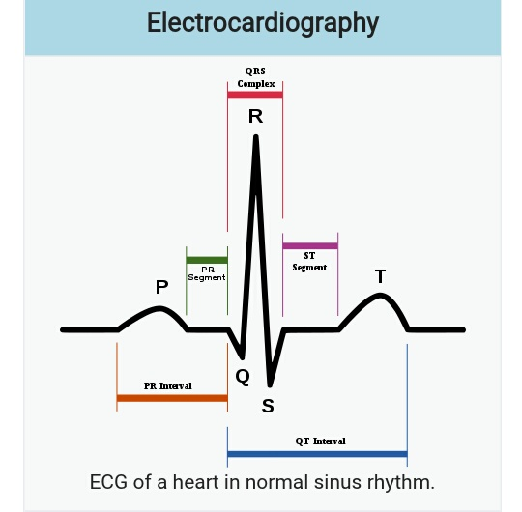

ECG of a heart in normal sinus rhythm.

ICD-10-PCS R94.31

ICD-9-CM 89.52

In a conventional 12-lead ECG, ten electrodes are placed on the patient's limbs and on the surface of the chest. The overall magnitude of the heart's electrical potential is then measured from twelve different angles ("leads") and is recorded over a period of time (usually ten seconds). In this way, the overall magnitude and direction of the heart's electrical depolarization is captured at each moment throughout the cardiac cycle.[4] The graph of voltage versus time produced by this noninvasive medical procedure is referred to as an electrocardiogram.

During each heartbeat, a healthy heart has an orderly progression of depolarization that starts with pacemaker cells in the sinoatrial node, spreads out through the atrium, passes through the atrioventricular node down into the bundle of His and into the Purkinje fibers, spreading down and to the left throughout the ventricles. This orderly pattern of depolarization gives rise to the characteristic ECG tracing. To the trained clinician, an ECG conveys a large amount of information about the structure of the heart and the function of its electrical conduction system.[5] Among other things, an ECG can be used to measure the rate and rhythm of heartbeats, the size and position of the heart chambers, the presence of any damage to the heart's muscle cells or conduction system, the effects of cardiac drugs, and the function of implanted pacemakers.

**PROGRAM**

%%Calculate HR

close all; clear all; clc;

fs = 100 % find the sampling rate or frequency

T = 1/fs;% sampling rate or frequency

window = 120; % 2 min 0r 120 second

%%Select a filename in .mat format and load the file.

fignum = 0;

hr_sig=load('I:\ECG\a01m.mat') % contains hr_sig and fs

hr_sig=hr_sig.val;

% Make time axis for ECG signal

tx = [0:length(hr_sig)-1]/fs;

fignum = fignum + 1;

figure(fignum)

plot(tx,hr_sig)

xlabel('Time (s)')

ylabel('Amplitude (mV)')

title('ECG signal')

xlim([21,31]) % Used to zoom in on single ECG waveform

disp('Contents of workspace after loading file:')

%whos

%% copy the data and put into excel

y1=hr_sig(1:600*fs);

% find the length of the data per second

N = length(y1);

ls = size(y1);

t = (0 : N-1) / fs;% sampling period

fignum = fignum + 1; %% keep track of figures

figure(fignum)

plot(t,y1);

title ('plot of the original of ECG signal')

xlabel ('time (sec)')

ylabel ('Amplitute (mv)')

grid on;

%% find PP interval

i = 0; %% to make the code start from 0.

rr = 0; %% each time the code run, rr distance two peaks

hold off % for the next graph

rrinterval = zeros(3600,1); % create an array to strore 2 peaks

beat_count =0;

for k = 2 : length(y1)-1

%the peak has to be greater than 1 and greater than the value before it and greater then the value after it.

if(y1(k)> y1(k-1) && y1(k) > y1(k+1) && y1(k)> 1);

beat_count = beat_count +1;

if beat_count ==1;

rr =0;

else

rr = k-i;

rrinterval(k)=rr;

i=k;

end

else

rrinterval(k)= rr;

end

end

%% heart rate analysis

% count the dominat peak

beat_count =0;

for k = 2 : length(y1)-1

%the peak has to be greater than 1 and greater than the value before it and greater then the value after it.

if(y1(k)> y1(k-1) && y1(k) > y1(k+1) && y1(k)> 200)

beat_count = beat_count +1;

end

end

display (k);

disp('dominant peaks');

%% this section is calculate heart rate of the ECG

%% divide the peak count by the duration in minute

duration_in_sec = N/fs;

duration_in_minute = duration_in_sec/60;

BPM = beat_count/duration_in_minute; %% this is calculation heart rate

msgbox(strcat('Heart-rate is = ',mat2str(BPM),' BPM'));

%Compute the spectrum of the ECG

%b) Compute the spectrum of the ECG and provide remarks on the spectral features of the ECG ( see reference “ECG Statistics, Noise, Artifacts, and Missing Data”).

%%% DFT to describe the signal in the frequency

NFFT = 2 ^ nextpow2(N);

Y = fft(y1, NFFT) / N;

f = (fs / 2 * linspace(0, 1, NFFT / 2+1))'; % Vector containing frequencies in Hz

amp = ( 2 * abs(Y(1: NFFT / 2+1))); % Vector containing corresponding amplitudes

figure;

plot (f, amp);

title ('plot single-sided amplitude spectrume of the ECG signal');

xlabel ('frequency (Hz)');

ylabel ('|y(f)|');

grid on;

figure;

psdest = psd(spectrum.periodogram,y1,'fs',fs);

plot(psdest)

title ('plot single-sided PSD of the ECG signal');

xlabel ('frequency (Hz)');

ylabel ('|y(f)|');

grid on;

% figure;

% psdest1 = psd(spectrum.periodogram,y1,'NFFT',length(y1),'Fs',fs);

% [psdest1, Fx] = pwelch(y1,[],[],1024,fs);

% plot(psdest1)

% avgpower(psdest1,[58,62]);

% title ('plot single-sided PSD of the ECG signal')

% xlabel ('frequency (Hz)');

% ylabel ('|y(f)|');

% grid on;

max_value=max(y1);

mean_value=mean(y1);

threshold=(max_value-mean_value)/2;

%% create a subset to zoom into the signal make easy to verify mark position

y1_1500 = y1(1:1850);

t2 = 1:length(y1_1500);

figure;

plot(t2,y1_1500);

title ('plot of subset of the ECG signal')

xlabel ('time (msec)')

ylabel ('Amplitute (mv)')

grid on

%c) Write code to automatically detect the various features of the ECG (PQRST) and use that to mark the ECG waveform features

%% used the snip code from this website.

%%%%http://www.mathworks.com/help/signal/examples/peak-analysis.html

%Detrending Data

%The above signal shows a baseline shift and therefore does not represent the true amplitude. In order to remove the trend, fit a low order polynomial to the signal and use the polynomial to detrend it.

[p,s,mu] = polyfit((1:numel(y1_1500)),y1_1500,6);

f_y = polyval(p,(1:numel(y1_1500)),[],mu);

ECG_data = y1_1500 - f_y; % Detrend data

N1= length (y1_1500);

t1 = (0 : N1-1) / fs;% sampling period

figure

%plot(t1,ECG_data); grid on

plot(t2,ECG_data); grid on

ax = axis; axis([ax(1:2) -2.2 2.2])

%ax = axis; axis([ax(1:2) -3.2 3.2])

title('Detrended ECG Signal')

xlabel('time msec'); ylabel('Voltage(mV)')

legend('Detrended ECG Signal')

%Thresholding to Find Peaks of Interest

%The QRS-complex consists of three major components: Q-wave, R-wave, S-wave. The R-waves can be detected by thresholding peaks above 0.5mV. Notice that the R-waves are separated by more than 200 samples. Use this information to remove unwanted peaks by specifying a 'MinPeakDistance'.

[~,locs_Rwave] = findpeaks(ECG_data,'MinPeakHeight',0.5,'MinPeakDistance',120);

%Finding Local Minima in Signal

%Local minima can be detected by finding peaks on an inverted version of the original signal.

ECG_inverted = -ECG_data;

[~,locs_Swave] = findpeaks(ECG_inverted,'MinPeakHeight',0.4,'MinPeakDistance',120);

%The following plot shows the R-waves and S-waves detected in the signal.

figure

hold on

plot(t2,ECG_data);

plot(locs_Rwave,ECG_data(locs_Rwave),'rv','MarkerFaceColor','r');

plot(locs_Swave,ECG_data(locs_Swave),'rs','MarkerFaceColor','b');

%axis([0 1850 -1.1 1.1]); grid on;

axis([0 1850 -2.2 2.2]); grid on;

legend('ECG Signal','R-waves','S-waves');

xlabel('time msec'); ylabel('Voltage(mV)')

title('R-wave and S-wave in ECG Signal')

[~,locs_Twave] = findpeaks(ECG_data,'MinPeakHeight',-0.02,'MinPeakDistance',40);

%% The following code detect and mark T

figure;

hold on

plot(t2,ECG_data);

plot(locs_Twave,ECG_data(locs_Twave),'X','MarkerFaceColor','y');

plot(locs_Rwave,ECG_data(locs_Rwave),'rv','MarkerFaceColor','r');

plot(locs_Swave,ECG_data(locs_Swave),'rs','MarkerFaceColor','b');

grid on

title('Thresholding Peaks in Signal')

xlabel('time msec'); ylabel('Voltage(mV)')

ax = axis; axis([0 1850 -2.2 2.2])

legend('ECG signal','T-wave','R-wave','S-wave');

**OUTPUT**

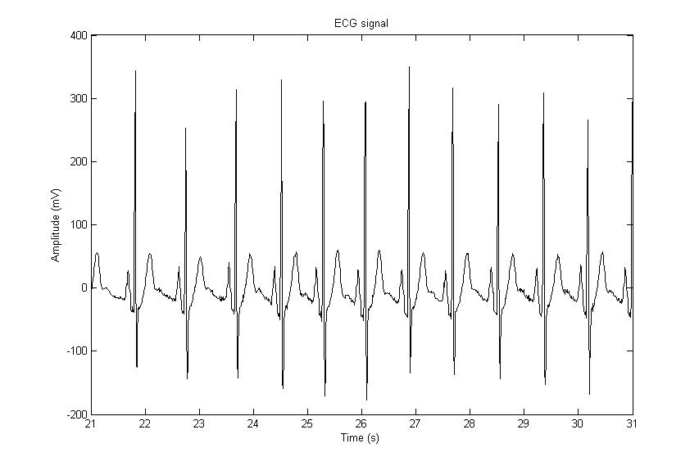

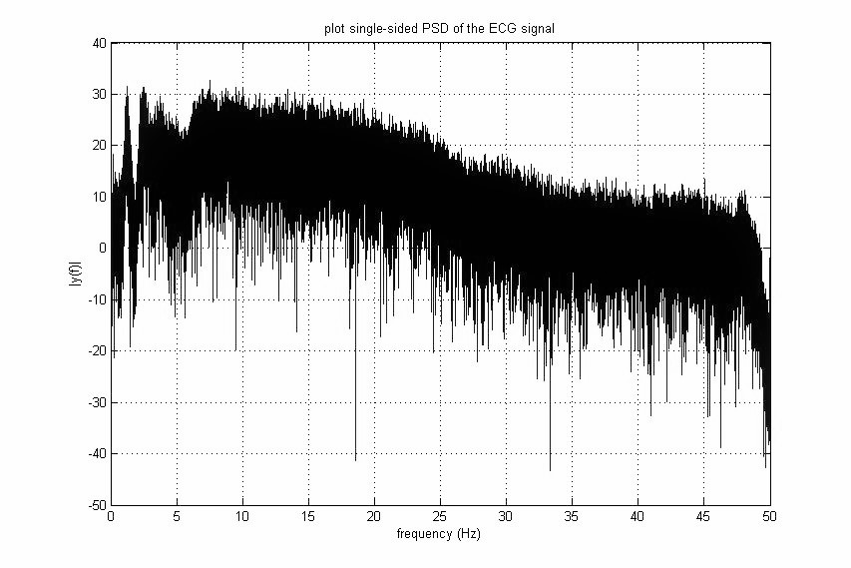

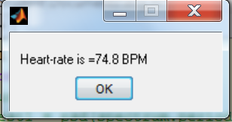

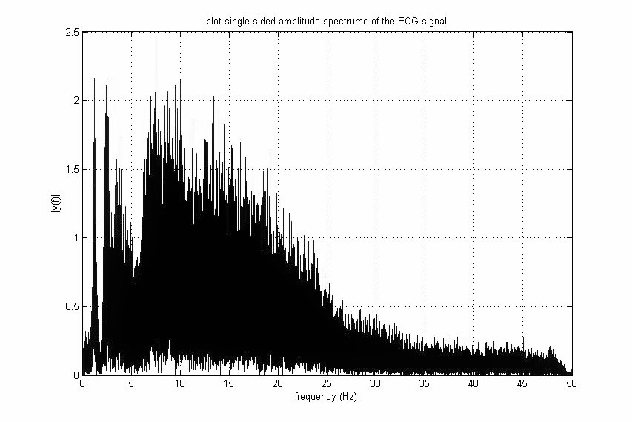

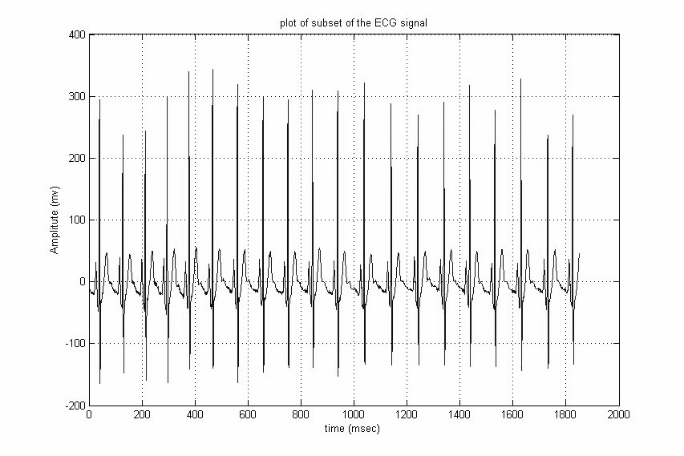

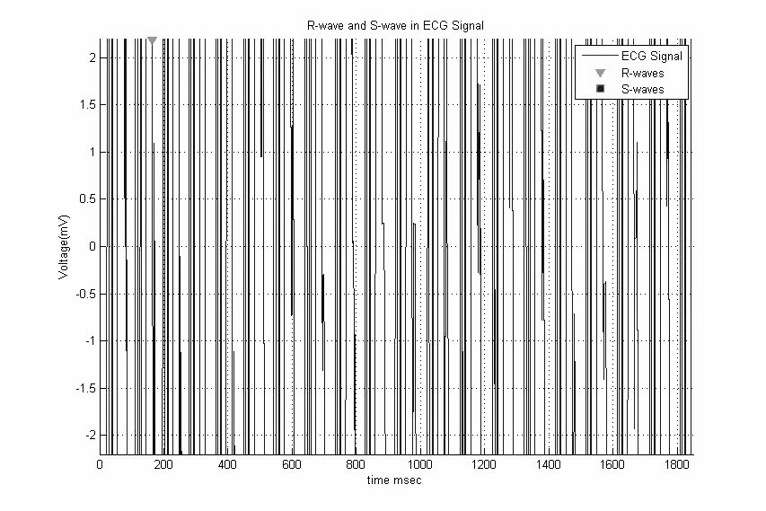

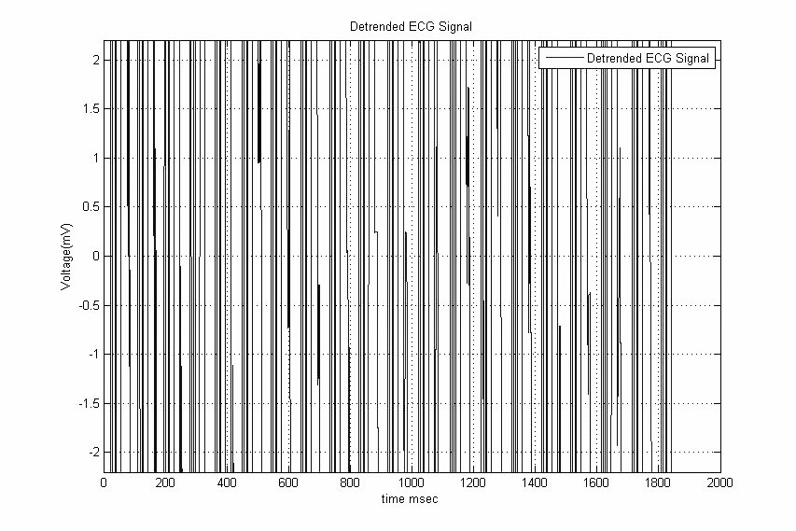

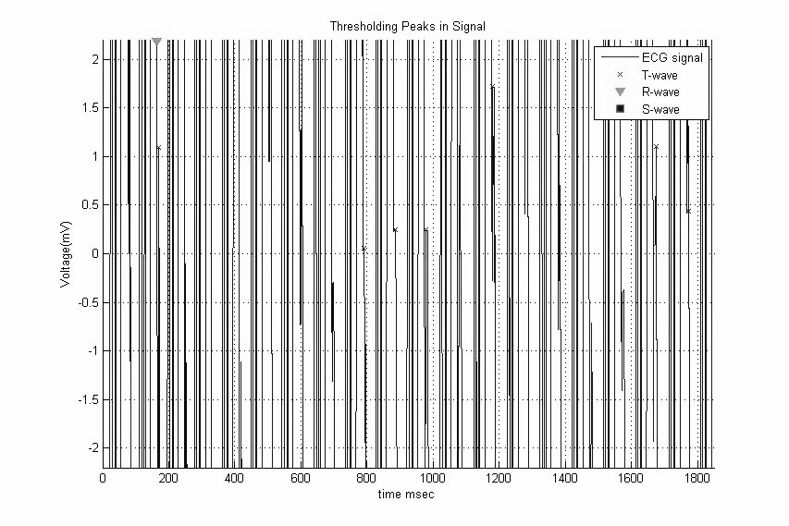

**APPLICATIONS**

The United States Preventive Services Task Force does not recommend electrocardiography for routine screening procedure in patients without symptoms and those at low risk for coronary heart disease.[16][17] This is because an ECG may falsely indicate the existence of a problem, leading to misdiagnosis, the recommendation of invasive procedures, or overtreatment. However, persons employed in certain critical occupations, such as aircraft pilots,[18] may be required to have an ECG as part of their routine health evaluations.

Continuous ECG monitoring is used to monitor critically ill patients, patients undergoing general anesthesia,[15] and patients who have an infrequently occurring cardiac dysrhythmia that would be unlikely to be seen on a conventional ten second ECG.

Performing a 12-lead ECG in the United States is commonly performed by specialized technicians that may be certified electrocardiogram technicians. ECG interpretation is a component of many healthcare fields (nurses and physicians and cardiac surgeons being the most obvious) but anyone trained to interpret an ECG is free to do so. However, "official" interpretation is performed by a cardiologist. Certain fields such as anesthesia utilize continuous ECG monitoring and knowledge of interpreting ECGs is crucial to their jobs

One additional form of electrocardiography is used in clinical cardiac electrophysiology in which a catheter is used to measure the electrical activity. The catheter is inserted through the femoral vein and can have several electrodes along its length to record the direction of electrical activity from within the heart.

**CONCLUSION:**

Currently, a paucity of evidence exists about the utility of ECG-based signal analysis technologies as a diagnostic test among patients at low to intermediate risk for CAD who present in the outpatient setting with the chief complaint of chest pain or with symptoms suggestive of ACS. Most devices identified by our gray literature search did not appear to have published articles describing their performance among the target population for this report. The literature was not sufficient to determine if factors such as body habitus, medications, and comorbid medical conditions affected test performance.

The limited available evidence demonstrates proof of concept, particularly for the PRIME ECG device, and it suggests that the sensitivity of BSM and signal averaging devices is higher compared with standard ECG for identifying patients with ACS who have either ischemic heart disease or CAD. However, this evidence is limited by the use of incomplete reference standards in the published studies, including elevated biomarkers for detecting acute ischemic heart disease.

**REFERENCE:**

* 1. [**Jump up^**](https://en.wikipedia.org/wiki/Electrocardiography#cite_ref-1) [EKG](http://www.oxforddictionaries.com/us/definition/english/EKG). Oxford Online Dictionaries
  2. [**Jump up^**](https://en.wikipedia.org/wiki/Electrocardiography#cite_ref-AMA_MOS_2-0) [*American Medical Association*](https://en.wikipedia.org/wiki/American_Medical_Association)*, "15.3.1 Electrocardiographic Terms",*[*AMA Manual of Style*](http://www.amamanualofstyle.com/)
  3. [**Jump up^**](https://en.wikipedia.org/wiki/Electrocardiography#cite_ref-MW_Collegiate_3-0) [*Merriam-Webster*](https://en.wikipedia.org/wiki/Merriam-Webster)*.*[*"Merriam-Webster's Collegiate Dictionary"*](http://unabridged.merriam-webster.com/collegiate/)*. Merriam-Webster.*
  4. [**Jump up^**](https://en.wikipedia.org/wiki/Electrocardiography#cite_ref-LHC_5-0) [*"ECG- simplified. Aswini Kumar M.D"*](http://www.lifehugger.com/doc/120/ecg-100-steps)*. LifeHugger. Retrieved 11 February 2010.*
  5. [**Jump up^**](https://en.wikipedia.org/wiki/Electrocardiography#cite_ref-6) Walraven, G. (2011). *Basic arrhythmias* (7th ed.), pp. 1–11
  6. [**Jump up^**](https://en.wikipedia.org/wiki/Electrocardiography#cite_ref-7) Braunwald E. (ed) (1997), *Heart Disease: A Textbook of Cardiovascular Medicine, Fifth Edition*, p. 108, Philadelphia, W.B. Saunders Co.. [ISBN](https://en.wikipedia.org/wiki/International_Standard_Book_Number) [0-7216-5666-8](https://en.wikipedia.org/wiki/Special:BookSources/0-7216-5666-8).