|  |  |
| --- | --- |
| **Module** | **Responsibility** |
| auth | Login, registration, OTP, session handling |
| user | Profile management, KYC data |
| account | Create/manage bank accounts, view balance |
| transaction | Internal/external transfers, history |
| otp | OTP generation, expiration, and SMS handling |
| teller | Teller login, customer search, deposit/withdrawal |

**Module Responsibilities**

**StackOverCash Database - Classified Relationships**

**Relationship Types Definition**

* **Mandatory One (1): Exactly one record must exist (NOT NULL constraint)**
* **Optional One (0..1): Zero or one record may exist (NULL allowed)**
* **Mandatory Many (1..*): At least one record must exist**
* **Optional Many (0..*): Zero or more records may exist**

**Core Entity Relationships**

**1. User Relationships**

* **User → Account: Optional Many (0..*)**
  + **A user may have zero or multiple accounts**
  + **An account must belong to exactly one user (Mandatory One)**
* **User → Transaction (as creator): Optional Many (0..*)**
  + **A user may create zero or multiple transactions**
  + **A transaction has one creator user (Mandatory One)**
* **User→ OTP Code: Optional Many (0..*)**
  + **A user may have zero or multiple OTP codes**
  + **An OTP code must belong to exactly one user (Mandatory One)**
* **User → Session: Optional Many (0..*)**
  + **A user may have zero or multiple sessions**
  + **A session must belong to exactly one user (Mandatory One)**
* **User → System Log: Optional Many (0..*)**
  + **A user may have zero or multiple system logs**
  + **A system log may or may not be associated with a user (Optional One)**
* **User → SMS Message: Optional Many (0..*)**
  + **A user may receive zero or multiple SMS messages**
  + **An SMS message must be associated with exactly one user (Mandatory One)**

**2. Account Relationships**

* **Account → User: Mandatory One (1)**
  + **An account must belong to exactly one user**
  + **A user may have zero or multiple accounts (Optional Many)**
* **Account → Transaction (as source): Optional Many (0..*)**
  + **An account may be the source of zero or multiple transactions**
  + **A transaction may or may not have a source account (Optional One)**
* **Account → Transaction (as recipient): Optional Many (0..*)**
  + **An account may be the recipient of zero or multiple transactions**
  + **A transaction may or may not have a recipient account (Optional One)**

**3. Transaction Relationships**

* **Transaction → Account (Sender): Mandatory One (1)** 
  + **A transaction must have a source account (for transfers)**
  + **An account may be the source of zero or multiple transactions (Optional Many)**
* **Transaction → Account (Receiver): Mandatory One (1)** 
  + **A transaction must have a recipient account (for transfers)**
  + **An account may be the recipient of zero or multiple transactions (Optional Many)**
* **Transaction → External Transfer: Optional Many (0..*)**
  + **A transaction may or may not have zero or multiple external transfer record**
  + **An external transfer must belong to exactly one transaction (Mandatory One)**
* **Transaction → OTP Code: Mandatory One (1)**
  + **A transaction must have one OTP code**
  + **An OTP code may or may not be associated with a transaction (Optional One)**
* **Transaction → User: Mandatory One (1)**
  + **A transaction must be created by exactly one user**
  + **A user may create zero or multiple transactions (Optional Many)**
* **Transaction → API Log: Optional Many (0..*)**
  + **A transaction may have zero or multiple API logs**
  + **An API log may or may not be associated with a transaction (Optional One)**

**4. External Transfer Relationships**

* **External Transfer → Transaction: Mandatory One (1)**
  + **An external transfer must be associated with exactly one transaction**
  + **A transaction may or may not have an external transfer record (Optional One)**
* **External Transfer → External Bank (conceptual, not enforced): Mandatory One (1)**
  + **An external transfer must reference external banks through bank codes**
  + **An external bank may be referenced by zero or multiple external transfers (Optional Many)**

**5. OTP Code Relationships**

* **OTP Code → User: Mandatory One (1)**
  + **An OTP code must belong to exactly one user**
  + **A user may have zero or multiple OTP codes (Optional Many)**
* **OTP Code → Transaction: Optional One (0..1)**
  + **An OTP code may or may not be associated with a transaction**
  + **A transaction may have zero or multiple OTP codes (Optional Many)**

**Supporting Entity Relationships**

**6. Session Relationships**

* **Session → User: Mandatory One (1)** 
  + **A session must belong to exactly one user**
  + **A user may have zero or multiple sessions (Optional Many)**

**7. System Log Relationships**

* **System Log → User: Optional One (0..1)** 
  + **A system log may or may not be associated with a user**
  + **A user may have zero or multiple system logs (Optional Many)**

**8. SMS Message Relationships**

* **SMS Message → User: Mandatory One (1)** 
  + **An SMS message must be associated with exactly one user**
  + **A user may receive zero or multiple SMS messages (Optional Many)**

**9. External Bank Relationships**

* **External Bank → External Transfers (conceptual, not enforced): Optional Many (0..*)** 
  + **An external bank may be referenced by zero or multiple external transfers**
  + **An external transfer must reference external banks (Mandatory One)**

**10. API Log Relationships**

* **API Log → Transaction: Optional One (0..1)**
  + **An API log may or may not be associated with a transaction**
  + **A transaction may have zero or multiple API logs (Optional Many)**
* **API Log → User: Optional One (0..1)**
  + **An API log may or may not be associated with a user**
  + **A user may have zero or multiple API logs (Optional Many)**

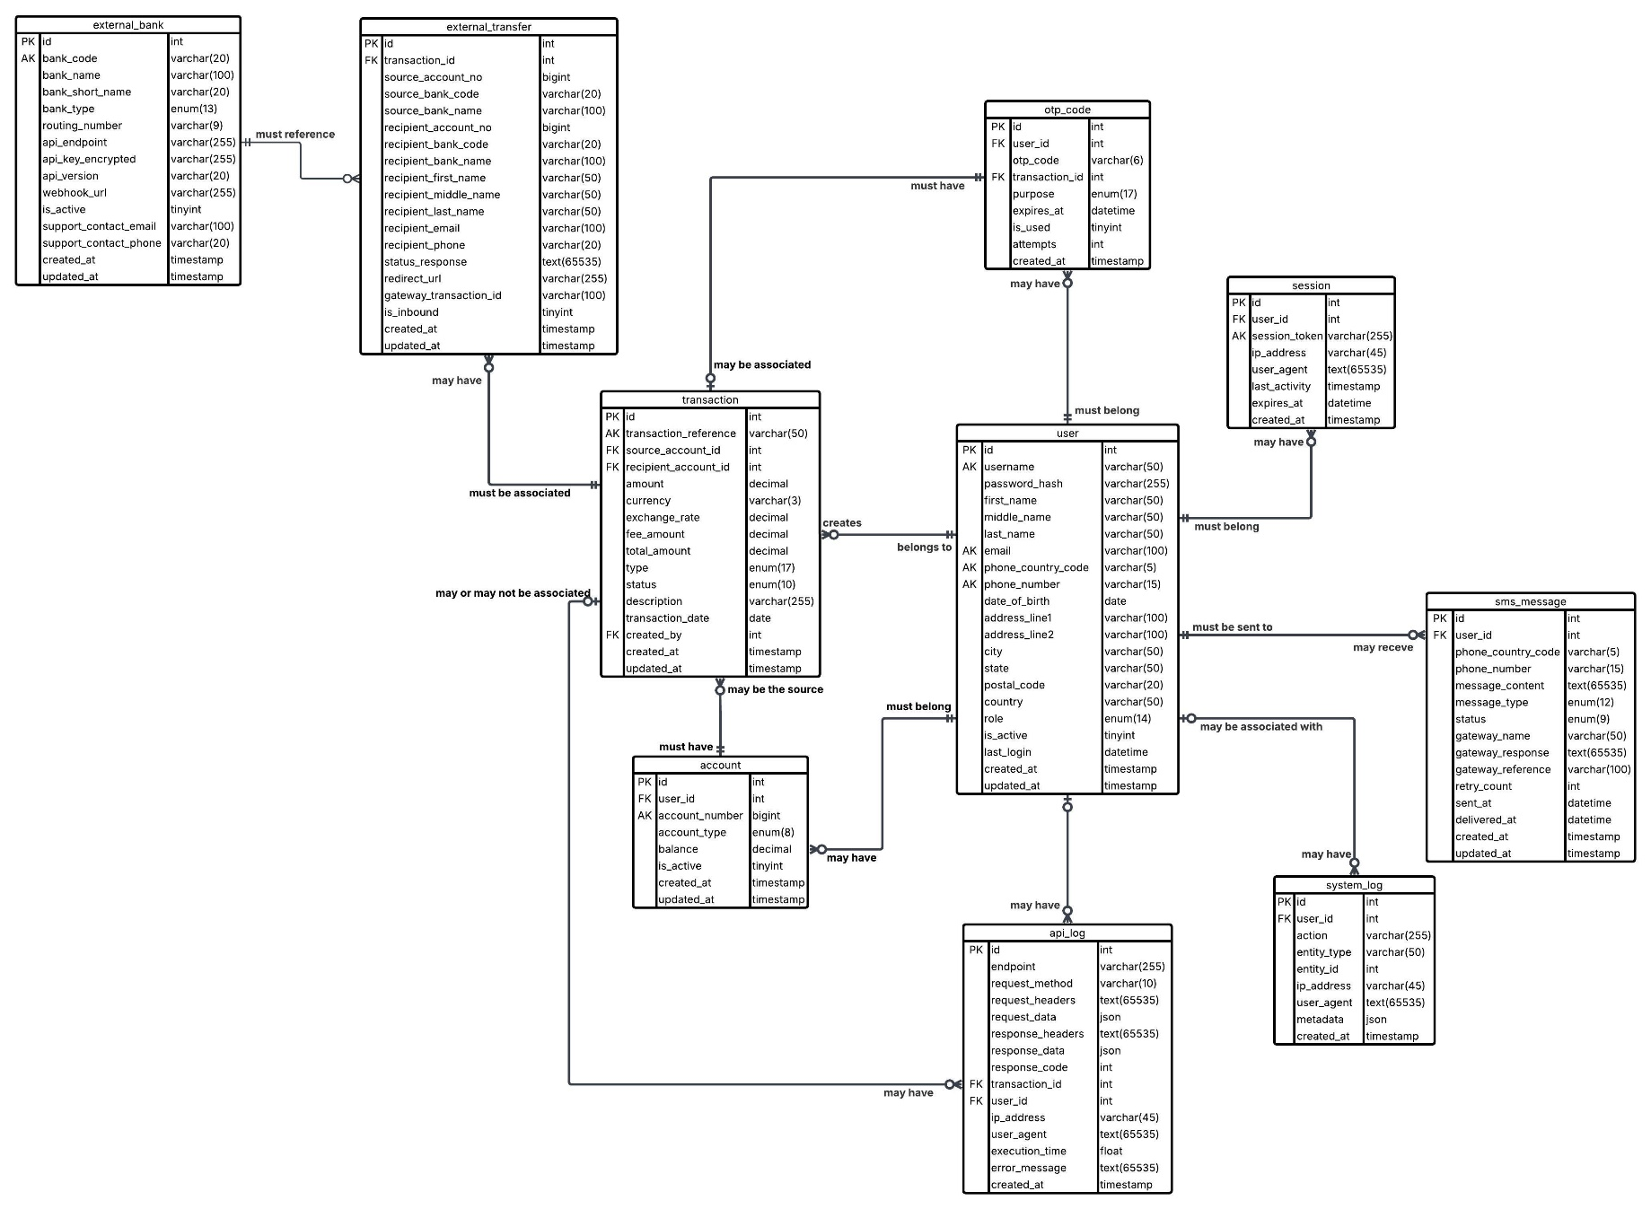**StackOverCash ERD**