**User Assigning with EMAILING FEATURE**

The system supports email notification. DJANGO provide this kind of feature so that we can easily email users using our developed system. Before we can use this emailing feature, first, we must configure this in our **settings.py**. Below is the code for emailing feature configuration:

The below code is 214 lines of codes that is responsible for assigning user/s to a parent folders and subfolders as Chairman, Co-chairman, and Member. There is a specific code that emails the user/s after the admin assigns a user to a folder. Below are the example emails to the user after the admin assigns a user to a folder.

The code below is the code that enables the ACMIS to email their users.

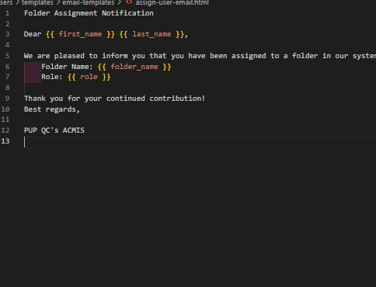

**Example Email Output**:

**CREATING A USER GROUP AND ADDING PERMISSION/S TO A USER GROUP FEATURE**

This feature allows admin to create a user role or user group. This user group can have one or more permissions based on the admin selection of permissions. Below are the codes for this feature:

**User Registration Feature with Emailing Feature**

This feature allows the admin to register new users. And after the admin registers the new user. It will send an email to the newly registered user using its email.

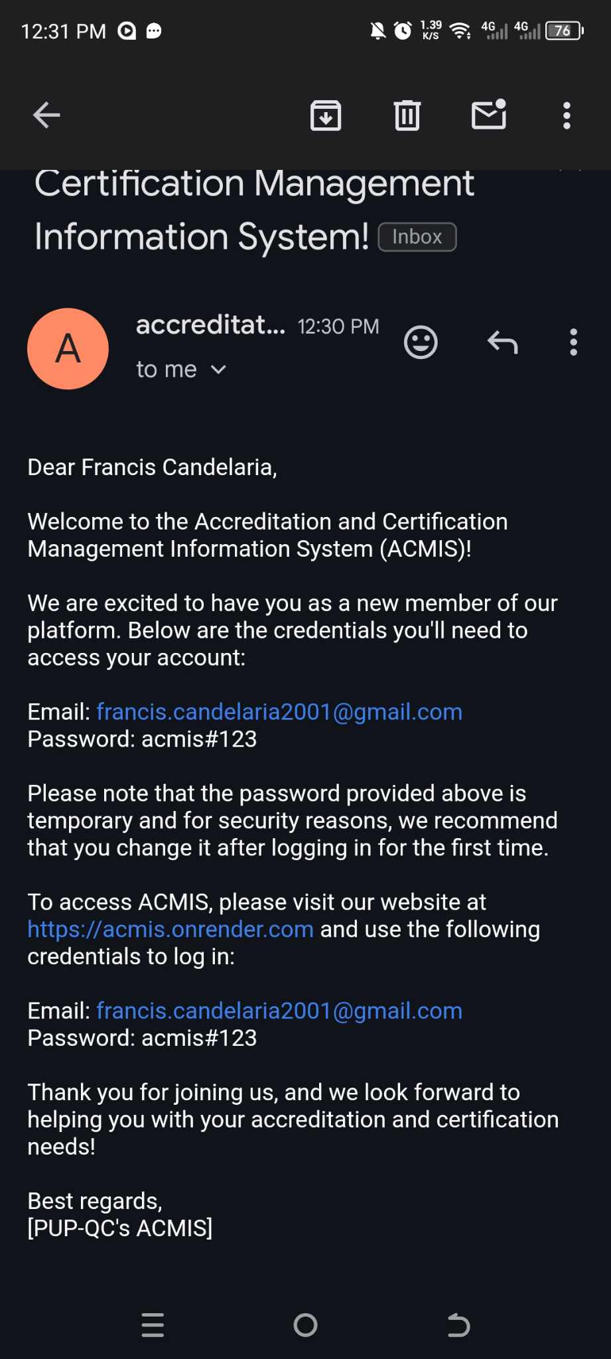The example Email output is this:

**PROGRAM APPLYING FOR ACCREDITATION FEATURE**

This feature allows the ACMIS-admin to choose a program that will be marked as under Accreditation. They can create a record by entering the below details:

* Program
* Instrument Level
* Mock Accreditation Date
* Survey Visit Date
* A computer screen with colorful text

  Description automatically generatedDescription

**INSTRUMENT CREATION FOR ACCREDITATION FEATURE**

This feature allows the admin to create an instrument so that the created instrument can be used when the admin chooses a program that will be marked as under Accreditation. This feature is more like a Google Drive because the admin and users can create a folder and upload files to that folder.

Below is the code for creation an accreditation instrument:

Below is the code for setting up the created accreditation instrument. Setting up means creating a folders where the users can upload and submit their required files.

**PARENT FOLDER CREATION**

**SUBFOLDER CREATION**

**UPLOADING FILE TO A PARENT FOLDER**

**UPLOADING FILE TO A CHILD FOLDER OR SUBFOLDER**

**CREATING A SUBMISSION BIN**Submission bin is a kind of folder that only accepts uploading of files. This folder prohibits admin or other users to create new parent folder and subfolder. The submission bin is a kind of folder that can be configured on what kind of files that can be uploaded to it, what is the maximum file count that can be uploaded to it, and what storage size of files that can be uploaded to it.

**PARENT SUBMISSION BIN** (Submission bin inside the parent folder)

**CHILD SUBMISSION BIN** (Submission bin inside the child folder or subfolder)

**ACCREDITATION OF STATUS OF A PROGRAM FEATURE**

This feature allows the admin or user to see the status of the under-accreditation program.

**The below code is responsible for throwing data to the html templates**

**The below code is how the throwed data was used to show the current Accreditation Status of a Program**

**UPLOADING THE ACCREDITATION RESULT OF A PROGRAM FEATURE**

This feature allows only admins to post and upload the accreditation result of the program after its survey visit or survey revisit. The admin can mark the result as Passed, Survey Revisit, and Failed. The admin can also upload files or evidence or certificates after the result was posted by the admin.

**Below is the code when the admin mark the accreditation result as ‘Passed’**

**Below is the code when the admin mark the accreditation result as ‘Subject for Survey Revisit’**

**Below is the code when the admin marks the accreditation result as ‘FAILED’**

**ACTIVITY LOG FEATURE**

This features allows the admin to monitor the activities that happened in the system. Every activity that a user made, this is recorded in the activity log. Every CRUD they perform, it will recorded or saved in the activity log of the ACMIS

**Below is the code on how their activity was saved or monitored. The user performs CRUD and this activity will be saved in the database.**

**Moreover, below is the code that is responsible in showing all the activities in the system:**

**DASHBOARD FEATURE**

This feature allows the admin and user to view the summary of all accreditation events in the PUP QC.

**SYNCHRONOUS DATA EXCHANGE FEATURE**

This feature allows the admin and user to get data from other systems like Faculty Information System, Research Information System, Student Performance System, and Extensions and Services Information System. The ACMIS gets the API of these systems and show it in the front end where the user can export of the data that they throw to the ACMIS.

**Below are the codes that is responsible for integrating the Faculty Information System in the ACMIS**

**Below are the codes that is responsible for integrating the Research Information System in the ACMIS**

**Below are the codes that is responsible for integrating the Student Performance System in the ACMIS**

**Below are the codes that is responsible for integrating the Extension and Services Information System in the ACMIS**

