What is Database:

The database is a collection of inter-related data which is used to retrieve, insert and delete the data efficiently. It is also used to organize the data in the form of a table, schema, views, and reports, etc.

**For example:** The college Database organizes the data about the admin, staff, students and faculty etc.

Using the database, you can easily retrieve, insert, and delete the information.

## Database Management System

* Database management system is a software which is used to manage the database. For example: [MySQL](https://www.javatpoint.com/mysql-tutorial), [Oracle](https://www.javatpoint.com/oracle-tutorial), etc are a very popular commercial database which is used in different applications.
* DBMS provides an interface to perform various operations like database creation, storing data in it, updating data, creating a table in the database and a lot more.
* It provides protection and security to the database. In the case of multiple users, it also maintains data consistency.

## What is Data?

Data is a collection of a distinct small unit of information. It can be used in a variety of forms like text, numbers, media, bytes, etc. it can be stored in pieces of paper or electronic memory, etc.

Word 'Data' is originated from the word 'datum' that means 'single piece of information.' It is plural of the word datum.

In computing, Data is information that can be translated into a form for efficient movement and processing. Data is interchangeable.

What is Database?

A **database** is an organized collection of data, so that it can be easily accessed and managed.

32.8M

|  |  |  |  |  |  |  |
| --- | --- | --- | --- | --- | --- | --- |
| **CustomerID** | **CustomerName** | **ContactName** | **Address** | **City** | **PostalCode** | **Country** |
| 89 | White Clover Markets | Karl Jablonski | 305 - 14th Ave. S. Suite 3B | Seattle | 98128 | USA |
| 90 | Wilman Kala | Matti Karttunen | Keskuskatu 45 | Helsinki | 21240 | Finland |
| 91 | Wolski | Zbyszek | ul. Filtrowa 68 | Walla | 01-012 | Poland |

746

Features of Java - Javatpoint

You can organize data into tables, rows, columns, and index it to make it easier to find relevant information.

**Database handlers** create a database in such a way that only one set of software program provides access of data to all the users.

The **main purpose** of the database is to operate a large amount of information by storing, retrieving, and managing data.

There are many **dynamic websites** on the World Wide Web nowadays which are handled through databases. For example, a model that checks the availability of rooms in a hotel. It is an example of a dynamic website that uses a database.

There are many **databases available** like MySQL, Sybase, Oracle, MongoDB, Informix, PostgreSQL, SQL Server, etc.

Modern databases are managed by the database management system (DBMS).

**SQL** or Structured Query Language is used to operate on the data stored in a database. SQL depends on relational algebra and tuple relational calculus.

# **DBMS Architecture**

* The DBMS design depends upon its architecture. The basic client/server architecture is used to deal with a large number of PCs, web servers, database servers and other components that are connected with networks.
* The client/server architecture consists of many PCs and a workstation which are connected via the network.
* DBMS architecture depends upon how users are connected to the database to get their request done.

## Types of DBMS Architecture

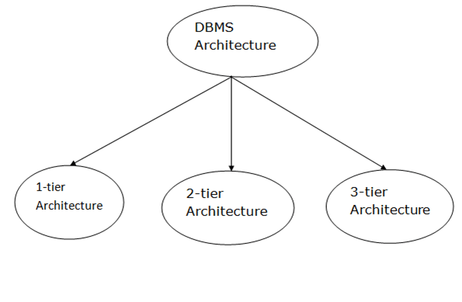

Database architecture can be seen as a single tier or multi-tier. But logically, database architecture is of two types like: **2-tier architecture** and **3-tier architecture**.

### **1-Tier Architecture**

* In this architecture, the database is directly available to the user. It means the user can directly sit on the DBMS and uses it.
* Any changes done here will directly be done on the database itself. It doesn't provide a handy tool for end users.
* The 1-Tier architecture is used for development of the local application, where programmers can directly communicate with the database for the quick response.

### **2-Tier Architecture**

* The 2-Tier architecture is same as basic client-server. In the two-tier architecture, applications on the client end can directly communicate with the database at the server side. For this interaction, API's like: **ODBC**, **JDBC** are used.
* The user interfaces and application programs are run on the client-side.
* The server side is responsible to provide the functionalities like: query processing and transaction management.
* To communicate with the DBMS, client-side application establishes a connection with the server side.

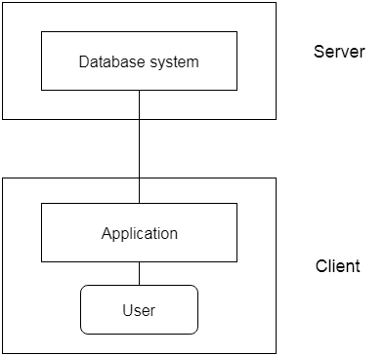

**Fig: 2-tier Architecture**

### **3-Tier Architecture**

* The 3-Tier architecture contains another layer between the client and server. In this architecture, client can't directly communicate with the server.
* The application on the client-end interacts with an application server which further communicates with the database system.
* End user has no idea about the existence of the database beyond the application server. The database also has no idea about any other user beyond the application.
* The 3-Tier architecture is used in case of large web application.

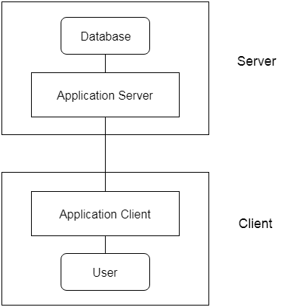

**Fig: 3-tier Architecture**

# **Types of Databases**

There are various types of databases used for storing different varieties of data:

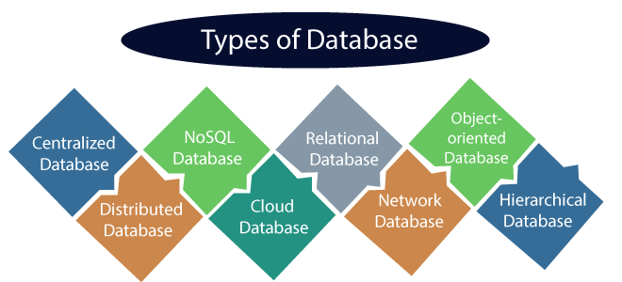

## 3) Relational Database

This database is based on the relational data model, which stores data in the form of rows(tuple) and columns(attributes), and together forms a table(relation). A relational database uses SQL for storing, manipulating, as well as maintaining the data. E.F. Codd invented the database in 1970. Each table in the database carries a key that makes the data unique from others. **Examples** of Relational databases are MySQL, Microsoft SQL Server, Oracle, etc.

### **Properties of Relational Database**

There are following four commonly known properties of a relational model known as ACID properties, where:

**A means Atomicity:** This ensures the data operation will complete either with success or with failure. It follows the 'all or nothing' strategy. For example, a transaction will either be committed or will abort.

**C means Consistency:** If we perform any operation over the data, its value before and after the operation should be preserved. For example, the account balance before and after the transaction should be correct, i.e., it should remain conserved.

**I means Isolation:** There can be concurrent users for accessing data at the same time from the database. Thus, isolation between the data should remain isolated. For example, when multiple transactions occur at the same time, one transaction effects should not be visible to the other transactions in the database.

**D means Durability:** It ensures that once it completes the operation and commits the

## 5) Cloud Database

A type of database where data is stored in a virtual environment and executes over the cloud computing platform. It provides users with various cloud computing services (SaaS, PaaS, IaaS, etc.) for accessing the database. There are numerous cloud platforms, but the best options are:

* Amazon Web Services(AWS)
* Microsoft Azure
* Kamatera
* PhonixNAP
* ScienceSoft
* Google Cloud SQL, etc.

# **What is RDBMS**

**RDBMS** stands for Relational Database Management Systems..

All modern database management systems like SQL, MS SQL Server, IBM DB2, ORACLE, My-SQL and Microsoft Access are based on RDBMS.

It is called Relational Data Base Management System (RDBMS) because it is based on relational model introduced by E.F. Codd.

## How it works

Data is represented in terms of tuples (rows) in RDBMS.

30.7M

720

OOPs Concepts in Java

Relational database is most commonly used database. It contains number of tables and each table has its own primary key.

Due to a collection of organized set of tables, data can be accessed easily in RDBMS.

## Brief History of RDBMS

During 1970 to 1972, E.F. Codd published a paper to propose the use of relational database model.

RDBMS is originally based on that E.F. Codd's relational model invention.

## What is table

The RDBMS database uses tables to store data. A table is a collection of related data entries and contains rows and columns to store data.

A table is the simplest example of data storage in RDBMS.

Let's see the example of student table.

|  |  |  |  |
| --- | --- | --- | --- |
| **ID** | **Name** | **AGE** | **COURSE** |
| 1 | Ajeet | 24 | B.Tech |
| 2 | Aryan | 20 | C.A |
| 3 | Mahesh | 21 | BCA |
| 4 | Ratan | 22 | MCA |
| 5 |  | 26 | BSC |

## What is field

Field is a smaller entity of the table which contains specific information about every record in the table. In the above example, the field in the student table consist of id, name, age, course.

## What is row or record

A row of a table is also called record. It contains the specific information of each individual entry in the table. It is a horizontal entity in the table. For example: The above table contains 5 records.

Let's see one record/row in the table.

|  |  |  |  |
| --- | --- | --- | --- |
| 1 | Ajeet | 24 | B.Tech |

## What is column

A column is a vertical entity in the table which contains all information associated with a specific field in a table. For example: "name" is a column in the above table which contains all information about student's name.

|  |
| --- |
| Ajeet |
| Aryan |
| Mahesh |
| Ratan |
| Vimal |

## NULL Values

The NULL value of the table specifies that the field has been left blank during record creation. It is totally different from the value filled with zero or a field that contains space.

## Data Integrity

There are the following categories of data integrity exist with each RDBMS:

**Entity integrity**: It specifies that there should be no duplicate rows in a table.

**Domain integrity**: It enforces valid entries for a given column by restricting the type, the format, or the range of values.

**Referential integrity**: It specifies that rows cannot be deleted, which are used by other records.

**User-defined integrity**: It enforces some specific business rules that are defined by users. These rules are different from entity, domain or referential integrity.