Java:

Java is a **programming language** and a **platform**. Java is a high level, robust, object-oriented and secure programming language.

Java was developed by Sun Microsystems (which is now the subsidiary of Oracle) in the year 1995. James Gosling is known as the father of Java. Before Java, its name was Oak. Since Oak was already a registered company, so James Gosling and his team changed the name from Oak to Java.

Features of Java

The primary objective of [Java programming](https://www.javatpoint.com/java-tutorial) language creation was to make it portable, simple and secure programming language. Apart from this, there are also some excellent features which play an important role in the popularity of this language. The features of Java are also known as Java buzzwords.

A list of the most important features of the Java language is given below.

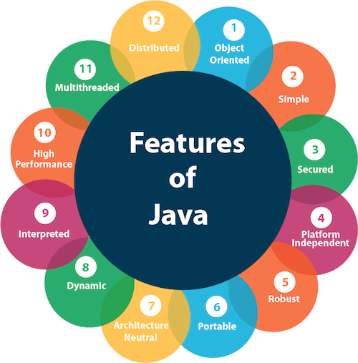

1. [Simple](https://www.javatpoint.com/features-of-java#Simple)
2. [Object-Oriented](https://www.javatpoint.com/features-of-java#Object-Oriented)
3. [Portable](https://www.javatpoint.com/features-of-java#Portable)
4. [Platform independent](https://www.javatpoint.com/features-of-java#Platform-independent)
5. [Secured](https://www.javatpoint.com/features-of-java#Secured)
6. [Robust](https://www.javatpoint.com/features-of-java#Robust)
7. [Architecture neutral](https://www.javatpoint.com/features-of-java#Architecture-neutral)
8. [Interpreted](https://www.javatpoint.com/features-of-java#Interpreted)
9. [High Performance](https://www.javatpoint.com/features-of-java#High-Performance)
10. [Multithreaded](https://www.javatpoint.com/features-of-java#Multithreaded)
11. [Distributed](https://www.javatpoint.com/features-of-java#Distributed)
12. [Dynamic](https://www.javatpoint.com/features-of-java#Dynamic)

Simple

Java is very easy to learn, and its syntax is simple, clean and easy to understand. According to Sun Microsystem, Java language is a simple programming language because:

* Java syntax is based on C++ (so easier for programmers to learn it after C++).
* Java has removed many complicated and rarely-used features, for example, explicit pointers, operator overloading, etc.
* There is no need to remove unreferenced objects because there is an Automatic Garbage Collection in Java.

Object-oriented

Java is an [object-oriented](https://www.javatpoint.com/java-oops-concepts) programming language. Everything in Java is an object. Object-oriented means we organize our software as a combination of different types of objects that incorporate both data and behavior.

Object-oriented programming (OOPs) is a methodology that simplifies software development and maintenance by providing some rules.

Basic concepts of OOPs are:

1. [Object](https://www.javatpoint.com/object-and-class-in-java)
2. [Class](https://www.javatpoint.com/object-and-class-in-java#class)
3. [Inheritance](https://www.javatpoint.com/inheritance-in-java)
4. [Polymorphism](https://www.javatpoint.com/runtime-polymorphism-in-java)
5. [Abstraction](https://www.javatpoint.com/abstract-class-in-java)
6. [Encapsulation](https://www.javatpoint.com/encapsulation)

Platform Independent

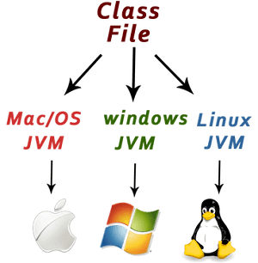

Java is platform independent because it is different from other languages like [C](https://www.javatpoint.com/c-programming-language-tutorial), [C++](https://www.javatpoint.com/cpp-tutorial), etc. which are compiled into platform specific machines while Java is a write once, run anywhere language. A platform is the hardware or software environment in which a program runs.

There are two types of platforms software-based and hardware-based. Java provides a software-based platform.

The Java platform differs from most other platforms in the sense that it is a software-based platform that runs on top of other hardware-based platforms. It has two components:

1. Runtime Environment
2. API(Application Programming Interface)

Java code can be executed on multiple platforms, for example, Windows, Linux, Sun Solaris, Mac/OS, etc. Java code is compiled by the compiler and converted into bytecode. This bytecode is a platform-independent code because it can be run on multiple platforms, i.e., Write Once and Run Anywhere (WORA).

Secured

Java is best known for its security. With Java, we can develop virus-free systems. Java is secured because:

* **No explicit pointer**
* **Java Programs run inside a virtual machine sandbox**

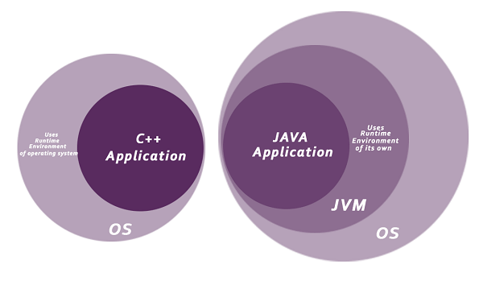

* **Classloader:** Classloader in Java is a part of the Java Runtime Environment (JRE) which is used to load Java classes into the Java Virtual Machine dynamically. It adds security by separating the package for the classes of the local file system from those that are imported from network sources.
* **Bytecode Verifier:** It checks the code fragments for illegal code that can violate access rights to objects.
* **Security Manager:** It determines what resources a class can access such as reading and writing to the local disk.

Java language provides these securities by default. Some security can also be provided by an application developer explicitly through SSL, JAAS, Cryptography, etc.

Robust

The English mining of Robust is strong. Java is robust because:

* It uses strong memory management.
* There is a lack of pointers that avoids security problems.
* Java provides automatic garbage collection which runs on the Java Virtual Machine to get rid of objects which are not being used by a Java application anymore.
* There are exception handling and the type checking mechanism in Java. All these points make Java robust.

Architecture-neutral

Java is architecture neutral because there are no implementation dependent features, for example, the size of primitive types is fixed.

In C programming, int data type occupies 2 bytes of memory for 32-bit architecture and 4 bytes of memory for 64-bit architecture. However, it occupies 4 bytes of memory for both 32 and 64-bit architectures in Java.

Portable

Java is portable because it facilitates you to carry the Java bytecode to any platform. It doesn't require any implementation.

High-performance

Java is faster than other traditional interpreted programming languages because Java bytecode is "close" to native code. It is still a little bit slower than a compiled language (e.g., C++). Java is an interpreted language that is why it is slower than compiled languages, e.g., C, C++, etc.

Distributed

Java is distributed because it facilitates users to create distributed applications in Java. RMI and EJB are used for creating distributed applications. This feature of Java makes us able to access files by calling the methods from any machine on the internet.

Multi-threaded

A thread is like a separate program, executing concurrently. We can write Java programs that deal with many tasks at once by defining multiple threads. The main advantage of multi-threading is that it doesn't occupy memory for each thread. It shares a common memory area. Threads are important for multi-media, Web applications, etc.

Dynamic

Java is a dynamic language. It supports the dynamic loading of classes. It means classes are loaded on demand. It also supports functions from its native languages, i.e., C and C++.

Difference between JDK, JRE, and JVM

1. [A summary of JVM](https://www.javatpoint.com/difference-between-jdk-jre-and-jvm)
2. [Java Runtime Environment (JRE)](https://www.javatpoint.com/difference-between-jdk-jre-and-jvm#jre)
3. [Java Development Kit (JDK)](https://www.javatpoint.com/difference-between-jdk-jre-and-jvm#jdk)

We must understand the differences between JDK, JRE, and JVM before proceeding further to [Java](https://www.javatpoint.com/java-tutorial). See the brief overview of JVM here.

If you want to get the detailed knowledge of Java Virtual Machine, move to the next page. Firstly, let's see the differences between the JDK, JRE, and JVM.

JVM

JVM (Java Virtual Machine) is an abstract machine. It is called a virtual machine because it doesn't physically exist. It is a specification that provides a runtime environment in which Java bytecode can be executed. It can also run those programs which are written in other languages and compiled to Java bytecode.

JVMs are available for many hardware and software platforms. JVM, JRE, and JDK are platform dependent because the configuration of each [OS](https://www.javatpoint.com/os-tutorial) is different from each other. However, Java is platform independent. There are three notions of the JVM: *specification*, *implementation*, and *instance*.

The JVM performs the following main tasks:

* Loads code
* Verifies code
* Executes code
* Provides runtime environment

[More Details.](https://www.javatpoint.com/internal-details-of-jvm)

JRE

JRE is an acronym for Java Runtime Environment. It is also written as Java RTE. The Java Runtime Environment is a set of software tools which are used for developing Java applications. It is used to provide the runtime environment. It is the implementation of JVM. It physically exists. It contains a set of libraries + other files that JVM uses at runtime.

The implementation of JVM is also actively released by other companies besides Sun Micro Systems.

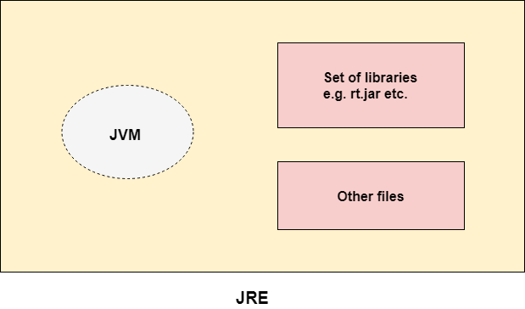

JDK

JDK is an acronym for Java Development Kit. The Java Development Kit (JDK) is a software development environment which is used to develop Java applications and [applets](https://www.javatpoint.com/java-applet). It physically exists. It contains JRE + development tools.

JDK is an implementation of any one of the below given Java Platforms released by Oracle Corporation:

* Standard Edition Java Platform
* Enterprise Edition Java Platform
* Micro Edition Java Platform

The JDK contains a private Java Virtual Machine (JVM) and a few other resources such as an interpreter/loader (java), a compiler (javac), an archiver (jar), a documentation generator (Javadoc), etc. to complete the development of a Java Application.

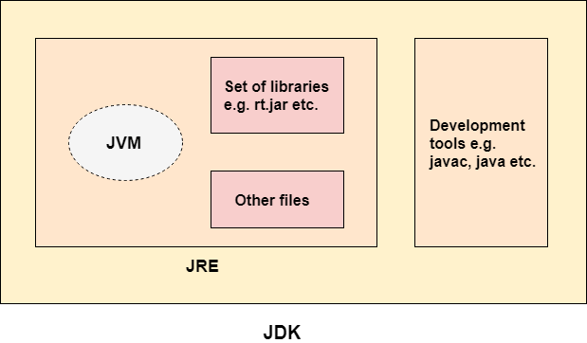

**class** Simple{

**public** **static** **void** main(String args[]){

     System.out.println("Hello Java");

    }

}

Steps:

1) javac Simple.java ->.class ---🡪byte code instructions

2) java Simple

U need to convert byte code into machine language instructions so that it will understand by every one

JVM (Java Virtual Machine) Architecture

JVM (Java Virtual Machine) is an abstract machine. It is a specification that provides runtime environment in which java bytecode can be executed.

**Java Virtual Machine (JVM)** is a engine that provides runtime environment to drive the Java Code or applications. It converts Java bytecode into machines language. JVM is a part of Java Run Environment (JRE).

1. **Runtime Instance** Whenever you write java command on the command prompt to run the java class, an instance of JVM is created.

What it does

The JVM performs following operation:

* Loads code
* Verifies code
* Executes code
* Provides runtime environment

JVM provides definitions for the:

* Memory area
* Class file format
* Register set
* Garbage-collected heap
* Fatal error reporting etc.

## JVM Architecture

Let's understand the internal architecture of JVM. It contains classloader, memory area, execution engine etc.

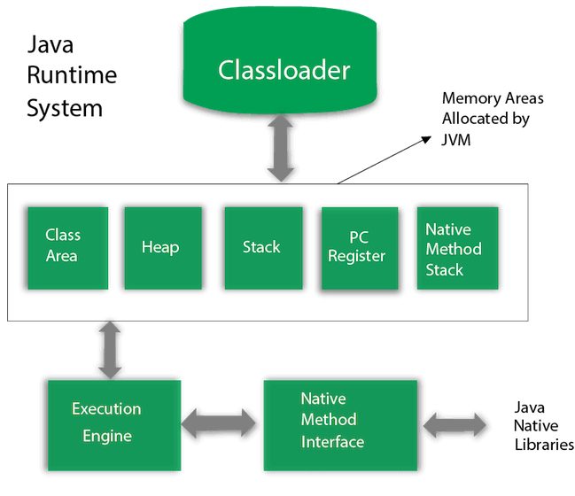

Class(Method) Area

Class(Method) Area stores per-class structures such as the runtime constant pool, field and method data, the code for methods.

3) Heap

It is the runtime data area in which objects are allocated.

4) Stack

Java Stack stores frames. It holds local variables and partial results, and plays a part in method invocation and return.

Each thread has a private JVM stack, created at the same time as thread.

A new frame is created each time a method is invoked. A frame is destroyed when its method invocation completes.

5) Program Counter Register

PC (program counter) register contains the address of the Java virtual machine instruction currently being executed.

6) Native Method Stack

It contains all the native methods used in the application.

7) Execution Engine

It contains:

1. **A virtual processor**
2. **Interpreter:** Read bytecode stream then execute the instructions.
3. **Just-In-Time(JIT) compiler:** It is used to improve the performance. JIT compiles parts of the byte code that have similar functionality at the same time, and hence reduces the amount of time needed for compilation. Here, the term "compiler" refers to a translator from the instruction set of a Java virtual machine (JVM) to the instruction set of a specific CPU.

8) Java Native Interface

Java Native Interface (JNI) is a framework which provides an interface to communicate with another application written in another language like C, C++, Assembly etc. Java uses JNI framework to send output to the Console or interact with OS libraries.

# Java Variables

A variable is a container which holds the value while the [Java program](https://www.javatpoint.com/simple-program-of-java) is executed. A variable is assigned with a data type.

Variable is a name of memory location. There are three types of variables in java: local, instance and static.

There are two types of [data types in Java](https://www.javatpoint.com/java-data-types): primitive and non-primitive.

## Variable

A variable is the name of a reserved area allocated in memory. In other words, it is a name of the memory location. It is a combination of "vary + able" which means its value can be changed.

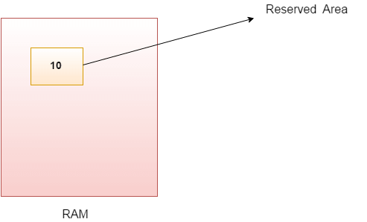

1. **int** data=50;//Here data is variable

### Types of Variables

There are three types of variables in [Java](https://www.javatpoint.com/java-tutorial):

* local variable
* instance variable
* static variable

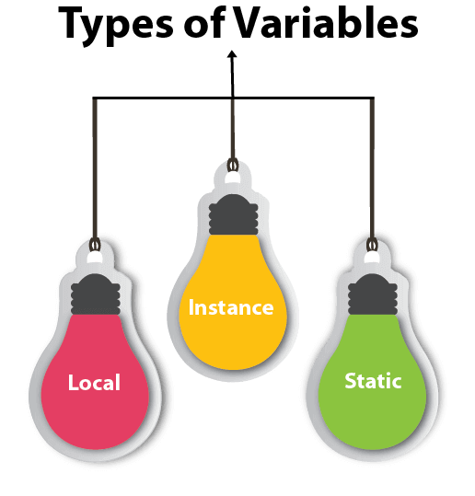

#### 1) Local Variable

A variable declared inside the body of the method is called local variable. You can use this variable only within that method and the other methods in the class aren't even aware that the variable exists.

A local variable cannot be defined with "static" keyword.

#### 2) Instance Variable

A variable declared inside the class but outside the body of the method, is called an instance variable. It is not declared as [static](https://www.javatpoint.com/static-keyword-in-java).

It is called an instance variable because its value is instance-specific and is not shared among instances.

#### 3) Static variable

A variable that is declared as static is called a static variable. It cannot be local. You can create a single copy of the static variable and share it among all the instances of the class. Memory allocation for static variables happens only once when the class is loaded in the memory.

**package** com.demo5;

**public** **class** Sample {

**int** id=10;//instance

**static** String *s*="sample"; //static

**public** **static** **void** main(String[] args) {

Sample sam=**new** Sample();

System.***out***.println(sam.id);

System.***out***.println(Sample.*s*);

}

}

### Example to understand the types of variables in java

1. **public** **class** A
2. {
3. **static** **int** m=100;//static variable
4. **void** method()
5. {
6. **int** n=90;//local variable
7. }
8. **public** **static** **void** main(String args[])
9. {
10. **int** data=50;//instance variable
11. }
12. }//end of class

### Java Variable Example: Add Two Numbers

1. **public** **class** Simple{
2. **public** **static** **void** main(String[] args){
3. **int** a=10;
4. **int** b=10;
5. **int** c=a+b;
6. System.out.println(c);
7. }
8. }

**Output:**

20

### Java Variable Example: Widening

1. **public** **class** Simple{
2. **public** **static** **void** main(String[] args){
3. **int** a=10;
4. **float** f=a;
5. System.out.println(a);
6. System.out.println(f);
7. }}

**Output:**

10

10.0

### Java Variable Example: Narrowing (Typecasting)

1. **public** **class** Simple{
2. **public** **static** **void** main(String[] args){
3. **float** f=10.5f;
4. //int a=f;//Compile time error
5. **int** a=(**int**)f;
6. System.out.println(f);
7. System.out.println(a);
8. }}

**Output:**

10.5

10

### Java Variable Example: Overflow

1. **class** Simple{
2. **public** **static** **void** main(String[] args){
3. //Overflow
4. **int** a=130;
5. **byte** b=(**byte**)a;
6. System.out.println(a);
7. System.out.println(b);
8. }}

**Output:**

130

-126

### Java Variable Example: Adding Lower Type

1. **class** Simple{
2. **public** **static** **void** main(String[] args){
3. **byte** a=10;
4. **byte** b=10;
5. //byte c=a+b;//Compile Time Error: because a+b=20 will be int
6. **byte** c=(**byte**)(a+b);
7. System.out.println(c);
8. }}