Basic of statistics: -

There are 6 types of data.

1. **Quantitative data**

* **Continuous or decimal-** we can measure the data in continuous(decimal) type of data.(e.g speed of car.10.5 ,clock-5.35AM,measurement scale-2.5 MM
* **Discrete-** in discrete type of data, we can not measure in decimal e.g. laptops,books,population of town. Data that can be counted and has finite values is known as discrete data. **This will be in whole number. E.gnumber of markes or number of football goals**

1. **Qualitative Data**

* **Nominal data-** This type of includes names. Nominal data are used to label variables without any quantitative value. Common examples include male/female (albeit somewhat outdated), hair colour, nationalities, names of people, and so on.

* **Ordinal-** eg. Grades. ordinal data are commonly used for collecting demographic information. This is particularly prevalent in sectors like finance, marketing, and insurance, but it is also used by governments, e.g. the census, and is generally common when conducting customer satisfaction surveys (in any industry).
* **interval**
* **ratio**

one example of dog.

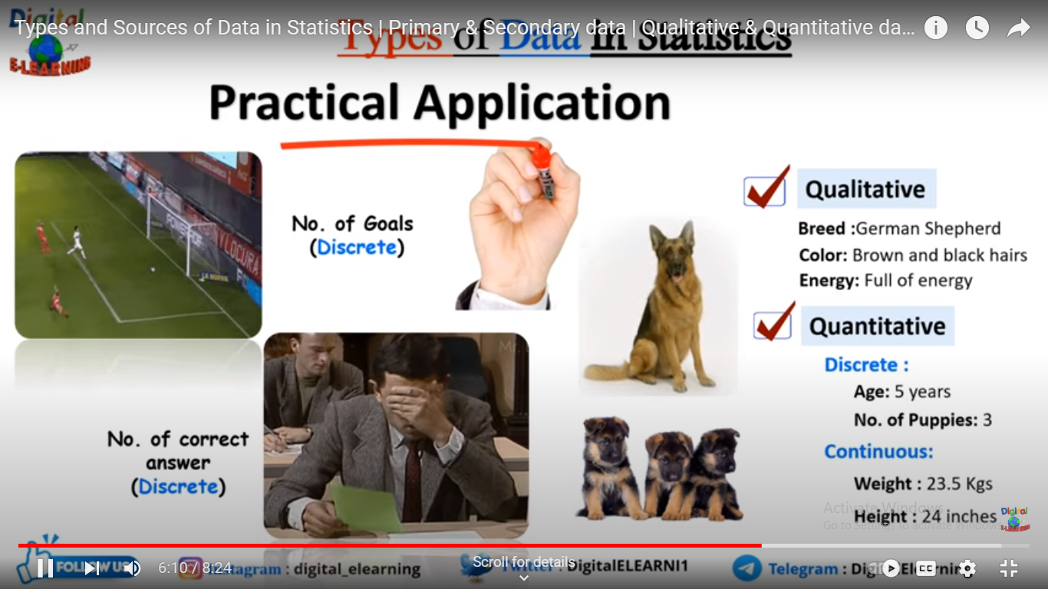

**Measures of central tendency**

* [**Mode**](https://www.scribbr.com/statistics/mode/)**:** the most frequent value.
* [**Median**](https://www.scribbr.com/statistics/median/)**:** the middle number in an ordered dataset.
* [**Mean**](https://www.scribbr.com/statistics/mean/)**:** the sum of all values divided by the total number of values.

**Mean = Sum of the Given Data/Total number of Data**

* To calculate the arithmetic mean of a set of data we must first add up (sum) all of the data values (x) and then divide the result by the number of values (n). Since ∑ is the symbol used to indicate that values are to be summed (see Sigma Notation) we obtain the following formula for the mean (x̄):
* **x̄=∑ x/n**

**Standard Deviation:**

**Standard deviation formula for sample-**

The formula for standard deviation (SD) is

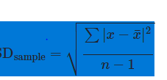

The standard deviation formula may look confusing, but it will make sense after we break it down. In the coming sections, we'll walk through a step-by-step interactive example. Here's a quick preview of the steps we're about to follow:

**Step 1:** Find the mean.

**Step 2:** For each data point, find the square of its distance to the mean.

**Step 3:** Sum the values from Step 2.

**Step 4:** Divide by the number of data points.

**Step 5:** Take the square root

