AutonomousCarH README

**Overview** - Radio controlled car with the bluetooth PS2 pad, which detects and avoids the obstacles automatically. While turbo mode also a racing car :)

**Description** - Whole project consists of two basic parts : the car and the program. The actual car is made of a plexiglas, 3 ultrasonic sensors, the STM32 microcontroller board, power bank, PS2 bluetooth controller with receiver, 2x Pololu robot wheels and 2x DC 50:1 Pololu engines. The are powered by 2x 18650 battery packet and 2x 2A Pololu motor controller (TB6612FNG). The program is written in C and loaded directly into the microcontroller with the CooCox suite.It can work in one of two modes: manual and auto. In the manual mode it’s just a RC car. While being on auto mode, it detects collisions and corrects its course, so to not hit anything (don’t try while turbo :P).

Here you can get the electrical scheme:

<https://easyeda.com/sebastianniespodziany/PTM_AUTO-011d756b3d9947a8887fc90812b57f9e>

**Tools** - CooCox IDE and Compiler. You can download it form http://www.st.com/en/development-tools/coide.html. The program is written in C and its operating language is English. During creating the project, we were using the 1.7 version.

**How to run** - The loaded program is basically fully automated. While you are steering the car, it automatically detects obstacles and change its direction, to avoid them. Switching on the car is done by pressing the START button. You can switch on/off the sensors by pressing SELECT. Navigating is also really simple, just use the analogs. Left analog is linked with the left wheel, the right with the right one. On the R2 button you can activate turbo while holding. It highers the voltage on the engine, so it gets more power. Remember to power on the car with the red switch on it and plug the cable into the STM board from the power bank.

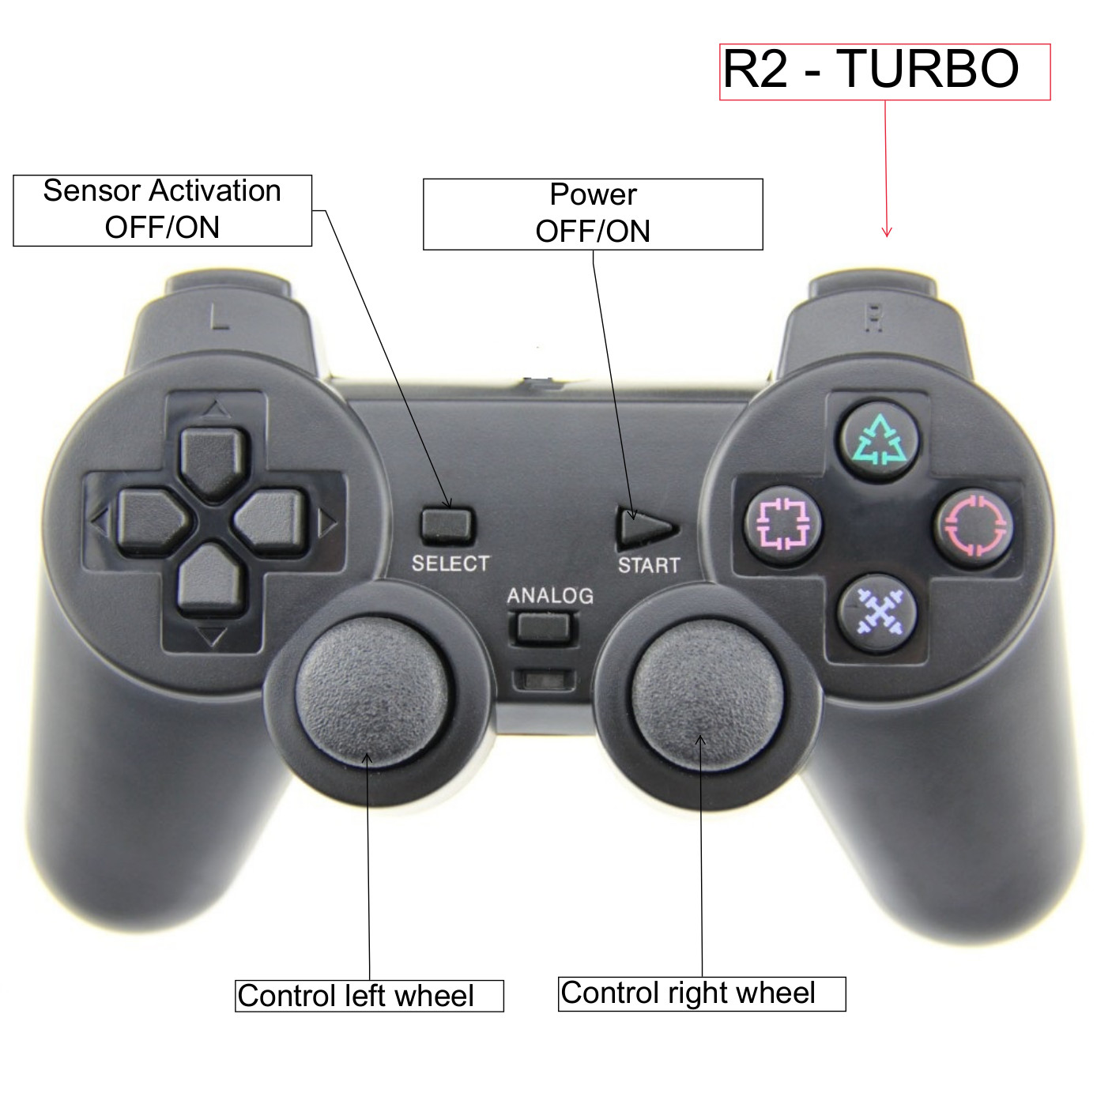

**How to compile** - It’s as easy as pie. Just copy paste and compile.

**Future improvements** - Ultrasonic distance sensors are poor quality, in addition they sometimes return fake measurement. In the future, they can be replaced by the certified one.

**License** - MIT

**Credits** - Sebastian Niespodziany and Bartłomiej Wierzbiński

The project was conducted during the Microprocessor Lab course held by the Institute of Control and Information Engineering, Poznan University of Technology.

**Supervisor** - Adam Bondyra