**Name : Putra Amalul Kamal**

**Student ID : 001202300221**

**Class : IT 6**

**WMP – Project Report**

**Application Overview:**

This is a 24/7 Healthcare application that allows users to digitally store and manage their medical prescriptions using their smartphone. Think of it as a digital prescription wallet.

**Real-Life Workflow:**

**1. User Registration & Login**

1. New users create an account with username, email, and a secure password
2. Returning users can directly login using their credentials
3. The app maintains session persistence, so users don't need to log in repeatedly

**2. Prescription Management**

1. After a doctor's visit, users can immediately capture their prescription using their phone's camera
2. The prescription is stored securely in the local database with:

- The user's identification

- Date of capture

- The prescription image

c) Users can access their prescriptions anytime, anywhere

**How This App Is Helpful:**

1. **Medical Record Keeping**

- No more lost or damaged paper prescriptions

- Creates a chronological history of all prescriptions

- Helps track medication history over time

- Useful for follow-up appointments

1. **Emergency Access**

- Quick access to medical prescription details when needed

- Helpful during travel or emergencies

- Can show previous prescriptions to new healthcare providers

1. **Convenience**

- All prescriptions in one place

- No need to physically carry multiple prescriptions

- Accessible 24/7 as implied by the app name

- Reduces paper clutter

1. **Patient Safety**

- Helps prevent loss of important medical documentation

- Reduces the risk of prescription misplacement

- Assists in maintaining accurate medical records

**Potential Improvements That Could Make It Even More Useful:**

1. Add ability to categorize prescriptions by type or doctor
2. Include medication reminders
3. Add option to share prescriptions with healthcare providers
4. Implement prescription expiry date tracking
5. Add functionality to list pharmacies nearby
6. Include option to set medication reminders
7. Add feature to track medication adherence
8. Include option to add notes or symptoms alongside prescriptions

**Target Users:**

1. Patients with regular medications
2. People with chronic conditions requiring multiple prescriptions
3. Elderly patients who need to keep track of multiple medications
4. Caregivers managing prescriptions for others
5. Anyone who wants to maintain digital copies of their medical prescriptions

**This application solves several real-world problems:**

1. Eliminates the problem of misplaced prescriptions
2. Provides easy access to prescription history
3. Helps in maintaining organized medical records
4. Makes sharing prescription information with healthcare providers easier
5. Reduces paper waste and contributes to environmental sustainability

**ERD**

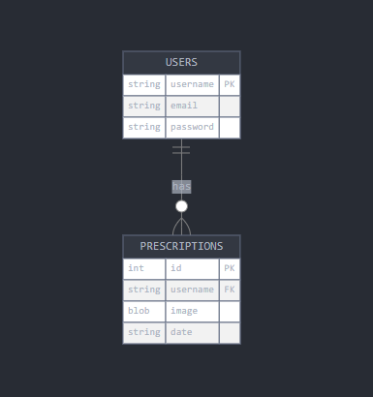

**Use Case Diagram**

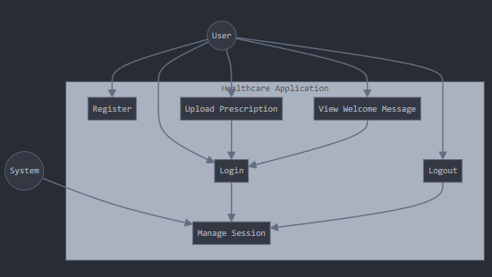

**Screenshots**

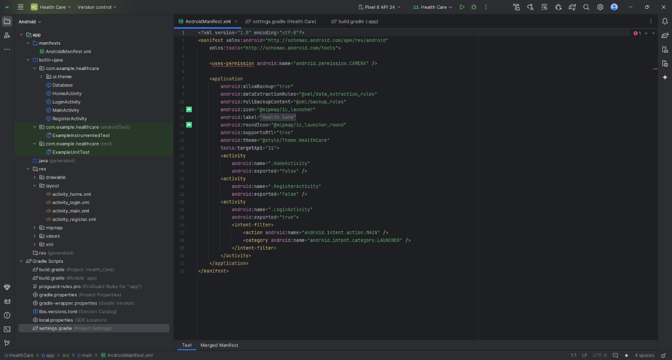

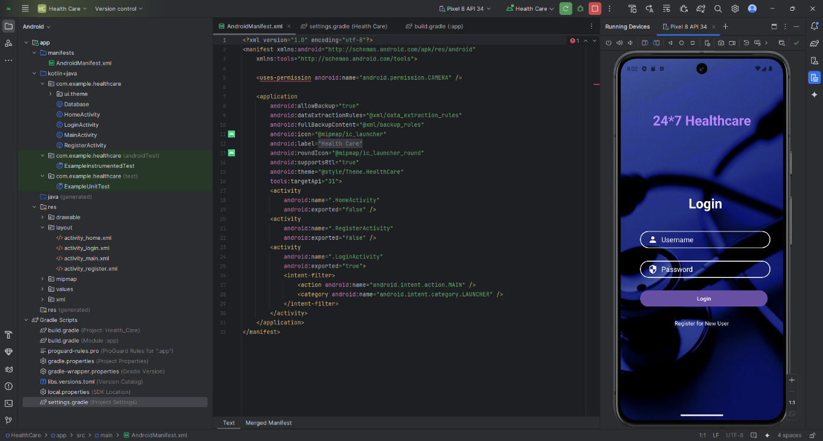

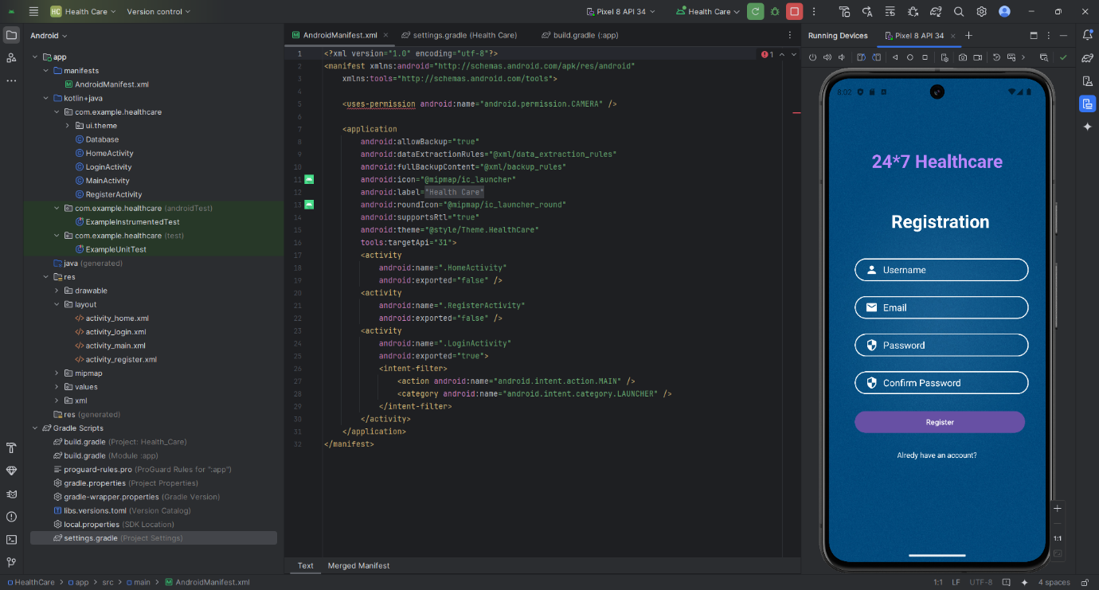

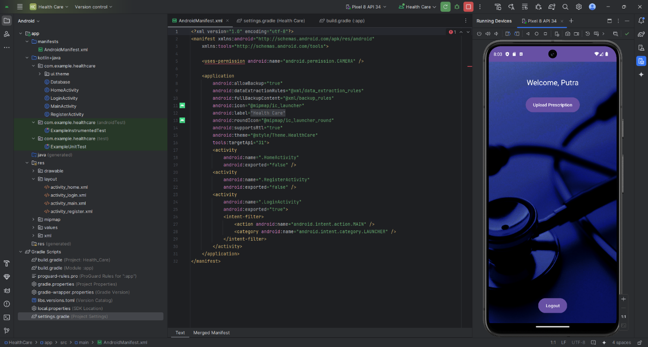

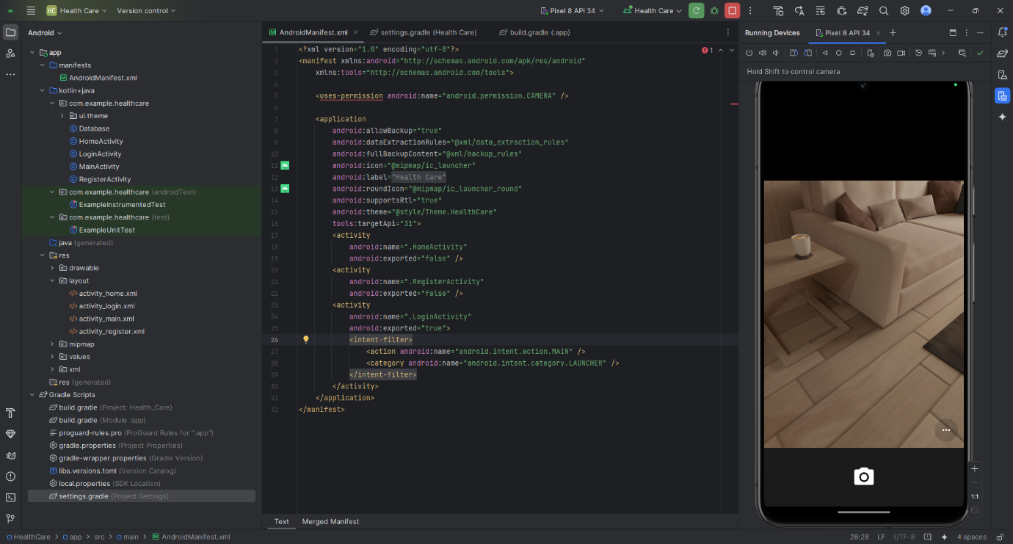

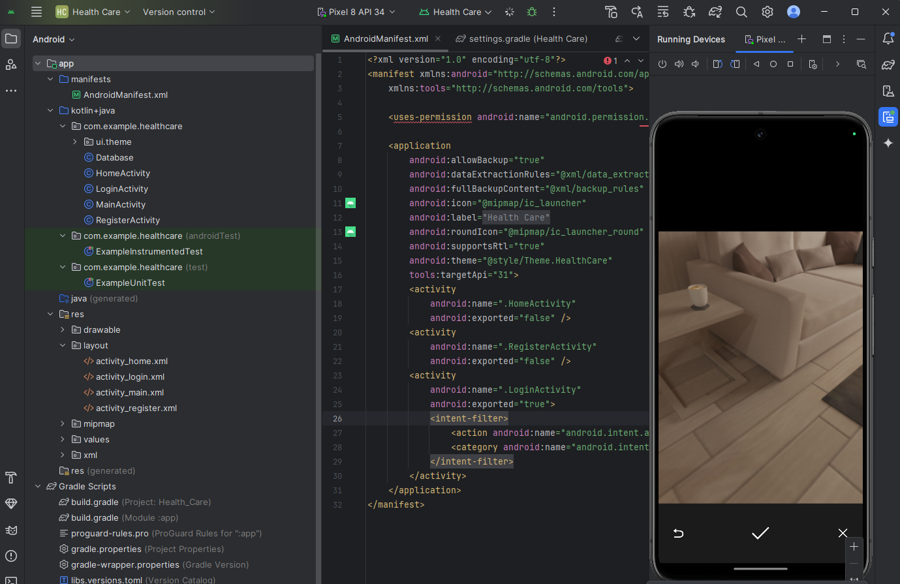

**GitHub:** <https://github.com/PUTRAJAKBOYZ/WMP_Project>